Let’s plan to leave hospital | Me whakamahere i te wehenga i te hōhipera
Hospital staff want you to leave feeling well informed and with answers to any questions you may have. This sheet will help. Some things may have already been discussed with you and won’t be relevant. There are spaces if you or your whānau want to make notes.

Preparing to leave | Te wehenga i te hōhipera

- If you have any concerns or unanswered questions about your health care, talk to your doctor or nurse.
- Note down names and contact details for anyone you may want to get in touch with about your health care after you leave hospital.
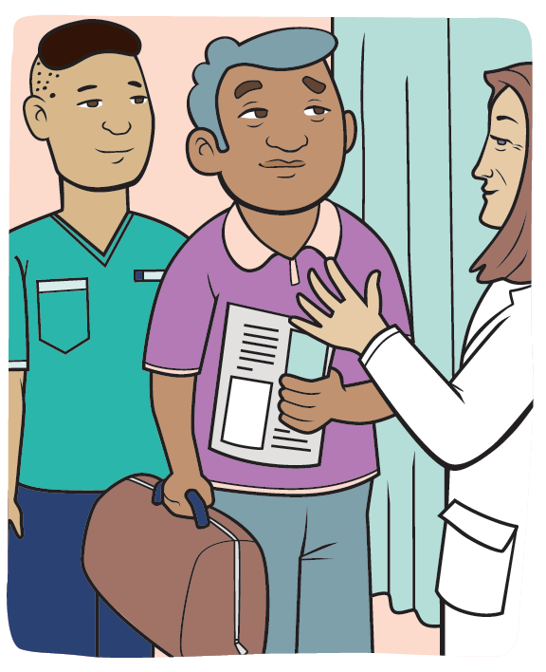

Follow-up appointments | Ngā toronga whai muri

- Check with your doctor or nurse if you need to attend any follow-up appointments or have further tests, and if so where (eg, at hospital or with your GP).
- If you need to see your GP after you leave hospital, make sure you know when and remember to make an appointment.
- If you’re expecting test results, find out how you will get them (eg, someone will phone you or you will need to make the call).

Medication | Ngā rongoa

- List any medicines you should take, when to take them, what they are for and if they have any possible side effects.
- Make sure you understand any changes that may have been made to your normal medicines (if you had any).
- If you’ve been prescribed any new medicine/s, be aware there may be costs involved.

Looking after yourself after you leave | Te tiaki i a koe anō

You may want to ask some questions:
- anything you should look out for after you leave hospital (eg, worrying symptoms like a raised temperature, increasing pain or bleeding)
- any special instructions you have been given (eg, about being able to work, drive or lift)
- what you can you do to stay as healthy as possible (eg, diet, exercise or rest)
- when you can get back to your normal activities
- anything you should do differently now.

This is a large print version of a resource published by the Health Quality & Safety Commission, available online at www.hqsc.govt.nz.

