Minutes of the Te Kāhui Mahi Ngātahi | Consumer Advisory Group (CAG)
to the Te Tāhū Hauora Health Quality & Safety Commission Board
Co-chairs | Angie Smith and Russ Aiton
Members in attendance | Mary Schnackenberg, Jodie Bennett, Maine Johnson, Lisa Lawrence
He Hoa Tiaki in attendance | Deon York, Allison Anderson, DJ Adams, Dez McCormack (minutes), Anne Buckley
Apologies | Boyd Broughton, Delphina Soti
Guests | Martin Thomas, Medical Director and Executive Lead, Heidi Cannell, Senior Strategic Support and Accountability Advisor (Te Tāhū Hauora) via Zoom. Office of the Health and Disability Commissioner staff: Catherine McCullough, Principal Advisor - Strategy and Engagement, Kylie Te Arihi Senior Advisor, Māori and Pasifika

The hui was held in Pounamu on 9 February 2024, starting at 9.40am.

Welcome and karakia
Russ welcomed everyone to the hui and Angie opened with karakia.

General business
  - The minutes from 10 November were confirmed as true and correct.
  - Action items were discussed at length and closed off. Some items may be raised, as per the terms of reference at the Board strategy session on 22 February.
  - Interests register. Updates previously advised are added. One for Maine to add for
next session.

Observations/feedback from the November board session
Lisa started and mentioned they were engaged and interested in the mahi of Te kāhui mahi ngātahi. Jodie added she was impressed with the engagement of board members.
Angie: The board themselves it seems was also impressed with the knowledge and experience of the consumer voice that can be bought to the table, hence the invite to the board strategy session in two weeks.
Russ: was pleased to hear from the board and the interest they had in what Te kāhui mahi ngātahi can add to the overall mahi of Te Tāhū Hauora.

Whakawhanaungatanga
Everyone spoke to their lineage and shared various aspects of their lives.

5. Top collective issues with recommendations identified for board paper
Jodie queried whether the board has had any contact with the new Minister and the new Minister for Mental Health. Deon mentioned the board chair and CE had met with the new Minister of Health, Dr Shane Reti.
The impact of the cost of living and housing on people’s health was discussed along with workforce shortages. Anne noted that this did not feature as prominently in the individual environmental scans this time. There was not a specific quote to include in the board report identified by the group. However, it was acknowledged that one of the co-chairs would have an opportunity to speak to the board paper at the board meeting itself. It was discussed that these issues of cost-of-living impact and workforce shortages continue to be of concern to CAG but that they have been repeated messages in the previous board reports.
Members discussed the importance of the consumer voice and the opportunity presented for the CAG to attend the Te Tāhū Hauora board’s strategic planning meeting on 22 February. They also highlighted the importance of the code of expectations and the efforts and exemplars the individual reports provided of how members were taking the opportunity to promote the code of expectations.

Consumer perspective for statement of performance expectations deliverable for 24/25
Deon ran through the proposal for our statement of performance expectations (SPE). We are looking at three SPE’s for the He Hoa Tiaki Partners in Care team. These are:
- Consumer code of expectations: A review is required in 2024. We would need to cover off the impact of the code to date and capability building to promote the code.
- Forum: We would plan to do a large annual forum and some bespoke regional workshops.
- Ngā Pae Hiranga: – centre of excellent. Further design, delivery and evaluation of consumer engagement mahi.
He Hoa Tiaki broad outline was discussed, and the group provided some initial feedback. He Hoa Tiaki will prepare and send out initial planning for more extensive feedback. Kōtuinga kiritaki consumer network will also be consulted and have input into the plan.
Most of the input required will be what can be under Ngā Pae Hiranga.

Board paper – final clinical governance framework
The following is a summary of Heidi and Martin’s presentation:

- ‘Collaborating for quality: a framework for clinical governance’ is a high-level approach, that is intentionally aspirational and not prescriptive.
- The intent of the framework is to support those working in the health sector to develop their own clinical governance, appropriately adapted to their context and settings.
- The framework aligns with the Pae Ora (Healthy Futures) Act 2022 and the Crown’s responsibilities to Te Tiriti o Waitangi.

Sector feedback:
- The framework has been shared widely across the health sector for feedback including the consumer network, with changes and improvements made to improve the framework’s utility and relevance.
- The feedback provided support for the framework being inclusive of the broader health sector and that it embeds Te Tiriti o Waitangi and equity.
- It acknowledged the necessity for a cultural shift, and with the appropriate support and resource to implement, continuous improvement in quality can be achieved.
- There was support for the whole health workforce being included, with clinical staff in particular needing to be able to relate to the framework.

Some changes made include:
- the need for intentional implementation, appropriate resourcing, and for the health workforce to be well-supported to engage and develop in clinical governance
- addition of reflection questions throughout the framework
- incorporating efficiency into a new quality domain Improved and effective health care
- re-enforced the importance of leadership and within this clinical leadership
- emphasising the significance of psychological safety
- strengthened to incorporate the need for supporting clinical governance within both strategy and funding within health organisations, health services and for the health workforce
- strategic and operational examples included have been strengthened to have wider applicability
- more clearly reflecting quality assurance activities such as measurement, risk and audit.

There are four quality domains:
  - consumer and whānau active members of the health team
  - engaged effective workforce
  - improved and effective health care
  - system safety and learning.

Equity must be encapsulated within all aspects of health care provision and governance.

System drivers:
The system drivers support a whole-of-system approach to clinical governance and collaborating for quality health care. They are:
  - collaborative care
  - leadership
  - monitoring and evaluation
  - relationships
  - health technologies and data
  - population health approach.

Next steps:
- Te kāhui mahi ngātahi feedback and the summary of themes will be provided to the board.
- Board approval is sought in late February, then progressing to Manatū Hauora and the Minister of Health.
- Release planned for mid-March 2024.
- Promotion activities including media release, social media, and newsletter and webinars.

Group feedback
Appears the code of expectation is woven throughout the document which make a strong focus from a consumer point of view. The ‘what next’ question was asked. Martin said there was still a lot of collaboration and while we can’t make this a must do, we can and will encourage embedding in the health sector. Jodie also commended the work done here and the essence of what the document covers. Angie liked the emphasis on locality and communities.

Mary liked the ease in which it was able to be read, having experience on local governance boards and the work here is easily followed.

Lisa also agreed with others positive comments and liked the quote, ‘It’s the ingredients not the recipe’.

Maine liked the language that has been used – style of writing but questioned the artwork and use of the koru. There will be feedback sent to PIC on the use of the artwork.

Code of expectations implementation guide – consumer representation

This section discussed after item 9.
The co-chairs of CAG represent the group on the consumer voice reference group (CVRG) which also includes representatives from the health entities and Manatū Hauora. A major focus of CVRG is overseeing the implementation guide for the code of expectations to ensure it meets the needs of the entities and the health sector as a whole. CVRG meets regularly, with the next meeting a scheduled zoom hui from 3 to 4.30pm on 22 February.
Anne was asked to give a brief update on where things are up to with the guide. The Implementation Guide has now been online since end June and so, as a ‘living document’ online, it was time for its 6-monthly review in January. A survey was sent out to CVRG members in December to get feedback on any changes or additions needed. CVRG members were also invited to send the survey on to others in their teams. Hector Matthews (National lead, consumer and whānau voice, Te Whatu Ora) sent the survey on to newly appointed members of his consumer engagement team. Several have already responded with useful feedback. Russ and Angie as members of the group also commented positively on the work of CVRG and will keep CAG updated on progress.

9. Review of Code of Rights and HDC Act – overview and feedback
Following Angie’s welcome to HDC staff and introductions around the table, Catherine provided a brief overview of the review, what was in scope and what they were hearing from people. She then talked about the upcoming public consultation phase and how it would be helpful to get the group’s insights on how best to engage with their communities.
The group provided the following feedback in regard to the question posed by HDC – “How can we best engage with your communities”:
Avenues for engagement:
- Jodie noted that Changing Minds could put a hui/zui on and get 10–20 people – you’d give them 3–4 questions in advance with time to think about what they want to share. CM would be keen to support this.
- DPO Coalition – top end national entity to engage with
- Consumer Councils – NGO world – individual groups can be used to feed information out. Would welcome the opportunity to have you guys come and talk to the Chairs etc.
- Law Commission is about to do its second round of consultation. Is there an opportunity to think about different ways to collaborate?
- There are lots of health conferences coming up this year – rainbow rights conference (HRC), multicultural council, whānau ora, allied health etc – national groups – always hungry for that type of opportunity
- Regulatory authorities also have CAG’s already
- Get into the regions – regional hospital discussions

Key things to consider:
- Lots of people that you want to talk to have lost faith in the system. What will work for many people is coming through their existing relationships – people that they trust.
- People won’t always engage because of the harm they have experienced (or fear)
- Can acknowledge the trauma and link it to the opportunity.
- People need to know it is a safe space.
- Lots of people in NZ with impairments but who don’t see themselves as disabled
- Don’t engage via survey – face to face with kaimahi that hold the relationship. Get the ones with the relationship on board
- Putea/aroha/reciprocity key. Feed them up – kai, koha
- Family vs whānau – Te Kāhui Piringa pulled us up – group of people who care for each other – use word to describe that wonderful connection
- Web – make sure people can follow progress of the review on the website
- Take some comfort in the fact that you have this opportunity

Opportunities for improvement
- The national advocacy service is important, but people have lost track of it and can’t always get it (or know they can get it) when they really need it.
- The video HDC has done highlighting people’s rights under the code is great and it needs to be on every screen in every waiting room.
- Enforceability is key.
- Have had UNCRPD since 1996. What’s the role of Whaikaha vs you guys? How can you best work with other rights-based organisations in the country? Where are the opportunities to get people support from somewhere else?
- Could condense the Code – mention it once and mention it well – easier to sell – less could be more.
- Complaint – not a favoured term.
- Health literacy and the sharing of info re rights etc need to be frontloaded into Cornerstone – should be a health literacy 101 when someone is enrolled – we do this in family planning service.
- Find the right wording within houhou te rongo – needs to be kanohi kitea – has to be seen.

The group was also keen for a session during the consultation period.
The session was closed off with mutual thanks and a karakia. The HDC were grateful for the opportunity to discuss the review.
Following is a summary of Catherine’s presentation slides:
Everyone accessing health and disability services has rights as set out in the Code of Health and Disability Services Consumers’ Rights.
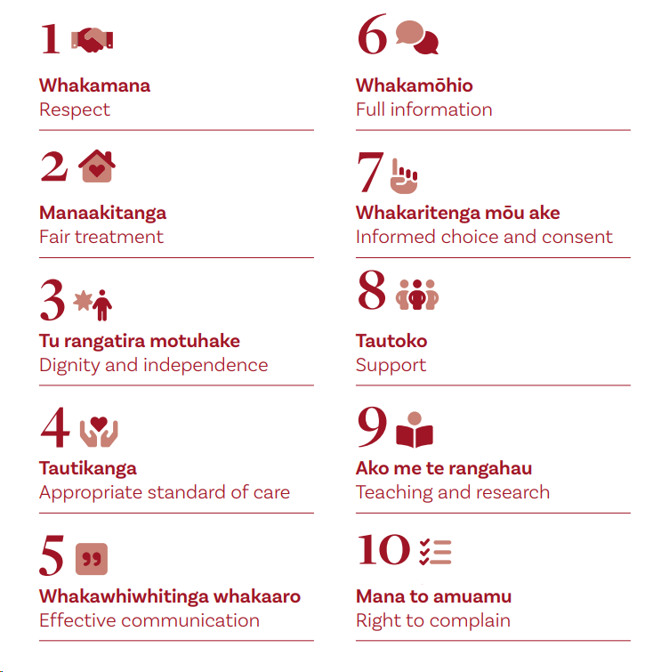
The Health and Disability Commissioner:
- HDC is responsible for promoting and protecting those rights and resolving complaints where those rights may have been breached.
- Anyone can make a complaint either directly with the provider, including with the support of the independent Advocacy Service contracted by HDC, or with HDC.
- HDC will consider the best complaint resolution pathway, eg to refer to another agency, the Advocacy Service or provider, provide educational comment to providers, or investigate in a small number of cases. Investigations can result in prosecution in the Human Rights Tribunal or Health Practitioners Disciplinary Tribunal in a small number of cases.
- HDC has recently introduced hui ā-whānau hohou te rongo as a way of managing complaints, led by the Director Māori

Review overview:
- We have a statutory requirement to regularly review the HDC Act and the Code of Health and Disability Services Consumers’ Rights
- We are focusing on five topics:
1. Supporting better and equitable complaints resolution
2. Making the Act and Code effective for, and responsive to the needs of Māori
3. Making the Act and Code work better for tāngata whaikaha | disabled people
4. Considering the options for a right of appeal for HDC decisions
5. Minor and technical improvements.

Topics:

Supporting better and equitable complaints  The Health and Disability Commissioner  resolution | Eg – introducing a people-centred focus into the purpose statement; strengthening Advocacy Service; strengthening Code requirements around cultural responsiveness; clarifying and supporting whānau| family involvement; introducing gender-neutral language
Making the Act and Code effective for, and  responsive to the needs of Māori | Eg – looking at opportunities to introduce and protect tikanga in the Code; looking at options to give practical effect to te Tiriti o Waitangi | the Treaty of Waitangi in the Act
Making the Act and Code work better for  tāngata whaikaha | disabled people | Eg – strengthening references to accessibility and supported decision-making in the Code; updating language; considering options for disability voice in the Act
Considering the options for a right of appeal  for HDC decisions | Eg – options for a legislative right of review, changing the threshold for accessing the HRRT
Minor and technical improvements. | Eg – timeframes for Act and Code reviews; updating fines, seeking feedback on responding to new tech

Engagement to-date:
- Internal team collaboration across strategy, Māori directorate, disability team and legal, with strong oversight from internal leadership.
- Wrote to 49 agencies and organisations to help determine scope
- Held wānanaga with rangatira Māori to seek guidance and direction on matters of tikanga
- Met with over 150 people, including holding 14 workshops, to help develop content of draft consultation document. Prioritised voices of Māori and tāngata whaikaha | disabled people, alongside a diverse representation of the health and disability sector.

Timeframes:
- Three-month public consultation period from late March/early April to late July 2024. Will include some in person and online hui.
- Our statutory deadline for reporting to Ministers with recommendations is 20 December 2024.
- You can be added to our mailing list for updates by emailing review@hdc.org.nz.
- You can help us during public consultation by promoting the consultation with your networks and sharing resources. We are also happy to come back to CAG and do a dedicated session.

10. Wrap of day, other business and PIC report for noting
The PIC report was noted as read. The consumer engagement person for Southern district was confirmed.

11. Karakia and close
Angie closed with karakia.

Actions list
Date | Action | Responsibility
10 Nov 2023 | Mary’s recommendation re update to national computer system to store personal health information | This mahi sits with Te Whatu Ora. Email with links sent 15 Feb 2024.

Next hui – 5 April 2024 via Zoom.

Appendix 1

He Hoa Tiaki report for Te Kāhui Mahi Ngātahi | CAG 9 February 2024
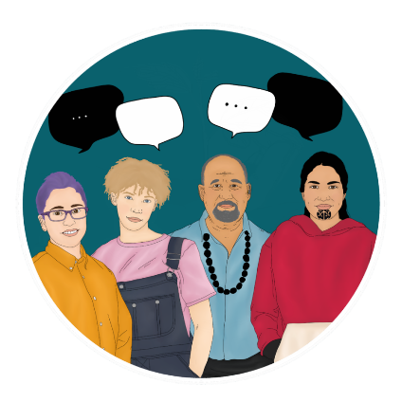
The following are highlights from the past few months with a focus on the second quarter of the financial year (1 October-31 December).

Consumer health forum Aotearoa

Consumer health forum Aotearoa events
Our Voices: Shaping health care together | Ō mātou reo: He tārai tahi i te tauwhiro hauora will be held on 15 May in Auckland at Waipuna Hotel and Conference Centre. The programme for the day is shaping up with the first 100 tickets sold and all early bird spots allocated.
The objectives of the forum are to:
- Increase your confidence and learn more about taking part in consumer and whānau engagement health initiatives.
- Explore how the code of expectations is impacting the health sector.
- Hear how consumers, whānau and community perspectives are shaping the design and delivery of health services.
- Connect with others involved in consumer and whānau engagement in the health sector and share best practice
We are pleased to confirm our MC for the event, Ma’a Brian Sagala, QSM.
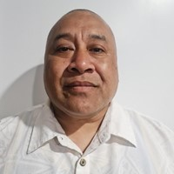
Brian has 30 years’ experience in public speaking, radio and facilitation. He has been a producer and presenter of 531pi with the Pacific Media Network since 2015 and has used his profile to support various causes within Pacific communities. Brian has helped host community fono with Pacific church leaders on a number of health and wellbeing issues. He was MC of Pasifika Festival from 2011 to 2019. He helped the then-Northern district health board with the Prepare Pacific COVID-19 campaign to communicate with harder-to-reach segments of the Pacific population during the pandemic, relaying key messaging to the community. While travelling the Pacific region for work, Brian has performed outreach work in local communities in his own time.
Figure 1- headshot of Ma'a Brian Sagala, QSM in front of a white background
Event webpage: Our voices: Shaping health care together | Ō mātou reo: He tārai tahi i te tauwhiro hauora | Te Tāhū Hauora Health Quality & Safety Commission (hqsc.govt.nz)

Registrations: https://hqsc.eventsair.com/cmspreview/ourvoices2024/

North island consumer workshops

In addition to our national consumer health forum event, we are holding three regionally based workshops for consumers interested in helping the health system design services for the communities they serve. These workshops are aimed at those new to consumer and whānau engagement and those who have some experience with it. They will take place over two weekends in March. Below are the locations and timings:
- Friday 15 March 2024, 10.00 am–1.00 pm, Terenga Paraoa Marae, Whangārei
- Saturday 16 March 2024, 10.00 am–1.00 pm, Te Ahu, Kaitaia
- Saturday 23 March 2024, 10.00 am–1.00 pm, Te Taiwhenua o Heretaunga, Hastings

There will be an afternoon workshop in Hastings on Saturday 23 March 2024 hosted by the Office of the Health and Disability Commissioner about the Code of Rights (www.hdc.org.nz).

We encourage both Te Kāhui Mahi Ngātahi and Kōtuinga Kiritaki members to share information about the upcoming regional events with their networks.
For more information visit: https://hqsc.eventsair.com/ourvoices2024/north-island-consumer-workshops.

Consumer forum opportunities
Since 1 Jan 2023 we have seen a growing interest in consumer opportunities through the consumer health forum Aotearoa. To date, we have been able to assist 24 organisations to recruit over 199 consumers to share their expertise via joining consumer councils and networks focus groups, and/or advisory, steering or governance groups. Some examples of these include:
- consumer advisors recruited by Pharmac,
- consumer advisory committee and panels with Manatū Hauora,
- working groups and consumer councils with Te Whatu Ora,
- advisory groups with ACC and
- focus groups led by HDC.
In addition, consumer health forum members have been given opportunities to share their thoughts and experiences through several surveys and consultation activities on areas of health such as mental health and addictions, advanced care planning and alternative medicines. The following table provides a breakdown of consumer opportunities by category:

Type of opportunities | Number of opportunities advertised | Participation figures
Advisory, steering and/or governance group | 27 | 81
Focus groups | 9 | 118
Surveys, (including user-testing IT solutions) | 6 | n/a- due to confidentiality
Totals | 43 | 199+
As the consumer health forum Aotearoa gains membership and awareness these opportunities are only expected to increase. Each opportunity listed and promoted is the result of a thorough engagement process between the health sector and He Hoa Tiaki. Through each of these engagements, we take the opportunity to share resources, best practice examples, and advice about genuine engagement practices, the code of expectations, and co-design.
Since 1 Jan 2023 we have had 5,037 views to our consumer opportunities webpage. Please keep sharing these with your networks as they come through our website, newsletters and media channels.

Forum membership
The total number of individuals who have signed up to the consumer health forum Aotearoa forum members is 899 (as of 31 December). We continue to encourage new membership, and work towards our goal of 1,000 members this year. Help the forum grow by sharing this sign-up link with those in your network:
The following table shows the breakdown of members by ethnicity from end of quarter 4 2022-2023 through end quarter 2 (31 December 2023).

Ethnicity | Quarter 4 2022-23 | Quarter 1 2023-24 | Quarter 2 2023-24
Māori | Quarter 4 total: 153 (18.4%) | Quarter 1 total: 170 (19.0%) | Quarter 2 total: 174 (19.4%)
Pacific | Quarter 4 total: 87 (10.1%) | Quarter 1 total: 91 (10.2%) | Quarter 2 total: 91 (10.1%)
Asian | Quarter 4 total: 39 (4.5%) | Quarter 1 total: 42 (4.7%) | Quarter 2 total: 43 (4.8%)
Pākehā/Caucasian | Quarter 4 total: 482 (56.0%) | Quarter 1 total: 494 (55.3%) | Quarter 2 total: 494 (54.9%)
Middle Eastern/ Latin American/ African | Quarter 4 total: 17 (2.0%) | Quarter 1 total: 18 (2.0%) | Quarter 1 total: 18 (2.0%)
Other ethnicity or ethnicity not specified | Quarter 4 total: 77 (9.0%) | Quarter 1 total: 78 (8.7%) | Quarter 2 total: 79 (8.8%)
Total | Quarter 4 total: 860 | Quarter 1 total: 893 | Quarter 2 total: 899

Welcome Lisa Lawrence to Te kāhui mahi ngātahi

In November, Lisa joined Te kāhui mahi ngātahi and was able to join the final meeting for 2023. Her experience as a consumer advisor includes lay representative on the New Zealand Psychologists Board, a Māori consumer representative for specific New Zealand College of Midwives audit/review projects, a member and chair of the Pharmac consumer advisory committee and a current member of the Māori advisory committee to the Nelson Bays Primary Health board. We are delighted to welcome Lisa to the team. Lisa’s full bio is available on our consumer advisory group webpage
Young Voices Advisory Group
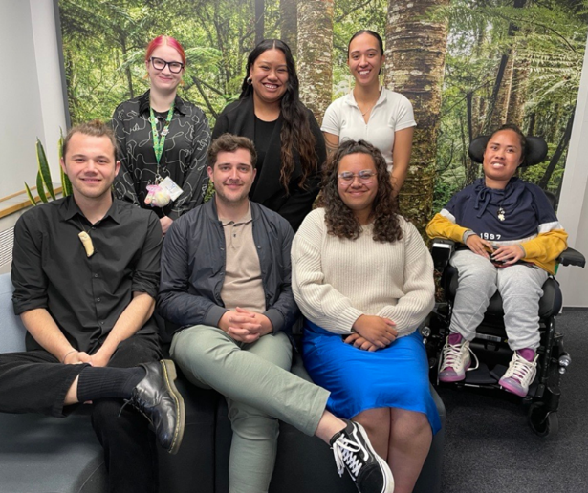
The Young Voices Advisory Group join Te Kāhui Mahi Ngātahi Consumer Advisory Group (CAG) and Kōtuinga Kiritaki Consumer Network (CN) in bringing the consumer and whānau perspective to the work of Te Tahu Hauora and He Hoa Tiaki, representing the voices of young people. In November, the group of seven members met first by Zoom and then again in person in Wellington. The advisory group provided additional input on our planned regional workshops and developing consumer engagement resources. They were introduced to the roles of Te Kāhui Mahi Ngātahi and Kōtuinga Kiritaki were able to learn more about the work of He Hoa Tiaki and more broadly, the work of Te Tāhū Hauora. We look forward to working with these inspiring young people!
Figure 2-Members of Young Voices advisory Group standing in front of a forest background. Back row L-R: Natasha Astill, Tiare Makanesi, Ciccone Hakaraia-Turner. Front row L-R: Jaden Hura-White, Joshua McMillan, Ataahua Hepi and Naomi Vailima.

Code of expectations and implementation guide

The team’s work socialising the code of expectations and implementation guide continues through a wide range of engagements across the sector. As the implementation guide has now been available online for 6 months, we are focused on identifying which areas of the guide need amending, updating or expanding. Consumer Voice Reference Group (CVRG) members have been invited to complete a survey and there is an offer to hold focus groups within some of the health entities to identify further practical changes for the guide. Website traffic statistics, similar to the table below are prepared regularly for the CVRG group and used to determine public engagement with the guide’s content.
The table below provides a summary of website traffic to the code of expectations, implementation guide, Co-design, Consumer health forum Aotearoa consumer opportunities and other forum- focused webpages over the Q1 and Q2 periods (July 1- 31 December) More details, including social media engagement are available in appendix a.

Tabe 1 Summary of website traffic
Description of content and link to web page | Quarter 1  1 July-  30 September | Quarter 2  1 October- 31 December
Understanding co-design | Kia mārama ki te hoahoa tahi here | Views: 667  Users: 426 | Views: 518  Users: 375
Consumer health forum Aotearoa | Wāhi whakawhiti kōrero hauora (landing page) here | Views: 930  Users: 656 | Views: 767  Users: 542
Consumer opportunities Tā te kiritaki whai wāhi here | Views: 1619  Users: 964 | Views: 1840  Users: 1010
Code of expectations for health entities’ engagement with consumers and whānau | Te tikanga mō te mahi tahi a ngā hinonga hauora ki ngā kiritaki me ngā whānau here | Views: 2011  Users: 1117 | Views: 1594  Users: 961
Code of expectations for health entities’ engagement with consumers and whānau here  (This page hosts the code translations and accessible formats) | Views: 1395  Users: 820 | Views: 1267  Users: 821
Code of expectations implementation guide |  Te aratohu tikanga (landing page here) | Views: 1862  Users: 940 | Views: 578  Users: 320
Co-designing with consumers, whānau and communities | Hoahoa tahi me ngā kiritaki, ngā whānau me ngā hapori here | Views: 793 Users: 447 | Views: 328  Users: 217
Using lived experience to improve health services | Te whakamahi wheako mātau hei whakapai ake i ngā ratonga hauora here | Views: 389  Users: 243 | Views: 245  Users: 165
Improving equity through partnership and collaboration | Te whakapai ake i te mana taurite mā te mahi tahi here | Views: 276  Users: 176 | Views: 107  Users: 76
Accessibility and resourcing for consumer, whānau and community engagement | Te whai wāhi me te whai rauemi mō te mahi tahi ki te kiritaki, te whānau me te hapori here | Views: 269  Users: 146 | Views: 107  Users: 58

Quality and Safety Marker for consumer engagement (QSM)
Due to the large-scale changes in the wider health sector we offered some flexibility for this past reporting period, ending 30 September. We extended the due date for submissions, reached out to each district individually, and offered support and guidance. Once received, the moderation team offered detailed feedback on each submission and indicated where stronger background evidence and or examples could be more explicitly linked to the code of expectations. This activity has allowed us to establish a number of new relationships and strengthen some existing connections within the districts. Nineteen out of twenty-four submissions have been published, including best practice examples. The next QSM reporting period ends 29 March 2024.
The Quality and Safety Marker for consumer engagement framework can be viewed in PDF or MS word formats on our website. Work is progressing to add further accessibility options and/or functions. The team would like to thank consumer network member, Oliver Taylor for his time and advice with moderating the submissions.

Engagements
For the period of 1 October -31 December, He Hoa Tiaki team took part in 148 separate events, engaging widely across the sector and at multiple levels.
Key aspects of these engagements included:
- supporting organisations with the Consumer Quality and Safety Marker (QSM) submissions,
- helping services to develop opportunities and recruit consumer forum Aotearoa members to projects,
- discussions with Te Whatu Ora districts, other health entity representatives, NGO’s and foundations.
- hosting the multi-agency Consumer voice reference group (CVRG).
- presentations on the code of expectations and other pillars of our work programme. More details of key presentations are below:
- BMJ international conference (Melbourne): Deon York presented on the code of expectations for health entities’ engagement with consumers and whānau and its role in the reforming health system.
- Te Whatu Ora Te Pae Hauora o Ruahine o Tararua Midcentral- DJ Adams presented at the consumer information day on the code, the code implementation guide and the consumer engagement Quality and Safety Marker (QSM)
- Designated Auditing Agency (DAA) auditor update conference. Anne and DJ gave a presentation on the code of expectations, the code implementation guide and the QSM.
Engagement with Te Whatu Ora Consumer and Whānau Engagement Team

Our team is building a collaborative working relationship with the consumer and whānau engagement team of Te Whatu Ora. Many of the Te Whatu Ora team were previously known to us, and we are looking forward to getting to know the new members of the team. We will be sharing our forward work plans, and from a Te Tāhū Hauora perspective, we will be closely focusing on our role and functions as set out in the Pae Ora Act 2022 and this will complement the work of Te Whatu Ora and minimise duplication. Collaboration will be important to achieve this.
We know that there is uncertainty about the structure of consumer advisory groups at the district or regional level. The Te Whatu Ora team will be looking at these former DHB structures. Te Tāhū Hauora recognised the significant changes and pressures of the reforming system and wanted to do our part to reduce barriers for the continuation of consumer council chairs meeting regularly and supported those who required it throughout the formation of Te Whatu Ora and the roll out of the Pae Ora Act (i.e. over two years). It was signalled that from 1 July 2023 that we would continue to support the consumer councils according to our functions. This does not change the ongoing relationship with the consumer councils/advisory groups as they evolve, but the infrastructure to support consumer councils and advisory groups, and how policies will be rolled out to support these structures is now managed by Te Whatu Ora in place of DHBs. We will continue to champion consumer engagement at all levels of the system.

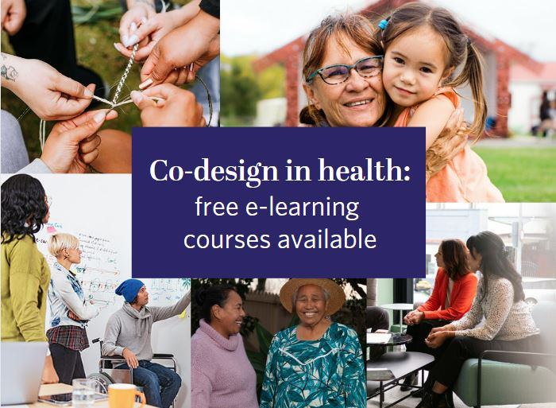
Co-design courses
We are glad to know that our co-design courses continue to be well-used and recommended by health organisations, staff and consumers alike.
This resource has now been accessed 1404 times compared with 1277 in Quarter 1 and 1093 times in Q4 last financial year, which tells us the course is still being shared and interacted with.
If you haven’t had a chance to complete the courses, this is a reminder that they are available anytime at no cost. First-time LearnOnline users will simply need to create a login. For more information, please visit the webpage

Appendix a: Website analytics
Our website remains our main engagement tool and is used widely. In 2023, we recorded 921,000 views across the website by 162,000 users. Our analytics show that 39 percent of users scrolled 10–90 percent of the pages they visited, showing good engagement with the content. We also recorded 155,000 file downloads.
Te Tāhū Hauora Health Quality & Safety Commission’s website analytics now collects data differently as ‘users’ rather than ‘unique views’. The website data shows varied engagement across different sections in quarters 1 and 2. Key highlights include:

- ‘Understanding co-design’ with 667 views (quarter 1) and 518 views (quarter 2),
- Consumer opportunities has seen a significant increase in traffic with 1840 views I quarter 2 and
- ‘Code of expectations for health entities’ with 2011 views (quarter 1) and 1594 views (quarter 2).

Summary of website traffic

Description of Table 1.
Understanding co-design had 667 views (426 users) in quarter 1 and 518 views (375 users) in quarter 2. Consumer health forum Aotearoa landing page had 930 views (656 users) in quarter 1 and 767 views (542 users) in quarter 2. Consumer opportunities had 1619 views (964 users) in quarter 1 and 1840 views (1010 users) in quarter 2. Code of expectations for health entities’ engagement with consumers and whānau had 2011 views (1117 users) in quarter 1 and 1594 views (961 users) in quarter 2. The code of expectations translations and accessible formats page had 1395 views (820 users) in quarter 1 and 1267 views (821 users) in quarter 2. The code of expectations landing page had 1862 views (940 users) in quarter 1 and 578 views (320 users) in quarter 2. Co-designing with consumers, whānau and communities had 793 views (447 users) in quarter 1 and 328 views (217 users) in quarter 2. Using lived experience to improve health services had 389 views (243 users) in quarter 1 and 245 views (165 users) in quarter 2. Improving equity through partnership and collaboration had 276 views (176 views) in quarter 1 and 107 views (76 users) in quarter 2. Accessibility and resourcing for consumer, whānau and community engagement had 269 views (146 users) in quarter 1 and 107 views and 58 users in quarter 2.

Social media
Our content featured in the reshared of most popular post from 2023. These include our voices and the code of expectations implementation guide and co-design modules.
We generated new context to re-promote accessibility videos featuring Mary Schnackenberg. This post had successful engagement including reshares from Paula Tesoriero MNZM, Carmela Petagna and Whaikaha, Ministry of Disabled People.
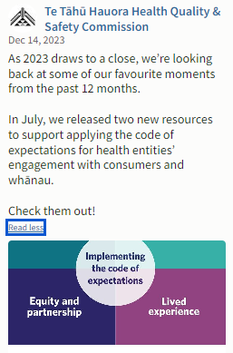
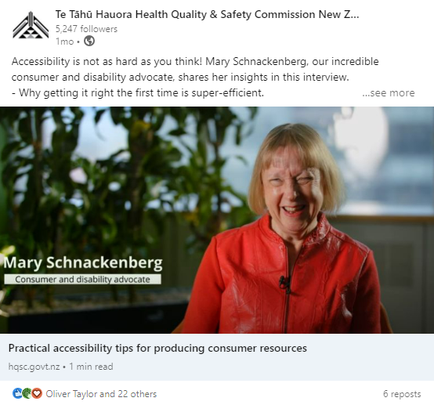

LinkedIn
Out of the top ten best-performing organic posts for Te Tāhū Hauora, only one of posts featured. Ranked #3 across the organisation was Young Voices Advisory Group:
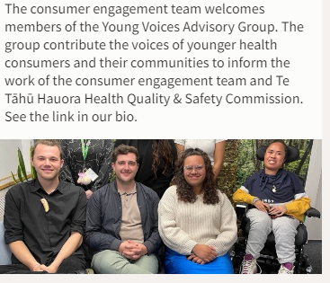
- Clicks: 25
- Engagement: 10%
- Impressions: 704
- Reactions: 42
- Shares: 5

Facebook
Out of the top ten best-performing organic posts for Te Tāhū Hauora, three were content from He Hoa Tiaki. The top post ranked #1 across the Te Tāhū Hauora was our post for the Young Voices Advisory Group with an engagement rate of 10.24 percent and new consumer opportunities with an engagement rate of 8.01 percent. The third best performing post was Te Tāhū Hauora Health Quality & Safety Commissions newsletter which has an engagement rate of 7.84 percent.
Our top posts ranked: #1, 2 and 6 across the organisation.

Instagram
60 percent of the top ten best-performing organic posts for Te Tāhū Hauora were He Hoa Tiaki content. The top post ranked #1 across the Te Tāhū Hauora was our post for the Young Voices Advisory group with an engagement rate of 10.24%
Our top posts ranked: #1, 5, and 6, 8, 9, 10. across the organisation. These included Our voices, featured consumer opportunities, #RACMA2023 and Aotearoa Patient Safety Day.

The top post ranked #1 across the organisation was young voices on 27 November 2023:
- 126 impressions and 29.57 engagement rate.
- Engagement: 24
- Comments: 2
- Likes: 24.

Appendix 2

Summary of Te kāhui mahi ngātahi members environmental scan for 9 February 2024
Russ Aiton (West Coast)
Independent Chair - National Chairs Group (Consumer Councils)
Co-Chair – Consumer Advisory Group (HQSC)
Co-Chair – National Quality Forum
Consumer Advisor – Public Hospital Audit Project
Chair – Cornerstone Family Support Services (Greymouth)

Real time monitoring Takiwā Poutini | West Coast Localities steering group – continues to successfully engage community outwardly and has collated feedback to locality specific “points of difference”. The challenge is to secure funding to deliver the identified needs successfully and sustainably. I met with the programme manager to scan the Code of Expectations and ensure that even though not mandated to, the work done is mindful and reflects the Code wherever practicable.

Te Whatu Ora – the final organisational changes have (seemingly) occurred, and we are entering a time of consolidation and reflection here. Issues of consumer engagement still are to the fore of any such conversations with the tension between SKILL and WILL remaining.

The frustration at inaction and clarity continues to be a discussion point with the slip back to operationalising the consumer council, even referring to “KPI’s” again as a method of demonstrating successful engagement? A plan to have a consumer council jointly with the PHO across all the consumer activities is a worthy concept to discuss but this was presented to the consumer council as a “done deal” and an inevitable conclusion negating any point of thought dialogue.

I continue to support the Co-Chairs and Quality Team in their determining of consumer council activities across West Coast. The CAG and National Chairs Group liaison is of value in maintaining the communication and feedback to all parties as we progress.

COVID-19 comments. There are still COVID cases, as well as seasonal flu cases, coming in via unplanned care tothe health centre maintaining the pressure on health of workforce. This is still providing stress for the workforce and immediate management.

National Consumer (Councils) Group The group has agreed to me continuing as Independent Chair for a period of 6 months to oversee the transition now that Te Whatu Ora (Hectors directorate) is establishing and to provide leadership as the group determines how best it can proceed against the envisaged (political) changes at national, regional and locality levels.

I have stood up a working group to review the tactical and operational aspects of the group and to determine our ToR document as we proceed to establish communication and feedback with the consumer engagement sectors. Now that HQSC has ceased support for the group and Te Whatu Ora, at present, have given no clear indication if any support will be forthcoming, the group wishes to determine, in part, its own strategies as to how it can best deliver the voice at a national level for the local (consumer council) groups.
Mary Schnackenberg (Tāmaki Makaurau)

Environmental scan/real time monitoring and services
In the media has been Last October's released report into IDEA Services which runs homes for learning disabled New Zealanders which was commissioned by Whaikaha – Ministry of Disabled People. I mentioned this in my last report and have now had time to read the full report and Whaikaha's summary response.
Whaikaha has inherited from the Ministry of Health responsibility for funding and monitoring of disability support services. Although the report was primarily about IDEA Services, complaints, policies and processes, the investigator found all sorts of challenges which Whaikaha, the new funder, had inherited from the Ministry of Health. The investigator uncovered a great deal of mistrust in the sector and has called on both Whaikaha and IDEA Services to collaborate to restore trust and establish processes that are transparent and open to scrutiny by the public.
As new ways of working are developed by Whaikaha and IDEA Services, their model will be rolled out to other contracts that Whaikaha holds with other service providers in the disability sector. The Health and Disability Commissioner is also engaged in this process with their complaints processes and their National Advocacy Service. Knowing some of the leaders as I do, I am confident of better things to come.
Yet again the media has picked up that health services for learning disabled New Zealanders are still pretty woeful. I remember at the time of the Special Olympics in 2013 there was shock about the health situations for several of the athletes who were tested for sight and hearing and other health checks. It seems that not much has changed. Some doctors find it very difficult to communicate with learning disabled patients and some carers find it hard to support both the patients and the doctors with supported decision making, plain language amidst medical jargon and other necessary techniques.
Services
My term of some five years at the Consumer Experiences Council of Auckland Health NZ as a consumer advisor has come to an end. As far as is possible amid the health reforms turmoil, I left the council in a good space with a mix of staff and consumer advisors working constructively.
Positive stories and exemplars
A blind person I know has had a second bout of cellulitis. He took himself to the local after-hours emergency service. The doctor read his notes from his first event which put him in Auckland City Hospital for four days. Prompt treatment meant the infection was cleared up quickly.
Advocacy is growing to allow pharmacists to give free vaccinations to children. No one can be looking forward to the predicted measles outbreak with such low vaccination levels among youngsters.
Recommendations
I will continue to raise the issue of access to personal health information in one's preferred format. Also, how is the technology progressing to join up the databases of personal health records across New Zealand?

Jodie Bennett, (Tāmaki Makaurau) Changing Minds (Mental Health and Addiction Sector – Northland & Auckland)
A New Government
As you will be aware, the new Cabinet has been sworn in. We now have a new portfolio, Minister of Mental Health, with Mr Matt Doocey now established into this role. Changing Minds, along with several other Mental Health and Addiction NGO’s, are sending BIM’s (Briefs to Incoming Ministers). Our focus has been on the value and importance of Lived Experience-led Community solutions and engagement, seeking to create equitable, improved health system and service responses.
Workforce
Significant workforce pressures persist, and are presenting ongoing challenges for tāngata whaiora to access the healthcare they need. Workforce shortage challenges continue, although Te Whatu Ora noted 6,000 more nurses are registered than last year. Programmes are in place to grow specialist mental health services as mentioned in my previous environmental scan, as well as those focusing on bringing more primary care doctors on board.
There remains an ongoing risk to cultural harm from workforce recruited from overseas. This is currently being explored further for discussion.
Workforce Development
Le Va and Te Whatu Ora have announced the establishment of a new scholarship programme for students focusing on careers in Alcohol and Other Drugs and Gambling Harm sectors.
At least 80 new scholarships will be awarded annually, to enhance the capacity and capabiity of the addiction and gambling harm workforce. Successful applicants will receive tailored support in the form of financial assistance, cultural support, mentoring and career planning.
Hospital and Specialist Services (HSS) Update – Northern Region
While an interim Regional Mental Health and Addiction Transition plan for He Hononga o te Raki Northern Regional Alliance Mental Health and Addiction Network is being reviewed, it has been noted that some of the main work priorities will include the challenges in the flow of acute patients, including the long length of stay of whānau where there is difficulty transitioning into the community.
It has also been noted that the direction regional Networks are moving towards is more of a service delivery model with Networks playing a part of the clinical management structure of the region. This includes more of a formalised matrix with people accountable horizontally to the Network and vertically up to their District Group Director of Operations. What these Networks look like is still to be determined.

Conversations are being held as to how to maintain the interface and relationships between HSS and Community and Primary Care, observing that a significant part of the hospital and specialist services provided in the Northern region Mental Health and Addictions sector are delivered in the community.

Te Whatu Ora Interview Panel
Late last year I was invited to join an interview panel for new roles in Te Whatu Ora, appointing the Consumer Engagement and Whānau Voice team, led by Hector Matthews. Jodie, Hector and a representative from Te Aka Whai Ora led the process, selecting EOI’s for the newly formed roles and interviewing for all of them accordingly. The appointed team will be announced as soon as all the roles have been formalised with contracts.

Lisa Lawrence (Whakatū)
Environmental scan/real time monitoring
A number of local consumer networks and locally led groups take pause over the December/January period and resume in February their regular discussion times, hence the brevity of information for this period.
The local primary health organisation presented to the regional Te Whatu Ora cardiologists with Department Lead Tammy Pegg stating she wants to do things differently in relation to outpatient services for Māori and has flagged this a main priority. This means changing from being referral based (waiting to be approached) to approaching Māori and Pasifika in the community. The Department Lead has been invited to meet with the PHO Māori Advisory Komiti to start the discussions on the design process for this change in engagement pathways.
The PHO has extended their annual reporting focus to include equity reporting related to Māori and Pasifika experiences of the health system to bring this important area into more focus for their relationship building with the community.
Consumers want health providers to have a short notice contact list. In the high summer season at present, there are unavoidable cancellations. If providers can fill those cancelled spots with people who can attend at short notice, it could well assist in getting more people attended to sooner and assist in reducing wait times.
Services
The need to increase vitamin B in pregnancy and breastfeeding is still being missed by the maternity health professionals to the Myanmar and Bhutanese communities. It’s Imperative to share communication particularly with literature/leaflets in their own language with these communities to assist with more informed decision-making.
Positive stories and exemplars
A local philanthropic organisation (Fifeshire Foundation) has partnered with a local private hospital (Manuka Street Hospital) to stand up a charity surgery service.
Patients may be eligible if they are assessed as gaining significant benefit from surgery, and:
• do not qualify for the public health waiting list
• do not have medical insurance or ACC cover/entitlements
• do not have any other means of covering the cost of their treatment
Procedures covered under this initiative include:
• General surgery e.g., hernias
• Endoscopy
• Oral and maxillofacial e.g., wisdom teeth complex extraction
• Orthopaedic surgery e.g., carpel tunnel decompression, Dupytren’s contracture, trigger finger, bursa, minor shoulder surgery
• Otolaryngology (ENT)
• Cosmetic and plastic surgery
• Urology e.g., vasectomy
Procedures requiring overnight hospital stays are not provided. It is expected that referrers will assess patients against the criteria to provide the best outcome.
A second good news story is the local work focused on the first 2000 days of life. Early engagement in the first 2000 days is a crucial time for the child’s cognitive, social, emotional, and physical development. Research during this period has highlighted its lasting impact on a child’s overall well-being, learning capabilities, and future success. The local PHO has engaged in a process to gather the data via Te Whatu Ora birthing registrations by Lead Maternity Carers within the hospital setting.
The PHO team separates the data to identify the hapū māmā yet to be vaccinated, this information is then shared directly with the relevant practices. Those patients not registered were followed up and supported via the local Kaiatawhai service, these hapū māmā are now enrolled and engaged with health services. The patients who may have had a registered practice but not engaged were identified and this process enabled their practice/service to take the steps to support successful re-engagement.
There have been other intended consequences through this process, they include but not limited to:
• Linking un-engaged enrolled or un-rolled whānau of pregnant women, or those already birthed, with other health, wellbeing, and social services. Focus being on immunisation, management of long-term conditions and enrolment with a practice/Kaupapa Māori services.
• Extended Care opportunities with the Plunket Educator and/or the PHO Kaiatawhai Service around food and nutrition, sleeping routines, immunisations, and smoking cessation
The mid-year report has identified that there is now no hapū māmā not registered with a GP service in Nelson/Tasman, this is a huge success and the team will continue this exceptional mahi.

