## 30–60–90: Ideas for action template

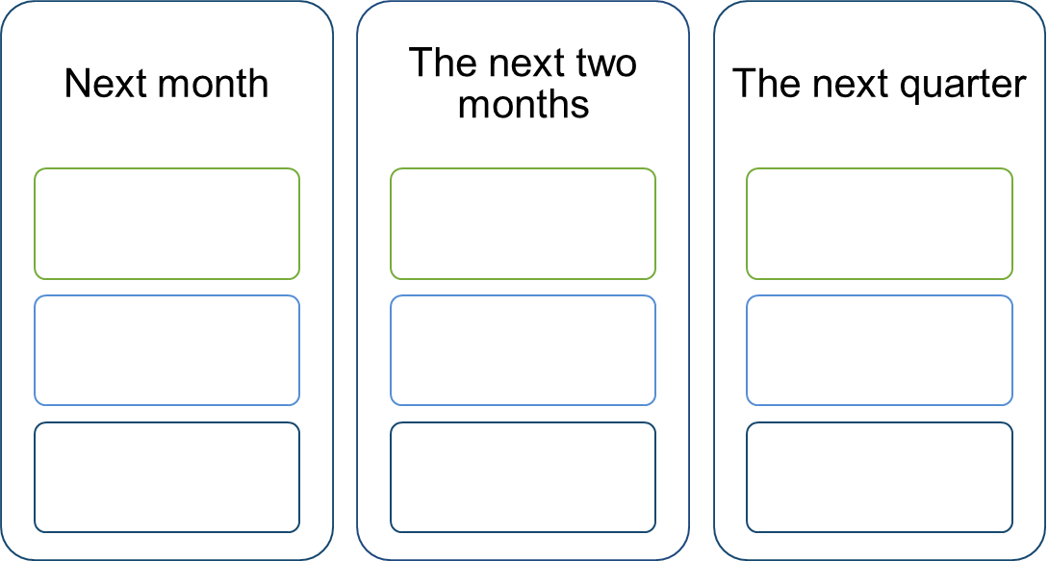

Longer-term actions

**What we could speed up/do more of: Accelerate**

**What we could stop doing: Brake**

**What we could start doing: Create**