PDSA cycle checklist
Cycle number:  Meeting number – date: | Start date:  End date:
Objective of cycle | ____Collect data to develop a change ____Test a change* ____Implement a change**  Short objective of the cycle:
Plan  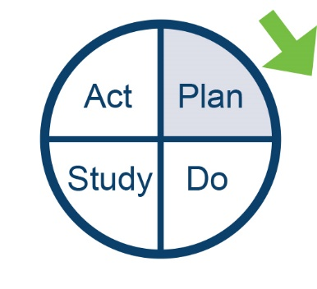 | Questions  - ?  Prediction:  - ?  Prediction:  - ?  Prediction:  - ?  Prediction:
Note  * For testing checklist, see Improvement Guide, p 96  ** For implementation checklist, see Improvement Guide, p 136 | Test/implementation plan  What change will you test or implement?  How will you conduct the change that you are testing or implementing? (Consider small scale early.)  Who will run the test or implementation?  Where will they run it?  When will the test or implementation take place?
Collect data plan (usually required for all PDSA cycles)
What information is important to collect?
Why is it important?
Who will collect the data?
Who will analyse the data before the study?
Where will data be collected?
When will the collection of data take place?
How will the data (measures or observations) be collected?
Do  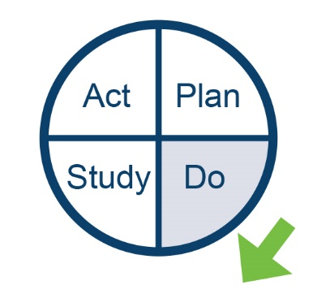 | Observations  Record observations not part of the plan.  Did you need to modify the original plan?  If so, how?  Begin analysis of data (graph of the data, picture).
Study  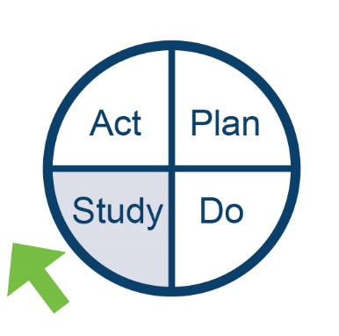 | Questions (Copy and paste questions and predictions from plan above and add results. Complete analysis of the data. Insert graphic analysis whenever possible.)  - ?  Prediction:  Learning (comparison of questions, predictions and analysis of data):  - ?  Prediction:  Learning:  New issues:  Summary:

Act  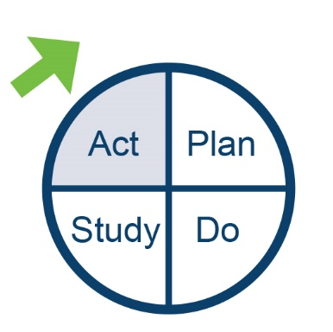 | Describe next PDSA cycle: new questions to answer, decisions to make, action to take.
Ad hoc contributors | Recognise subject-matter experts and others who have contributed to the learning.

Langley GJ, Nolan KM, Nolan TW, et al. 1996. The Improvement Guide: A practical approach to enhancing organizational performance. San Francisco: Jossey Bass.

