PDSA cycle worksheet

Plan
List the tasks needed to set up the test of change. Predict what will happen when the test happens. Decide who will run the test.

Do
Run the test. Document what happened when you ran the test. Describe problems and observations.

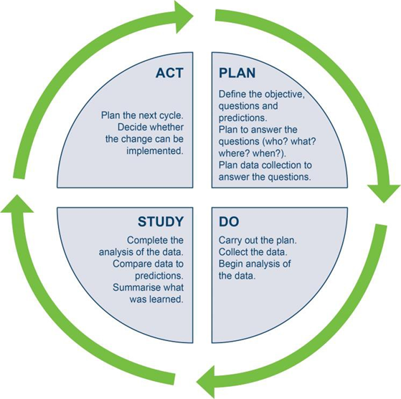
Study
Describe the measured results and how they compare with your predictions.

Act
Decide what your next PDSA cycle will be based on your learning.

