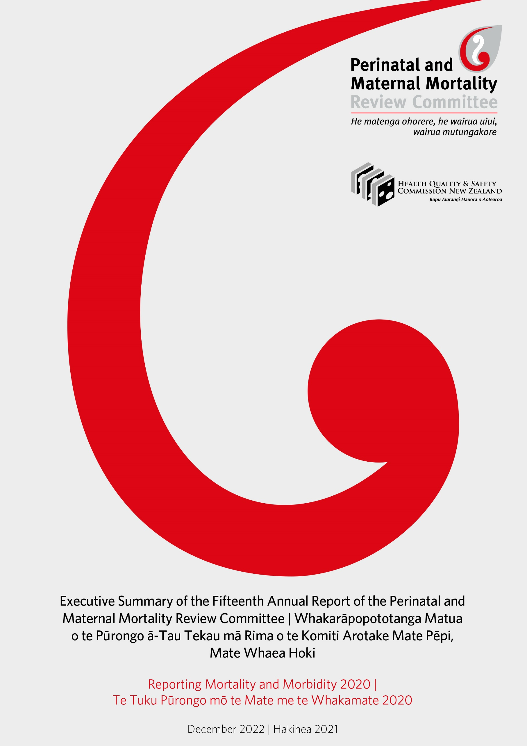

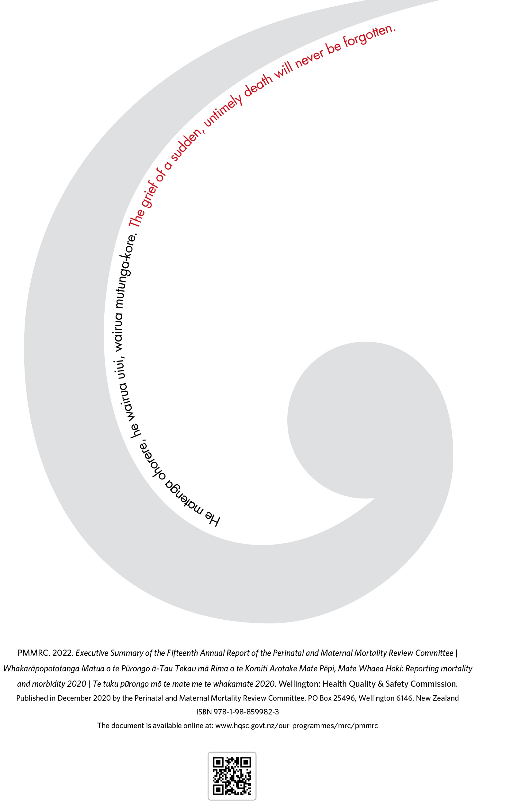

Contents | Ngā Ihirangi
Foreword – Dr Dale Bramley | Kupu Takamua – nā Tākuta Dale Bramley 4
Chair’s Introduction | Te Kupu Whakataki a te Manukura – Mr John Tait 5
Parents, Families, Communities | Ngā Mātua, ngā Whānau me ngā Hapori 7
Neonatal Encephalopathy Infographic Poster Developed by the PMMRC for Health Professionals 9
Key Findings from the PMMRC’s Fifteenth Annual Report | Ngā Kitenga Matua Mai i te Pūrongo ā-tau Tekau mā Rima o te PMMRC 11
Executive Summary | Whakarāpopototanga Matua 12
Definitions Used by the PMMRC – Perinatal Related and Infant Deaths 12
Perinatal Mortality 13
Neonatal Encephalopathy 13
Maternal Mortality 14
COVID-19 14
Report Recommendations 15
Appendix B: Perinatal and Maternal Mortality Review Committee Recommendations Yet to be Fully Implemented (2007–2019) | Āpitihanga B: Ngā tohutohu a te Komiti Arotake mō Te Mate Pēpi, Mate Whaea Kāore anō kia Tino Whakaritea (2007–2019)
Introduction | He Kupu Whakataki 17
Government Departments and Agencies | Ngā Tari me ngā Pokapū Kāwanatanga 17
Te Whatu Ora – Health New Zealand Districts | Te Whatu Ora – Ngā Rohe 21
Health Organisations, Colleges and Regulatory Bodies | Ngā Rōpū Hauora, Kāreti me ngā Rōpū Ture 26
Health Practitioners | Ngā Mātanga Hauora 28
Maternal Mortality | Te Mate Whaea 30
Researchers | Ngā Kairangahau 32

Foreword – Dr Dale Bramley | Kupu Takamua –
nā Tākuta Dale Bramley
The Health Quality & Safety Commission (the Commission) is pleased to present the fifteenth report of the Perinatal and Maternal Mortality Review Committee (the PMMRC).
As with previous reports from the PMMRC, the content has been difficult to read, and we appreciate how much harder it is, and has been, for families and whānau who personally endure the loss of a loved one. We owe it to them to listen and learn – and to improve.
The whole Commission Board wishes to emphasise the clear lack of improvement over the years highlighted within this report and the ongoing serious systemic issues demonstrated. Many of these deaths are preventable.
On behalf of the Commission Board, I fully support and endorse the recommendations within this report. These recommendations must be prioritised immediately to achieve equity for whānau Māori and groups where inequities persist in both prevention and bereavement care pathways and services.
We are committed to working with Te Whatu Ora – Health New Zealand and Te Aka Whai Ora | Māori Health Authority to drive and enact progress and continued prioritisation of maternity. This requires increased understanding of how we can support the people and organisations working within the system as well as being accountable for implementing and embedding recommendations to eliminate preventable harm.
Investment in women’s health, and particularly the health of wāhine Māori, in Aotearoa New Zealand needs fast-tracked prioritisation to enhance the wellbeing of our communities and of society as a whole. The death of a mother or a baby is a devastating loss, and this work to inform efforts to minimise the number of these tragic events needs serious attention.
We know there are clinicians going ‘above and beyond’ within the work they do. The system, including the Commission, needs to support them to provide the care that would bring better outcomes for our mothers and babies.
I would like to thank the Chair, Mr John Tait, and the PMMRC members for their dedication and determination to improve the quality and safety of maternal and perinatal care.
Also, I wish to acknowledge the dedicated team of people who assisted with the significant amount of work required to prepare this report: the local coordinators across Aotearoa New Zealand who care for our mothers and babies and provide the data; the New Zealand Mortality Review Data Group and the epidemiology team; and the mortality review committees’ secretariat staff at the Commission.
My sincere thanks go to you all as you influence system change and improvement across our perinatal and maternity services.

Dr Dale Bramley
Chair, Health Quality & Safety Commission

Chair’s Introduction | Te Kupu Whakataki a te Manukura –
Mr John Tait
Every year in Aotearoa New Zealand, approximately 650 babies and 10 mothers die in pregnancy or shortly afterwards. I want to say that these deaths have reduced over time, but I am saddened and frustrated to say this is not so.
Since the first Perinatal and Maternal Mortality Review Committee (PMMRC) report was released in 2007, it has been the purpose of the PMMRC to collect information on perinatal deaths to improve knowledge and understanding, with the aim of reducing the number of families who experience the death of a baby.
However, the rates of death have not significantly changed since 2007.The unacceptable disparities and differential access to care and resources continue for the groups that bear the collective name of ‘priority populations’. These are the people who the system continues to fail, including Māori, Pacific peoples and Indian families and whānau, mothers under 20 years old and those living in high areas of deprivation. Yet again, it is these families and whānau who experience the worst outcomes in perinatal and maternal mortality compared with New Zealand European.
It is important to also note that, while in 2020 there were no statistically significant differences detected in perinatal and maternal mortality outcomes in the context of the COVID-19 pandemic, infection became much more widespread in the community from 2021. Continued monitoring is imperative.
As health care professionals, government officials and regulatory bodies, we all play a part in this lack of equitable, or even improved, outcomes. Aotearoa New Zealand continues to tolerate a health and welfare system that serves Pākehā better than anyone else, having been built around western values and bio-medical ideals. This report, and the previous 14 PMMRC reports, are evidence of this.
The report details a legacy of neglect and indifference to Māori (and Pasifika) in the perinatal system. The system is ignoring the opportunity to prevent large amounts of preventable morbidity and mortality as opposed to just recording it.
Dr Owen Sinclair, paediatrician
In this, the fifteenth report, we aim to:
- provide epidemiological analysis of perinatal mortality from 2007 to 2020, maternal mortality from 2010 to 2020 and neonatal encephalopathy from 2010 to 2020
- monitor and track trends and disparities to identify areas for improvement
- stimulate discussion around appropriate areas for further research
- provide information on outcomes by year and the appendix containing 2019 tables and figures can be used as a marker in time for future reference
- focus on previous, critical recommendations that must be embedded into policies, protocols, consensus statements, guidelines and practices to reduce these deaths.
The PMMRC recommendations support the reformed health system’s aim to create a more equitable, accessible, cohesive and people-centred system. It is imperative that our focus in achieving this is to prioritise our responsibility to Te Tiriti o Waitangi and ensure an overarching emphasis on achieving equity. We believe urgent prioritisation is required to implement the following previous four recommendations to accelerate high-quality, appropriate and equitable care.
Recommendation 1: Regulatory bodies to mandate cultural safety education for all individuals working across all areas of the maternity and neonatal workforce. Culturally safe care is an expectation.
Recommendation 2: Government agencies to address the impact of structural racism and recognise and address the impact of socioeconomic deprivation on perinatal death, specifically on preterm birth, which after congenital abnormality is the leading cause of perinatal death.
Recommendation 3: Te Whatu Ora – Health New Zealand districts to prioritise the development of evidence-based solutions in consultation with young mothers; maternity services that meet the needs of, and are acceptable to, mothers under 20 years old; and adequate resources for these services.
Recommendation 4: Health practitioners to identify women with risk factors for perinatal related death and work individually and collectively to ensure that care is accessible and appropriate to the needs of these women. Equitable health care is a fundamental right. Risk factors that require particular focus include:
- pre-pregnancy care for known medical diseases, such as diabetes
- access to appropriate antenatal care
- antenatal recognition and management of threatened preterm labour
- following evidence-based recommendations for indications for induction of labour
- advice to women and appropriate management of decreased fetal movements.
I am encouraged to report that since the release of the fourteenth PMMRC annual report in 2021, work on the following recommendations has commenced.
- The introduction of mandatory folate in bread is coming into effect from mid-2023. We expect to see a reduction in perinatal deaths related to congenital anomalies as a direct result of this.
- In November 2021, the Associate Minister of Health Hon Dr Ayesha Verrall announced that work had commenced on a bereavement pathway. Further work is needed to expedite and embed a national bereavement pathway/service to improve access and reduce local inconsistencies in care and services received by parents, particularly for Māori, Pacific peoples and Indian families and whānau and mothers under 20 years old.
- Also, in November the Maternal Mental Health Service Provision in New Zealand: Stocktake of district health board services report was released in response to a recommendation made by the PMMRC. The stocktake found that current service delivery is inequitable, with unmet need and gaps in the continuum of care. The next step is to take action on the key findings of the report, including expanding the maternal mental health workforce and strengthening cultural models of care.
On behalf of the PMMRC, I acknowledge those whose lives and deaths are represented in this report and the families and whānau who bear the grief of a death. We will continue to work to prevent others from experiencing the loss that you have experienced.
And finally, to those who provide safe care and support for families and whānau, my biggest and most heartfelt thank you goes to you all. Thanks also to those who enact the principles of Te Tiriti o Waitangi, those who privilege priority groups, those who remain accountable to and advocate for these babies, mothers and families and whānau, those who provide information and knowledge to prevent and support bereavement, those who embrace bicultural and multicultural practices and those who embrace change and work to implement recommendations by the PMMRC. Your continued dedication to this work is essential and invaluable.
Ngā mihi nui ki a koutou katoa.

John Tait
Chair, Perinatal and Maternal Mortality Review Committee

Parents, Families, Communities | Ngā Mātua, ngā Whānau me ngā Hapori
Tuia i runga, tuia i raro, tuia i roto, tuia i waho, tuia te here tangata e pae nei, tēnā koutou, tēnā koutou, tēnā koutou katoa. – I thread together the forces from above, from below, from within and from what surrounds us, to bind us together and I pay special greetings to you all.
Ka rere ngā mihi matakuikui ki a koutou katoa kua eke ki tēnei waka e pā ana ki te pūrongorongo o te PMMRC. Nau mai, haere mai. – Special greetings once again and welcome to our PMMRC report.
Ko wai au? Ko Pania Paraku ahau, he uri au nō Hauraki, nō Aerana hoki. – My name is Pania (Lisa) Paraku and I hail from the beautiful Coromandel with ancestry and connection to Northern Ireland.
It is my pleasure once again, to greet you on behalf of our kaimanaaki/lived experience advocates. This will be my last greeting to you, as my time on this important committee comes to an end. Our advocacy continues with our remaining kaimanaaki and all of our members at the PMMRC.
It is my pleasure to summarise the mahi that has been done during our time together:
Joining the committee in 2017 to serve our pēpi, māmā, whānau and on behalf of our Jasmine Lee, I was grateful to continue the fine work completed by my predecessors Dr Vicki Culling and Linda Penlington in our kaimanaaki roles and my fellow kaimahi Māori Dr Sue Crengle, Dr Donna Cormack and Louise Kuraia.
- In 2018, I trust I represented you when I said that our hope following the loss of our precious pēpi or māmā is ‘to be seen, kanohi kitea’ – to be listened to, understood and cared for in the way that we need, so that our grief journey can be a little more gentle.
- In 2019, we as the PMMRC created our vision to serve – working together across the system towards zero preventable deaths or harm to all mothers and babies, families and whānau.
- In 2021, in the thick of the COVID pandemic we issued a wero or a challenge to the system and on behalf, I asked – Why? Is this kaupapa not important enough, the health and wellbeing of our precious babies, their mothers? Why are our babies and mothers dying, when in some cases this is preventable? Why are my people the ones most affected, when we hold the right to equitable outcomes under Te Tiriti? Why are our cousins in the Pacific, our young mothers and our friends from India also those most affected? I then asked – How? How can we engender a collective response that recognises shared space and shared value in order to implement the recommendations of the PMMRC? How do we dismantle and decolonise our system, standing strong in anti-racism and begin to heal the mamae of historical trauma? The answers have been gifted to us, within the Hauora Report, within the Health and Disability System Review, in particular the alternative view, and within our humble recommendations from the PMMRC.
I tēnei wā, in this time of 2022, with the changes to the health system and forming of Te Aka Whai Ora standing together with Te Whatu Ora, along with the changes to our own Health Quality & Safety Commission mortality review committees, we continue the wero that equity must prevail, that anti-racism remains at the heart of all we do, and that decolonisation is realised. The system has heard our collective call and is changing.
And we are hopeful.
The system has taken up our three priority recommendations:
- Folic acid in breads to be released in 2023 for our hapū māmā.
- Our plea for a focus on maternal mental health and wellbeing of our hapū māmā, especially our hapū māmā of non-European ethnicities, with Māori, Pacific and Asian women more likely to experience antenatal depression. The system has responded with the approval of a maternal mental health ‘stocktake’.
- Our hope for equitable bereavement care for those of us who must walk the path that no one ever wishes for, bereavement care that is not reliant on where we live, what level of knowledge we hold about the health system in order to gain entry, or our alignment to the care models that are predominantly western. Care that is available when we need it, where we need it and tailored to who we are and how we need it. This is the focus of the National Bereavement Care Pathway/Service project led by Whakarongorau Aotearoa.
And we are grateful.
E hoa mā, he kaupapa nui tēnei. My friends, this is such an important kaupapa for us all. To my fellow PMMRC whānau, e mihi maioha ki a koutou, many thanks for what you do. This is heavy mahi that must be done to achieve equitable outcomes, prevent our babies and mothers dying where we can, and create a gentle path when our loved ones do die. You do this mahi with grace – I acknowledge you and on behalf, I thank you. To my fellow bereaved parents, whānau and families, we stand with you. I thank you for having me and hope I have managed to give voice to the hopes of our bereaved whānau.
Let me close with a whakataukī or proverb from my home and people of Pare Hauraki – ‘Ngātini ki te rangi, hōrapa rapa ki te whenua’ – ‘Let the myriad of stars of the heavens glow over the land’. Jasmine Lee, I know you are one of those stars that glows over us, I do this mahi for you.
E ngā pēpē, moe mai rā. Ki ngā huia kaimanawa kua ngaro ki te pō, moe mai koutou. To our precious ones who have disappeared into the night, rest in peace. I acknowledge our precious babies, our grief and our journey.

Pania Paraku

Neonatal Encephalopathy Infographic Poster Developed by the PMMRC for Health Professionals

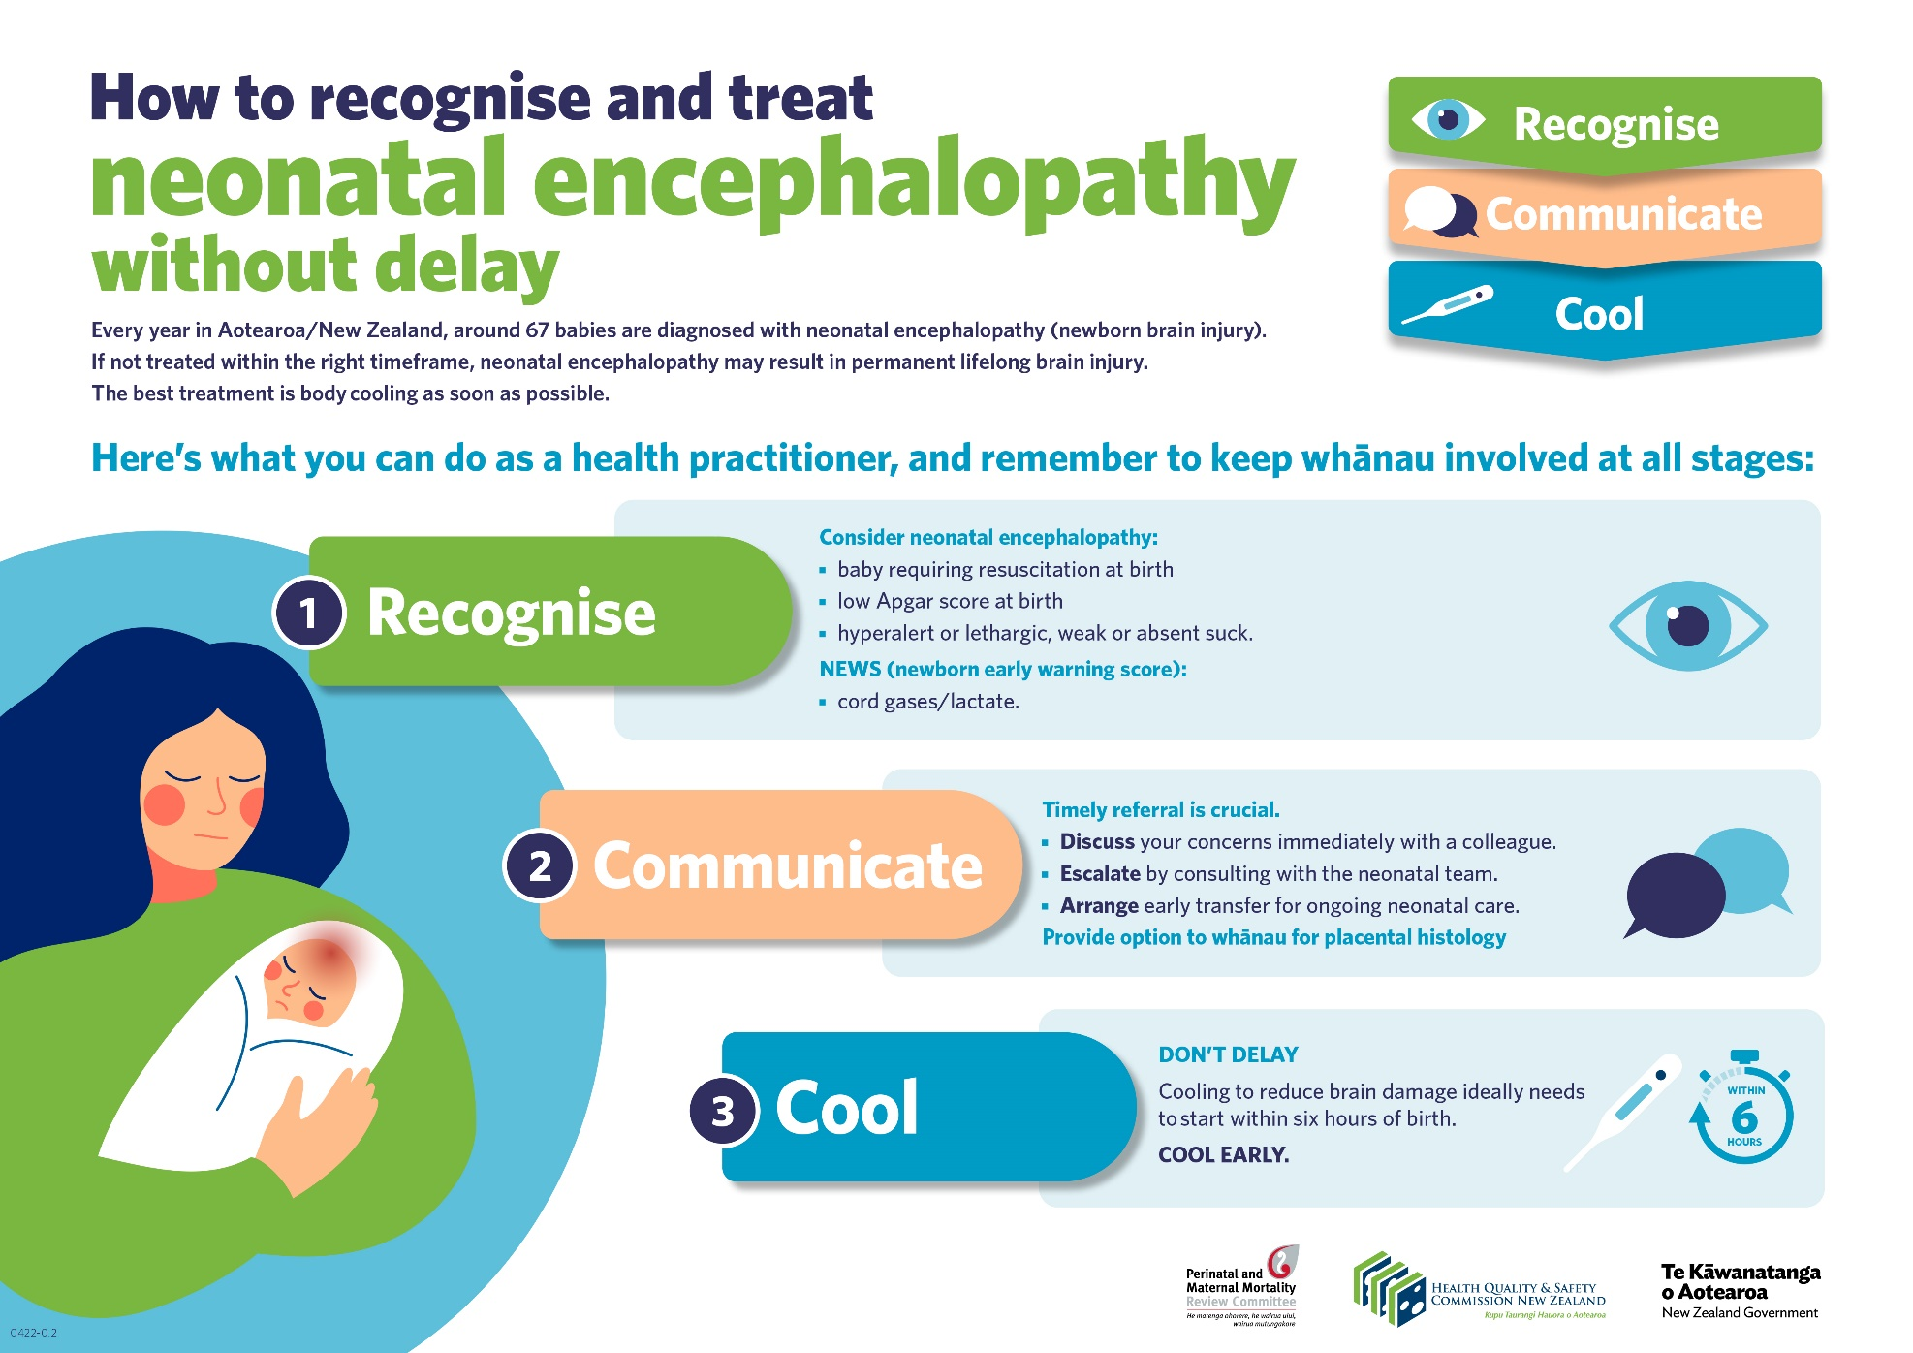
English Version

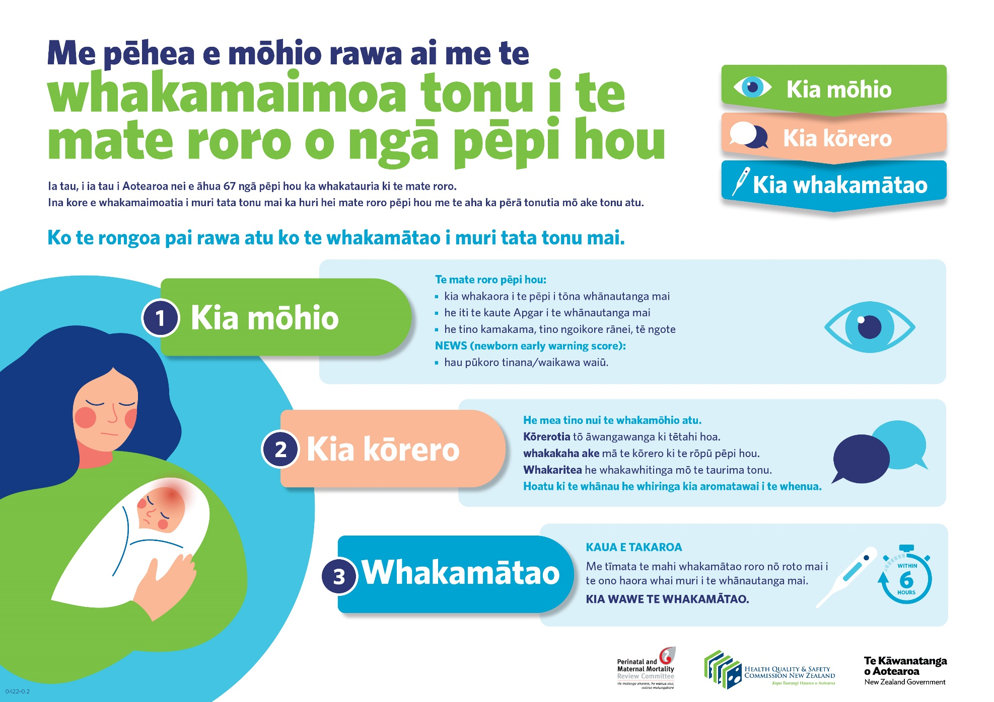
Te Reo Māori Version

Key Findings from the PMMRC’s Fifteenth Annual Report | Ngā Kitenga Matua Mai i te Pūrongo ā-tau Tekau mā Rima o te PMMRC
Ethnic, deprivation and age inequities persist in all findings.
The health system continues to fail:
- Māori
- Pacific peoples
- Indian populations
- those aged under 20 years
- those living in areas of high deprivation,
all of whom experience worse perinatal outcomes than those of New Zealand European ethnicity.
Neonatal encephalopathy rates remain static with no significant improvement. While it is recommended that all babies with moderate neonatal encephalopathy receive magnetic resonance imaging (MRI), this is not being achieved.
Wāhine Māori, Pacific women and women in higher deprivation areas suffer a disproportionate burden of maternal mortality.
Increased risk of maternal mortality is correlated with women aged 40 years and over.
Wāhine Māori were 2.91 times more likely to die by suicide as a direct result of maternal mortality than women of New Zealand European ethnicity in the 2006–2022 period.

Executive Summary | Whakarāpopototanga Matua
The vision of the Perinatal and Maternal Mortality Review Committee (PMMRC) is to work with mothers, families, whānau, hapū and iwi providers, health professionals, policymakers and researchers to ensure that all women in Aotearoa New Zealand have equitable access to high-quality health care that meets their needs.
This fifteenth annual report outlines some of the trends in mortality in babies and mothers and serious morbidity from neonatal encephalopathy (NE). Deaths are usually multifactorial in nature, with more than one thing usually causing a death.
The Family Violence Death Review Committee speaks in its seventh report about the legacy of colonisation and how this is a significant factor in the context of which these deaths occur in Aotearoa New Zealand, stating, ‘… the Committee has drawn attention to the legacy of colonisation, trauma and inadequate service responses that has resulted in layers of social entrapment, erroneously placing the responsibility on women for finding safety for themselves and their children’. The PMMRC also acknowledges this legacy impact on whānau whose data are contained within this report.
The aim of our work is to monitor trends and look at systems issues that could be modified to prevent future deaths.
This fifteenth report contains data up to and including 2020, with commentary, and an appendix (A) of data analysis up to and including 2019, without commentary.
The report takes a ‘Year A’ format. In 2020, the PMMRC approved the adoption of Year A and Year B report formats for use in future PMMRC annual reporting. Both Year A and B formats report key summary data on perinatal and neonatal mortality year to year, but each format has a different focus. The overall format was streamlined to improve flow and ease of reading but maintains content by appending some tables and figures.
Recurring themes in perinatal and maternal mortality show the disproportionate impact on Māori, Pacific and Indian women, those under 20 years old and the effects of increasingly severe socioeconomic deprivation on these outcomes.

Definitions Used by the PMMRC – Perinatal Related and Infant Deaths
Gestation Birth 7 days 28 days 1 year
20 weeks or more
or
≥400 grams birthweight
0–<7 days
7–27 days
28 days–<1 year
Late
Neonatal
deaths
Early
Neonatal
deaths
Post-neonatal
deaths
Fetal deaths
Perinatal deaths
Perinatal related deaths
Neonatal deaths
Infant deaths
(Adapted from Fetal and Infant Deaths 2003 & 2004 and Fetal and Infant Deaths 2006.)

Perinatal Mortality
The PMMRC has collected data since 2007. Over this time, the overall perinatal related mortality rate (which includes both fetal and neonatal mortalities) has not significantly decreased. There has been a reduction in the fetal death rate, which is due to a significant decrease in the rate of stillbirths. Overall rates of termination of pregnancy and neonatal deaths have not changed significantly over this period.
Whilst perinatal related mortality rates have reduced for babies with mothers of Indian ethnicity over the period 2011–2020, no other perinatal related mortality ethnicity indices have improved, and there are worse outcomes for babies of Māori and Pacific mothers compared with those of New Zealand European mothers, indicating these inequities are yet to be addressed.
It is also evident that socioeconomic deprivation is associated with worse perinatal outcomes. Mothers from New Zealand Index of Deprivation (NZDep) quintile 5 (most deprived) areas have higher perinatal mortality rates for almost all causes compared with babies born to mothers living in quintile 1 (least deprived) areas. Over the period 2016–2020, the association of deprivation with perinatal mortality rates has become even more marked.
Women aged under 20 years of age experienced the highest rate of neonatal death, at a rate of 5.46 deaths per 1000 live births, compared with an average rate of 2.72 deaths per 1000 live births for all maternal age groups.

Neonatal Encephalopathy
Neonatal encephalopathy (NE) is a clinically defined syndrome of disturbed neurological function within the first week after birth in an infant born after 35 weeks gestation.
The PMMRC collects data on babies who present with moderate or severe NE in the first seven days after birth. Data have been collected on babies with NE from 37 weeks gestation onwards since 2010 and have included 35- and 36-weeks gestations from 2016.
Over the period 2016–2020, including gestations from 35 weeks, the rate of NE cases per 1000 births varied from year to year. However, there has been no statistically significant trend in either direction, for either 2010–2018 for ≥37 weeks gestation or 2016–2020 for ≥35 weeks gestation. Therefore, while rates have not significantly worsened, they have not improved either.
No ethnicity group reached a statistically significant difference, but again Other European mothers continue to have the lowest rates. NE rates varied by NZDep quintile. Rates of NE were higher at 41 weeks gestation. However, included for the first time, rates of NE were highest in babies born at 35–36 weeks gestation. Although the PMMRC has previously recommended that all babies with moderate and severe
NE receive an MRI scan, about 12 percent of babies with moderate NE did not receive an MRI scan in 2016–2020.

Maternal Mortality
Maternal death is the death of a woman while pregnant or within 42 days of the end of pregnancy (miscarriage, termination or birth), irrespective of the duration and site of the pregnancy, from any cause related to or aggravated by the pregnancy or its management but not from accidental or incidental causes.
Over the period 2006–2020, there were 76 direct maternal deaths and 57 indirect maternal deaths recorded. Suicide was the largest single cause of maternal death in Aotearoa New Zealand. Cardiac and neurological complications resulting in indirect maternal deaths were the second most common causes of mortality.
A maternal age of 40 years or over was associated with the highest risk of maternal death of all age groups. Wāhine Māori and Pacific women had significantly higher rates of deaths per 100,000 maternities than New Zealand European women. There was a general pattern of increasing mortality with increasing deprivation.
Death by suicide continues to disproportionately affect wāhine Māori. Over the period 2006–2020, wāhine Māori were 2.91 times more likely to die by suicide than women of New Zealand European ethnicity; with wāhine Māori having both the highest number of deaths and highest rate of death due to suicide over this period. Prevention of maternal suicide requires not only individual interventions but also a systems-level response; addressing the wider political and social systems that create the structural determinants of health – these include poverty, housing, employment and institutional racism.,

COVID-19
The continuing COVID-19 outbreak has impacted on maternity care in a number of ways. There have been, and continue to be, difficulties in health care access across the health and disability sector. Whānau have not always been able to attend hospital for their births and the maternity sector has been challenged with caring for women with recommendations of staying out of hospital as much as possible.
While in 2020 there were no statistically significant differences detected in perinatal and maternal mortality outcomes, monitoring will continue as COVID-19 infection became much more widespread in the community from 2021.

Report Recommendations
(Provisional)
Similar to the fourteenth annual report published in February 2021, the PMMRC again insists that prioritised and accelerated focus be applied to implement previous recommendations.
Furthermore, the PMMRC highlights some key previous recommendations that need to be prioritised immediately, with an overarching emphasis on achieving equity for Māori whānau and other groups where inequities persist in both prevention and bereavement care pathways/services. These key previous recommendations are as follows.
- Regulatory bodies to mandate cultural safety education for all individuals working across all areas of the maternity and neonatal workforce.
- Government agencies to recognise and address the impact of socioeconomic deprivation on perinatal death, specifically on preterm birth, which is the leading cause of perinatal death after congenital abnormality.
- Te Whatu Ora – Health New Zealand districts to develop evidence-based solutions in consultation with young mothers and maternity services that meet the needs of, and are acceptable to, mothers under 20 years of age and adequately resource these services.
- Health practitioners to identify women with modifiable risk factors for perinatal related death and work individually and collectively to ensure that care is accessible and appropriate to the needs of these women. Modifiable risk factors that require particular focus include:
- pre-pregnancy care for known medical diseases such as diabetes
- access to antenatal care
- antenatal recognition and management of threatened preterm labour
- following evidence-based recommendations for indications for induction of labour
- advice to women on and appropriate management of decreased fetal movements.
Further urgent work is needed on implementing recommendations commenced since the fourteenth annual report release, including the following recommendations.
- Expedite and embed a national bereavement pathway/service to improve access and reduce local inconsistencies in care and services received by parents.
- Strengthen services based on the findings of the Maternal Mental Health Service Provision in New Zealand: Stocktake of district health board services. The stocktake recommended that the maternal mental health workforce be expanded and kaupapa Māori models of care provided to improve maternal mental health, having found that current service delivery is inequitable, with unmet need and gaps in the continuum of care.

This document is an extract taken from the full report, available online at: www.hqsc.govt.nz/pmmrc15report

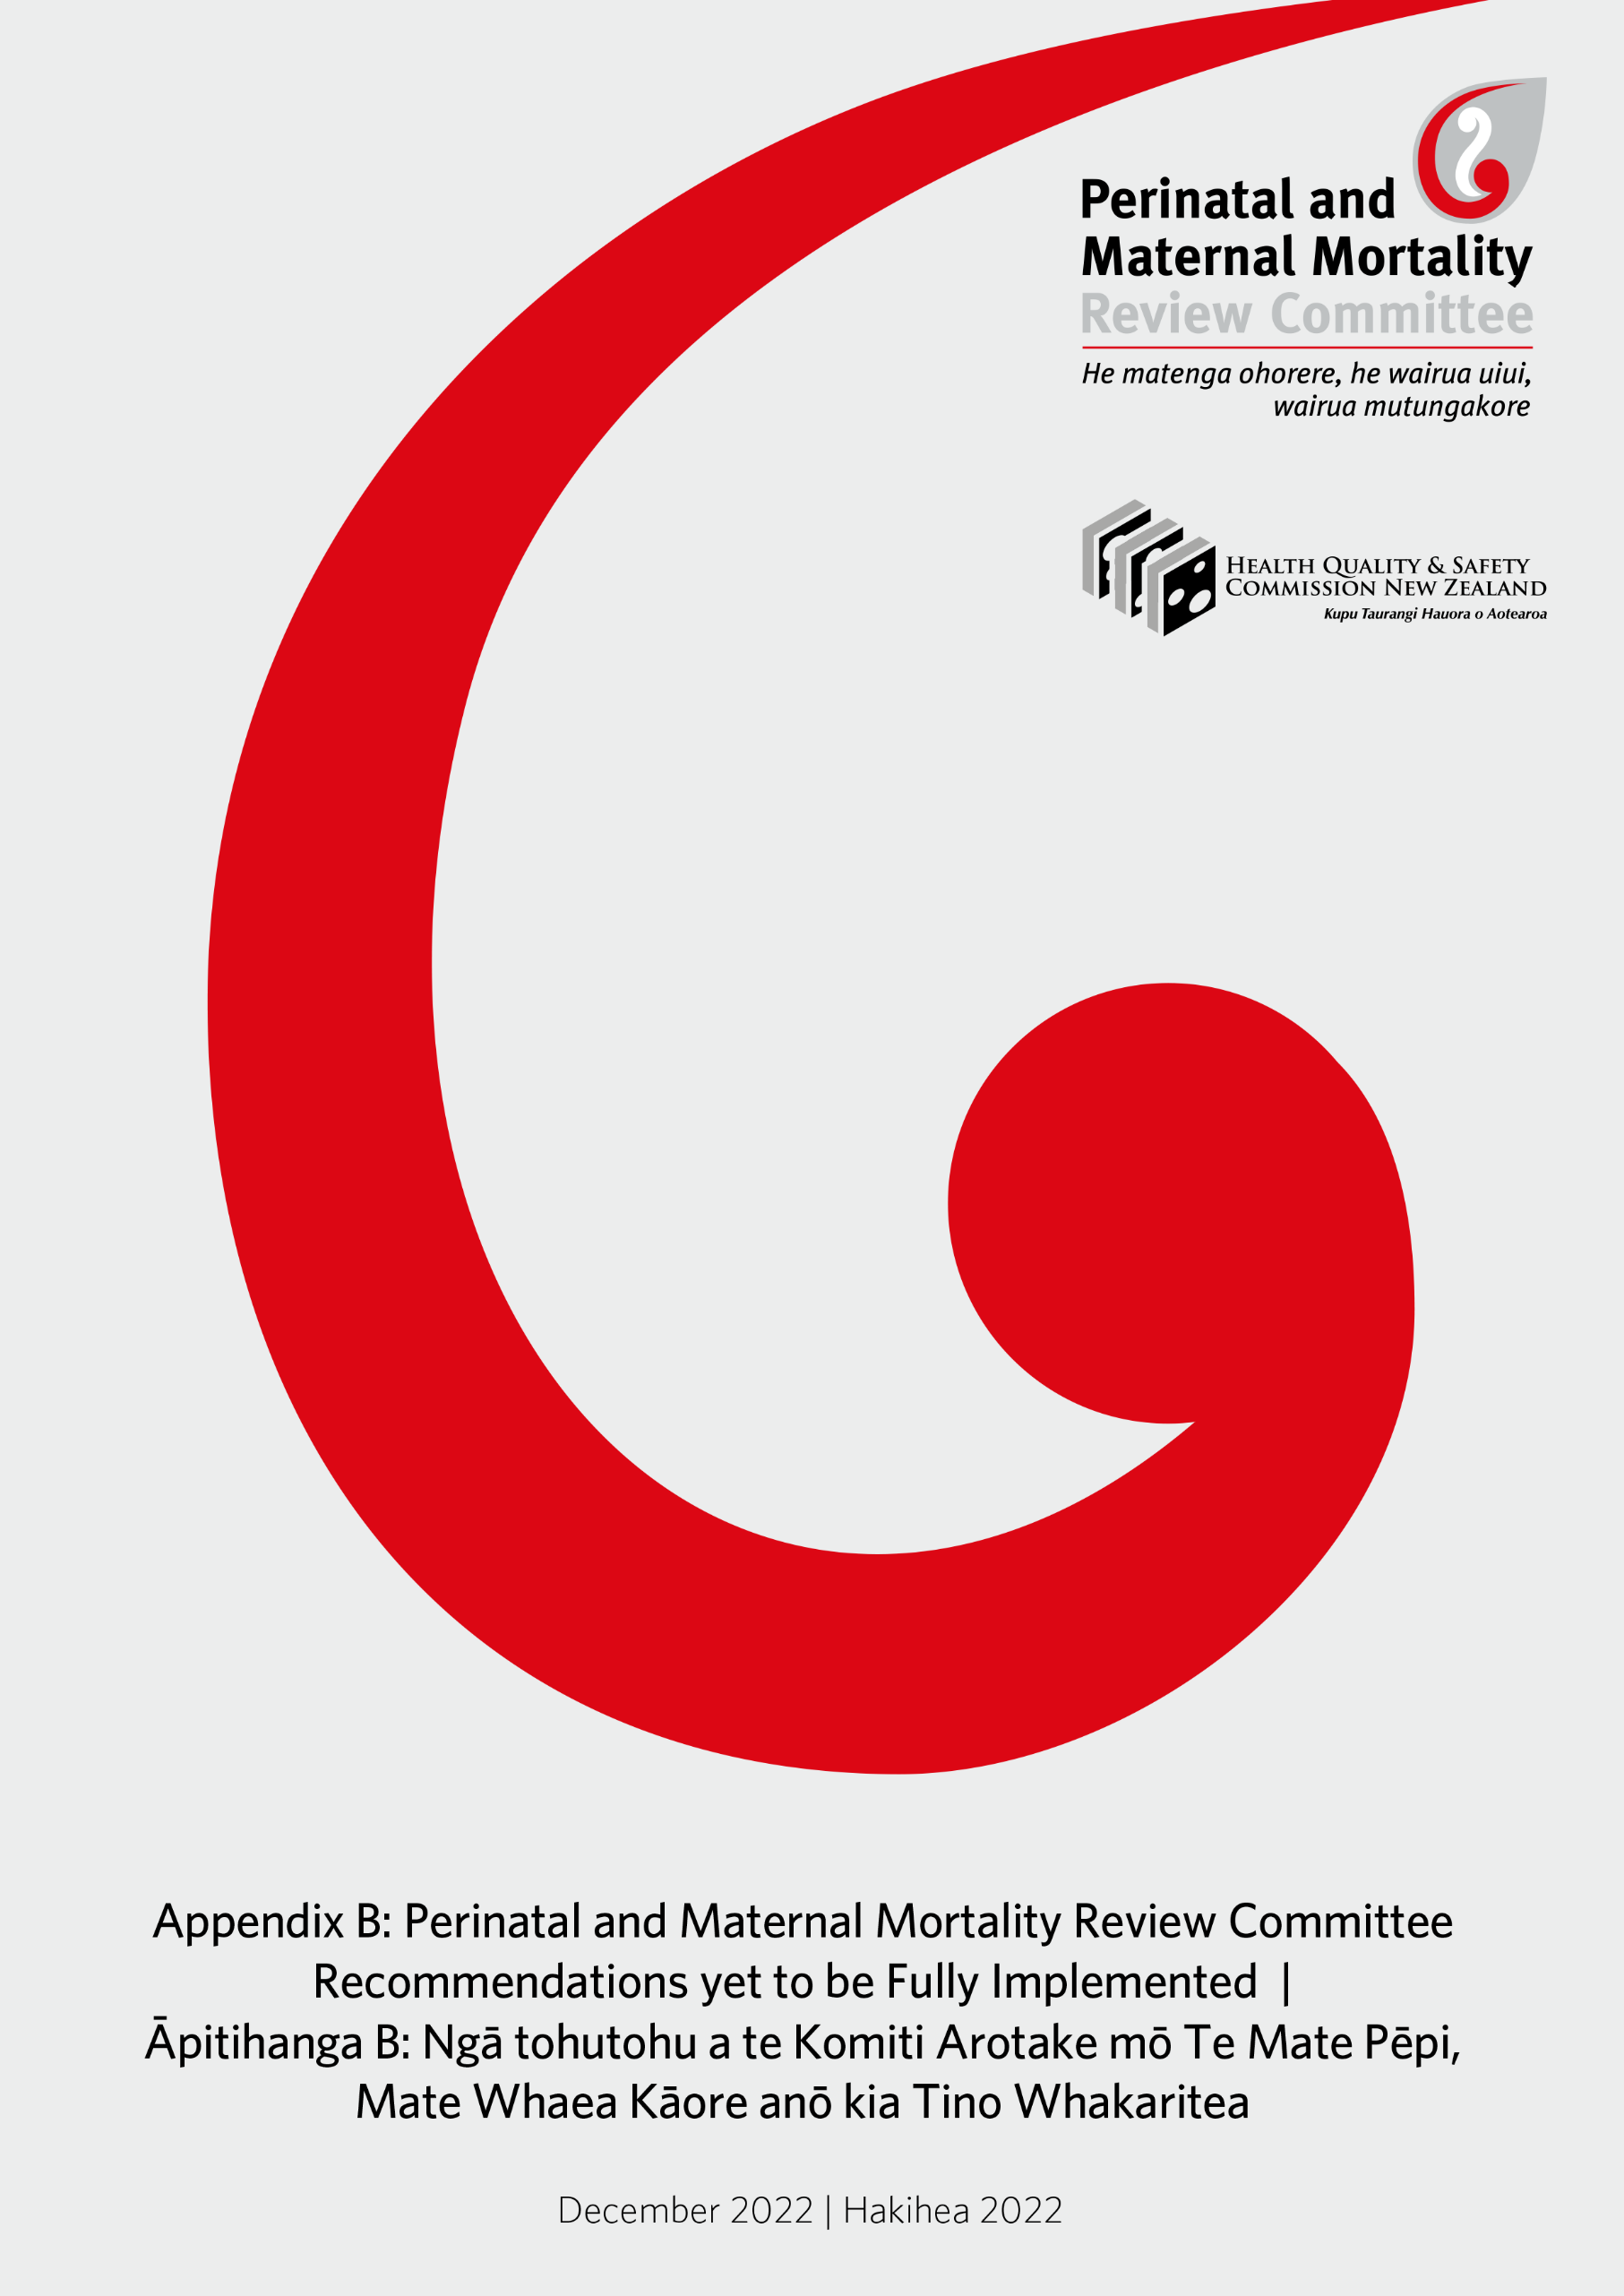

Introduction | He Kupu Whakataki
This document includes sets of recommendations that have been made by the Perinatal and Maternal Mortality Review Committee (the PMMRC) since its first report in 2007 but that are not yet fully implemented. Although significant work has been undertaken towards implementing these recommendations, preventable deaths continue, and further priority must be given to the recommendations in this document. Each set of recommendations is aimed at a different area of maternity services and governing bodies. Importantly, we must all continue to support the work of our colleagues and organisations in owning these responsibilities. Together, we can make the greatest and most valuable impact towards changing outcomes for women and their babies, families and whānau. The report in which each recommendation first appeared is given in italics.

Government Departments and Agencies | Ngā Tari me ngā Pokapū Kāwanatanga
The recommendations in this section are aimed at government departments and agencies, and they should be viewed alongside the other tables. It is important that government ensures adequate funding and infrastructure to enable regions, districts and clinicians to implement the PMMRC recommendations.

Perinatal Mortality

Antenatal care/screening
- All women should commence maternity care before 10 weeks, for the following reasons:
- opportunity to offer screening for congenital abnormalities, sexually transmitted infections, family violence and maternal mental health and to refer as appropriate
- education around nutrition (including appropriate weight gain), smoking, alcohol and drug use and other at-risk behaviours
- recognition of underlying medical conditions with referral for secondary care as appropriate
- identification of vunerable women at increased risk of perinatal related mortality. (Fifth Annual Report, 2011)
- As smoking is a significant modifiable risk factor for both stillbirth and neonatal death, every effort must be made to encourage women to engage in effective smoking cessation programmes prior to, during and after pregnancy. (Eighth Annual Report, 2014)
- Strategies to improve awareness of antenatal care services and increase access among women who are isolated for social, economic, cultural or language reasons should be developed. (Third Annual Report, 2009)

Guidelines
- The PMMRC recommends a review of epilepsy in the Guidelines for Consultation with Obstetric and Related Medical Services (Referral Guidelines). (Ninth Annual Report, 2015)

Data Collection
- The Ministry of Health should continue to support and fund [district health boards (DHBs); now health districts] and lead maternity carers (LMCs) in their collection of complete perinatal mortality statistics. (Third Annual Report, 2009)
- As a matter of urgency, the Ministry of Health update the National Maternity Collection (MAT), including the ethnicity data as identified by the parents in the birth registration process. (Eleventh Annual Report, 2017; Ninth Annual Report, 2015)
- The national MAT, linked to birth registration ethnicity data, be available for use by the mortality review committees. Access to these data would allow PMMRC to report the independent associations between ethnicity, maternal age, socioeconomic status and perinatal related death, adjusting for smoking and maternal body mass index. (Seventh Annual Report, 2013)
- The PMMRC recommends the Ministry of Health:
- urgently require DHBs to provide complete and accurate registration data to the MAT dataset (as required of LMCs providing services to pregnant women in order to receive funding for those services). Specifically, this should include women who present for birthing at DHB facilities without previous antenatal LMC registration and women who are provided primary maternity care by DHB maternity services
- require that the MAT dataset include complete registration and antenatal data on live and stillborn babies from 20 weeks gestation (including terminations of pregnancy). (Eleventh Annual Report, 2011)

Mothers less than 20 years
- Maternity and primary care providers need to be aware of the increasing risk of perinatal mortality for mothers under 20 years of age in New Zealand. Inequity in perinatal mortality for babies born to mothers under 20 years of age needs to be actively addressed. The PMMRC recommends the Ministry of Health and DHBs:
- develop, in consultation with young mothers, acceptable and safe methods for mothers under 20 years of age to access and engage with care in order to achieve equitable health outcomes
- identify and adequately resource evidence-based solutions to address risks for mothers under 20 years of age, paying attention to smoking cessation, screening and treatment for infections, screening for fetal growth restriction, and providing adequate information about the causes and symptoms of preterm labour
- consider how they can support LMCs caring for mothers aged under 20 years. (Twelfth Annual Report, 2018)

Preterm birth
- The PMMRC recommends the Ministry of Health establish a multidisciplinary working group to review current evidence for implementation of a preterm birth prevention programme such as that implemented in Western Australia, taking care to:
- identify and adequately resource evidence-based solutions
- ensure equitable access to screening and/or treatment for priority populations
- ensure that priority populations have a voice in the development of health policy, process and practice in order to achieve equitable health outcomes
- ensure that the outcomes of any implemented programme, including equity of access, are evaluated. (Twelfth Annual Report, 2018)
- Birth in a tertiary centre is associated with improved outcomes for preterm babies at the lower limits of viability (prior to 25 weeks gestation). The PMMRC recommends the Ministry of Health leads the development of a national consensus pathway for the care of women in preterm labour or requiring delivery prior to 25 weeks gestation. The PMMRC recommends this pathway includes:
- ensuring that all groups of women (irrespective of ethnicity, age, socioeconomic status or place of residence) are offered and provided the same level of care
- strategies for secondary units for management of women in threatened or early preterm labour, or who require delivery, prior to 25 weeks gestation. Including:
- administration of corticosteroids and magnesium sulphate
- timely transfer from primary and secondary units to tertiary units
- management of babies inadvertently born in their units at the lower limits of viability
- ensuring that priority populations have a voice in the development of health policy, process and practice in order to achieve equitable health outcomes
- guidance on monitoring that care provision is equitable by ethnicity, age, socioeconomic status and place of residence. (Twelfth Annual Report, 2018)
- Priority recommendation: There is a need to recognise the independent impact of socioeconomic deprivation on perinatal death, specifically on preterm birth, which after congenital abnormality is the leading cause of perinatal death. Addressing the impact of poverty requires wider societal commitment as has been highlighted in the recent health select committee report on improving child health outcomes. The PMMRC supports the implementation of the recommendations. The report can be found at https://www.parliament.nz/en/pb/sc/reports/document/50DBSCH_SCR6007_1/inquiry-into-improving-child-health-outcomes-and-preventing. (Eighth Annual Report, 2014)

Sudden unexpected death in infancy (SUDI) prevention
- The PMMRC recommends that the Ministry of Health and DHBs have a responsibility to ensure that midwifery staffing ratios and staffing acuity tools:
- enable active observation of mothers and babies who are undertaking skin-to-skin contact in the postnatal inpatient period
- allow for the identification of, and additional needs of, mothers who have increased risk factors for SUDI. (Twelfth Annual Report, 2018)

Neonatal Encephalopathy (NE)
- The Neonatal Encephalopathy Working Group (NEWG) and PMMRC support the development of a guideline for the investigation and management of NE. (Eighth Annual Report, 2014)

Maternal Mortality

Maternal mental health
- The PMMRC recommends that a maternal and infant mental health network is funded by the Ministry of Health and that the network then determine an achievable work stream by the end of 2018 detailing work to be completed by the end of 2020, to include as potential areas of priority:
- a national pathway for accessing maternal mental health services, including:
- cultural appropriateness to ensure equity of service access and provision
- appropriate screening
- care for women with a history of mental illness
- communication and coordination. (Twelfth Annual Report, 2018)
- That a perinatal and infant mental health network be established to provide an interdisciplinary and national forum to discuss perinatal mental health issues. (Tenth Annual Report, 2016)
- A comprehensive perinatal and infant mental health service should include:
- screening and assessment
- timely interventions including case management, transition planning and referrals
- access to respite care and specialist inpatient care for mothers and babies
- consultation and liaison services within the health system and with other agencies, for example, primary care and termination of pregnancy (TOP) services. (Sixth Annual Report, 2012)

Mortality review committees Māori caucus relating to maternal mental health
- Improve awareness and responsiveness to the increased risk for Māori women. (Eleventh Annual Report, 2017)

Support for Parents, Families and Whānau
- Priority recommendation: The Ministry of Health should resource, support and facilitate the development of a national perinatal bereavement pathway with key stakeholders, including governmental and non-governmental organisations, to ensure high-quality, appropriate and equitable care for all. (Thirteenth Annual Report, 2019)
- Develop and improve the provision of perinatal pathology services with regards to accessibility, training and appropriateness and ensure quality and equitable services are available across the country. (First Annual Report, 2007; Second Annual Report, 2008)

Te Whatu Ora – Health New Zealand Districts | Te Whatu Ora –
Ngā Rohe
The recommendations in this section are aimed at Te Whatu Ora – Health New Zealand districts. It is important that Te Whatu Ora districts view these recommendations alongside recommendations for health practitioners. This is to ensure that districts, through good systems and processes, can effectively support clinicians to implement PMMRC recommendations.
- DHBs should demonstate that they have co-developed and implemented models of care that meet the needs of mothers of Indian ethnicity. (Thirteenth Annual Report, 2019)
- Priority recommendation: That all maternity care providers identify women with modifiable risk factors for perinatal related death and work individually and collectively to address these strategies to address modifiable risk factors, including:
- pre-pregnancy care for known medical disease such as diabetes
- access to antenatal care
- accurate height and weight measurement in pregnancy with advice on ideal weight gain
- prevention and appropriate management of multiple pregnancy
- smoking cessation
- antenatal recognition and management of threatened preterm labour
- following evidence-based recommendations for indications for induction of labour
- advice to women and appropriate management of decreased fetal movements.
- All DHBs should report the availability and uptake of relevant services in their annual clinical report to ensure that these strategies are embedded and to identify areas for improvements. (Ninth Annual Report, 2015)
- Priority recommendation: There is a need to recognise the independent impact of socioeconomic deprivation on perinatal death, specifically on preterm birth, which after congenital abnormality is the leading cause of perinatal death. Addressing the impact of poverty requires wider societal commitment as has been highlighted in the recent health select committee report on improving child health outcomes. The PMMRC supports the implementation of the recommendations. The report can be found at https://www.parliament.nz/en/pb/sc/reports/document/50DBSCH_SCR6007_1/inquiry-into-improving-child-health-outcomes-and-preventing. (Eighth Annual Report, 2014)
- For the management of suspected ectopic pregnancies, the PMMRC recommends DHB gynaecology services have:
- clear pathways/processes for primary care regarding early pregnancy management.
- Clear hospital guidelines for assessment of the collapsed woman of reproductive age that include the differential diagnosis of ectopic pregnancy. Collapse due to ectopic pregnancy requires rapid assessment and surgical management. (Thirteenth Annual Report, 2019)
- Strategies to improve awareness of antenatal care services and increase access among women who are isolated for social, economic, cultural or language reasons should be developed. (Third Annual Report, 2009)

Communication and coordination
- Pregnant women who are admitted to hospital for medical conditions not related to pregnancy need to have specific referral pathways for perinatal care. (Fifth Annual Report, 2011)

Education
- Priority recommendation: The PMMRC recommends that regulatory bodies require cultural competency training of all individuals working across all areas of the maternity and neonatal workforce. Training should address awareness of, and strategies to reduce and minimise the impact of, implicit bias and racism. (Twelfth Annual Report, 2018)
- The PMMRC recommends that DHBs provide free interdisciplinary fetal surveillance education for all clinicians involved in intrapartum care on a triennial basis. This is to be provided free for staff and at no cost to LMCs. The PMMRC encourages the Midwifery Council, the New Zealand College of Midwives (NZCOM) and Royal Australian and New Zealand College of Obstetricians and Gynaecologists (RANZCOG) to work with DHBs in the implementation of this recommendation.
- This education includes risk assessment for babies throughout pregnancy as well as intrapartum observations.
- The aims include strengthening of supervision and support to promote professional judgement, interdisciplinary conversations and reflective practice. (Thirteenth Annual Report, 2019; Ninth Annual Report, 2015)
- Offer education to all clinicians so they are proficient at screening women and are aware of local services and pathways to care for the following:
- family violence
- smoking
- alcohol and other substance use. (Ninth Annual Report, 2015)
- All clinicians involved in the care of pregnant women should undertake regular multidisciplinary training in management of obstetric emergencies. (Tenth Annual Report, 2016; Fifth Annual Report, 2011)

Mothers less than 20 years
- Priority recommendation: Maternity and primary care providers need to be aware of the increasing risk of perinatal mortality for mothers under 20 years of age in New Zealand. Inequity in perinatal mortality for babies born to mothers under 20 years of age needs to be actively addressed. The PMMRC recommends the Ministry of Health and DHBs:
- develop, in consultation with young mothers, acceptable and safe methods for mothers under 20 years of age to access and engage with care in order to achieve equitable health outcomes
- identify and adequately resource evidence-based solutions to address risks for mothers under 20 years of age, paying attention to smoking cessation, screening and treatment for infections, screening for fetal growth restriction, and providing adequate information about the causes and symptoms of preterm labour
- consider how they can support LMCs caring for mothers aged under 20 years. (Twelfth Annual Report, 2018)
- Priority recommendation: Maternity services for teenage mothers need to address this increased risk by the provision of services that specifically meet their needs, paying attention to:
- commencing maternity care before 10 weeks
- smoking cessation, prevention of preterm birth (including smoking cessation, sexually transmitted infection screening and treatment, urinary tract infection screening and treatment) and screening for fetal growth restriction using regular fundal height measurement on customised growth charts
- providing appropriate antenatal education. (Fifth Annual Report, 2011)

Preterm birth
- DHBs make available appropriate information, including appropriate counselling for parents, families and whānau, about birth outcomes prior to 25 weeks gestation to enable shared decision making and planning of active care or palliative care options. (Twelfth Annual Report, 2018)
- DHB maternity services audit the rates of antenatal corticosteroid administration, including repeat doses when indicated, to mothers of neonates live born at less than 34 weeks gestation, including auditing whether administration is equitable by ethnicity, DHB of residence and maternal age. (Twelfth Annual Report, 2018)

SUDI prevention
- The PMMRC recommends that LMCs and DHBs ensure that every baby will have access to a safe sleep place on discharge from the hospital or birth unit, or at home, that is their own place of sleep, on their back and with no pillow. If they do not have access to a safe sleep place, then a wahakura or Pēpi-Pod must be made available for the baby’s use prior to discharge from hospital. (Twelfth Annual Report, 2018)
- The PMMRC recommends that DHBs have a responsibility to ensure that midwifery staffing ratios and staffing acuity tools:
- enable active observation of mothers and babies who are undertaking skin-to-skin contact in the postnatal inpatient period
- allow for the identification of, and additional needs of, mothers who have increased risk factors for SUDI. (Twelfth Annual Report, 2018)

Data collection
- Clinicans and LMCs should be encouraged to collect accurate ethnicity details at the time of booking. (Fourth Annual Report, 2010)

Post-mortem
- It is recommended that mothers who experience intrapartum stillbirth or intrapartum deaths of babies at term without obvious congenital abnormality are encouraged to have a full investigation, including a post-mortem examination. (Third Annual Report, 2009)

NE
- All NE cases need to be considered for a severity assessment code (SAC) rating. Neonatal hypoxic brain injury resulting in permanent brain damage (or permanent and severe loss of function) should be rated as SAC1. Those who received cooling with as yet undetermined outcome should be rated as SAC3. (Thirteenth Annual Report, 2019)
- All babies with NE, regardless of severity, should have a multidisciplinary discussion about whether to refer to the Accident Compensation Corporation (ACC) for consideration for cover as a treatment injury, using ACC’s Treatment Injury Claim Lodgement Guide. Parents should be advised that not all treatment claims are accepted. All clinicians involved in the care of pregnant women should undertake regular multidisciplinary training in management of obstetric emergencies. (Tenth Annual Report 2016; Fifth Annual Report, 2011)
- DHBs with rates of NE significantly higher than the national rate review or continue to review the higher rate of NE in their area and identify areas for improvement. (Twelfth Annual Report, 2018; Eleventh Annual Report, 2017; Tenth Annual Report, 2016)
- Widespread multidiscipinary education is required on the recognition of NE with a particular emphasis on babies with evidence of neonatal asphyxia (eg, babies who required resuscitation) for all providers of care for babies in the immediate postpartum period. This should include:
- recognition of babies at increased risk by their history
- signs suggestive of encephalopathy
- knowledge of clinical pathways to induce cooling if required. (Ninth Annual Report, 2015)
- All DHBs should undertake local review of cases of NE to identify areas for improvement in care, including adequacy of resuscitation and cooling. (Eighth Annual Report, 2014)

Maternal Mortality

Antenatal care/screening
- Women with pre-existing medical conditions (such as epilepsy, hypertension or mental health) should have individualised pre-conceptual counselling about their condition and the medication they are taking. Health professionals providing care to these women need to communicate the importance of continuing their medication in pregnancy, if appropriate, and to advise women to seek early medical review. (Seventh Annual Report, 2013)
- Women with complex medical conditions require a multidisciplinary approach to care, often across more than one DHB. Each woman requiring such care should be assigned a key clinician to facilitate her care. (Third Annual Report, 2009)

Communication and coordination
- Women who are unstable or clinically unwell should be cared for in the most appropriate place within each unit in order for close observation to occur. When observations are abnormal, clear documentation, early review by a senior clinican and development of a detailed management plan are required. (Eighth Annual Report, 2014)
- Pregnant women who are admitted to hospital for medical conditions that are not related to pregnancy need to have specific referral pathways for perinatal care. (Fifth Annual Report, 2011)
- Women with serious pre-existing medical conditions require a multidisciplinary management plan for the pregnancy, birth and postpartum period. This plan must be communicated to all relevant caregivers. (Eighth Annual Report, 2014)

Maternal mental health
- A comprehensive perinatal and infant mental health service includes:
- screening and assessment
- timely interventions, including case management, transition planning and referrals
- access to respite care and specialist inpatient care for mothers and babies
- consultation and liaison services within the health system and with other agencies, for example, primary care and TOP services. (Sixth Annual Report, 2012)
- TOP services should undertake holistic screening for maternal mental health and family violence and provide appropriate support and referral. (Sixth Annual Report, 2012)

- At first contact with services, women should be asked:
- are you currently receiving, or have you ever received treatment for a serious mental illness such as severe depression, bipolar disorder, schizophrenia or psychosis?
- have you ever had treatment from a psychiatrist or specialist mental health team in the past?
- do you have a family history of mental illness, including perinatal mental illness?
Women with a previous history of serious affective disorder or other psychoses should be referred in pregnancy for psychiatric assessment and management, even if they are well. Regular monitoring and support is recommended for at least three months following delivery. (Fifth Annual Report, 2011)

Mortality review committees Māori caucus relating to maternal mental health
- Improve awareness and responsiveness to the increased risk for Māori women. (Eleventh Annual Report, 2017)
- All providers of maternity, obstetric, mental health and maternal mental health services should improve their systems, guidelines and professional development to ensure that they are responsive to the identified increased risk for Māori women. (Eleventh Annual Report, 2017)
- Māori women who have a history of serious mental illness and are currently well should be referred to specialist mental health services for a mental health birth plan, and monitored closely by their maternity care provider +/- mental health services. Where such a woman has a miscarriage, the general practitioner (GP) should be notified immediately and an explicit process for early follow-up that includes a review of mental health status agreed with the GP. (Eleventh Annual Report, 2017)
- Where Māori women exhibit symptoms suggesting serious mental illness or distress, an urgent mental health assessment, including consultant psychiatrist review and consultation with perinatal mental health services, on the same day these symptoms are first noted should be undertaken. (Eleventh Annual Report, 2017)
- Primary care (GPs, family planning association [FPA]), LMCs, TOP services, alcohol and drug services and secondary and tertiary providers of maternity, obstetric, mental health and maternal mental health services should improve their systems, guidelines and professional development to ensure that they are responsive to the identified increased risk for Māori women. (Eleventh Annual Report, 2017)
- Communication and coordination between primary care (GPs, FPA), LMCs, TOP services, alcohol and drug services and secondary providers of maternity, obstetric, mental health and maternal mental health services should be improved and enhanced using a variety of means, including but not limited to case management, integrated notes systems and electronic transfer of information. (Eleventh Annual Report, 2017)

Auditing
- The PMMRC recommends that DHBs with rates of perinatal related mortality and NE significantly higher than the national rate review, or continue to review, the higher rates of mortality in their area and identify areas for improvement. (Twelfth Annual Report, 2018; Eleventh Annual Report, 2017; Tenth Annual Report, 2016)
- DHBs should monitor key maternity indicators by ethnic group to identify variations in outcomes. They should then improve areas where there are differences in outcome. (Thirteenth Annual Report, 2019)
- Further research is warranted to understand the higher rate of perinatal related mortality in the Counties Manukau region. (Third Annual Report, 2009)

Health Organisations, Colleges and Regulatory Bodies |
Ngā Rōpū Hauora, Kāreti me ngā Rōpū Ture
The recommendations in this section are aimed at health organisations, colleges and regulatory bodies. It is important that health organisations view these recommendations alongside Appendix E recommendations for health practitioners. This is to ensure that health organisations, through good systems and education, can effectively support clinicians to implement PMMRC recommendations.

Perinatal Mortality

Antenatal care/screening
- The PMMRC recommends that DHBs provide free interdisciplinary fetal surveillance education for all clinicians involved in intrapartum care on a triennial basis. This is to be provided free for staff and at no cost to LMCs. The PMMRC encourages the Midwifery Council, the NZCOM and RANZCOG to work with DHBs in the implementation of this recommendation.
- This education includes risk assessment for babies throughout pregnancy as well as intrapartum observations.
- The aims include strengthening of supervision and support to promote professional judgement, interdisciplinary conversations and reflective practice. (Thirteenth Annual Report, 2019; Ninth Annual Report, 2015)
- The PMMRC endorses all recommendations of the audit of congenital abnormalities. Key recomendations from the audit include:
- all primary care providers (if first contact of a pregnant woman with the health service) should offer first trimester screening and facilitate expeditious registration
- the National Screening Unit review the cost benefit of the current algorithms in the first and second trimester screening programme, so they are calibrated for maximal sensitivity for all chromosomal abnormalities
- the National Screening Unit review false-negative screening tests
- the New Zealand National Maternal Fetal Medicine Network regularly audit time from referral to review to ensure that the majority of women are seen within seven days as recommended. (Seventh Annual Report, 2013)

Education
- Priority recommendation: The PMMRC recommends that regulatory bodies require cultural competency training of all individuals working across all areas of the maternity and neonatal workforce. Training should address awareness of, and strategies to reduce and minimise the impact of, implicit bias and racism. (Twelfth Annual Report, 2018)

NE
- Widespread multidiscipinary education is required on the recognition of NE, with a particular emphasis on babies with evidence of neonatal asphyxia (eg, babies who required resuscitation) for all providers of care for babies in the immediate postpartum period. This should include:
- recognition of babies at increased risk by their history
- signs suggestive of encephalopathy
- knowledge of clinical pathways to induce cooling if required. (Ninth Annual Report, 2015)
- The NEWG and PMMRC support the development of a guideline for the investigation and management of NE. (Eighth Annual Report, 2014)

Maternal Mortality

Mortality review committees Māori caucus relating to maternal mental health
- Improved awareness and responsiveness to the increased risk for Māori women. (Eleventh Annual Report, 2017)
- Primary care (GPs, FPA), LMCs, TOP services, alcohol and drug services and secondary and tertiary providers of maternity, obstetric, mental health and maternal mental health services should improve their systems, guidelines and professional development to ensure that they are responsive to the identified increased risk for Māori women. (Eleventh Annual Report, 2017)

Health Practitioners | Ngā Mātanga Hauora
The recommendations in this section are aimed at health practitioners involved in the care of pregnant women. It is important that government departments, agencies and Te Whatu Ora regions and their districts fund, develop and maintain effective systems and processes to enable health practitioners to implement these recommendations.

Perinatal Mortality

Antenatal care/screening
- Priority recommendation: That all maternity care providers identify women with modifiable risk factors for perinatal related death and work individually and collectively to address these.
Strategies to address modifiable risk factors include:
- pre-pregnancy care for known medical disease such as diabetes
- access to antenatal care
- accurate height and weight measurement in pregnancy with advice on ideal weight gain
- prevention and appropriate management of multiple pregnancy
- smoking cessation
- antenatal recognition and management of threatened preterm labour
- following evidence-based recommendations for indications for induction of labour
- advice to women and appropriate management of decreased fetal movements.
All DHBs should report the availability and uptake of relevant services in their annual clinical report to ensure that these strategies are embedded and to identify areas for improvements. (Ninth Annual Report, 2015)
- All women should commence maternity care before 10 weeks, for the following reasons:
- opportunity to offer screening for congenital abnormalities, sexualy transmitted infections, family violence and maternal mental health and to refer as appropriate
- education around nutrition (including appropriate weight gain), smoking, alcohol and drug use and other at risk behaviours
- recognition of underlying medical conditions with referral for secondary care as appropriate
- identification of vunerable women at increased risk of perinatal related mortality. (Fifth Annual Report, 2011)
- If small for gestational age is confirmed by ultrasound at term, timely delivery is recommended. (Sixth Annual Report, 2012)
- Pregnant women should consult their midwife, GP or specialist services as soon as symptoms of influenza-like illness develop or if other family members are unwell to allow:
- referral to hospital for assessment if there are symptoms of respiratory compromise due to influenza, that is, worsening shortness of breath, especially at rest, productive cough, pleuritic chest pain, haemoptysis
- prescription of antiviral medication. (Fifth Annual Report, 2011)

Communication and coordination
- Pregnant women who are admitted to hospital for medical conditions not related to pregnancy need to have specific referral pathways for perinatal care. (Fifth Annual Report, 2011)

Data collection
- Clinicans and LMCs should be encouraged to collect accurate ethnicity details at the time of booking. (Fourth Annual Report, 2010)

Education
- All clinicians involved in the care of pregnant women should undertake regular multidisciplinary training in management of obstetric emergencies and resuscitation. (Tenth Annual Report, 2016; Fifth Annual Report, 2011)
- Priority recommendation: Maternity services for teenage mothers need to address this increased risk by the provision of services that specifically meet their needs, paying attention to:
- commencing maternity care before 10 weeks
- smoking cessation, prevention of preterm birth (including smoking cessation, sexually transmitted infection screening and treatment, urinary tract infection screening and treatment) and screening for fetal growth restriction using regular fundal height measurement on customised growth charts
- providing appropriate antenatal education. (Fifth Annual Report, 2011)

SUDI prevention
- The PMMRC recommends that LMCs and DHBs ensure that every baby will have access to a safe sleep place on discharge from the hospital or birth unit, or at home, that is their own place of sleep, on their back and with no pillow. If they do not have access to a safe sleep place, then a wahakura or Pēpi-Pod must be made available for the baby’s use prior to discharge from hospital. (Twelfth Annual Report, 2018)

NE
- All NE cases need to be considered for a SAC rating. Neonatal hypoxic brain injury resulting in permanent brain damage (or permanent and severe loss of function should be rated as SAC1. Those who received cooling with as yet undermined outcome should be rated as SAC3. (Thirteenth Annual Report, 2019)
- For all babies diagnosed with NE, a multidisciplinary discussion about whether to refer to the ACC for consideration for cover as a treatment injury, using ACC’s Treatment Injury Claim Lodgement Guide, should be arranged. Parents should be advised that not all treatment claims are accepted. (Thirteenth Annual Report, 2019)
- If NE is clinically suspected in the immediate hours after birth, early consultation with a neonatal paediatrician is recommended in order to avoid a delay in commencing cooling. (Sixth Annual Report, 2012)
- Cord gases should be performed on all babies born with an Apgar 7 at one minute. (Sixth Annual Report, 2012)

Maternal Mortality | Te Mate Whaea

Antenatal care/screening
- Women with serious pre-existing medical conditions require a multidisciplinary management plan for the pregnancy, birth and postpartum period. This plan must be communicated to all relevant caregivers. (Eighth Annual Report, 2014)
- Women who are unstable or clinically unwell should be cared for in the most appropriate place within each unit in order for close observation to occur. When observations are abnormal, clear documentation, early review by a senior clinican and development of a detailed management plan are required. (Eighth Annual Report, 2014)
- Women with pre-existing medical conditions (such as epilepsy, hypertension or mental health) should have individualised pre-conceptual counselling about their condition and the medication they are taking. Health professionals providing care to these women need to communicate the importance of continuing their medication in pregnancy, if appropriate, and to advise women to seek early medical review. (Seventh Annual Report, 2013)
- Pregnant women who are admitted to hospital for medical conditions not related to pregnancy need to have specific referral pathways for perinatal care. (Fifth Annual Report, 2011)

Communication and coordination
- Women with complex medical conditions require a multidisciplinary approach to care, often across more than one DHB. Each woman requiring such care should be assigned a key clinician to facilitate her care. (Third Annual Report, 2009)

Maternal mental health
- A comprehensive perinatal and infant mental health service should include:
- screening and assessment
- timely interventions, including case management, transition planning and referrals
- access to respite care and specialist inpatient care for mothers and babies.
- consultation and liaison services within the health system and with other agencies for example, primary care and TOP services. (Sixth Annual Report, 2012)
- TOP services should undertake holistic screening for maternal mental health and family violence and provide appropriate support and referral. (Sixth Annual Report, 2012)
- At first contact with services, women should be asked:
- are you currently receiving, or have you ever received treatment for a serious mental illness such as severe depression, bipolar disorder, schizophrenia or psychosis
- have you ever had treatment from a psychiatrist or specialist mental health team in the the past?
- do you have a family history of mental illness, including perinatal mental illness?
Women with a previous history of serious affective disorder or other psychoses should be referred in pregnancy for psychiatric assessment and management even if they are well. Regular monitoring and support is recommended for at least three months following delivery. (Fifth Annual Report, 2011)

Mortality review committees Māori caucus relating to maternal mental health
- Improved awareness and responsiveness to the increased risk for Māori women. (Eleventh Annual Report, 2017)
- Communication and coordination between primary care (GPs, FPA), LMCs, TOP services, alcohol and drug services, and secondary providers of maternity, obstetric, mental health and maternal mental health services should be improved and enhanced using a variety of means, including but not limited to case management, integrated notes systems and electronic transfer to information. (Eleventh Annual Report, 2017)
- Primary care (GPs, PA) LMCs, TOP services, alcohol and drug services and secondary and tertiary providers of maternity, obstetric, mental health and maternal mental health services should improve their systems, guidelines and professional development to ensure that they are responsive to the identified increased risk for Māori women. (Eleventh Annual Report, 2017)
- Where Māori women exhibit symptoms suggesting serious mental illness or distress, an urgent mental health assessment, including consultant psychiatrist review and consultation with perinatal mental health services, on the same day these symptoms are first noted should be undertaken. (Eleventh Annual Report, 2017)
- Comprehensive assessment of risk factors for all Māori women, including those seeking a TOP, should be undertaken at diagnosis of pregnancy and/or on first presentation for antenatal care. (Eleventh Annual Report, 2017)
- Māori women who have a history of serious mental illness and are currently well should be referred to specialist mental health services for a mental health birth plan and monitored closely by their maternity care provider +/- mental health services. Where such a woman has a miscarriage, the GP should be notified immediately and an explicit process for early follow-up that includes a review of mental health status agreed with GP. (Eleventh Annual Report, 2017)
- The referring doctor of women who undergo a TOP is expected to provide a free post-TOP follow-up consultation 10–14 days after the procedure. The referring doctor should actively follow-up Māori women referred for TOP to ensure this consultation is completed and review mental health status during this consultation. (Eleventh Annual Report, 2017)
- Clinicans are reminded that mental illness can deteriorate very rapidly in pregnancy and the postnatal period and that suicide is the most common cause of maternal death in New Zealand at this time. (Fifth Annual Report, 2011)

Researchers | Ngā Kairangahau
The recommendations in this section are aimed at researchers. It is worthwhile viewing the below recommendations alongside other recommendations contained within this document.

Recommendations Relating to Research
- Collectively, we need to increase our understanding of the reasons for adverse outcomes in certain groups. For example, within Aotearoa New Zealand and internationally, we have an incomplete understanding of what puts women and babies of Indian ethnicity at increased risk. (Thirteenth Annual Report, 2019)
- Research on the best model of care for teenage pregnant mothers in New Zealand should be undertaken with a view to reducing stillbirth and neonatal death. (Fifth Annual Report, 2011)
- Key stakeholders in the provision of health and social services to women at risk should work together to identify existing research on:
- reasons for barriers to engagement with maternity care
- interventions to address barriers to engagement with maternity care. (Fifth Annual Report, 2011)
- Possible causes for the increase in perinatal-related death of babies born to Pacific women, Māori women, women under the age of 20 and over the age of 40, and women who live in areas of high socioeconomic deprivation should be researched. This information is necessary in order to develop appropriate strategies to reduce these possibly preventable deaths. (Fourth Annual Report, 2010)
- Strategies to improve awareness of antenatal care services and increase access among women who are isolated for social, economic, cultural or language reasons should be developed. (Third Annual Report, 2009)

While this report uses the terms women, mothers, and maternities, the PMMRC acknowledges the gender diversity of birthing people in Aotearoa New Zealand. We look forward to adopting inclusive language in future reports.
Verrall A. 26 November 2021. Investment to support maternal mental health. Releases, Beehive.govt.nz. URL: beehive.govt.nz/release/investment-support-maternal-mental-health (accessed 18 October 2022).
Ministry of Health. 2021. Maternal Mental Health Service Provision in New Zealand: Stocktake of district health board services. Wellington: Ministry of Health. URL: health.govt.nz/system/files/documents/publications/maternal_mental_health_service_provision_in_new_zealand-19_nov.pdf (accessed 18 October 2022).
Family Violence and Death Review Committee. 2013. Seventh Report: A duty to care – Me manaaki te tangata. Wellington: Health Quality & Safety Commission. URL: hqsc.govt.nz/assets/Our-work/Mortality-review-committee/FVDRC/Publications-resources/Seventh-report-transcripts/FVDRC-seventh-report-web.pdf (accessed 4 November 2022).
New Zealand Health Information Service. 2007. Fetal and Infant Deaths 2003 & 2004. Wellington: Ministry of Health. URL: health.govt.nz/system/files/documents/publications/fetal200304.pdf (accessed 18 October 2022).
Ministry of Health. 2010. Fetal and Infant Deaths 2006. Wellington: Ministry of Health. URL: health.govt.nz/system/files/documents/publications/fetal-and-infant-deaths-2006.pdf (accessed 18 October 2022).
Regression for trend (95% confidence intervals) -0.062 (-0.118, -0.006), p<0.05
Regression for trend (95% confidence intervals) -0.090 (-0.129, -0.031), p<0.01.
American College of Obstetricians and Gynecologists' Task Force on Neonatal Encephalopathy. 2014. Executive summary: Neonatal encephalopathy and neurologic outcome, second edition. Report of the American College of Obstetricians and Gynecologists' Task Force on Neonatal Encephalopathy. Obstetrics & Gynecology 123(4): 896–901. DOI: 10.1097/01.AOG.0000445580.65983.d2 (accessed 7 November 2022).
Regression for trend 2016–2020=0.089 (95% CI -0.007, 0.185); 2010–2020=-0.11 (95%CI -0.42-0.020)
PMMRC. 2013. Seventh Annual Report of the Perinatal and Maternal Mortality Review Committee: Reporting mortality 2011. Wellington: Health Quality & Safety Commission. URL: hqsc.govt.nz/assets/Our-work/Mortality-review-committee/PMMRC/Publications-resources/Seventh-PMMRC-Report-FINAL-June-2013.pdf (accessed 8 November 2022).
Termination of pregnancy is the interruption of an ongoing pregnancy (whether the baby was stillborn or live born). This report only includes termination of pregnancy from 20 weeks gestation.
Ngā Pou Arawhenua, Child and Youth Mortality Review Committee, Suicide Mortality Review Committee. 2020. The Mauri – the Life Force. Wellington: Health Quality & Safety Commission. URL: hqsc.govt.nz/assets/Our-work/Mortality-review-committee/SuMRC/Publications-resources/TeMauriTheLifeForce_final.pdf (accessed 29 April 2022).
Dawson P, Jaye C, Gauld R, et al. 2019. Barriers to equitable maternal health in Aotearoa New Zealand: an integrative review. International Journal for Equity in Health 18: 168.
Ministry of Health. 2021. Maternal Mental Health Service Provision in New Zealand: Stocktake of district health board services. Wellington: Ministry of Health. URL: health.govt.nz/publication/maternal-mental-health-service-provision-new-zealand-stocktake-district-health-board-services (accessed 7 November 2022).

