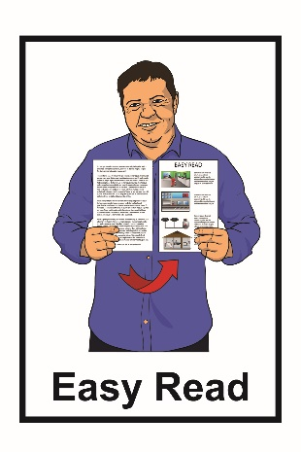
Getting ready for
your next health
care visit
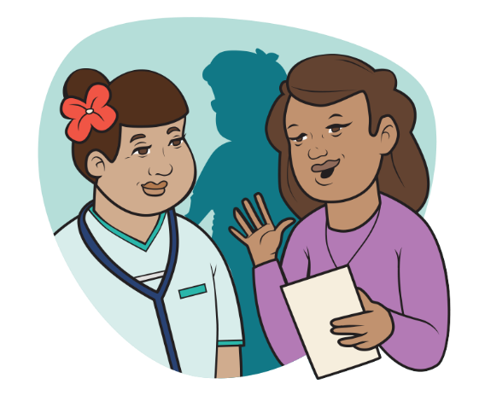
What is this document about?

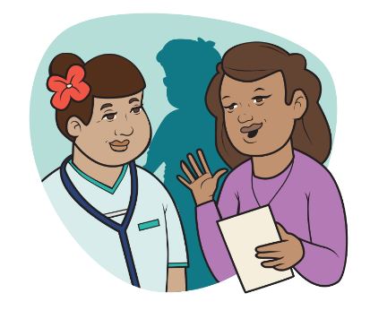
This Easy Read document is about getting ready for your next health care visit.

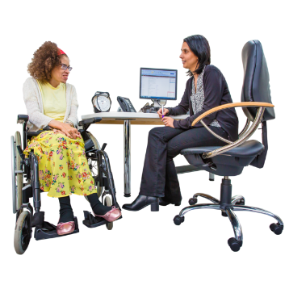
Health care visit is things like:
- going to see a doctor or nurse
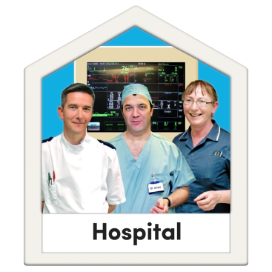
- going to an appointment at the hospital

- going to see a specialist service such as:

- physiotherapist

- dentist

- counsellor.

This document has ideas about what you can do to plan for your next visit like:
- what you might need to take with you
- questions you might want to ask.

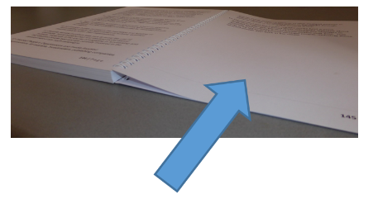
On pages 13 to 15 of this document there is a place to write down all the important things so that you are ready for your health care visit.

- Getting ready for your visit
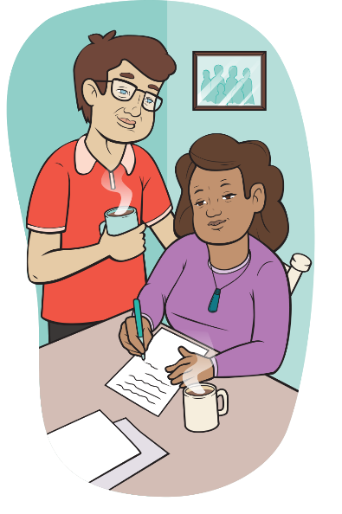
Getting ready for your health care visit will make it easier to learn more about your health.

To get ready for your visit you can write down any questions you want to ask at your health care appointment.

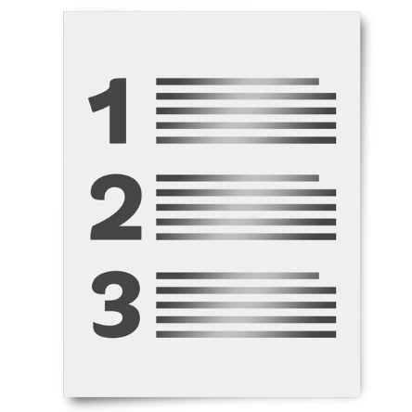
You can write down things like:
- the questions you want to ask / the things you want to find out

- what you are worried about.

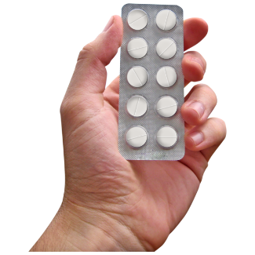
You can also write a list of all the medication and supplements you take.

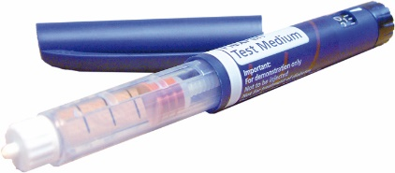
Medication might be things your doctor gave you to take like:

- tablets

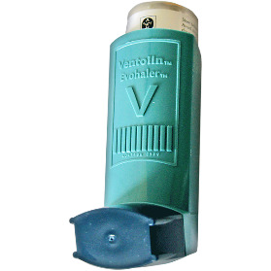
- injections

- inhalers

- sprays.

Supplements are things like vitamins that you might choose to take.

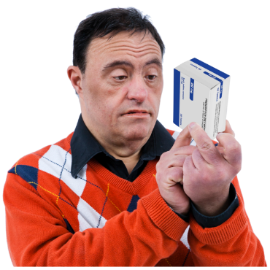
You can write down:

- the name of your medication / supplement
- when you take your medication / supplement

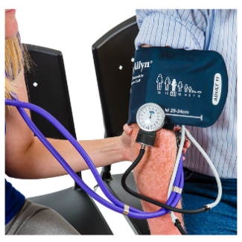
- how much of the medication / supplement you take
- why you take the medication / supplement.

When you are planning for your health care visit you can decide if you want to take a support person with you.

This support person could be:
            - whānau / family member
            - a friend
            - a carer.

You can also decide if you need to ask for a translator such as:

- language translator

- New Zealand Sign Language Interpreter.

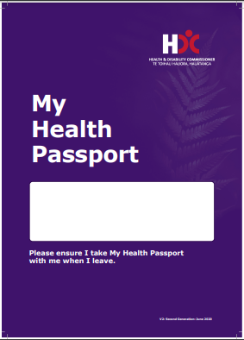
If you have a My Health Passport you can take this with you to your appointment.

The My Health Passport:

- is a booklet you can fill out that you can take with you to health care visits

- tells people what you want them to know about you.

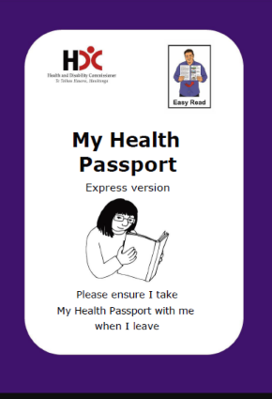
You can find an Easy Read My Health Passport on the Health and Disability Commissioner’s website at:
www.hdc.org.nz

- Share and listen
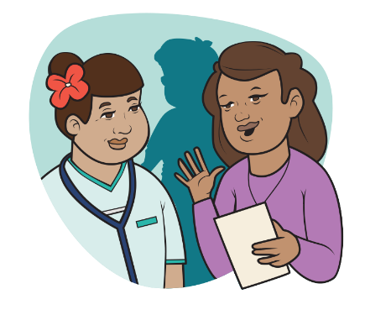

When you meet with the health care worker you can talk to them about:

- how you are feeling

- any problems you have with the treatment or medication
- anything you do not understand
- the best ways of explaining things to you such as the health worker:

- writing down the hard words

- doing a drawing or showing you some pictures.

You can also ask questions about:

          - what any medications are for

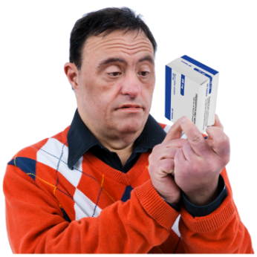
          - how to take the medication

          - any side effects of the medication.

Side effects are things that sometimes happen after you take your medication.

Some side effects can be things like:

- feeling more tired

- having a headache

- having an upset stomach.

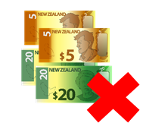
You should talk to your healthcare worker if:

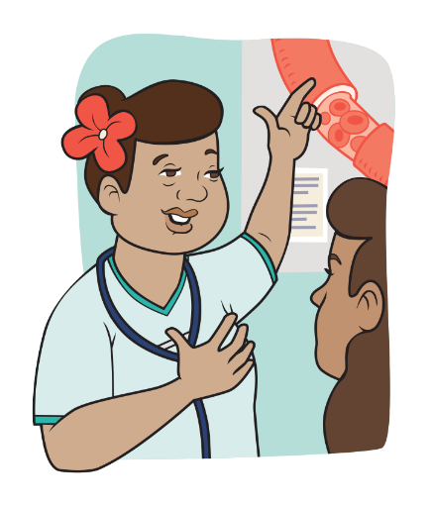
- you do not have enough money to pay for the treatment or medication

- there is anything else you think they need to know about you.

- Ask any questions

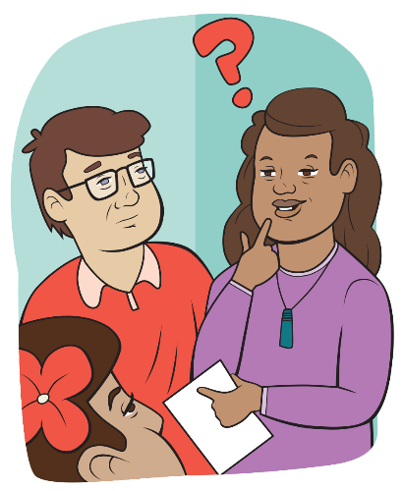
Before your appointment finishes you can ask the health care worker any questions you might still have.

These questions might be:
- What is my health problem?

- What happens next?

- Why is that important?
- Are there any other options / treatments / medication that I can take?

- What can I do to look after my health?

- At the pharmacy

If your doctor says you need to take medication you will need to get it from the pharmacy.

You can ask the pharmacist any questions you have such as:

- What the medication is for?

- What is the name of the medication?
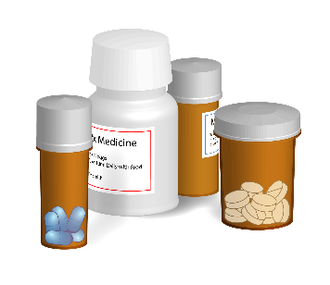
- How do you take the medication?

- When do you take the medication?
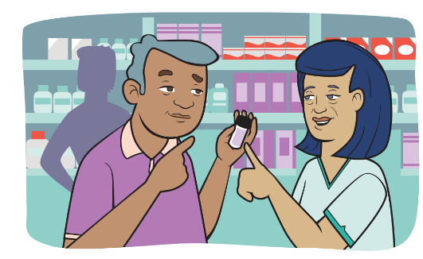
- What could happen if I stop taking the medication?

- What can I do about any side effects?
A place to write your questions and
note down answers

- Write down any questions you have:
- Write down your medications and supplements:

Remember to write down:

- the names of your medications and supplements
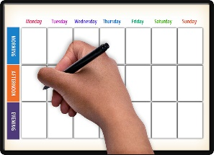
- how you take your medications

- when you take your medications.

- Write down what to do next:

This information has been written by Te Tāhū Hauora Health Quality & Safety Commission New Zealand.
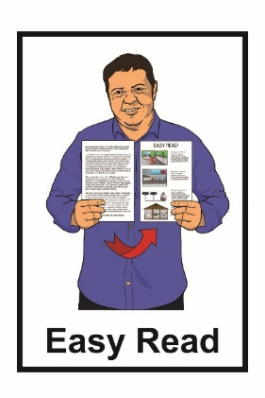
It has been translated into Easy Read by the Make It Easy service of People First New Zealand Inc. Ngā Tāngata Tuatahi.

The ideas in this document are not the ideas of People First New Zealand Inc. Ngā Tāngata Tuatahi.

In this translation Make It Easy uses images:

- from Photosymbols.com
- as supplied by Te Tāhū Hauora Health Quality and Safety Commission.

All images used in this Easy Read document are subject to copyright rules and cannot be used without permission.

