Let’s plan for your next health care visit | Me whakamahere i tō toronga haumanu hauora

Planning for your next health care visit and asking questions will help you understand more about your health and treatment for an illness or injury. Your doctor, nurse and others included in your health care want you to ask questions to help you make decisions together.

Prepare for your visit | Whakarite toronga

- Write down your main concerns or questions.
- Make a list of your medicines and supplements.
- Did you know you can take a support person or whānau with you and ask for a translator?
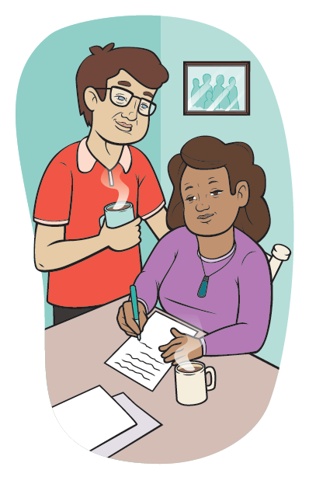

Share and listen | Te kōrero tahi me te whakarongo

- Tell your doctor or nurse what you are feeling.
- Say if you don’t understand and if a drawing could help.
- Say if you’re having problems with your medicines or treatment, or can’t afford them.
- Is there anything else you can tell your doctor or nurse about your health?
- Ask questions about your medicine if you need to know more about what it is for, how to take it and any side effects.

Ask any questions | Pātai noatia

- What is my health problem?
- What happens next?
- Why is that important?
- Are there any other options?
- What can I do to help with my health?

Note down what to do next | Tuhia ngā mahi mō muri

Collecting your medicine from the pharmacy | Kohia tō rongoa i te toa rongoā

You may want to ask some questions:
- What is the medicine for?
- What is its name?
- How and when do I take it?
- How long do I need to take it for?
- What could happen if I stop taking it?
- What are the side effects?
- What should I do if I get these?
This is a large print version of a resource published by the Health Quality & Safety Commission, available online at www.hqsc.govt.nz.

