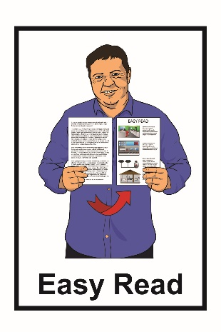
Getting ready to
leave hospital

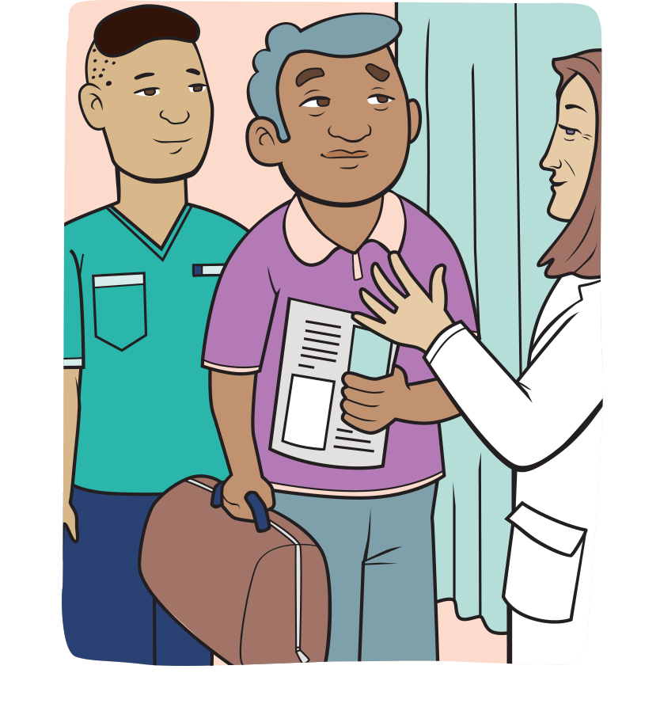

What is this document about?

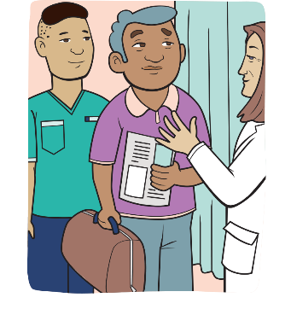
This Easy Read document is about the things you can do to get ready when you leave hospital.

Hospital staff want you to leave the hospital with answers to any questions you have.
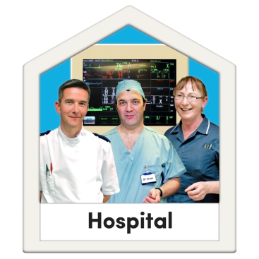

This document talks about things like:
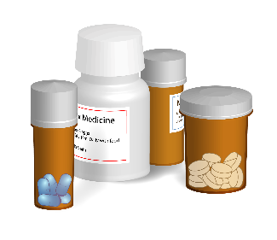
- what to do before you leave hospital
- follow-up appointments
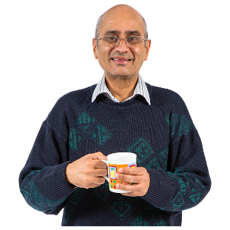
- medication
- taking care of yourself at home.

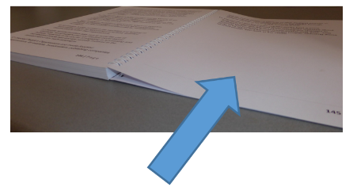
On pages 13 to 15 of this document here is a place to write down all the important things so that you are ready to leave hospital.

- Getting ready to leave hospital

If you have any questions about your health care you can ask your:
- doctor
- nurse.
You can write down the details of people you might want to talk to about your health care like their:
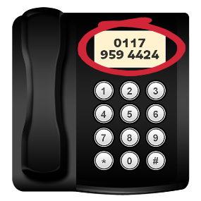
- name
- phone number.

- Follow-up appointments

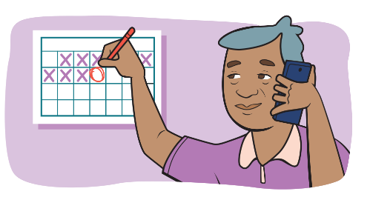
Sometimes after leaving the hospital you need to:
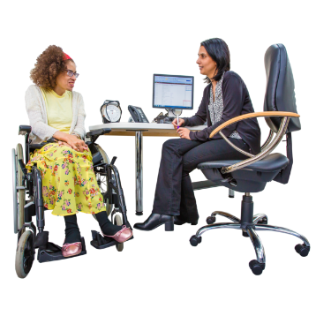
- come back to see the doctor at the hospital
- go to your own doctor.

These are called follow-up appointments.

You can check if you have follow-up appointments with your doctor or nurse at the hospital.

If you need to see your own doctor after you leave the hospital you need to:

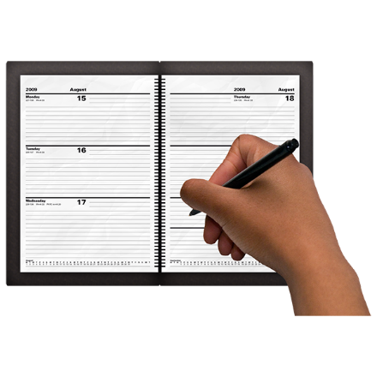
- make sure you know when you need to see your doctor
- remember to make an appointment with your doctor.

- Tests

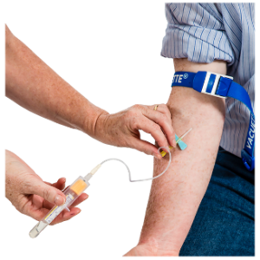
You may be waiting to hear about your test results.

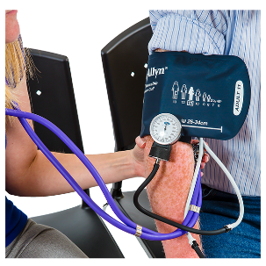
Tests are things that check how your health is such as:

- blood tests
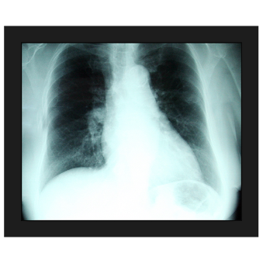
- blood pressure checks

- x-rays.
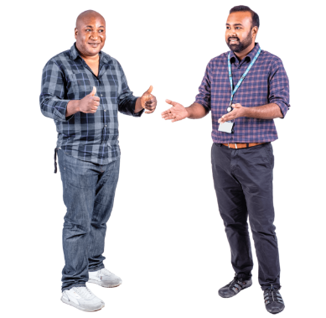
If you are waiting for test results you can ask how you will get your results.

You might find out about your test results by:
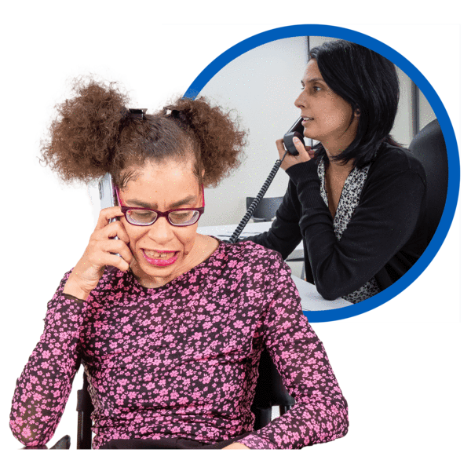
- calling your doctor
- calling the hospital
- whoever has the test results calling you.

- Medication

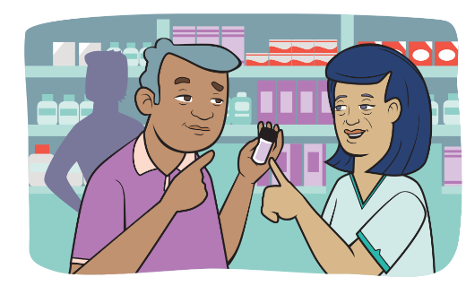
Before you leave the hospital you should write down a list of the medication you take.

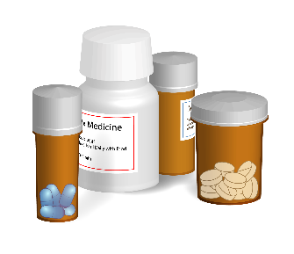
Medication might be things your doctor gave you to take like:

- tablets
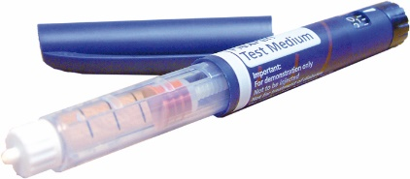
- injections
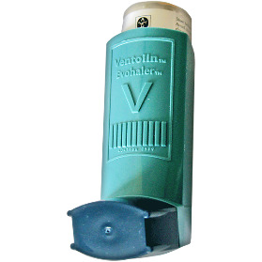
- inhalers

- sprays.

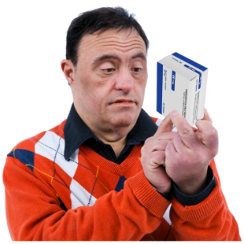
You might need to write down:

- what medication you take
- when to take your medication
- what your medication is for
- if your medication has any side effects.
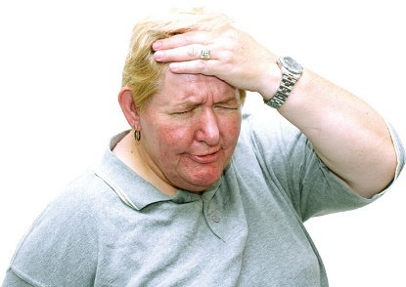
Side effects are things that sometimes happen after you take your medication.

Some side effects can be things like:

- feeling more tired

- having a headache

- having an upset stomach.

Sometimes your doctor will change your medication.

You should ask your doctor about these changes so you can understand them.

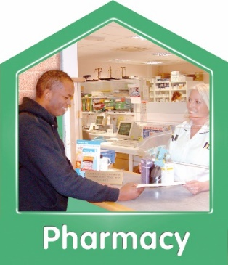
New medications might cost you money to get from the pharmacy.

- Looking after yourself at home
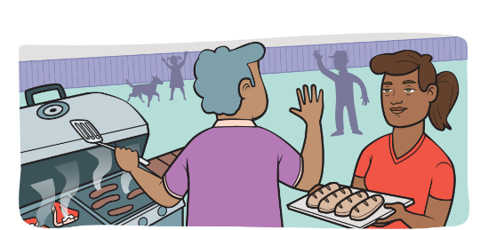

It is important to look after yourself when you get home.

Before you leave the hospital you might want to ask if there are any symptoms that you should look out for.

Symptoms are things your body does to tell you something is wrong like:
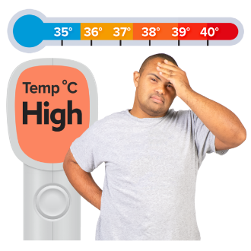
- headaches

- fever / feeling hot
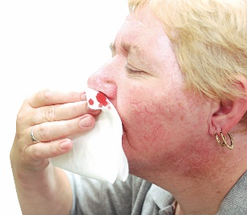
- more pain
- bleeding.

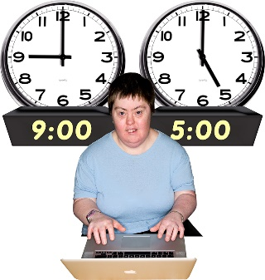
You can ask if there is anything you need to know such as when you can:
- go back to work

- go back to driving a car
- lift heavy things.

You can ask about what you can do to stay healthy like:
- what you should eat
- how you should be exercising
- if you need to do a lot of resting.
A place to write your questions and
note down answers

- Write down any answers to questions you have:

- Write down your medications:

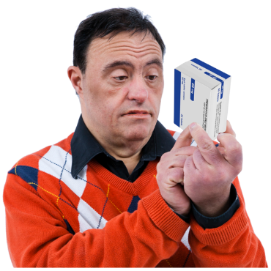
Remember to write down:

- the name of the medication

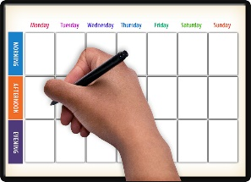
- how you take the medication

- when you take the medication.

- Write down what to do when you get home:
- Write down names / phone number for people who you might need to talk to about your health:

This information has been written by Te Tāhū Hauora Health Quality & Safety Commission New Zealand.
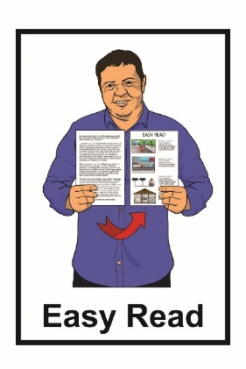
It has been translated into Easy Read by the Make It Easy service of People First New Zealand Inc. Ngā Tāngata Tuatahi.

The ideas in this document are not the ideas of People First New Zealand Inc. Ngā Tāngata Tuatahi.

In this translation Make It Easy uses images:

- from Photosymbols.com
- as supplied by Te Tāhū Hauora.

All images used in this Easy Read document are subject to copyright rules and cannot be used without permission

