# Patterned strip in red and purple with a repeating tohu, against a grey background.

# **Findings from the consumer health forum Aotearoa hui on 10 November 2022 | Ngā kitenga o te wānanga hauora kiritaki Aotearoa i te 10 o Whiringa-ā-rangi 2022**

The Health Quality & Safety Commission (the Commission) facilitated a hui for the consumer health forum Aotearoa at Te Papa, Te Whanganui-a-Tara Wellington on 10 November 2022.

The consumer health forum Aotearoa is a platform for consumers, whānau and communities to share their experiences and talk about what matters to consumers at every level of the health system.

The forum members decided to focus on the hauora of Māori people, Pacific peoples, disabled people and older people and on mental health and addictions. Each table focused on the perspective of one of these groups to workshop the following key questions:

1. How would you like to be involved in the planning, design and delivery of health services?
2. What improvements are necessary to keep people well in their community?
3. 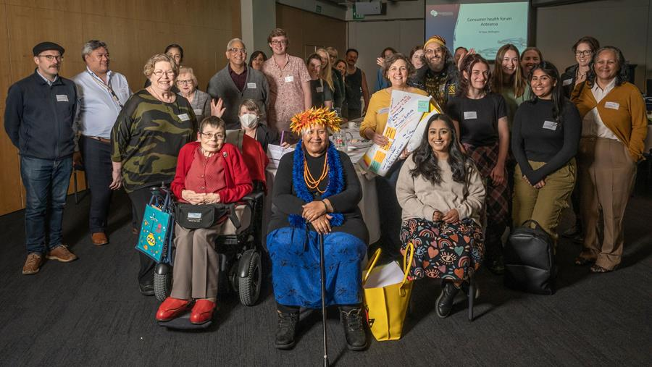What do equitable health outcomes mean to you, and how can we work to achieve them?

Participants from the consumer health forum Aotearoa hui  
Thursday 10 November 2022 at Te Papa, Te Whanganui-a-Tara Wellington.  
Photography: Dave Allen.

Staff from the Commission and Te Whatu Ora facilitated these discussions, and consumers used their experiences and collective knowledge to discuss how their voices could help improve and influence the health system from the perspective of their chosen group. The key themes and findings from this hui are described below.

## **Question one: How would you like to be involved in the planning, design and delivery of health services? | Pātai tahi: Ka pēhea ki a koe te āhua o te uru mai ki te mahi whakamahere, hoahoa me te tuku ratonga hauora?**

Consumers indicated that three important elements would help them be effectively involved in the planning, design and delivery of health services.

First, co-design and partnership is important to consumers. Participants felt strongly that groups engaging with consumers for the purpose of co-design projects must include a range of consumers, including everyday people, consumers with lived experience of a relevant condition and equity groups rather than clinicians. People with specific conditions are experts in their own right because of their experience. Consumers must be included as true partners in the process in a variety of contexts and stages, including advisory, strategy and governance. Consumers suggested that having them map out their user journeys would help in the design of systems and services that fit their needs. Participants were very clear that consumers and whānau should be considered a necessary part of planning and design decisions across the sector and that they should be involved right from the beginning.

Second, consumers need accessible, clear and friendly feedback systems that allow them to provide input into all levels of the health care system. This may require examination of why this is difficult in the existing feedback system. Once feedback is given, consumers need to know it has been heard and acted upon, and those within the sector should understand that consumers, whānau and communities with lived experience are best placed to provide this feedback. Providing information about how feedback has been heard and acted upon is called ‘closing the loop,’ and bringing results back to the community concerned must   
become standard practice. Image credit: Huriana Kopeke-Te Aho

Finally, it is important that information is accessible for everyone and provides clear details about what is expected and will be offered. This and all health-related information should be provided in plain English, in the languages most relevant to the people involved and in alternative formats such as New Zealand Sign Language and Braille. Organisations wanting to engage consumers and communities should proactively seek out such participants.

Overall, consumers valued proactiveness, shared meaning and having a long-term vision.

## **Question two: What improvements are necessary to keep people well in their community? | Pātai rua: He aha ngā mahi hei whakapai ake i te noho ora o ngā tāngata ki ō rātou hapori?**

Participants identified a range of improvements that are necessary to keep people well in their community:

* meeting cultural needs
* designing health care to be more person- and whānau-centred
* addressing the equity of services
* improving the health workforce
* improving access to services
* addressing the social determinants of health
* improving health communication and literacy.

Community- and location-specific solutions such as better infrastructure are also needed. Much of the discussion centred around co-design and adequate feedback systems, emphasising the importance of these aspects. Some feedback was specific to certain areas such as mental health, funding of health care services and ACC. The need to promote the code of expectations within the health sector was also discussed. An all-of-government collaboration is essential to address both health and wellness in communities.

## **Question three: What do equitable health outcomes mean to you, and how can we work to achieve them? | Pātai toru: He aha ki a koe te tikanga ngā te putanga hauora mana taurite, me te pēhea e whakatutuki ai?**

To achieve equitable health outcomes, communities must be engaged. To do this, people engaging communities must show genuine interest, proactively reach out to involve communities from the beginning and resource communities to challenge the health care system. Using consumer views and sharing information and feedback will increase consumer trust in the system.

Consumers stated that the system needs to be a person-centred rather than a business-centred model and that biases and racism need to be addressed and deconstructed. This will require a holistic shift in culture and truly valuing diversity. Participants also noted that the health care workforce needs to be cared for, paid well, further educated in cultural safety and not overworked; that health care needs to be affordable; that whistleblowing should be enabled; that variations in care should be addressed; and that whānau education around mental health is needed.

## **Summary | He kupu whakarāpopoto**

The Commission supports consumers being actively involved in decision-making about their health at all levels. The consumer health forum Aotearoa promotes and advances the engagement of consumer and whānau voices in the health system. This event reminded us that we must all continue to connect with, listen to and learn from one another. The passion in the room was evident, as was the hope and expectation that not only will consumer voices be heard but also that tangible actions will arise from these forums.

The next steps following this hui:

* This report summarises the findings from and discussion at the hui. Specific (and identifiable) suggestions for system improvements were also offered. The Commission will provide this information to the relevant agencies and share any resulting feedback with forum members.
* When we design future opportunities to connect with the consumer health forum Aotearoa, we will be influenced by how forum members would like to be involved.

Watch consumers share why they got involved in the consumer health forum Aotearoa here: [https://www.youtube.com/watch?v=f0WfpIBg4XQ](https://www.youtube.com/watch?v=f0WfpIBg4XQ%20)

Document published in December 2022 by the Health Quality & Safety Commission, PO Box 25496, Wellington 6146, New Zealand.

Available online at [www.hqsc.govt.nz](http://www.hqsc.govt.nz)

Enquiries to: [info@hqsc.govt.nz](mailto:info@hqsc.govt.nz)