Minutes of the Kōtuinga Kiritaki / Consumer Network
Chair | DJ Adams
Members | Mary Schnackenberg, Oliver Taylor, Joanne Neilson, Ricky Ngamoki, Jennie Harré-Hindmarsh, Zechariah Reuelu,  Mark Rogers, Marlene Whaanga-Dean, Tofilau Bernadette Pereira, Tyson Smith, Toni Pritchard, Edna Tu’itupou-Havea
He Hoa Tiaki | PIC Team | Allison Anderson, Anne Buckley, LJ Apaipo, Robbie Manning (part meeting)
Te Tāhū Hauora staff: | Gillian Bohm, Heidi Cannell Senior Policy Analyst
Apology | Deon York, Amanda Stevens, Vishal Rishi, Dez McCormack, Arana Pearson
Guests | Rose Wall, Deputy Commissioner, and Jane Carpenter, Principal Advisor (Act and Code Review Project), Office of the Health and Disability Commissioner

The hui was held at Rydges Wellington Airport, on 16 November 2023.
The hui began at 9.15 am.

1. Welcome and karakia
DJ welcomed the group and opened the meeting with a karakia.

2. Standard business
Previous minutes:
Minutes from 23 August 2023 accepted as correct.

Action items:
There were no outstanding action items. The diagram of the restructured health system was circulated with the 23 August minutes.

Interests register:
Previous updates circulated prior to the meeting. Toni reported she has updates to be included in the next update. Members were asked to forward any changes to the Interests Register to Dez McCormack.

3. Feedback on previous CAG hui
Mary provided an update – Following is her written report:

Report to HQSC Consumer Network 16 November 2023 Item 3 Consumer Advisory Group, Mary Schnackenberg

HQSC has three groups of consumer advisors across the organisation.
• today's Consumer Network, Kōtuinga Kiritaki;
• Consumer Advisory Group (CAG) Te Kāhui Mahi Ngātahi – I am a member of both groups; and
• Te kāhui piringa which supports Māori advocates.

There are consumer advisors on other groups in HQSC and we were able to network with them on Friday 26 May after the Consumer Health Forum which took place the previous day.
The Consumer Advisory Group met face to face on 7 September and over Zoom on 10 November. Our primary role is to provide a consumer lens over papers going to the Board. We also go through our environmental scans to bring out the top issues to raise with the Board.
At our 7 September in-person meetings we had time in the morning with the Te kāhui piringa and in the afternoon we met as the Consumer Advisory Group.
The new HQSC Chief Executive, Dr Peter Jansen, joined us in the morning. Considering the issues of equity and the cost-of-living crisis, Peter said he was committed to working with us to ensure our recommendations are impactful. The consumer voice is crucial for him.
In the afternoon the Consumer Advisory Committee met. We discussed our relationship with the HQSC Board. While there is no formal consumer appointment on the Board, there are Board members who have had consumer experience in different consumer advocacy spaces.
The Consumer Advisory Group met again over Zoom on 10 November.
We reviewed a paper going to the Board about healthcare associated infections. These are infections we could acquire when we are in hospital. The focus was on surgical site infections, and bloodstream infections. The paper was able to provide actual costs of extra time spent in hospital because of these infections. A quality lens was applied to improve services and reduce the infections.
Some of our feedback was about making the language of these reports less medical and more straightforward. Other feedback was about how to capture the costs of social/psychological damage for patients and their whānau, particularly when patients may need extra care after they have left hospital.
Moving on to other issues, we had a very thoughtful discussion about how to deal with clinicians who have been recruited from overseas and have not been supported with sufficient cultural awareness training. We agreed to raise this as an issue with the HQSC Board at our meeting with them on 24 November. We will be seeking feedback from the Board to close the loop and help us be more impactful.

Discussion

Members thanked Mary for her report and discussion followed about the issue of cultural safety that had been raised. Some key points included:
- Cultural safety training is a requirement for health professionals – but what is offered for the unregulated workforce? This includes others working in the health sector who are not registered health professionals (e.g. orderlies, admin staff etc).
- Initial contact of consumers is often with receptionists so they are a key part of care.
- Cultural safety training is important but there is a risk of it being a ‘tick box’ exercise. Important to evaluate what is consumers experience of it within the sector.
- Unconscious bias can potentially be an issue for some in the health workforce.
- Important that cultural safety is addressed as part of the recruitment process for overseas health workers.
- The importance of kindness and empathy being shown to people presenting for care and with mental health and addiction problems in particular was highlighted. It was recognised that staff shortages have the potential to impact on this aspect of care.

4. He Hoa Tiaki | Partners in Care report for Kōtuinga Kiritaki
The report is an update since the 23 August hui and was circulated to members with the agenda. The report is attached as Appendix 1.

Allison spoke to the report highlighting key information in each section. She advised members that Consumer Health forum stats will now be reported on a quarterly basis, rather than gathered ahead of meetings. This will help with consistency and tracking of membership data.

QSM - Robbie Manning (Data Analyst) for the team spoke briefly on the QSM Quality & Safety Marker for Consumer Engagement. The team are reviewing all submissions received as part of the moderation process prior to finalising scores and publishing them online. A number of the submissions have yet to come in and in terms of submissions from the district. It was acknowledged that there are appointments pending for Consumer Engagement roles in Te Whatu Ora and that system changes are having an impact on timeliness of District submissions. Three of the five health entities have provided September submissions.
Members questioned whether submissions had been received from Bay of Plenty and Tairawhiti and were answered in the negative. A member asked what more could be done to ensure Districts submit to the QSM. It is anticipated that when the regional consumer engagement teams are in place in Te Whatu Ora that this could be progressed more readily with HQSC support.

2024 Forum – DJ gave a brief update on the forum planned for Auckland, May 15, 2024. Of note, the venue has now been confirmed as the Waipuna Hotel and Conference Centre, Waipuna Road, Mount Wellington, Auckland. DJ thanked those members who had given feedback on this as a suitable venue.
Some members of the group have been approached about contributing and the programme is continuing to be shaped. A member stated that it would be good to have the Minister of health/Associate Minister open/attend the event if possible.

5. Comments/questions on members reports submitted.
The reports were acknowledged and accepted as read. DJ noted that Tyson and Marlene’s environmental scan was circulated after than the main group. Full reports attached at Appendix 2. There was a round table opportunity for key points and discussion.
Points shared and discussed included:
- This week (13-19 November) is Transgender Awareness and remembrance week.
- Rare Disorders Strategy has been launched - a request from the Rare Disorders community is the coding of rare disorders in rolling-out of electronic records to improve patient identification and care.
- Wairarapa consumer council has been stood-up again. Marlene is co-chair of this council.
- Concerns re staffing including availability of GPs, the flow-on effect to Emergency Departments of lack of GP appointments, and the impact on health staff of providing care when understaffed. In Otago, midwifery shortages were reported relating to COVID vaccine requirements and staff leaving for Australia.
- Consumers, including Oliver, involved in ‘front of whare’ committee to improve flow and improve services at Capital & Coast and Hutt Valley districts.
- The benefits of cultural performance for some patients with cancer was highlighted in terms of increased feelings of wellness.
- It was suggested that HQSC could have a role in monitoring vaping rates which are of concerns; also that HQSC could advise on how personal health information is held and available to consumers.

6. Clinical Governance Framework

Heidi Cannell and Gillian Bohm from Te Tāhū Hauora presented on the draft of the revised Clinical Governance Framework. The draft is out for a 3-week consultation period (from 1 November) for health sector and consumer and whanau feedback and members are invited to provide their feedback on it.
DJ recirculated an email to the group inviting feedback on the framework during the meeting to ensure all members received it. For more information on the framework and submitting see Clinical governance framework: collaborating for quality draft feedback.
As per the email, members were advised they are welcome to provide feedback in their personal capacity or as a member of a group and were also invited to send the information on to their relevant networks.
Key information was included in the presentation about how the revised framework has been updated from the 2017 framework – in particular through incorporating principles of Te Tiriti o Waitangi as well as the Pae Ora Act and links with existing key health system guidance. The Quality Domains and System Drivers underpinning the framework were also discussed. The presentation will be circulated with the Minutes.

Jennie Harré-Hindmarsh is a consumer representative on the Expert Advisory Group (EAG) involved in the revision of the framework and raised the issue of the name of the framework, specifically the use of ‘clinical’ which other members also felt may not be ideal. Heidi advised that this had been raised and considered within the EAG and on balance it was decided to retain the use of ‘clinical’ in the name as it helped the health professional workforce to recognise the relevance of the framework to them.

7. Regional Workshops/ Leadership & Capability Toolkit/Training – Update & Discussion
He Hoa Tiaki team advisors provided an update on planning for the regional workshops:
Northland - Whangarei Friday March 15 & Kaitaia Saturday March 16
Hawkes Bay – Hastings 23 March 2024
For the Hastings event, the team will partner with the Health and Disability Commissioner’s Office to focus on consumer views on the review of the Code of Health and Disability Services Consumers’ Rights.
The process of identifying locations to engage with priority populations for the workshops (Māori, Pacific disabled people), to identify potential venues and to connect with local networks was outlined by LJ. As part of ‘closing the loop’ and getting further input Anne also spoke to a ‘Summary 1-pager’ (see Appendix 3) about how the team were drawing on the content ideas shared by members and others in the Leadership & Capability Survey they completed for He Hoa Tiaki. The 1-pager was provided to members in the meeting and highlighted possible workshop topics and presentation content as well as topics that may suit development into a ‘top tips’ consumer engagement resource.
Discussion focused on the following points/suggestions for workshop/resource content & development:
- Look for good practice in those locations and engage with ‘strength’ groups, that is groups doing consumer engagement well.
- Include discussion of barriers to trust in consumer engagement – for consumers and health sector professionals.
- Keep in mind those who don’t have access to the internet or physical access.
- Connect in with Cook Island and other cultural groups to help develop resources.
- Use Auckland contacts.
Members were invited to forward any further thoughts/ideas relating to the regional workshops through to the He Hoa Tiaki team at any time.

8. Review of Code of Rights and HDC Act – overview and feedback
Jane Carpenter, Principal Advisor, and Rose Wall, Deputy Commissioner, from the Health and Disability Commissioner’s Office (HDC) attended the meeting to present and facilitate a workshop with members. Jane gave an overview of the HDC code review process.
Meeting attendees then divided into 3 groups in a ‘World Café’ style workshop activity where the groups considered specific questions and offered suggestions and input. The groups were supported by both HDC and He Hoa Tiaki staff scribing and facilitating the conversations.

The groups then came back together, and spokespeople gave a brief summary of their group’s feedback. HDC will take the feedback provided and send a summary of the workshop feedback to HQSC. The summary will then be sent out by He Hoa Tiaki to members.

Action: He Hoa Tiaki team to liaise with HDC (Jane Carpenter) re summary notes from the workshop and circulate the summary to members.

At the conclusion of the HDC item, the deputy commissioner departed the session prior to hearing the feedback and closing discussion. Zechariah spoke to the group and raised this as showing disrespect to our group - Kōtuinga kiritaki Consumer network, and for the mahi we had just undertaken and the taonga given.
He Hoa Tiaki staff advised they would take those comments as feedback to HDC on behalf of Kōtuinga kiritaki.

9. Closing comments/other business
It was requested that a draft agenda be circulated early to give an opportunity for members to add agenda items. Members were invited to send through agenda items at any time for inclusion.

10. Karakia & close
DJ closed with a karakia.

Next hui: 14 February 2024 - Rydges Hotel, Wellington Airport

Actions list
Date | Action | Responsibility
16 Nov 2023 | Clinical Governance Framework presentation – to be circulated with Minutes | He Hoa Tiaki
16 Nov 2023 | He Hoa Tiaki team to liaise with HDC (Jane Carpenter) re summary notes from the workshop and circulate them to members. | He Hoa Tiaki

Appendix 1
He Hoa Tiaki report for Kōtuinga Kiritaki
10 November 2023
Since we last met on the 7 September, the team have been busy. The following are some highlights from the past two months.

Consumer health forum Aotearoa

Consumer opportunities
Since the beginning of quarter 1 this financial year (1 July 2023 onwards), we have had 20 18 consumer opportunities listed via the forum newsletters, social media advertisements and on our website. Some of these opportunities sought to recruit several consumers to participate in projects or advisory groups. As the Consumer health forum Aotearoa gains recognition throughout the sector, these opportunities are expected to increase. Each opportunity that is listed via Ngā Pae Hiranga represents an engagement process between the health entity and He Hoa Tiaki that involves sharing resources, best practice and further information on the code of expectations, co-design and genuine engagement practices. See our current opportunities here: https://www.hqsc.govt.nz/consumer-hub/consumer-health-forum-aotearoa/consumer-opportunities/
You can help by sharing these opportunities with your networks as they come through our website and media channels:
Facebook: Te Tāhū Hauora Health Quality & Safety Commission
LinkedIn: Te Tāhū Hauora Health Quality & Safety Commission New Zealand
Instagram: @hqscnz
X (formerly Twitter): @HQSCNZ

Consumer health forum Aotearoa events
- Our Voices: Shaping health care together | Ō mātou reo: He tārai tahi i te tauwhiro hauora. The national event will be held on 15 May in Auckland at Waipuna Hotel and Conference Centre. The programme for the day is being finalised. We will share it as it becomes available.
- We will visit two regions for some smaller consumer leadership and capability hui/workshops. The dates for these events are as follows: Northland March 15 Whangarei and 16 March Kaitaia; Hawkes Bay (Hastings) 23 March 2024. For the Hastings event, we will also partner with the Health and Disability Commissioner’s Office to focus on consumer views on the review of the Code of Health and Disability Services Consumers’ Rights.

Forum membership stats by ethnicity
The total number of forum members as of 31 September is 893. The following table is provided to show the breakdown of members by ethnicity from end of quarter 4 2022-2023 to quarter 1 2023-24.
Ethnicity | Quarter 4 2022-23 | Quarter 1 2023-24
Māori | Quarter 4 total: 153 (18.4%) | Quarter 1 total: 170 (19.0%)
Pacific | Quarter 4 total: 87 (10.1%) | Quarter 1 total: 91 (10.2%)
Asian | Quarter 4 total: 39 (4.5%) | Quarter 1 total: 42 (4.7%)
Pākehā/Caucasian | Quarter 4 total: 482 (56.0%) | Quarter 1 total: 494 (55.3%)
Middle Eastern/ Latin American/ African | Quarter 4 total: 17 (2.0%) | Quarter 1 total: 18 (2.0%)
Other ethnicity or ethnicity not specified | Quarter 4 total: 77 (9.0%) | Quarter 1 total: 78 (8.7%)
Total | Quarter 4 total: 860 | Quarter 1 total: 893

Aotearoa Patient Safety Day Te Rā Haumaru Tūroro o Aotearoa 2023
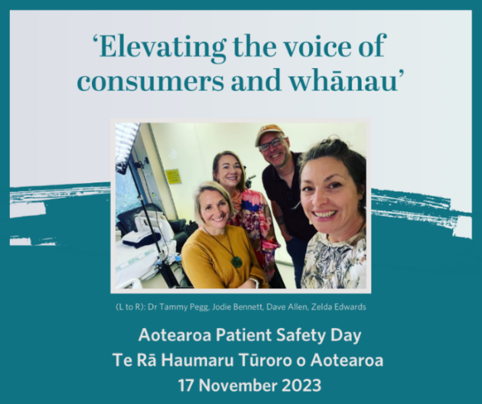
World Patient Safety Day is a worldwide campaign aimed at creating global awareness and united action for patient safety. This year’s theme is ‘Engaging patients for safety’, therefore it was important that Aotearoa Patient Safety Day mirrors this theme. On 17 November, we will focus on promoting the code of expectations. We have prepared various digital resources, including a promotional video, social media content, and an online quiz, to support consumer and whānau engagement. The communications kit is available. For more information, you can visit our 2023 campaign webpage or contact Zelda Edwards zelda.edwards@hqsc.govt.nz.
He Hoa Tiaki team have collaborated with the communications team to produce a video highlighting the importance of co-design and collaboration with consumers and whānau in health care services. Filmed in Nelson, the video is about elevating the voice of consumers and whānau by applying the code of expectations and using co-design. It features insights from Dr Tammy Pegg, consultant cardiologist at Te Whatu Ora Nelson Marlborough, and Jodie Bennett, Kaiwhaihua at Changing Minds, and members of our Consumer Advisory Group Te Kāhui Mahi Ngātahi.

Quality and Safety Marker for consumer engagement (QSM)
The latest QSM submission deadline was on the 30 September. Due to staff changes within Te Whatu Ora, some submissions to the QSM have been delayed. The He Hoa Tiaki team have been guiding Te Whatu Ora districts and health entities that are new to the process. We have received eleven out of twenty-four submissions so far, with more expected in the next two weeks. Moderation of the scoring will begin soon, and we will update you when the submissions and scores are published. We are working with Te Whatu Ora (national) and Te Aka Whai Ora to assist with these entities’ submissions.
The Quality and Safety Marker for consumer engagement framework can be viewed in PDF or MS word formats on our website here. Work is progressing to add accessibility options and/or functions.

Engagements
For the period of 1 July- 31 September, He Hoa Tiaki team attended 198 engagements.
Key aspects of the engagements included:
- presentations on the code of expectations
- helping services to develop opportunities and recruit consumer forum Aotearoa members to projects and
- discussions with Te Whatu Ora districts and with health entity representatives, including the multi-agency Consumer voice reference group.
He Hoa Tiaki engaged widely across the sector at multiple levels. Deon York met with national leads in Te Whatu Ora and Te Aka Whai Ora as well as the new Te Whatu Ora Commissioner and Te Aho o Te Kahu Cancer Control Agency to promote and support consumer and whānau voice. He Hoa Tiaki also participated in Te Whatu Ora ‘Rapid review of consumer engagement mechanisms’ along with representatives of (former DHB) Consumer Councils.
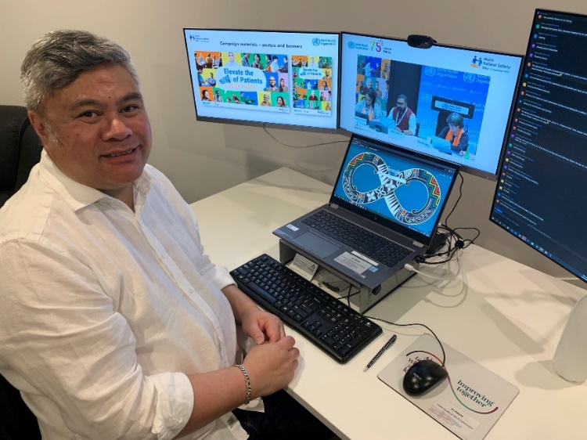
Some other highlights were:

WHO Global conference (online)
DJ Adams took part in the World Health Organisation worldwide webinar on patient safety. During the virtual networking time DJ shared the work our He Hoa Tiaki programme does to support consumer, whānau and community engagement in the planning, delivery and monitoring of health care services in Aotearoa New Zealand.

Royal Australasian College of Medical Administrators Conference (RACMA)
Te Tāhū Hauora was delighted to take part in the #RACMA2023 conference in Tāmaki Makaurau last month. Deon York was invited to present alongside Morag McDowell, Health and Disability Commissioner, in the leadership session. Deon spoke about enabling consumer engagement and its implications for health system leadership. Morag presented on leadership and balancing consumer rights and resourcing. To view the full programme, visit: https://racmaconference.com.au/2023-program/
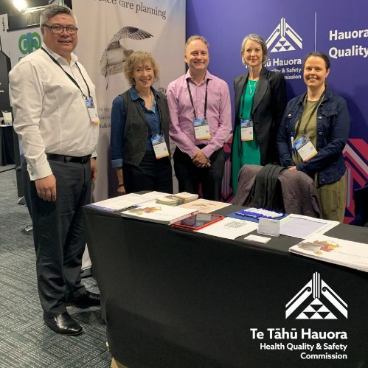

Practice Managers & Administrators Association of New Zealand (PMAANZ) conference
Te Tāhū Hauora participated in the annual Practice Managers & Administrators Association of New Zealand (PMAANZ) conference in Ōtautahi Christchurch on 18-19 September. The code of expectations, patient experience data and advance care planning were all topics of interest for the attendees. It was an incredible opportunity to share the work our team is doing and to connect with fellow delegates.

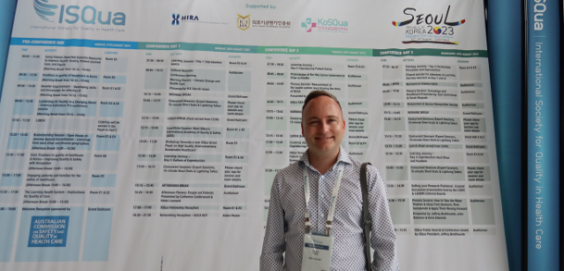
International Society for Quality in Healthcare (ISQua) Conference Seoul, Korea
Deon York attended the conference on behalf of Te Tāhū Hauora and ran a 45-minute workshop session entitled ‘Building a culture of Co-design: A National Code of Engagement- Expectations for New Zealand’s Health sector. Upon returning, Deon shared his learnings with the team and the wider Commission. Some of these included topics on: Adoption of artificial intelligence for patient safety, Workforce shortages globally, Climate change and its impact on health care, Designing the system with patients, Individualising measurements to create higher resolution portraits of quality-harnessing data and Cultural safety.

Code of expectations and implementation guide update
Since the launch of the implementation guide for the code of expectations for health entities’ engagement with consumers and whānau in June 2023, we have been continuing to socialise the guide and the code of expectations. This is a key part of engagements with the sector including attendance at events and presentations. A Communications Toolkit was provided in July through the Consumer Voice Reference Group (CVRG) which includes the two co-chairs of the CAG as consumer representatives. A slide kit was added to this toolkit in October and distributed through the group. The code of expectations and the implementation guide are also being promoted in a further Communications Kit which was distributed at the end of October. This promotional campaign for Aotearoa Patient Safety Day Te Rā Haumaru Tūroro o Aotearoa will be live from 17 November. Additional promotional campaigns focused on specific parts of the implementation guide are also planned.
The CVRG are currently meeting bi-monthly with a view to recommending any updates to the implementation guide in January 2024. As part of informing the update, CVRG are monitoring website traffic to the Code of expectations and implementation guide webpages.
The table below provides a summary of website traffic to these webpages over the period since the Implementation Guide launch (19 June).

Table 1. Code of expectations and implementation guide

Summary: Website analytics | 1 August –  10 October | 1 June –  10 August
Code of expectations for health entities’ engagement with consumers and whānau |  Te tikanga mō te mahi tahi a ngā hinonga hauora ki ngā kiritaki me ngā whānau  here | Views: 1,649  Users: 959 | 1,488 views
Code of expectations for health entities’ engagement with consumers and whānau here  (This page hosts the code translations and accessible formats) | Views: 1,182  Users: 716 | 952 views
Code of expectations implementation guide |  Te aratohu tikanga (new landing page here) | Views: 1,163  Users: 632 | 1,650 views
New code of expectational implementation guide and co-design e-learning suite | Views: 526  Users: 349 | Views: 460 Users: 302
Co-designing with consumers, whānau and communities | Hoahoa tahi me ngā kiritaki, ngā whānau me ngā hapori here | Views: 558  Users: 325 | 622 views
Using lived experience to improve health services | Te whakamahi wheako mātau hei whakapai ake i ngā ratonga hauora here | Views: 290  Users: 177 | 324 views
Improving equity through partnership and collaboration | Te whakapai ake i te mana taurite mā te mahi tahi here | Views: 172  Users: 111 | 253 views
Accessibility and resourcing for consumer, whānau and community engagement | Te whai wāhi me te whai rauemi mō te mahi tahi ki te kiritaki, te whānau me te hapori here | Views: 161  Users: 87 | 254 views

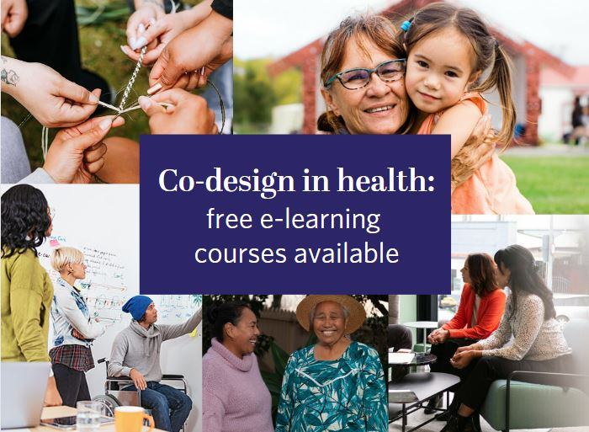
Co-design courses
A reminder of our co-design resources: Co-design in health: Supporting consumers, whānau and communities to contribute to co-design, Engaging Pacific consumers in co-design, Engaging Māori consumers in co-design, and Co-design in health: How you can be involved – a guide for consumers, whānau and communities. You can access the co-design in health modules through the LearnOnline platform. First-time LearnOnline users will need to create a login. For more information, please visit our webpage
This resource has now been accessed 1277 times compared with 1093 times in Q4 last financial year.
We currently have a completion rate of about 45%. We have begun an awareness campaign to increase completion rates and we will know if this is working towards the end of 2023.

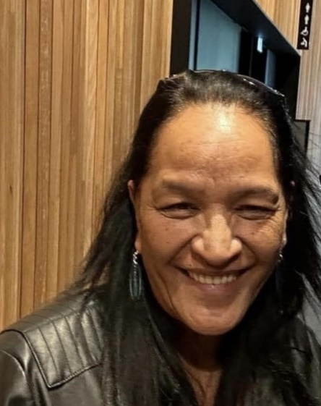
Farewell to Dr Te Raina Taite-Gunn
It is with great sadness that we acknowledge the passing of our dear colleague and friend Dr Te Raina Taite-Gunn.
Te Raina was instrumental in the development and writing of the Te Anga Ao Māori | Te Ao Māori Framework. Many of you knew her and supported her in some of that mahi,in particular the research paper Ngā Taero a Kupe: Whānau Māori experiences of in-hospital adverse events. This was a specific piece of mahi which allowed Te Raina to showcase her strength in research, utilising a matauranga Māori worldview. Through her hard work, commitment and drive to realise improvements for whānau Māori and people in general, Dr Te Raina Taite-Gunn’s research, dedication and humble nature has opened doors for Te Tāhū Hauora.
Te Raina was generous, kind and stoic. She was a colleague, a friend and a true advocate for consumer and whānau engagement in health. We will miss her presence, support, quick wit and her smile.

Appendix 2 Summary of Kōtuinga Kiritaki Consumer Network member reports for 16 November 2023 hui

Mary Schnackenberg (Auckland)

Environmental scan/real time monitoring and services
Ongoing delays in gaining access to primary healthcare with long waiting lists.
The blind, deafblind and low vision community I am in touch with are concerned about the high monthly costs of access to continuous blood glucose monitoring that connects to smart phones. These devices allow blind diabetics to stay in touch with glucose levels and manage insulin and diets interactively.
A similar concern relates to the high cost of melatonin, a naturally occurring hormone that manages the 24-hour body clock. Natural melatonin is controlled by light. Some 70% of lifelong blind people experience sleep disorders. Subsidised synthetic melatonin is available in New Zealand but apparently not via GPs for the blind people who genuinely need it to restore normal sleep patterns.
There is no reliable certainty that personal health information can be made available to print disabled healthcare recipients in their preferred formats. This makes it more difficult to get the best outcomes from face-to-face engagements with busy time-constrained clinicians.
In the media is the outcome of an inquiry into IDEA Services who run care homes for people with learning impairments. Report findings show they have generally not managed well any complaints made by residents or their whānau. This is particularly troubling given that learning impaired people are generally more vulnerable than other groups of disabled people.
Input / involvement in Te Tāhū Hauora meetings/groups.
7 September morning: joint hui of Te Kāhui Piringa and Te Kāhui Mahi Ngātahi | Consumer Advisory Group (CAG)
7 September afternoon: hui of Te Kāhui Mahi Ngātahi | Consumer Advisory Group (CAG)
Activity (since last report)
5 September, Disability Advisory Panel, Office of the Ombudsman.
13 September, 11 October, 8 November: Pharmac Consumer Advisory Committee meetings.
16 October, Consumer Experiences Council Auckland Health New Zealand. This was my final meeting after five years' membership of the council.
Services
See environmental scan above.
Positive stories and exemplars
Not this time, other than, when the consumers I know actually reach their clinicians, they generally receive excellent attention.
I have been involved in reviews of reports on the Quality Safety Marker in two different groups. Both conversations went well with improvements agreed to in the reports prior to their submission to HQSC.
Recommendations
That Te Tāhū Hauora updates the Consumer Network on progress of work to have a national computer system to store personal health information with release to the individuals as well as clinicians, subject to standard privacy conditions being applied.

Jennie Harré Hindmarsh (Tairawhiti)
Environmental scan
Concerns about potential negative impacts on progress made over last few years given the health policies promoted in their election campaigns by the potential new National-Act-NZ First Coalition government (e.g. loss of recent implementation of free prescriptions based on evidence from HRC-funded research involving patients and whānau served by two iwi providers in Te Tairawhiti https://www.nzdoctor.co.nz/article/news/otago-study-quantifies-harm-caused-5-prescription-fee, and the proposed dis-establishment of Te Aka Whai Ora Māori Health Authority).
No information about preparation of the Tairāwhiti Locality Plan as part of the new Pae Ora health system, the revised process for which was to be completed later 2023 (according to Te Whatu Ora Tairāwhiti Consumer Council leaders in July/August).
Ongoing concerns about decreased rates in childhood vaccinations in Coast communities which before the Covid pandemic had high rates, thus Iwi providers are in discussion with hapu and whanau to develop solutions.
Whilst Covid and other transmissible diseases are increasing again, ‘silence’ about both eligibility for next 6-monthly covid booster and the importance of re-activating actions to limit/prevent transmission is concerning those most vulnerable, including older persons.

Input / involvement in Te Tāhū Hauora meetings/groups

Working Group member: Te Tāhū Hauora Pae Ora Quality Framework Project

The aim of this Te Tāhū Hauora HQSC project (begun in September 2022 and initially led by Synergia with the Whanau Ora Commissioning Agency) is to embed the Pae Ora Act principles of equity, tino rangatiratanga, and engagement with Māori and other population groups into a new ‘Pae Ora Quality Framework: Guidelines for clinical and cultural quality and safety in Aotearoa New Zealand’. The new Framework will replace the current ‘Clinical Quality and Safety Governance Framework’.

4 Sept: Zoom meeting followed by emails with Heidi Cannell (Senior Policy Analyst) about current work underway by Te Tāhū Hauora to further refine the Draft Clinical Governance Framework and provide her with information about my and other consumers’ input up to the Draft of June 2023.
20 Sept: Zoom meeting and emails with Te Tāhū Hauora (Heidi Cannell, Toni Duder Senior Communications Adviser, and DJ Adams) about their next steps to complete the refined Framework. Discussion focused on how to obtain ‘sense checks’ on the final draft from a broad range of consumers, including the intended variety of ‘community voices’ in remote rural & provincial areas whose intended participation was compromised by impacts of the pandemic & cyclones in 2022/23.
16 Oct: Reviewed and emailed comprehensive written feedback on HQSC’s latest draft of the Framework. This was mainly about ways to strengthen and/or clarify content related to: Te Tiriti o Waitangi, achieving equity, consumers and whānau as part of the health system, and the methodology (various sources of information) used to update the Framework.
3 Nov: Forwarded Te Tāhū Hauora email inviting feedback on the final-draft Framework by 22 Nov to those in Te Tairāwhiti invited to contribute to earlier stages of the project via the Thought Exchange survey and local focus groups/interviews (latter cancelled due to cyclone in Feb).

Te Tāhū Hauora Draft QSM Report
20 Sept: Participated in Consumer Network zoom meeting, followed by email, to provide feedback to Te Tāhū Hauora on the Draft QSM Report, the first to include a review of HQSC’s progress to fulfil the Code of Expectations for Consumer and Whānau Engagement.

Activity (since last report)

12 Sept: Online lecture - “A critical reflection on sustaining a NZ health service through growing challenges: global and local” - by Massey University Professor of Nursing, Jenny Carryer, about health system challenges. During the discussion, the elevation of ‘Consumer & Whānau Engagement’ through the Pae Ora Healthy Futures Act was acknowledged but not explored to any depth (Video recording available https://youtu.be/WORPD6MZJVM).
15 Sept: Online seminar - “Think before you spit - privacy perceptions in the context of direct-to-consumer genetic testing” - led by Andelka Phillps (University of Queensland) about serious risks for consumers using commercial genetic testing services promoted by companies like 23+Me, Ancestry.com, and Nebula. Issues documented by a recent survey in Aotearoa NZ and Australia include the lack of security, lack of privacy, lack of control for and by consumers, and an associated lack of public understanding about how their genetic data can or will be used for other purposes by such commercial entities.
9 Oct: At the request of Synergia (who along with Wai Rangahau have partnered with Te Whatu Ora and Te Aka Whai Ora to develop national guidance to improves access to diabetes services -especially for those at risk of complications), forwarded their invitation to express interest to be on this project’s 2023/24 Working Group to locals who have lived experiences of diabetes services in our remote rural areas with predominantly Māori populations and a passion to improve equitable access.

Positive stories and exemplars
Tūranga Health has ‘pivoted’ to respond to vulnerabilities exposed by Cyclone Gabrielle and its aftermath, including those experienced by 161 Pasifika men working in local orchards, vineyards, and crops. This Iwi health service provider quickly connected with these RSE workers to better connect them to welfare and health services, and nine months later continues to work with them and the wider Pasifika community to co-identify gaps in and improve their access to dental care, health services and opportunities to gather as a community (www.gisborneherald.co.nz/news/rse-workers-find-trusted-voice-in-tairawhiti).
Recently Kaniwa Kupenga-Tamarama, a Ngāti Porou Oranga leader of the successful Kaupapa Māori Mama and Pepi Service ‘Nati Pepi’, was named one of the top 100 Māori Leaders for Te Rau Ora 2023. Nati Pepi, the moemoea of many ‘Aunties’ and a blend of clinical science and Matauranga Ngāti Porou, began as a Māori Health Innovation pilot project and is now funded to operate through many hubs along the Coast as part of the Population Health & Research section of the Runanga’s Ngāti Porou Oranga. They focus on strengthening the village and strengthening connections, wrapping support around wāhine and their whānau before, during and after giving birth: “when wāhine are strong, their whanau are strong, our land will be strong, and we are all strong.” https://ngatiporou.com/article/nāti-pēpis-kaniwa-kupenga-tamarama-named-te-rauora-100-maori-leaders-2023
Taunakitanga Takitini, a recently HRC-funded five-year research programme which includes Tūranga Health in its leadership group, aims to co-design (with service providers, whānau and communities) models for how collaborative community healthcare professionals and kaiāwhina can support and work alongside whānau and communities to enable them to support themselves within their own context. Aotearoa-specific knowledge will be developed about ‘self-management’ to enable those who experience greatest health inequities and their whānau (underserved populations living with lifelong conditions) to be supported to live the best possible life. These models will then be implemented and outcomes evaluated (www.hrc.govt.nz/resources/research-repository/taunakitanga-takitini-reframing-self-management-support-all-aotearoa).
Recommendations
That Te Tāhū Hauora
- Co-develop, with consumers and health service providers, quality and safety guidelines (and related education resources) for their use of genetic testing services and genetic/genomic information to prevent, decrease risk of, and treat or manage health issues.
- Collaborate with community leaders, health researchers, and national entities to advocate for urgent legislation to make vaping products prescription-only (an issue noted in August report).
- Engage directly with leaders of the exemplars outlined above (and provided in other Consumer Network reports) to explore if and how Te Tāhū Hauora could add resources to empower such groups both to add resources/value for such initiatives and at the same time inspire wider implementation/uptake, without over-burdening their already stretched workforces and communities.

Oliver Taylor (Wellington)

Environmental scan
Consumer engagement is changing within Te Whatu Ora, with management roles now being disestablished. Capital, Coast and Hutt Valley has recently disestablished the Consumer Manager role, leaving the work to a single employee across the whole district. While this process is aimed at simplifying our health system, there are major risks to maintaining cohesive consumer engagement structures and practices for the public health entity, and there is no clarity around how consumers will continue to be supported with these changes. Despite claims that more will be invested in consumer engagement, these changes do not appear to reflect this. Consumers need to be given clarity by Te Whatu Ora national office on how they will commit to strong and cohesive consumer engagement in health, in line with the Code of Expectations.
Input / involvement in Te Tāhū Hauora meetings/groups.
20 September: Review of Te Tāhū Hauora QSM Reporting. The submission aimed to reflect the engagement, responsiveness, and experience domains of their work with consumers within the organisation. I suggested various things, mostly on providing clearer evidence on what consumer engagement looks like and recognising that ‘experience’ means of the organisation, not of the consumers themselves. It is positive to see the Commission submitting themselves and taking on consumer feedback for improvement.
15 November: QSM Moderation session. The moderation will review the submissions of all entities who submit to Te Tāhū Hauora and provide any necessary feedback to improve submissions in the future. This will be the first submission that uses the revised framework developed with the QSM Reference Group.

Activity (since last report)
1 November: Te Whatu Ora Capital, Coast and Hutt Valley: Front of Whare project steering group meeting. The Front of Whare project aims to relocate and expand Te Pae Tiaki Wellington Emergency Department (ED) and expand the acute services in the Medical Assessment and Planning Unit (MAPU), Surgical Assessment and Planning Unit (SAPU), Intensive Care Unit (ICU), at Wellington Regional Hospital. The project was approved in June this year for $10 million to develop a detailed business case for major works, which are expected to cost $100+ million. As one of the two consumers on the group, I support the project to achieve better outcomes for consumers entering the services.
10 November: Te Whatu Ora Capital, Coast and Hutt Valley: DCAG end of year meeting. The District Consumer Advisory Group will meet on Friday to consolidate and celebrate our work over the year.
Services
Wellington Regional Hospital’s Women’s Health Service is under so much pressure that it has told GPs to stop referring people unless they suspect something requiring urgency or cancer. The severe staff shortages seem to be causing this. It is increasingly frustrating for consumers in limbo waiting for tests, with these issues potentially creating risk of substantial harm. The long-term impacts of this, while yet to be seen, might reflect poorer health outcomes for females.
Positive stories and exemplars
I was recently appointed to the Front of Whare project steering group alongside Dennis Te Moana, who is the chair of Wellington DCAG. Having two consumers on the steering group helps provide us confidence to contribute to the group and shows the interest in hearing a more diverse set of views for the project.
Recommendations
Recommend Te Whatu Ora create short-term and long-term plans to address the backlog of people needing to access gynaecological services in Wellington Regional Hospital.
Recommend that Te Whatu Ora create a long-term staff attraction and retention action plan to secure clinicians for New Zealand.
Recommend that Te Whatu Ora create an Emergency Services Action Plan to address the failing emergency services in our hospitals, working in conjunction with expanded and better-funded Urgent Care practices and community practices, so consumers who need to can access emergency care, and those who don’t can better access urgent care.

Mark Rogers (Timaru)
Environmental Scan
We are all watching with interest as to what effect the change of government will have on the health system.
Activity
Contributed to the bi-annual Voice of Rare Disorders survey.
I’ve been invited to be part of Manatū Hauora Ministry of Health Rare Disorders Sector Reference Group. This has come about following the result of 2022 review of Pharmac.

Zechariah Reuelu (Porirua)
Environmental scan
In various communities, Cannons Creek and Waitangirua many concerns have been raised regarding the accessibility and affordability of health services. Many individuals have expressed frustration over long wait times, limited access to specialists, and inadequate coverage for certain treatments. Elderly, 84 years old Samoan with health conditions was told there’s two weeks waiting period to access her doctor therefore visited A & E, when condition worsen.
Additionally, disparities in healthcare provision based on socioeconomic status and geographic location have been a significant issue, exacerbating Pacific inequities in health outcomes.
The change of Government has raised conversations of concerns among Pacific families with the reinstalment of the $5 top-up fee for funded prescriptions. The decision with the new Government to reinstate the fee would place pressure on household budgets. About 135,000 adults did not collect their prescriptions because of cost in 2021-22.
Input / involvement in Te Tāhū Hauora meetings/groups.
9th August Kōtuinga Kiritaki | Consumer Network 1 hour zoom to discuss planning for
the 2024 Our voices | Ō mātou reo Forum.
23 August Kōtuinga Kiritaki Consumer network Hui
Activity (since last report)
The Porirua Locality Te Wāhi Tiaki Tātou is gaining momentum across Porirua. It has been facilitating co-design Reimagining workshops in Hune/Hūrae (June/July) focused on dental and oral health services, for the month of Ākuhata (August), it focused on our Tāngata Whaikaha (Disabled people) community.
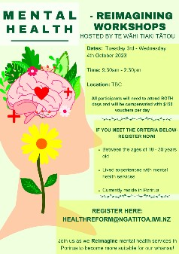
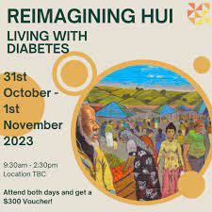
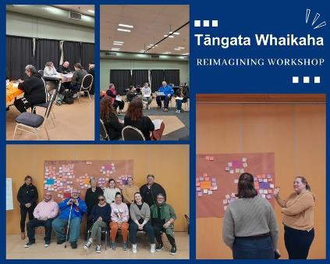

Reimagining Workshop – Tāngata Whaikaha (Disabled People) Community
In the month of Ākuhata (August), Te Wāhi Tiaki Tātou hosted another fantastic Reimagining Workshop with our Tāngata Whaikaha (Disabled people) community! Passionate Tāngata Whaikaha representatives participated in a focus group, engaging in courageous discussions about their personal realities and lived experiences around accessing and self-identification within healthcare systems in Porirua. Theming main discussion points that were agreed upon by the group:
Creating an options paper with recommendations
Sharing the options with the focus group – FIRST
Recommendations to our Community Governance Group
Work with Te Whatu Ora on contracting services for new initiatives
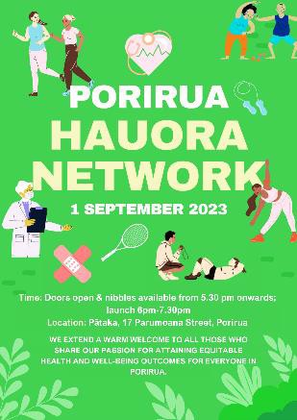
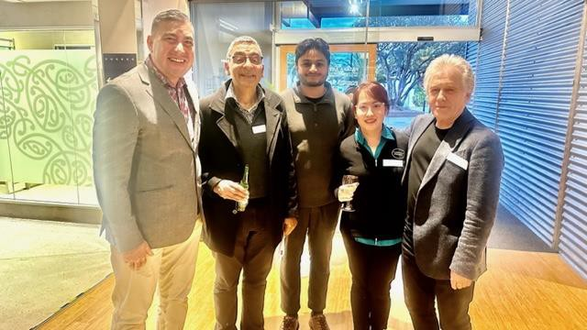

I attended the launch of the Porirua Hauora Network, a space created for Porirua providers to participate in impactful kōrero, create meaningful connections across services. We introduced the three community pharmacists, Waitangirua, Porirua and Cannons Creek with the Director of Health, Mr Michael Rongo responsible for the Porirua Locality. Consequently, the pharmacists meet with Mr Rongo to discuss community driven solutions. It was such a great opportunity
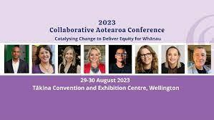
to connect our fantastic community pharmacies with the Director of Health, Michael Rongo. I truly believe our local pharmacy - Waitangirua, Cannons Creek, Porirua and Titahi Bay are locally connected, accessible, and able to coordinate to achieve community health aspirations.

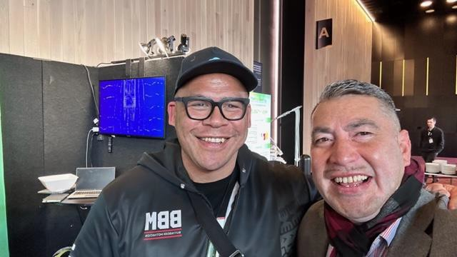
The 2023 Collaborative Aotearoa conference
in Wellington has already seen a number of
inspirational speakers on stage, including
Dave Letele who shared his amazing story
and the From the Couch programme. He's
not just talking the talk, but also walking the
walk and changing lives. Through the
conference, made important connections
with new partners to discuss strategies
for improving Pasifika gout outcomes.

The Fono: Strategic Alliance
Talanoa with Tavita Funaki @ CEO, ProCare, Mihi Blair @ General Manager, Māori Health & Equity, to shape a strategic alliance approach to improving gout management for Pacific population. The party agreed to explore collaboration to target key areas such as health literacy, training and education opportunities and partnering that would support both strategies to positive health outcomes for our Māori and Pasifika peoples.

The Cause Collective
The Cause Collective is a Pacific community organisation based in South Auckland that focuses on developing breakthrough solutions to complex and persistent problems. The organisation is not a service delivery provider of traditional social services as there are several great organisations who offer the needed services to support Pacific and mainstream populations.
Held meeting with Lui Poe @ Strategic Advisor. The Cause Collective (TCC) utilises three disciplines to underpin their approach for developing breakthrough solutions for large scale social change: systems thinking, critical thinking and design approach. The three disciplines are weaved together by the cultural frameworks of our different Pacific ethnic groups. We will be planning 2024 engagements with Pasifika church leaders.

Services
The current landscape with medical clinic at full capacity and cannot accept new registrations, families face significant challenges. The impact is two-fold: first, individuals with urgent medical needs are left without access to timely care, jeopardizing their health. The barrier causes, families to experience heightened anxiety and frustration as they struggle to find alternative healthcare options. This situation underscores the importance of the Porirua Locality to collaborate with adequate healthcare infrastructure and the need to address the growing demand for medical services and support.

Toso Vata Challenge
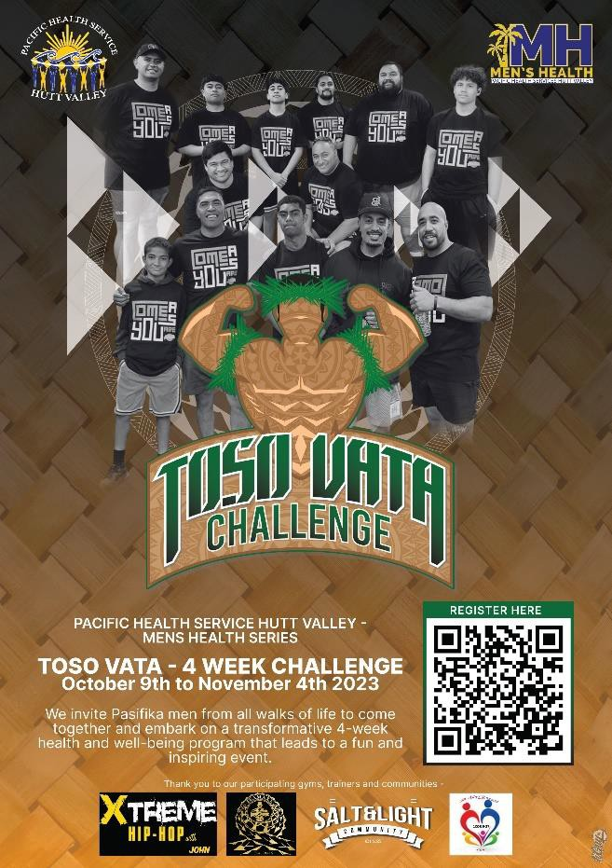
Monday 9th October to Saturday 4th November 2023. Toso Vata in Fijian language means to move together. We want to encourage our men to move with others they are comfortable with. Be active at least 3 days a week:

4 Week Toso Vata Challenge Days and Times
Monday 6pm Esava Tiko, Hutt Rec
Tuesday 6pm Alex Telea, Petone Rec
Wednesday 5.30pm John Mainu’u, Step Class,
Thursday 7pm Antonio Pilitati, Wainui
Friday 6pm Flag Touch, Hutt Rec Turf

The challenge leads towards their Mens Health
celebration event on Saturday 4th November in
Wainuiomata. Zechariah invited to be the guest
key speaker to share his health journey and work
at Arthritis New Zealand.

I shared to the Pasifika men to encourage openness to include their children with their health journey. When men actively include their children in their health journey, numerous benefits arise. Firstly, it fosters strong parent-child bonds, promoting emotional connection and trust. Secondly, it sets a positive example of self-care, encouraging children to prioritize their well-being. Thirdly, it facilitates open communication about health-related topics, enhancing overall family awareness and education. Finally, involving children in health activities promotes a healthier lifestyle for the entire family, leading to improved physical and mental well-being.

Dan Olive @Pacific Practitioner at Pacific Health Services Hutt Valley, commented how beautiful message to empower a family approach to improve the health destination of each man and their aiga/families. His quote “How great timely, amazing uso, testimony and connection through your story”

Positive stories and exemplars
During the month of August, we collaborative with Positive Pacific to focus on arthritis gout. We co-design a video to talk about; Unveiling Gout: Impact on our Pacific Community.
The short video Arthritis NZ breaks it down:
Gout 101 - Gout is no joke – its arthritis caused by uric acid buildup. And it's hitting our Pacific men harder.
Spot the Signs - Big toe pain, swelling, and redness – that's gout's calling card. Zechariah says early spotting is key. Let's spread the word!
Everyone's at Risk - Gout doesn't play favorites. Men, women, and especially our Pacific community can be targets. Awareness matters.
Real Talk: Gout's Toll Gout's not just pain – it's life disruption, impacting work, family, and life.
https://www.facebook.com/positivelypacific/videos/1351572682406497/?extid= NS-UNK-UNK-UNK-IOS_GK0T-GK1C&mibextid=csC8WJ.
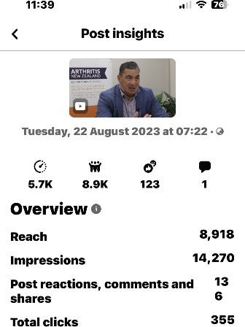
Some interesting analytics of the video:

Since the video released, I have engaged with several gout consumers via FB platform to assist with gout related enquiries. The video viewed by 6,1K people.

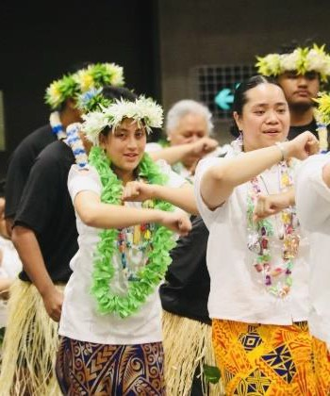
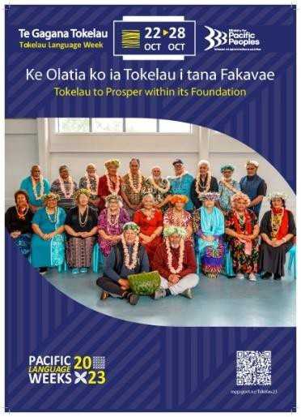
Tokelau Gagana Language Week was celebrated
throughout the country, where concentrated Tokelau
families lived; Porirua, Auckland, Rotorua, Taupo
and Hutt Valley. The week nurtures a sense of
identity and belonging, providing individuals with a
strong foundation rooted in their heritage and
traditions. This fosters self-esteem and a positive
intergenerational self-image. The cultural wellbeing
enhances social cohesion and celebrates cultural
heritage ensuring its continuity for future generations heritage.
The Wellington Fatele Finale held at Te Rauparahau enriches individuals' lives, offering opportunities for artistic expression, creativity, and personal growth. It enhances overall happiness and fulfilment in society. Up to 1,800 Tokelau people attended.

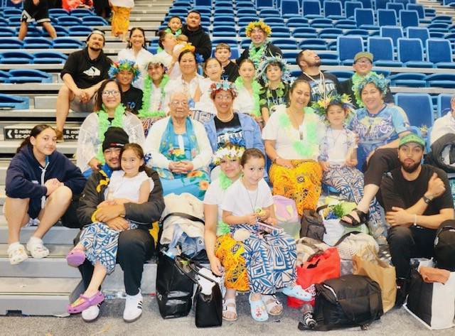
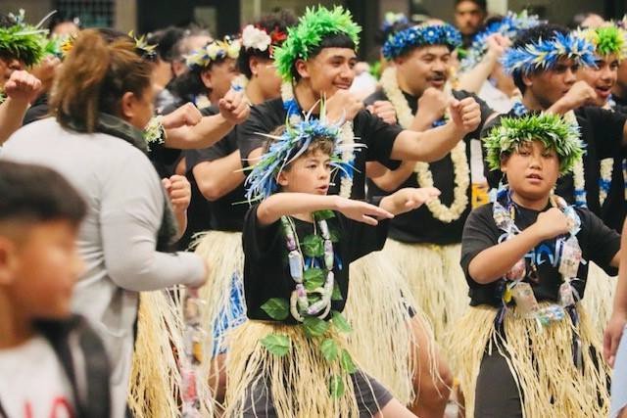
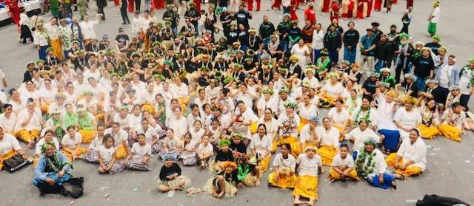
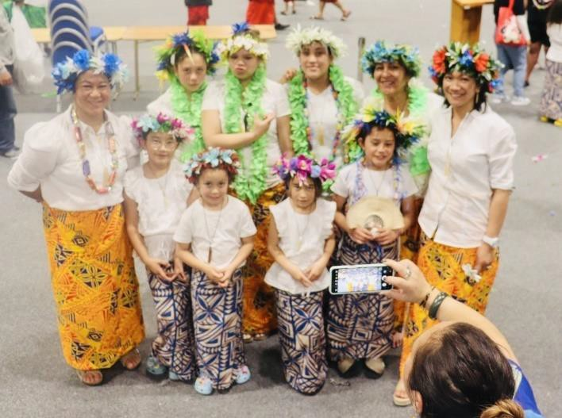

Joanne Neilson (Tairawhiti)
Environmental scan
We saw sunshine for a bit but the rain has been back with vengeance. This puts a huge strain on Hauora and Patients. Stress regarding the roads and will they get down from the coast or worse will they be able to get home. The doctor and Nurse shortage is the same as everywhere but the remoteness of Tairawhiti and surrounding districts makes us feel even more isolated. The Free Shuttle now 5 days a week is a great service that seems to be well used. Staff are tired and stressed and the change of government bring uncertainty, Time will tell!
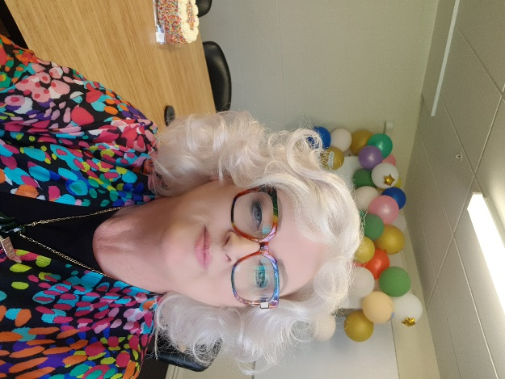
Activity (since last report)
So, by the time I see you all again we will have had our 2nd Āniwaniwa meeting. I realized there is a lot of diverse people in the Hauora. I wanted to offer a place where they were free to discuss any issues. Inclusivity and Visibility are just 2 of the things we need to be aware of in the rainbow community. Inclusion because we are part of the wider community and while there is a small core of people in society working to exclude us the more we are included the safer we will all feel. Visibility is vital for our Rangitahi to see positive role models and for our community to feel safe in the hospital as for a number of our people the hospital can be a barrier to accessing healthcare. Moreover, yes there was cake, Rainbow of course.
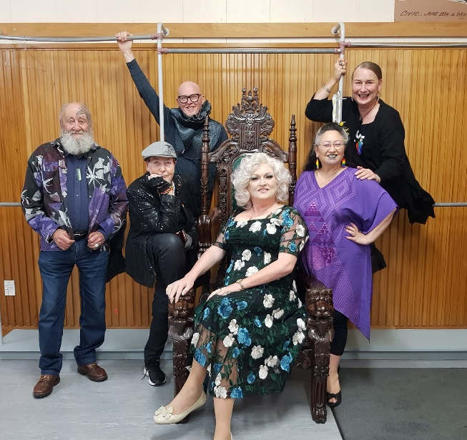

In September, I was invited to speak on a panel discussion in Invercargill as part of their Pride celebration. It was an amazing evening curated by the Chroma Team in Invercargill.
A diverse audience meant a varied discussion across the Rainbow spectrum.
Included was Jack Byrne (HRC), Rhonda Stace (Police) Marni Bruce Mitchell (Intersex Community Icon), Elizabeth Kerekere (Takatāpui Advocate), George Jardine (kaumatua) and Me of course. I love this picture, I think it looks like a reunion album cover of a really cool band in the 80’s LOL..
House renovations continue … there nothing more I need to say.

Ricky Ngamoki (Ōtepoti)
Environmental scan
Concern about what things might look like, under a new Government if there are major cuts and changes
Continuing to support whānau that are struggling with housing and jobs since Covid-19
It has been great to see that amount of Māori services that have popped up since Covid-19 to support Māori and Pacific people. It is positive to see the uptake of kupu Māori.
It would be nice to see all of the new services and initiatives that have been setup, communicating with each other, effectively, and working together to support whānau in the hāpori. It is sad, when it is clear that there is patch protection, that is created by the funding models. People are scared of losing the small resource attached to their new short-term contracts and this is creating boundaries and separation.
There are still services receiving large amounts of resource, that are not meeting the needs, they are contracted too. This is dis-heartening and is affecting the smaller services that are having to carry that load, because they are not.
Particularly in mental health, there needs to be a shift, to preventing the issues, that then present as depression, or suicidal thoughts, or waiting for offending to occur before we help people. The workforce is overworked and under-staffed, this we know. However, we also know that if we are able to successfully provide preventative services, this achieves better results for whānau and hāpori in the long run.

Tofilau Bernadette Pereira (Auckland)
Environmental scan
The critical issue of concern and has been for the past 7 months has been the chronic situation with a shortage of clinical staff from the primary level to secondary, including hospitals.
The health system in the country is a long way away from being resolved, people still wait for 3 - to 4 weeks before seeing a GP, and the ED departments are becoming the default solution for consumers needing to see GPs. People would rather wait 8 - 9 hours at the ED at least until they eventually see a doctor, than wait for four weeks.
The workforce shortage is the issue and will continue to have a major impact on the health and wellbeing of our communities.

Tyson Smith (Te Puke)

Environmental scan
No visible public pathway for adults seeking treatment/diagnosis for attention deficit hyperactivity disorder (1 year from GP referral to private treatment -approx. $900).
Fear in the community regarding the change of government (loss of free scripts, disestablishment of Te Aka Whai Ora etc.)
Local (BOP) Pathlab access issue/crisis seems to have worked itself out. Open and accessible with reasonable wait times.
Hauora a toi Health Consumer Council is not representative of the demographic that uses health services in the bay (uni educated ex clinicians).
Inpatient Wards
- Te Toki Maurere Unit (Whakatāne Hospital)
Te Toki Maurere Unit (Whakatāne Hospital) is not fit for purpose.
A new unit was announced early 2020 (approx. $15million funded) nothing has been built to date.
Routinely runs over its 10-bed capacity.
- Te Whare Maiangiangi (Tauranga Hospital)
Routinely runs over its 24-bed capacity (30 patients when Te Aka Whai ora did an inspection)
Prohibitive visiting policies/procedures at Te Whare Maiangiangi (have preventing whanau easy access RE: Visiting – Cases of whanau leaving/giving up (have to communicate using a intercom, pre book a room etc.))
Te Wheke (Lived Experience Network complained – took a while, doors are open) and a policy is being created for the future. Doors got unlocked after the district inspector got locked out
Ombudsman’s OPCAT report viewed the locked doors as unrecorded environmental restraint.
Input / involvement in Te Tāhū Hauora meetings/groups.
Kōtuinga Kiritaki Consumer network Hui

Activity (since last report)
Friday, 27 October Consumer, Peer Support, Lived Experience (CPSLE) workforce development hui (Hamilton) which set the foundation for Convergence Aotearoa (Hamilton). Rōpū will be lead by David Austin - Lived Experience Community Development Advisor Te Whatu Ora Waikato
9 November 2023 Te Huinga Takiora Manukura Monthly meeting with the Mental Health Foundation/Nga Hau E wha and Noku te Ao (a nationwide programme to end prejudice and discrimination against people with experience of mental distress). Going well, but uncertainty regarding the future (change of government)
Great turnout for a lived experience wananga (sold out)
Plan to take the lived experience wananga to the regions next year
Tuesday, 7 November Te Aka Whaiora – MHA Inpatient Visit in BOP
No surprises regarding the filthy state of the seclusion rooms in Whakatāne (known/historic issue)
24 bed unit with 30+ patients (Tauranga)
Wednesday, 8 November Office of the Health and Disability Commissioner Hui whanau Māori Team
Hui set up in response to the lack of answers or timeframes given and the unsatisfactory response to Te Wheke’s complaint regarding the locked external doors of our inpatient ward (TWM)
Showed large gaps with HDC process.

Services
Nga Kaitautoko Nationwide Health and Disability Advocacy Service
  - 40+ plus day wait for a complaint response (after acknowledgment)

  - declined support to an individual with a valid issue, - individual went to a second advocacy provider and had a positive outcome.

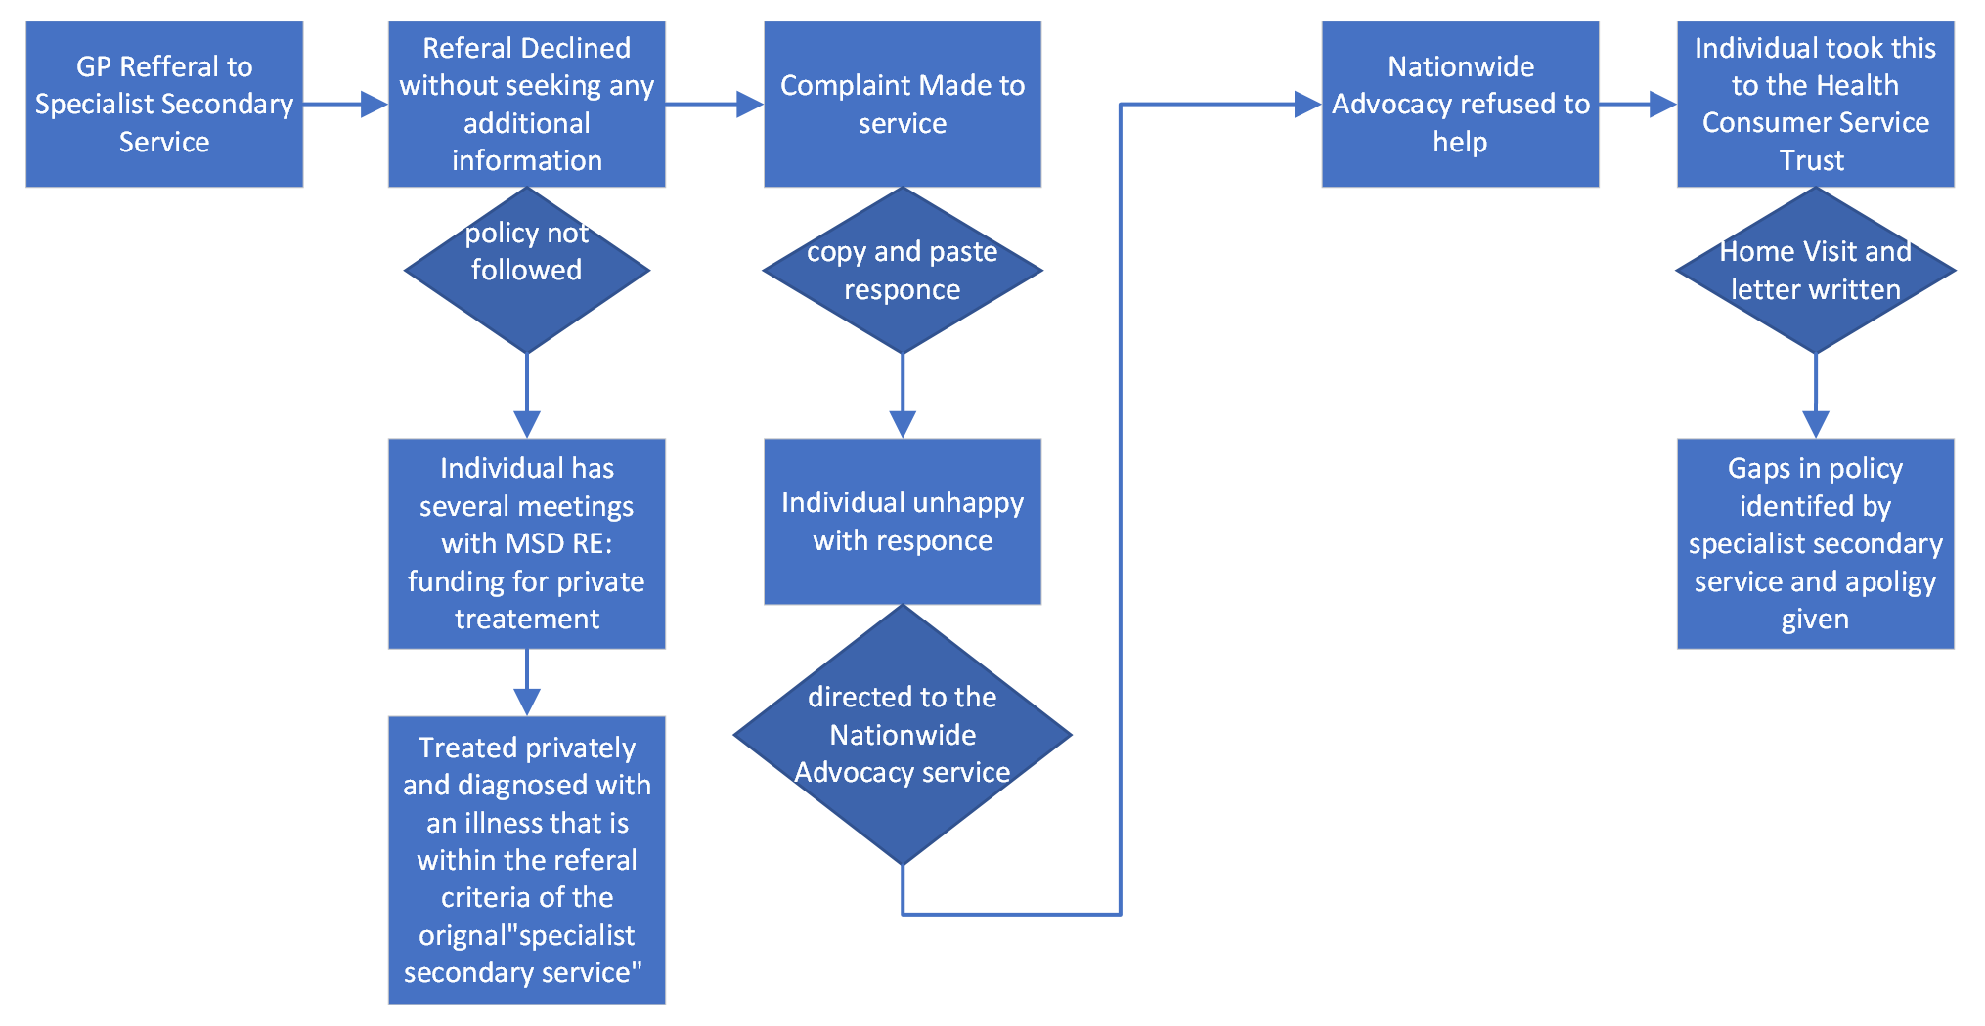
Hauora a Toi Bay of Plenty
Failure to complete required reporting (QSM Marker) -Te Wheke (Regional LE Network) provided notice, asked along the way, were supportive – Hauora a toi were intentionally obstructive.
Emergency Department (Hauora a Toi) social workers only work 9-5, no consideration is given to whanau who present at ED and are discharged afterhours.
Community Mental Health and Addictions are declining referrals without following documented policy or gaining any additional information. (flowchart above)
BOPAS (addiction service) Case managers are now refusing face to face hui (zoom) only, this could be considered culturally inappropriate – Whanau Māori prefer kanohi ke te Kanohi.
Hauora a Toi Bay of Plenty – Community Mental Health is not aware of what treatment it provides “Hauora a Toi Mental Health and Addiction Services does not have a documented list of therapeutic interventions/treatments that are provided” – OIA request https://fyi.org.nz/request/24000-consumer-expectations-and-roles-within-secondary-mental-health-addiction-services#incoming-91633
Hauora a Toi Bay of Plenty – Mental Health & Addictions Service are showing apprehension regarding the release of their mental health polices/procedures to the public “This email is to let you know that Te Whatu Ora needs more time to make a decision on your request. Unfortunately, it will not be possible to meet that time limit and we are therefore writing to notify you of an extension of the time to make our decision, to 28 November 2023. https://fyi.org.nz/request/24292-mha-policies#incoming-92547
Te Toihau Hauora, Hauātanga Health and Disability Commission
Refused to give a time frame for a closed file review, Te Wheke had to complete and official information act request to get any information regarding timeframes. https://fyi.org.nz/request/24271-closed-file-review-process-and-timeframe#incoming-92345

Positive stories and exemplars
Convergence Bay of Plenty (mātau ā-wheako workforce forum) has had to rebrand to Convergence Aotearoa (due to interest outside of the Bay of Plenty) https://cpsle.org/
Convergence Aotearoa (Hamilton) established.

The BOP lived experience community self-funded and released the first of what has become a biannual newsletter. (attached)

Majority of Nga Hau e Wha (National Forum of Consumers with lived experiences) Membership have joined NAMSCHA (National Association of Mental health Service Consumer advisors (combined hui planned for the end of the month)
Advocacy via Te Wheke Network regarding the equity in health conference, which is inherently inequitable ($1999 Ticket or 10 free spots for all of LE within NZ to fight/beg for) Te Whatu Ora pulled out, Te Aka Whaiora pulled out.

Recommendations
Open letter to Hauora a Toi Senior Management Regarding reporting obligations under the Pae ora act (Code of expectations by extension – and the QSM marker)
Review of the wider health complaint structure (from the consumers perspective) to prevent consumers been stuck in the middle.
Te Whatu Ora shouldn’t just direct consumers to advocacy services without knowing that the service will help.
Advocacy services should list exclusion criteria (e.g. we won’t help if your complaint is about access to service & declined referrals)
When an advocacy service is engaged there should be discussion/handover between the provider and the advocacy service (rather than the consumer have to relive the traumatic experience that made them complain)
People shouldn’t be made to feel like a “piggy in the middle”.
Question why HDC places NGOs (nationwide advocacy) between themselves and people with complaints (creates another step for people to work though/get turned away/loose hope)

Marlene Whaanga Dean (Wairarapa)
Environmental scan
There are several concerns in our community regarding limited doctors in our region and the longevity wait time of up to 2-3 weeks to see your GP, which clutters and puts pressure on our A&E. This is still on going.
The transitional from WDHB to Te Whatu Ora continues to be unsettling for our community, nothing has changed, still a wait list for hip operations and basic procedures. (no doubt this could be across the board).
Yellow Brick Road continues to partnership with Pasifika O Wairarapa to promote F.A.S.T Stroke Foundation N.Z. We had training for kaimahi to understand and teach whānau to identify through F.A.S.T what to look out for. Time is crucial. Training has been useful. I extended out the invitation to other services to take up this training. It was interesting how people had personal stories to bring and share of their experiences surviving a stroke and recovering or losing a loved one that could have been prevented. The youngest reported to have had a stroke at the age of 3, also a wāhine Māori at 40 years had a stroke while giving birth to her son, that was a long recovery for her as she shared her story with us, two different stories both cases from Masterton and doing well.
Activities:
28/10 F.A.ST Promotion held at Pasifika O Wairarapa. Women’s Health Day, combined with other Health providers, such as Whaiora nurses checking blood pressure, cervical smear, Te Hauora promoting rongoa, Tu Ora, YBR, Te Whatu ora Bowel Screening, Breast Screening, cervical screening. High volume of wāhine Māori attendance.
These organised venues contribute holistic wellbeing for wāhine /whānau and hāpori. Give-aways did capture more consumer voice on how these free health days are important to be held on a regular basis. There is a need to improve and support, data information feedback. Free Health days to be successful involved kaimahi, whānau and hāpori.
09/11 Attending MHALG (Mental Health Alliance Leadership Group) meeting. & Presentation re: MH&A Collaborative Design Project.
MHALG meeting to provide direction for the Wairarapa Mental Health & Addictions project. Priority areas to support and improve wellbeing. Interventions will have an emphasis on equity, greater access to care in the community and early intervention services, a whānau-centred care approach.

19/10 Te Whatu Ora consumer Network consumer council, we are back in action. Agenda items for Consumer Council members and Portfolios, ToR to be updated.

31/10 PECSG Hui – health system patient reported measures continue to be used alongside improving quality and particularly patient safety. Continued development, and to better understand how to improve patient experience to achieve Pae Ora.

15/08 Changeability in Masterton organised with Media Works for free airtime to promote, to support whānau in our region re: Mental Health and Addictions. Ongoing monthly meetings. Matt Brown visit ‘I’m not your rehab” White ribbon day coming up.

8/11 Māori Women’s Welfare League Wairarapa

Services:
Always looking to improve access for health, service providers like Whaiora Medical, Te Hauora Rūnanga and Yellow Brick Road use their resources (kaimahi working with whānau) / transporting whānau /tangata to appointments, whether it requires GP visits, MSD, Hospital, to help support their appointment times. If transport is unavailable, we do our best to accommodate to reduce stress, anxiety and this may include affordability e.g.: no money to pay for transport, no pūtea for petrol.
No changes in COVID or reporting from my region.

Positive Stories
19/10 Te Whatu Ora Wairarapa Consumer Council had our first hui. Kieran McCann, Group Director Operations is on board with us. We comprise of 8 members from diverse backgrounds, coupled with knowledge and skills.
Next Hui: 15 November, Chair: Linda Penlington, Co-Chair Marlene Whaanga-Dean
Ngā mihi ki a koutou ki te tīma o He Hoa Tiaki. He mihi whakawhtaitanga ki a koutou katoa.
Thank you to the team, He Hoa Tiaki, the manaakitanga that you provide to us, the members of Kōtuinga kiritaki is unreal. We are always made to feel welcome and Dez takes care of every detail.

Appendix 3. Summary Update on Regional Workshops & Consumer Leadership & Capability Toolkit
Kōtuinga Kiritaki Consumer Network meeting 16 November 2023

Prepared by: Anne Buckley, DJ Adams & LJ Apaipo – He Hoa Tiaki
Locations
Northland - Whangarei Friday March 15 & Kaitaia Saturday March 16
Hawkes Bay – Hastings 23 March 2024
For the Hastings event, we will also partner with the Health and Disability Commissioner’s Office to focus on consumer views on the review of the Code of Health and Disability Services Consumers’ Rights.
Currently identifying suitable potential venues for these 3 locations.

Content
Focus is health consumer leadership & capability to support consumer engagement in design, delivery and evaluation of health services.
Survey responses and feedback
Collation of ideas - survey responses and feedback in meeting discussions from Kōtuinga Kiritaki | Consumer Network and Te Kāhui Mahi Ngātahi | Consumer Advisory Group were collated and reviewed by the advisor group to identify related ideas.
- Looking to also identify what content would be best addressed in the face-to-face workshop format., what as a resource, and what with links to other sites contents
Workshop possibilities
Could include short introductory presentation covering topics suggested such as:
- Health system structures
- Code of expectations & code of rights
- Consumer Health Forum Aotearoa
Other ideas for inclusion:
- Levels of engagement/influence/participating in decision-making
- Communication skills – with health professionals
- Mentoring/coaching/buddying others
- Facilitation/conflict resolution
- Sharing lived experience
- Cultural understanding & diversity
Links to information /courses - Some information may be addressed by providing suitable links e.g. about medical terms and acronyms:
Healthify He Puna Waiora (formerly Health navigator) – Commonly used medical words and abbreviations
See https://healthify.nz/hauora-wellbeing/m/medical-words-explained/

Also general skills, for example business writing skills, may be addressed by identifying appropriate links or course content.
2-pager resources - Consumer Engagement: Top Tips
To be available online as well as in print,
Looking to develop a suite of short resources (3-4 this financial year):
1st topic being considered : :‘Effective committee meetings’ – this has come through as a topic of interest both from the survey– and also from the survey of Health entity representatives so seems a productive place to start. Thoughts?

