Minutes of the Kōtuinga Kiritaki / Consumer Network
Chair | Deon York
Members | Edna Tu’itupou-Havea, Hyejung Kim, Jennie Harre-Hindmarsh Joanne Neilson, Mark Rogers, Marlene Whaanga-Dean, Mary Schnackenberg, Oliver Taylor, Ricky Ngamoki, Vishal Rishi, Zechariah Reuelu.
He Hoa Tiaki | PIC Team | Allison Anderson, Anne Buckley, DJ Adams, Dez McCormack, Robbie Manning, LJ Apaipo (minutes)
Te Tāhū Hauora staff: | Gillian Bohm and Arana Pearson (consumer engagement advisor,  Mental Health and Addictions)
Apology | Amanda Stevens, Tofilau Bernadette Pereira, Renee Greaves

The hui was held at the Distinction hotel, Christchurch on 24 May 2023.
The hui began at 9.30am

Welcome and karakia
Deon welcomed the group and DJ opened with a karakia.

Whakawhanaungatanga for Robbie Manning
Everyone introduced themselves and briefly spoke of their health experience and background in being in this group.

Standard business
Previous minutes:
Minutes from 16 February 2023 accepted as correct, unanimously.

Action items:
One item carried forward (see action items at end). The diagram will be produced when the SPE and SOI are finalised.

Interests register:
Previous updates listed. Deon asked for any updates to the interests register be advised to Dez.

4. Feedback on previous CAG hui
Mary provided an update – Following is her written report:

“HQSC has three groups of consumer advisors across the organisation.
- Today's Consumer Network, Kōtuinga Kiritaki.
- Consumer Advisory Group (CAG) Te Kāhui Mahi Ngātahi – I am a member of both groups; and
- Te Kāhui Piringa which supports Māori advocates.

This Friday we get to meet consumer advisors from other parts of HQSC. Please take the time to network with them.
The Consumer Advisory Group met once since our February meeting on Tuesday 4 April via Zoom.
Our attention was brought to this year's World Patient Safety Day. The theme is engagement with consumers and family whānau. We were asked for ideas. This is also on our Agenda today.
Considerable work is going into the Implementation Guide for the Code of Expectations. We each need to lend a hand as working collaboratively in a climate where clinicians are so stretched will be a challenge for us all. Specifically, if you have any resources you can share with HQSC, they will be pleased to see them.
We received an update on the Partners in Care Workplan for the coming year 2023-2024. This is also on our Agenda for today.
Finally, we didn't have any Board papers to review at our April meeting”
Joanne thanked Mary for her update and shared that the nurses are striking on the Patient Safety Day.
Deon advised that the date of the patient safety day had been shifted and is now on Friday 17 November 2023.
Marlene also thanked Mary for the update and the kōrero about Patient Safety Day. Frontline staff are tired and over-worked. Marlene also acknowledged Mary’s whakaaro, about the need to take care of ourselves too.
Arana shared that the MH&A CAG met and are wanting to have a better relationship with He Hoa Tiaki. There are 5 projects that are part of the MH&A programme including the Zero Seclusion programme.
Deon summarised Dr Janice Wilsons’ farewell and spoke of the pōwhiri yesterday to welcome the New Chief Executive, Dr Peter Jansen.

Feedback on Board hui
The draft performance review is underway. This is voluntarily undertaken by Te Tāhū Hauora. Leading with influence will be the next phase for the organisation. Government have requested the Statement of Performance expectations, which requires ministerial approval.
Jennie asked if a new board chairperson had been appointed and this has yet to be announced.
Deon advised the names of current board members noting that Sir Dr Colin Tukuitonga has resigned.
Oliver asked if there was likely to be any consumer voice representation, at the board level.
Deon advised that this is not currently in the pipeline but will be discussed with the new CE in the future.

He Hoa Tiaki | Partners in Care report
Allison spoke to the report previously sent to members. The report follows:

Te Tāhū Hauora
On 30 March, the Commission officially launched its new identity at the all-staff day. You can watch the video explaining the different aspects which form our new Te Tāhū Hauora logo here. Staff then attended a presentation and worked in small groups to discuss the evidence-based, anti-racism kaupapa called Ao Mai te Rā, developed by Manatū Hauora. Each group offered ideas of how we could integrate this work into our programmes.

Our voices: The journey to healthy futures | Ō mātou reo: Te huarahi ki pae ora.
Preparations and promotion of the consumer health forum Aotearoa event on 25 May and consumer events both sides of that date have featured prominently with our team this quarter. This event is aimed at both consumer and the health sector. They will hear how to incorporate consumer perspectives in the design, delivery, and evaluation of health services. We look forward to hearing and learning from our speakers, presenters and Commission-based consumers who will have roles supporting the event.

E-learning course: Co-design in Health: an introduction
This resource has been looked at by 819 people since it launched in October 2022. We currently have a completion rate of 44%, which is satisfactory. With an aim to improve this rate, we will survey the users next financial year to find out more details about their experience, their learning and request their ideas for improvements.
We are in the final stages of our four additional courses: Co-design in health: Supporting consumers, whānau and communities to contribute to co-design, Engaging Pacific consumers in co-design, Engaging Māori consumers in co-design, and Co-design in health: How you can be involved – a guide for consumers, whānau and communities. The modules will be delivered and promoted in Q4. Marketing and promotion of the courses will be apriority for Q4 and will follow into the new financial year.

Client relationship management software (CRM)
The CRM system (Microsoft Dynamics 365) is currently in a trail-phase. Our advisors and coordinators are working through some test data and simulations so that we can work out any bugs before the system becomes BAU. This software will help us to track our relationships with consumers and other entities. It will enable us to automate and streamline reporting on our engagements. The CRM will also be adopted by the rest of the staff at Te Tāhū Hauora, as a replacement for the current, outdated stakeholder database.

Advisory Groups
The Bula Satu Advisory group met on 2 Feb to re-connect post- Covid. In response to the Bula Sautu report, the advisory group is working towards creating some clear outcomes to effect change and bring positive impacts for our Pacific communities.
The Commission’s QSM reference group was re-established in late 2022 and has been advising us on how to best integrate both the code of expectations and principles derived from Wai 2575 into an updated reporting framework, helping to guide QSM submissions to be explicitly linked to the code of expectations and Te Tiriti o Waitangi. Work continues drafting a final framework for publication late Q4.

The Consumer voice reference group (CVRG) is an advisory group made up of representatives from the health entities, Te Whatu Ora, Te Aka Whai Ora, NZ Blood, Pharmac and includes the HDC, Manatū Hauora, consumers and Commission staff. CVFRG have met regularly since Q1. Out of this advisory group, PIC will produce an Implementation guide, (our SPE deliverable for this FY), to be completed by Q4. On 22 March, CVFRG were shown a revised draft of the implementation guide content developed to date, which the group’s input helped to shape. The guide’s structure is that of a ‘living guide’ which is accessible and inclusive in the form of web pages pertaining to sections of the code of expectations. The changes to the first web page were well received and now form a template for the remaining web pages. The CVFRG meet next on 19 April to review and discuss guidance content. A final draft will be completed, shared with CVFRG and suggested changes will be made to finalise content for the implementation guide by 26 May. Following this, a survey will confirm the entities and consumers who were consulted in the development of the guide will find it useful for implementing the code.
Te Whatu Ora
The team have had a few opportunities this quarter to get acquainted with Hector Matthews the new Director Consumer Engagement and Whānau Voice - Te Whatu Ora. We continue to meet with the consumer co-leads from Te Aka Whai Ora and Te Whatu Ora on a fortnightly basis to share ideas and ensure no duplication of work is happening within the consumer voice framework- sharing operating models, programme plans and other collaborative discussions.
Staffing:
Anne Buckley, as a full-time Senior Advisor joined the team 9 January and Robbie Manning, Data Analyst joined the team on 17 April. As of then, our team is completely staffed at 10 FTE.
Engagements
The team were involved in over 237 engagements in quarter 3 and it’s looking like a busy fourth quarter is upon us.
Of note:
- We continue our international connections on subjects such as patient experience, the code of expectations and research on consumer engagement.
- Planning for Our Voices event has been a strong focus.
- We continue to give presentations involving the code of expectations. These engagements range from offering (and co-designing) code implementation guidance, code socialisation, and aspects of developing a Te Tiriti- based framework for the monitoring and evaluation of consumer engagement (QSM).
- Cross-Commission involvement in the team is strong and rages from activities with the ACP steering group, adverse events, various projects with HQI, the acute flow project, the safer use of anticoagulants project, mental health and addictions and more.
- ASB Polyfest was a highlight in quarter three! DJ and Lauagaia represented He Hoa Tiaki at the Commission booth where staff engaged with more than 800 festival attendees. Visitors to the booth ranged from preschool to kaumātua. The team was delighted when Prime Minister Chris Hipkins, Deputy Prime Minister Carmel Sepuloni and Minister for Pacific Peoples, Barbara Edmonds popped in for a visit.

Professional Development
In February, several He Hoa Tiaki staff participated in the Otago Public Health Summer school. Courses attended were:
- Introduction to NVivo (qualitative research data analysis software)
- Introduction to the NZ health system
- Countering disinformation in Public Health
- The reformed health system, where to form here?
- Introduction to Pacific health: approaches to action
- Hauora Māori: towards tino rangatiratanga in Public Health
Learnings from these courses will help to shape an inform our work going forward. We are grateful to Otago University for making these courses available.

Ngā Pae Hiranga Insights
Five consumer voice stories were produced onsite at Te Papa during the consumer health forum Aotearoa at Te Papa on 10 November 2022 with the support of Videographer Dave Allen. These have now been published to ‘Our voices’ page on our website and YouTube Channels along with captions and accessibility transcriptions. The videos will also be promoted through the consumer health forum Aotearoa update and social media channels. In addition, we produced and re-edited four animations from our co-design courses developed with Kineo. They were repurposed as individual assets to support for the code of expectations implementation guide. There are three videos in pre/ post-production in Q3 that will be published in Q4:
- Co-designing the consumer health forum Aotearoa
- Lynne Maher, introduction video for Our Voices conference
- What you need to know about creating accessible resources (working title), interview with Mary Schnackenberg for the code implementation guide.
The code of expectations page has been viewed 1464 times this quarter compared with 3641 in Q1 and 1628 in Q2.
The Ngā Pae Hiranga consumer hub landing page had 2,030 page views in Q3 compared with 1,761 page views Q2 and 2,036 page views in Q1.
Consumer health forum Aotearoa opportunities (expressions of interest) page had 934 page views in Q3 compared with 1,035 page views Q2 and 213 page views in Q1.
If you have any specific queries about our insights on web traffic, please get in touch.
Planning for next financial year. (1 July 2023 - 31 June 2024)
The planning and prioritising for next financial year (23-24) has begun. There are quite a few variables to consider, notwithstanding a new health minister and a new SOI for the Commission. The team have developed our two SPE’s for next year and they relate to the consumer health forum and the code of expectations. We are currently developing a work plan and prioritising projects within it.
The below table describes progress of the He Hoa Tiaki workplan to date.
Growing and strengthening Ngā Pae Hiranga - Workstream 1 | Progress |  | Details |  | Project lead |  | Collaborators
Produce an implementation guide for the code of expectations for consumer and whānau engagement and explore the development of a learning module | 3/4 |  | Intended completion date 17 April |  | AB |  | AA, LCJ, LJA DJA, ZE
Co-design: new modules. Promotion of courses | 3/4 |  | Launching soon |  | AA |  | AA, ZE, DJA, LCJ, LJA
Sponsored data project | 3/4 |  | Has moved to an all of Commission initiative via PIC and Comms |  | Comms |  | AAT
Stakeholder mapping | 1/4 |  | Will now be incorporated w/CRM project. |  | CJ |  | LJ, DJ
Support consumers and the sector to set their own specialty satellite within COE (e.g., Māori, Pacific, youth, rural etc) | 1/2 |  | Additional push needed to reach other groups |  | Cat Jefferies |  | Cat, DJ
Facilitate targeted engagement training to consumer groups as required | Complete |  | As required |  | TS, DM
Code of expectations finalised and tabled | Complete |  |  |  | DY |  | PIC
Final code of expectations printing and layout (all formats) | Complete |  |  |  | ZE
Code translation (languages and accessible formats) | Complete |  |  |  | ZE
Cross-sector code implementation working group formed | Complete |  | Ongoing |  | AB |  | AA, DJA, TS, DY
Promo/socialisation of co-design in health: an introduction | Complete |  |  |  | ZE |  | AA
Supporting Consumer Health Forum - Workstream 2 |  | Progress as of 31/9/22 |  | Details |  | Project Lead |  | Collaborators
Membership drive/ marketing campaign |  | 3/4 |  | 845 members as at end Q3 |  | TS |  | ZE
Evaluating and refining the 3-year CHFA strategic plan (with input from CAG, CN and CHFA) |  | 3/4 |  |  |  | AA, TS |  | PIC
3x in-person forum events throughout the country - targeting regions and/or population groups |  | 3/4 |  | Last event for year: Cch 25 May |  | TS |  | PIC
Further development of existing digital infrastructure, continuous improvements to consumer forum ‘hub’ online |  | ongoing |  | As needed web-requests |  | TS
Forge international CHFA research/partnerships |  | ongoing |  |  |  | DY |  | TS, AA, PE (summer student)
Media & marketing: create the ‘your voice, your health’ campaign to increase awareness and draw new members. Includes collateral development. |  | Complete |  |  |  | ZE |  | ZE, DJ, LCJ, TS
Video: why join CHFA? |  | Complete |  |  |  | ZE |  | TS
2x online, facilitated CHFA events |  | Complete |  |  |  | TS |  | PIC
Develop a bank of content and collateral specific in look, feel and purpose to CHFA, driven by members’ input |  | Complete |  |  |  | ZE |  | DJ, LCJ

On 22-23 February, the Consumer Health forum held a successful two-day co-design workshop with ten selected members of the CHFA plus a member of CAG and the Consumer network, collectively. The group helped to develop plans for the future of the forum. These plans will be further solidified as we survey wider.

In late February, the Consumer Heath forum helped to organise and run two focus group sessions on behalf of the Law Commission. The Law Commission were seeking health consumers’ opinions about adult decision-making capacity law reform. Twenty members form the forum were able to attend and offer their feedback. This was the first cross-sector event we have offered, and it went very well. It became an opportunity for us to link the Law Commission in with the ACP team. We will look to offer more cross-sector engagements, as opportunities arise.

Below are stats from the Consumer health forum as of 31 March 2023. The membership numbers have grown, which is encouraging. We are carefully considering how to better target membership in underrepresented and priority areas.

Membership by self-identified ethnicity | Quarter 1 |  | Quarter 2 |  | Quarter 3
 | Total | Percent | Total | Percent | Total | Percent
Māori | 124 | 14 | 136 | 17 | 162 | 19
Pacific | 73 | 8 | 91 | 11 | 90 | 11
Asian | 51 | 6 | 52 | 6 | 49 | 6
Pākehā/Caucasian | 561 | 65 | 58 | 73 | 614 | 73
Other | 21 | 2 | 19 | 2 | 21 | 2
Unspecified | 34 | 4 | 33 | 4 | 33 | 4

Membership by district | Quarter 1 |  | Quarter 2 |  | Quarter 3
 | Total | Percent | Total | Percent | Total | Percent
Auckland | Tāmaki Makaurau | 198 | 26 | 221 | 27 | 225 | 27
Bay of Plenty | Te Moana-a-Toi | 50 | 7 | 56 | 7 | 55 | 7
Canterbury | Waitaha | 110 | 14 | 115 | 14 | 128 | 15
Gisborne | Te Tai Rāwhiti | 7 | 1 | 8 | 1 | 10 | 1
Hawke's Bay | Te Matau-a-Māui | 18 | 2 | 17 | 2 | 19 | 2
Manawatū-Whanganui | 38 | 5 | 40 | 5 | 39 | 5
Marlborough | Te Tauihu-o-te-waka | 5 | 1 | 5 | 1 | 5 | 1
Nelson | Whakatū | 10 | 1 | 10 | 1 | 11 | 1
Northland | Te Tai Tokerau | 22 | 3 | 23 | 3 | 24 | 3
Otago | Ōtākou | 48 | 6 | 53 | 7 | 53 | 6
Southland | Murihiku | 7 | 1 | 8 | 1 | 8 | 1
Taranaki | 15 | 2 | 14 | 2 | 14 | 2
Tasman | Te Tai-o-Aorere | 7 | 1 | 7 | 1 | 7 | 1
Waikato | 43 | 6 | 44 | 5 | 45 | 5
Wellington | Te Whanganui-a-tara | 130 | 17 | 142 | 18 | 144 | 17
West Coast | Te Tai Poutini | 18 | 2 | 20 | 2 | 19 | 2
Unspecified | 34 | 4 | 26 | 3 | 39 | 5
Total | 760 |  | 809 |  | 845

Building C&W leadership  and capability | Progress  as of  31/9/22 | Details | Project  Lead | Collab-  orators
CHFA Te Tiriti advocacy workshop offering | 1/4 | in planning | AA | AA, TS
Development and support of a youth consumer group to inform PIC and the Commission | 1/4 | Draft TOR complete | LA | AB,  DY
Review and refresh of Consumer  Network ToR’s | 1/2 | end Q4 | DM | PIC
Developing programme, curriculum, and awareness campaign consumer leadership academy to launch 2023-24. Facilitate leadership training for CAG, CN and CHFA | 1/2 | with input  from LM | DJ, LCJ, LJ | AA
Summer scholarship in place for summer 2022, report and evaluation of programme to follow Q4 | 3/4 | Awaiting final report form Vic | AA | DY,  AB
CN meetings for 2022/23 | 3/4 | Last for 22-23 FY  24 May | DM | PIC
Socialisation and promotion of national consumer participation policies | Ongoing | W/ CVFRG | AB | DY,  DJ,  AA,  TS
Investigate consumer leadership  options within the Commission | ongoing | Will feed into below: | DM | All
Partnership with DHB consumer councils to support a transition to locality/regionally focused councils | ongoing |  | DJA | DY
CAG Meetings for 2022/23 | Complete |  | DM | PIC
Upskilling/onboarding all new CAG and CN members | Complete |  | DM | PIC
CAG and CN offered Te Tiriti and decolonisation workshops and/or online training options | Complete |  | DM
Review and Refresh of Kahui mahi ngātahi | CAG ToR's | Complete |  | DM
Enhancing and embedding the consumer and whānau perspective throughout the nine pilot localities. | Re-prioritised | Moved to next FY | DY | DY

The Summer research conducted by Penny Evans, post graduate health psychology student from Te Herenga Waka | Victoria University. This joint project with the School of Health focused on a literature review of latest consumer engagement evidence, both within NZ and internationally. Penny also conducted interviews with 6 international representatives and her project not only provided the impetus to reach out to our known international colleagues, but we were also able to make some new connections. A summary of this project is expected near the end of June.
Measuring and Responding to the C&W voice- Workstream 4 | Progress as of 31/9/22 | Details | Project Lead | Collaborators
CRM software | 3/4 | Training in progress for coordinators/advisors | TS/DM | PIC
Qualitative, Patient experience (Māori) data automation (joint project w/HQI) | half | Stage 1 of project nearing completion. Stage 2 yet to be scoped. Will be a long-term project. | BJ | AA
Formation and strategic planning of Pacific group to respond to Bula Satu report findings | quarter | Group formed. Ongoing discussions re: intended outcome(s) | LCJ | LCJ,  LJA
Further scoping for using QSM, Survey, focus group and other data for improvement projects and exemplars | ongoing |  | PIC | PIC
Support teams across the Commission to identify, plan and facilitate opportunities for whānau, consumer, and community engagement | ongoing |  | DY | PIC
QSM maintenance and improvements, promotion of new features, training, facilitating a national QSM group | ongoing | Group formed, QSM draft with updates out for consultation with QSM and code implementation groups | RM, DA | AA,  DY
Partnering w/ HQI, MHA&HNZ to develop PREM/PROMS | ongoing | Update @ end Q4 | DY | RM

Other comments provided in this section:
- We continue to look for more consumer success stories and to video these for Ngā Pae Hiranga. More info to follow in the programme plan update.
- Interest remains high for the EOI’s that are being shared via the Consumer Health Forum Aotearoa platform.
- Vishal noted that there is the issue with the Health & Disability Commission (HDC). Wondering if there is a functional relationship with Te Tāhū Hauora and the HDC? There are several consumers that are very upset with them because they are waiting 1.5 years to hear back when a complaint is made. Is it possible for the complaints to be raised with Te Tāhū Hauora?
Deon advised that it is a different process. We don’t get involved in HDC complaints. Also mentioned was that since COVID-19, the HDC have been inundated with complaints. They used to have an advocate advisor, however that role is no longer filled.
- Deon and Gillian shared about different international groups that support consumers. There was then kōrero shared about the Consumer Health Forum Australia.
- Mark shared that Russ and himself are engaged with both and the comms of them can be confusing, because the colouring for them both is rather similar.
- Jennie asked about the statistics and membership of the Consumer Health Forum Aotearoa, and how the ethnicity data was being captured. Would be interested in seeing the populations for each district, and if the CHFA membership is commensurate with those percentages. Action item for Robbie.
- Vishal asked how we might be able to access the information that is captured by Te Whatu Ora and Te Aka Whai Ora, so that it might be easier translated for use by communities. Gillian suggested that the Atlas would be a good place to begin to access the information.
- Oliver shared that there is concern in the frontline staff of Te Whatu Ora admin staff, which are currently in the process of restructures. They are fearful that they may no longer have jobs.
- LJ shared unfortunately there are many Pacific staff across the motu from administration to clinicians that are in limbo. Staff are concerned with job insecurity affecting their mental health and well-being.
- Jennie highlighted the concerns about the amount of noise in hospitals when people are ill and trying to recover. People are unable to sleep with the noise which hinders recovery.
- Deon shared that there is a new renal unit at Taranaki Base Hospital, Te Huhi Raupō, Mana whenua were included in this process and gifted the name to the unit.
- Jennie discussed the lack of privacy and confidentiality in small communities’ health centres. Very little privacy for the front reception, receiving calls for appointments, everyone seems to know who is unwell and their health issues.
- Deon shared that Te Whatu Ora are being asked continually about reform changes and restructures. People still await updates and confirmation of structures and how they will function.
- Jennie shared that people are still facing postcode inequities and that these are real things in many communities. Depending on where you are in the region, the responses and timings vary.
- Mark commented that Radio NZ has started a programme on Thursday evenings, where they speak to people about their experience with the health system. The link was emailed to everyone by DJ. https://www.rnz.co.nz/national/programmes/nights/audio/2018890775/what-is-22q-deletion-syndrome

Comments/questions on members reports submitted.

The reports were acknowledged and accepted as read. Full reports appear at appendix 1.

Update and kōrero on World Patient Safety Day

A slideshow was presented with proposals to acknowledge this day. Confirmed the date had changed, as it was originally on a day that was planned for a national strike.
The theme will be patient and whānau engagement.

Update on the programme plan for 2023/2024
Update provided by Allison on the changes and influencing factors for 23/24 and beyond. These include:
An updated, and soon to be finalised Statement of Intent and Statement of Performance Expectations
He Hoa Tiaki now has two SPE deliverables and an entire team of ten FTE.
Reviewed the wording of the Pae Ora Act and Te Tāhū Hauora responsibilities within it.
Allison noted that in the updated SOI, it is recognised that Te Tāhū Hauora cannot improve quality alone. Instead, through strong reciprocal relationships and partnerships we deliver analysis, advice, tools and resources. We lead out with influence.
He Hoa Tiaki will maintain 4 distinct, yet interconnected workstreams. Some work planned for each workstream was discussed.

Update on the Code of Expectations implementation guide for health entities
Anne provided an update on the implementation guide in development to support health entities apply the code of expectations.
The guide is taking the form of a series of webpages and includes information, videos sharing the consumer voice, resources including practical tools and case studies, and recent literature. It has been developed by a working group which includes consumer representation. The guide will ‘go live’ by end June 2023 and will be updated 6-monthly. A communication strategy to socialise the code of expectations and the implementation guide is also in development.
Screenshots of two of the draft webpages were shared and three short video interviews with Mary Schnackenberg on improving accessibility of information and resources for consumers were also shown as part of the presentation.
Discussion followed, with members highlighting the importance of creating consumer awareness of the code of expectations and considering how health entities might apply the code, for example in their commissioning of services. He Hoa Tiaki will be promoting the code of expectations at events and members were invited to advise the team of any specific opportunities they identify to connect with communities about the code of expectations.

Update on QSM and reporting

DJ presented a PP.
There was feedback that Te Tiriti could not be seen upfront
By adding more information, it went from one A3 sized sheet, to being four A3 sized sheets
DJ spoke to the framework review and reporting. This will be emailed out to the group after the hui. Timeline is mid-July.

Brief of the next two days
Deon provided an update reminding people what would be happening for the next two days and thanking everyone for being available and keen to participate. Dez provided a reminder of logistics etc.

Wrap of day. Closing comments
Members provided a brief comment on their thoughts of today’s meeting.
Deon thanked everyone for their attendance and participation.

Karakia & close
No further business. DJ closed with a karakia.

Next hui: 23 August - Rydges Hotel, Wellington Airport

Actions list
Date | Action | Responsibility
16 Nov 2022 | Carried forward: Request for diagram to show HQSC’s positioning in the new health system. Where consumers sit in relation to Te Whatu Ora & Te Aka Whai Ora. | Allison
24 May 2023 | Request (Jennie) for ethnicity data for Forum stats to be captured for populations in each district (see item 6). | Robbie

Appendix 1
Summary of consumer member reports for 24 May 2023 hui

Mary Schnackenberg (Auckland)
Environmental scan/real time monitoring
The ongoing issue about getting relevant personal health information to disabled individuals and whānau is highlighted by the adverse weather events this year. We know about helpful information from the National Emergency management Agency and Whaikaha Ministry of Disabled People on various websites and telephone information services, but marketing of the availability of this information to those who are offline is an ongoing challenge.
Pharmac continues to advise its stakeholders of changes to medicines. Recently their emails have made clear what the particular medicine is used for. This helps any reader who can't spell the names of their medications to be alert to the possibility that the medicine may well be one that they might be taking because the announcements let us know what conditions the medicines are for.
I participated in a focus group and subsequently made a submission on the Review of Adult Decision-making Capacity Law. The Law Commission will come back to us later this year with a report on their proposed recommendations to Government about possible changes in the laws affecting decision-making. This impacts on the health system, but in addition involves almost everyone in society at some time or other, so hopefully we will take this consultation very seriously.
Input / involvement in HQSC meetings/groups.
4 April 2023, Consumer Advisory Group

Activity (since last report)
I continue to serve on the Pharmac Consumer Advisory Committee, the Auckland Health New Zealand Consumer Experiences Council, and the Ombudsman's Disability Advisory Panel. Each group is working to support and advise during challenging times of uncertainty about health structures for consumer advisors.
Services
Long waiting times to get appointments with GPs, specialists and treatments including surgery.
Positive stories and exemplars
The groups of advisors I serve on are well supported by the various organisations. Their leadership is listening to the advice we enjoy providing.

Jennie Harré Hindmarsh (Tairawhiti)
Environmental scan
Increased challenges to accessing and providing timely health care services continue, especially for those in coastal and inland rural areas of Te Tairāwhiti, during what is becoming a ‘very long recovery’ from extensive damage and roading disruptions incurred from a year of very intensive rainfall events. The long-predicted rapid climate change is now a real and immediate issue to be factored in to improving health services for all.
From mid-April to end of May local community members are being encouraged to contribute to development of the Toitu Tairāwhiti Locality Plan via email and/or by completing the brief survey and poll on website https://toitutairawhitilocalities.co.nz/your- voice/ The Tairāwhiti Localities are defined as depicted on the map to the right.

For example, between 6 & 21 May Ngāti Porou Oranga is encouraging people to pop into any of the six Ngāti Porou Hauora community health centres on the Coast to have input.
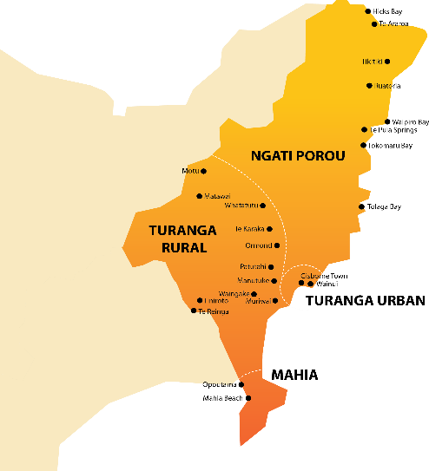

Many older persons are taking advantage of the opportunity recently offered to have their Covid vaccination booster with an annual flu vaccination. During March-April local covid cases resurged and at one stage nine people were in Gisborne Hospital due to covid – one the highest local hospitalisation rates to date during the pandemic.

Input / involvement in HQSC meetings/groups

HQSC Pae Ora Quality Framework Project Working Group

The aim of this HQSC project (begun in September 2022 and led by Synergia with the Whanau Ora Commissioning Agency) is to embed the Pae Ora Act principles of equity, tino rangatiratanga, and engagement with Māori and other population groups into a new ‘Pae Ora Quality Framework: Guidelines for clinical and cultural quality and safety in Aotearoa New Zealand’. This new Framework will replace the current ‘Clinical Quality and Safety Governance Framework’.

22 February: Liaised with HQSC to invite consumer group members to complete an online survey via the Thought Exchange platform. Also invited some others in my network to complete the survey.

March: Provided further advice to the Synergia project manager about re-communicating with Ngāti Porou and Turanganui a Kiwa iwi health services and the coordinator of Tairawhiti Consumer Voice to identify whether they were now in a position to re-activate focus groups scheduled in February - to increase the diversity te ao Māori and non-Māori voices by involving some rural and provincial communities in informing the new Framework. Unfortunately, these focus groups, derailed by Cyclone Gabrielle’s severe impacts in Feb, did not proceed as locals needed to continue prioritising the ongoing Cyclone Recovery efforts.
26-28 March: Reviewed the first draft of diagram of summarising key components of the part-drafted Framework and provided feedback through the Working Group’s third online meeting on 28 March.

20-21 April & 27 April: Reviewed the revised draft diagram and full-draft Pae Ora Quality Framework. Emailed detailed feedback to Synergia (cc Deon York & DJ Adams, the other HQSC consumers working group members) and discussed this and next steps to complete the Framework in the fourth Working Group meeting on 27 April.

HQSC and Synergia have now invited the consumers and health providers who provided input earlier this year through the Thought Exchange survey (including members of HQSC’s consumer groups) and some focus groups to comment on the final draft of the Framework by 15 May. This will inform its completion by the end of this month.

Activity (since last report)

3 April: Livestream presentation about the current health sector reforms by Rob Campbell (immediate past Chair of the Pae Ora Healthy Futures Board) and subsequent discussion with Professor Marie Bismarck (hosted by Wellington Fabian Society). During the discussion HQSC’s ‘excellent and important work in involving patients & consumer groups’ was mentioned (see approx. 6.08pm in the videorecording of the discussion https://www.youtube.com/watch?v=bWXqnI7K3Pw). Consumer network colleagues may also find this discussion thought-provoking. A transcript is also available on https://www.fabians.org.nz/top-home/286-rob-campbell-on-pae-ora-health-reforms.

April-May 2023: Encouraging community members to contribute to development of the Toitu Tairāwhiti Locality Plan via email and/or by completing the brief survey and poll on the Toitu Tairāwhiti website.

28 April: Genomics Aotearoa’s online presentation by Professor Greg Jones (University of Otago) about delivering on the promise of ‘precision’ use of epigenetics information to improve risk prediction for cardiovascular disease. This talk described the Otago Vascular Research Group’s work to identify epigenome-wide associations for various forms of cardiovascular disease (CVD). Some specific DNA markers appear to be useful in proactively predicting the risk of developing CVD and its progression, including a marker to predict the relationship between smoking exposure and heightened CVD risk. A simple sensitive technique has been developed which appears to have the ability to quantify a range of CVD risk effects associated with exposure to smoking, including passive smoking and length of since smoking cessation.

Services

Chronic understaffing, over-reliance on locums and long waiting lists continue to compromise quality of care – especially in rural primary care and some dental and hospital services.

The collaboration of Turanga Health, Te Runanganui o Ngāti Porou (Ngāti Porou Oranga/Hauora) and Te Whatu Ora Tairāwhiti (formed in response to the Covid vaccination challenges in 2022) has recently reactivated weekend drive-thru events in various community locations during which childhood and pregnancy vaccinations as well as to ‘flu and Covid vaccinations are available - along with health information, kai and fun activities. For example, Easter Egg-travaganza on the Coast https://www.facebook.com/photo/?fbid=233333559259469&set=pb.100077484783811.-2207520000 and city and inland events such as https://www.facebook.com/photo/?fbid=645186350954578&set=a.469611408512074

Hyejung Kim (Auckland)
Activity (since last report)
New Zealand Health Strategy Engagements with Ethnic Communities on 23 Feb
Good opportunity to meet other ethnic community members and I could get to know their experiences of health services and what opportunities they think exist for improvement. Immigrants often have difficulty accessing health care services because of their English language skills and for seniors even worse.
We discussed the basic medical cost such as GP, dental, etc. Many say costs are too high, should be lowering the cost for everyone, so people can take more regular health checks instead of getting sick first and having greater problems.
Workshops with Asian Family Service and Korean Society on 25 Feb, 4 Mar & 25 Mar
Topics were:
- Support for people affected by the flooding in Auckland
- Insurance & EQC
- Dementia
- Understanding counselling services
- Anxiety & stress
- Cognitive Stimulation Therapy

Many Koreans have a negative attitude toward counselling, and do not want to engage with, or to inform others about the fact that they have received it. They may assume they will be regarded as mentally deficient or being weak, so think they don’t need or want counselling.
Korean Day event on 15 Apr
HQSC resources materials provided: Advance care planning, Code of expectations.
Talked with people about health service
I met several Korean community workers, showed HQSC resources materials; they suggested Korean translated resources would be more useful.
Korean Health Day organised by Korean Society on 8 May
- Health Seminar – exercise for seniors, prevent depression etc.
- Celebrating 101 years living – there are 2 Korean men aged 101.
- Free health check – blood pressure, blood sugar level, waist-to-height ratio

It was a fun day. Lots of Korean food, Korean traditional tea, games and karaoke!
https://www.nzkoreapost.com/bbs/board.php?bo_table=news_all&wr_id=44775
Attended Korean society & KWWCG meetings on 6 Mar & 11 Mar
Discussion on providing Health seminar, counselling service, census, and delivery of the Cognitive Stimulation Therapy (CST) programme to the Koreans.

Services
A Korean mum went the Middlemore hospital emergency because her child was unwell. She can’t speak English; they had to wait nearly 4 hours for an interpreter to visit.
Maybe the hospital should arrange telephone interpreters, so the patient doesn’t have wait for such a long time.
Some Korean migrants felt more isolated from the mainstream especially when facing challenging situations such as Auckland flooding, cyclone Gabrielle damage, ongoing COVID issues, business recession, and financial difficulties. As a member of Korean society of Auckland, I helped people to receive accurate and vital information by using this service.

Oliver Taylor (Wellington)
Environmental scan
Restructures and changing public health environments have meant there are stresses on staff and consumers in providing their insights into healthcare services. Wellington District has established a new District Consumer Advisory Group which will strengthen and centralise much of the consumer advice given in the region, however, it has not been met without uncertainty. Staff are aware that restructures may impact how they can support consumers including tight budgets and changing responsibilities. This, along with potential future change in the system, makes it unclear how future consumer engagement will look.
Input / involvement in HQSC meetings/groups.
QSM Reference Group hui:
5 May: Discussion around feedback received from members surrounding the draft consumer engagement QSM framework. Feedback was received well and HQSC will develop a definitions list to support the document, a possible template to ask about consumer engagement for projects, and an attempt to truncate it. There will be ongoing work to make sure the QSM is fit for purpose.
Activity (since last report)
District Consumer Advisory Group (DCAG) meetings:
1 March, 14 April: Initial meetings discussing the new group and working out our goals for the year. Discussion has been around our values, training options for upskilling consumer members, and discussion on the QSM review. A feedback document was produced and sent to HQSC. Overall, the DCAG found that there was a lack of clarity around its usefulness and how to demonstrate positive consumer engagement at different levels.
Services
Ongoing concerns with ED exist in Wellington, much like others around the motu. The DCAG is set to meet with the Front of Whare project that aims to improve the service for consumers and staff. There will be ongoing support and actions involving consumers throughout the process. We will continue to advocate for a revitalisation of both emergency and urgent care services to best address the needs of Wellingtonians.
Positive stories and exemplars
Consumers are happy to hear about the Consumer Health Forum and its importance in listening to the voices of consumers across the country. Many are very eager to attend meetings and provide their input into the health system.

Mark Rogers (Timaru)
Environmental Scan
A lot of concern about the state of our health system, mainly from the elderly.
There’s real concern about clinical staff heading offshore. This also impacts the private hospitals who are doing a lot of the work that the public system has subcontracted to them.
Lack of staffing is impacting aged care.
Frustrations with not knowing who can make decisions.
The health system needs to move more quickly to install confidence as an election is looming and who knows what impact this may have.
Input / involvement in HQSC meetings/groups.
HQSC/Major Trauma New Zealand sTBI (Traumatic Brain Injury) team. Participated in sessions (In Person – Wellington & Zoom) on 28 Feb, 7, 14 & 21 March, 2 May.
Activity (since last report)
Attended Brain Injury Awareness month promotion in Timaru.
Participated in Quality and Safety Consumer Engagement Thought Exchange
Pae ora; Responsiveness to Rare Disorders in our future health system. Often, the ‘rare community’ has been forgotten about, so it’s great to see some positive inclusive moves being made.
Assisting Mid-Central area to complete their sTBI (Traumatic Brain Injury) project for phase 2. Assisted Hawkes Bay during phase 1.

Joanne Neilson (Tairawhiti)
Environmental scan
It has been a summer to forget, cyclones, flooding, slash; you name it the East Coast has seen it. This has had quite an effect on the hospital as clinics get cancelled and only the acute are seen. Once the cyclone crisis calmed the hospitals were limited by staff shortages and an ever-increasing number of patients requiring treatment.
Several patients have had to travel over 6 hours to get urgent treatment if they weren’t fortunate enough to be airlifted out of the isolated East Cape. The bridges and road access are a vital link to these communities, and this is being addressed.
The destruction of crops throughout the region is going to have an ongoing effect for all New Zealanders. It was incredibly sad to see the day before the cyclone, hectares of crops just ready to begin harvest and then the day after, flattened or gone completely. Thousands of apples floating in raging streams and culverts, grape vines filled with tomatoes, watermelons, and squash rotting in mud. Some businesses will recover, some won’t and that will end up putting more stress on families and people’s health.
Input / involvement in HQSC meetings/groups.
Te Tāhū Hauora HQSC
It has been interesting hearing feedback about HQSC from one of the nurses who attended the Serious Illness Conversation workshop. They were very impressed and suggested all the nurses here should have attended.
I sent the discharge summary to the Communications team, and they are implementing them in the discharge process and were very impressed at the number of languages available.
Activity (since last report)
National Scan
February/March are Pride months in New Zealand. It was wonderful to celebrate a booth in Gisborne and Christchurch where we celebrated diversity and inclusion and remembering Georgina Beyer and the history she made. Walking in the Pride Walk with 500 or so people in Central Christchurch was a highlight as I reflected that, 42 years ago I was walking in protest marches for Gay rights.
It is quite distressing to see the Anti Trans movement taking hold in Aotearoa. This was shown very prominently at the Queens Telling Stories where a vocal group protested with signs calling us pedophiles and that we were grooming children.
The incredible amount of incorrect information is quite scary to witness. We did have our biggest turnout at the event, and we are so grateful for the members of the LGBT communities and allies that stood in front of the protesters as a wall of support and sung waiata to drown out the vile comments.
Unfortunately, near the end some of the protestors stormed the library and we (performers and families and children) were evacuated to safety. It was very distressing and while I have been the victim of violence and protests in the past this seems scarier that we are moving in this direction. Then, of course, there was Posie Parker …
Services
To be honest, the misinformation these people are hating against can be terrifying and I wonder if the Commission would be interested in working with me to dispel some of these myths before someone gets killed. (in New Zealand we have had a few deaths although not recently). I have some ideas for a campaign that I think would be worthwhile and would help a number of communities at the same time.
Positive stories and exemplars
I was recently awarded the WAKA Award recognising the four values, Whakarangatira, Awhi, Kotahitanga and Aroha when dealing with a client. Lovely but odd to be awarded for doing what I do every day. Nice to have the work acknowledged though.

Marlene Whaanga Dean (Wairarapa)
Environmental scan
Mental Health: Counselling sessions face to face are not always available or free in our area. Feedback from whānau are the pressures of cost to attend face to face although they feel more comfortable in that space, talking and been heard with an almost instant result. Barriers, computer literacy / navigation online.
After COVID lockdown, communication for kaumatua living alone and in isolated rural areas proved the unknown. Through identifying after Covid that there was a need for elderly / Kaumatua to learn basic technology to communicate. UCOL / College students with support from NGO’s gave free sessions to help our elderly (an option) with computer literacy and mobile phones, learning to access whānau face-to-face visual calls.
The safety support for those experiencing mental health is available through online resources, free phone calls, and texting etc.
Still a barrier accessing services for mental distress in primary and secondary care. Whaiora NGO Māori Primary Care provider, offer free counselling service. Only available to Whaiora consumers.
Input / involvement in HQSC meetings/groups.
- Feb: Patient Experience of care
- Te Whatu Ora Consumer Council Member, Masterton, Wairarapa. (No movement) the reshuffling from WDHB to Te Whatu Ora with positions/jobs within our hospital (restructure). Our Suicide intervention prevention program service delivery has not been renewed for 2023, gone to Regional Public Health.
Activity (since last report)
More intersectoral and collaboration with services within Wairarapa over the quarter.
- Rangitane (iwi) working with SWISS in schools. YellowBrickRoad offering CUMI Service.
- Transitional Housing (Crisis Housing) YellowBrickRoad -
- Community Centre Wairarapa (YBR team spent half a day cooking healthy meals that are placed in medium containers stacked in freezers ready to heat/eat and handed out to our most vulnerable i.e.: Elderly, disability, leaving hospital, young mums’ children (no criteria needed) in our community for FREE. With the cost of food this is available in our community. High numbers for food parcels this quarter.
- Partnership in Men’s group lead by Pathways working with our YellowBrickRoad support worker, “Mauri Tangata,” men’s group, supporting mental illness to mental wellness.
- April: Attended Mental health Collaborative Co-design workshop.
Mental Health informative Solutions Jenna Jeffcoat, Te Whatu Ora. Te Tihi have been working on the collaborative co-design of mental health and addiction services project since June 2022. The project is on the background in the local mental health and addiction service review which was completed in 2018 with an outcome of 59 recommendations. Te Tihi have held four workshops to date with various stakeholders in 2022 specifically to look at the recommendations, and consider which recommendations remain relevant. The relevant recommendations have been categorised into four area's-Low effort, high impact, high effort high impact, high effort low impact, low effect low impact. To support Te Tihi in developing an implementation plan determining FIVE priority recommendations, Te Tihi need the support, input and voice of all key stakeholders, frontline staff, leaders and peers working within local mental health and addiction services. Workshop being held 20th April, suggested consumer participation.
- April: Collective Karakia at YBR all services within Wairarapa attend to update relevant information with what activities are happening within their services. A good platform to network.
- Police Te Pae Oranga – Sargent Roger, using Tikanga Māori, Kaupapa Māori and restorative justice, supporting whānau.
- Women’s Welfare League Masterton Peka, Kuia Nanny Francis Reiri – Smith.
- F.A.S.T Stroke foundation Wellington, YBR working alongside Pacifica Wairarapa.
- ChangeAbility: Family Harm Team
- CAMHS
Services
Whānau Voice: Current trends for whānau that are identifying no easy access to services particularly to see their GPs. Extreme waiting time due to limited doctors available, booking can take up to 2-3 weeks for an appointment. This increases anxiety, worries, medication issues (prescription).
Psychiatrist shortage remains a significant risk within the adult community mental health team operating with 0.4fte psychiatrist cover rather than available 3.6fte.
Education we have been offering from Yellow Brick Road Masterton, CUMI (children understanding Mental illness) to support whānau.
We know mental health & addiction issues at home create many barriers for our children, making it almost impossible to learn and engage at school. We have 3 trained CUMI facilitators-champions at our whare. We deliver this programme at school and/or in our tari and provide outcomes and strengthen communication kōrero for children & their whānau to understand mental health & addiction issues.
This is not from a punitive perspective, just learning, listening to understand, and communicate more effectively, in a safe environment.
COVID
- Circulating in the Wairarapa, 2 staff off this quarter with covid. No data on community covid.
Positive stories and exemplars
Supporting community
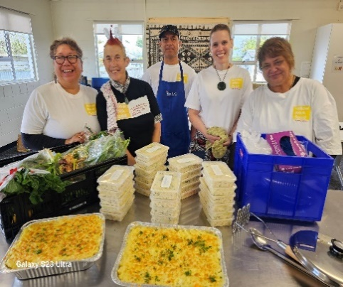
YellowBrickRoad, Masterton, Wairarapa
Our Team, with compassion embedded to support Whānau / Tangata in our community.
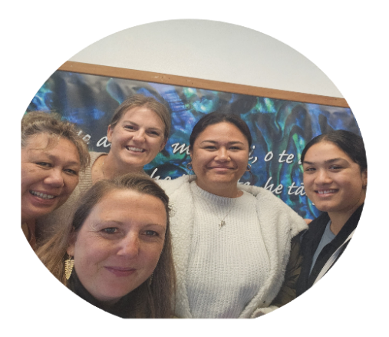
RN Manager Marlene, Awhi Whānau support Workers Tarn and Warren 20 years of experience in Mental Health, Vocational Services Lil, Manager Transitional Housing Serena

Stroke Foundation
Whakawhanaungatanga: Thank you Julia and her team for their community engagement with Wairarapa Hāpori Māori and Pacific. This is a reminder to all of us how we can ensure whānau voice is heard.

Zechariah Reuelu (Porirua)
Environmental scan
The increasing rising global energy and food prices have strained many Pacific families' budgets, added to inflation, and ultimately increased the cost of living for families across the community. The rising cost of living is putting the family household under huge pressure, we’re hearing stories of middle-class families, lining up for food parcels for the 'new poor'. At the start of the school year, we saw the impact of rises in the cost of essentials – power bills, rental housing, food, and fuel that have outstripped average increases in people’s wages and welfare payments. We’re experiencing increasing anxiety among Pacific households who are falling into mortgage arrears once the interest rates increase in June. Data released at the end of February, there were 18,900 mortgages on which borrowers had missed payments, up from 18,400 the previous month.
Input/involvement in HQSC meetings/groups.
This quarter I participated in the following:
- HQSC Bula Sautu Pacific Advisory Group Fono
- HQSC Consumer Network
- HQSC Quality & Safety Governance Pacific Focus Group
- HSQC Code of Expectations Presentation to Arthritis NZ All Staff Hui – LJ Apaipo

Activity
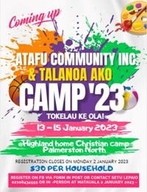

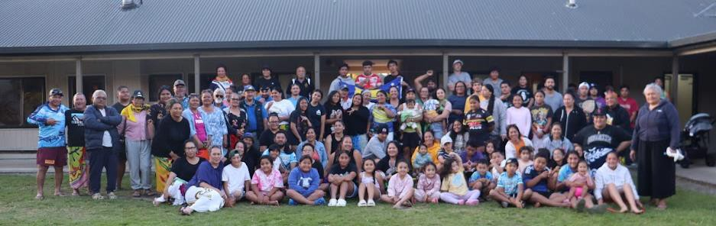

The Atafu Tokelau Porirua Family Camp aims to equip and empower parents, families and supporters with the skills, knowledge, and confidence they need to champion their children’s education.
The collaboration with Tu Ora PHO to support our Pacific and Māori men to increase health awareness in the Wellington Rugby Premier Norths Club

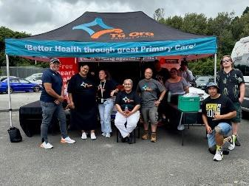

The Porirua City Council engaged with the Pacific community to develop a disability strategy.
Issues highlighted:
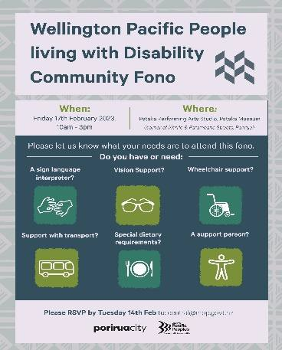

- Continued lack of engagement by agencies and providers
- Health and socio-economic status continue to hamper the ability of Wellington Pacific Peoples Living with Disabilities participation in education, employment and training.
- Pacific young people who provide care for their family members who are disabled may not have the necessary skills and experience to provide adequate care.
- Pacific young people providing care for their family members may disrupt future opportunities resulting in low morale, depression and anxiety.
- Service and support for Wellington Pacific Peoples Living with Disabilities must stand alone and not compete with other services.

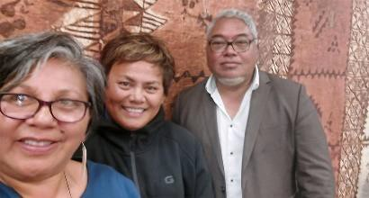
Submission to Parliament's Justice Select Committee

The Atafu Tokelau Porirua group submitted a formal written submission to Parliament's Justice Select Committee on the Sale and Supply of Alcohol (Community Participation)
Amendment Bill, and last week made an oral submission. It's believed to be the first time the organisation has made a formal submission on a bill through the select committee process and likely to be one of the few times a Tokelau community group has formally responded this way on new proposed legislation.

Toa Rangatira Ora Toa invited Arthritis NZ to be a part of their Roopu Hauora Whanau Day - a collective of health/community providers to provide healthy key messages working in unison for our Porirua community. The aim: promoting wellness and healthy lifestyles, with offering to screen (early detection). Health information/education to encourage & empower our whānau/fanau with making healthy choices/decisions.
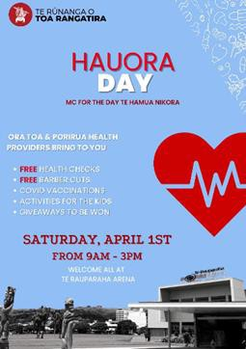

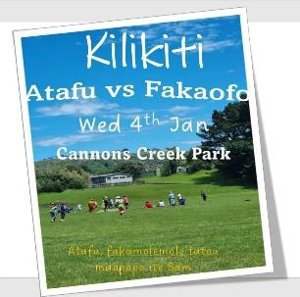
The Annual Kilikiti fixture inspires the Tokelau community to be physically and socially active, resulting in strengthening community resilience and cohesion through Kilikiti, bringing together over 700 participants consisting of players, supporters, families, and community leaders to celebrate their connectedness and cohesion. Kilikiti involves much more than just physical activity and recreation. It brings together to strengthen cultural identity, language, and sense of belonging. This has a massive impact on their holistic well-being.

GAGANA TOKELAU BI-LINGUAL HUB GLENVIEW SCHOOL
Friday 24 March 2023 was a significant step for the revitalisation of the Gagana Tokelau with the official opening of the new Tokelau Bilingual unit at Glenview School, Porirua. It is believed that this is the first one in the country and the Tokelau community.

The vision is that a clear pathway is made for our Tokelau learners from Primary to Tertiary education for the benefit of our endangered language.
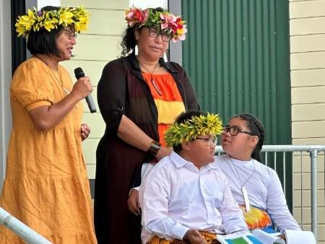

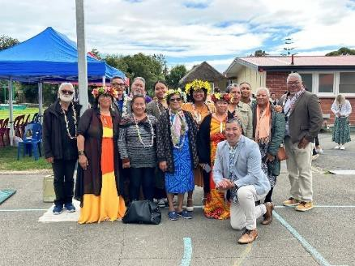

Pacific Research Collective – University of Auckland
An intervention to increase uptake of urate-lowering therapy for gout in Pasifika.

A meeting with Dr Malakai Ofanoa – Lead Researcher to discuss their research findings. The
proposed intervention is an alternative access path for gout management:

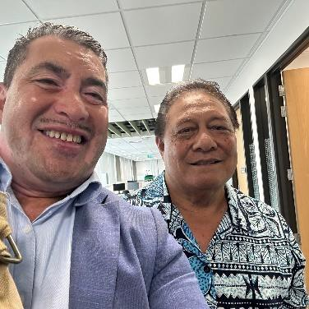
- increase access for Pasifika with gout by funding a pharmacist- led one-stop-shop intervention, streamlining urate testing, and prescribing and dispensing of allopurinol.

- Co-design with Pasifika a user-friendly education resource for Pasifika to understand the importance of taking allopurinol regularly. This will be informed by the Change your life resources (https://www.health.govt.nz/your-health/conditions-and- treatments/diseases-and-illnesses/gout) but co-designed by Pasifika to communicate the health problem in a way that is clear for them.

Your Way / Kia Roha

SAUTU – Empowering Pasifika Communities: A Celebration of Success and Support
The SAUTU event is a joyful celebration of Pasifika culture to commemorate two key Pasifika initiatives: vAsifika and Tupu Aotearoa. vAsifika, a collaboration between Mila’s Books, Te Pou and Your Way | Kia Roha, featured 12 stories of Pasifika autism journeys, while Tupu Aotearoa, a Ministry for Pacific Peoples funded initiative, supports tāngata Pasifika people with disabilities in education, employment, and training.
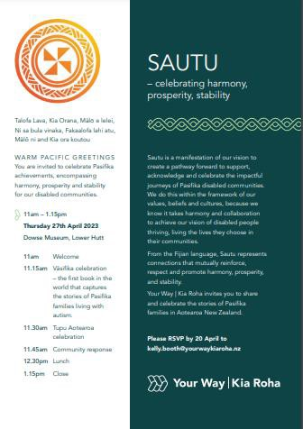

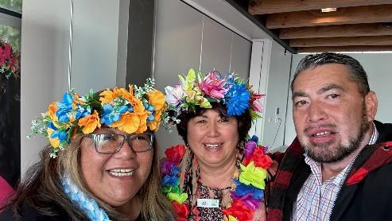

Wellington Rugby League Masters - Health Hauora Promotion
The Hauora Health Expo was to promote health providers to men, in particular, Māori and Pacific to access information and services to support their health journey with access and testing The collaboration with Tu Ora PHO is the continuation of the partnership between Arthritis NZ to support our Māori and Pacific communities across the greater Wellington region.
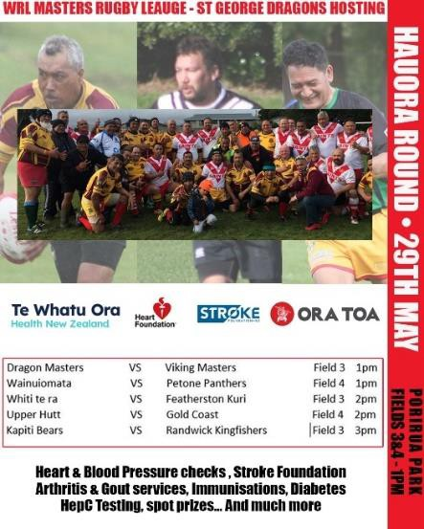

The Hauora is to increase awareness with prevention is better than a cure, with small steps to better health and well-being.

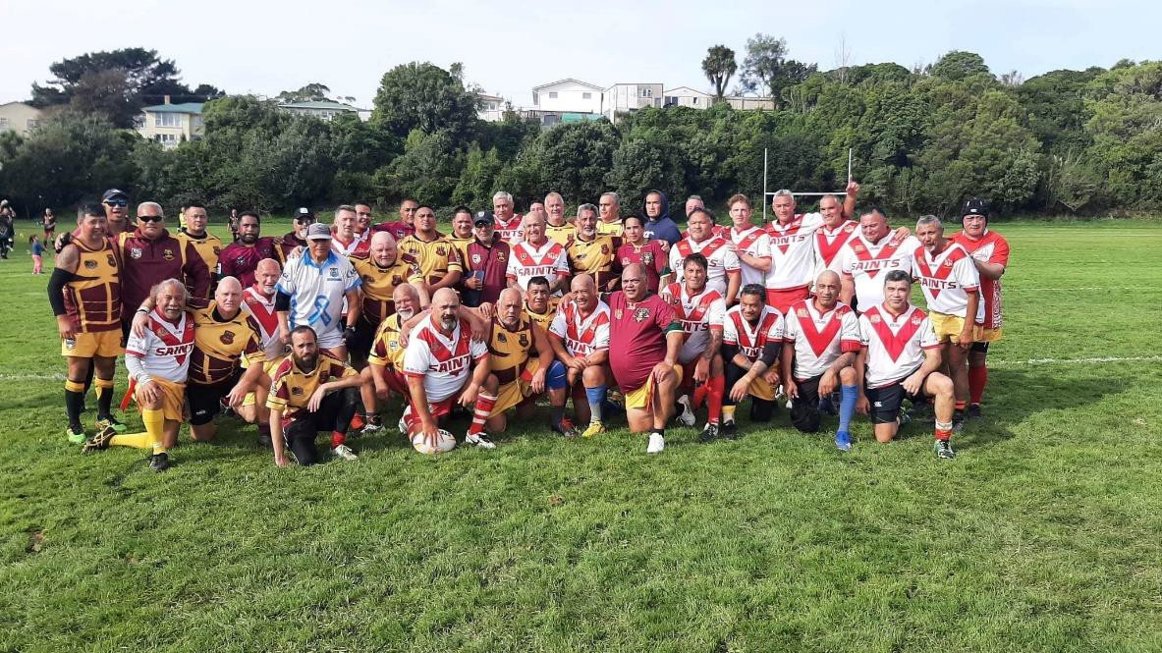

Ricky Ngamoki (Ōtepoti)
Environmental scan
Moderate to severe, Whai ora are unable to get into services because the waiting lists are so high. There are not enough hospital beds in Ōtepoti, because there is a lack of Mental Health Staff. Whai ora are being released, even though they are not back at a level where they are able to function on their own, in the hāpori.
People are being released from the Mental Health Unit without their whānau and support people are not being informed.
The nurses that have been in the mental health systems, they have been there for many years, they are all still working, until they are retiring and there is concern about what the future of the Mental Health service looks like in this country.
The new hospital is still short of the hospital that is required for the population. It seems ridiculous that there would be a hospital built, that is smaller than the one that we currently have, yet the population is growing and getting bigger.
There was a lot of support in the hāpori here in Ōtepoti, when there were the floods in Auckland and on the coast. It was sad for a lot of people, which have whānau in those areas. It meant that there was a lot of cross community collaborations and whakawhanaungatanga that took place, and people were able to support each other, and support the resources getting to coast and Tāmaki Makaurau.
Services
There is New Mental Health Service for moderate to severe mental health in Ōtepoti. This was a great victory for the city; however, the service was awarded to an organisation that does not have a good relationship with the community and has a troublesome reputation. It is hoped that this will be a service that they can deliver, because it is certainly needed.
Positive stories and exemplars
Corrections workshops
Corrections staff supporting the Whai ora, to ensure that they are able to get to the wānanga
(driving for an hour to collect the Whai ora)
4 x 1.5-hour sessions during the week for a 4-week period. The purpose of the workshops is to ensure that they can get the support that they need in community, so that they are able to complete the terms of their sentence.
We are working to establish the same relationship as the Dunedin Corrections office, so that we can support the Whai ora that are working with them. It has been a good engagement for the corrections staff and the Whaiora that were involved. It showed that there can be cross-sector collaboration (Health and Justice) and the kinds of relationships that can flourish out of positive interactions, changing the perception that former inmates have of the PPO staff, and corrections as a department.

Edna Tu'itpou-Havea (Porirua)
Environmental scan
Attended the Whānau Ora Conference ‘Navigating new waters’ in Auckland on 23rd – 24th March 2023. After three years of Covid-19 lockdown and restrictions, Pasifika Futures (Pacific Commissioning Agency) hosted the first post Covid conference attended by 28 Whānau Ora core providers across New Zealand joined in reflecting on Covid 19 and discussing Pasifika communities’ response and resilience to emergency and natural disasters.
Services
Housing remains a key issue for Pacific people and worse off for families with young children, elderly, and disabled people. Vulnerable groups such as the elderly and disabled people are struggling to connect to health and social agencies and need strong advocates to voice their needs and for these agencies to respond in a timely fashion.

Arana Pearson (Te Tāhū Hauora mental health consumer engagement advisor)
Environmental scan
There was an incident where a police officer gave a mental health client two seconds notice before he shot the client dead. There was no immediate risk at that time. The police union openly disagreed with the police complaints authority ruling on that situation. We have seen police violence to the mentally ill overseas, and many consumers of mental health who have seen these statements by the police organisation feel increasing fear about whether the police will be supportive or whether this incident is a turning point of more to come.
Your input / involvement in HQSC meetings/groups.
Facilitated the first face to face mental health consumer advisory group. Was the first kanohi ki te kanohi hui in over a year. The mental health CAG had direct input across all the active mental health projects on the day and met with the programme manager and LJ from PIC presented. I presented to sector meetings with NZQSC in Auckland and Wellington (twice) with the zero-seclusion project and the physical health project with mental health. Outside the mental health part of HQSC I have connected with: PIC, MAPS (client expectations/ advanced directives project)

Your activity (since last report)
I am actively engaged over the whole of the mental health projects. See above.
Services
Homeless people who experience mental illness are at risk of being criminalised by communities in order to achieve housing and to ‘remove the nuisance’ from those communities. Hospital services do not clearly understand the extent of homelessness as clients need to give an address for service approval and data collection. So, clients will give an address in order to fulfil the system requirements and the unintended consequence is our understanding of homelessness is not systematically reported nor addressed.
Hospital inpatient services are increasingly not fit for purpose. Government has made large amounts of funding available for new inpatient builds. However, some have not been approved for construction after five years of the funding signalled being available. An equity lens tracking this might throw up an interesting light as to why. For example, Whakatane has had a damning Ombudsman report from some years ago, however, the BOP district is not progressing to a rebuild yet they were funded to do so. The Eastern Bay has many communities where Māori are over 50% of the population.
Positive stories and exemplars
Many new jobs have been created in primary health with HIPS and often people with consumer experience are employed in these roles.
I’ve been personally involved in a BOP online training for consumers who want to participate more in the health sector. Currently working on a companion piece for staff for staff training about consumer engagement. We include the consumer code of expectations in this.

