Instructions for completion
Notes to the Assessor to guide completion

The introduction of the Consumer Engagement Quality and Safety Marker is mandated by the Health Quality and Safety Commission of New Zealand (HQSC). HQSC aim to build a better understanding for how District Health Boards in New Zealand (NZ) are engaging and including consumers in care delivery, and the co-design of healthcare services. Monitoring and reporting on the Quality and Safety Markers are mandatory for all NZ DHBs.

Consumer engagement is a process where consumers of health and disability services are encouraged and actively empowered to participate in decisions about the treatment, services and care that they need and receive. It is most successful when consumers and staff demonstrate mutual respect, active listening and have confidence to participate in full and frank conversation. It is most effective when consumers are actively supported to input at the levels of ‘lived experience, organisational design and governance.

This self-assessment collects information to assess the level and quality of consumer engagement in provision of health and care processes and services. This knowledge will help us to understand and improve consumer engagement and equity within our services. For consistency with the Health Quality and Safety Commission’s terminology, we adopted the term ‘consumer’ to describe the persons using the health service you are providing.

This self assessment tool has been designed to be undertaken by Services and Departments within Counties Manukau DHB. It is framed around the three quality domains in the HQSC Maturity Matrix which incorporates the CARMAN model which encourages consumer engagement at all levels.

Appendix 1 CARMAN MODEL

Appendix 2 Maturity Grid

Self-Assessment Template (DRAFT)
Services
Brief description of Organisation
Service / specialties | Contributors

Self-assessment template
Quality domain | Narrative | Prompts  Add suggestions for evidence and examples of interventions | Maturity Matrix  Circle (Appendix 2)  1 2 3 4
Engagement  The environment created to support community engagement | - Is the AI2DET tool routinely used for every patient interaction. Please describe. | AI2DET = Acknowledge, Introduce, Duration, Explanation and Thank You | 1 2 3 4
 | - How do Consumers exercise choice in care and treatment | eg consent. Information provided, family involvement | 1 2 3 4
 | - How are Consumers involved in shaping service delivery at eg direct care, service delivery, policy and governance | Refer to CARMAN Model (appendix 1)  Are consumers involved in working and governance groups?  Do the consumers represent the population the service cares for  Is there a transparent process for recruiting membership | 1 2 3 4
 | - To what extent is Equity understood and acted upon in service planning and delivery | If consumers are consulted is representation equitable | 1 2 3 4
 | - To what extent is co-design understood and used within the service  - What co-designed improvements have been made? | Refer to the Maturity Matrix for descriptions of levels of co-design | 1 2 3 4
 | - To what extent does your workforce reflect its patient population? |  | 1 2 3 4
 | - To what extent is health literacy understood and used during patient interactions  - Describe how you engage with consumers when developing patient information and education resources | Is the three step model used to build understanding (find out what they know, build on knowledge, check understanding) | 1 2 3 4
Responsiveness  Responding to acting on what consumers are saying about the service and having the right information at the right time for consumers accessing services | - What systems in place to capture and respond to consumer feedback | Eg feedback forms, surveys, focus groups  List projects and initiatives.  Note whether completed, in progress or planned  Have you engaged the CM Health Consumer Council for any of the projects above | 1 2 3 4
 | - What has been the outcome of those interventions | EG: Project reports  Audits from service changes  Follow up survey results  Follow up on completed projects – was this successful | 1 2 3 4
 | - How do you allow for diverse feedback eg disabled, ethnicity, age |  | 1 2 3 4
 | - How are voices of the community eg Consumer Council brought to the attention of senior leaders |  | 1 2 3 4
 | - What strategies do you have in place to facilitate Consumers timely access to services eg | Websites, signage, patient information, communication systems, communication systems | 1 2 3 4
Experience  The systems in place to capture consumer experience and act upon the results | - How does your service encourage consumer engagement | Do you advertise how to provide feedback  eg Feedback Forms, surveys, Family meetings | 1 2 3 4
 | - Metrics (What metrics are in place to support the monitoring of patient experience surveys and patient feedback. How are those metrics analysed, shared and reported up and who too) | Are there policies that support patient participation and feedback | 1 2 3 4

Appendix 1 – CARMAN MODEL
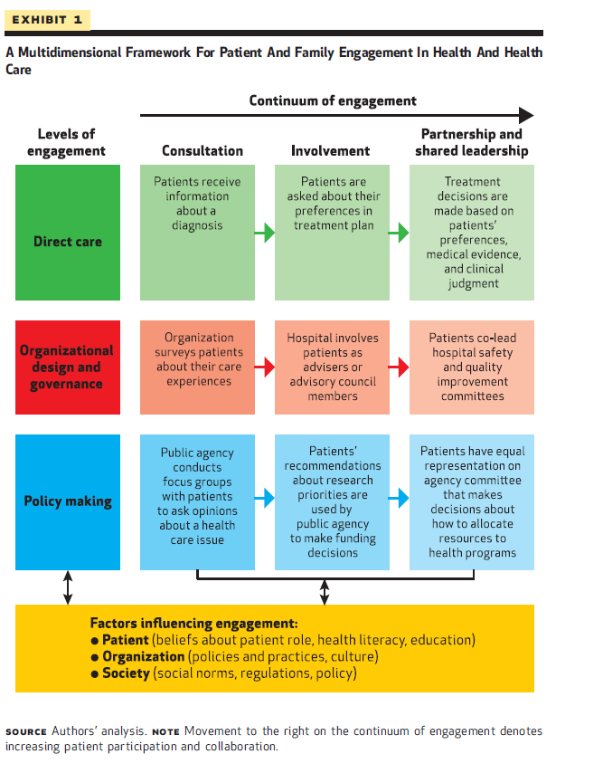
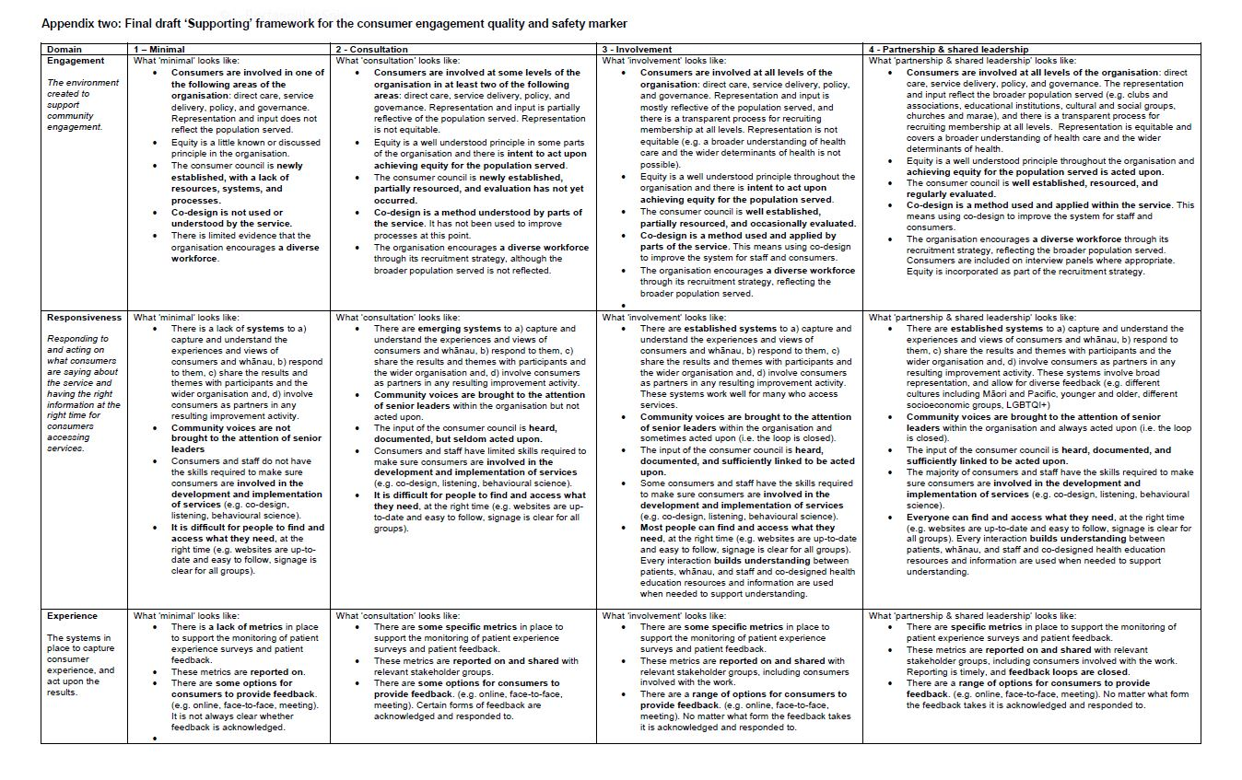

Describe how you achieve this.

