
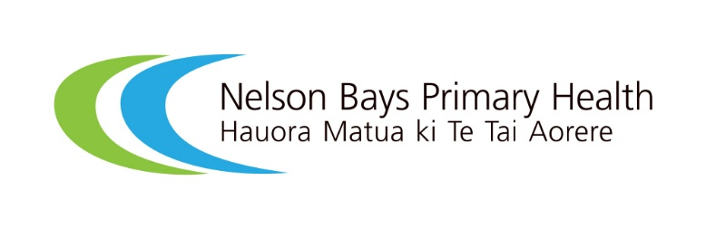

He Ako Ngātahi (learning together): Partnering with whānau to redesign antenatal education in Nelson Bays: A case study

Introduction
In late 2024, the closure of Aotearoa New Zealand’s largest provider of antenatal education created the opportunity to rethink how antenatal education should be delivered in Motueka, located in the Nelson Bays region.
This case study shares how Nelson Bays Primary Health - Hauora Matua ki Te Tai Aorere (NBPH) chose not to simply replicate previous arrangements with a new provider. Instead, they paused, recognising that whānau in the Nelson Bays region should play a central role in reimagining what antenatal education could look and feel like. Local whānau were invited to participate in a co-design process that was shaped around their realities, aspirations and lived experience.
The aim was to develop an antenatal education programme that is accessible, relevant and reflective of what matters most to those who use it.
This case study is supported by two companion resources:
- a video documenting the co-design journey
- a reflective process review.
Together, these resources provide a practical guide for organisations seeking to strengthen consumer and whānau voices in their engagements and service design activities. They demonstrate how authentic partnership can be applied to design services to better meet community needs.

Key lessons: What made the process work
From NBPH’s perspective, strong leadership, early governance planning and support from the NBPH Health Consumer Advisory Group and the Health Quality & Safety Commission Te Tāhū Hauora helped create clarity, momentum and the conditions for genuine partnership. Practical design elements, such as kai, koha and welcoming spaces, helped build trust and reduce barriers to participation. Clear feedback loops, such as inviting whānau to review draft resources to validate emerging themes, ensured their experiences were honored and accurately reflected. Antenatal educators also played an important role by contributing practical insights, helping bring whānau ideas to life in sustainable service improvements.
Whānau said that being well informed, working together as a group, feeling heard and participating in a whānau friendly environment, including being able to bring children along, were important aspects of the process. Feedback from participants indicated they felt welcomed, respected and their culture was valued. They described the environment making them feel ‘very comfortable’, enabling them to openly share their thoughts throughout the co-design process.
Key lessons from this work
- Start with listening rather than replicating previous service models.
- Engagement works best when whānau are involved early and can help shape decision-making.
- Welcoming, culturally grounded environments help people contribute openly.
- Multiple participation options support inclusion of a wider range of voices.
- Closing the feedback loop strengthens trust and accountability.
- Lived experience can directly improve service design and delivery.

Listening first: understanding what mattered
The team at NBPH engaged with people in the Motueka area who were pregnant or had been pregnant within the previous five years, along with their whānau and childbirth educators.
A range of engagement approaches were used to support participation, including focus groups, one-on-one conversations, koha and welcoming, whānau friendly environments. Skilled facilitation grounded in te ao Māori created a safe and inclusive space where participants felt comfortable sharing their experiences and perspectives. Smaller follow-up sessions and the option to provide feedback by email ensured quieter voices also had opportunities to contribute. Together, these approaches signaled that whānau belonged here and that their time, perspectives and lived realities were valued and mattered.
Whānau described antenatal education as an opportunity to build confidence, strengthen connections and normalise the early parenting journey. They emphasised the importance of receiving consistent, trustworthy information, understanding how to access support and services and having access to mental health support. Whānau also valued learning from the lived experiences and stories of others.
What helped whānau participate
- Skilled facilitation grounded in te ao Māori helped create safety and trust
- Koha, kai and child-friendly spaces reduced practical barriers to participation
- One-on-one conversations and follow-up opportunities helped quieter voices contribute
- Feedback processes showed participants their perspectives had been heard and valued

Turning insights into action – whānau insights driving change
Whānau voices directly shaped the redesign of the final programme. Feedback from participants informed contracting requirements, including the structure and delivery of antenatal education sessions and the design of supporting resources.
Content on early parenting, support networks and mental wellbeing was strengthened because whānau told us these mattered. Opportunities for lived experience sharing will also be trialed within classes.
The team introduced an opt-in process for sharing contact details, enabling whānau to connect with and support one another beyond the antenatal education sessions.
Turning engagement into service change
- Whānau feedback directly informed contracting expectations and programme design.
- Lived experience highlighted the importance of mental wellbeing, early parenting support and social connection.
- Building mechanisms for ongoing peer connection strengthened the programme beyond classroom teaching.
- Engagement is most meaningful when people can see how their input shaped outcomes.

A living, evolving programme shaped by whānau
The programme will be regularly monitored and refined using qualitative and quantitative measures, including participant feedback, attendance trends and performance against contracted expectations. This will help ensure antenatal education in the region continues to evolve in response to whānau needs and remains grounded in what whānau say matters most.

Acknowledgements
We would like to thank the Motueka whānau who generously shared their experiences, perspectives and ideas with us. We recognise we were asking whānau to participate at a busy and significant time in their lives as they welcomed new pēpi and navigated the challenges and joys of early parenthood.
By openly sharing what worked well, what could be improved and what mattered most to them, these whānau have helped shape a more responsive and relevant antenatal education for their community.

Food/meal
Donation/contribution

