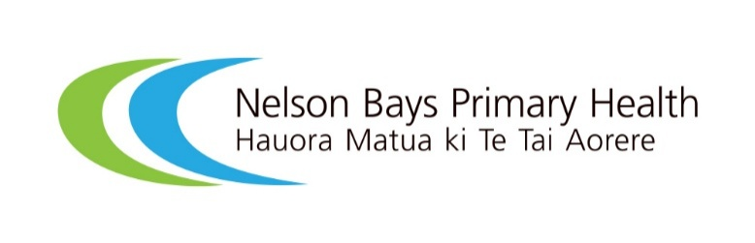


Nelson Bays Primary Health – Hauora Matua ki Te Tai Aorere: Partnering with whānau to redesign antenatal education in Nelson Bays, a reflective process review
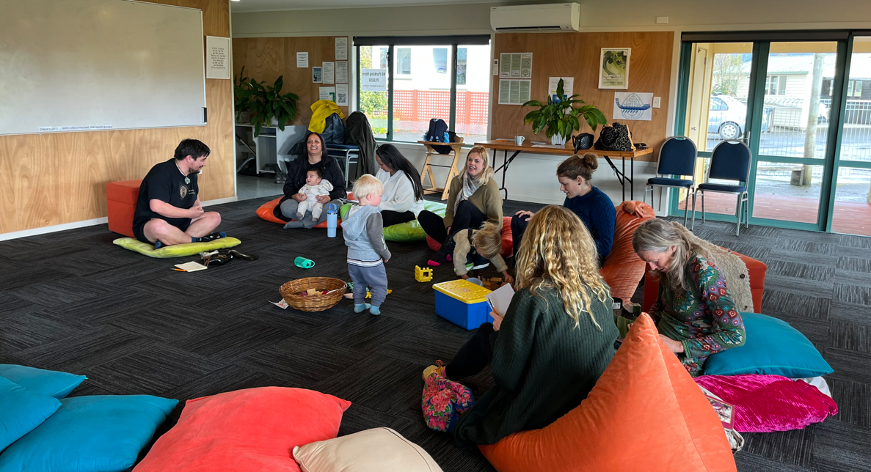

How to use this resource
This review is not intended as an exemplar; rather it provides a real-world example of a co-design process, sharing practical steps, insights and tools that can support organisations and groups that are planning their own consumer engagement journey. Refer to it when planning your own engagement and adapt the approach to suit your community’s needs and context.
This resource offers visibility into how organisations might approach engagement and how consumer voices shape decisions. This transparency helps build trust, strengthens understanding of what meaningful engagement can look like and supports consumer groups to advocate for and participate confidently in future co-design activities.
A separate case study companion document and video are available for those seeking a shorter and more accessible overview of the co-design journey and key lessons. While the case study provides a snapshot of the work, this process evaluation is intended for readers who would like a more detailed understanding of the engagement process, reflections, challenges and practical insights that emerged throughout the project.
We include a glossary of key terms at the end of this document to support readers who may be unfamiliar with terminology used throughout the review.

Executive summary
In late 2024, the largest provider of antenatal education in Aotearoa New Zealand announced it would close by the end of the year, leaving a gap in antenatal education provision in Motueka, located in the Nelson Bays region.
Nelson Bays Primary Health – Hauora Matua ki Te Tai Aorere (NBPH) chose not to simply replace the service. Instead, it saw an opportunity for real world application of the principles outlined in the Health Quality & Safety Commission Te Tāhū Hauora (the Commission) Code of expectations for health entities’ engagement with consumers and whānau (the code of expectations). This enabled it to pause, reflect and work with whānau and the wider community to co-design antenatal education that is accessible, acceptable and locally relevant.
This reflective process review is one of three learning resources created alongside a video and a short case study. Together, they aim to support other health entities to undertake authentic consumer and whānau engagement, guided by the code of expectations.
The engagement process resulted in meaningful changes to the antenatal education programme. Community priorities shaped the programme content, preferred delivery approaches and the expectations set for providers through contracting requirements. It also led to the establishment of clearer feedback loops and a practical framework for measuring success, helping to ensure the programme remains responsive to the needs and experiences of whānau over time.
Purpose
The primary purpose of this co-design project was to design an antenatal education programme that is accessible, culturally safe and responsive to the needs of hapū māmā, partners and whānau as defined by the lived experience and aspirations of the local community.
A second purpose was to document an example of applying the code of expectations to service design and delivery.
The review provides:
- the whakapapa (how and why the work began)
- the co-design approach and practical steps used
- what whānau told us mattered most
- what we changed as a result
- challenges encountered and how we addressed them
- suggested measures and feedback loops to support ongoing learning.
Background and context
NBPH is a primary health provider and commissioning network for primary and community health services in the Nelson Bays region. The region’s population is predominantly European but is becoming increasingly diverse, with growing Māori, Pacific, Asian and Middle Eastern, Latin American and African (MELAA) communities.
Antenatal education provides pregnant people and their whānau with information and support on healthy pregnancy, preparation for labour and birth, newborn care and early parenting. Evidence suggests antenatal education can reduce fear and anxiety, support informed decision-making and birth satisfaction, increase rates of breastfeeding and strengthen parenting confidence and social connection/peer support network.
In November 2024, the largest provider of antenatal education in Aotearoa New Zealand announced it would cease operating at the end of December 2024. This created an urgent need to ensure antenatal education remained available. NBPH arranged interim provision of education while also using the opportunity to redesign the programme with the community.
Why co-design (our ‘why’)
Rather than rushing to fill the gap with a like-for-like replacement, NBPH treated the moment as an opportunity to pause and assess what was working, what was missing and what good antenatal education looks like from the perspective of whānau – particularly those who are often under-represented in generic feedback channels.
It was guided by the code of expectations, developed by the Commission, which sets the expectations for how health entities must work with consumers, whānau and communities in planning, designing, delivering and evaluating health services.
The team
The team leading this work consisted of:
- Tonia Talbot – health promotion manager, NBPH
- Charlotte Etheridge – general manager primary care, NBPH
- Lisa Lawrence – Kaiwhakahaere, Motueka Family Service Centre
- Kahutane Whaanga – facilitation
- Digital Diligence – videography and editing
- Whānau and community members who shared lived experience and perspectives
- Nelson Bays Health Consumer Advisory Group – endorsement, advice and feedback
- Health Quality & Safety Commission – support and learning resource development.
Co-design approach and scope
NBPH engaged whānau who had accessed or were planning to access antenatal education. These people had responded to an expression of interest to participate in a co-design journey. In addition, NBPH engaged with local childbirth educators to ensure the proposed changes were feasible. Feedback on antenatal education classes had historically been infrequent, making it hard to judge whether individual and community’s needs were being met. The co-design approach focused on both improving the programme and defining how success should be measured.
The scope included:
- modules/topics: wellbeing in pregnancy, labour and birth preparation and options, newborn care, partner/whānau involvement, emotional wellbeing and more
- delivery: in-person and/or online options, timing, length and session structure
- resources: take-home materials, online content and accessibility
- facilitation: whether sessions are delivered by one educator or a multi-disciplinary team (for example, a lactation consultant, health improvement practitioners – HIPs).
The work was iterative, with several steps overlapping. Figure 1 provides a simplified overview of the process.
Figure 1: Antenatal education co-design – process overview

What we did (step-by-step)
Step | When | What we did
Test the water for willingness for change | Dec 2024–January 2025 | Early conversations confirmed appetite to rethink how antenatal education courses are shaped and delivered.  The NBPH Health Consumer Advisory Group endorsed a co-design process and provided advice on who to engage with (including young māmā) and how to reduce barriers.
Early planning and governance | June–July 2025 | Following the advice of the NBPH Health Consumer Advisory Group, work to plan a co-design workshop began.  The team considered:  - when and where planning sessions would be held to suit the community  - what other barriers might exist and how they could be mitigated  - what legal obligations there were in regard to maternity services service specifications  - how to document consent with participants, ensuring there were plans for if people changed their minds about being involved in the work at any point  - data governance, including place, length of time, devices stored on, security, etc.  To ensure sustained commitment to the process, we prioritised obtaining leadership buy-in and putting a formal funding agreement in place early.  NBPH engaged a facilitator experienced in discovery led by whānau and co-design to be part of this work.
Recruitment and practical planning | June–August | NBPH sought expressions of interest (EOI) explaining the purpose, time commitment and how contributions would be used. Included within this was the intention to be whānau friendly, have an accessible venue and provide kai and koha as manaaki for participants.  The EOI was promoted through various networks, the local newspaper and social media outlets utilising advice from the Health Consumer Advisory Group.  A facilitation plan grounded in te ao Māori was made by the facilitator and agreed by NBPH.
Whānau workshop/engagement | 29 August 2025 | The Motueka Family Service Centre was offered as a venue to use for the workshop.  6 participants registered for the workshop, and on the day, 6 attended.  The session prioritised whānaungatanga, manaakitanga and the creation of a safe space to share without judgement.  A dedicated note-taker captured themes alongside the facilitation team.
Follow-up conversations (small group / 1:1) | August–October 2025 | To include quieter voices and allow privacy for sensitive topics, the team offered smaller group and one-on-one conversations. In addition, participants of focus groups were invited to email after the session with any further thoughts or feedback. Both options were taken up, and further feedback reinforced the initial themes and surfaced additional insights.
Sense making and theme synthesis | October–November 2025 | The facilitation team grouped insights into themes and tested their interpretation with stakeholders.
Wider stakeholder engagement | November 2025 | NBPH staff met with current antenatal educators to share themes from consumer engagement and ensure feasibility of suggestions. Educators reported the feedback from the community was valuable regardless of contracting outcomes.
Translating insights into requirements | February – May 2026 | Because providers would ultimately deliver the programme, whānau themes were incorporated into contracting requirements and expectations. As part of the EOI, potential providers were asked to respond how they would meet the expectations of the focus group in their programme delivery.  Expectations were also incorporated into a quarterly reporting template. This creates a clear line of sight from engagement to decision-making.
Draft resources and feedback loop | January–April 2026 | Draft outputs (video, case study and this review) were developed. Whānau who participated were invited to review drafts to confirm accuracy. Accessibility requirements for the video included captions and transcripts.
Measurements of success and ongoing learning | Ongoing until April 2028 | The team identified a mix of quantitative and qualitative measures focused on whether the education meets community needs and whether resources are being accessed and used.
What whānau told us mattered
Recommendations and consistent themes emerged from the community and whānau engagement. Whānau described antenatal education as more than information delivery. They wanted support that builds confidence, normalises the realities of early parenting and strengthens connection while providing clear pathways to services and consistent take-home resources. Specific findings and whānau insights included the following points.
Whānau support and the importance of a village
Participants emphasised the critical role of whānau, extended family, friends and 'birthing angels' as key supports throughout pregnancy and early parenting. This reinforces the collective nature of wellbeing and reflects the Māori world view that it takes a village to raise a child.
Access to support services
Participants identified key existing supports, such as Plunket and Te Piki Oranga, which were seen as trusted and accessible. Whānau highlighted the value of knowing where to go for help and the need for better integration between services.
Positive mindset and hypnobirthing
There was strong discussion around hypnobirthing — focusing on positive self-talk, managing pain and celebrating pregnancy as a miracle. Whānau saw this approach as empowering and spiritually affirming.
Mental health and post-natal depression
A strong theme was the need to break down stigma around post-natal depression and foster supportive, non-judgmental spaces where people feel comfortable seeking help. Participants spoke of feeling unseen or hesitant to speak up. Suggestions included storytelling, mental health education and programmes such as ‘Good Grief I’m a Mum’.

Information sharing and choices
Whānau wanted clear, unbiased and choice-based information across topics such as immunisation, birthing methods and post-natal care. They emphasised the importance of plain language, questions and answers with specialists and inclusion of evidence-based alternative perspectives.
Whānau and women-centred practice
Participants expressed a preference for women-centred health professionals — not necessarily female but those who embody empathy, understanding and respect for women.
Practical take-home resources
Whānau suggested that antenatal classes provide take-home resources — clear written summaries or guides for parents to reflect on later.
What worked well
- Leadership buy-in and formal agreements created clarity, accountability and momentum.
- Early endorsement and advice from the Health Consumer Advisory Group strengthened recruitment and planning.
- Design that was whānau friendly (venue, kai, koha, welcoming tamariki and wider whānau) reduced barriers and signalled respect.
- Skilled facilitation grounded in te ao Māori supported a safe space for honest conversations.
- Multiple ways to contribute (group workshops plus smaller conversations and email feedback) helped include quieter voices.
- Clear feedback loops (sharing drafts back with participants) supported trust and accuracy.
- Stakeholder engagement improved feasibility and helped educators learn directly from community priorities.

Whānau said that what worked well for them was being informed, working together as a group, feeling heard and making it whānau friendly – being able to bring children along. They said the environment made them feel very comfortable sharing their thoughts through the co-design process. Those who provided feedback strongly agreed that the process was welcoming and respectful of them and their culture.
Challenges identified and how we addressed them

Time
Co-design takes longer than expected. Recruitment took several months to achieve the desired diversity. Interim service arrangements were needed while engagement and design occurred, requiring flexible contracting and regular check-ins.

Diversity
The team aimed for participation that reflected the diversity of the birthing population and upheld commitments to Te Tiriti o Waitangi. Initial registration was low, with no Māori whānau expressing interest. The team used trusted networks to reach whānau Māori and secured participation. They also had a back-up plan in place which ultimately was not needed.

Group dynamics and confidence to speak
Group settings can amplify confident voices. Offering smaller conversations and email feedback created space for privacy, reflection and inclusion, particularly for sensitive topics or for participants who were less comfortable speaking in a group.
Resourcing and hidden costs
Resourcing came from a combination of NBPH and the Commission support (facilitation and documentation). Additional costs included accessibility requirements (captions and transcripts) and participant manaaki (kai, travel support and koha). While these hidden costs were absorbed by NBPH and the Commission, planning for hidden costs early would have been useful.
Conflicting preferences
Not all whānau wanted the same delivery model. For example, some preferred weekday evenings over several weeks, while others preferred a weekend intensive format. Recording these preferences and exploring options (including online alternatives or referring to out-of-region classes) helped acknowledge different needs even where funding was limited.
Ongoing resourcing of education
There is no additional funding for antenatal education classes, so any changes must be delivered within existing budgets. To make this workable, we looked for creative ways to use current resources, for example, drawing on other funded primary health care services, such as a Nelson Bays-funded lactation consultant to run the breastfeeding session or HIPs to provide information on mental health and wellbeing in pregnancy and early parenting.
Engaging consumers, whānau and communities
NBPH used the code of expectations as a practical guide for planning, engagement, decision-making and learning. The SURE (Supporting, Understanding, Responding, Evaluating) framework was used to prompt reflection in fortnightly check-ins and to ensure the project stayed grounded in what matters to consumers and whānau.
Fortnightly check-ins between Nelson Bays and the Commission provided a regular opportunity to discuss progress, plan upcoming steps and reflect on work already completed. These sessions also helped create space for open discussion, problem-solving and brainstorming as questions or challenges emerged.
How the code of expectations and SURE framework were applied
Domains | Engagement (Te tūhononga) | Responsiveness (Te noho urupare) | Experience (Whaeko)
What we did | Early endorsement and planning advice from NBPH Consumer Advisory Group  Created an environment to support consumer and whānau involvement. Removed barriers: kai, koha, whānau friendly  The centrality and importance of whānau in tea o Māori was recognised, valued and elevated.  Intentional recruitment through trusted networks to include whānau Māori  Multiple ways to contribute | Asked what ‘good’ looks like  Translated themes into service requirements  Shared drafts with whānau for checking | Created evaluation measures  Built in quarterly reporting
Why it mattered | Created a safe and inclusive environment  Signals respect and Manaaki  increased participation  reduced barriers  ensured cultural safety | Demonstrated that feedback leads to action  Strengthened trust  Improved service relevance  Provided transparency and accountability  Ensured resources met community needs | Ensures continuous learning  Enables monitoring  Supports transparency
Practical tips for others | Budget for hidden costs (travel, food, etc)  Use trusted networks for recruitment  Ensure consent and data governance up front  Build multiple ways for people to engage  Secure leadership buy-in early on | Keep a live ‘you said / we did’ record  Co-design resources  Embed accessibility standards, such as captions and transcripts | Co-design evaluated early  Regularly ‘close the loop’ with contributors
Measures of success
To demonstrate impact, we split measures into short, medium and long term and combined quantitative and qualitative data.
Short term (0–6 months)
- Antenatal education contracting, programme and resources clearly reflect whānau themes (documented in the ‘You said / We did’ log).
- Participant satisfaction and perceived usefulness (post-workshop survey).
- Participant feedback on ease of attending (time, location, transport), cultural safety and inclusion.
- Whānau who contributed confirm the outputs accurately represent their input (member-checking).
Medium term (6–18 months)
- Increase in uptake of participants regularly attending antenatal education.
- Attendance by key population groups.
- Whanau reporting feeling connected to community.
- Evidence that delivery aligns with contracted expectations (participant feedback and facilitator quarterly reporting using new reporting template).
Long term (24+ months)
- Increased rate of breastfeeding.
- Increased rate of full immunisation at 24 months of age.

In addition to measuring success of the project / antenatal education programme, we sought to understand whether the resources developed as part of this co-design project were a clear practical reference for what co-design might look like using a real-world model rather than abstract guidance. One of the measures of success used for this includes tracking the number of downloads/views of the case example. We will also seek feedback from the Consumer Voice Reference Group (a national group of government officials that support implementation of the code of expectations) to determine if the resources were:
- easy to follow
- helpful for building understanding
- transferable to different contexts.
We would like to thank the Motueka whānau who generously shared their experiences, perspectives and ideas with us. We recognise we were asking whānau to participate at a busy and significant time in their lives as they welcomed new pēpi and navigated the challenges and joys of early parenthood.
By openly sharing what worked well, what could be improved and what mattered most to them, these whānau have helped shape a more responsive and relevant antenatal education for their community.
Glossary
Co-design: A collaborative approach where services are developed with the people who use them, rather than for them.
Hapū māmā: Pregnant woman/women.
Health improvement practitioner (HIP): A registered health professional who supports people with behavioural, mental health and wellbeing needs in primary health care settings.
Kai: Food.
Kaiwhakahaere: A leader, coordinator or manager.
Koha: A gift, contribution or acknowledgement offered in appreciation.
Manaaki/Manaakitanga: The process of showing respect, care, hospitality and generosity towards others.
NBPH (Nelson Bays Primary Health – Hauora Matua ki Te Tai Aorere): A primary health provider and commissioning network for primary and community health services in the Nelson Bays region.
Pēpi: Baby.
Te ao Māori: The Māori world view, including Māori perspectives, values and ways of being.
Te Piki Oranga: A Māori health and social service provider supporting whānau wellbeing.
Whakapapa: Background, genealogy or the origin and development of something.
Whānau: Extended family and connected support networks.
Whānaungatanga: The process of building relationships, connection and a sense of belonging.

HQSC. 2022. Code of expectations for health entities’ engagement with consumers and whānau. Wellington: Health Quality & Safety Commission Te Tāhū Hauora (HQSC). URL: hqsc.govt.nz/consumer-hub/engaging-consumers-and-whanau/code-of-expectations-for-health-entities-engagement-with-consumers-and-whanau
Health NZ. Maternity service specifications. Health New Zealand | Te Whatu Ora (Health NZ). URL: tewhatuora.govt.nz/assets/Our-health-system/National-Service-Framework/Service-specifications/Maternity/T2_MS_PregnancyAndParentingInformationAndEducation_202409.pdf (accessed 11 June 2026).
HQSC. Consumer and whānau engagement quality and safety marker. Health Quality & Safety Commission Te Tāhū Hauora (HQSC) URL: hqsc.govt.nz/consumer-hub/engaging-consumers-and-whanau/consumer-engagement-quality-and-safety-marker (accessed 13 June 2026).

