Minutes of the Consumer Network hui held on 24 August 2021,
Via Zoom. 10.30 to 12.00noon and then 12.45pm to 2.30pm
Present: Mary Schnackenberg, Bernadette Pereira, Mark Rogers, Hyejung Kim, LJ Apaipo, Russ Aiton, Vishal Rishi, DJ Adams, Joanne Neilson, Amanda Stevens

Apologies:  HQSC staff: | Renee Greaves, Marlene Whaanga-Dean, Edna Tu’itupou-Havea  Chris Walsh (Chair), Deon York, Dez McCormack, Gillian Bohm, Shelley Hanifan,  Shaun McNeil, Ying Li

The meeting commenced at 10.30am
- Opening and welcome
Chris welcomed everyone to the meeting. Dez opened with a karakia.
Apologies (as above) were noted.
Chris welcomed comments from everyone, how they were affected by lockdown etc. There was wide ranging commentary on what is happening personally and in everyone’s communities.
- Minutes of the meeting held 2 June 2021, action items and Interests register.
Minutes accepted. Re action item - the group agreed to adopt the Te Reo name previously discussed “Kōtuinga Kiritaki”, to sit alongside Consumer network.
Changes to the Interests register from Edna Tu’itupou-Havea and Mark Rogers were noted and will be updated for the next hui.
Consumer network members written reports are recorded below these minutes. These will also be sent to the Extended Senior Leadership Team (ESLT).
- Feedback on previous CAG hui
Chris gave feedback on the most recent CAG hui and requested that the minutes (not ratified) be sent out to the network for their information. (actioned)
- Partners in Care (PIC) report
Deon gave a brief update on PIC activities. These have mainly been around the health review and groundwork for the establishment of the new consumer code.
Advised of the new staff that will be coming on board next month and the additional vacancies being advertised in the next week. Two positions - a Māori and a Pacific advisor.
- Progress on principles etc. for new “code”
Shelley Hanifan discussed where we were at with the code and the current iteration (we have had many) and the number of people that have so far feed into this developmental draft of the “code”. There was a wide-ranging discussion and feedback provided by everyone. This is an important piece of work, being the first consumer code of this nature. Wider consultation over the next few months will take place. Overall feedback was positive with the direction of the document.

- QSM report on first input of data and presentation on the dashboard. Sample form.
Ying gave an update on the dashboard and answered questions. The sample form for future submissions is in development.
- Comments/ questions on members reports submitted.
Time restraints dictated we were unable to have this session however, as member reports have been distributed, any questions can be sent individually to members.
- Review of Interventions for Students with the Highest Level of Learning Support Needs
Mark spoke to this item he is involved in, which is also in his report (below). He has subsequently provided a paper that has been sent to the group for any feedback including specific situations members may be aware of and any recommendations or suggestions.
- Planning for road shows. What these look like? How would members like to be involved? Who we need to reach?
There was a general discussion around what the road shows might look like and the involvement of network members. What they would like to see etc. Key messages/ suggestions were:
- Identify who we need to contact. Stakeholder mapping.
- Any community involvement, wherever possible, needs to be in person. Some don’t like or can’t do zoom. They want to see a face.
- Accessibility needs to be considered for all disabled people
- Radio advertising is a good medium for those that don’t have internet access and can include translations for different ethnicities. Access radio good. Talk back radio good for older insomniacs
- Bernadette happy to take over some aspects of the Auckland community groups. There are many and they are varied.
- DHB’s already have some structures in place. Use these.
- Need a good cross section of voices
- Disability sector a little exhausted with the number of organisations that contact them. (and promises from the health sector). They will need clarity of firstly, who HQSC is and then the health system in general about how their issues can be fixed. Use a variety of outlets to connect with people. Online approach, in person, surveys, questionnaires etc. for those not on-line.
- Vishal can bring on board Asian community leaders
- Suggestion that a package of information be put together so some can independently get the message out to groups. Have FAQ ready to answer – consistently.
- For vision impaired etc., any online sites to provide request information should have as a header “This link has been checked for accessibility” then take-up would be stronger.
- Need to provide a lot of preliminary information before any regional visits. So, people know what the purpose is.
- Social media (Facebook, Instagram etc.) needs to be included as an info medium also. #Consumer engagement
- Telehealth is another medium.
- Include iwi, hapu & urban Māori communities/Marae with a reason and background before any visit
- Any preliminary info sent out must be accessible.
- Clinical people and health providers also need to be included and feedback sought
10. Summary of day, next steps, and other business
Vishal asked for any up-to-date info that maybe available for a 1-day annual Asian forum in October. This includes health providers. A great chance for consultation. Vishal to ask nearer the time for information.
Russ asked about a temporary expansion to the network of local members to assist with this role out of consultation etc. for the roadshow etc. for the work locally. We can look at this on a case-by-case basis. what resources are needed and who the nominated person might be.
Mark commented on the member reports and the breadth and amount of great work being done. The reports will in future be forwarded to ESLT prior to being published, once ratified.
11. Karakia and close
LJ closed with a Karakia.

Next Consumer network hui – 10 November 2021

Members written reports follow:
DJ Adams

Te Reo Māori
I have not had any further progress on suggestions for the te reo name for the consumer council. I have seen instances where organisations are “gifted” a te reo maori name from a person with standing in the community. Perhaps it is appropriate to ask the Māori team to suggest whom might be the best person to ask.

The name suggested by the ōkupu app team is: Tūhononga Kiritaki

On a personal note, I recently commenced the Poupou Huia te Reo – Te Hōkainuku course with Te Wānanga o Raukawa https://www.wananga.com/ . This is 20-week online course.

QSM
Since our last meeting I have attended the QSM Reference Group hui, and this has been a regular topic in the Consumer Council chairs/co-chairs group which meets the first Tuesday evening of each month – chaired by fellow Consumer Network member Russ Aiton.

As mentioned in the minutes of the previous meeting, I reviewed the DHB submissions with a Te Tiriti perspective with Chris and Deon. Feedback was provided to the DHB’s with suggestions on how they might include more information particularly regarding engagement with Māori and their whanau.

Waitematā DHB has prepared the September upload with the Consumer Council to approve the details prior to its upload.

Waitematā District Health Board – Consumer Council
I have since June chaired two council meetings. The Agenda and Minutes for all our meetings can be found on the Waitematā DHB’s webpage - https://www.waitematadhb.govt.nz/about-us/consumer-council/

A regular discussion point has been the role Consumer Councils will have in the new Health system under Health NZ, the Māori Health Authority and Public Health Units. We are concerned that all the work, development and investment that has been made in the Consumer Council might be lost.

CEO Lecture Series – Information Session with Stephen McKernan
This is an opportunity to find out more about the planned transition of DHBs to Health NZ during an information session by Stephen McKernan at North Shore Hospital’s Whenua Pupuke auditorium on Friday, 20 August at 11am. The presentation is being delivered as part of the CEO Lecture Series. Mr McKernan is leading the Government-appointed Transition Unit tasked with carrying out the policy and design work necessary for the switch-over to a national health agency.

The Memorandum dated 13th August 2021 - Consumer council’s role in the reformed health system from Dr Dale Bramley – Chair of Health Quality and Safety Commission (also the Chief Executive of Waitematā DHB) has been a welcome communication. The memo, reiterated the Commissions tasks 1. National Code of Expectations 2. Consumer Health Forums and 3. Establishing the commission as the centre of excellence for consumer engagement. He also reconfirmed the DHB’s requirement to establish and maintain Consumer Councils.
The Waitematā DHB Consumer Council elected a new Deputy Chair – Lorelle George.

David Price Director of Patient Experience at Waitematā DHB, was the driving force behind the establishment of the Consumer Council, has recently resigned from his role to take on a newly created Customer focused role for Accident Compensation Corporation (ACC) at their national office in Wellington. I, along with the Consumer Council members, thank David for his hard work and support to the consumer council and wish him well in his new role.

Healthier Lives Consumer Advisory Group
The National Science Challenge, Healthier Lives, proposed research which aims to identify the facilitators and barriers to the equitable implementation of health interventions in Aotearoa NZ, and to develop an equity readiness assessment tool.

The first phase of this project has now been funded by the National Science Challenge, which is exciting news. The project is led by Professor Sue Crengle, University of Otago, working in partnership with Waitematā DHB.

HQSC Health Reforms Reference Group
Wednesday 21st July a reference group was convened from members from the consumer network and consumer advisory group. The task was to create the “Code of Responsibilities” (or expectations). The second meeting via Zoom held on Wednesday 18th August.

Covid-19
The vaccination roll out is underway, and I am happy to advise that my family is on board with getting their vaccinations. My mum has had her first dose and will have her second in September. I am proud of her setting a brave example to the rest of my whānau. My sister and niece have both now had their first doses and my partner and I are booked in to receive our first doses in September.
My friends and extended whanaunga are onboard and are all booking in or attending walk in clinics.
As of today 17th August, we have remained covid free - and no confirmed cases of the Delta variant in the community. At 2.30pm the Ministry of Health advised a case in Auckland being investigated with an announcement to come. https://www.health.govt.nz/news-media/media-releases/health-officials-are-investigating-1-new-case-covid-19-community my prayers are with the country at this uncertain time.

Hyejung Kim

Recording Radio session,
Date: 24 Jun 2021, Role: Guest Speaker
Topic: COVID 19 vaccine
- Information on COVID-19 vaccine & other vaccines - flu, MMR
- Rollout plan
- How to book the vaccine
- Side effects
- Scams and frauds

Face to face Support for COVID-19 vaccine booking with Korean Society
13 July 2021
Helped for booking for older people who can’t speak English & are not familiar for new technology – using online booking system
Health Seminar for Korean - presenter
- 17 July 2021 with Korean Women's Association of NZ and Korean Society
- 31 July 2021 with Auckland library
Topic: COVID 19 vaccine
- Information on COVID-19 vaccine & other vaccines - flu, MMR
- Rollout plan
- How to book the vaccine
- Side effects
- Scams and frauds

Attended Korean Society Committee meetings and outcomes.
- Providing Helpline for Korean
- Providing information on COVID-19 vaccine & rollout plan to Koreans – ran a workshop in July 2021

Korean Women's Wellness Community Group Meeting
Discussion on providing information for COVID 19 Health and safety issues, vaccine rollout plan, and care for older people, cervical and breast cancer

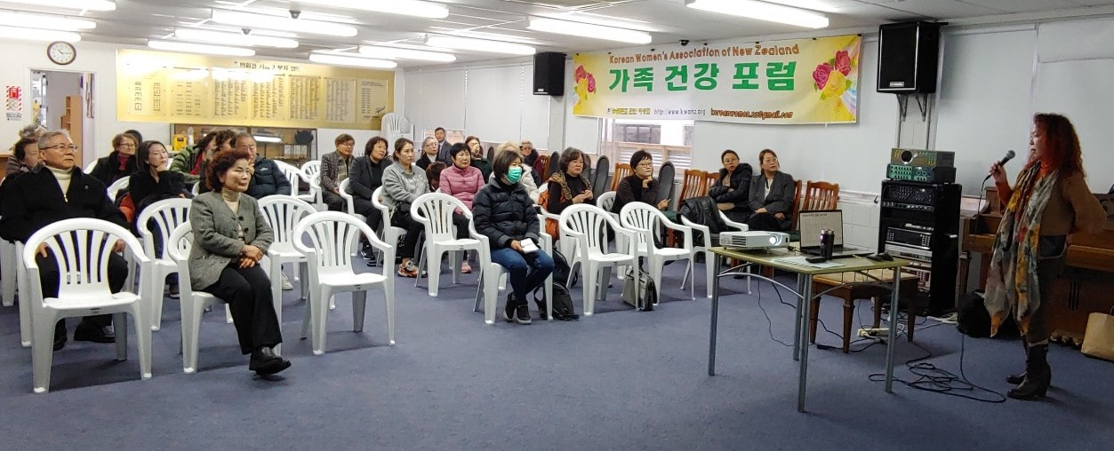

Joanne Neilson

Meetings: Trans Health Care group for Pegasus
Pride Meetings Bimonthly (zoom)
Patha (zoom meeting)
Pride Meeting Bimonthly
Pegasus Meeting 3 monthly
Invercargill Patha Monthly
Trans Health Care is continuing working with PATHA on upcoming National Conference in Christchurch in September which we are co hosting
Pride has announced its dates for Pride 2022 which will be over 2 weeks. We are still working on becoming a Charitable Trust.
Next speaking engagement is for the Southern Women in Public Service in Christchurch in October, I am discussing my life and work as a Trans Advocate.

Mark Rogers
- I kept our local DHB Consumer Council up to date with the consultation process for consumer engagement when DHB’s cease to exist. Much of the information is publicly available.
- Attended the Patient Deterioration virtual summit. This covered Korero Mai, National patient deterioration programme, Shared Goals of Care, Electronic Vital Signs, co-design, and patient centred care. There was clearly a lot of value in having consumers involved.
- Completed both experience surveys for ‘Consumers Working at Governance level’.
- I received an invitation to engage on the Review of Interventions for Students with the Highest Level of Learning Support Needs. My involvement/inclusion was with the Rare Disorders group who were offered a Microsoft Teams Zoom session with the Ministry of Education.

The purpose of the review is to ensure students and young people with high health needs are receiving the right education support. This is a co-design process where the first phase of engagement is to agree on the Scope and Terms of Reference for this review with Treaty partners, Pacific communities, the education sector, parents, disabled people, and disability organisations.

The next phase (ToR to be confirmed) will be conducted in the coming months.

Our family experience through the school system with a child with a disability that doesn’t fit a certain box has been challenging. Therefore I raised the known issue where quiet, well-behaved children with a disability fall through the cracks in the system.

- Attended the bi-annual South Canterbury Health Awards. These awards cover Primary, Secondary, Public & Private Health.

Mary Schnackenberg
I attended:
• the Health and Wellness group convened two-monthly at CCS Disability Action in Auckland
• the Consumer Experiences Council of the ADHB
• the Pharmac Consumer Advisory Committee; and
• the Auckland Branch of Blind Citizens NZ.
Of great interest is the outcomes of the Health and Disability Review implementation, especially as they effect consumer participation. For some, the impact of decisions about consumer involvement for disability service providers may be considerable.
In every meeting I attend, aspects of lack of equity of services for Māori and Pasifika are brought to the fore with respectful calls for improvements. ADHB is enhancing its policies and practices around equity of service. Pharmac has a Māori/Pasifika focus on recent changes to diabetes to availability of some medicines.
The training of counsellors about the impact of disability, or the lack of such training has become a serious issue of discussion at the Health and Wellness group in Auckland. We are trying to connect with university level course designers to find out if we can influence an improvement in this regard. A disabled colleague taking a counselling diploma at Massey University has confirmed to me the lack of disability awareness training on their course. One disability service provider has made redundant all their specialist counsellors, outsourcing counselling to a generic provider.
Blind Citizens NZ have three different telephone information lines. Most listeners to these phone lines are not online and don't have smartphones or computers. Auckland Branch has been focusing on information about COVID-19 vaccinations. Our offline listeners generally get their current health information from talkback radio, not always that reliable! We have received several positive comments about the information we have provided through our telephone information lines.
In response to recent examples of embarrassing situations affecting some low vision patients, the Consumer Experiences Council at ADHB will be exploring how we can help patients and consumers to say to providers “I don't understand” or “I can't make your suggestion work for me” or even “Please may I speak with your supervisor”. Despite 25 years of the Health and Disability Commissioner's Code of Rights and the National Advocacy Service, still many of us are afraid to clearly express our needs, even in some quite simple situations. Perhaps it's time for each of us to work on socialising Right 1 of the HDC Code of Rights — Respect.

Russ Aiton
I have had the opportunity to present at HQSC Leadership Workshops in Wellington, Auckland, and Christchurch. The subject has been Consumer Leadership and the process of engagement of WCDHB to the community. An invitation followed to speak at the Quality improvement scientific symposium 2021 to be held in November and again Consumer Leadership is the keynote talk.
Consumer Council has continued to present opportunities to the DHB to work on the QSM Framework and this has proved operationally challenging for the DHB leadership team to engage. The next data upload, September 2021, has yet to gain any traction on identifying a process of data capture and implement learnings from the first data collection/upload processes.
I continue to facilitate the Chair/Co-chair national group each month and we are looking at repositioning the time as numbers have fallen due to other commitments. We are hopeful of a more inclusive time and although numbers are small, the content, passion and drive for consumer engagement is as strong and determined as ever. The forth coming changes to the health system will present many opportunities to support each other as we progress.
I have been able to work with the project teams of rural generalist and national bowel screening program to identify example opportunities for the HQSC QSM marker. This has provided opportunity to discuss the Locality Framework and how the Consumer Forum would link to these projects in the future.
The WCDHB locality consumer groups continue to establish themselves and are still recruiting as required to reflect their communities and needs. We have engaged Tatau Pounamu in ensuring a co-design process is commenced that reflects Māori/Pacifica representation on consumer council alongside the locality model.
Meetings undertaken

General Manager  Philip Wheble Monthly Meeting | Monthly meetings to discuss Consumer issues and how  communication is managed to Communities.
NBSP – West Coast roll-out | monthly meetings on the Equity Advisory Group and Steering  Committee for this project. Working with the Project team to identify  QSM examples.
HQSC Projects  Zero Seclusion/Connecting Care Weekly meeting/updates | Ongoing work around PDSAs and focus on Consumer journey and  Whanau involvement.  Member of the Steering/Governance group for these (now finished)  projects and maintaining momentum of the learnings from both projects.

Bernadette Pereira
The focus continues to be the raising of vaccinated numbers for Pacific communities in the wider Auckland region. We still lag behind the mainstream population and with the entire nation going on Alert level four, it's a stressful time for families, and more organisations like SouthSeas are doing their bit to reach out to Pacific families who are anti-vaccine at this stage.
Attended two meetings of the Counties Manukau District Health Board Council in the months of July and August 2021.
Also attended a meeting of the SMS group in Counties Health Board on 17/08/21 for the first time and most of the discussions revolved around 'evaluation' and what form it should be. The group will meet every two weeks to finalise the format and other heath educational materials which they hope to distribute to patients and their whanau.
Working with Young Vinnies Organisation to provide food parcels for the vulnerable families since lockdown as a huge surge in families needing food parcels have increased. Currently awaiting financial supports from government sources.

Amanda Stevens
Since our last meeting a book has been published that includes and highlights inequalities for blind, deafblind, and low vision people with respect to digital exclusion during Covid-19 and in particular to access to information.
Link to the book here: https://bristoluniversitypress.co.uk/volume-i-community-and-society (it is available as a hard copy, epub, kindle). We are Chapter 21 right towards the end. Deafblind Association NZ have requested that Blind Low Vision NZ have this publication produced in accessible formats. We note that the chapter included for Aotearoa is the only one addressing disability issues, with Brian Doucet the editor noting on Twitter that "It’s an outstanding chapter. We are so glad that it could be part of the series!"
Graham, R., Masters-Awatere, B., Cowan, C., Stevens, A., Wilkinson, R. (July 2021). COVID-19 and blind spaces: Responding to digital (in)accessibility and social isolation during lockdown for blind, deafblind, low vision, and vision impaired persons in Aotearoa New Zealand. In B. Doucet, R. van Melik, & P. Filion (Eds). Global reflections on COVID-19 and urban inequalities. Volume 1: Community and Society. Chapter 21. pp 234-244. London; Bristol University Press.
Chapter 21 – I have popped this into the report for interest only as a taster of the first few paragraphs:
“Contemporary digital spaces inhabited during lockdown prioritized the needs of the fully able citizenry. Consequently, inherited power structures and hierarchies were digitally (re)produced (Lefebvre, 1991). Everyday space is typically designed by and for non-disabled people (Chouinard et al, 2010). Additionally, disabled people are marginalized from everyday social, economic, and political processes and spaces (Milner and Kelly, 2009). As a result, disabled persons are prevented from full participation as active and engaged citizens by abled persons in positions of decision-making power. In understanding the ways in which digital space(s) were (re)produced for blind, deafblind, low vision, and vision impaired (BLV) persons during COVID-19 lockdown we make visible how contemporary urban society perpetuates historical processes of exclusion.
Aotearoa New Zealand’s founding document, Te Tiriti o Waitangi, is an agreement between Māori (Indigenous people of Aotearoa) and the Crown to reside together as equal partners. To that end, our chapter brings together Māori (Bridgette Masters-Awatere, Chrissie Cowan) and non-Māori authors (Rebekah Graham, Amanda Stevens, Rose Wilkinson) in critically examining the experiences of Blind and Low Vision persons during the COVID-19 lockdown. In considering these experiences we also acknowledge the value of working together as academics (Graham, Masters-Awatere) and disability advocates (Cowan, Stevens, Wilkinson). Aotearoa New Zealand is also a signatory to the United Nations Convention on the Rights of Persons with Disabilities (CRPD) and to the United Nations Declaration on the Rights of Indigenous Peoples (UNDRIP). Despite a stated commitment to disabled persons and to Māori, economic and accessibility inequities for both groups remain entrenched. Historical experiences by persons with disabilities are of being marginalized from economic opportunities and excluded from societal participation (Johnson, 2020). Disabled persons and Māori are disproportionately represented in Aotearoa New Zealand’s disparity statistics (Hickey, 2020; Johnson, 2020), and digital access is no exception. Twenty-nine percent of New Zealanders with disabilities do not have internet access (Grimes and White, 2019). Māori are also over-represented in digital exclusion statistics, with factors such as poverty, health, education, and social needs that disadvantage Māori generally having a direct correlation to the accessibility of digital spaces (Citizens Advice Bureau (CAB), 2020). Despite government awareness of these inequities, progress towards ensuring inclusivity in digital spaces has been slow-moving.”
Further we have been working with Wendy Chiang, deafblind, in respect of her Master’s in Public Health and dual sensory loss during Covid-19.
We have also worked with the Commerce Commission in respect of the Tele Communications Fact Sheet that is currently inaccessible using screen reading software. This fact sheet offers information to people who need a mobile phone when the power goes down, have difficulty for any reason with touch screens, cannot hear Voice Over or equivalent, and need a “easy use” phone with touch buttons. The most obvious need being making a 111 call.
We now head into our Annual General Meeting by Zoom, with its technical challenges for deafblind. (See Chapter 21!)

Marlene Whaanga-Dean
AIG – Integrated Advisory Group, my niece passed away and I couldn’t attend in the month of June.
WDHB: Consumer Member, we are currently recruiting 2 more members to join us.
Russ/Marlene - Carl Shuker leading the window on COVID project from the Health Quality intelligence team in the Commission. Recording my story and lived experiences an insight to our community and I guess how it affected our community. This has been postponed due to Covid L4.
June: Our Whaiora COVID clinic ‘Te kau ma iwi’ have been running since beginning of June: 2020 operating every Friday/Saturdays. Providing whanau/tangata to come and get their 1st and 2nd Covid vaccines. Walk-ins are invited to get vaccinated.
I attended COMMUNITY Covid -19 presentation for local Pacifica, held YMC Masterton, free kai was provided from WDHB, with Immunisation Advisory Centre rolling out information to community. I believe there needs to be ongoing education for our Pacifica community and other.
Lockdown has increased numbers to vaccinate especially for those that are essential workers. There are concerns in our district for those of priority populations such as Pacifica, Māori and disability will be left behind, however DHBs are keeping our priority population at the forefront. There has been also uncertainty circulating taking the vaccine, there has also been a small group of people protesting in high street Masterton, which created a stir with some residents in the area to halt on the vaccine. But in saying that we had an increase last Friday /Saturday with children aged 12yrs and over coming in with their parents
I have been busy with supporting our own Covid - 19 vaccination clinic, Tekau ma iwa. We have Jacob Carlson, who is our co-ordinator & lives in Carterton, hails from Rangitane, nga iwi, he also affiliates to Ngai Tumapuhia from the coast here in the Wairarapa. It’s a pleasure to have him on board at Whaiora.
Started to attend karakia once a week weds mornings from 8.30am to 9.15am a great platform to engage with multiple services in Masterton, it’s a brief networking hui with a range of services coming together and knowing what other providers / services are doing in our community for whanau, what supports are available, what workshop, trainings are happening in our region.
July: Missed Anthony Hill (June 2020) - webinar keynote speaker Consumer Engagement & Involvement in Primary Care. Learnings about partnering with patients and consumers and gathering whanau voice in planning and delivering high quality primary care services. I will revisit that at some stage if it ever presents itself again.
August: I completed e- learning Privacy Act for 2020 updated Acts, staff requirement.
During Lockdown we have also monitored an increase of food parcels, so our Foodbank has been busy, Whaiora has been pro-active in ordering food parcels and even drop off to those that couldn’t pick it up, for example one elderly kuia couldn’t pick up her food parcel as she needed a new battery for her scooter, lived alone and no other whanau member. Local iwi has been supporting whanau /tangata with supplies of wood for kaumatua, food and a few hygiene resources. Ongoing phone contacts from all community service providers, encouraging neighbours to keep connected.
I had the pleasure with working alongside Sean Thompson facilitator for Advance care planning.
On the 3rd of August we held a staff training (primary care) RNs Managers, to learn more about using this important tool for consumers/whanau. I have had another request for Sean to have a presentation with our local Māori Welfare league “Peka” group in Masterton hopefully sometime this year.
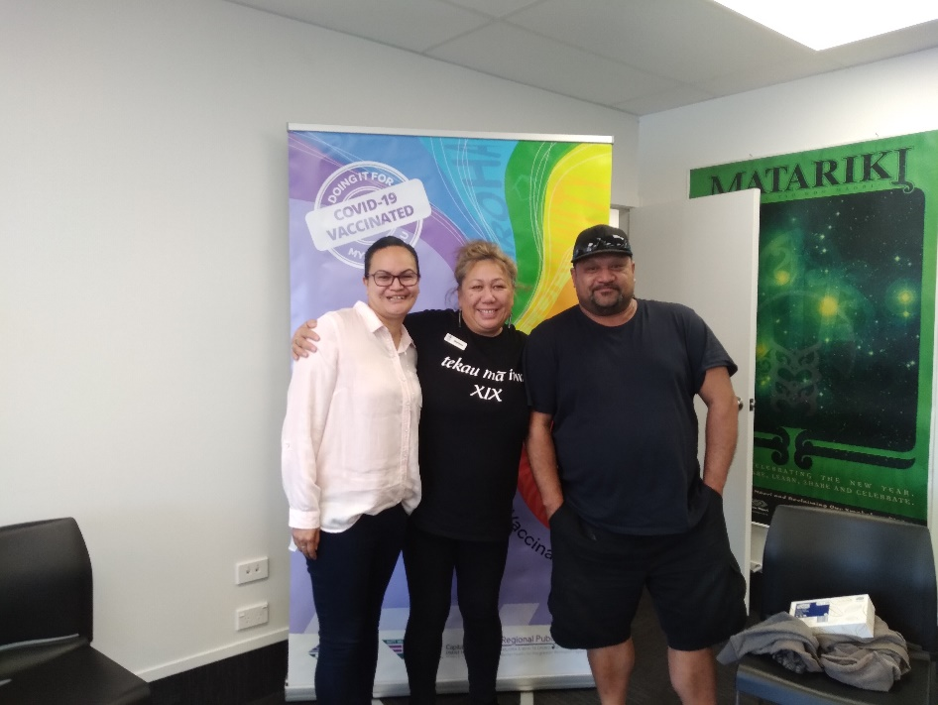
Keeping connected to our community in the Wairarapa.

LJ Apaipo
Tēnā koutou katoa.
It is with great pleasure that I submit my report to you all.
Since our last meeting, have been quite busy and engaged in mahi with the commission, and with that in my hāpori, supporting and assisting, considering Covid 19 and the nationwide Level 4 lockdown.

Code of responsibilities
There has been several huis about this, and we were fortunate to have presented thoughts and ideas in person. Special mihi to Chris and the team, for their manaakitanga and awhi of those of us that travel considerable distance to be present at these Kanohi ki kanohi.
This has been a piece of mahi that has required presence and brainpower.
Shelley Hanifan has been great in executing swift turnaround in draft documents and has been most accommodating of the voices and opinions of consumers and makes time and space to have the korero. This is the nature of mahi with the amazing team in the Health Quality and Safety Commission. I also want to highlight Caroline Tilah and acknowledge her time and feedback that has been able to whakamana the whakairo of the consumers present. So please do make sure that Janice see’s this report and knows of the magic that the Partners in Care team are creating and working on. The group that are involved in this process are a diverse mix of the people that we have involved in the commission and a cross-section to reflect the high and complex needs of our people, are ever present and it is a privilege and honour to sit amongst them.
Interviews
I have had the privilege of joining the Commissions interview panel, in selection of the new Senior Communications Advisor. This was a most pleasant experience. The awhina I received in making sure that I was prepared and ready for the day of interviews was an experience second to none. The interviews themselves were conducted with passion and vigour. It was heartening to see and hear the values of the Commission in action, in every step and aspect of the process. Deon and Victoria were great to work with and assured that I was informed and comfortable from woah to go. Thanks to Deon and Victoria for their time and space.
Hapori Ōtākou
There has been much to do back home considering the Level 4 lockdown that the country is facing.
I have been working to support Pacific Students, Māori and Pacific Families and Pacific Elders in the hāpori. A lot of them are isolated and do not have major support networks.
There has been a great roll out of vaccinations in the community by a local Iwi entity, however, there has not to date been a pacific specific space, where Pacific were able to go somewhere they felt safe and have their vaccine administered. Some have held off and will wait for that to happen.
I emailed the leader of the Māori Health Directorate for the Southern District Health Board to see if they were doing anything to support Pacific Trust Otago.
SDHB
Unfortunately, as I had been seconded down to Maruawai (Gore) for the past 4 months, I have not been as active in the DHB consumers group, however I am keeping up with the emails of Charlotte, one of the outgoing advisors.
I will reactivate my works in this space now that I am home and will have more time to engage. I understand that the new build is not without its challenges, however there are great teams that have this in hand.

Mana Moana Pacifica
We have recently held and EGM and are about to conduct our regional Connects. We are looking to expand the membership and begin the work of establishing as a Pacific DPO that encompasses, Mental Health, Addictions and Disability. We will then be looking to the Pacific Community across the country to build membership.
We have also been extending support to our people in the time of Covid and assisting them to access services and supports in L4 Lockdown.
I have kept this report short and brief as there is a lot that I could write.
He mihi whakawhetaitanga kia koutou, moo too nuinga mahi. Humble thanks to my fellow consumer advisors, for all that mahi that you undertake in your own rohe. We have a long way to go, however we are seeing improvements every day.

Vishal Rishi
I am delighted to submit this quarterly report to the HQSC consumer network. The report period covers the months of June, July, and part of August 2021. The below mentioned activities have taken place in the consumer space within metro Auckland geographical area and where we were directly involved in.
- Developed collaborative opportunities and strengthen working relationship with key stakeholders:

  - One of our team members have been appointed at the WDHB’s consumer council. He attended his first meeting in June this year.
  - Attended breast cancer fundraising event
  - Attended the elder abuse awareness day organised by Shanti Niwas Charitable Trust
  - Attended International Refugee Day celebrations.
  - Joined the Social Cohesion Forum
  - Attended the Youth 19 Asian students Report launch
  - Attended the CM Health Asian health & Wellbeing Community Network.
  - Collaboration work with key stakeholders: ADHB & CM Health mental health team, WDHB Bowel Screening Team, Immunization Advice Centre, Waster Wise Services Centre.
  - Presented at the Perinatal and Antenatal Depression Aotearoa (PADA) Asian seminar
  - Participated in the Asian Health Action & Advisory Group (AHAAG)
  - Participated in the Auckland Regional Asian & MELAA Primary Care Service Improvement Group
  - Attended the Asian Mental Health & Addiction Workstream Network Meeting
  - Co-ordinated the consultation for Asian parents and autism workshop
  - Invited two mental health service professionals from ADHB & CMDHB to promote mental health for the east Auckland Asian community
  - Further educational health seminars for Burmese community leaders were organised
  - Health Talks delivered for the following topics:
    - “Covid-19 & Vaccinations” at Glen Innes Library and Te Oro
    - “Stress & Mental Health” at Highland Park Library
    - “Women’s Health” at Te Manawa Library
    - “Environmental Health” at Pt. Chevalier Library

- Organised and coordinated a regional network meeting that was attended by more than 70 participants comprised of health consumers, community leaders, DHB staff and academia. We invited Burns Unit, NZ Police and NZ Fire Services to demonstrate the importance of taking special safety measures during winter season. This was a good refresher and a gentle reminder for the community leaders and present service providers on the day.

- Organised and co-ordinated a dedicated consultation hui on the draft Family Violence Prevention national strategy. This was organised in collaborations with the office for seniors and the joint venture. We contacted movers and shakers from the migrant Asian communities in the room, including relevant service providers. This is the cohort we can utilise for any of our HQSC road shows. More than eighty participants and Asian leaders took part in this half day consultation hui.

- Continued outreaching the consumers via social media channels and through several community events.

Very pleased to share that I have been awarded an “excellence in serving the communities” award at the seventh Indian Newslink Arts, Culture and Community awards.

