Engaging with consumers and whānau

Lauagaia Cat Jeffries and DJ Adams
Consumer Engagement Advisors, He Hoa Tiaki Partners in Care, Te Tāhū Hauora Health Qualioty & Safety Commission
April 2023

Creating safe spaces for engagement
- Te Ao Māori framework
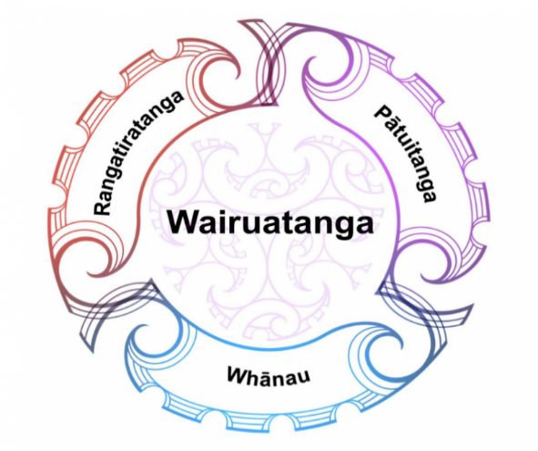

Te Ao Māori Framework

- Whakawhanaungatanga
  - the process of establishing relationships
  - creating connections with people and places are foundational to everything we do
- Creating le vā
  - a spatial way of conceiving the secular and spiritual dimensions of relationships and relational order, that facilitates both personal and collective well-being (Anae, 2007)
- Teu le vā
  - the ‘valuing’, ‘nurturing’ and ‘looking after’ of these relationships to achieve optimal outcomes for all stakeholders (Anae, 2007)
- Involve consumers and whānau from the beginning
  - are key stakeholders
  - must be at the forefront
  - need to be involved from the beginning
  - hold the knowledge and solutions
- Find out their preferences
Your priorities and timelines
are not the same as theirs
  - meet kanohi ki te kanohi
  - suitable timing/ allow for flexibility
  - meet in an environment of their choice
  - consider whether further support is required
- Listen to understand
  - be open minded
  - be honest and transparent
  - be patient and compassionate

Encouraging consumer, whānau and community participation
- Who to approach
  - use your established networks
- How to grow and create new connections
  - whakawhanaungatanga
  - create the vā
  - use your established networks
  - reach out to forums
  - sponsor and attend local/national events
  - social media platforms, ie, LinkedIn
- Create safe spaces
  - different platforms/environments

Effective ways of communication and information sharing
- Demonstrate health literacy guidelines
- Use visuals, ie, photos, diagrams, videos, social media platforms
- Use Easy Read
- Use translator and interpreter services (support person or available external services)
- Whiteboard or notebook

