

Evaluation and summary of Te Tai o Poutini West Coast workshops

Outline
In February 2025, the Health Quality and Safety Commission Te Tāhū Hauora (the Commission) Te Pūkāea Matatika Māori Health and Consumer team held two regional consumer workshops and one health provider workshop in Te Tai o Poutini West Coast.
One of the goals for the workshops was to meet with consumers, whānau and communities from rural areas to hear about their perspectives and experiences of accessing the health system.
To plan these regional workshops, the team consulted with the Commission’s consumer groups and populations of focus (rural communities, rural health needs).
The consumer regional workshops were held in Hokitika at the Arahura Marae, and in Reefton at the Dawson Hotel. The health provider workshop was held in Greymouth at the Ashley Hotel.
Zechariah Reuelu, member of the consumer network Kōtuinga Kiritaki, was also invited to join these workshops.
It is now early 2026. The release of this evaluation and summary a year after these events gives us the ability to share the ways in which the workshops impacted the Commission’s work in 2025 – particularly during the leadup to the national Ō Mātou Reo: Our Voices 2025 event in October.

Aim
The workshops were an opportunity to meet with consumers,whānau and communities who live on the West Coast and to hear about their experiences of accessing the health system in a rural area.
The aims for the regional consumer workshops included:
supporting consumers to engage in health service improvement activities, including primary care
listening to and understanding ways consumers can share their lived experiences to help shape the health system
discussing the ‘Code of expectations for health entities’ engagement with consumers and whānau’ (the Code) (see Appendix one) and its review.
We held the health provider workshop after the consumer workshops, so we were able to share feedback from consumers, whānau and communities from the earlier sessions. With providers, we discussed the Code and talked about how they are already engaging with consumers and whānau, and about whether they need support from the Commission.
Consumers engaged enthusiastically and effectively in all workshops, and we were encouraged by the positive feedback we received from attendees. We are grateful to everyone who participated for their time and contributions. Their openness and honesty provided important insights into how they are already engaging with health services and the strength of community networks on the West Coast.

Consumer workshops – attendees, activities and focus
Four people attended the workshop held in Hokitika, and eight took part in the Reefton session. Among those present were representatives from primary care organisations such as the West Coast Rural Education and Activities Programme.
The workshop format provided two walk-in sessions, to allow consumers and whānau more options for attendance. Lunch was provided.
Attendees appreciated the flexibility the two-time options offered them, and the venue worked well.
Consumer workshop format
10.00 am | Morning walk-in session
11.00 am | Code of expectations review workshop
12.00 pm | Lunch
1.00 pm | Afternoon walk-in session

The walk-in sessions started with whakawhanaungatanga from the Commission’s Te Pūkāea Matatika Māori Health and Consumer team and attendees.
The session then focused on understanding and navigating the health system (see Appendix two for resources used). The discussions during this session were relaxed and informal, which supported authentic conversations.
The team provided a brief overview of the health system and invited participants to share how they navigate it on the West Coast. One key challenge attendees shared was the issue of accessing transportation to and from clinics and hospitals. Strengths they mentioned included resource sharing and strong connections within the community.
During the session, we discussed sharing lived experiences. Appendices three and four were the resources used for this activity, to discuss with consumers on planning what to share, why it is important to share and how can you share your story safely.
Attendees shared their lived experiences in facing the health system locally. This helped us understand some of the challenges. Attendees noted in their evaluations that they had felt there was an openness to listening to rural needs and establishing lines of communication.
The second walk-in session included a discussion on the review of the Code. Some of the feedback focused on how we can promote the Code on the West Coast, including by:
placing posters around town
promoting the Code to other groups in the community and encouraging their engagement
learning from good news stories.

Health provider workshop – activities and focus
The format of the health provider hui was as follows.
Health provider hui format
5.30 pm | Workshop began
 | Supper was provided throughout the workshop
7.30 pm | Workshop ended

There were 12 attendees for the hui, including from Health New Zealand I Te Whatu Ora (Health NZ) (Te Waipounamu, South Island), primary health organisations and non-governmental organisations. The hui opened with whakawhanaungatanga from Te Pūkāea Matatika.
Feedback was provided from the consumer workshops to the health provider hui, including the following points:
Consumers want providers to engage with them.
Challenges and barriers include:
lack of access to appointments
lack of communication with health providers.
Evidence from local providers demonstrated to us how they were enacting the Code, including the following.
Community Voice West Coast is a collaboration between West Coast Health (a primary health organisation) and Health NZ Te Tai o Poutini.
West Coast Connect is a community service and directory offering listings of community groups and support services available on the West Coast.
Who Cares House is a social support organisation that provides services supporting the community.
Ensuring that providers are closing the loop with consumers, meaning feedback is responded to and everyone involved knows the outcome
During the session we also discussed the Code, including providers’ understanding of it and the work they are doing to implement it.
We had productive conversations about the ways communities can communicate that should be implemented everywhere (for example, 0800 numbers). There were discussions on data and stories and the training needed in the system to use storytelling as a way of engaging with consumers, whānau and communities.

Evaluation of the workshops
An evaluation survey (see Appendix five) was provided to all attendees of the consumer workshops to assess how well the workshop met its purpose and seek ideas on potential improvements for future workshops and events. Note: one attendee did not complete the evaluation.
The survey asked attendees whether they identified with one of Health NZ’s priority populations. All attendees self-identified as people living rurally, which was the main audience we wanted to reach (see Figure 1).
Figure 1: Answers to survey question ‘Please confirm if you identify with one or more of these priority populations (as defined by Health New Zealand)’
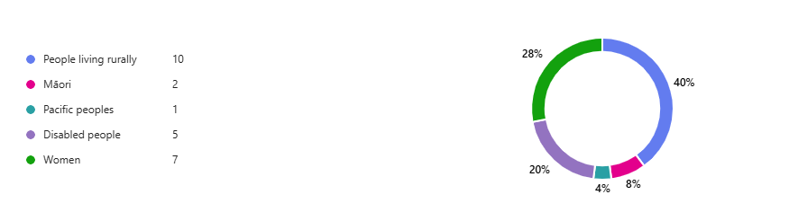

Figure 2: Answers to survey question about whether the workshop met its purpose to support consumers to engage in health service improvement activities, including in primary care
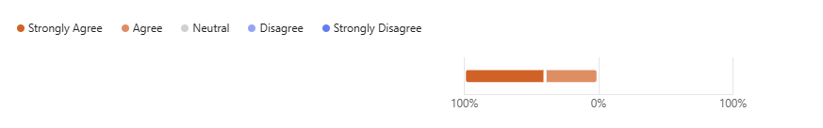
Figure 2 outlines attendees’ response to a question about whether the workshop met its aim; 100 percent of responses chose ether ‘Strongly Agree’ or ‘Agree’. This reflects strong support from attendees, including those working in primary care, for the workshop’s approach to strengthening and supporting consumer involvement.

How we are using feedback and evaluations
Thanks to attendees’ excellent engagement with the consumer workshops, and the positive feedback we received, the team was able to share insights with local health providers during their session in Greymouth. We learned about various ways in which we could better engage with West Coast communities, which has supported our efforts to promote the final review of the Code and other events hosted by the Commission.
Participants noted that the accessibility of the workshops had made the events easy to attend, and the friendly, informal approach made people feel as though their stories were valued.
This feedback influenced other events in 2025, including the national Ō Mātou Reo: Our Voices 2025 event, at which accessibility and a friendly, informal atmosphere was a focus. This approach has helped make consumers, whānau and communities feel more comfortable and confident to share their stories.
The evaluations provided us with a clearer understanding of how successful the workshops had been, including in terms of our promotion of them, the venue and the catering. We have used these perspectives to adapt and tailor future workshops and events.
Some attendees mentioned they had not been aware the workshops were happening in their area and noted we could have involved community and advertised more in the leadup to the event.
Attendees provided clear suggestions for improving future promotion of workshops or events. These included using local newspapers, such as The Clarion and The Greymouth Star, and promoting within community Facebook groups.
This feedback has influenced our promotion for subsequent events. Since receiving the feedback, we have begun our promotion of events much earlier and involved our partners and the consumer community to a greater extent, to reach the right audiences. This is something we will continue working on. We will make an effort to involve local media earlier where relevant and engage more efficiently with community groups through social media platforms.
Feedback from Te Tai o Poutini workshops has influenced the development of Ō Mātou Reo: Our Voices 2025 and other smaller consumer events. We thank attendees for sharing their thoughts.

Promotion
Our promotion for the workshops began in early December. To reach our target audience of consumers, whānau, communities and providers on the West Coast, we used a mix of channels:
newsletters: both the Commission’s general newsletter and the Consumer health forum Aotearoa newsletter, which has a consumer focus
social media: the Commission’s LinkedIn, Facebook and Instagram, as well as:
targeted advertising through Facebook to consumers and providers on the West Coast
events set up on Facebook
advertising: advertisement placed in the West Coast Messenger, which has a circulation of 14,000 people from Karamea to Haast
direct emails to West Coast health providers, including health providers and Māori organisations, to ask for their support in sharing the workshops with their communities. These emails included posters to print and display in public areas
direct emails to Health NZ West Coast communications teams asking for their support sharing the hui with local networks – health providers in particular
an event page on the Commission’s website.
Throughout promotion for the event, we repeated messages, to highlight what the workshops were about, and key information, including location and timing of the event and information on how to register.
Our promotion reached a large number of people on the West Coast, but this did not translate to high registration numbers. Feedback from participants showed us that most consumers learned about the workshop on Facebook. They recommended that, for future events, we engage to a greater extent with community groups on Facebook and local publications – including sports clubs and school news bulletins – to more directly reach local communities.
For future events, we will begin promotion earlier and place a greater focus on working with local communities to encourage interest and attendance.

Conclusion
Our workshops successfully supported consumers living on the West Coast to engage in health service improvement activities.
The workshops provided us with valuable opportunities to listen to and learn from consumers and health providers about their unique experiences and how they can use these experiences to shape the health system. Additionally, the workshops encouraged open conversations about the Code and its review in 2025, highlighting to us that awareness of the Code is vital in building a shared understanding of how to work together in a meaningful and respectful way.
The Commission would like to thank everyone who attended the workshops and took the time to share their stories and insights with us. The feedback we gathered has already played an important role in influencing other consumer, whānau and community events and will continue to do so into the future.
“It was a humble experience to listen to the consumers living on the West Coast, sharing firsthand how vital it is for their whānau to be involved in shaping the health services. I heard, for too long, many of them have felt like passengers in our own health journeys, unsure of our rights or what to expect.
“A kaumatua shared how attending hui and engaging with the Code of Expectations is so important to understand how it applies when we go to the GP. When I first joined hui, I felt nervous, but I soon realised how powerful our voices can be. The kōrero gave me confidence – I learned that we have the right to be treated with respect, to be involved in decisions, and to expect high-quality care.
“In the Reefton hui, I listened to farmer wives living in remote areas; we know the challenges of isolation. But together, we’ve built strong connections – sharing resources, checking in on each other and organising local health and wellbeing events. By working collaboratively, we overcome distance and support our communities to stay well. We may be far apart, but through unity and care, we ensure no one feels alone on their journey to better health. Being part of these conversations helps ensure our needs are met.
“On the Coast, where health services can feel distant, this kind of engagement is life changing. We’re not just consumers – we’re partners in the system, and our voices matter.”
Zechariah Reuelu, member of Kōtuinga Kiritaki Consumer Network

Appendices

Appendix one: Code of expectations for health entities’ engagement with consumers and whānau
Context
The code of expectations for health entities’ engagement with consumers and whānau (the code) sets the expectations for how health entities must work with consumers, whānau and communities in the planning, design, delivery, and evaluation of health services.
This code is required by the Pae Ora (Healthy Futures) Act 2022 and is underpinned by the health sector principles. All health entities must act in accordance with the code and are required to report annually on how the code has been applied.
The health sector principles incorporate Te Tiriti o Waitangi (the Treaty of Waitangi) principles identified by the Waitangi Tribunal in its Hauora Inquiry. These include the principles of tino rangatiratanga (self-determination); ōritetanga (equity); whakamaru (active protection); kōwhiringa (options); and pātuitanga (partnership).
This code does not replace the Code of Health and Disability Services Consumers’ Rights (Code of Rights). The Code of Rights specifies important rights that providers must uphold when delivering services directly to consumers, whereas this code sets requirements for how health entities must work with consumers, whānau and communities in the planning, design, delivery, and evaluation of health services.
Engagement expectations
- When engaging with consumers, whānau and communities, health entities must:

  - be guided by the health sector principles contained in section 7 of the Pae Ora (Healthy Futures) Act 2022

  - value and recognise the centrality and importance of whānau in te ao Māori and provide opportunities for Māori to exercise decision-making authority

  - value engagement: engagement is built on trust, authenticity, reciprocity, transparency, and a willingness to share and learn from each other. It is inclusive of all population groups and those with specific needs
  - share leadership: knowledge and expertise drawn from lived experience are valued equally alongside clinical and other knowledge. Consumers, whānau and communities are experts by experience, often holding solutions to make improvements to the health system

  - promote quality and safety: the experience of consumers, whānau and communities underpin health quality and safety, including cultural safety
  - promote equity: there is an imperative to engage with those with greater health needs, particularly Māori, Pacific peoples, and disabled people. This recognises that addressing equity is best achieved through involving consumers, whānau and communities.

- Health entities must apply these expectations by:

  - co-designing with consumers, whānau and communities so there is collective development of organisational priorities, processes and evaluation, and consumers, whānau and communities are involved at all levels

  - using lived experience, including consumer experience data to inform improvements in health services with a focus on reducing health inequities, particularly for Māori, Pacific peoples, and disabled people

  - addressing the reduction of health inequities through cross-sector collaboration with other agencies and in partnership with consumers, whānau and communities

  - ensuring that information, resources, and engagement opportunities are accessible to all consumers, whānau and communities, and remove any barriers that may hinder full and effective participation and engagement

  - resourcing consumers, whānau and communities to contribute and engage meaningfully and having policies to reflect this

  - ensuring that, when services are commissioned, they are set up to enable consumers, whānau and communities to engage at all levels as determined by the code.

- Review date

  - July 2024

Appendix two: Navigating the health system (information provided by the Ministry of Health – Manatū Hauora)
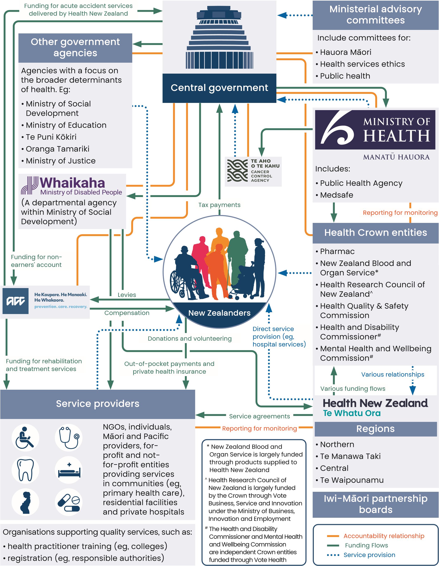

Appendix three: Sharing our lived experiences workshop material
This worksheet will help you plan what to share about your experience in health or the
experience of whanau.

What things went well? What was said or done that was helpful?

What did not go well? What was said or done that was not helpful?

What do you suggest would improve the experience for others and their whanau in health?

Alcohol Drug Helpline Freephone 0800 787 797.
The Alcohol Drug Helpline provides friendly, non-judgmental, professional help and advice. If you are concerned about your own drinking or drug taking, they can assist with information, insight and support.

QuitLine Freephone 0800 778 778.
The Quit Group is committed to helping all New Zealanders quit smoking, with a particular focus on Māori, Pacific peoples and pregnant women.

Healthline Freephone 0800 611 116
Freephone 24-hour helpline. Healthline is staffed by experienced registered nurses who can provide you with health information and advice on care.

Lifeline Freephone 0800 543 354 or send a text to HELP (4357).
Provides safe, effective and innovative services that support the emotional and mental wellbeing of our communities.

Suicide Crisis Helpline Freephone 0508 828 865 (0508 TAUTOKO).

What’s Up Freephone 0800 What's Up (0800 942 8787)
A free counselling service just for kids and/or teens. So, if you need support or someone to talk to, call What's Up – no matter what the issue, the What's Up counsellors will listen.

Youthline
Freephone 0800 37 66 33 or text 234, for free 24/7 support.
Free counselling for young people. Provides access to support and help for young people, as well as leadership development and upskilling.

OUTLine Freephone 0800 688 5463 (0800 OUTLINE)
For people with sexuality or gender identity issues.

Rural Support Freephone 0800 787 254
For people in rural communities.

St John Caring Caller Freephone 0800 4 CALLER (0800 422 5537) or emailcaringcaller@stjohn.org.nzA free St John’s Caring Caller service that connects people who need a friend with people who have time to ring them to listen and chat or check that all is well. Trained volunteers are matched with people with similar personalities or interests.

Family Action Freephone 0800 326 327 Monday to Friday 8.30 am to 5 pm.
Provides help for adults, youth, children and families who have experienced domestic or sexual violence.

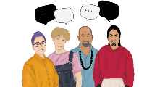
Appendix four: Sharing our lived experiences dashboard
Ō Mātou Reo: Regional Workshop February 2025
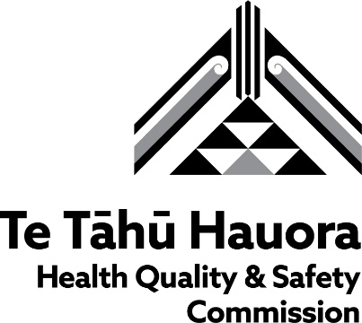

WORKSHOP DASHBOARD

For each question:
- Use the post-it notes to capture your ideas.
- Compare ideas with your partner.
- Put your post-its on the dashboard
- Group common themes together.
- Prepare to share a summary with everyone.

Self

How can I share my story in a way that is safe?
What is the importance of sharing our lived experience?

Others

Appendix five: Evaluation using the workshop survey
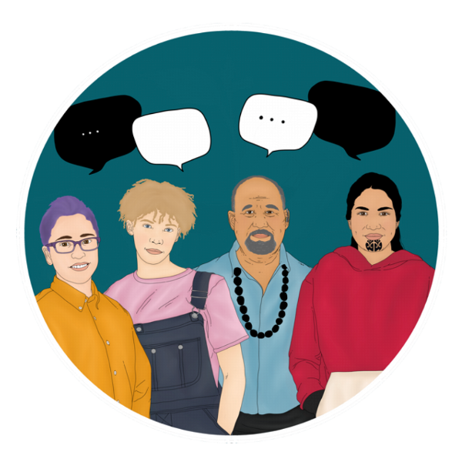 Consumer health forum Aotearoa - February workshops
Evaluation: Health consumer workshops, February 2025
Tēnā koe, Kia orana, Talofa lava, Tālofa ni, Ni sa bula vinaka, Malo e lelei, Fakatalofa atu, Fakalofa lahi atu, Noa'ia, Mauri and warm greetings!
Thank you for joining a Consumer health forum Aotearoa workshop. Your responses to this survey will help us make improvements for future forum events. We value your feedback and time, thanks for answering these questions. Your privacy is important to us, the information you provide will be treated as confidential.

* Required

Workshop attendance
- Which workshop did you attend? *
□ Hokitika session
□ Reefton session

Priority populations
- Please confirm if you identify with one or more of these priority populations (as defined by Health NZ) *
□ People living rurally
□ Māori
□ Pacific peoples
□ Disabled people
□ Women
- Please confirm if you identify with one or more of areas of health interest *
□ Rural
□ Chronic or long-term condition (including asthma, diabetes, heart, respiratory, stroke etc)
□ Disability
□ Maternity
□ Mental health & addictions
□ Migrant
□ Older adult or aged care
□ Rainbow
□ Rare disorder
□ Refugee
□ Youth

Workshop purpose
The purpose of the workshops was to support consumers to engage in health service improvement activities, including in primary care.
- The workshop met its purpose to support consumers to engage in health service improvement activities, including in primary care. *
Strongly Agree Agree Neutral Disagree Strongly Disagree

- Use the space below to add any further comments to your responses above
Enter your answer
- What would you like to see in future workshops?
Enter your answer

- How did you hear about the Consumer workshops? *
□ LinkedIn post
□ Facebook post or event
□ Instagram post
□ Newspaper ad
□ Community notice boards
□ Other

- Please add any final comments you would like to make about the workshop, such as the venue, timing or accessibility.
Enter your answer

Published May 2026 by Health Quality & Safety Commission Te Tāhū Hauora, PO Box 25496, Wellington, 6146. Available online at www.hqsc.govt.nz. Enquiries to: info@hqsc.govt.nz



Principles described in: Waitangi Tribunal. 2019. Hauora: Report on Stage One of the Health Services and Outcomes Kaupapa Inquiry (Wai 2575). URL: https://waitangitribunal.govt.nz/inquiries/kaupapa-inquiries/health-services-and-outcomes-inquiry.
Health and Disability Commissioner. 1996. Code of Health and Disability Services Consumers' Rights. Wellington: Health and Disability Commissioner. URL: www.hdc.org.nz/your-rights/about-the-code/code-of-health-and-disability-services-consumers-rights/ (accessed 12 April 2022).
United Nations. 2006. United Nations Convention on the Rights of Persons with Disabilities. URL: www.un.org/development/desa/disabilities/convention-on-the-rights-of-persons-with-disabilities.html.

