Position Description
Position Title | Senior Policy Advisor (Mortality Review)
Location | Wellington
Organisation | Health Quality & Safety Commission
Work Role Group | Mortality Review Committees Secretariat | Job Band | Band 18

Mortality review is a tool for learning about and preventing mortality with powerful potential for improvement within health system and social sector. It is a long term, multi-agency, and multi-sector continuous improvement programme.
There are currently five mortality review committees (Committees) within the national mortality review function in Aotearoa New Zealand dedicated to reviewing deaths of children and young people, babies and mothers where death is caused by pregnancy or childbirth, deaths resulting from family violence, deaths associated with surgery, and deaths by suicide. The Committees have important role to play in reducing Māori health inequities through analysing and interpreting mortality review data and making recommendations to the Health Quality & Safety Commission (the Commission) for improvement to reduce preventable mortality and morbidity.
The Mortality Review Secretariat supports the mortality review committees in their statutory roles and provides governance and leadership to mortality review systems and advice regarding reviews. The Secretariat also manages and supports the ongoing operational systems of information collection and review for each of the committees.
The Commission leads and coordinates work across the health and disability system (both private and public) to improve service safety, quality and outcomes for all who use these services in New Zealand. The Commission is a Crown Entity with a Board responsible to the Minister of Health.
The Commission is charged with:
- providing advice to the Minister of Health to drive improvement in quality and safety in health and disability services
- leading and coordinating improvements in safety and quality in health care
- identifying data sets and key indicators to inform and monitor improvements in safety and quality
- reporting publicly on the state of safety and quality, including performance against national indicators
- disseminating knowledge on and advocating for safety and quality.
The Commission’s strategy is outlined in the Tauākī Koronga - Statement of Intent (SOI) 2020-24. This outlines four strategic priorities underpinned by the three articles of Te Tiriti o Waitangi and the Ritenga Declaration:
- Kāwanatanga – partnering and shared decision making, informed and shaped by tangata whenua and tangata Te Tiriti worldviews and perspectives
- Tino rangatiratanga ‒ recognising Māori authority and the importance of tangata whenua authority and autonomy. Also supporting tangata whenua led processes, actions and decision making, through shared power and resources
- Ōritetanga ‒ equity. Undertaking specific actions to ensure equitable outcomes for tangata whenua and recognising that these actions can also support equitable outcomes for other groups
- Wairuatanga ‒ upholding values, belief systems and worldviews. Prioritising tangata whenua worldviews, values, and belief system

The Commission’s strategic priorities are:

- Improving experience for consumers and whānau. People and whānau are the centre of the health and disability system and partner actively in determining their care
- Embedding and enacting Te Tiriti o Waitangi, supporting mana motuhake. The health and disability system supports and partners with Māori to achieve the health outcomes that they determine as priorities
- Achieving health equity. Health equity is embedded into all aspects of the health and disability system, and into the care relations
- Strengthening systems for quality services. A stronger health and disability system is proactive and anticipates quality and safety issues. Its leaders authentically focus on trust, partnerships, and knowledge sharing

Organisational values
The way we work reflects our role as a national ‘leader and coordinator’ and is encapsulated in our values:
It’s about people | Mō te iwi
We are driven by what matters to patients/consumers and their families/whānau; and by what will improve the health of communities and populations.
Open | Ngākau tuwhera
We have an open, honest, transparent and respectful culture. We value the expertise, knowledge and experience of others and welcome creative approaches and diverse opinions.
Together | Kotahitanga
We partner with others, and learn and share together. We use consumer experience, expert knowledge and current information to come up with new ways of thinking and better ways of doing things.
Energising | Whakahohe
We are energised by our passion for improving health and disability support services.
Adding value | Te tāpiri uara
We demonstrate our value to the health and disability system and to the health of communities.
Position Purpose and Responsibilities
The purpose of the Senior Policy Advisor role is to lead and influence best practice policy outcomes to support the work of the mortality review function, currently comprising of five Committees; and the Commission to achieve its statutory objectives.
The Senior Policy Advisor (Mortality Review) will be expected to:
- Provide operational policy leadership and advice to the Committees
- Manage relationships important to policy outcomes for the Committees
- Ensure best practice mortality review governance processes
- Develop and implement best practice research policies and guidelines that meet the requirements of the Committees
- Manage the development and writing of Committee reports as required
- Manage accountability and reporting processes for the Committees
- Lead / contribute to projects with ranging complexity
- Contribute to the implementation of the Business Change Process around reforming the National Mortality Review Function (to be confirmed).
This position has a broad and strategic focus given the range of activity and areas covered by the Committees and the Commission. The position will be reviewed in 12 months to align with the implementation of the Business Change process for the National Mortality Review Function and the Commission.

Key responsibilities and expectations
These include but are not limited to:
Key responsibilities | Performance expectations
Provide operational policy leadership and advice required by the national mortality review function, Committees and the Commission | - Work with other Commission staff, and staff in other agencies to develop joint advice on policy, legislation and regulation as required by the national mortality review function and Commission  - Lead the drafting of policy documents, guidelines and ad hoc advice required by the Committees and national mortality review function  - Undertake peer review of documents and material prepared by colleagues to ensure quality, validity, accuracy, and consistency  - Prepare/provide input to, monitoring and report progress against project plans, and review and evaluate projects upon completion, as required by the Senior Programme Manager
Manage relationships important to policy outcomes for the national mortality review function and Committees | - Build and maintain strong relationships with Committee Chairs and members  - Identify opportunities to build relationships to influence policy outcomes for the national mortality review function  - Build and maintain policy relationships with key advisors to the Committees across health and social sector agencies (all of government), as required to best support policy outcomes for the national mortality review function  - Ensure consultation with key advisors and other representatives on recommendations and reports, right up to CE level as required  - Manage relationships with Minister of Health’s office, in close partnership with staff responsible to manage these relationships on behalf of the Commission
Provide leadership into, and provide support, with best practice governance processes | - Support governance processes to meet the requirements of the PSC and the expectations of the national mortality review function and Commission Board  - Ensure a high standard of preparation, written material and agenda planning  - Ensure a high standard of record keeping and follow up of actions arising  - Ensure ‘no surprises’ to the Committees or the Commission  - Provide briefing and related services to the Minister and Associate Ministers of Health, on behalf of the national mortality review function and the Commission
Develop and implement best practice research policies and guidelines that meet the requirements of the national mortality review function | - Provide operational policy leadership, support, and advice to the Committees on research applications, process and follow through  - Ensure best practice governance processes as they pertain to research and decision making with regards to research  - Build and maintain relationships with researchers who apply to use mortality review data and particularly those who are granted access by the Committee, where required  - Undertake a review of Memorandums of Understanding (MoUs) with government agencies to align with the new legislation and the data requirements of the national mortality review function  - Build and maintain positive relationships with those who work for, and with, the Committees (internally and externally) including lead and national coordinators and those that work with mortality review data.
Manage the development and writing of reports / documents as required | - Contribute to the development and / or project management of each report as directed, with the support of the Senior Programme Manager, and the other staff that are allocated roles in report development  - Contribute writing reports or documents, as required  - Ensure the report development processes meet the timing requirements of the internal planning and the SPE  - Work to ensure a high standard of report for the Committees, and Commission
Manage the publication and release of reports, as required | - Work closely with the Commission’s communications team and relevant specialists to develop plans for publication (including journals) and communications.
Lead / contribute to projects with ranging complexity | - Undertake projects as required by the national mortality review function, Committees, and the Group Manager, Mortality Review Committees
Cultural Safety | - Apply the principles of cultural safety to the projects being managed  - Display respect, sensitivity, and cultural awareness in interpersonal relationships  - Support and partner with Māori to achieve the health outcomes that they determine as priorities
Risk Management (including Health & Safety in Employment Act | - Take responsibility for meeting the Commission’s obligations in workplace health and safety  - Contribute to a healthy and safety working environment and healthy and safe working practices

Key relationships
All Commission employees have a responsibility for managing relationships in some or all of the key sectors we work with. In this role, the key relationships to be developed are as follows:
Reports to: | Group Manager, Mortality Review
Key internal relationships | Chief Executive, Policy Manager, Tier 2 Managers, Senior Specialists Advisors, Senior Programme Manager /Deputy Group Manager, Business Change Process for the National Mortality Review Function, Committee Chairs, members, and wider Commission
Relationships with the Public sector: | Government departments and other key stakeholders with related interests
Relationships within the Health and disability sector: | Government departments and other key stakeholders with related interests – including Manatū Hauora, Te Whatu Ora, Te Aka Whai Ora, Social Development, Business Innovation and Enterprise; Justice; Education, Police, ACC, NZCSU; Department of Corrections, and other organisations that the Committees and Secretariat may determine

The organisation structure for the Commission is provided below.

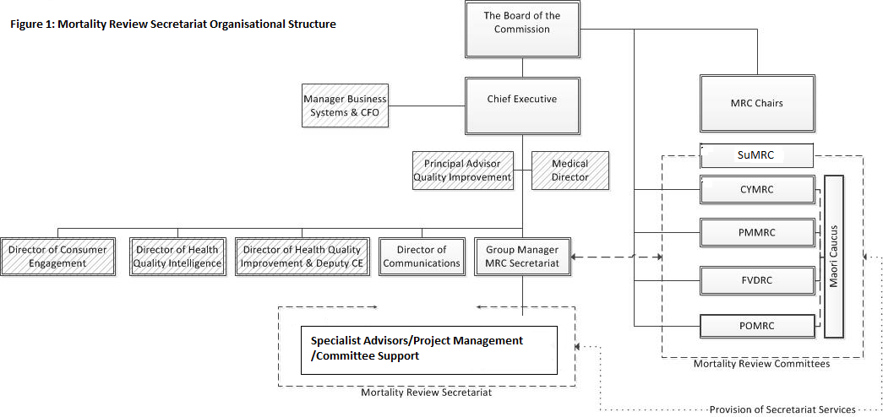

Key Selection Criteria
To be considered for this role, the ideal person will need to demonstrate:
- Policy Experience – work experience in policy development at the level of Principal Advisor/Senior Policy Advisor in previous policy roles, building from a relevant tertiary qualification. A high degree of familiarity and comfort within government policy processes is also required.
- Demonstrated knowledge and understanding of Te Tiriti o Waitangi as applied in a policy setting
- Critical thinking - A high level of skill in problem solving, conceptual thinking, and distilling ideas into decision-making.
- Interpersonal Savvy – an ability to effectively manage relationships at all levels, including to convey the Commission’s position on policy issues in a persuasive way cognisant of the views/perspectives of other stakeholders.
- Communication Skills – highly developed written and verbal communication skills, including the ability to present information in a lucid, succinct, and coherent way (including in plain English) in a variety of communication settings and styles.
- Contextual Awareness – an understanding of the machinery of government and the health system, and ability to work effectively to obtain outcomes in these contexts.
- Innovation and strategic acumen – an ability to develop new ideas and approach to problem solving, see the big picture and think and act strategically
- Project management – an ability to effectively lead and manage projects, including multiple tasks and priorities
- Collaboration – an ability to develop appropriate networks, internally and externally, for collaborative work (a key aspect of developing the Commissions policy perspectives).
- Self-management – able to take the initiative to develop and progress project and initiate contact and discussion internally and externally
- Commitment to improving the quality and safety of services for New Zealanders
- Cultural safely – understand and able to apply the principles of cultural safety to the projects being managed
- A demonstrated understanding of how health inequities have developed in Aotearoa New Zealand and local and national health policy approaches to addressing inequity.

