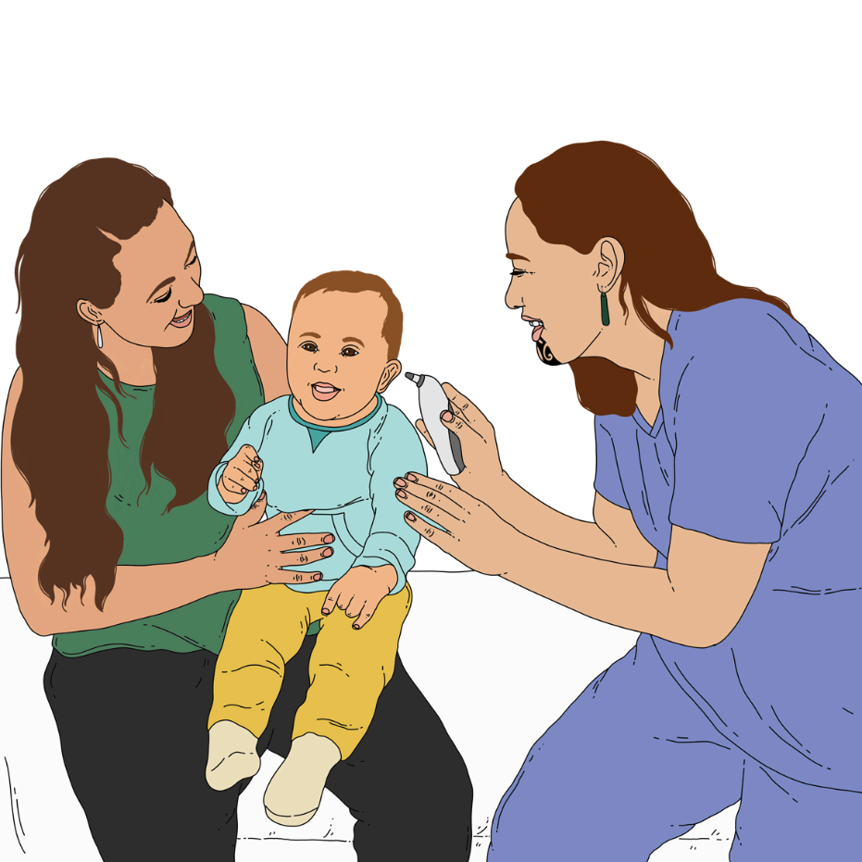
Code of expectations for health entities’ engagement with consumers and whānau

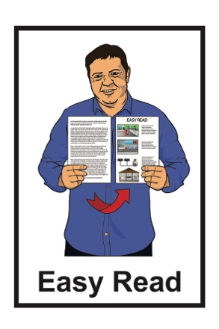

October 2022

What is the Health Quality and

Safety Commission?
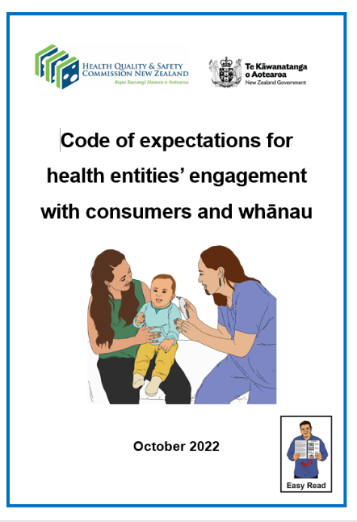

This Easy Read document is about a new code called the:

Code of expectations for health entities’ engagement with consumers and whānau.

It has been written by the Health Quality and Safety Commission.
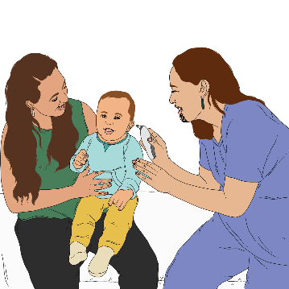

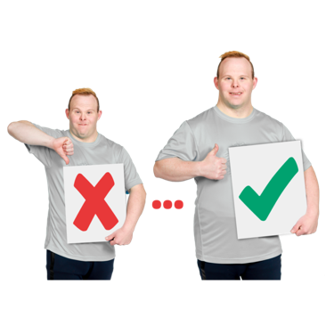
The Health Quality and Safety Commission works to improve health and disability support services in New Zealand.

Improve means to make something better.
The Health Quality and Safety Commission believes in hauora kounga mō te katoa.
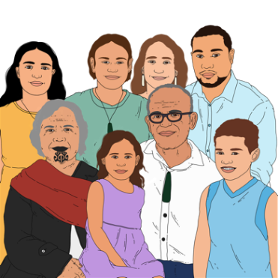

This is te reo Māori for quality health for all.

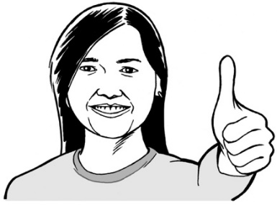
Quality means:

- how good something is

- if something does what it is meant to do.

The Health Quality and Safety Commission works with:

- people who work in health and disability support services

- people who use health and disability support services.
The Health Quality and Safety Commission does things like looking at:

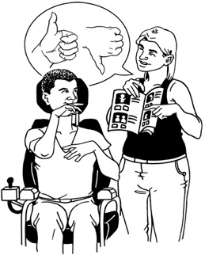
- what health and disability services do

- how good the services are

- how safe the services are.

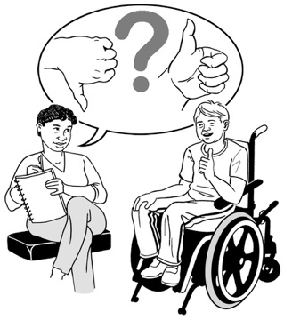
The Health Quality and Safety Commission shows the people who work in health and disability support services how they can make them better.

About the Code of expectations

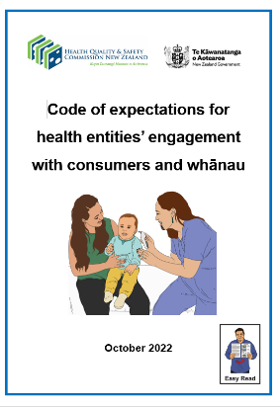

In this document we will call the Code of expectations for health entities’ engagement with consumers and whānau the Code.

A code is like a set of rules people follow to do things well.

The Code lists expectations for what health entities do.
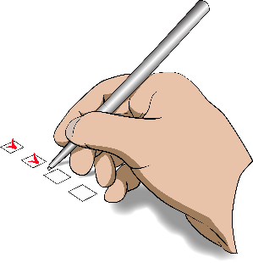

Expectations are what needs to be done to follow the Code.

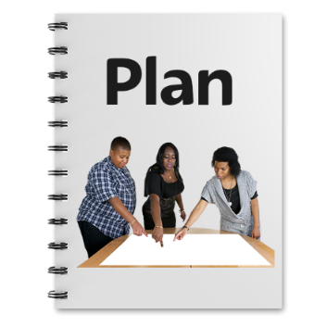
Health entities are organisations that are in charge of:
- planning the health system
- checking how the health system is going.

In New Zealand the health entities are:
- Māori Health Authority
- Health New Zealand
- Health Quality and Safety Commission
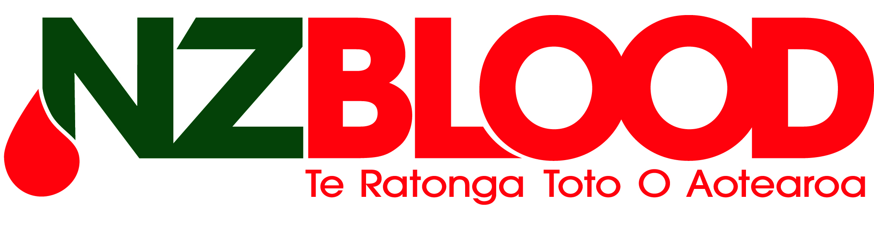
- Pharmac which looks after getting medicine
- New Zealand Blood Service.

The Code says what the expectations are for how health entities engage with:
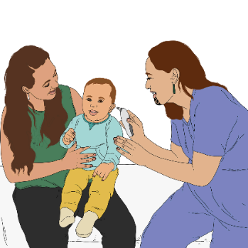
- people who use health services who are sometimes called consumers
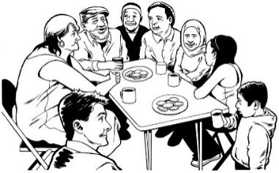
- whānau / aiga / family
- communities.

To engage means things like:
- working together
- listening to what each other has to say.

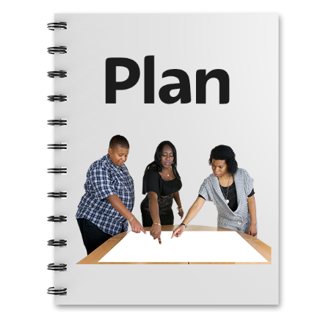
Organisations would engage with people to:

- plan health services
- design services which is working out what services will be like
- deliver services which means making services happen
- check how well health services are doing.

All health entities will have to:
- follow the Code
- say every year how they have followed the Code.

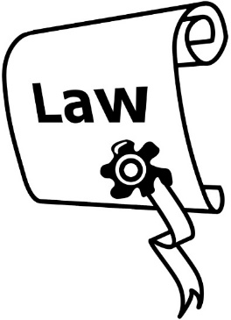
A law called the Pae Ora (Healthy Futures) Act 2022 says this Code is needed.

The principles in Section 7 of the Pae Ora (Healthy Futures) Act 2022 are important to the Code.

Principles are like ideas that you use to decide what to do.

You can read all the principles in Section 7 of the Pae Ora (Healthy Futures) Act 2022 on this website:

http://www.legislation.govt.nz/act/public/2022/0030/latest/LMS575484.html

This website is not in Easy Read.

The principles in Section 7 of the Pae Ora (Healthy Futures) Act 2022 are to do with things like:
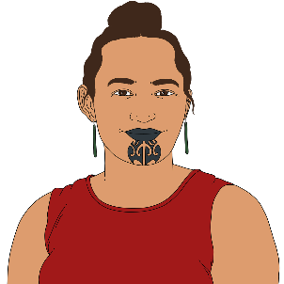
- making sure healthcare is fair for everyone
- Māori being able to make decisions on things that are important to them
- different groups of people being part of planning what healthcare is like.

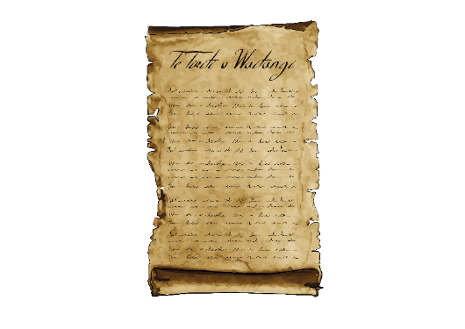
The Code also includes Te Tiriti o Waitangi / The Treaty of Waitangi principles.

Te Tiriti o Waitangi / The Treaty of Waitangi is an important agreement between Māori and the British Crown.
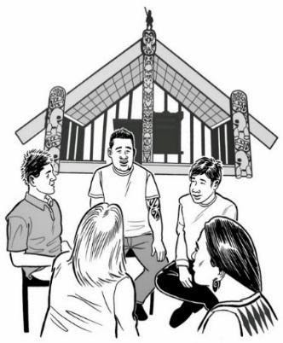
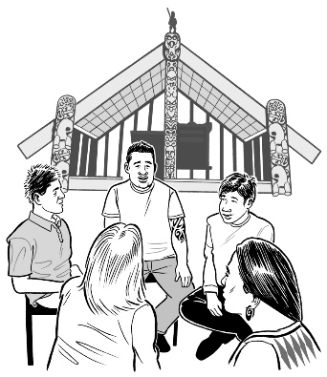
Some of the principles in Te Tiriti / The Treaty are:

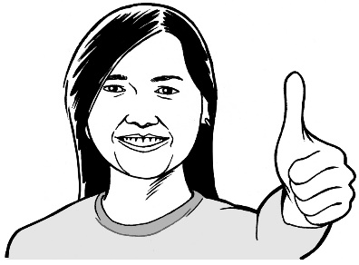
- tino rangatiratanga /
self-determination which means Māori get to decide what is best for them
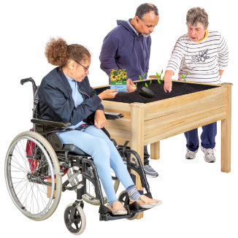
- ōritetanga / equity which is about being fair to everyone
- whakamaru / active protection which means looking after things
- kōwhiringa / options or being able to make different choices
- pātuitanga / partnership which is like working together.

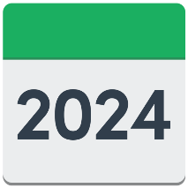
The Health Quality and Safety Commission will review the Code in July 2024.

Review means to:
- look at something again
- check it is still working well.

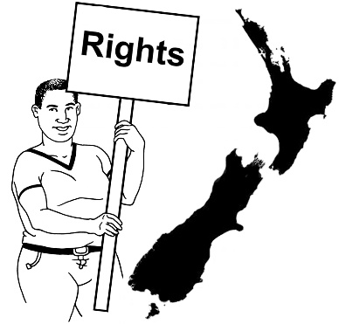
There will also be another Code called the Code of Health and Disability Services Consumers’ Rights.

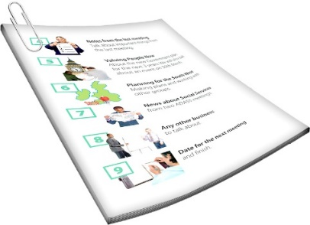
In this Easy Read document we call the Code of Health and Disability Services Consumers’ Rights the Code of Rights for short.
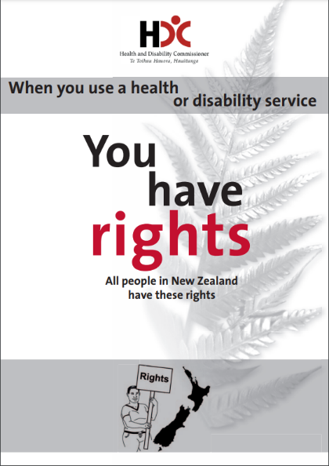

You can find an Easy Read version of the Code of Rights at:
www.hdc.org.nz/media/2813/you-have-rights-easy-read-version.pdf

Both the Code and the Code of Rights are very important.

Expectations

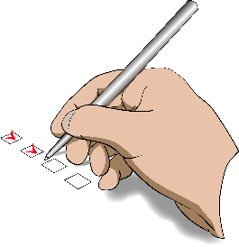
The Code says that when health entities engage with consumers / whānau / communities they must:
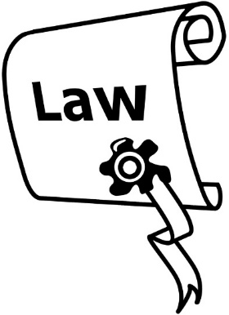

- Follow the health sector principles in section 7 of the Pae Ora (Healthy Futures) Act 2022.
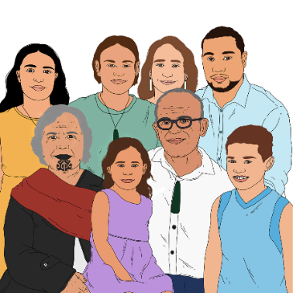

- Understand how important whānau is in te ao Māori / the Māori world.
This includes making sure there are ways Māori can be in charge of making decisions.

The Code says that when health entities engage with consumers / whānau / communities they must:

- Treat engagement as important.

Some of the things that make it easier to have engagement are:
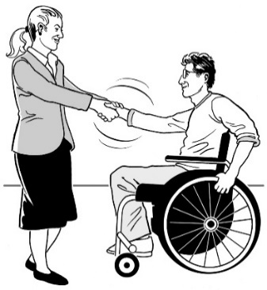
- honesty which is telling the truth and making sure you say the things that are important
- trust which is like thinking people will do what they say
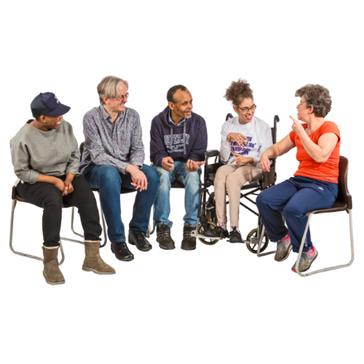
- being happy to share information or ideas
- wanting to learn from others.

The Code says that when health entities engage with consumers / whānau / communities they must:
- Share leadership.

Sharing leadership means to:

- be open to the ideas of other people

- make decisions together

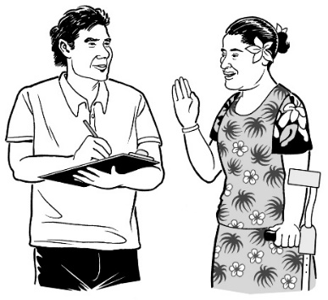
- know that the experiences of consumers are just as important as what people know from things like learning to be a doctor.

Consumers / whānau / people in the community often know the ways to make the health system better.
The Code says that when health entities engage with consumers / whānau / communities they must:

- Show that quality and safety are important.

A very important part of quality and safety is what things have been like for:
- consumers
- whānau / aiga / family
- communities.

The Code says that when health entities engage with consumers / whānau / communities they must:

- Work for more equity.

Equity is about being fair to everyone.
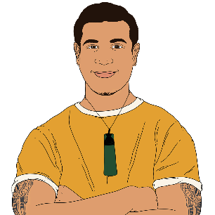

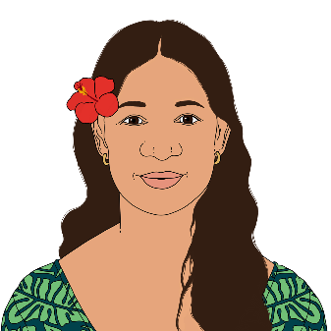
It is important to engage with those who have higher health needs like:
- Māori
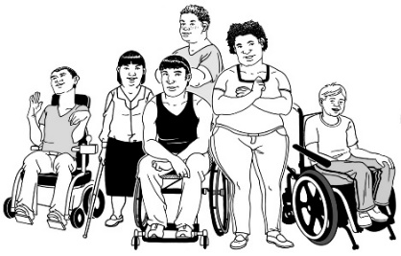
- Pacific peoples
- disabled people.

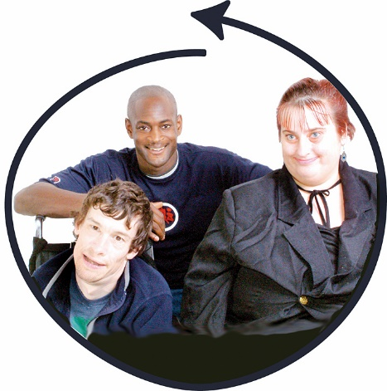
The best way to get better equity is by involving:
- consumers
- whānau / aiga / family
- communities.

How will health entities

meet the expectations?

These are the ways health entities must make the expectations happen:

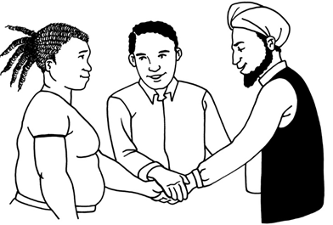
- Health entities must co-design with:
- consumers
- whānau / aiga / family
- communities.
Co-design means working together on:
- what things should be done first
- how things are done
- checking how things are going.

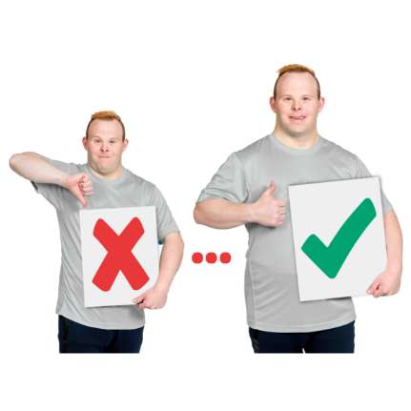
- Health entities must use the experiences people have had to make health services better.

An important part of this is making sure health services are fair for:
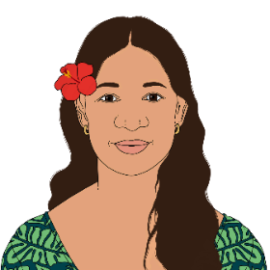
- Māori
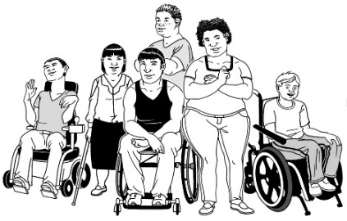
- Pacific peoples
- disabled people.

- Health entities must work towards more equity by working together with other organisations.

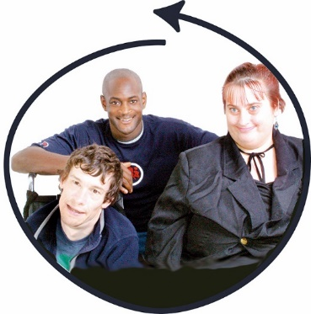
- Health entities must make sure that everyone can access information / resources.
Being able to access things means that it is easy for you to do or get them.

Resources are things like:
- money
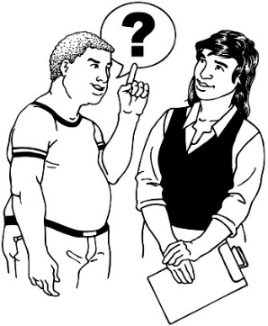
- places to meet
- being able to ask people questions.

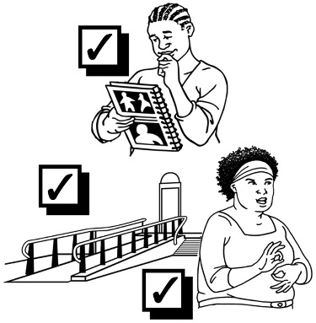
Health entities need to remove any barriers that may make it hard for people to engage.

Barriers are things that stop people from doing things.
- Health entities must give consumers / whānau / communities what they need to:
- be part of what health entities are doing
- have their say.

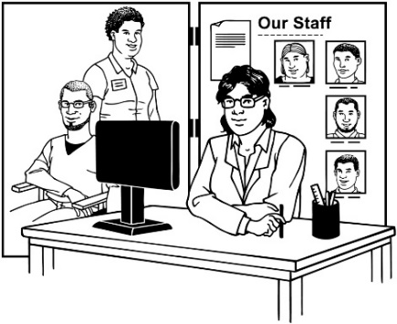
- Health entities must make sure that when new services are started they are set up to fit well with this Code.

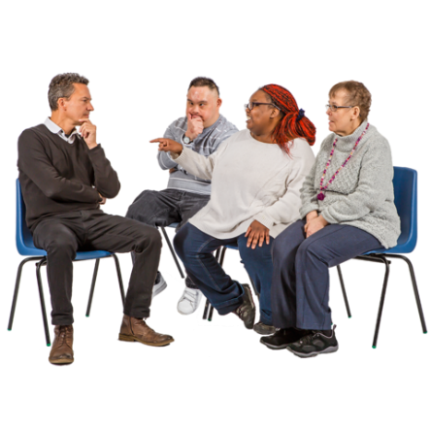

This means that they should be set up so consumers / whānau / communities can be part of things.

More information

You can find more information about the Code on the Health Quality and Safety Commission website:

hqsc.govt.nz/thecode

To contact the He Hoa Tiaki - Partners in Care team at Health Quality and Safety Commission you can:
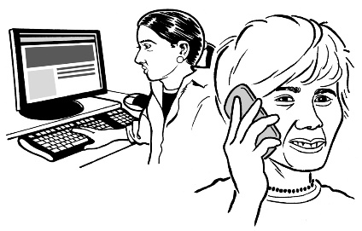
- Email: consumers@hqsc.govt.nz

- Phone: 0800 275 742

It does not cost any money to call this phone number.
This information has been written by the Health Quality and Safety Commission.
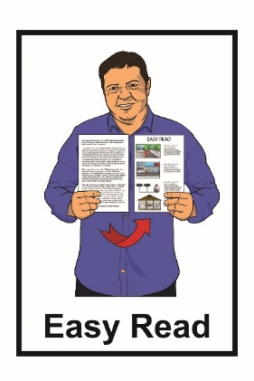
It has been translated into Easy Read by the Make It Easy service of People First New Zealand Inc. Ngā Tāngata Tuatahi.
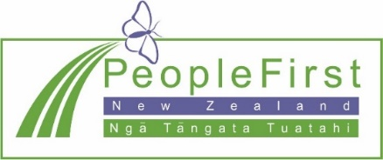
The ideas in this document are not the ideas of People First New Zealand Ngā Tāngata Tuatahi.
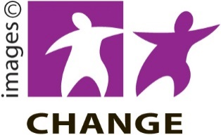
Make It Easy uses images from:

- Changepeople.org

- Photosymbols.com

- Sam Corliss

- Huriana Kopeke-Te Aho.

All images used in this Easy Read document are subject to copyright rules and cannot be used without permission.

