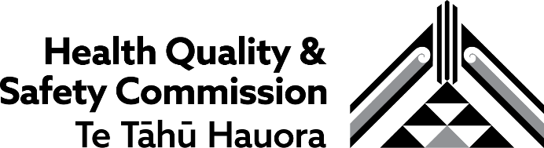
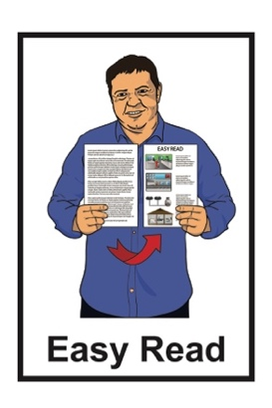

Summary:

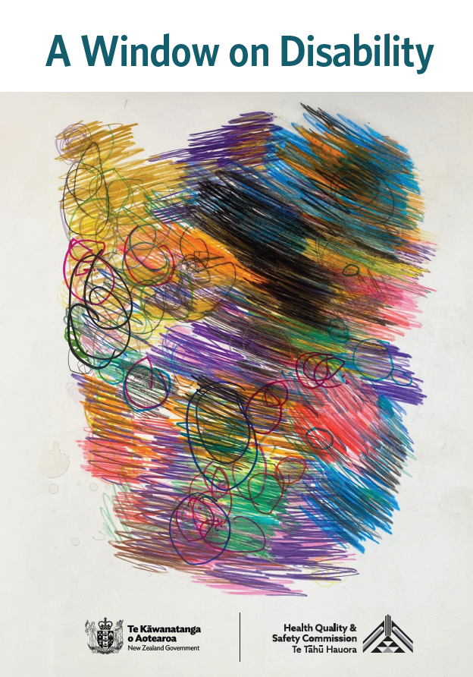
A Window on Disability

Published: May 2026

Before you start

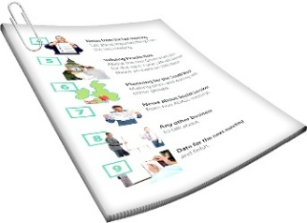
This is a long document.

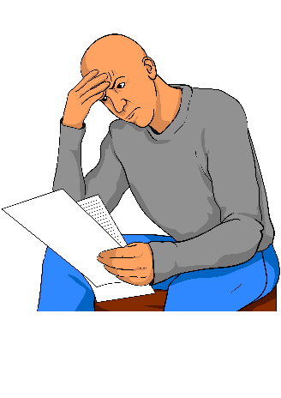
It can be hard for some people to read a document this long.

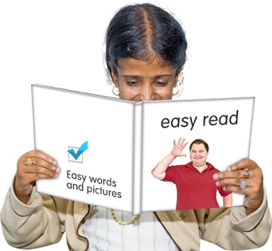
Some things you can do to make it easier are:
read it a few pages at a time
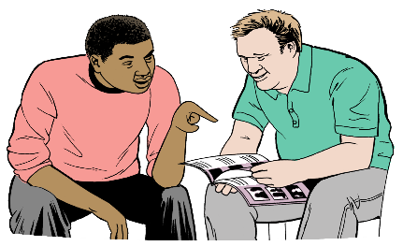
set aside some quiet time to look at it
have someone read it with you to support you to understand it.

Some of the information in this document may make people:
upset
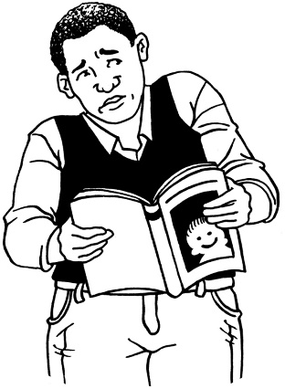
worried.


This information is not meant to scare anyone.


This information does not mean the things in this document will happen to:
you
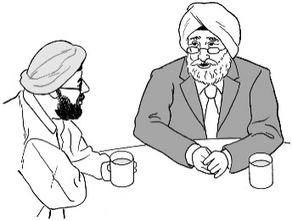
people you know.

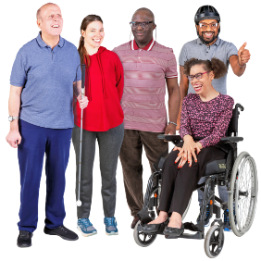
People with learning disability all have different health needs.

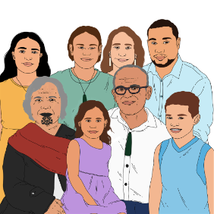
If you are worried you can talk to your:
whānau / family
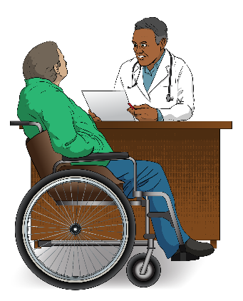
friends
doctor.

What you will find in here

Page number:
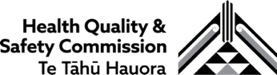

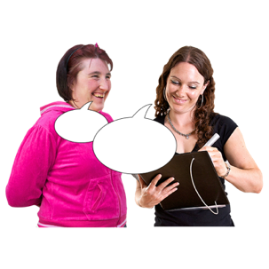
What this Easy Read is about 5

About the research 8
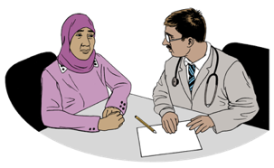

What we found out 13
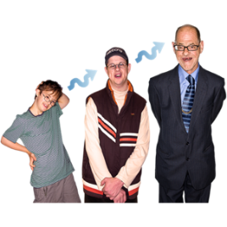

Life course stages 20


Recommendations 38

What this Easy Read is about

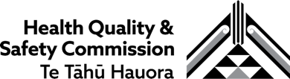
This Easy Read is from the Health Quality and Safety Commission Te Tāhū Hauora.
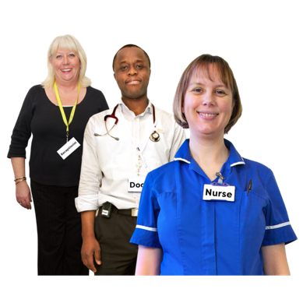

The Health Quality and Safety Commission Te Tāhū Hauora makes sure healthcare in Aotearoa New Zealand:
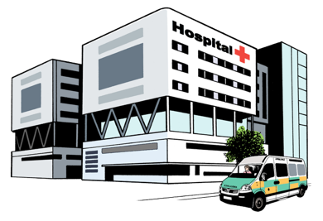
works well
is safe.

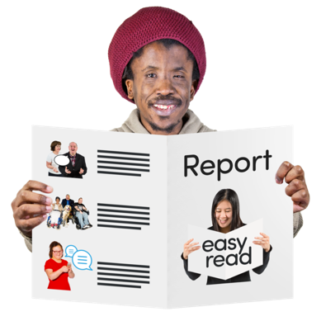
In this Easy Read we / our / us means the Health Quality and Safety Commission Te Tāhū Hauora.

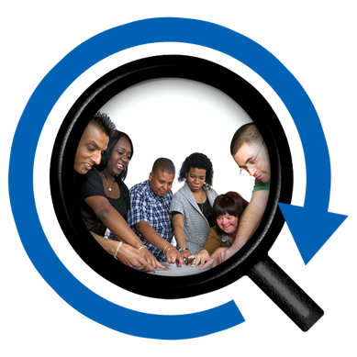
This Easy Read is about some research into healthcare for disabled people we did with the Donald Beasley Institute.

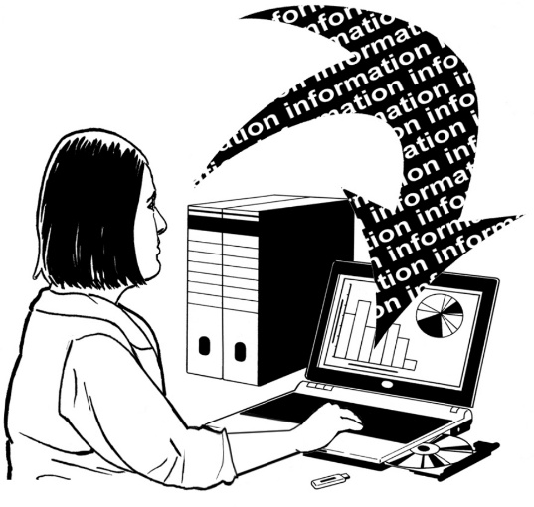
Research is when a lot of
information about something is put together to learn about it.


The Donald Beasley Institute is a place that researches things to do with disability.

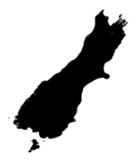
It is based in Dunedin in Aotearoa New Zealand.

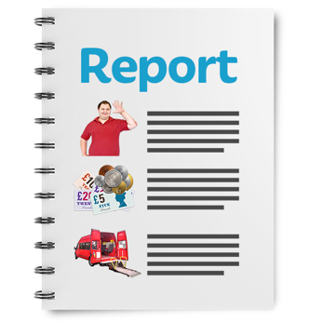
This Easy Read is a summary of the full report about our research.


A summary:
is shorter than the full report
tells you the main ideas.


You can read the full report at:

https://www.hqsc.govt.nz/a-window-on-disability.html

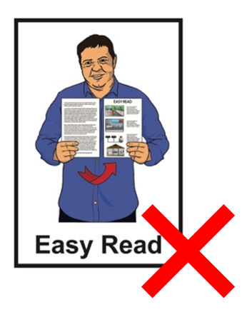
The full report is not in Easy Read.

About the research

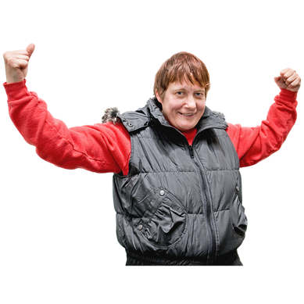
Disabled people should have the healthcare they need to:
be as healthy as possible
lead an ordinary life.
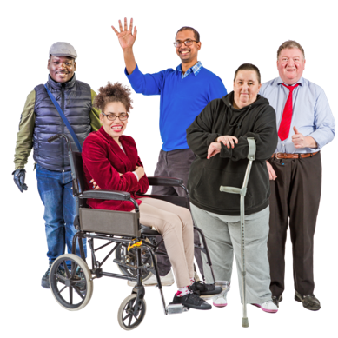

An ordinary life means being able
to do the same things as other people.


We wanted to find out if the healthcare disabled people get is:
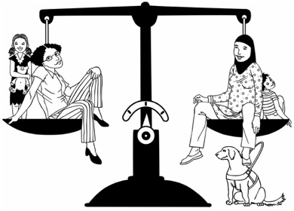
good enough
the same as the healthcare
non-disabled people get.

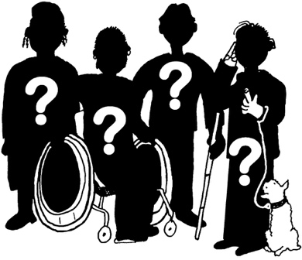
There is not much information about disabled people in Aotearoa
New Zealand.

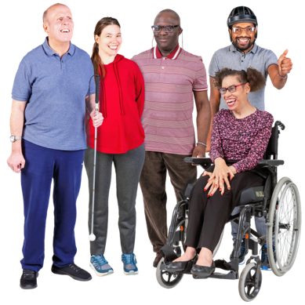
In 2023 the New Zealand census found that 5 out of every 1 hundred New Zealanders are disabled.

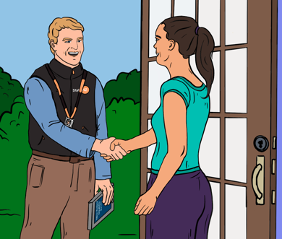
In Aotearoa New Zealand the census is research that finds out a lot of information about people in New Zealand.

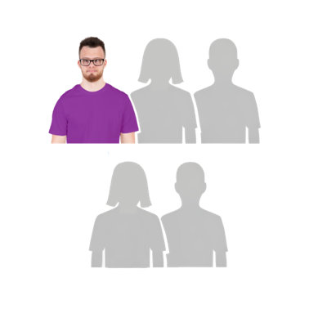
The 2023 Household Disability Survey found that almost 1 in 5 New Zealanders are disabled.

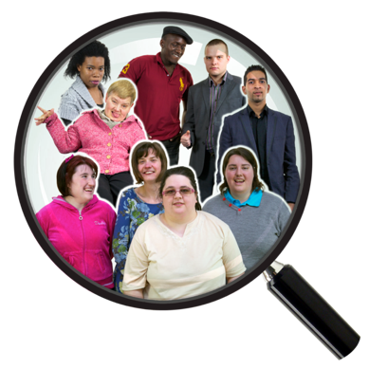
The Household Disability Survey
is research that was done to find out:
how many disabled people there are in Aotearoa New Zealand
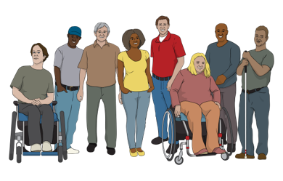
what life is like for disabled people in Aotearoa
New Zealand.
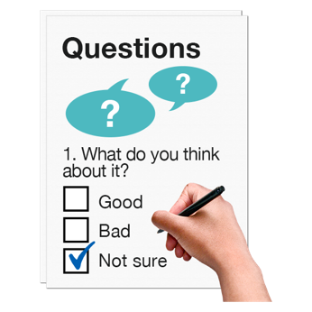

The Household Disability Survey:
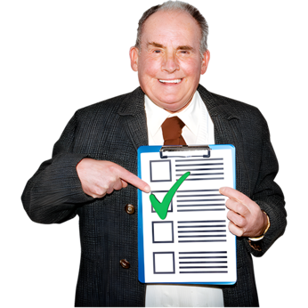
asked more question about disability than the census
is more likely to be right about the number of disabled people.

1 in 5 people means there are more than 8 hundred and 50 thousand disabled New Zealanders.

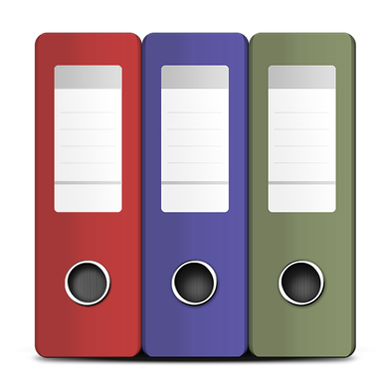
Most health data in Aotearoa New Zealand does not have information about disability.

Here data is information that shows what groups of people:
are doing
need.

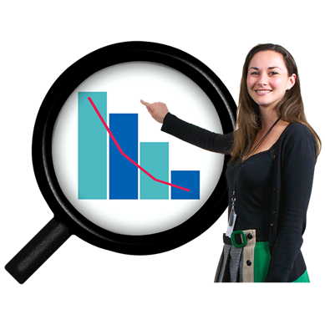
This means there has been very little research about healthcare for disabled people.

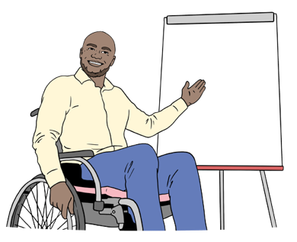
The research for this report was:
led by disabled people
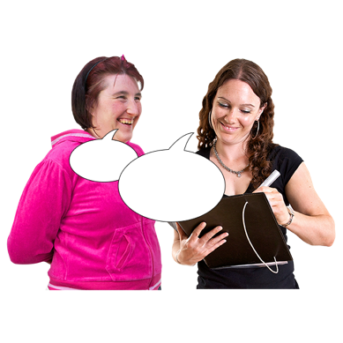
used a lot of different kinds of data
asked disabled people about their experiences of healthcare.

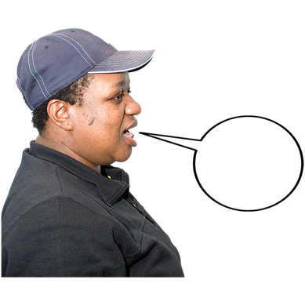
This Easy read includes some quotes from people we talked to for our research.

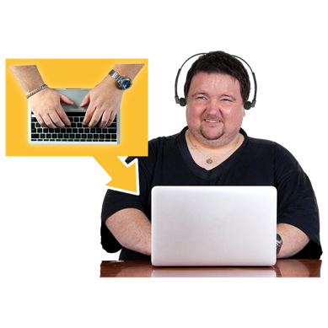
A quote is an exact copy in writing of
what someone has said.

The quotes are in purple boxes like this.

The quotes are not in Easy Read.

What we found out

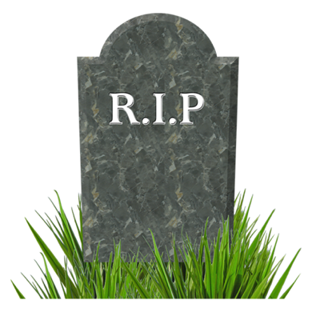
Disabled people are 5 times more likely to die from treatable conditions than non-disabled people.

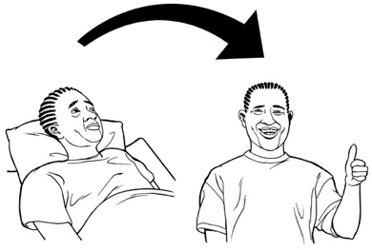
A treatable condition is a medical condition that can be:
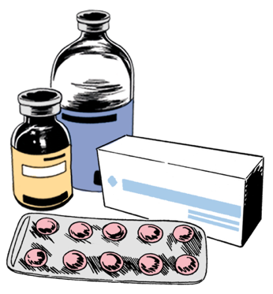
made better with treatment
or
treated so that someone can live with it for a long time.

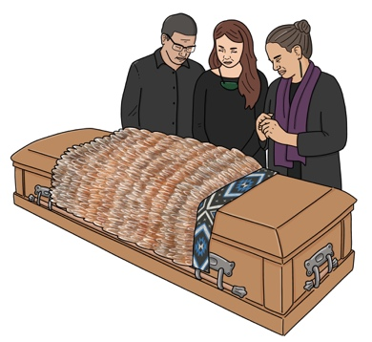
Māori disabled people are more than 10 times as likely to die from treatable conditions than people who are not:
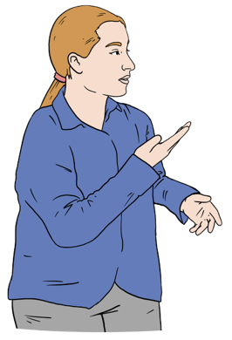
Māori
Pacific
disabled.

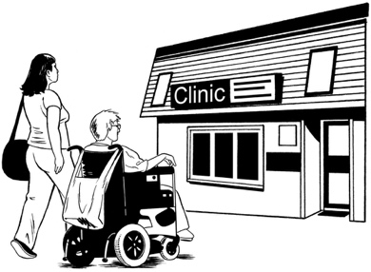
Disabled people are more likely to be enrolled in primary care than
non-disabled people.

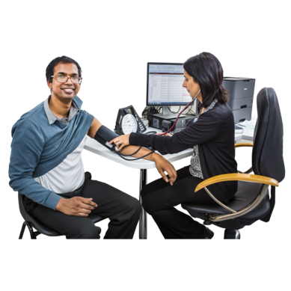
Here enrolled means you have a healthcare provider who:
has your medical information
you see for most health things.

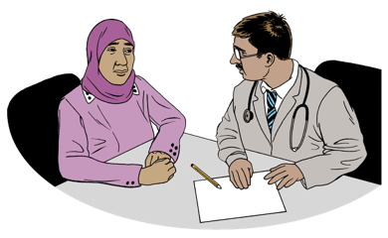
Primary care means healthcare that is not in a hospital like seeing your usual doctor / GP.
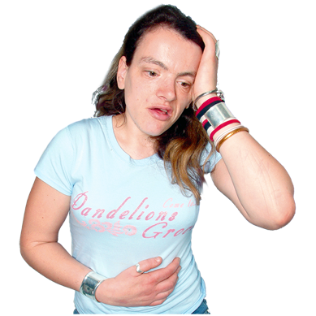

Many disabled people often cannot see a doctor when they need to even when they are enrolled in primary care.

This means that disabled people often go to the hospital emergency department when they are unwell.


Not getting healthcare when they need it means that disabled people are more likely to:
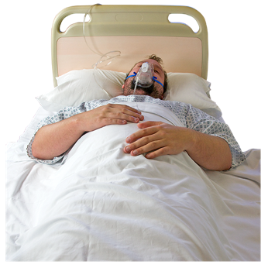
get more unwell than if they had been treated earlier
need to go to hospital
stay in hospital for longer
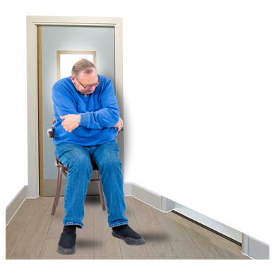
have worse:
- health
- lives.


It can also mean the government has to spend more money on healthcare.

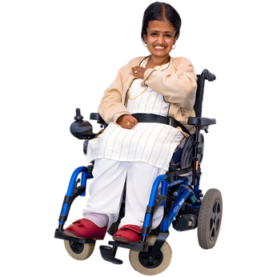
Getting healthcare is even harder for disabled people who:
have more than 1 disability
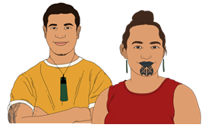
are Māori
are Pacific.

One of the people we talked to for our research is Jacinta Tevaga who is:
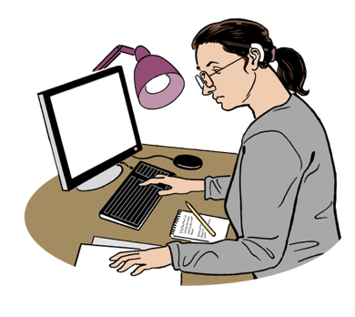
disabled
Samoan
a disability researcher.

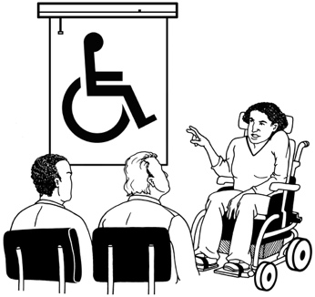
Jacinta Tevaga said:

Disabled people deserve to be listened to. We need staff who are trained in disability awareness.
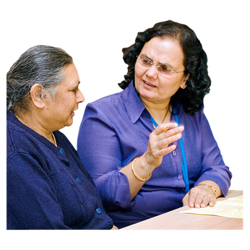

Accessible communication must be normal, not something we have to beg for.

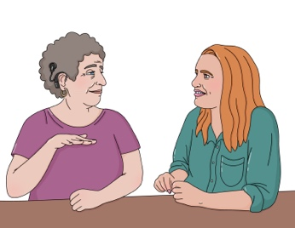
Accessible communication is communication that works for disabled people like:
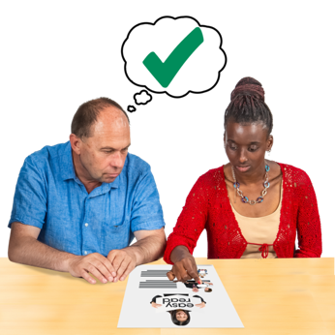
using New Zealand Sign Language
having written information in Easy Read.

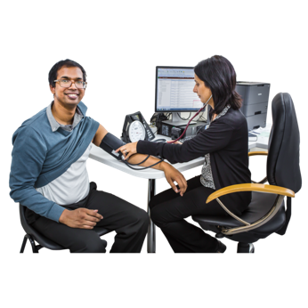
Jacinta Tevaga also said:

The system must understand that disabled people have other health conditions too.

We are whole people, not just our primary disabilities.

Life course stages
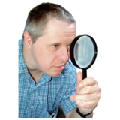

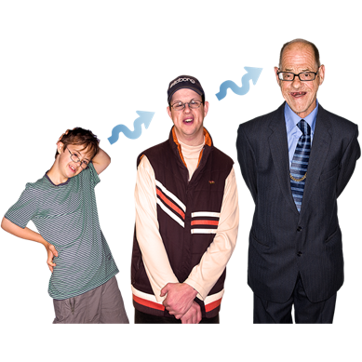
We took a close look at how disabled people experience healthcare at different life course stages.

Here life course stages means different times in your life.


This supported us to understand why there are such big inequities in healthcare.

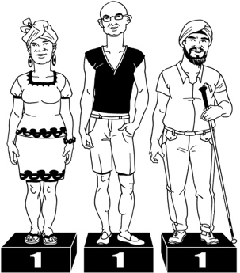

Inequities are things that are not:
fair
the same for everyone.

Pregnancy and birth
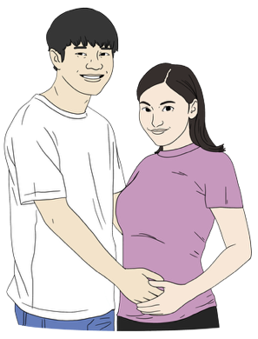
In Aotearoa New Zealand disabled people are less likely to have a lead maternity carer early in their pregnancy.

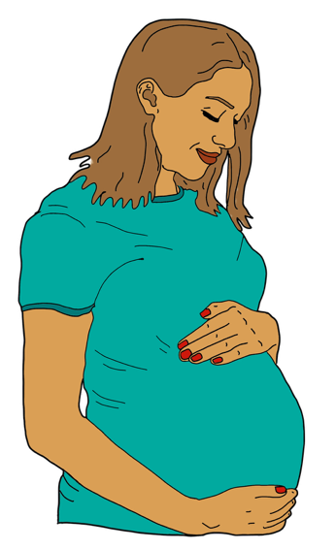
A lead maternity carer is the main healthcare worker when someone is:
pregnant
giving birth.

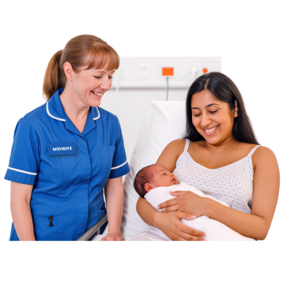
Lead maternity carers are people like:
midwives
obstetricians.

People with more than 1 disability are even less likely to have a lead maternity carer.

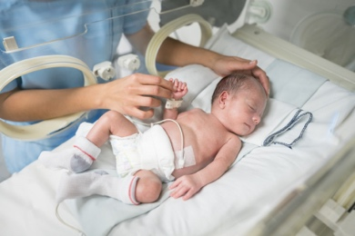
Disabled people are more likely to have pre-term births than non-disabled people.


Pre-term birth is when a baby is born too early.

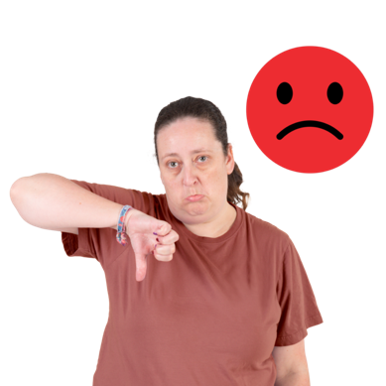
Disabled people are also more likely to say they did not have a good experience during:
pregnancy
birth.

We talked to Tamara Grant who is a disabled mother.

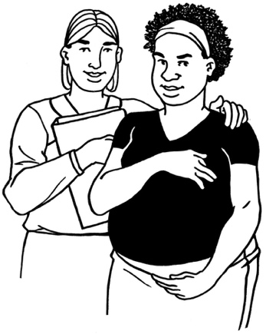
Tamara Grant said:

We deserve a health system that sees us, listens to us and believes we know our own bodies.

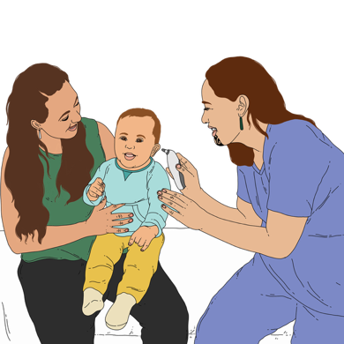
Children and youth

The health system seems to work well for disabled children.

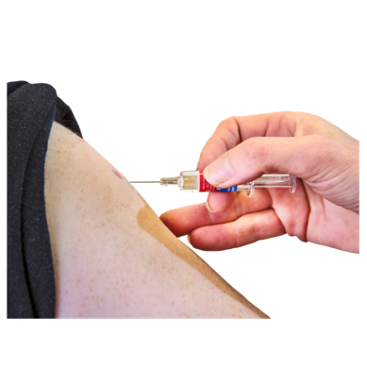
Disabled children were about as likely to get vaccines as non-disabled children before COVID-19.

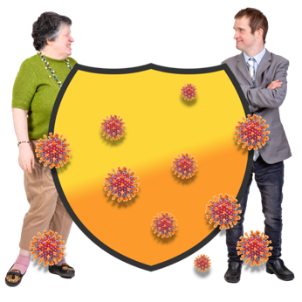
A vaccine is a medicine that can stop you getting very sick from a disease.
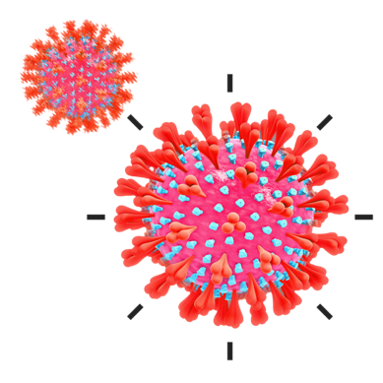
COVID-19 is a virus that can make people very unwell.

The COVID-19 pandemic started in 2020.
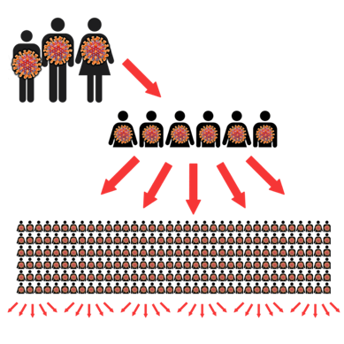

A pandemic is when a lot of people become unwell with the same disease at the same time.



We think that COVID-19 changed things so that disabled children are less likely to get vaccines now.

We do not have enough information to say this for sure.

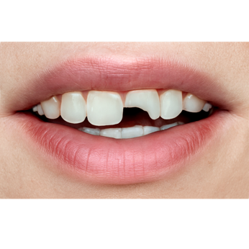
Disabled children often have problems with their teeth.

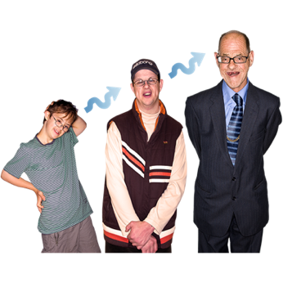
These problems often last for their whole lives.

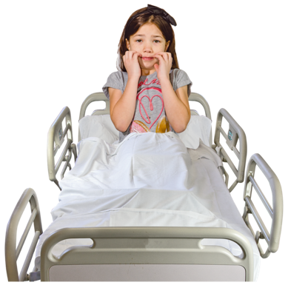
Disabled children are more likely to have such bad problems with their teeth they need to be treated in hospital.

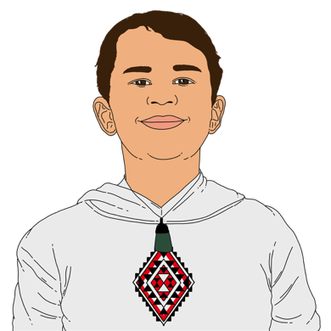
Disabled children are even more likely to need to have their teeth treated in hospital if they are:
Māori
Pacific.

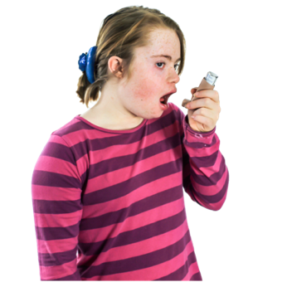
Disabled children are less likely to get the right treatment for asthma than non-disabled children.

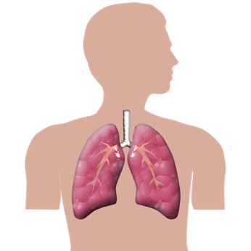
Asthma is a condition that can make it hard to breathe.

Disabled children are more likely to need to go to hospital because of asthma than non-disabled children.

Disabled children are more likely to experience avoidable hospitalisation for a lot of reasons like:
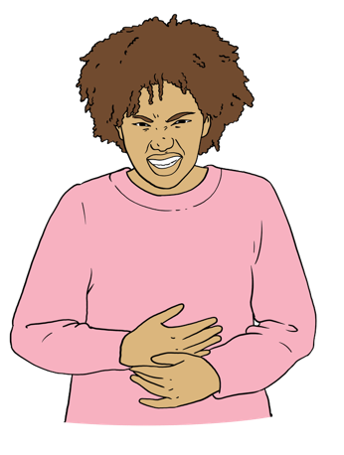
tooth problems
gastroenteritis / stomach bugs
constipation / not being able to poo.
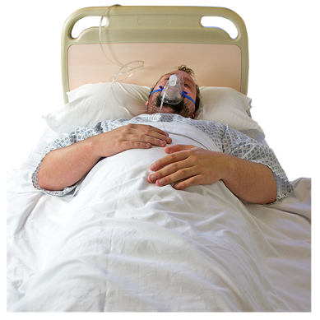
Avoidable hospitalisation means someone has to be in hospital when getting treatment earlier would have stopped them getting so sick.

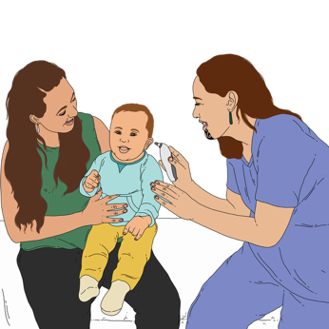
Disabled children often do not have all their needs met for:
primary care
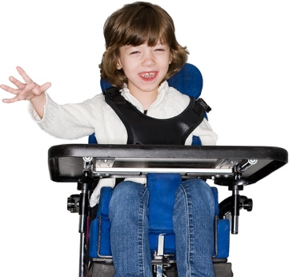
medication
assistive equipment.

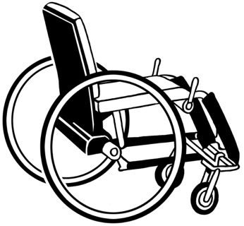
Assistive equipment means things that make life easier for disabled people like:
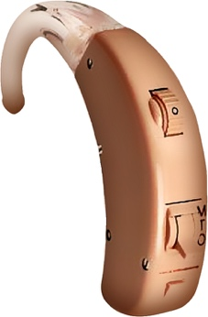
wheelchairs
hearing aids.

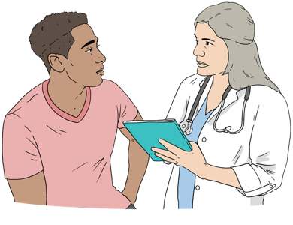
There can also be problems when disabled young people start using adult healthcare services.

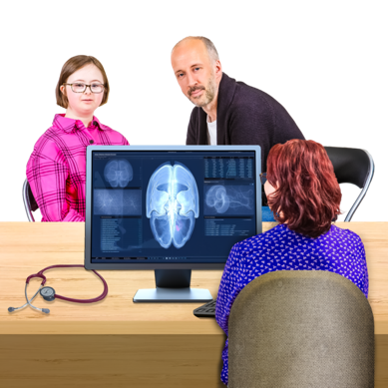
It can be hard to have to leave healthcare providers who:
know you well
you trust.

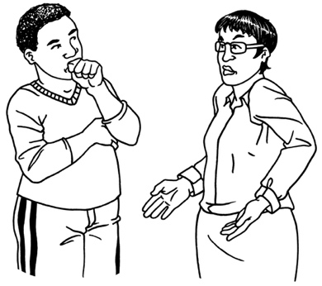
Some adult healthcare providers do not know a lot about disabled young people.

We talked to Kimberly Graham and her son Finlay Butcher.

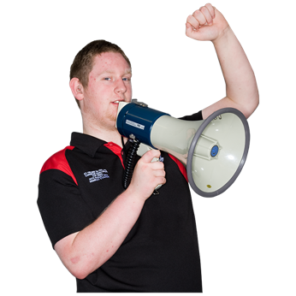
Kimberley Graham and Finlay Butcher said:

Instead of the steady, familiar
support we used to have from
long-term paediatric specialists, every service now seems to require constant and persistent advocacy.

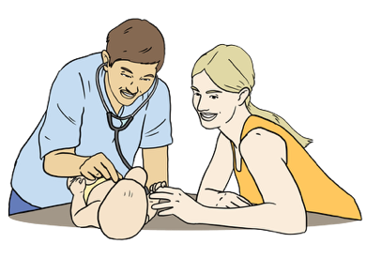
Paediatric specialists are healthcare workers who know a lot about giving healthcare to children.


Here persistent means to keep trying to do something a lot of times.
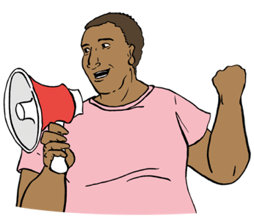

Advocacy means speaking up for someone.

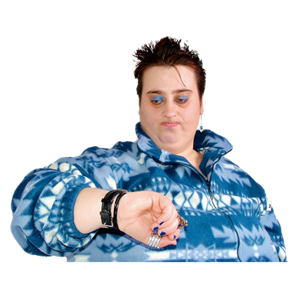
Adults

1 of the biggest barriers to healthcare for disabled adults is having to wait a long time.
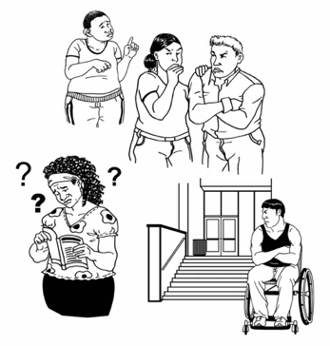

Barriers are things that make it harder for people to do things.

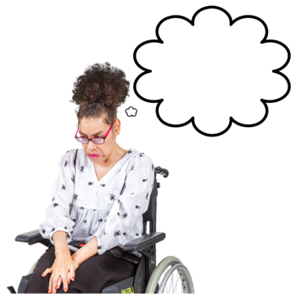
Disabled adults have more problems with mental health like:
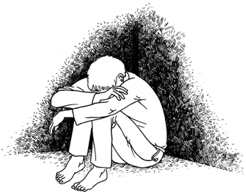
anxiety / feeling very worried a lot of the time
depression / feeling very unhappy a lot of the time.
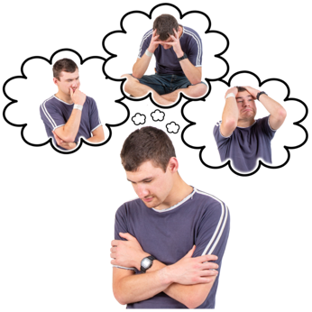

Mental health is about how you
think / feel in your mind.

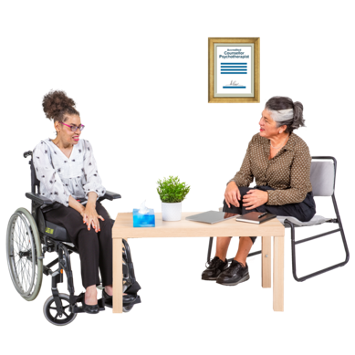
Disabled adults use more:
mental health services
addiction services.

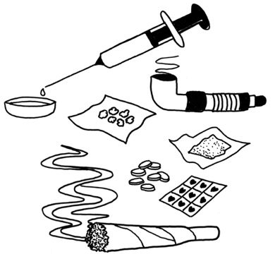
Addiction means not being able to stop yourself using things like:
drugs
alcohol.
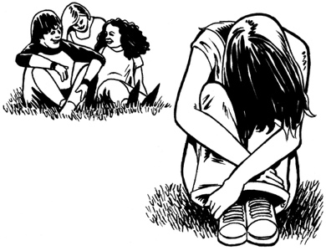

There are not enough mental health services for disabled adults.

We talked to Abel who is he tāngata turi / a Deaf Māori man.

Abel said:
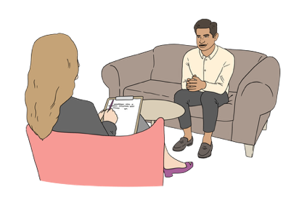
It shouldn’t be this hard to be seen, heard and supported in our own health system.

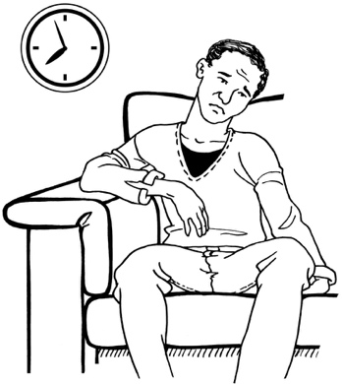
Disabled people are more likely to have to wait longer than 4 months to get treatment after a treatment plan has been made.

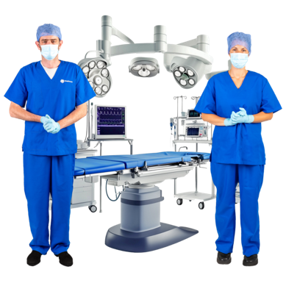
Disabled people are more likely to have problems getting better after an operation than non-disabled people.

There are more problems getting better after an operation for people who:
have more than 1 disability
are Māori
are Pacific.

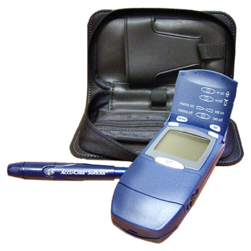
Disabled adults are more likely to have diabetes than non-disabled adults.
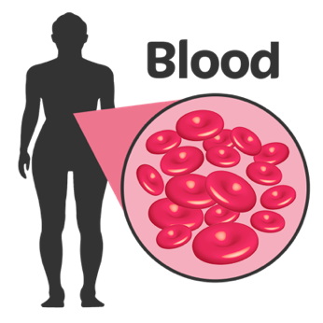

Diabetes is when someone has too much sugar in their blood.

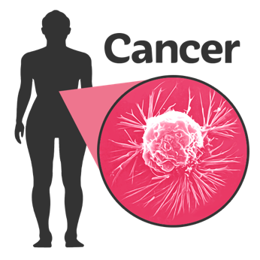
Disabled adults are also more likely to get many kinds of cancer than non-disabled adults.

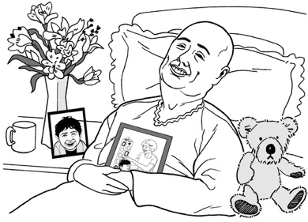
Cancer is a disease that can make people very sick.

There is not enough primary health care that works for disabled adults.

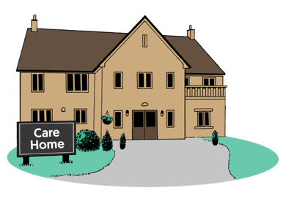
A lot of disabled adults who are less than 64 years old live in aged care homes.

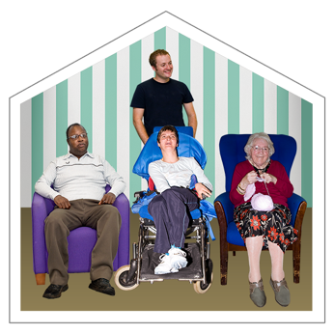
Aged care homes are not set up to meet the needs of younger adults.

We spoke to Waata Houia who is a Māori man with learning disability.

Waata Houia said:
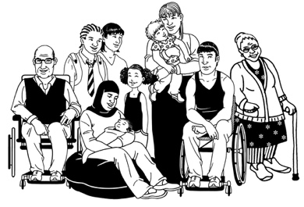
We’re the same as everyone else, but we’ve got a learning disability.

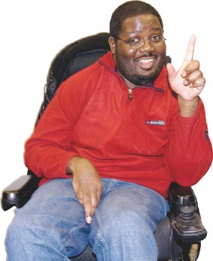
We know what we can do, we know what we want to talk about, and we know what they need to learn so
they can be accessible to us as who we are.

We won’t be changing! Treat us as equal.

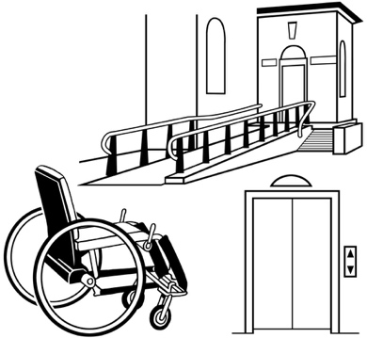
Accessible means everyone can do the things they need / want to do.

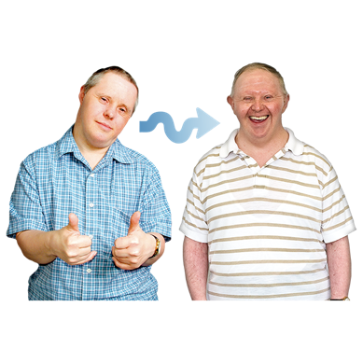
Older Adults

Disabled people are living longer than they did in the past because of better:
medicine
supports
services.

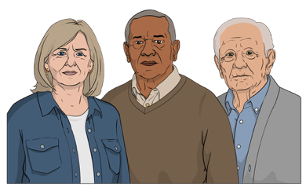
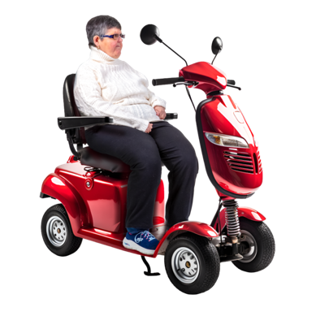
A lot of people also become disabled as they get older.

People who have become disabled when they are older often have different needs from people who have been disabled for a long time.

There is not a lot of information about the differences between these 2 groups of people.
Older people with more than
1 disability are more likely to:
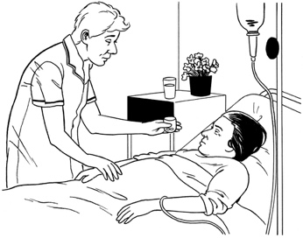
go to a hospital emergency department
need to stay in hospital.

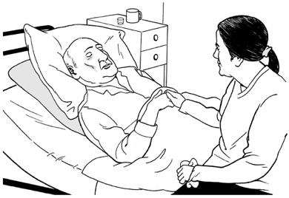
Older people with more than 1 disability often stay in hospital longer than other older people.


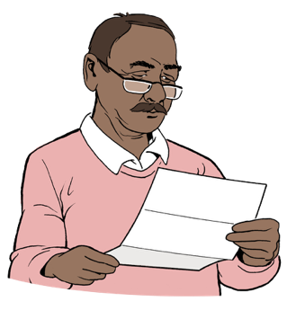
Disabled people who live in aged care homes are less likely to say they get good care than other people who live in aged care homes.

Recommendations

Our research shows that there is not enough data about disabled people in Aotearoa New Zealand.
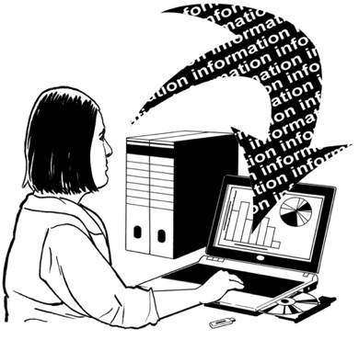

The data we do have shows that disabled people often:
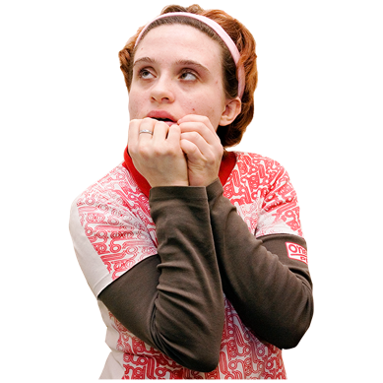
have worse health than
non-disabled people
are less safe than non-disabled people.

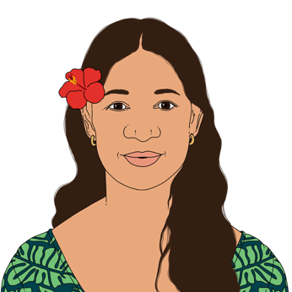
The data shows this is even worse for:
Māori
Pacific people.

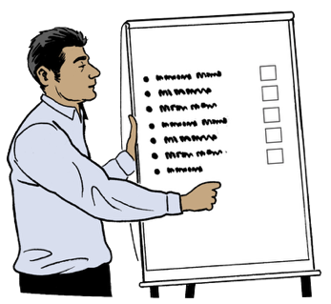
We have some recommendations for how to make healthcare better for disabled people.

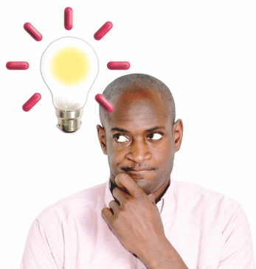
A recommendation is something we think would be good to do.

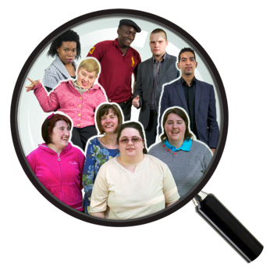
We need to know more

It is important that data about disability is part of health data.

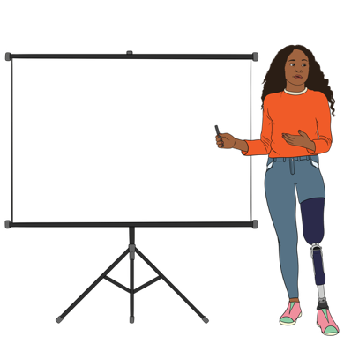
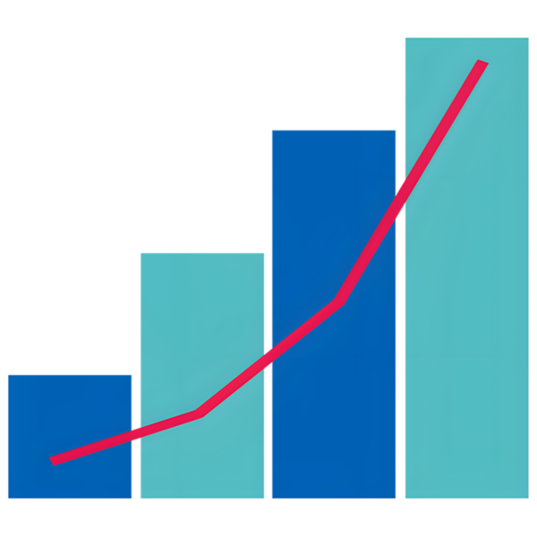
The work to get better data about disability should be led by:
disabled people
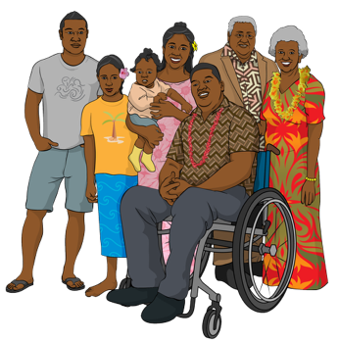
tāngata whaikaha / Māori disabled people
whānau / families of disabled people.
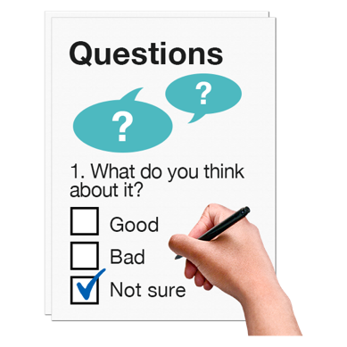
A good first step would be to make a rule that organisations must ask about disability when they ask people for health data.

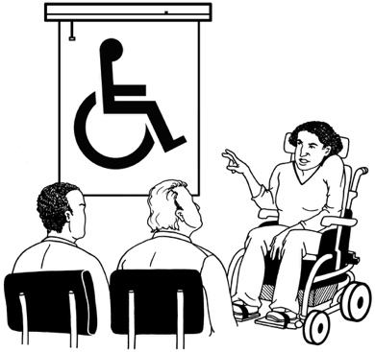
We need to train healthcare workers

All healthcare workers should get training about disability.

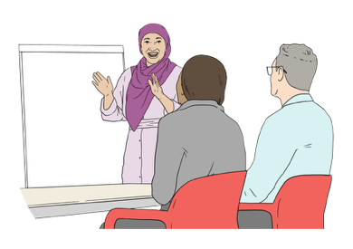
Information about disability should be part of all stages of training healthcare workers.
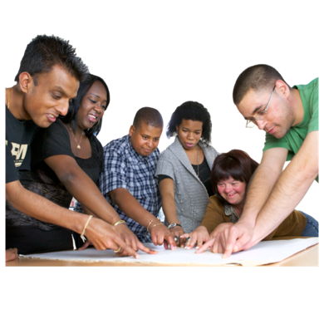

We need to write a curriculum for teaching healthcare workers about disability.


A curriculum says the things that should be taught in a course of study.
Everyone who trains healthcare workers should have to use the disability curriculum.

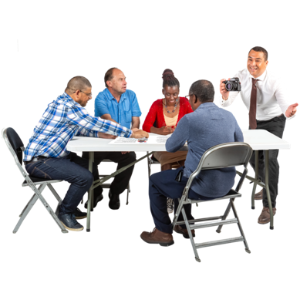
A good first step would be to start a working group of:
disabled people
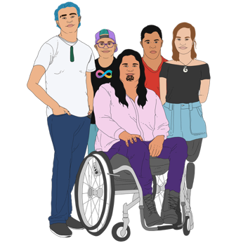
tāngata whaikaha / Māori disabled people

people who know a lot about healthcare for disabled people
people who decide how healthcare workers are trained.

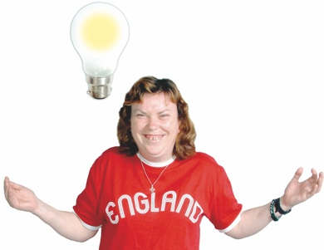
A working group is a group of people who:
know a lot about something
work together to get something done.
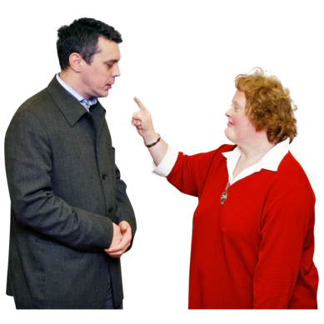

The working group should have the power to say what healthcare workers must learn about disability.

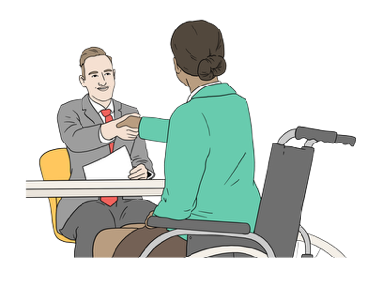
We should employ the right people

Employ means to give someone a job.
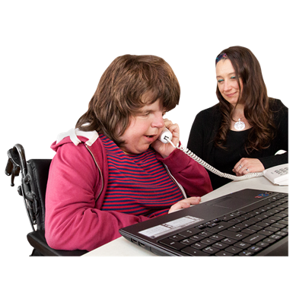

All healthcare services can give better care by having disabled people working for them.

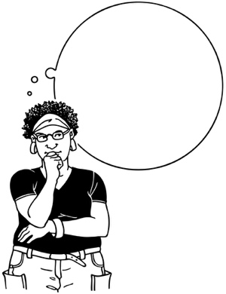
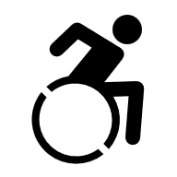
Disabled people are best at understanding what it is like to be disabled.

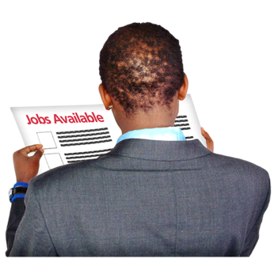
Healthcare services should do everything they can to:
find disabled people to work in healthcare

keep disabled healthcare workers in their jobs
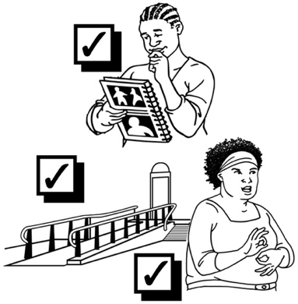
train disabled healthcare workers so they can move ahead in their jobs
make reasonable accomodations for disabled healthcare workers.

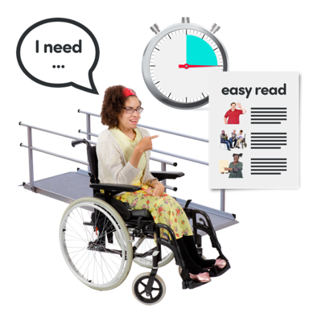
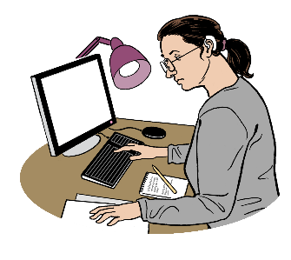
A reasonable accommodation is making changes to something so disabled people can do things like:
work
get information
use services.

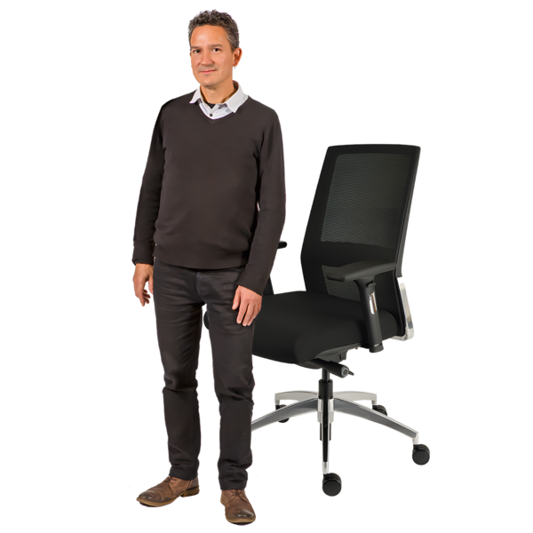
Reasonable accommodations might include:
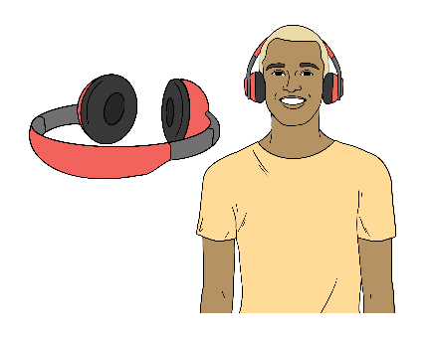
having a different kind of chair at work
being allowed to wear headphones to block out noise.

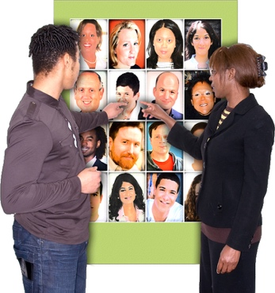
A good first step would be to look at how services choose which healthcare workers to employ.

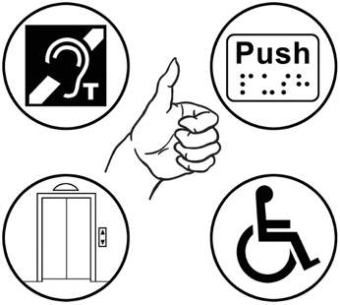
We need to make sure the way services choose healthcare workers is:
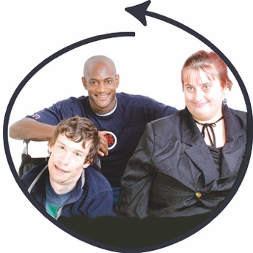
accessible
inclusive.

Inclusive means that:
everyone can take part
no one is left out.

We need to think about how healthcare services:
advertise jobs

interview people for jobs
support healthcare workers to do well in their jobs.

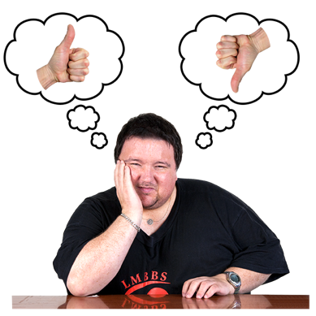
We need to involve

We need to make sure disabled people can be part of choices about their healthcare using:
self determination
supported decision making.

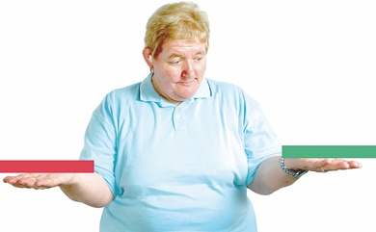
Self determination means disabled people have control over their own lives.

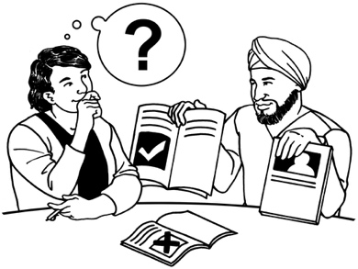
Supported decision making is when someone has support to:
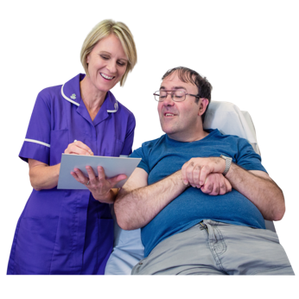
understand their choices
make the decision that is right for them.


We need to make sure disabled people have what they need to make decisions about their healthcare like:
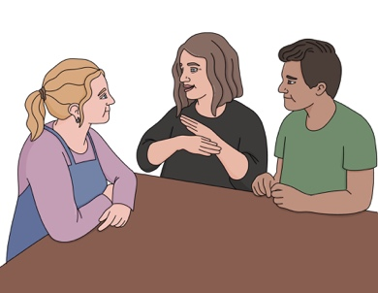
information they can understand
support with communication
enough time.

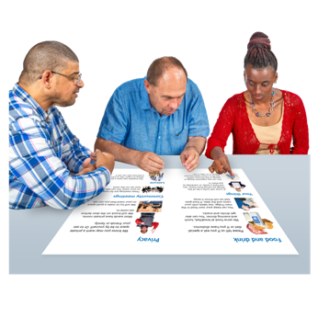
A good first step would be to work with disabled people to:
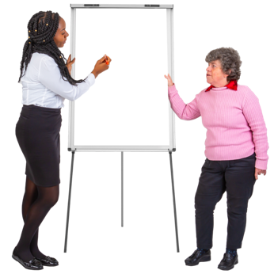
design ways of doing supported decision making that can be used all over Aotearoa New Zealand
train healthcare workers to use supported decision making.

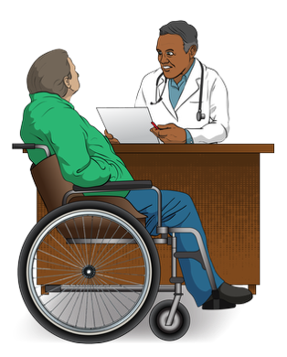
We need to make sure healthcare is done in a way that supports the rights of:
disabled people
tāngata whaikaha / Māori disabled people.

Rights are things everyone should:
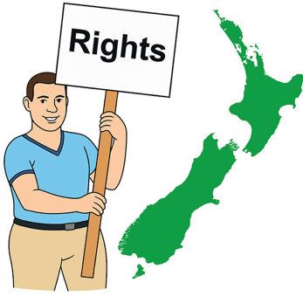
have
be able to do.

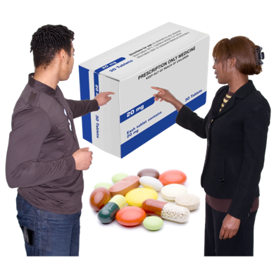
Rights are things like:
getting the healthcare you need
making your own choices about healthcare.


This information has been written by Health Quality and Safety Commission Te Tāhū Hauora.

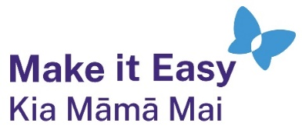
It has been translated into Easy Read by the Make it Easy Kia Māmā Mai service of People First New Zealand Ngā Tāngata Tuatahi.
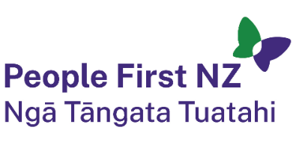
The ideas in this document are not the ideas of People First New Zealand Ngā Tāngata Tuatahi.

All images used in this Easy Read document are subject to copyright rules and cannot be used without permission.

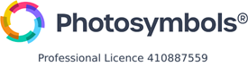
Make it Easy uses images from:

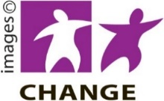
- Photosymbols

- Change Images


- Huriana Kopeke-Te Aho

- SGC Image Works

- T Wood


- Studio Rebeko

- Inga Kramer.

