A Window on Disability
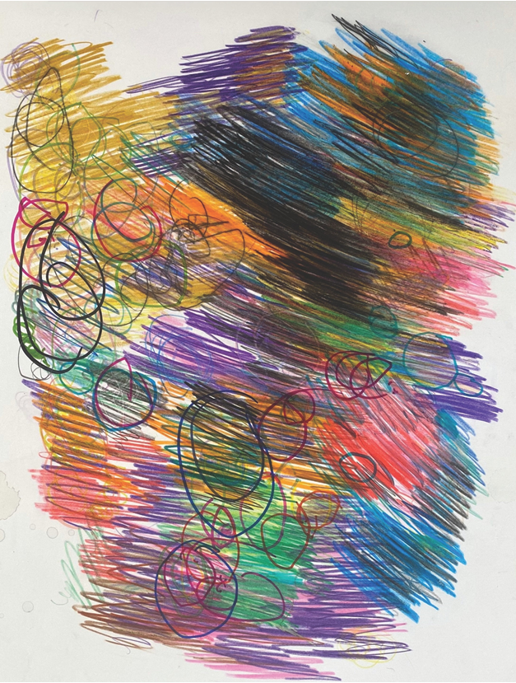


Cover artwork by Sasha Wells, Dunedin, 1986.

Sasha Wells is a Studio2 artist. Sasha likes to draw dogs and cats, using different colours to layer paint, pens, and coloured pencils. Sasha enjoys coming to Studio2 because it’s fun – ‘This is a picture of sleeping dogs.’

Studio2 is a creative studio space in Ōtepoti Dunedin, where disabled artists are supported to create artwork, experiment with a range of materials, and develop their own artistic styles and profiles.

Published May 2026 by Health Quality & Safety Commission Te Tāhū Hauora,
PO Box 25496, Wellington, 6146.

ISBN: 978-1-991122-44-5 (online)
Available online at www.hqsc.govt.nz
Enquiries to: info@hqsc.govt.nz

This work is licensed under the Creative Commons AttributionNonCommercial-ShareAlike 4.0 International (CC BY-NC-SA 4.0). To view a copy of this licence, visit https://creativecommons.org/licenses/by-nc-sa/4.0


Executive summary
Disabled people should have the opportunity to survive, thrive and lead ordinary lives with their whānau and friends. The Window on Quality reports are designed to provide a snapshot of the quality and safety of our health system at a given point of time. This is a summary of the high-level findings from the full Window on Quality report about disabled people’s health. If you would like to read the full report, you can find it on the Health Quality & Safety Commission Te Tāhū Hauora (the Commission) website at: hqsc.govt.nz/a-window-on-disability.

The difficulties of disability data
Disability in New Zealand is not measured well. While the limited questions in the New Zealand Census 2023 found 5% of New Zealanders were disabled, the deeper and broader questions in the Household Disability Survey run by Stats NZ found that, in 2023, 17% of New Zealanders were disabled.

That figure represents more than one-sixth of the population, or more than 850,000 people.

Despite this, the disability status of New Zealanders is not collected in all our normal health data sources, so the quality of health care for disabled people has not been measured properly before.

The Commission has produced the ‘Window on Disability’ report in partnership with the Donald Beasley Institute (DBI) and Nicholson Consulting. The report combines disabled-led research and disability community engagement with advanced Integrated Data Infrastructure (IDI) data analytics.

This report uses new techniques to examine whether there are differences in health care access, experience, quality and outcomes between disabled and non-disabled people, as many disabled people have reported from personal experience. Findings confirm community insights and, for the first time at scale, reveal how disabled people interact with and experience the health system.

High-level findings: amenable mortality (death from treatable conditions) and health care usage of disabled people

Disabled people die from treatable conditions (known as ‘amenable mortality’) at five times the rate of non-disabled people.

Amenable mortality rate per 100,000 population, ages 5–64 years, by disability status, 2019 and 2020
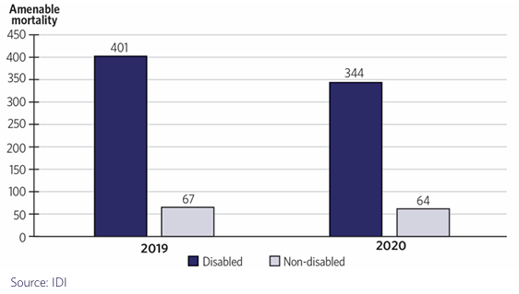

Māori disabled people die from treatable conditions at about 10 times the rate of non-Māori, non-Pacific non-disabled people.

Amenable mortality rate per 100,000 population, ages 5–64 years, by disability status and ethnicity, 2019 and 2020
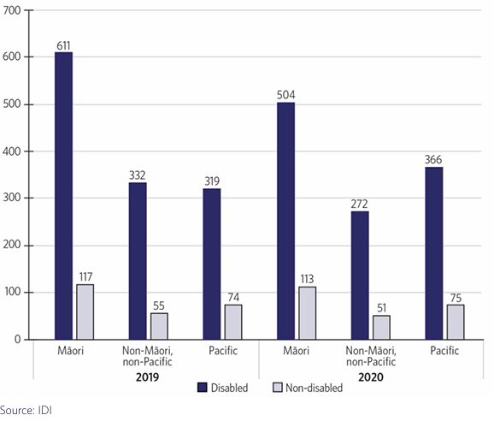

A high-level view of disabled people’s health care usage shows that despite having higher rates of enrolment in primary health care, difficulties in accessing a GP appear to drive large numbers of disabled people to emergency departments, contribute to higher rates of hospitalisations and lead to longer average hospital stays than non-disabled people. All of this comes at a cost to people’s lives and to the health system in dollars. Having more than one disability or being Māori or Pacific disabled makes these inequities worse.

Jacinta Tevaga, is a proud Samoan woman, born Tangata Te Tiriti, who came from Samoa to Aotearoa in the early 1990s. She has trained and worked in mental health and addiction, and disability and is now a researcher focused on Disabled Person-Led Monitoring of the United Nations Convention on the Rights of Persons with Disabilities. As a vision-impaired user of our health system, Jacinta says, “Disabled people deserve to be listened to. We need staff who are trained in disability awareness – not just nurses, but health care assistants, doctors, everyone. Accessible communication must be normal, not something we have to beg for. And the system must understand that disabled people have other health conditions too. We are whole people, not just our primary disabilities.”

We dive deeper into life course stages to understand some of the contributors to these high-level inequities.

Life-course stage – Maternity and birth

In New Zealand, disabled people are less likely than non-disabled people to be enrolled with a lead maternity carer (LMC), such as a midwife, in their first trimester of pregnancy. People with multiple impairments are even less likely to be enrolled with an LMC.

Later, compared with non-disabled people, disabled people experience higher rates of pre-term birth, and report lower scores on their experience of maternity care and their satisfaction with the maternity experience. Tamara Grant (Ngāti Tūwharetoa, Ngāti Tama, Ngāi Tahu), who is autistic, has fibromyalgia and is a mother of two, says. “We deserve a health system that sees us, listens to us and believes we know our own bodies.”

Life-course stage – Children and youth

Broadly, the system appears responsive to disabled children. Before the COVID-19 pandemic, disabled children were vaccinated at similar rates to non-disabled children. It is likely that the pandemic led to some inequity, but we do not have data to support this. The IDI uses older census data, so we do not have information for babies born after the census. However, data for five-year-olds appears to support the suggestion that there has been a downturn in immunisation rates for disabled children – Māori and Pacific disabled children in particular.

Poor oral health is an early issue and recurs throughout the life course. Evidence comes from rates of dental hospitalisations for dental disease, which are higher for disabled children than for non-disabled children. Rates are higher again for Māori and Pacific disabled children.

Compared with non-disabled children, asthma in disabled children is less likely to be treated well, and higher rates of hospitalisation follow. Disabled children experience higher levels of potentially avoidable hospitalisations for different causes, including dental, gastroenteritis and constipation, than non-disabled children. Disabled children and young people, along with their whānau, report significant unmet need for primary health care, assistive equipment and medication. The shift from paediatric to adult health care services is fraught. For example, it can involve poorly managed transitions, limited expertise in youth health among adult providers, loss of trusted paediatric relationships, and weak communication across adult care. This experience is reflected in the story of Kimberly Graham, and her son Finlay Butcher, as Finlay transitioned from paediatric services: “Instead of the steady, familiar support we used to have from long-term paediatric specialists, every service now seems to require constant and persistent advocacy.”

Life-course stage – Adults

Patients’ experiences of barriers to accessing primary health care indicate that wait times are a key issue. In terms of mental health, disabled adults experience higher rates of anxiety and depression and use specialist mental health and addiction services more frequently but still experience greater unmet need for mental health services.

Abel, Tāne Maori, he tangata turi (Māori Deaf male), says, “For too long, Māori and tangata turi men like me have been in survival mode. We adapt, we prepare, we advocate – not because we want to, but because we have to. It shouldn’t be this hard to be seen, heard and supported in our own health system.”

The elective surgery cluster of indicators shows that the proportion of disabled people waiting longer than four months for their first specialist assessment after referral is similar to that for non-disabled people. However, the proportion of disabled people waiting more than four months for treatment once a treatment plan is committed to is higher than that of non-disabled people. Disabled people experience higher rates of post-operative complications for common surgeries. Moreover, the risk increases as the number of impairments increases and is disproportionately higher for Māori and Pacific disabled people.

Like disabled children and young people, disabled adults experience higher levels of dental surgeries as oral health worsens over time, and significant unmet need particularly for primary health care. Disabled adults have a higher prevalence of diabetes than non-disabled adults. Many disabled adults under 64 years of age live in long-term care homes – that is, aged residential care (780 people in the first quarter of the 2024/25 financial year), despite these settings not being designed for the needs of younger adults. Data from Te Aho o Te Kahu – Cancer Control Agency shows disabled people experience higher rates of major cancers – lung cancer in particular – than non-disabled people.

Waata Houia, a 41-year-old Māori man with a learning disability, says, “We're the same as everyone else, but we've got a learning disability. We know what we can do, we know what we want to talk about and we know what they need to learn so they can be accessible to us as who we are. We won’t be changing! Treat us as equal.”

Life-course stage – Older adults

Improved access to medicines, supports and services has contributed to increased life expectancy among disabled people compared with earlier periods. At the same time, many non-disabled people acquire age-related impairments and disabilities later in life. However, there is limited data distinguishing between these groups and their distinct health needs.

Older disabled people (65–79 years) with more than one impairment use ED at higher rates, are hospitalised at higher rates and stay longer in hospital once there.

Robyn Hunt is disability consultant, blogger and commentator. She is a lifelong wheelchair user, vision impaired and hearing impaired. Robyn talks about the experience of ageing with disability into a cohort characterised by newly acquired disability, including the negotiation of a health system that is primarily set up to address late-acquired and age-related disability.

This chapter also addresses the quality of care in home and community support settings for older disabled adults, their experience of this care and what could be improved – in particular, older disabled people were significantly less likely than non-disabled people to report positive experiences with effective and reliable scheduling of care.

Conclusion

A Window on Disability demonstrates that the nature of our data on disabled people depends critically on the questions that are asked, when they are asked, who they are asked of and how they are asked. Greater rigour is urgently needed in the way disabled people’s health and safety are documented within New Zealand’s public health system. While the complexity of capturing disability data and the gaps in the evidence base are clear, the data that does exist tells a consistent and deeply concerning story. This Window affirms what many disabled people already know through lived experience: disabled people experience poorer health and safety outcomes than their non-disabled peers, with disparities further compounded for Māori and Pacific disabled people.

Recommendations

1. We need to know
The central problem identified in this Window report is the absence of disaggregated data related to disability. Disability must be accurately reflected in national health data.

Programmes such as the Patient Profile and National Health Index (PPNHI) show a way forward. Both Health New Zealand – Te Whatu Ora (Health NZ) and the Ministry of Health Manatū Hauora (the Ministry) are engaged in work-around approaches to effective and accurate reflection of disability in national health data.

This work must be genuinely led by disabled people, tāngata whaikaha and their whānau and fully engaged with by every health service and agency in the country as a matter of priority.

A good first step would be to:

commit to, and fully resource, the mandatory inclusion of standardised disability identification questions across all existing and future health data collection processes.

2. We need to train

Disability knowledge must be embedded into all stages of the education, training and professional development of our health care workforce. We must agree on a disability curriculum with the disability community and make it compulsory.

This responsibility falls first to the governing bodies of the medical schools, then to the medical and nursing councils, and onward into the Ministry and Health NZ itself.

A good first step would be to:

mandate a high-level working group to embed disability-inclusive competencies across all health workforce curricula. This group needs to comprise disabled people, tāngata whaikaha and their whānau, and disability health experts, alongside senior decision-makers from professional training and development bodies.

3. We need to employ

Every health agency and service can benefit their users through the employment of disabled people and tāngata whaikaha who understand the disability experience. Actions to recruit, retain, make reasonable accommodations for and support the progression of disabled people within the health workforce are needed to achieve this.

A good first step would be to:

conduct a comprehensive review of existing hiring frameworks to identify and extend, and if necessary develop, robust inclusivity and accessibility policies. This includes recruitment, ensuring that both digital platforms and physical interview processes are accessible by design, and support is provided for disabled people’s long-term success and career progression within the role.

4. We need to involve

We must embed self-determination and supported decision-making as core principles in the New Zealand health system. Disabled people, tāngata whaikaha and their whānau must be involved, and know they are involved, in decisions about their treatment and care. They must be provided the means to enable this: accessible tools and information, communication supports and time to enable meaningful participation.

A good first step would be to:

implement nationwide supported decision-making frameworks and training, developed in partnership with disabled people and tailored specifically for frontline health services to ensure clinical practice aligns with the human rights of disabled people and tāngata whaikaha.

