NZ Patient Experience Surveys | Cultural Safety Cognitive
Pre-test Report

Author: Ipsos
Date: February 2021

Contents
Introduction 2
Pretesting approach 2
Results of new questions proposed 3
Feedback on existing questions 9

Introduction

‘Cultural safety focuses on the patient and provides space for patients to be involved in decision-making about their own care, and contribute to the achievement of positive health outcomes and experiences.’

The patient experience surveys were identified as a way to understand the patient’s experience of receiving culturally safe care. The goal is to support providers identify areas where they are doing this well and areas where they may need to improve.

This mahi was guided by a Māori and Pacific cultural support expert advisory group that the Health Quality & Safety Commission (the Commission) convened specifically.

The process included a literature review and identifying and reviewing existing cultural safety frameworks. Additional feedback was provided by the Patient Experience of Care Governance Group and the Commission’s Te Rōpū. Draft questions were then devised, and stakeholders from both primary and hospital health care were consulted on the proposed questions. Following this, the questions were cognitively tested, and results from patients will be collected for the first time in the February 2021 survey round.

This report outlines the findings of the pretesting and provides recommendations to the group.

Pretesting approach
Pretesting was undertaken in Auckland and Wellington. Newtown Union Health and Capital & Coast DHB provided patients for pretesting in Wellington and the Commission’s Consumer Network provided patients for the pre-tests held in Auckland. Ipsos also sourced one hospital patient in Auckland.

The pre-tests were held by Commission and Ipsos researchers. Patients were interviewed in their homes and interviews lasted approximately 1 hour. Patients received a koha for their time.
Pre-test participants were asked to complete a hard copy of the full patient experience survey (either the adult hospital or primary care version) talking through their reaction to questions. The full questionnaire was used to ensure the questions were seen in context. Interviewers probed on the cultural safety questions, asking specific questions to ensure comprehension was as intended and questions were easy to answer.

The following table provides a breakdown of the participants:

 | Primary Care | Hospital
TOTAL | 7 | 4
Māori | 4 | 1
Pacific peoples | 2
NZ European | 1 | 2
Other ethnicity |  | 1
English as a second language | 1
Patients with a disability | 2 | 1
Younger (15-25 years) | 1

Results of new questions proposed

Saying your name correctly (Primary Care and Hospital Surveys)
Two versions of this question were shown to respondents. The hospital version is shown below:

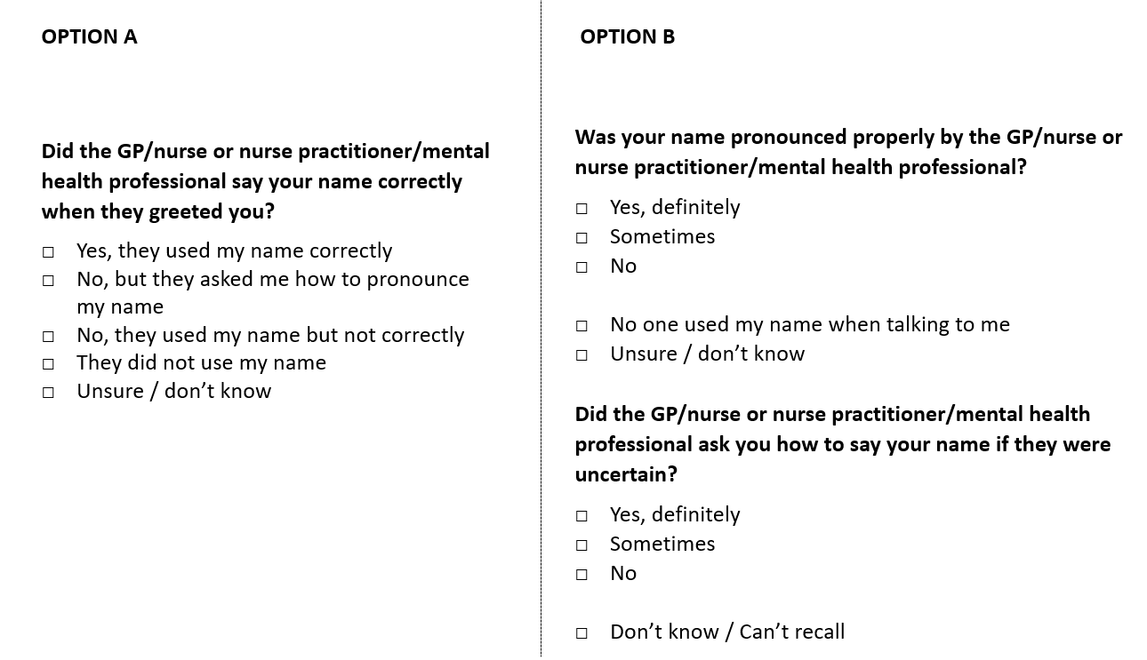
The general reaction to this question from respondents was that this was an important question area. Option A worked well when the name had been used correctly but was confusing if not. Option B was preferred by all but two, as it was easier to understand – especially for those with lower language and literacy levels. It was suggested that the second question of option B could be sufficient, although this is only suitable if the name is easy to pronounce. The two-option approach allows for correct pronunciation (part a) as well as effort (part b).

Recommendation
To use option B allowing for effort as well as correct pronunciation. Asking both questions of all. We have suggested asking both questions of all patients as even if their name was not used, someone may have initially made an effort to ask how to pronounce it if perceived as difficult. We recommend slight rewording as follows:

Was your name pronounced properly by the GP/nurse or nurse practitioner/mental health professional?

- Yes, definitely
- Sometimes
- No
- No one used my name
- Unsure / don’t know
Did the GP/nurse or nurse practitioner/mental health professional ask you how to say your name if they were uncertain?
- Yes, definitely
- Sometimes
- No
- They did not need to ask
- Unsure / don’t know

How to improve involvement in decisions about treatment and care (Primary Care only)
This new question followed an existing question which reads: Did the GP/nurse or nurse practitioner/mental health professional involve you as much as you wanted to be in making decisions about your treatment and care? It is asked only if the response to the previous option is No or Somewhat.

During pretesting it was shown as follows:

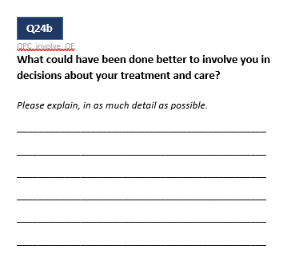
The open-ended question was easy to understand and answer.
However, there are a large number of open-ended questions in the survey already. This question will only be asked if respondents said somewhat or no, which was 9.8% and 2.8% of respondents in the August Primary Care survey.

Recommendation
Include, but review the total number of open-ended questions to see if one or more should come out. This review will take place after the February survey round to allow us to understand the impact of the added questions on respondent burden.

Feeling comfortable to ask questions (Primary care and Hospital surveys)
These were new questions and were shown during pre-testing as follows:

Hospital version: Primary care version:
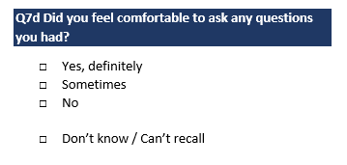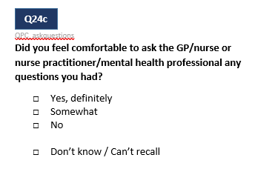
Not all patients identified with having had questions to ask. However, the word ‘comfortable’ was interpreted in a way that they understood the question related to having a level of rapport that would have allowed them to ask questions if needed, and so respondents were able to answer the question without difficulty.

One respondent mentioned the time pressure in their primary care appointment came to mind when answering this question.

It was noted that there was some overlap with other questions, including listen, explaining things in a way you can understand and involvement in decisions. However, this question could potentially be harder to action than the others. The cultural support expert advisory group recommended that we include this question despite some overlap with other questions.

The word ‘question’ was understood to be relating to questions about their care or medical situation (rather than functional questions such as “where is the toilet’) as intended.

Recommendation
This new question works well, however there is some overlap with other questions, so we recommend considering whether it is necessary to add this question.

Having enough time with the doctor (Primary Care only)
The question was presented as follows:
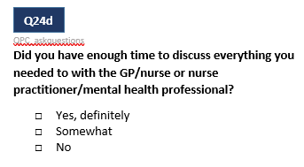
This question overlapped with an existing question (‘Did the GP/nurse or nurse practitioner/mental health professional spend enough time with you?’) for most respondents although some found it slightly different (about covering everything vs number of minutes). This was in part due to the questions that appeared between these instances in the questionnaire. The existing question appears in a grid at the front of the recent experience question with concepts like respect and trust. These questions are followed by questions asking about involvement in decision making and whether you felt comfortable asking questions, and then the proposed question (above) follows.

With the grid, patients reflected on whether they felt rushed or treated different due to a time constraint. Similar themes were raised with the proposed question, however a few also connected this with the depth of discussion and ability to ask questions. The impact on everyone’s wait times if a lot of time is spent answering every question. However, the understanding and involvement questions also discretely covered these aspects of the recent experience.

Recommendation
Keep the existing question, no need to ask again as shown here.

Individual, cultural and spiritual needs (both surveys)
Two options were shown for this question set.
Hospital versions shown:

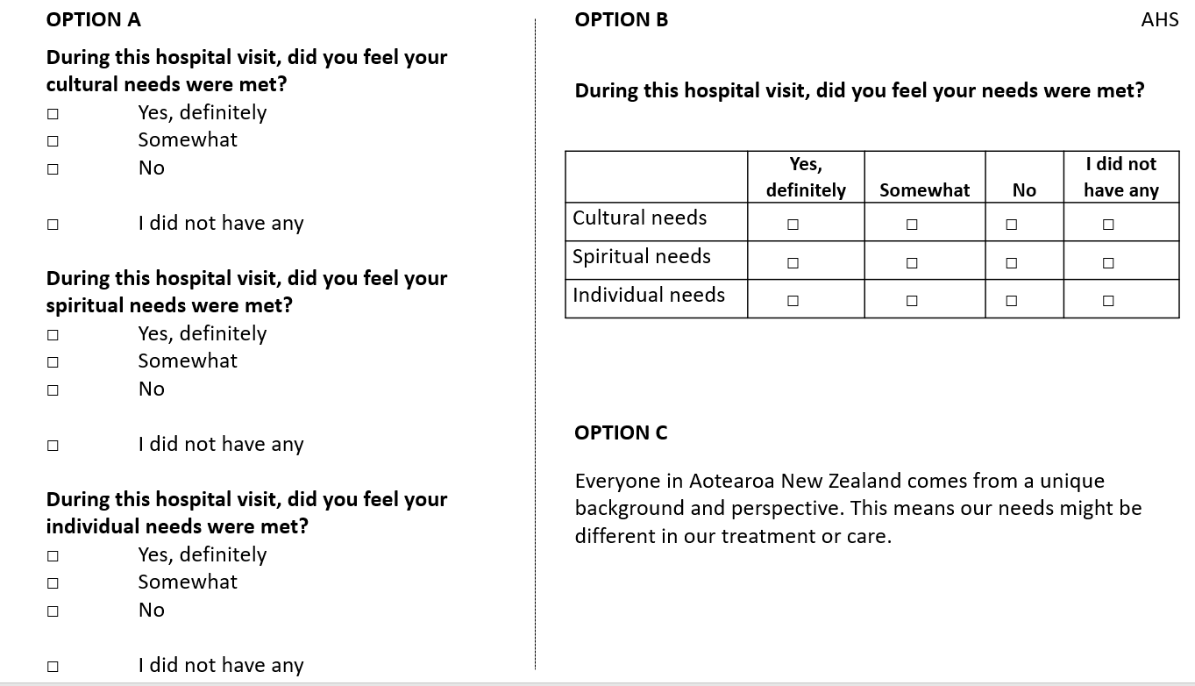
Primary care versions shown:

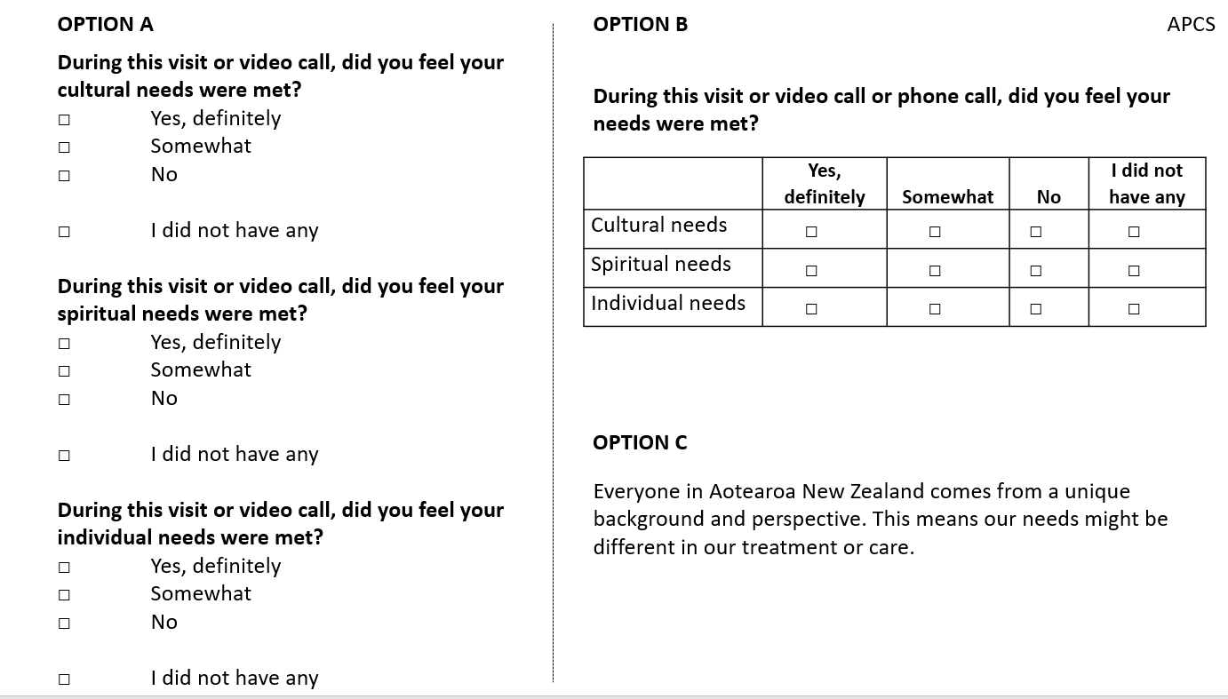

The grid (Option B) was easier to answer for respondents than asking each question individually. It also gave better context to the three concepts and was less repetitive.

The intended interpretation of the ‘individual’ question is to understand whether patients were receiving care that was tailored to them. In the initial testing the individual question was presented before cultural and spiritual needs. In this context, ‘individual’ was often interpreted as their medical needs (for example they went to the doctor for a medical issue, and received a prescription). When the individual needs question was moved to follow cultural and spiritual needs, the interpretation moved closer to the intended interpretation. Once the individual needs question was shifted to after the cultural and spiritual needs some examples given by respondents were their family situation, the fact they were blind. Respondents were more likely to believe they had individual needs when it followed cultural and spiritual needs in the questionnaire. For instance, one respondent said she only saw female doctors, but this wasn’t considered to be an individual need until later in the discussion. Similarly, another noted needing childcare options if attending an appointment for herself.

Cultural and spiritual needs were closely related for participants. For cultural needs, some talked about the use of the hospital table (how they felt about the mixed use of it - serving food, medication and blood work as well as one who had shoes placed it) food and language use (e.g. good use of te reo, bad use of Samoan - when a hcp learning the language corrected the pronunciation of a native speaker).

Spiritual needs were interpreted by participants mostly as religious or spiritual wellbeing needs. Most of the participants didn’t feel spiritual needs applied to themselves or had a strong overlap for others with culture or individual needs. Two participants discussed the connection between mind or spirit and body as very important, and one noted her connection to Te Ao Māori. One person spoke about the hospital Christian Māori Spiritual leader being sent to see them, despite them not being Christian.
Most reported that the spiritual needs questions was the hardest of the three to answer. However, the question was not seen as offensive for those to whom it did not apply. One respondent who was an atheist was happy to say she didn’t have any spiritual needs and wasn’t offended by the questions.

The explanation (Option C) added context – framing by what we mean by “needs”. The use of the word “our” was confusing and should be changed to “each person’s”; ‘Everyone in Aotearoa New Zealand comes from a unique background and perspective. This means each person’s needs might be different in their treatment or care’.

The open-ended question worked well as one (rather than 3 separate open-ended) as there was seen to be a lot of overlap in the three concepts. We propose including the question with wording along the lines of How could your needs have been better met?

Recommendations
- Add context from Option C (slightly reworded to remove the word “our”).
- Show these questions as a grid with individual needs asked last.
- Reword the open-ended question to how could your needs have been better met?

Whānau / family involvement (Primary Care only)
This question is already asked in the hospital survey and was tested as part of the primary care question set. It was shown to respondents as follows:
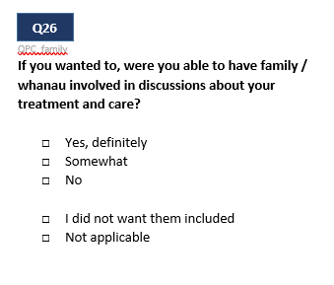
One version had just whānau and one had both family / whānau and it was noted by participants that we should have both words.

One participant said she had chosen her practice based on the level of whānau involvement.
Participants said they found it was relevant, even though it may not have been for the most recent interaction. Some participants answered generally about their practice, rather than thinking specifically about their last interaction.

Recommendation
Consider adding this question to the practice section rather than the last visit. It would require a slight reword to change tense. We recommend this as a number of participants noted that whānau involvement is important in a number of situations, however it may not have been appropriate/relevant in the last interaction.

Feedback on existing questions
The existing questions that fit within the cultural safety suite of questions were also in the questionnaire. Although not probed on as they have already been tested in previous cognitive testing round, interviewers noted any comments made by respondents on these questions as well.

The existing cultural safety questions are listed below, with comments where participants commented on these questions:

- Being treated with respect by reception / admin staff (primary care only) – there can be a disconnect, so important to have both this question and respect from doctor / nurse / mental health professional
- Spent enough time with you (primary care) – overlaps with proposed new question – this version is sufficient

The remaining existing questions had no significant feedback from patients:

- Being listened to (both surveys)
- Treated with kindness and understanding (both surveys)
- Involvement in decisions about treatment and care (both surveys)
- What could have been done better to involve you in decisions about treatment and care (Primary care only)
- Treated with respect (both surveys)
- Include whānau / family in discussions about your care (hospital only)
- Unfair treatment / discrimination (both surveys)

There were no issues raised with these questions and they are already used in the surveys, therefore we do not recommend any changes.

https://www.mcnz.org.nz/our-standards/current-standards/cultural-safety/

