A report about how some disabled people experienced health care during the 2020 lockdown

# December 2021

# What is the Health Quality and

# Safety Commission?

This is a report by the **Health Quality and Safety Commission.**

The **Health Quality and Safety Commission** works to **improve** health and disability support services in New Zealand.

**Improve** means to make something better.

We work with:

* A group of people posing for a photo

  Description automatically generated with medium confidencepeople who work in health and disability support services
* people who use health and disability support services.

We believe in **hauora kounga mō te katoa**.

This is te reo Māori for **quality health for all**.

**Quality** means:

* how good something is
* if something does what it is meant to do.

We do things like looking at:

* A picture containing text, book

  Description automatically generatedwhat health and disability services do
* how good the services are
* how safe the services are.

We show the people who work in health and disability support services how they can make them better.

We also:

* A picture containing person, posing

  Description automatically generatedsupport people to be good leaders so they can show others how to make the services better
* support leaders when they want to change things for the better.

One of the ways we can see what kinds of things need to change is by asking other people what they think.

The Health Quality and Safety Commission does 2 **surveys** in New Zealand every 3 months.

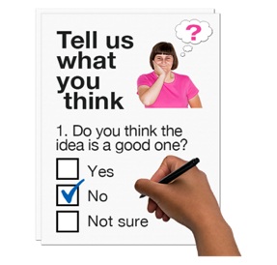

A **survey** is when we ask a group of people some questions.

We do this so we can get information about how people **experience**

health care in:

* A picture containing text, linedrawing

  Description automatically generatedNew Zealand hospitals
* **primary care** in New Zealand.

**Experience** in this report means something that a person:

* has done
* has lived through.

**Primary care** is when people get health care in the community from:

* a doctor such as their GP
* a nurse
* a pharmacy.

# About this survey

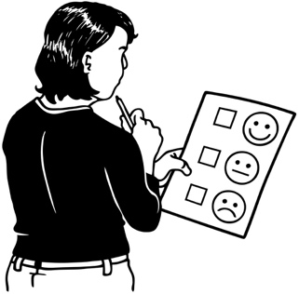

The questions in this survey asked people how they felt about health care during the **COVID-19 lockdown** in 2020.

The **COVID-19 lockdown** was the time when people in New Zealand needed to stay at home because of the COVID-19 virus.

1

2

3

4

There were 4 different lockdown Alert Levels.

The Government used Alert Levels to stop the spread of COVID-19.

The Alert Levels had rules everyone needed to follow to keep themselves safe from COVID-19.

The lockdown for Alert Levels 3 and 4 lasted from 23 March 2020 to 13 May 2020.

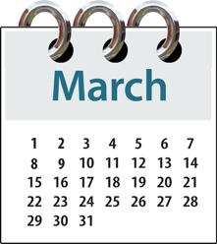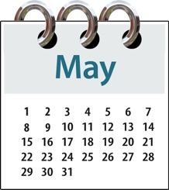

We wanted to find out how people experienced health care:

* A picture containing person, standing, posing, group

  Description automatically generatedduring the lockdown
* after the lockdown.

We ran a **one-off** survey in the months of June and July 2020 to find out more about this.

**One-off** means something that only happens once.

The questions asked people about their experiences of getting health care in Alert Levels 3 and 4.

We wanted to know how people felt during lockdown Alert Levels 3 and 4.

4

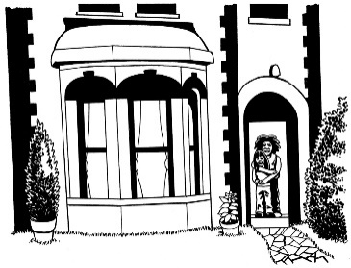

3

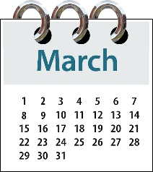

The questions asked people to think about the time between 23 March 2020 to 13 May 2020.



We asked a **selection** of **patients**

15 years and older to answer the questions.

A **selection** means a group from which some people are chosen.

A **patient** is a person who is getting health care.

Some of these people had:

* signed up with a doctor that they could see when they needed to

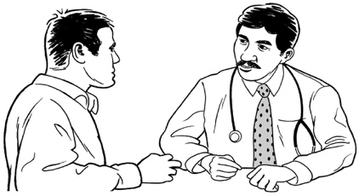

* seen their doctor in the time the survey looked at.

Some of these people had:

* signed up with a doctor that they could see when they needed to

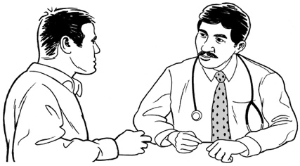

* not seen their doctor in the time the survey looked at.

None of the people we asked were under 15 years old.

Around 26 thousand people answered the survey.

About 21 thousand people told us if they had a disability.

Out of this 21 thousand people about 4 thousand people:

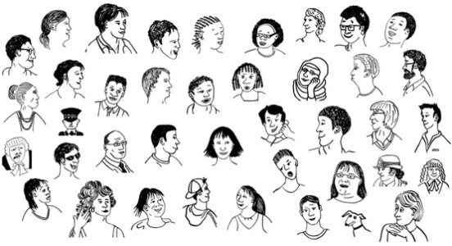

* A person sitting in a wheelchair

  Description automatically generated with medium confidencesaid they **self identified** as being disabled



* could be identified as being disabled as they met the guidelines set out by the **Washington Group Short Set.**

**Self identified** is when a person chooses to describe themselves as being part of a group.

The **Washington Group Short Set** is a set of questions that can be asked to find out if someone is disabled.

This report is about the answers that disabled people gave us.

# What this survey found

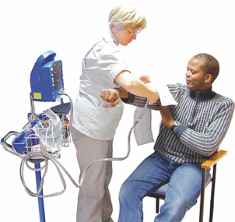Disabled people who answered the survey were most likely to:

* have 1 or more health conditions that were likely to last a long time
* A picture containing text, linedrawing

  Description automatically generatedlive in places in New Zealand where people often:
* Diagram

  Description automatically generateddo not have enough money
* do not have as good a standard of living as other people in New Zealand.

Of the people who did the survey Māori were more likely to be disabled than non-Māori.

Disabled people told us that they found it harder to get the health care they needed during the lockdown.

This was because some of the lockdown Alert Level rules made it harder to do things.

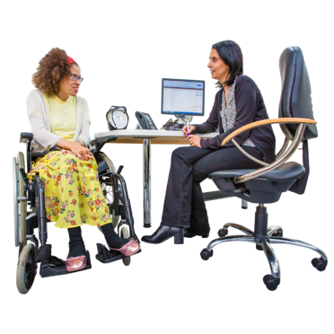

Many disabled people chose not to try to get health care during lockdown.

One of the reasons for this was because they did not want to go to places where people were sick.

Many disabled people were worried that they might catch COVID-19.

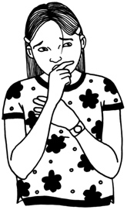

Disabled people were more likely to have a **virtual appointment** during lockdown than non-disabled people.

**Virtual appointments** are when people to talk to their doctor:

* over the telephone
* over video.

More disabled people than

non-disabled people said there was nothing they liked about virtual appointments.

Around half of the disabled people who answered the survey said they got to see their doctor on:

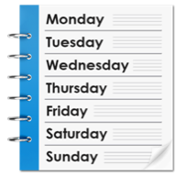

* the same day
* the next working day.

Some people had to wait longer for their appointment because of where they live in New Zealand.

This waiting time meant that some disabled:

* A picture containing cup, coffee, table, indoor

  Description automatically generatedwere seen sooner than others
* got any medicine they needed sooner than others.

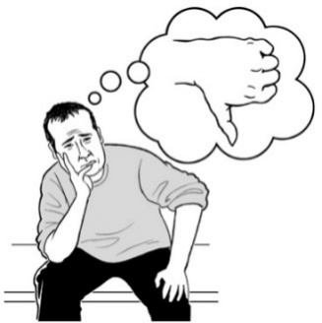Disabled people were more likely than other people to say they had a worse experience at their appointment.

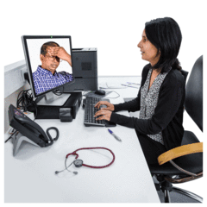The things that a disabled person might experience could be:

* being informed about their health care
* how things are explained

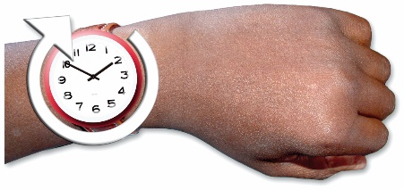

* having enough time during their appointment.

Other things that disabled people might need are **cultural needs**.

**Cultural needs** are things like how their doctor:

* A picture containing text

  Description automatically generatedrespects their religion
* understands their food choices

* understands how they choose to live.

Disabled people said that getting **prescriptions** from their doctor in lockdown was:

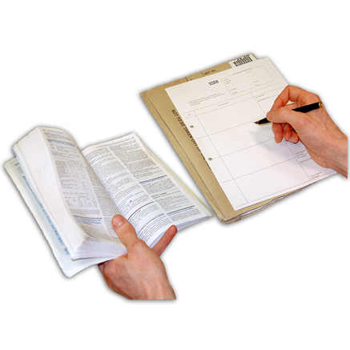

* easier than before lockdown

or

* about the same as before lockdown.

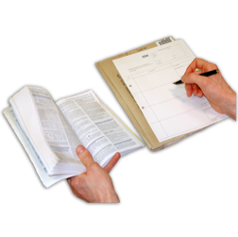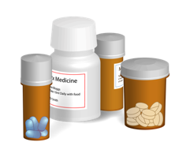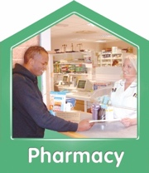

A **prescription** is the note your doctor writes so you can get the medicine you need from a pharmacy.

Disabled people said they found it harder to pick up their prescriptions from the pharmacy during lockdown.

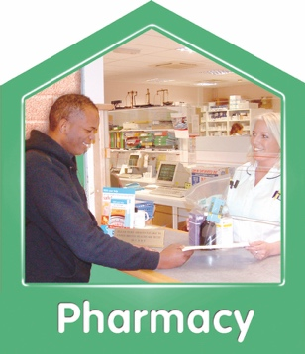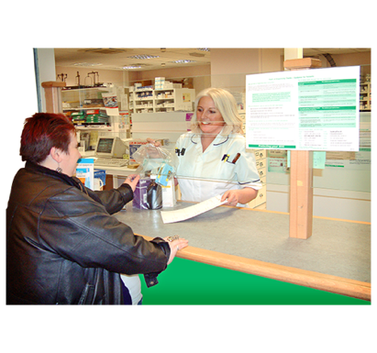

Some disabled people said that the need for **social distancing** made them less likely to pick up their prescription.

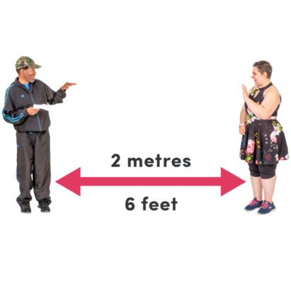**Social distancing** is when you stay **2 metres away** from people you do not know.

**2 metres** is about as long as a bed.

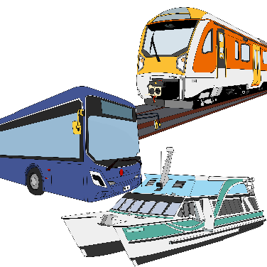Other things that made it harder for disabled people to pick up their prescriptions were:

* some people did not want to travel as they were frightened of catching COVID-19

* their doctor would only give them enough medicine for 1 month not their usual 3 month supply.

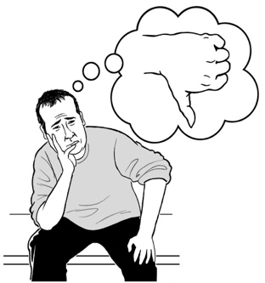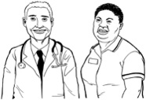

Disabled patients said they felt they had a worse experience with their doctor during lockdown.

# What the Health Quality and Safety Commission will do next

This was the first time the Health Safety and Quality Commission has reported on the health care experiences of disabled people.

We cannot tell from the survey answers if the worse experiences disabled people had:

* were because of the lockdown
* would have happened anyway.

We will look at the results of other surveys from after the lockdown to find out more.

We will **compare** what we find in those surveys with the results from this survey.

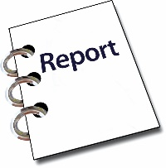

Survey

1



Survey

2

**Compare** is when we look at 2 or more things to find out what is:

* the same
* different.

You can read more information about our patient experience surveys on our **website**:

**https://www.hqsc.govt.nz/our-programmes/health-quality-evaluation/projects/patient-experience/**

**This information has been written by the Health Quality and Safety Commission.**

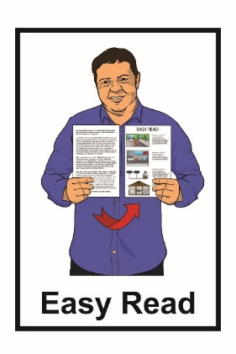

**It has been translated into Easy Read by the Make It Easy service of People First New Zealand Inc. Ngā Tāngata Tuatahi.**



**The ideas in this document are not the ideas of People First New Zealand Ngā Tāngata Tuatahi.**

Change logo.
Change is the name of the organisation.

**Make It Easy uses images from:**



* **Changepeople.org**
* **Photosymbols.com**
* **Sam Corliss**
* **Huriana Kopeke-Te Aho.**

**All images used in this Easy Read document are subject to copyright rules and cannot be used without permission.**