



**From PES to PDSA**

**Workbook: Using adult primary care patient experience survey data for quality improvement**

Me mahi tahi tātou mō te oranga ō te katoa.

We should work together for the wellbeing of everyone.

Revised October 2025, Health Quality & Safety Commission Te Tāhū Hauora,   
PO Box 25496, Wellington 6146.

ISBN 978-1-991122-40-7 (online)

Available online at [www.hqsc.govt.nz](http://www.hqsc.govt.nz)

Enquiries to: [survey@hqsc.govt.nz](mailto:survey@hqsc.govt.nz)

This work is licensed under the Creative Commons AttributionNonCommercial-ShareAlike 4.0 International (CC BY-NC-SA 4.0). To view a copy of this licence, visit <https://creativecommons.org/licenses/by-nc-sa/4.0>





Contents

Purpose 5

Introduction 6

About the adult primary care patient experience survey 6

The value of reviewing patient experience feedback 6

Links with Foundation Standard and Cornerstone accreditation 7

Links with performance measurement 7

Finding your survey data 8

Survey reporting portal 8

Finding your quality improvement opportunity 9

Example 1: Identify your improvement opportunity from low‑scoring questions 9

Example 2: Identify your improvement opportunity by comparing Māori results with non-Māori, non-Pacific 11

Example 3: Identify your improvement opportunity by reviewing responses by demographic variables (eg, age, ethnicity, gender and disability status) 12

Before you start 15

Model for Improvement 16

Plan–do–study–act: Plan 21

Plan–do–study–act: Do 22

Plan–do–study–act: Study 22

Plan–do–study–act: Act 23

Tell everyone 23

Appendix 1: Intervention logic 24

Appendix 2: Quality improvement worksheet 31

Appendix 3: PDSA template 36

Appendix 4: PDSA example (plan) 38

Appendix 5: ‘You said, we did’ poster 43

Appendix 6: Resources, links and articles 44

Figures

Figure 1: The Model for Improvement 5

Figure 2: Patient experience survey portals 8

Figure 3: Overview page identifying your improvement opportunity from the lowest scoring question 9

Figure 4: Low-scoring question detail 10

Figure 5: Overview page identifying your improvement opportunity by comparing Māori results with non-Māori, non-Pacific (these results are also presented in a table format) 11

Figure 6: Survey results page reviewing responses by demographic variables 12

Figure 7: How did you feel about the wait? (Percent that did not mind the wait) 13

Figure 8: Selecting quarterly or annual results 14

Figure 9: Change prioritisation matrix 21

Tables

Table 1: Define your aim 17

Table 2: Example change ideas using adapted FrEEIA components (includes WAI2575 principles) 20

Purpose

This workbook is designed to help you use data from the Aotearoa New Zealand adult primary care patient experience survey to conduct quality improvement initiatives and track the progress of these initiatives. This will help you implement the code of expectations for health entities’ engagement with consumers and whānau (consumer code of expectations)[1] and meet indicator 8.2 of the Royal New Zealand College of General Practitioner’s Foundation Standard.

Data-informed quality improvement initiatives can help you pursue changes that count. The Model for Improvement is a well-established roadmap to guide improvement.[2] It is based on three questions followed by a learning cycle: Plan-Do-Study-Act (PDSA). This guide will assist you to apply the Model for Improvement and PDSA cycles using patient experience data to inform opportunities for quality improvement.

We show you how to engage with your data in the patient experience survey reporting portal and use this to undertake a PDSA cycle. We break down the PDSA cycle into well-defined steps so you can streamline quality improvement activities within your organisation. We include a worksheet at the end, which takes you through an example of how to find your improvement opportunity from your survey data in the reporting portal.

Figure 1: The Model for Improvement[3]

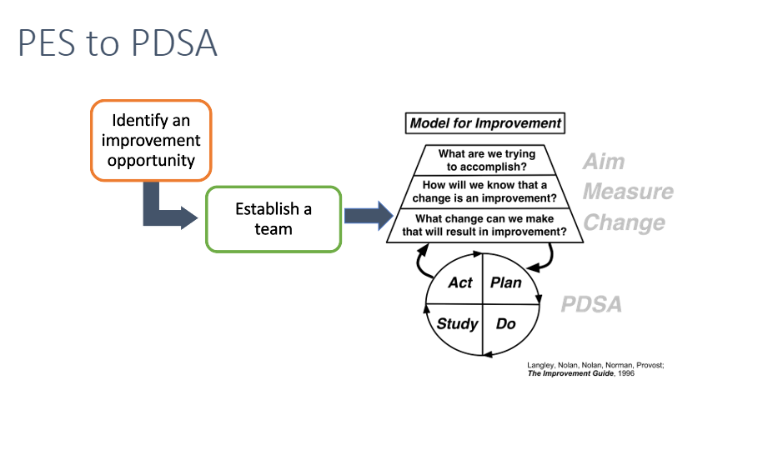

Introduction

About the adult primary care patient experience survey

Patient experience is a good indicator of the quality of health services. Positive patient experiences and strong partnerships with consumers are hallmarks of patient- and whānau centred care with benefits for health, clinical, financial, service and satisfaction outcomes.

The Health Quality & Safety Commission Te Tāhū Hauora conducts the adult primary care patient experience survey with its survey provider, Ipsos. The survey gathers information about patients’ experience of the care they receive in primary care and how their overall care was managed between their general practice and other parts of the health system.

Every three months, a sample of adult patients (15 years and over) enrolled with and seen by participating general practices are invited to take part.

See: [www.hqsc.govt.nz/our-data/patient-experience/adult-primary-care-patient-experience/](http://www.hqsc.govt.nz/our-data/patient-experience/adult-primary-care-patient-experience/)

The value of reviewing patient experience feedback

Reasons for reviewing patient experience feedback include:

* it helps practices to understand what they are doing that benefits their patients the most and identify where opportunities exist for improvement
* it helps practices to maintain a strong patient–practice relationship by listening and responding to their patients’ feedback. This encourages patients to seek care when they need it and to remain with the practice. It can also help maintain the reputation of the practice in the community
* it respects and honours the time patients have taken to give feedback
* it can help strengthen the consumer and whānau voice in your improvement project and support the voice of consumers you engage with to co-design improvements.

Links with the consumer code of expectations

The consumer code of expectations sets out how health entities must work with consumers, whānau and communities in the planning, design, delivery and evaluation of health services.

For practices, actively participating in the survey programme and using lived experience, including consumer experience data, to inform improvements in health services is part of implementing the consumer code of expectations.

See: [www.hqsc.govt.nz/consumer-hub/engaging-consumers-and-whanau/code-of-expectations-for-health-entities-engagement-with-consumers-and-whanau/](http://www.hqsc.govt.nz/consumer-hub/engaging-consumers-and-whanau/code-of-expectations-for-health-entities-engagement-with-consumers-and-whanau/).

Links with Foundation Standard and Cornerstone accreditation

The survey forms part of the evidence to meet indicator 8.2 of the Royal New Zealand College of General Practitioner’s Foundation Standard. This requires practices to survey their population and use the results for improvement.

See: [www.hqsc.govt.nz/resources/resource-library/primary-care-patient-experience-survey-foundation-standard-cornerstone-accreditation/](http://www.hqsc.govt.nz/resources/resource-library/primary-care-patient-experience-survey-foundation-standard-cornerstone-accreditation/).

Links with performance measurement

Patient experience measures are included in the Government Policy Statement on Health and Te Pae Tata. The example question used in the worksheet forms part of the Entity Performance framework.

See: Health-NZ-Statement-of-Intent-2024-28.pdf.

Finding your survey data

Survey reporting portal

Ipsos has built two portals to support the sector in preparing for the survey and looking at the results.

Figure 2: Patient experience survey portals

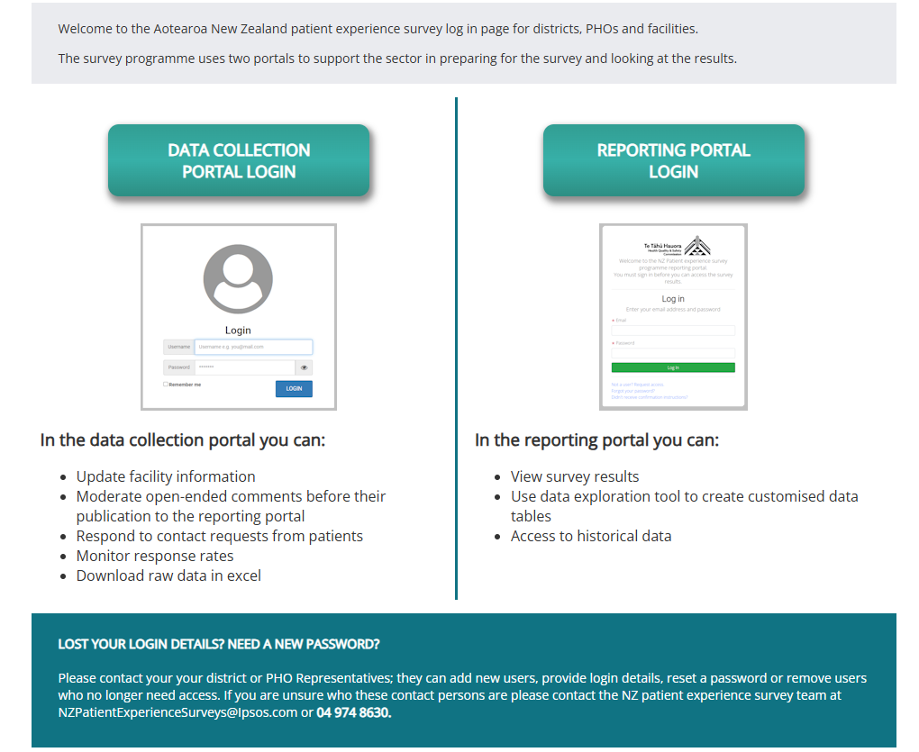

The **data collection portal** is where you can update facility information, moderate open-ended comments before their publication to the reporting portal, respond to contact requests from patients, monitor response rates (by primary health organisation and practice) and download raw data in Excel.

The **reporting portal** is where you can see an overview of survey results compared with the national average, view each question by demographic details and use the data exploration tool to create customised tables. Free-text responses can be downloaded from this portal.

This URL: myexperience.health.nz/sector takes you to a page with links to both portals.

For this workbook, you will use the reporting portal. After selecting the reporting portal page, select the Adult Primary Care Survey tab on the top of the ‘levels’ page.

If you have lost your login details or forgotten your password, please contact your primary health organisation representative.

If you are unsure who this is, please contact the patient experience survey team at [NZPatientExperienceSurveys@Ipsos.com](mailto:NZPatientExperienceSurveys@Ipsos.com) or 04 974 8630.

A webinar of how to use the reporting portal, and a Q&A document are available in the How‑to Library: <https://cx.myexperience.health.nz/library>. Also provided is a Reporting Portal How to Guide.

Finding your quality improvement opportunity

Working with consumers, whānau and the community from the start can help you identify topics for improvement that are important to them. This also helps with meaningful interpretation of the data from different perspectives, particularly for Māori. You may already know the area you wish to focus on and who is best placed to work with you. You likely know that, unless you take the time to stop and look at the problem, nothing will change. However, you don’t have to do this work alone. Luckily, the reporting portal is designed to lessen the burden of time. So, let’s log in.

The portal’s dashboard (Figure 6) gives you an immediate snapshot of where to focus. You can quickly see where you are doing well and areas to work on. Topics for improvement can come in many forms. We have provided some examples on the following pages, based on looking at national results for:

1. a low-scoring question
2. variation between groups of people (eg, Māori reporting worse access to care compared with non-Māori, non-Pacific)
3. variation between practices and,
4. considering deteriorating performance over time
5. You may also like to consider:
6. themes or improvement suggestions emerging from your qualitative comments.

Example 1: Identify your improvement opportunity from low‑scoring questions

Figure 3: Overview page identifying your improvement opportunity from the lowest scoring question

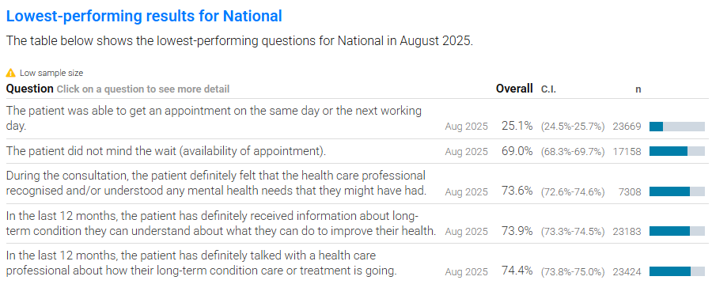

Lowest-performing and highest performing results are shown in the tables. Key questions below the chart shown above highlight the lowest scoring questions to investigate. The lowest scoring result for National is: The patient was able to get an appointment on the same day or the next working day (24 percent) and that is significantly worse than the previous survey result. When we click on the lowest scoring question for more detail, it shows us all the access questions: continuity, access and wait times. We can see that access questions ‘How did you feel about the wait?’ and ‘In the last 12 months, was there ever a time when you wanted health care from a GP or nurse, but you couldn’t get it?’ have deteriorated over time and the second question is significantly worse for Māori.

Figure 4: Low-scoring question detail

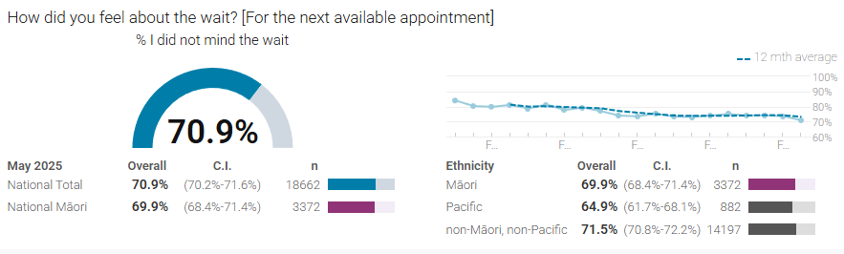

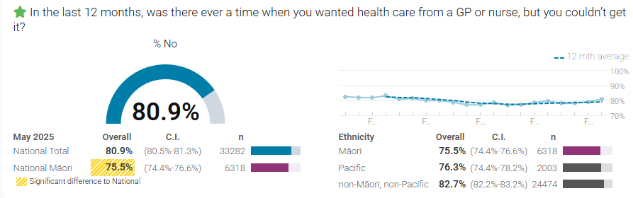

Example 2: Identify your improvement opportunity by comparing Māori results with non-Māori, non-Pacific

Figure 5: Overview page identifying your improvement opportunity by comparing Māori results with non-Māori, non-Pacific (these results are also presented in a table format)

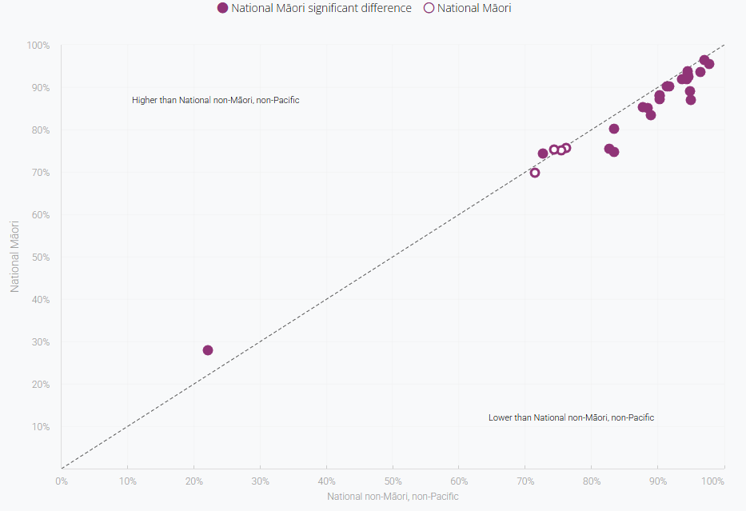

In the example in Figure 5, the questions with a filled-in dot represent a significant difference in results. Filled dots above the line show where Māori results were significantly more positive than non-Māori, non-Pacific, and filled dots below the line show where Māori experience was poorer. Hover over the dot to see which question it represents. In this example the lowest scoring question is ‘The health professional always asked if uncertain how to say patient’s name’. The second lowest scoring question is ‘In the last 12 months, was there ever a time when you wanted health care from a GP or nurse, but you couldn’t get it?’.

Note, these results are not standardised for age. We recommend further analysis to look at results by age and ethnicity.

Example 3: Identify your improvement opportunity by reviewing responses by demographic variables (eg, age, ethnicity, gender and disability status)

**Tip: Interpreting confidence intervals**

The confidence intervals are calculated at 95 percent confidence level. If the lower or upper limits do not overlap with other groups, the difference is considered statistically significant.

In the example in Figure 6, the upper limit for Māori (76.6 percent) does not overlap with the lower limit for National Total (80.5 percent). This means the difference between responses for Māori and non-Māori, non-Pacific is statistically significantly different, and Māori were significantly more likely to report a time when they wanted care but could not get it. The column ‘n’ shows the number of people who answered the question by each ethnicity; in this example, 3,372 Māori responded.

Figure 6: Survey results page reviewing responses by demographic variables

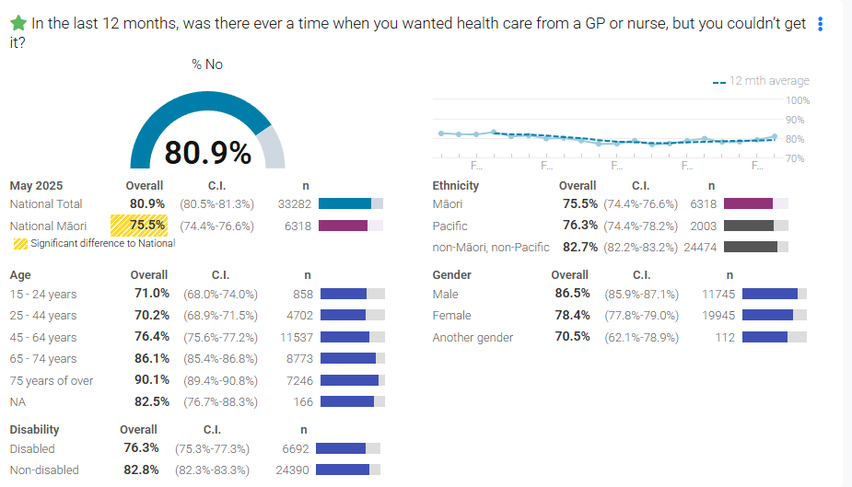

**Tip: In the survey results page, click on the three blue dots on the top right of the question and select ‘show demographic breakdown’ to view results by age, ethnicity, gender and disability status.**

The higher the percent the more people are reporting being able to access healthcare from a GP or nurse when they wanted to in the last 12 months. In our example 81% of people were able to access healthcare, and this means that 19% were unable to get healthcare every time they wanted to. From looking at these results, you can see the following groups were more likely to report not being able to access a GP or nurse as much as they wanted (the higher the percent the more positive the result):

* those aged 15–64 years (71 percent, 470.2, and 76.4 percent compared with 80.9 percent total)
* disabled people (76.3 percent disabled compared with 82.8 percent non-disabled)
* Māori people (75.5 percent compared with 80.9 percent)
* females (78.4 percent, another gender 70.5 percent, compared with male 86.5 percent).

By investigating our low scoring questions further, we can see that more people are minding the wait than previously (Figure 7). We then look at answers to the question: Why could you not get health care from a GP or nurse when you wanted it during the last 12 months? This shows that the biggest barrier is that wait times to get an appointment are too long (National (N):87.4%/Māori (M) 86.1%) followed by the appointment was too expensive (N:7.9%/M:9.6%) and, difficult to get time off work (N:7.7%/M:10.7%). This last reason is supported by the demographic data that shows working age people are more likely to experience access problems. We can also see that more people mind the wait than in previous surveys (Figure 7) as the percentage who did not mind the wait is decreasing over time. This analysis can help us to generate ideas for improvement. For ideas on how to analyse your access patient experience data and generate a range of improvement ideas, refer to the intervention logic in Appendix 1.

Figure 7: How did you feel about the wait? (Percent that did not mind the wait)



The comments section in the survey can be used, together with the demographic information survey respondents provide. We discuss how to do this on page 8. The qualitative data from survey comments is a source of soft intelligence that can provide key insights and meaning to patient scores and motivation to drive improvement efforts.[4]

**Tip: Data suppression and small numbers**

For confidentiality, where the number of people responding to a question is less than five, filters such as age, gender or ethnicity will not be able to be applied. This is to prevent potential loss of anonymity. Where results are suppressed, we recommend using the national data as a guide. For example, we see from the national data that young people more commonly report barriers to access than older people. What is seen nationally is likely to be observed in your practice as well.

For statistical robustness, a warning of low numbers is given where the number of people responding to the question is lower than 30. When you want to use the data to inform a quality improvement project, it is better if you base this on at least 30 responses per question. Fewer than 30 responses can limit your ability to see trends and make predictions, but when compared against national data are still useful. For example, you will be able to see if your patients’ responses are markedly different or not.

You can group your data to display annual rather than quarterly survey results, to increase the number of responses.

Figure 8: Selecting quarterly or annual results

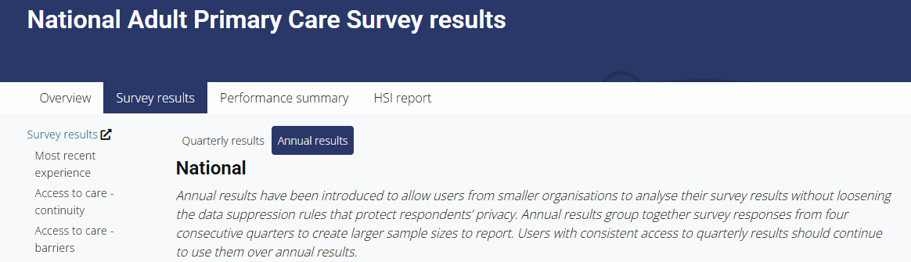

A minimum number of responses does not apply to qualitative comments. Each comment can provide rich insight from your patients. Some questions allow free text comments. You can see these comments by clicking on the three blue dots and selecting show comments. For example, these comments give some indication of the length of time some patients have waited for an appointment:

Appointment time is far too long to wait. Should be days not a month.

It would have been nice not to have to wait a month to get an appointment.

To access the full list of comments, we recommend downloading a survey answer export from the data collection portal. The How-to Guide for this is available here: nz.ipsos.com/patientexperience/APCS_Download_Raw_Data_How-to-guide.pdf.

Before you start

Before you start, think about how you will manage any potential ethical risks for the consumers involved and how you will manage the use of new or existing data.

When involving consumers in quality improvement efforts, be respectful of them, their time and their data. People need to know what you are asking of them and what is involved. Is this new or existing data? If you are using existing data, are you using it for its intended purposes that were agreed to by consumers? If they are sharing new data and information, what use will be made of that data and how will it be managed? While quality improvement projects usually do not require a full ethical review, you do still need to consider ethical risks and plan how to eliminate or minimise them for participants. Team discussions and consulting professional peers are a good basis to start from.

For a quick guide, you can refer to: [www.hqsc.govt.nz/our-work/leadership-and-capability/ethics-guide/](http://www.hqsc.govt.nz/our-work/leadership-and-capability/ethics-guide/)

The full guidance on ethical review of quality improvement activities is available within the National Ethical Standards for Health and Disability Research and Quality Improvement (2019): <https://neac.health.govt.nz/assets/Uploads/NEAC/publications/national-ethical-standards-health-disability-research-quality-improvement-2019-v3.pdf>

Model for Improvement

The Model for Improvement provides a common and consistent approach to improving the quality of care and can be a useful model to improve your processes and implement change. The quality improvement project process first asks three fundamental questions:

1. What are we trying to accomplish?
2. How will we know that a change is an improvement?
3. What changes can we make that will result in improvement?

This is followed by the iterative testing to learn, action-oriented Plan–Do–Study–Act (PDSA) cycles. It is important to include patients in the process to get feedback. It is also important to assess the impact of changes to verify that interventions have made a difference.



Gather your team

Now you have clearly identified a problem and found data to support it, gather a team to help you understand and solve the problem. Developing a short description of what you have found, why it is important to address (called a problem statement) and why you need people to work with you on this (sometimes called an ‘elevator pitch’) can help you to engage participants more easily.

The size of the team will reflect the size of your practice and the scope of the challenge you are working to improve. We generally recommend a team of four to eight people as being a good size. Make sure everyone in the team has a job because this avoids having ‘too many cooks in the kitchen’ and each person is helping the team.

Health entities are expected to include consumers and whānau in co-designing health system improvements as part of the consumer code of expectations. Having staff, patients and whānau working together can create ideas that will work for both patients and staff because they are not based on assumptions. If you want to learn more about co-design and developing an ‘elevator pitch’ to engage others, you can complete a free online learning programme on Ko Awatea Learn: [Co-design in Health](https://koawatealearn.co.nz/enrol/index.php?id=9540) and [Co-design in health: How you can get involved.](https://koawatealearn.co.nz/course/view.php?id=11499)

Finally, assign a leader or driver for your project to ensure follow-up and check on progress. This may be you.

Define your problem statement

A problem statement should clearly and succinctly identify the problem or improvement opportunity and the impact that it has on patients, the practice and staff. The statement explains WHY the topic is important to address and can be used to engage others to support improvement initiatives. An example of a problem statement using the data provided in the examples above is shown below.

**Box 1: Example problem statement**

|  |
| --- |
| Patient experience survey results and the two lowest scoring questions for our practice indicate that access to primary healthcare is a problem for our patients. In our enrolled population 78 percent of people were able to access healthcare from a GP or nurse when they wanted to, meaning that 22 percent were unable to get healthcare every time they wanted to, and this is worse for Māori people at 26.5 percent. Only 26 percent of all patients were able to get an appointment in the same or next working day and that over 30 percent had to wait over a week for an appointment. The performance on both these questions and particularly for wait times, has worsened over the past five years. Poor access to primary care can lead to delayed diagnosis, increased pressure on acute care (costing the practice in clawbacks), emergency services and departments, and increased inequities, hospital admissions and mortality from conditions amenable to preventative and early management in primary care. |

Define your aim

Next, create an aim statement to clearly define what you are hoping to achieve. This is the answer to the first question from the Model for Improvement: ‘What are we trying to accomplish?’. It will help you set a clear outcome measure for the project. The aim should focus on the outcome for patients. The aim statement will answer four questions shown in Table 1.

Table 1: Define your aim

|  | Elements of aim | | Example |
| --- | --- | --- | --- |
| **1. For whom?** | Who? | Population focus | Enrolled patients |
| Where? | Location | Our practice |
| When? | During what part of the process | Access to appointments with a GP or Nurse |
| **2. What?** | What is it about? | | Access to care |
| **3. How much?** | Baseline | | 26.5% Māori  22% all |
| Target | | 15% Māori |
| Metric used | Eg, percentage, average | Percentage |
| **4. When?** | Timeline | | One year from start of project |

Ideally, we start as small as possible to learn and increase the size of the project as we build knowledge. Start with a small group of patients and gradually roll out across the whole of the enrolled population. This increases the likelihood that the change will produce an improvement and reduces the risk of unsuccessful action as you learn about what and what does not work. As the biggest equity gap population (Māori) are also a smaller population size, we can make meaningful change and learn what works for Māori first and monitor our data for the total population to discover if any adaptation is required for other population groups. Following our example, our aim statement could be:

To reduce the percentage of Māori patients in our practice reporting inability to access care when they wanted to from 26.5 percent to 15 percent by (a specified date in the future).

Measuring your progress

Now you and your team are clear about your aim, you will need to answer the second question from the Model for Improvement: ‘How will we know that a change is an improvement?’.

We can use a time series chart from the reporting portal to see whether any changes have occurred to the baseline of X percent from quarter to quarter. Take a screen shot of this and put it into your practice action plan.

A quarter can be a long time to wait for feedback in quality improvement. Obtaining real-time and focused feedback helps you rapidly test changes, identify progress quickly and sustain motivation. Staff can get live feedback from patients using verbal feedback and a check sheet or other simple tools developed by your team for this purpose. There may also be practice or PHO specific measures that you collect that can give you some indication of how you are progressing, for example following our example your practice or PHO may collect data on urgent care clawback cost, third next available GP or Nurse appointment or patient complaints about access appointments. Other measurement ideas are included in Appendix 1.

You will need a range of measures that capture progress towards achieving your aim (Outcome measures), processes that need to be improved to achieve your aim (Process measures), and measures of important and related areas in the system that you do not want to be negatively affected by the changes you introduce (Balancing measures).

Next, determine what your intervention is going to be, that is, what you are going to do differently to try to achieve your aim. Try brainstorming ideas with your team and particularly consumers using survey feedback (including the comments section) or ask other people from outside your practice who might provide valuable insight. You can also use this as an opportunity to identify the voice of a particular age, gender, ethnic group or disability status. A literature review can be useful not only to generate change ideas but learn from other efforts and identify potential pitfalls or ingredients necessary for success.

Many problems in healthcare can be quite complex and a driver diagram can be helpful to organise your team thinking, generate change ideas and identify what you will need to measure. All driver diagrams are specific to your problem, your teams thinking and your context. You can learn more about driver diagrams from the [Institute of Healthcare Improvement](https://www.ihi.org/library/tools/driver-diagram) and the [Clinical Excellence Commission](https://www.cec.health.nsw.gov.au/CEC-Academy/quality-improvement-tools/driver-diagrams). A driver diagram is provided in the quality improvement worksheet example provided in Appendix 2.

What changes can you make that will result in an improvement?

This is the third question from the Model for Improvement.

Depending on which example you are using, propose ideas about what your intervention is going to be, that is, what you are going to do differently to try to achieve your aim. Try brainstorming ideas with your team, clients, family and whānau using survey feedback (including the comments) or ask other people from outside your service who might provide valuable insight. Are there other providers who scored well in this area who can share their approach? Is there any literature on this topic? See Appendix 6 for a selection of research articles and reports about quality improvement initiatives to improve access.

You will need multiple ideas because it is unlikely just one, no matter how clever, will achieve the desired result. Appendix 1 includes potential improvement ideas. Engaging consumers in your project can generate practical ideas for change that will affect the things that matter most to your patients. Consumers provide a different way of looking at things that can be useful for generating change ideas. They can provide guidance about what is important from the community, patient and whānau perspective.

We should apply a Te Tiriti o Waitangi and equity ‘lens’ to our improvement ideas. Apply frameworks such as the Wai 2575 principles,[5] the He Pikinga Waiora Framework[6] or the Framework for Effective and Equitable Implementation Aotearoa (FrEEIA)[7] to reflect on, if the changes you are considering will create more of the same or reduce inequities. Do you have local frameworks you can use to help expand your thinking? Table 2 shows how working through the FrEEIA can expand your thinking and generate new change ideas.

Review your change ideas and think about which ones will have the most effect and are the easiest for you to test. Testing quick, simple change ideas is a good place to start while you work on developing high impact but more complex change ideas. Table 2 shows change ideas from our example:

Table 2: Example change ideas using adapted FrEEIA components (includes WAI 2575 principles)

|  |  |
| --- | --- |
| Tino rangatiratanga:  Provision for Māori self-determination and mana motuhake in the design, delivery and monitoring of health and disability services | 1. Joint leadership of co-design/improvement 2. Incorporate mātauranga design features and change ideas 3. Codesigned website, patient information and self-triage 4. Patient portal with appointment booking, repeat prescriptions and communication |
| Equity:  Commitment to achieving equitable health outcomes for Māori | 1. Equity focused aim 2. Staff meetings and newsletter discussing the results and need for action 3. Add the equity aim to our strategic plan 4. Te Tiriti education |
| Active protection:  Acting, to the fullest extent practicable, to achieve equitable health outcomes for Māori. | 1. Schedule acute appointment times for same day/next day appointments 2. Early appointments for Māori as they have a significantly higher barrier to access during work hours 3. Enhanced triage system |
| Options:  Provision and proper resourcing for Kaupapa Māori health and disability services. Ensuring services are provided in a culturally appropriate way that recognises and supports the expression of Hauora Māori models of care. | 1. Staff training on cultural safety 2. Te Reo education 3. Tuakana-teina practice sessions focusing on correct name pronunciation 4. Staff self-reflection on cultural bias: [Ko Awatea Learn: How to Recognise and Overcome Bias](https://koawatealearn.co.nz/enrol/index.php?id=8653) |
| Partnership:  Working in partnership with Māori in governance, design, delivery and monitoring of services. | 1. Co-design with Māori community members and staff 2. Team based models of care 3. Expanded workforce 4. Continuity of care |
| Values-based:  Explicitly articulate and reflect guiding principles of the intervention’s priority or target population (population experiencing health inequity), as determined by that population. | 1. Clear and measurable aim to eliminate inequitable access for Māori 2. Balancing measures to ensure other equity gaps are not created or increased 3. Regular measurement and feedback to ensure progress and sustain motivation. Focus on our ‘why’. |
| Contextual factors:  The social, economic, commercial and political determinants of health that impact implementation processes and outcomes and health equity. | 1. Extended hours for priority population 2. Whānau appointments 3. Payment plans 4. Bus timetables at reception 5. Long-term condition group appointments 6. Carpool lists for group appointments 7. Expanded health workforce: Comprehensive primary and community teams: extended care paramedics, clinical pharmacists, integrated mental health and addiction services, health navigators, kaiāwhina |

Multiple change ideas are desired but implementing too many can be confusing and overload staff. A useful matrix to prioritise change ideas is shown in Figure 9. Major projects will take more time to implement and show an impact but will often be what ensures sustainability of improvement efforts. You can assess your project using the [FrEEIA Equity Readiness Tool.](https://www.impsciaotearoa.org.nz/_files/ugd/eaa2f6_aca778b1926f4043b94dcdcca707cc3c.pdf) Quick wins help with motivation and to gain momentum for improvement. Fill-ins, while not a priority, shouldn’t be discounted, as collectively they may add value or have more impact than initially predicted.

Figure 9: Change prioritisation matrix

|  |  |  |
| --- | --- | --- |
|  | Low impact | High impact |
| High effort | *Thankless tasks*  23 | *Major projects*  18  5  11  29  27 |
| Low effort | *Fill-ins*  144  8 | *Quick wins*  10  11 |

Plan–do–study–act: Plan

Now that you have answered the first three questions in the Model for Improvement, the thinking part of the model, the action starts with testing your ideas through PDSA cycles. Plan who will do what and when. Plan how you will measure this PDSA cycle: What data will you collect; Who will collect it and how?

A template for planning your PDSA cycles is provided in Appendix 3 and a completed example in Appendix 4. There are likely to be multiple PDSA cycles within any one improvement project and this template will help you to plan these and assess the effectiveness of the changes tested. It is important to think about what you expect (or hope) will happen and ensure you have a way of assessing this. Plan who will be doing what differently and when they will start. Also plan what data will be collected, how, by whom, from what source and how frequently will data be collected so that you can assess the effectiveness of each PDSA cycle.

Plan–do–study–act: Do

As you implement an intervention, that is, what it is you will be doing differently, you will want to make sure the change is occurring. Because the survey runs quarterly, the intervention your practice chooses will need to be implemented over a three-month period before the results show in the portal.

To make sure the change is occurring, look at what is happening and make sure you have local feedback processes in place. Is the new procedure being followed? Does everyone know what they are meant to be doing? Try scheduling regular meetings with the people involved to see how the quality improvement activity is going. It could be quite demotivating to find out after three months that the intervention had unintentionally been forgotten within the first two weeks. Changing processes is not always easy and you will need to undertake multiple PDSA cycles.

Plan–do–study–act: Study

Track the progress of your initiative at regular team meetings through the local feedback mechanisms you have set up. This could be a waiting room survey or check sheet, staff, patient, whānau and community feedback, clinical audits, practice patient management system data or whatever works best for you in your context and for your specific initiative.

Regularly compare what you thought might happen against what actually happened. At the end of each survey round, once you have received the results, analyse your data and the other information gathered.

1. What happened? Check with your staff to find out how the new system is going. Has it been implemented as planned or do people need extra support?
2. What is the information telling you? Did any patients or whānau talk about the new system? Did they provide any extra feedback?
3. Is the latest survey information telling you different things for different people?
4. What worked and what didn’t work? Did this work for all groups of people or just for some? Was the intervention too difficult to implement?
5. What should be adopted, adapted or abandoned?

As you look to improve your practice’s services, try to identify any changes from quarter to quarter. If you do not notice any improvement, you may want to review what your intervention is and see if you could try something else. Pay attention to the equity gap: has this decreased? A reduction in an equity gap is considered an improvement, even if the overall level has not changed.

Plan–do–study–act: Act

At the end of the PDSA test of change, act on the feedback and data results by deciding whether you should abandon the change, whether modifications are needed, or you are ready to embed the change into business as usual. Keep testing different change ideas as frequent PDSA cycles until you have achieved your aim. The end of your quality improvement activity is also an important point for determining the next step. Imagine you have reached the end of the trial period of our example quality improvement activity (see Worksheet 1). You and your team have completed four survey cycles and numerous PDSA cycles and it is now [date]. Two outcomes are possible.

**It worked!** The survey results showed … However, by X date, the number of patients and whānau who … decreased to X percent.

**It didn’t work.** The survey results showed … However, by X date, the number stayed fairly similar to previous quarters. What happened to the equity gap?

In both instances, consider the following questions with your team.

1. Did your action plan achieve its desired results?
2. Are you going to embed the new practice into long-term business as usual? How will you ensure the gains made can be sustained?
3. Summarise changes that took place and how they are a result of patient feedback.

Whatever happens, let your patients, whānau and colleagues know you will or will not be implementing the changes tested in your PDSA cycles. Let everyone know the changes to the services within the practice are a direct result of patient and whānau feedback.

Tell everyone

Once you know what you are going to do and have perhaps started doing it, let other practice staff and your patients and whānau know the service changes your practice is incorporating as a result of feedback collected by the adult primary care patient experience survey. Telling patients and whānau what you are doing may even prompt them to talk to their doctor and help to embed the change.

You can communicate via posters throughout your practice, email, flyers on the waiting room table and/or telling patients and whānau what to look for when they first come into your practice. An example poster you could print and fill out is provided on page 43. Highlighting the work you are doing will signal to patients and whānau who have completed the survey that their voice is being heard, and for those yet to take the survey that their voice will be heard.

Appendix 1: Intervention logic

Better primary care: People report they can get primary care when they need it

Data source: Adult Primary Care Survey (APCS)

**Question 35: In the last 12 months, was there ever a time when you wanted health care from a GP or nurse, but you couldn’t get it? (No; yes).**

**National baseline (July 2025):** 81 percent of respondents answered no, 19 percent answered yes.

**High-level aim:** More people report they can get primary care when they need it, or there is no difference by ethnicity, age or gender

|  |
| --- |
| **Summary of national findings. In May 2025, of those who answered yes, there was a time they couldn’t get care:**   * Young people (15 – 44) were significantly more likely to answer yes than people aged 65 and over (27 percent compared with 13 percent) * Māori and Pacific people were significantly more likely to answer yes than non-Māori, non-Pacific, although these findings are not adjusted for age.   **Those who respond yes, are asked: ‘why could you not get health care from a GP or nurse when you wanted it during the last 12 months’**   * 77 percent selected wait time to get an appointment was too long * 32 percent said the GP or nurse they wanted to see was not available * 15 percent said the clinic was closed (e.g. after hours, in the weekend, or a public holiday) * 12 percent said they could not get through to the clinic to make an appointment * 7 percent said the appointment cost was a barrier   Other issues around appointment availability relate to the ability for people to see their usual doctor at short notice; the wait time for the appointment once they reach the clinic; and clinic hours not being compatible with work hours. This is particularly an issue when people urgently wanted care. Cost and a lack of transport were reported less frequently. |

| Action or questions to explore | Contributory measures |
| --- | --- |
| What are the reasons locally people report as access barriers?  How do patients make contact / what does the front door look like? What is the utilisation of patient portals and telehealth? Is the whole healthcare team used, eg is an appointment the right solution?  Who is most likely to report being unable to access care when wanted? Undertake further analysis of patient responses to give a priority list of barriers people report. | When you made the booking, how quickly were you able to get an appointment? (same day, next day, within a week, over a week) (APCS) |
| Percentage of patients reporting they can get an answer about something important on the same day (APCS) |
| Time to third next available appointment3 |
| Complaints related to accessing services over time. Are they reducing or increasing? |
| What reasons do people cite for going to ED that relate to general practice, eg GP or afterhours too expensive, waiting time to get an appointment was too long at usual medical clinic. (APCS) |
| ED attendance rate for health conditions that could be managed in primary care |
| **Wait times.** One driver of long wait-times could be workforce constraints.  What is current FTE, FTE mix and how does it compare?   * What is FTE by patient need? * Staff turnover, absenteeism and vacancies * What are your GP and nurse utilisation rates? * What is workforce (WF) retention like? * How is WF wellbeing managed? * Is a WF strategy needed? * What proportion of practices have closed books? * What options are offered to patients unable to enrol in a practice close to home? * What training and development is resourced? (Equity around WF conditions, eg SMO MECA). | FTE by profession and ethnicity (GP, nurse, nurse practitioner, practice nurse, other) |
| FTE by patient need (FTE high need vs general) |
| Staff absenteeism - sick leave usage |
| Staff turnover |
| Long term vacancies (vacancies unfilled for longer than x months) |
| Use of locums |
| GP utilisation. Consults per year - raw and standardised for age and sex |
| Nurse utilisation. Consults per year, raw and standardised for age and sex |
| Output: a workforce strategy implemented by [timeframe] |
| Refer to indicator DHB contracted FTE per 100,000 population |
| **Wait times.** Could changing the model of care4 reduce wait times?  Is there a formal planned system for triage5?  What options are available for acute care during office hours?  What care is available after-hours and do patients know how to access it?  Are other models an option, eg, locally tailored Comprehensive Primary and Community Teams, Nurse and Nurse Practitioner clinics, kaiāwhina, health improvement practitioners/health coaches or pharmacist prescribers6?  Would virtual consults reduce wait time?7  Is clinical pharmacist support available in practices?  Are a range of services provided in general practice, eg skin lesion removal or IUD insertion/removal?  Is there point of care access and coordination? | Implement a formal triage system by [timeframe] |
| Percent of patients reporting not being able to get an answer to an important question on the same day. (APCS) |
| Percent of patients who attend ED reporting that after-hours availability was a reason for not being to access care. (APCS) |
| Number and percent of consults offered by:  a) phone  b) video  c) different primary care workforce |
| **Difficulty taking time off work.** Are opening hours meeting patient needs, especially those who are working?  Review clinic opening hours. Have patients been involved in selecting these times?  Do these hours meet patient need?  Are extended hours offered? | The percent of patients reporting that clinic opening hours are a barrier. |
| The percent of primary care hours when the general practice is open outside of normal business hours |
| How long do patients wait once they arrive? (APCS) |
| What percent report the wait is unacceptable? (APCS) |
| Is appointment cost a barrier?  Does your population know how to access relevant subsidies?  Is community services card information visible at the practice? | Percent of patients reporting that appointment cost is a barrier. (APCS) |
| Percent of patients reporting that prescription cost is a barrier. (APCS) |
| **Is the service culturally safe?** (as an important aspect of access to services)  Is the workforce supported to provide culturally safe care? Is development needed?  Understand differences in care by ethnicity, eg audits of care provided and self-reflection on own biases.  Review cultural safety question set2. Are there questions where Māori, Pacific or other minority groups respond less positively? | Did you feel your cultural needs were met? (APCS) |
| Was your name pronounced properly? (APCS) |
| Did the [HCP] ask you how to say your name if they were uncertain? (APCS) |
| If you want to, are you able to have family / whānau involved in discussions about your treatment and care? (APCS) |
| **Does the service provide access based on Te Tiriti principles?** For all providers:  Is culturally safe and responsive care available in places accessible to whānau?  Would having trusted people in the community such as community support workers improve access?  Are there linkages with Iwi Māori Partnership Boards?  Use data to know where whānau are accessing services and identify gaps  Audit and review to see whether the quality of care provided to Māori is the same as non-Māori | What percent of Māori patients report being unable to get care?  What are the main reasons cited? |
| Co-design and deliver projects with providers to address access barriers |
| Are digital services used to provide care in people’s homes?  How could communities be upskilled and empowered to manage care at home?  What can be learnt post-COVID in managing support and recovery at home?  Is telehealth available and offered where appropriate?  Is technology in the home available, eg pulse oximeters and HR and BP monitors. | In the last 3 months, how have you had an appointment, advice, or health information from your GP/nurse clinic for your own health? (in-person visit / video call / phone call / email / text message / other).  Proportion of patients reporting using phone or video calls. |
| FTE community support workers |
| Do people have access to integrated primary and community services?  What access to community services is there?   * Can GPs refer direct to ultrasound and other diagnostics? * Is there information so people know how and where they can access services in the community? * What services can people self-refer to, eg, contraception or midwifery?   Are alternatives to acute care such as hospital at home available?  What are the transport options to access services? Consider travel distance, available transport options, how convenient they are and the cost. |  |
| People with LTC are more likely to report difficulty getting care when they wanted it. Would providing those with LTC or high needs with additional support improve their access to care?  Do patients with long term conditions have a care plan?  Are outpatient consults offered in general practice?  Stratify high-risk patients to ensure they are receiving effective medicines support  Would pharmacy involvement in LTC management improve support?  Would group or whānau appointments provide more comprehensive wrap around care effectively and efficiently? | Do you have a shared treatment or care plan agreed with a health care professional to manage your conditions? (APCS) |
| Co-design with communities to agree on service specifications to standardise service delivery in pharmacies |
| Youth (15-24) are more likely to report barriers to access than those aged 45 and over  What are the most common reasons this age group reports as barriers?  Co-design with youth ways to improve access based on the most common barriers.  Are marae, youth one-stop-shop and school-based services linked to localities? Better integration important.  Review youth access to services: sexual health; mental health and wellbeing; alcohol and other drugs; oral health utilisation  What mental health services are available? (Link to primary access and choice initiative) | Percent of youth reporting that the HCP recognised and/or understood any mental health needs they might have had. (APCS) |
| Chlamydia testing coverage for 15–24-year-olds |
| Self-harm hospitalisations 12 - 24-year-olds, total and intentional |
| Alcohol-related ED presentations for 10 - 24-year-olds |
| Adolescent oral health utilisation for school year, 9 – 17-year-olds |

|  |
| --- |
| Resources   1. Health Care Home has a wide range of resources. <https://collab.org.nz/model-of-care/interactive-model-of-care/> 2. Measuring culturally safe care through patient experience surveys. <https://www.hqsc.govt.nz/our-programmes/health-quality-evaluation/publications-and-resources/publication/4242/> 3. https://wellsouth.nz/community/health-care-homes/continuous-improvement-toolkit/third-next-available-appointment/; <http://www.ihi.org/resources/Pages/Measures/ThirdNextAvailableAppointment.aspx> 4. Evidence that GP triage can free up appointments for those who really need it and increase patient satisfaction: <https://www.healthnavigator.org.nz/clinicians/g/gp-triage/> 5. Jean-Frederic Levesque 1, Mark F Harris, Grant Russell. Patient-centred access to health care: conceptualising access at the interface of health systems and populations. *Int J Equity Health*. 2013 Mar 11;12:18. 6. General Practice New Zealand. 2025. Extended primary care teams: Current state, future opportunities. Auckland, New Zealand. Downloaded 6 August from: https://gpnz.org.nz/wp-content/uploads/250401-GPNZ-workforce-current-state-future-opportunities_FINAL.pdf 7. Health Care Home collaborative, alternatives to in-person consults. <https://my.visme.co/view/mxrkqr08-13-1-alternatives-to-in-person-consults-2> |

|  |
| --- |
| Royal New Zealand College of General Practitioners, Quality programmes  Foundation Std 2022v:  [Indicator 2: Patient Information and privacy](https://www.rnzcgp.org.nz/Quality/Foundation/Foundation_2022/T_roro___Patients_/Indicator_2__Patient_Information_and_privacy/Quality/Foundation_2022/Indicator_2_Patient_Information_and_privacy.aspx?hkey=9d1ef540-4b78-416d-bce2-6b4df35d87a8)  [Indicator 3: Rights and health needs of Māori](https://www.rnzcgp.org.nz/Quality/Foundation/Foundation_2022/T_roro___Patients_/Indicator_3__Rights_and_health_needs_of_M_ori_/Quality/Foundation_2022/Indicator_3_Rights_and_health_needs_of_M%c4%81ori.aspx?hkey=dfdebb87-93e8-431b-8199-93b775e6f601)  [Indicator 4: Responsiveness to diversity](https://www.rnzcgp.org.nz/Quality/Foundation/Foundation_2022/T_roro___Patients_/Indicator_4__Responsiveness_to_diversity/Quality/Foundation_2022/Indicator_4_Responsiveness_to_diversity.aspx?hkey=383aad4c-9d1a-42ee-927e-cd5c4f73b441)  [Indicator 5: Continuity of care](https://www.rnzcgp.org.nz/Quality/Foundation/Foundation_2022/Manaaki_Haumanu___Clinical_Care/Indicator_5__Continuity_of_care/Quality/Foundation_2022/Indicator_5_Continuity_of_care.aspx?hkey=f292fb12-f164-459c-9a58-6a536f9d19fb)  [Indicator 6: Responsiveness to urgent health needs](https://www.rnzcgp.org.nz/Quality/Foundation/Foundation_2022/Manaaki_Haumanu___Clinical_Care/Indicator_6__Responsiveness_to_urgent_health_needs/Quality/Foundation_2022/Indicator_6_Responsiveness_to_urgent_health_needs.aspx?hkey=b4e5dad5-a862-40ce-af4f-b4f3b9f4d291) (6.2, 6.3, 6.4)  [Indicator 8: Clinical governance and patient experiences](https://www.rnzcgp.org.nz/Quality/Foundation/Foundation_2022/Manaaki_Haumanu___Clinical_Care/Indicator_8__Clinical_governance_and_Patient_experiences/Quality/Foundation_2022/Indicator_8_clinical_governance_and_patient_experiences.aspx?hkey=5c21ee1b-8c4b-4a65-8962-76f232eebca2) (8.2)  Cornerstone Modules  [Equity Module Indicators](https://www.rnzcgp.org.nz/Quality/Cornerstone/Your_purchased_Te%20Mana_Taurite_Equity_Module_2021/Equity_Module_indicators/Quality/Equity_module_2021/Equity_Module_indicators.aspx?hkey=f935b5c5-676e-49ac-8909-91250a42a294) : (3, 4)  [CQI Module](https://www.rnzcgp.org.nz/Quality/Cornerstone/Continuous_Quality_Improvement_module/Quality/CQI_module/CQI_introduction.aspx?hkey=b65d1953-0905-49a9-bdb9-f809d921577e) : potential CQI project |

Appendix 2: Quality improvement worksheet

In the last 12 months, was there ever a time you wanted health care from a GP or nurse, but you couldn’t get it?

#### Define the problem

The results of our practice patient experience survey, in particular for the two lowest-scoring questions, indicate that access to primary health care is a problem for our patients. First, among patients responding to the survey, 78 percent were able to access health care from a GP or nurse when they wanted to. That means 22 percent were unable to access health care every time they wanted to, and the experience was worse for Māori, at 26.5 percent. Second, only 26 percent of all patients were able to get an appointment in the same or on the next working day and over 30 percent had to wait over a week for an appointment. The performance on both these questions, but particularly for wait times, has worsened over the past five years.

#### Rationale (Why change is needed)

Poor access to primary care can lead to poor continuity of care; delayed diagnosis; increased pressure on acute care (costing the practice in clawbacks), emergency services and departments; and increased inequities, hospital admissions and mortality from conditions amenable to preventative and early management in primary care.[8],[9],[10] Access inequity contributes to disparity in health outcomes and accumulates across the life course for Māori.[11]

#### Baseline data and benchmarks

* **Current baseline:** 26.5 percent of Māori patients and 22 percent of all patients in our practice are unable to get an appointment with a GP or nurse when they want to**.**
* **Industry benchmark:** 13–18 percent of all patients enrolled with the two highest-performing practices reported being unable to access care. This is a national problem. The Government’s 2025 Letter of Expectations to Health New Zealand – Te Whatu Ora identifies enabling faster access to primary care as a priority.

#### Expected outcomes and benefits

* Improved patient experience: Patients can access the right care when they need it.
* Early diagnosis: Early diagnosis improves the effectiveness of treatment and patient outcomes, reducing mortality, morbidity and lost time and improving quality of life.
* Improved continuity of care: Improvements to continuity of care lead to better provider–patient relationships, improved uptake of preventative care, enhanced adherence to treatment and lower health care use.
* Reduced pressure on acute and emergency department services: Patients avoid acute presentations and can access acute and emergency services when they need them in a timely manner.
* Reduced practice clawback costs: Patients are seen in their enrolled practice, maintaining continuity of care and practice relationships. The practice reduces its expenditure on urgent care clawbacks.
* Improved staff wellbeing: Practice–patient relationships are improved, and staff feel more in control of their working day.

#### Aim statement

To reduce the percentage of Māori patients in our practice reporting that they are unable to access care when they wanted to from 26.5% to 10% by (a specified date in the future).

#### Driver diagram

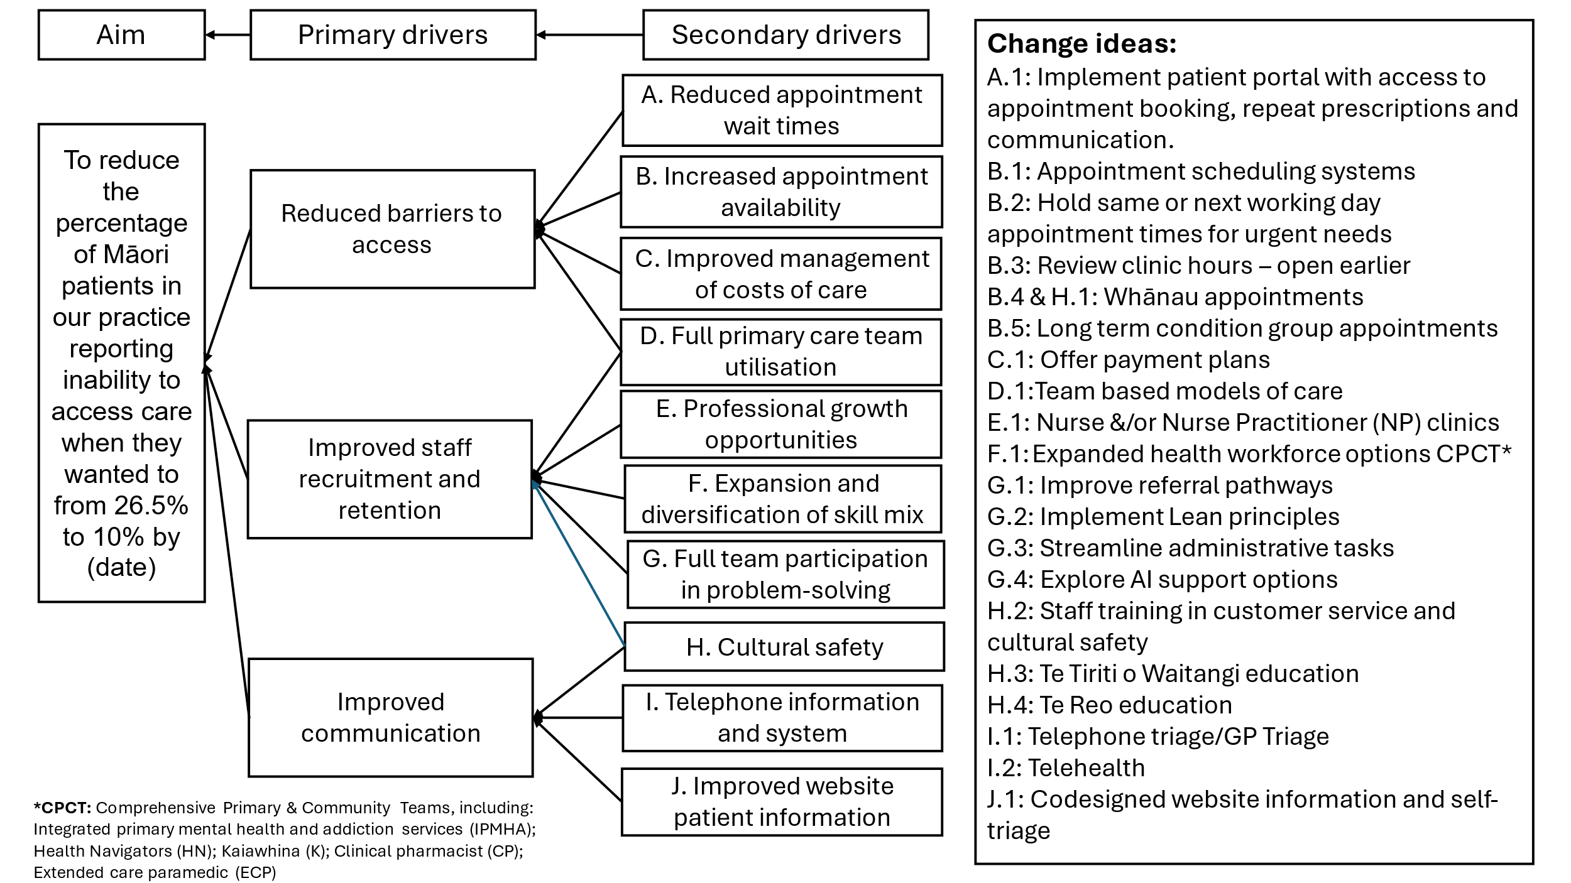

How will we know that a change is an improvement?

#### Outcome measures

* The percentage of enrolled Māori patients reporting that they were able to access health care from a GP or nurse when they wanted to

#### Process measures

* The percentage of enrolled Māori patients seen within the same or next working day, one week, one to two weeks, and over two weeks
* The percentage of enrolled Māori patients reporting that the wait time to get an appointment was too long
* The number of daily Comprehensive Primary and Community Team (CPCT) appointments filled, split into professions
* The percentage of Māori patients reporting that ‘Difficult to take time off work’ was a barrier to appointment access

#### Balancing measure(s)

* The number of enrolled patients seeking care at alternative providers
* The percentage of staff reporting feeling in control of their day
* The percentage of Māori patients reporting that the unavailability of the GP or nurse they wanted to see was a barrier to appointment access
* The percentage of total enrolled patients reporting that they were able to access health care from a GP or nurse when they wanted to

#### Changes to improve the process

The following change ideas were selected based on need, impact, effort, and evidence of effectiveness.[12],[13]

* Open early appointments (7.30–8.15 am) to Māori patients. More Māori (13.2 percent) identify the lack of early appointments as a barrier than patients in general (6.6 percent). (Change 1)
* Schedule acute (same day/next working day) appointments into the appointment template. (Change 2)
* Use the expanded workforce of the CPCT: extended care paramedic, clinical pharmacist and health improvement practitioner. (Change 3)
* Renew Te Tiriti of Waitangi and cultural safety training. (Ongoing)
* Implement tuakana–teina staff partnerships in developing te reo Māori skills, with a focus on name pronunciation. (Change 4)

#### Key stakeholders

* **Patients and whānau:** Keep well informed and invite feedback and suggestions for improvement.
* **Practice manager:** Leads the change.Support them by collecting data, understanding and relaying the results, and communicating key messages across the practice.
* **General practitioners:** Contribute to developing the triage system, monitoring and feedback.
* **Nurses and nurse practitioners:** Contribute to developing the triage system, monitoring and feedback.
* **Receptionist:** Contributes to developing the triage system, monitoring and feedback.
* **Comprehensive Primary and Community Team:** Contributes to developing the triage system, monitoring and feedback.
* **Support staff:** Keep well informed. Participate in discussions and feedback.

#### Barriers and solutions

|  |  |
| --- | --- |
| Barrier | Proposed solution |
| Patient uncertainty | Provide clear information and guides both online and from staff  Monitor regular feedback and respond to it |
| Staff uncertainty | Provide full information and involve them in making the changes  Provide regular updates via meetings and newsletters  Provide with scripts and FAQ sheets |
| Workforce capability and capacity | Implement a recruitment, retention and upskilling programme  Gain support from the primary health organisation and professional organisations |

#### Timeline for implementation – action plan

| Task | Start date | Completion date |
| --- | --- | --- |
| All staff communication | 28 July | Regular meetings |
| Clinical and reception team to co-design the new triage system | 4 August | 1 September |
| Train staff in communication to support new triage system | 25 August | Ongoing review |
| Start testing of new triage and CPCT booking system | 1 September | Ongoing review |
| Feedback and monitoring | 4 August | Feedback via regular meetings  Weekly/monthly practice data collection by practice manager and via patient experience survey quarterly |
| Add more same day/next working day urgent care appointments in appointment template | 1 September | Ongoing review |
| Offer 7.30 am appointments for Māori patients | 1 September | Ongoing review |

#### Expected outcomes and benefits

* Improved patient experience: Equity improves for Māori patients; more patients can see a GP or nurse when they need to.
* Care continuity improves: Patients have fewer missed appointments; preventative care improves.
* Reduced system pressure: Rates of ambulatory sensitive hospitalisation (ASH) admissions reduce; acute and emergency services workload reduces.
* Practice clawback expenditure reduces.
* Staff experience, particularly in the mornings, improves.

Appendix 3: PDSA template

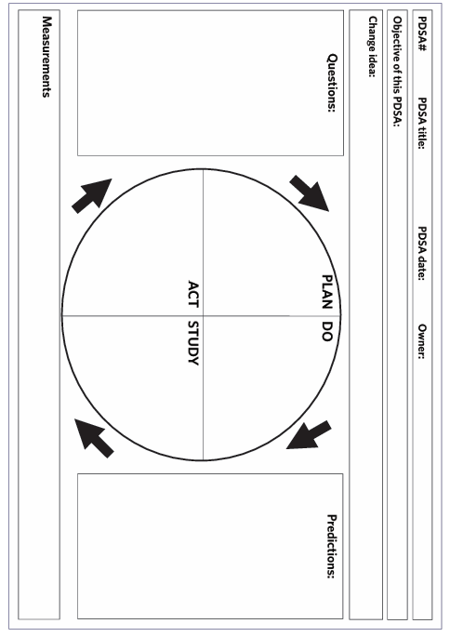

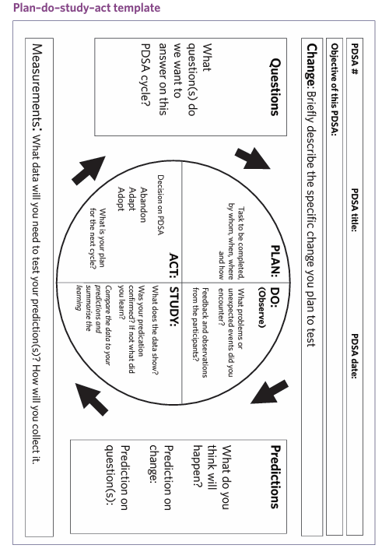

Appendix 4: PDSA example (plan)

This is an example of how to document one complete PDSA cycle, and the plan stage of the subsequent PDSA cycle.

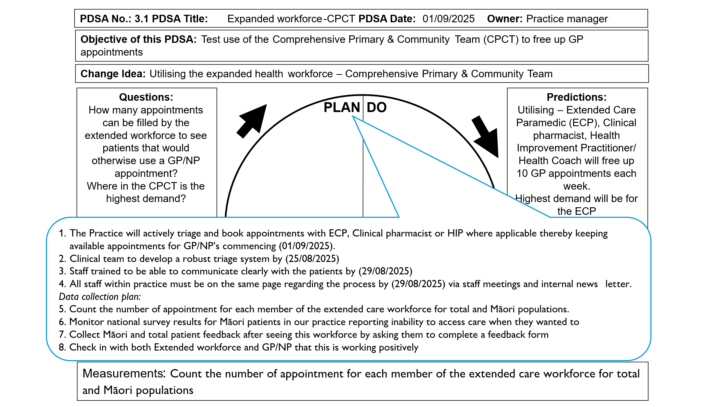

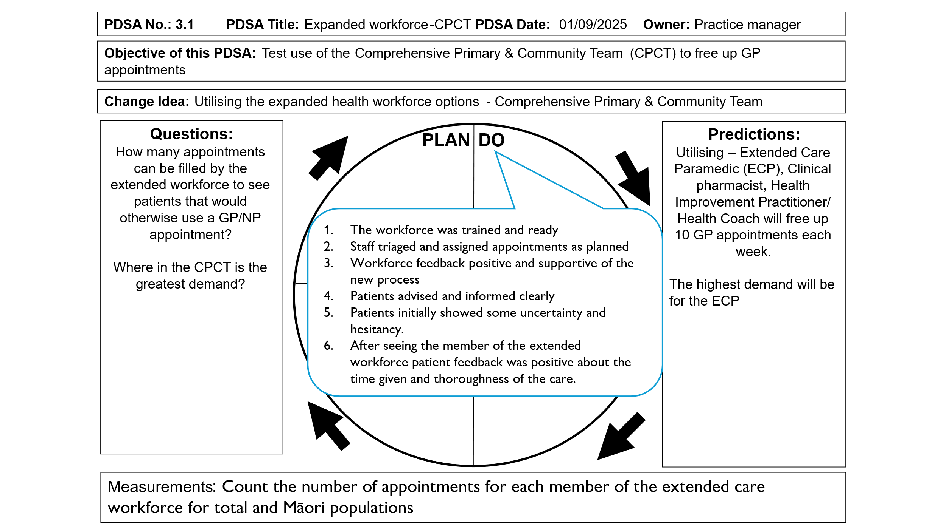

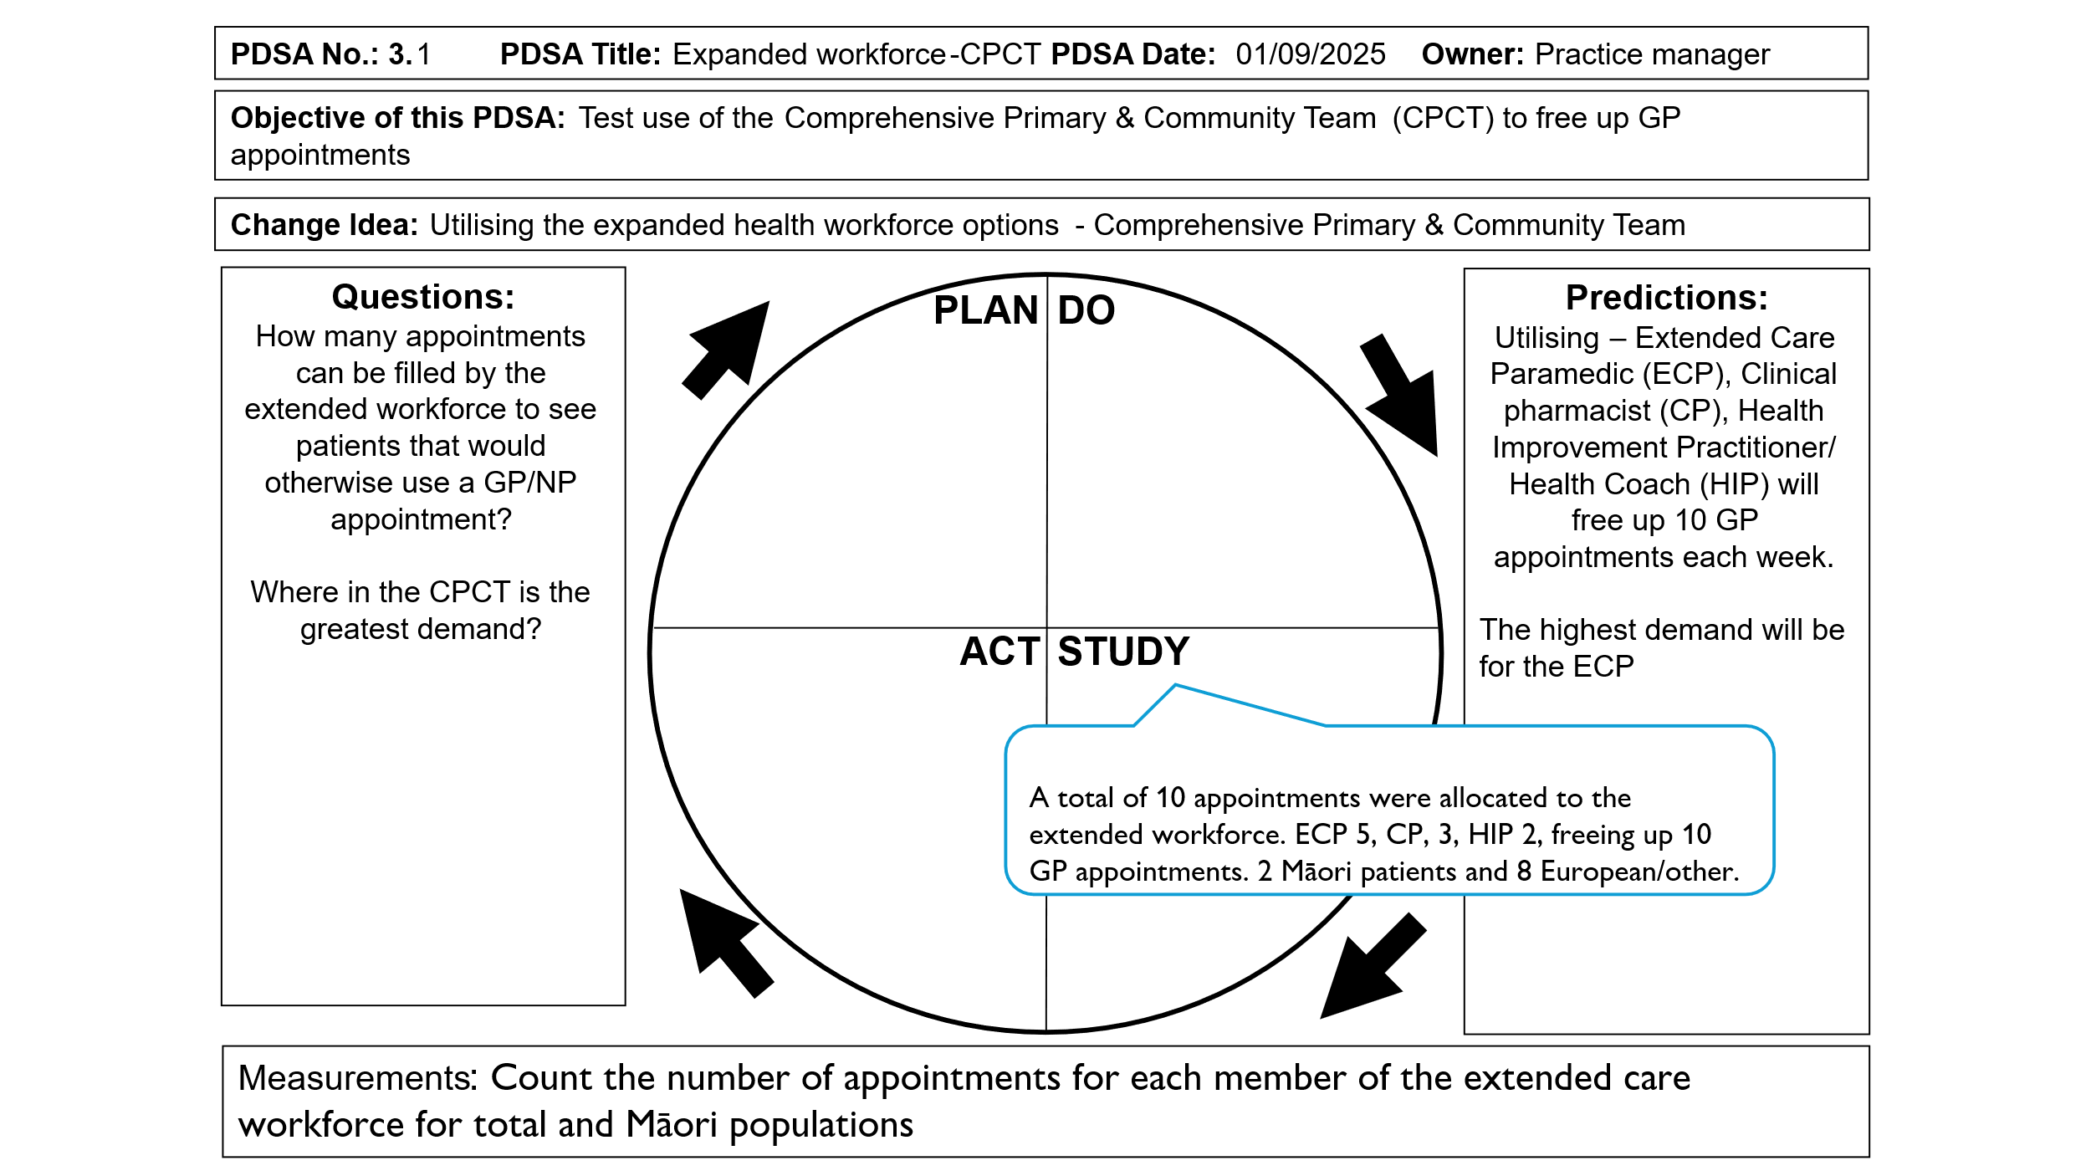

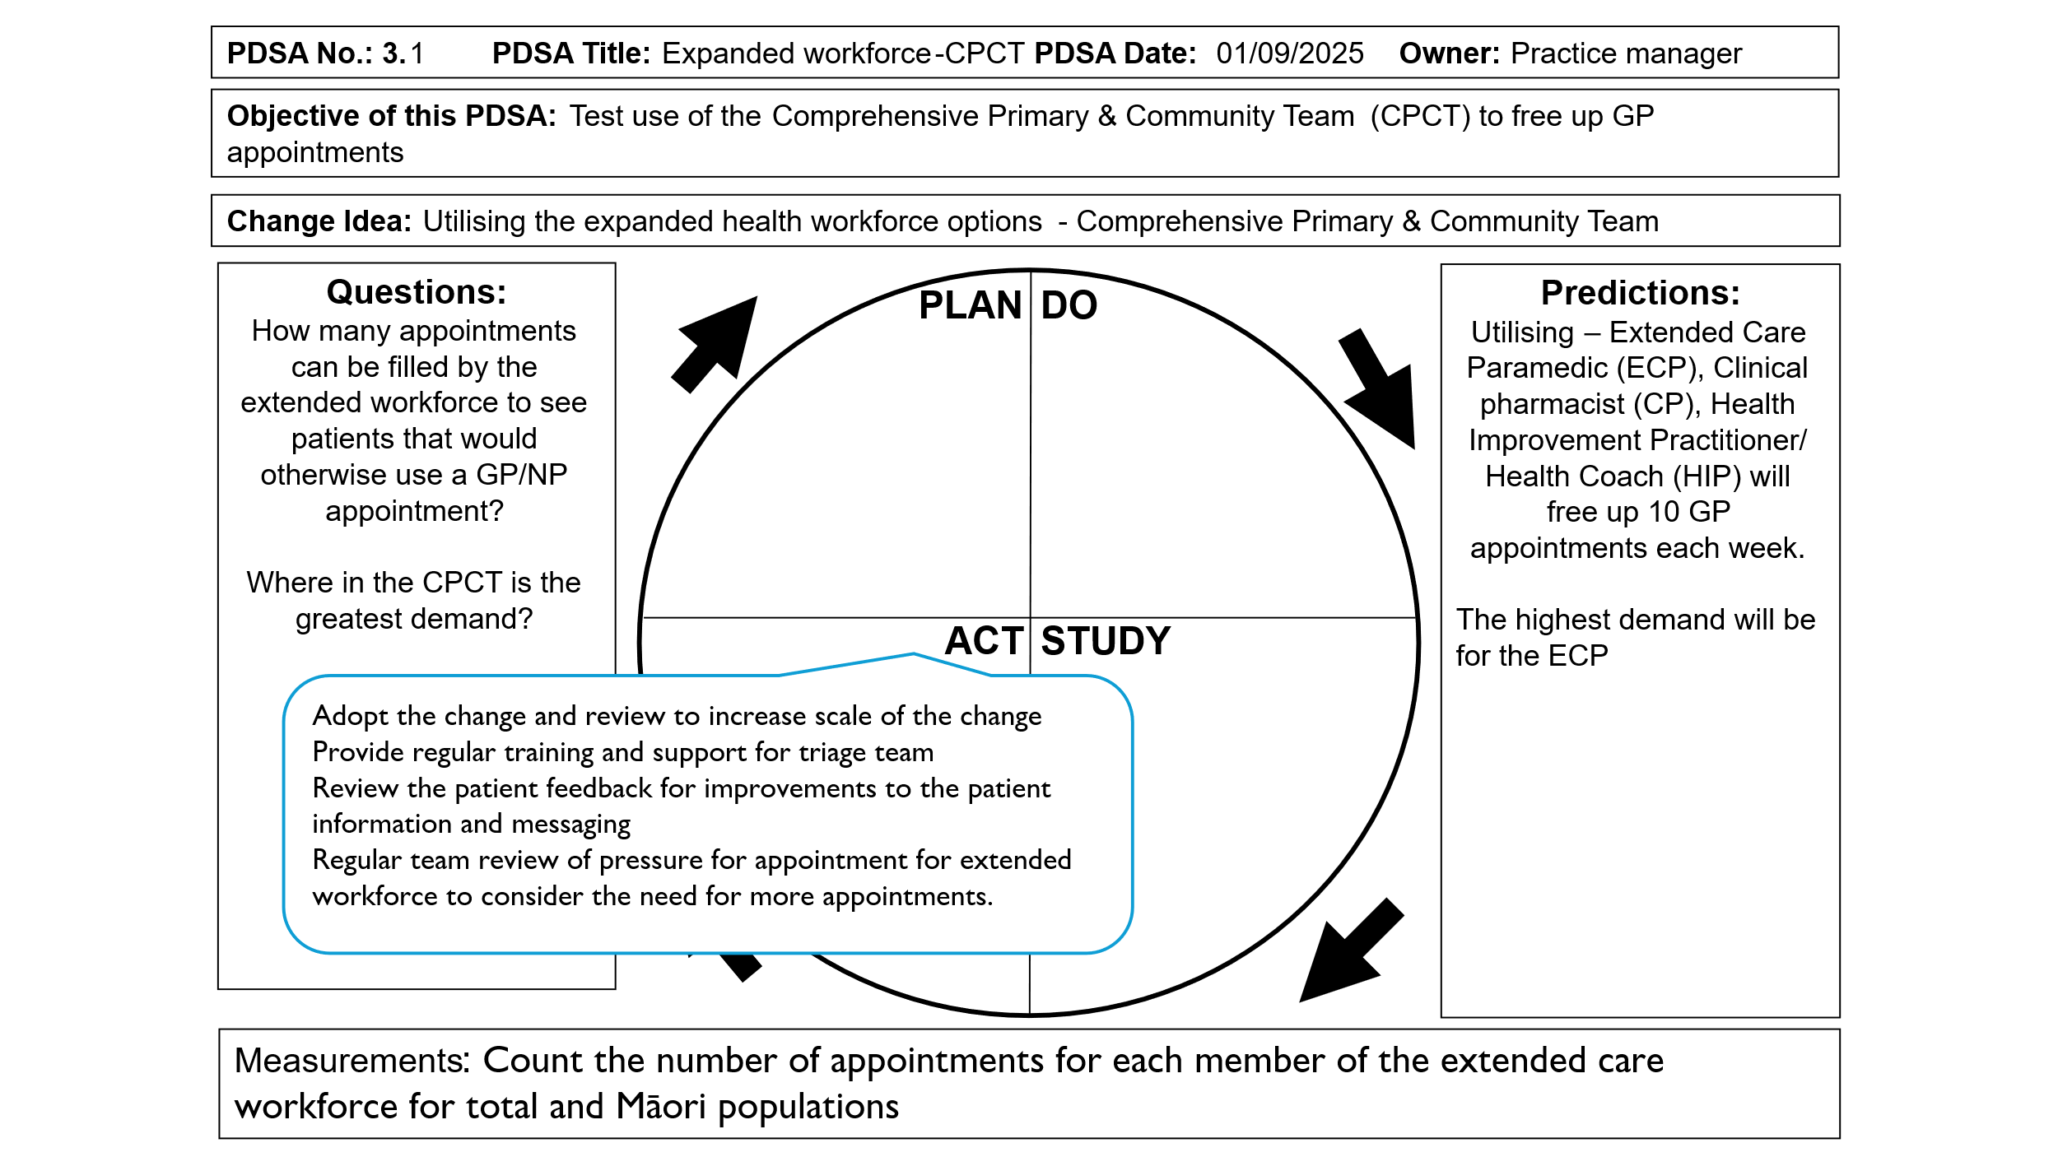

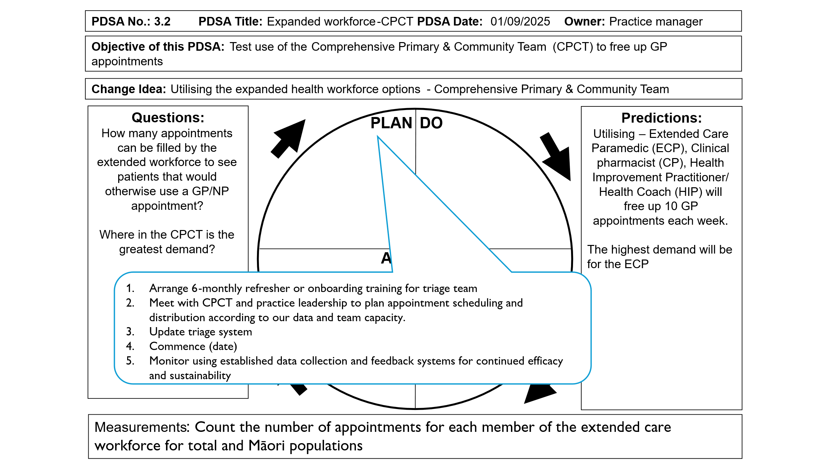

Appendix 5: ‘You said, we did’ poster

|  |
| --- |
| A page with four blue frame boxes. On the top two thirds of the page is two large blue frame boxes the left box is labelled 'You told us' and the right box is labelled 'What we did'. On the bottom third is two smaller boxes the left is labelled ' Where we're up to' and the right is labelled 'Where we want to get. By When' |

This is also available on the Health Quality & Safety Commission Te Tāhū Hauora website: <https://www.hqsc.govt.nz/resources/resource-library/hcss-survey-you-said-we-did-poster/>

Appendix 6: Resources, links and articles

#### Useful links

Aotearoa New Zealand adult primary care patient experience survey: [www.hqsc.govt.nz/our-data/patient-experience/adult-primary-care-patient-experience](http://www.hqsc.govt.nz/our-data/patient-experience/adult-primary-care-patient-experience)

Code of expectations for health entities’ engagement with consumers and whānau: [www.hqsc.govt.nz/consumer-hub/engaging-consumers-and-whanau/code-of-expectations-for-health-entities-engagement-with-consumers-and-whanau/](http://www.hqsc.govt.nz/consumer-hub/engaging-consumers-and-whanau/code-of-expectations-for-health-entities-engagement-with-consumers-and-whanau/)

Progressing consumer engagement in primary care: [www.hqsc.govt.nz/resources/resource-library/progressing-consumer-engagement-in-primary-care-te-whakakoke-i-te-whai-wahi-a-te-kiritaki-ki-te-tiaki-hauora-tuatahi/](http://www.hqsc.govt.nz/resources/resource-library/progressing-consumer-engagement-in-primary-care-te-whakakoke-i-te-whai-wahi-a-te-kiritaki-ki-te-tiaki-hauora-tuatahi/)

Engaging consumers and whānau: [www.hqsc.govt.nz/consumer-hub/engaging-consumers-and-whanau/](http://www.hqsc.govt.nz/consumer-hub/engaging-consumers-and-whanau/)

Open access to co-design learning modules (log in required):

[Co-design in Health](https://koawatealearn.co.nz/enrol/index.php?id=9540) (Health Quality & Safety Commission Te Tāhū Hauora)

[Co-design in health - How you can get involved](https://aus01.safelinks.protection.outlook.com/?url=https%3A%2F%2Fkoawatealearn.co.nz%2Fcourse%2Fview.php%3Fid%3D11499&data=05%7C02%7CJane.Cullen%40hqsc.govt.nz%7Cb0325da19fe94e6cb17a08dd9f24c901%7C701cefdf35f44444863855f0e12ab1c4%7C0%7C0%7C638841702590533847%7CUnknown%7CTWFpbGZsb3d8eyJFbXB0eU1hcGkiOnRydWUsIlYiOiIwLjAuMDAwMCIsIlAiOiJXaW4zMiIsIkFOIjoiTWFpbCIsIldUIjoyfQ%3D%3D%7C0%7C%7C%7C&sdata=rxcmHhWk408DOJT6YwpZrvw1LG%2FZvKGWZ3ThXkZrsrw%3D&reserved=0)

Understanding co-design (primary care co-design case studies are available for 2020–21 and 2018–19): [www.hqsc.govt.nz/consumer-hub/engaging-consumers-and-whanau/co-design](http://www.hqsc.govt.nz/consumer-hub/engaging-consumers-and-whanau/co-design/).

New Zealand patient experience survey programme refresh 2019/20: [www.hqsc.govt.nz/resources/resource-library/new-zealand-patient-experience-survey-programme-refresh-201920/](http://www.hqsc.govt.nz/resources/resource-library/new-zealand-patient-experience-survey-programme-refresh-201920/)

Measuring culturally safe care through the patient experience surveys: [www.hqsc.govt.nz/resources/resource-library/measuring-culturally-safe-care-through-the-patient-experience-surveys/](http://www.hqsc.govt.nz/resources/resource-library/measuring-culturally-safe-care-through-the-patient-experience-surveys/)

Wai 2575 principles:

* Waitangi Tribunal, *Hauora: Report on Stage One of the Health Services and Outcomes Kaupapa Inquiry* <https://forms.justice.govt.nz/search/Documents/WT/wt_DOC_195476216/Hauora%202023%20W.pdf>
* Ministry of Health, Wai 2575 Health Services and Outcomes Inquiry, [www.health.govt.nz/maori-health/wai-2575-health-services-and-outcomes-inquiry](http://www.health.govt.nz/maori-health/wai-2575-health-services-and-outcomes-inquiry)

Equity:

* Community co-design framework and tools: He Pikinga Waiora, [www.hpwcommunity.com/](http://www.hpwcommunity.com/)
* Framework for Effective and Equitable Implementation in Aotearoa self-assessment and action planning tools: Implementation Science Aotearoa, [www.impsciaotearoa.org.nz/freeia-framework](http://www.impsciaotearoa.org.nz/freeia-framework)

Adult primary care patient experience survey: protocol for reviewing patient comments: [www.hqsc.govt.nz/resources/resource-library/adult-primary-care-patient-experience-survey-protocol-for-reviewing-patient-comments/](http://www.hqsc.govt.nz/resources/resource-library/adult-primary-care-patient-experience-survey-protocol-for-reviewing-patient-comments/)

Patient Experience Agency (Australia) with free webinars and blogs with practical tips for engaging with consumers, patient experience and co-design: [www.patientexperienceagency.com.au/](http://www.patientexperienceagency.com.au/)

Healthcare Excellence Canada with webinars and resources to support patient engagement and equity: [www.healthcareexcellence.ca/en/resources/](http://www.healthcareexcellence.ca/en/resources/)

Other websites with information, tools and resources for quality improvement:

* Institute for Healthcare Improvement, Engaging people with lived experience of inequities, [www.ihi.org/library/tools/engaging-people-lived-experience-inequities-community-transformation-tools](https://www.ihi.org/library/tools/engaging-people-lived-experience-inequities-community-transformation-tools)
* Institute for Healthcare Improvement, Quality Improvement Essentials Toolkit, [www.ihi.org/library/tools/quality-improvement-essentials-toolkit](https://www.ihi.org/library/tools/quality-improvement-essentials-toolkit)
* QI Hub, About QI, [www.theqihub.com/about-qi](https://www.theqihub.com/about-qi)
* NSW Clinical Excellence Commission, Improve quality, [www.cec.health.nsw.gov.au/improve-quality](http://www.cec.health.nsw.gov.au/improve-quality)

#### Useful patient experience articles

Burt J, Campbell J, Abel G, et al. 2017. Improving patient experience in primary care: a multimethod programme of research on the measurement and improvement of patient experience. *Programme Grants for Applied Research* 5(9): 1–452.

Cunningham R, Artus J, Imlach F, et al. 2024. Primary care experience in people with mental health conditions: results from a national patient experience survey. *New Zealand Medical Journal (Online)* 137(1606): 22–39.

Dimopoulos-Bick T, Dawda P, Maher L, et al. 2018. Experience-based co-design: tackling common challenges. *Journal of Health Design* 3(1).

Gerard C, O’Brien I, Shuker C, et al. 2024. Patient experience surveys are vital in the twenty-first century: let’s put some myths to rest. *New Zealand Medical Journal (Online)* 137(1588): 80–9.

Hudson Smith M, Smith D. 2018. Directing improvements in primary care patient experience through analysis of service quality. *Health Services Research* 53(6): 4647–66.

Kumah E, Osei-Kesse F, Anaba C. 2017. Understanding and using patient experience feedback to improve health care quality: systematic review and framework development. *Journal of Patient-Centered Research and Reviews* 4(1): 24.

Song HJ, Dennis S, Levesque JF, et al. 2020. How to implement patient experience surveys and use their findings for service improvement: a qualitative expert consultation study in Australian general practice. *Integrated Healthcare Journal* 2(1): e000033.

#### Articles on primary care access improvement

Anawade PA, Sharma D, Gahane S, et al. 2024. A comprehensive review on exploring the impact of telemedicine on healthcare accessibility. *Cureus* 16(3).

Eccles A, Bryce C, Driessen A, et al. 2024. Evidence for access: systematic scoping review of access systems in general practice. *British Journal of General Practice* 74(747): e674–e682.

Fisher R, Beech J, Alderwick H, et al. 2024. Rethinking access to general practice: it’s not all about supply. The Health Foundation. URL: [www.health.org.uk/reports-and-analysis/briefings/rethinking-access-to-general-practice-it-s-not-all-about-supply](https://www.health.org.uk/reports-and-analysis/briefings/rethinking-access-to-general-practice-it-s-not-all-about-supply) (accessed 23 September 2025).

General Practice New Zealand. 2025. *Extended Primary Care Teams: Current state, future opportunities*. Auckland: General Practice New Zealand. URL: <https://gpnz.org.nz/wp-content/uploads/250401-GPNZ-workforce-current-state-future-opportunities_FINAL.pdf> (accessed 6 August 2025).

Jeffreys M, Lopez MI, Russell L, et al. 2020. Equity in access to zero-fees and low-cost primary health care in Aotearoa New Zealand: results from repeated waves of the New Zealand Health Survey, 1996–2016. *Health Policy* 124(11): 1272–9.

Jeffreys M, Smiler K, Ellison Loschmann L, et al. 2021. *Prevalence and Consequences of Barriers to Primary Health Care*. Wellington: Ministry of Social Development. URL: [www.msd.govt.nz/documents/about-msd-and-our-work/publications-resources/research/barriers-to-primary-health-care/prevalence-and-consequences-of-barriers-to-primary-health-care.pdf](http://www.msd.govt.nz/documents/about-msd-and-our-work/publications-resources/research/barriers-to-primary-health-care/prevalence-and-consequences-of-barriers-to-primary-health-care.pdf) (accessed 16 July 2025).

Laurant M, van der Biezen M, Wijers N, et al. Nurses as substitutes for doctors in primary care. *Cochrane Database Syst Rev* 2018, Issue 7, Art. No. CD001271. DOI: [10.1002/14651858.CD001271.pub3](https://doi.org/10.1002/14651858.cd001271.pub3) (accessed 23 September 2025).

Li E, Clarke J, Ashrafian H, et al. 2022. The impact of electronic health record interoperability on safety and quality of care in high-income countries: systematic review. *Journal of Medical Internet Research* 24(9): e38144. DOI: 10.2196/38144 (accessed 23 September 2025).

MacNeill L, Légère K, Balcom S, et al. 2025. Staff experiences with the implementation of nurse practitioner (NP)-led clinics in New Brunswick, Canada. *Canadian Journal of Nursing Research* 57(3): 364–74. DOI: [10.1177/08445621251333678](https://doi.org/10.1177/08445621251333678) (accessed 23 September 2025).

Peart A, Lewis V, Brown T, et al. 2018. Patient navigators facilitating access to primary care: a scoping review. *BMJ Open* 8(3): e019252

Sinnott C, Ansari A, Price E, et al. 2024. Understanding access to general practice through the lens of candidacy: a critical review of the literature. *British Journal of General Practice* 74(747): e683–e694. DOI: [10.3399/BJGP.2024.0033](https://doi.org/10.3399/BJGP.2024.0033) (accessed 23 September 2025).

Sinnott C, Price E, Ansari A, et al. 2025. What’s been tried: a curated catalogue of efforts to improve access to general practice. *BJGP Open* 9(2). DOI: [10.3399/BJGPO.2024.0184](https://doi.org/10.3399/BJGPO.2024.0184) (accessed 23 September 2025).

Feedback

Please provide feedback on this workbook and your experience of using it to [survey@hqsc.govt.nz](mailto:survey@hqsc.govt.nz).

1. For more information see: [www.hqsc.govt.nz/consumer-hub/engaging-consumers-and-whanau/code-of-expectations-for-health-entities-engagementwith-consumers-and-whanau](http://www.hqsc.govt.nz/consumer-hub/engaging-consumers-and-whanau/code-of-expectations-for-health-entities-engagementwith-consumers-and-whanau).
2. Langley GJ, Moen RD, Nolan KM, et al. 1996. *The Improvement Guide*. San Francisco, CA: Jossey‑Bass.
3. Adapted from: *ibid*.
4. Locock L, Graham C, King J, et al. 2020. Understanding how front-line staff use patient experience data for service improvement: an exploratory case study evaluation. *Health Services and Delivery Research* 8(13).
5. For information on the Wai 2575 principles, see: Ministry of Health. 2024. Wai 2575 Health Services and Outcomes Inquiry. URL: [www.health.govt.nz/maori-health/wai-2575-health-services-and-outcomes-inquiry](http://www.health.govt.nz/maori-health/wai-2575-health-services-and-outcomes-inquiry) (accessed 23 September 2025); Waitangi Tribunal. 2023. *Hauora: Report on Stage One of the Health Services and Outcomes Kaupapa Inquiry*. Wellington: Legislation Direct. URL: <https://forms.justice.govt.nz/search/Documents/WT/wt_DOC_195476216/Hauora%202023%20W.pdf> (accessed 23 September 2025).
6. See: He Pikinga Waiora. (nd). Community co-design implementation framework. URL: [www.hpwcommunity.com](http://www.hpwcommunity.com/) (accessed 23 September 2025).
7. See: Implementation Science Aotearoa. (nd). Implementation science and equity. URL: [www.impsciaotearoa.org.nz/implementation-science-and-equity](http://www.impsciaotearoa.org.nz/implementation-science-and-equity) (accessed 23 September 2025).
8. Stange KC, Miller WL, Etz RS. 2023. The role of primary care in improving population health. *The Milbank Quarterly* 101(Suppl 1): 795.
9. Eissa A, Rowe R, Pinto A, et al. 2022. Implementing high-quality primary care through a health equity lens. *The Annals of Family Medicine* 20(2): 164–9.
10. Pledger M, Cumming J. 2024. Unmet need for primary health care and subsequent inpatient hospitalisation in Aotearoa New Zealand: a cohort study. *Journal of Primary Health Care* 16(2): 128–34.
11. Health Quality & Safety Commission Te Tāhū Hauora. 2019. *A window on the quality of Aotearoa New Zealand’s health care 2019*. Wellington: Health Quality & Safety Commission Te Tāhū Hauora.
12. General Practice New Zealand. 2025. *Extended Primary Care Teams: Current state, future opportunities*. Auckland: General Practice New Zealand.
13. Johnson C, Bourgoin D, Dupuis JB, et al. 2024. Exploration of primary care models and timely access to care in New Brunswick (Canada). *BMC Primary Care* 25(1): 366. Sinnott C, Price E, Ansari A, et al. 2025. What’s been tried: a curated catalogue of efforts to improve access to general practice. *BJGP Open* 9(2). DOI: [10.3399/BJGPO.2024.0184](https://doi.org/10.3399/BJGPO.2024.0184) (accessed 23 September 2025).