Patient experience survey – adult hospital:
Methodology and procedures

August 2020

© Health Quality & Safety Commission 2020
Health Quality & Safety Commission
PO Box 25496, Wellington, New Zealand
This document is available on the Health Quality & Safety Commission’s website:
www.hqsc.govt.nz

Contents
1. Introduction 5
1.1 Background 5
1.2 Purpose of the PCPES 5
1.3 Project governance 6
1.4 Implementation and evaluation 6
1.5 Purpose of this document 6
2. Survey sample method 7
2.1 Overview of the survey process 7
2.2 Survey inclusion and invitation 7
2.2.1 Inclusion and exclusion criteria 7
2.2.2 Email and mobile phone collection 7
2.2.3 Email notification and online collection 8
2.2.4 SMS notification and online collection 8
2.2.5 Invitations and reminders 8
2.2.6 Opting out 8
2.2.7 Frequency of surveying 9
2.3 Collection method 9
2.4 Survey sample 9
2.4.1 Sample size 10
3. Survey tool 11
3.1 Domains of patient experience 11
3.1.1 Coordination subdomains 11
3.2 Question set 11
3.2.1 Refresh of the survey tool 11
3.3 Question score method and score calculation 12
4. Survey process 13
4.1 Patient contact and demographic information 13
4.2 Informing patients about the use of their information 13
4.3 Quarterly timetable 14
4.4 Data flows and system access 15
4.5 In situ solution 18
5. Reporting and weighting 19
5.1 Data access 19
5.2 Demographic weighting 20
5.3 Non-response bias 21
Appendix 1: Primary care patient experience survey questionnaire 22
Appendix 2: Patient experience – patient data extract 50
Appendix 3: Correspondence with patients 53

Introduction

1.1 Background
Until 2011 the Ministry of Health required district health boards (DHBs) to undertake mandatory inpatient surveying following the Patient Satisfaction Survey Guidelines published in 2000. In 2011 the national quality and risk managers group reviewed the requirement to survey inpatients.
This review concluded that the reliability and validity of the existing reporting regime was ‘very limited’, and recommended that the reporting requirement be withdrawn from November 2011. This recommendation was accepted and reporting ceased.
The review also recommended that DHBs be required to report on their system for capturing patient experience by September 2012 and evaluate changes made by September 2013. However, this parallel recommendation was not implemented consistently. While a toolkit and guide were produced by the national quality and risk managers group and issued in June 2012, there was no consistently applied national standard for measuring patient experience.
This left a gap in the Health Quality & Safety Commission’s (the Commission’s) national quality and safety indicator set and in the Ministry of Health’s accountability metrics.
In 2013 KPMG provided the Commission with a report of recommendations for implementing a national adult inpatient experience survey. This included a recommendation to move the focus away from satisfaction to experience and to use four domains of patient experience.

1.2 Purpose of the survey
Understanding patient experience is vital to improving patient safety and the quality of service delivery. Patient experience has been shown to be a sound indicator of the quality of health and disability services. Growing evidence indicates that better experience, developing partnerships with consumers, and patient- and family-centred care are linked to improved health, clinical, financial, service and satisfaction outcomes. Integrating the lessons from patient experiences into a quality improvement programme increases the chances of achieving service improvement.
The national adult patient experience survey fills this gap. It is a tool for DHBs to obtain a set of consistent national indicators and carry out local assessment and improvement. The survey tool contains both quantitative and qualitative information.
The aim of the patient experience survey is to improve the quality of health services in New Zealand by enabling patients to provide feedback that can be used to monitor and improve the quality and safety of health services.
Being able to capture, understand and act on patient experiences in a timely manner is a vital contributor to improving health service delivery and also prioritising attention and resources.

1.3 Patient experience programme

1.3.1 Project governance
A sector-led Patient Experience of Care Governance Group (Governance Group) has been established to provide independent advice to the Ministry of Health and the Commission on the ongoing management of the adult inpatient and the primary care patient experience surveys. This includes ensuring the results of the surveys are best used to improve the patient experience at local and national levels. The Governance Group also provides governance on the collection, storage, access and use of the survey data.

1.3.2 The national system
The first national inpatient survey was run in August 2014 and DHBs have been participating quarterly (four surveys a year) since then.
The national system has the added value to DHBs of:
- involving minimal administration for DHBs – a patient data extract is provided in accordance with the survey timetable
- allowing more frequent surveying – up to a survey every two weeks if required – resulting in a continuous flow of data, which is more valuable for improvement purposes than a quarterly ‘temperature check’
- giving DHBs the option of enhancing reporting with additional department-level reporting on the dashboard, using the additional data fields as per the data specification
- using online surveying, which provides higher-quality, more timely data and requires minimal intervention. The system allows for paper-based postal surveys if required.
The ongoing licensed software support is detailed in Appendix 5.

1.4 DHB participation
Patient experience is one of six measures in the System Level Measures Framework. This measure uses the Commission’s national adult inpatient and primary care patient experience survey tool, data collection and reporting system. The focus of this framework is on providing the opportunity for alliances, DHBs, primary health organisations (PHOs) and practices to review and understand their survey results and to use the results to improve delivery of quality and coordinated care.
The DHBs' Operational Policy Framework is also clear that DHBs are required to participate in activities led by the Ministry of Health and the Commission to measure patient experience nationally (9.8.1). DHBs are expected to survey patients’ experience of the care they received and to take part in a national review facilitated by the Commission to assess mechanisms to collect information about patient experience and to make recommendations for future data collection strategies (9.8.2).

1.5 Review of the inpatient experience questionnaire
In 2019, following five years of continuous surveying, the Commission let a contract to review the current questionnaire to answer two core questions:
- Does the Picker question set remain the best approach?
- If not, which option/s should be adopted?
This review recommended moving to a non-proprietary approach combining two to three validated international questionnaires. The questionnaire review provided a final questionnaire for use from May 2020.

The survey sample method

2.1 The survey timetable
The survey is run according to the survey timetable shown in Table 1.

Table 1: Survey timetable
Process | Example quarter  Q3 Jan–Mar19
Inpatients discharged from DHB for set 2-week period | 4 Feb–17 Feb 2019
DHB extracts patient data | Tuesday, 26 February 2019
Extract uploaded to national survey provider | Tuesday, 26 February 2019
Survey emailed or texted to sample group of patients | Tuesday, 26 February 2019
Survey posted to patients | Wednesday, 27 February 2019
Reminder (email or text) sent 7 days later | Tuesday, 5 March 2019
File for post reminders available by 10 am | Friday, 8 March 2019
Reminder (post) sent 10 days later | Friday, 8 March 2019
Email or text survey links close after 21 days | Tuesday, 19 March 2019
All paper survey links close (DHBs enter data in national database by …) | Sunday, 7 April 2019
Survey response data files provided to the Commission | Tuesday, 9 April 2019
Weighted reports (draft) provided to DHBs by the Commission | Tuesday, 16 April 2019
Final weighted reports provided to DHBs and Ministry of Health by the Commission | Tuesday, 30 April 2019

2.2 Survey inclusion and exclusion criteria
Patients aged 15 years and older with at least one night’s overnight stay, where the hospital event ended with a routine discharge or self-discharge, are included in the survey sample.
Specific exclusions are patients admitted to a mental health specialty, patients who were transferred to another health facility and patients who died in hospital.
Patients who were sent a survey invitation in the previous quarter are excluded. Full details of the patient data extract, including rules for inclusions and exclusions, are set out in Appendix 2.

2.3 Collection methods
Most information is collected online. This method is the most cost-effective and least time-consuming to administer.
Patients selected for surveying are contacted by (in order of priority) email, SMS (text) or paper. They are provided with a unique online survey link to click on or type in to submit their response.
According to Statistics New Zealand, 80 percent of New Zealanders have residential internet access, with 1,524 million connections, while there were 4,963 million mobile phone internet connections in 2018. Of all internet connections, 99 percent used broadband and over 70 percent of all broadband internet connections had no data cap. Residential connections were up 20 percent from June 2017.
Absence of internet access is concentrated among poorer populations, rural communities and people aged 75 and older, some of whom may be high users of hospital services. Paper surveying may be the best option for this cohort; see the note on in situ collection in 2.3.3.
For effective use of the online system, the survey needs to collect email addresses and mobile phone numbers (for SMS contact). We appreciate that DHBs have different approaches to collecting this data and strongly recommend that they capture this information on admission to make administration of the survey as simple and cost-effective as possible.

2.3.1 Email notification and online collection
Each DHB runs the patient data extract for the two-week period in accordance with the data extract and file format rules. The file is uploaded through a secure portal on the same day to the national survey provider. The survey provider then selects a random sample of patients, or all patients with an email address if there are fewer than 400. The survey invitation is emailed to each of these patients on the day of the upload. The patient can click on the link to complete the survey online. If the patient has not completed the survey within 7 days, they will receive an email reminder. After 21 days (from the original send date) the survey link will expire.

2.3.2 SMS notification, online collection
Following selection of patients with email addresses, any patient whose records do not have an email address but do have a mobile phone number will be sent an SMS invitation to complete the survey. DHBs may choose to restrict the number of these. If the patient has a smartphone, they can tap on the link to complete the survey online on their phone. If they have a standard mobile phone, they can go to a web page in their PC’s internet browser, enter a short code (that is in the SMS message) and complete the survey online. If the patient has not completed the survey within seven days, they will receive an SMS reminder. After 21 days the survey link will expire.

2.3.3 Mail notification and online or paper collection
Finally, if the patient extract record contains neither an email address nor a mobile phone number, the national survey provider will create an extract of the remaining sample containing a unique code and the patient name and postal details. This file will be provided back to the DHB within eight working hours of the initial upload.
The DHB can then use this file to mail merge with address labels, to code the paper form and to send each patient a paper survey. The patient will have two options, to either:
- go to the survey webpage, enter the short code from the paper survey and complete the survey online, or
- fill out the paper form and post it back to the DHB. The DHB then enters the responses into the survey system.
The DHB is responsible for sending reminders to people who have not responded to the paper survey invitation. The national survey provider will send a reminder list to each DHB showing the outstanding records in time for the reminders to be sent by the DHB.
Each DHB decides individually whether they want to utilise the mail option.

2.3.4 Invitations and reminders
Invitations are sent promptly after the survey provider receives the patient data extract. This approach aims to minimise the risk that the patient’s circumstances have changed, which may include that they have died. It can take up to three months after a patient’s death for DHB systems to be updated with this information. While there is no way to entirely remove the risk of sending a survey or reminder to the family of someone who has died, we can mitigate the risk by minimising the time between admission and when the survey and reminder are sent. We have also included a ‘sensitivity’ statement in the correspondence.
Good evidence indicates that the use of reminders increases survey response rates, generating one-third to a half of the responses the original survey invitation achieves. For this reason, our methodology includes a reminder seven days (or 10 days for mail) after the initial contact with the patient.
The national system provider will facilitate reminders for the mandatory quarterly survey. Reminders are not required for those who choose to survey fortnightly.

2.3.5 Frequency of surveying
The survey runs every three months (four times a year). For national reporting purposes and consistency, the survey will be sent to patients discharged within the same two-week period in each quarter in each DHB. The two-week period chosen avoids public holidays, but it is not intended as a representation of the quarter in which it sits. Rather, it will be one of a series of snapshots recorded over a year. This fits with our recommendation that DHBs collect patient feedback constantly to monitor changes and stimulate improvement in patient experience.
Due to their smaller size, four DHBs – Whanganui, Taranaki, South Canterbury and West Coast – sample over a four-week period. This means their survey sample period starts two weeks earlier than other DHBs.

2.4 In situ collection
In areas with such low access to the internet that an online approach to delivering the survey presents a substantial risk of unrepresentative responses and/or very low response rates, DHBs may discuss with the Commission using an in situ alternative for the collection of data.
Because there are many cautions and concerns about this sort of approach, the Commission will only support it where no practical alternative that is likely to produce reasonable response rates exists. We see this as a last resort where no other method is likely to garner enough data.
The arguments against in situ reporting are that:
- questioning in the middle of the event is premature, giving the respondent insufficient time to collect and compose their thoughts about what they have experienced
- the response in the middle of a hospital stay could be unrepresentative if the experience improves or deteriorates through the remainder of the stay
- the power imbalance between patient and professional may be such that the patient feels intimidated into giving unrealistically positive responses
- of even more concern, anecdotal evidence indicates staff may seek out patients with more positive experiences to complete the survey in order to gain more positive responses.
Some strategies can be applied to reduce the risk of these negative effects, which we set out below, but even with these in place, the results risk being incomparable with post hoc collected surveys. For this reason, reporting will make it clear that the DHBs using the in situ methodology have a different methodology and that their results will not be directly comparable with those of other DHBs using the post hoc methods.
DHB enters survey responses online or sends survey response data file to national survey provider.
The process for in situ survey collection is as follows.
- Use of an in situ method survey collection method needs to be agreed with the Commission before it is undertaken.
- Agreement of technical requirements and method for transmitting the data to the national system needs to be made with the national survey provider before undertaking this method.
- Data must be collected in a consistent manner for all patients surveyed so that:
- the administration of the survey is the final interaction with the patient prior to discharge
- the survey is not administered by a member of clinical staff
- the person administering the survey does not stay with, advise or otherwise prompt the person taking the survey
- the survey is physically completed by the person taking it or a carer with them, not by the person administering the survey
- an introduction, based on the survey invitation (Appendix 3), emphasises that the DHB staff member (or volunteer) administering the survey is unable to view the surveyed patient’s response.

2.5 Sample size
Adequate sample size is essential to ensure the recorded results represent the DHB’s eligible patient population. At least three risks need to be addressed:
- the sample of respondents may be too small, leading to excessively wide confidence intervals and unstable results that make changes hard to interpret
- the sample may be unrepresentative of the eligible patient population structure
- response bias may occur, where patients with unrepresentative opinions – either more or less content with their experiences than the average – are more likely to respond.
Well-designed samples can mitigate these risks.

2.5.1 Sample size calculation
Determining the correct sample size for a given survey is both an art and a science. While the statistics of determining the size of confidence levels are well understood and comparatively straightforward to derive mechanistically, the art lies in balancing these with ideas about what are acceptable (and affordable) samples, understanding likely response rates (which play a fundamental role in the reliability of the results) and the size of confidence limit (‘margin of error’) that we are prepared to accept.
We have modelled various options and, based on a reasonable expectation of a response rate of about 40 percent (which is around an average response rate internationally); have set the sample size at 400 patients to be contacted. In five or six DHBs this total is more than the number of patients they treat within the average two weeks. In these cases, all eligible patients should be contacted. This gives confidence intervals of about 6–7 percent at a 40 percent response rate and of about 5 percent at a 60 percent response rate.

The survey tool

3.1 Design and principles
Working with KPMG to review international evidence and best practice, the Commission identified four domains or areas of interest that were most important to understand patient experience.
We have reviewed the ideas in KPMG’s report and tested them with a number of stakeholders and consumers, including our expert advisory group on quality and safety indicators. As a result of this process, we chose the following domains:
- communication
- partnership
- coordination
- physical and emotional needs.
The Picker survey tool used from 2014–2019 was built around these four domains.
A full copy of the original Picker survey tool is included in Appendix 1.
The new questionnaire was available from May 2020.

Survey process

4.1 Patient identifiable information
All responses to the survey are anonymous unless respondents choose to provide their contact details because they wish to talk to someone at the DHB.
Each survey sent has a unique ID that enables line-by-line analysis of responses. When the patient data extract is imported to the national system, a number is assigned to each line of information. The national survey and reporting process does not require patient identifiable information to be held in the database. Initially that information is needed to enable email and text correspondence to be addressed but once each survey link is closed (three weeks after email and text surveys are sent), all identifiable information is deleted from the system.
Note that demographic information – age, gender and ethnicity – is retained.
The national survey provider is required to host the database within New Zealand and strict privacy and security protocols are maintained.
A privacy impact report has been prepared and the Office of the Privacy Commissioner has reviewed it.

4.2 Informing patients about use of their information
DHBs are well aware of the need to inform patients about how the information they provide will be used. DHBs will already have a statement in their registration/admission form that is similar to this:
GENERAL PRIVACY STATEMENT
We collect your health information to provide you with appropriate care, to plan for and fund health services, to carry out teaching and to monitor quality. We share this information with other health care providers and agencies involved in your care. We treat your information as confidential and ensure that it is kept secure and only accessed by authorised persons. You have a right to request access to your records and to request correction of the information. Information may be supplied to family, support people or other agencies if you give us your permission or disclosure is authorised by law.
This statement covers the collection of the patient’s email address to monitor quality through patient surveys.
Another useful statement to include is something like:
PATIENT EMAIL ADDRESS FOR RECEIPT OF CLINICAL CORRESPONDENCE
Please provide your email address if you are happy for <DHB name> to send your clinical correspondence via email. We may also invite you to give us feedback about your care. Please advise <DHB name> as soon as possible in writing if your contact information changes.
This statement is useful given the patient’s email address may be accessed by other people in the household. The email survey invitation includes an ‘unsubscribe’ option.
DHBs’ public notices and ‘your rights’ brochures should also include similar information around the use of patient information for monitoring service quality and other purposes. It would be useful to add information about collecting patient email addresses to these notices to increase the uptake and awareness of this option among both patients and staff.

4.3 National survey process
DHBs, apart from contributing financially to the provision of the national system, are required to run an extract according to the rules set out in Appendix 2 once a quarter, and to review and respond to the results being provided via the reporting portal.
The national survey provider will undertake the following process.
- Create and maintain a secure portal and data warehouse for online completion of the inpatient survey and secure storage, analysis and reporting of the results.
- Import the patient data extracts to the data warehouse and draw a random sample of 400 from the extract of eligible patients provided by the DHB. If the extract contains fewer than 400 patients, then the whole extract can be used.
- Contact the sample of patients through, in order of priority, email or SMS, with one of the invitations in Appendix 3 asking them to participate in the survey.
- Ensure that the branding, email signature and survey conclusion signature that each respondent to the electronic survey sees match the branding of the DHB they were discharged from.
- Provide DHBs administering mail surveys with contact details and a unique survey link to be printed on the paper survey if the DHB sample includes records without email or mobile phone details.
- Send electronic reminders to complete the survey seven days following initial contact, using the same method as initial contact (for quarterly surveys only).
- Create and maintain dashboards to allow reporting of unweighted results. DHBs will be able to filter results and download reports in multiple formats.
- Create login access for system users, which DHBs will then manage themselves to reflect changes in required staff access.
- Send an email alert to a nominated DHB contact person when a respondent indicates they wish to be contacted by the DHB. Provide contact details and reason for contact to the DHB for those respondents who wished to discuss some aspect of their response.
- Create a survey data extract and provide it to DHBs and the Commission for local analysis on request once per quarter in the format prescribed in Appendix 4. Ensure DHBs running the fortnightly survey and reporting cycle can access and download their DHB data at any time they require it.
- Provide a national extract to the Commission at least quarterly to allow us to calculate the national indicators.
- Conduct the above process in accordance with the national timetable.
- All data received from DHBs should be validated (batch files and records) with error reports sent back to DHBs.
Figure 1 summarises this process.

Figure 1: Information flow diagram – adult inpatient experience survey
Sample from inpatients discharged from DHB during a set period each quarter
DHB extracts patient data in accordance with survey rules 9 days after set period ends
Extract uploaded to Ipsos Data Collection Portal same day

Survey sent by email, text or mail to sample group of patients the same day
Reminder sent to patients (who haven’t completed the survey) 7 days later, or 10 days later for mail
Email and text survey links close after 21 days
Additional three weeks allowed for DHBs to enter mailed survey data in national survey database
Survey response data is published in the reporting portal
Commission provides final weighted reports to DHBs and Ministry of Health 1 month after the quarter end
Survey data files available to the Commission and DHBs two days later
System reports available one week later
DHBs communicate use of patient information for quality purposes through a range of methods

5. Reporting and weighting
Survey responses are provided to DHBs in the national reporting portal.

5.1 National accountability
The survey is designed to encourage local improvement and provide four national indicators by DHB on each of the domains.

5.2 Quantitative and qualitative analysis
The national survey provider will provide a survey data file in accordance with Appendix 4 to DHBs and the Commission so that they can undertake further analysis.
DHBs will be able to further analyse or report the patient survey information as they choose for internal purposes. The patient comment field will be of particular interest to DHBs. Further qualitative analysis can be undertaken by the DHBs using the data extract provided.
Both the Commission and the survey provider will take a broader view of the information and perform additional analyses. The survey provider will undertake analyses to help understanding of the drivers of good and poor patient experience. Understanding how important each component of an experience is to patients will help hospitals determine which areas they should focus their improvements on to have the biggest impact on the overall experience. This approach gives sector users the tools to prioritise their efforts.
Response rates will be monitored each quarter. The Commission will also report on national trends.

5.3 Data access
Data access rules decided by the Patient Experience of Care Governance Group are in place. Different system users have access to different levels of information. Table 2 presents the data access matrix.

Table 2: Data access matrix
What data can be seen
Information | Data level | Patient | PHO | DHB | National | Commission | Approved research ª | Public
Patient data file (ex DHB) | Individual – identifiable |  |  | ^{b}
Survey responses | Individual – identifiable |  |  | ^{c}
Online reporting portal – quantitative | All DHBs, DHB identifiable
Online reporting portal – qualitative comments | Individual (anon) – DHB level, their own |  | ^{d} | ^{d}
Raw data extract | Unit record level (anon)
Published reports | High-level, national aggregate information
ª Approval granted by Governance Group, following formal request and following the data access guidelines. Access to qualitative comments may be granted, provided that comments can be cleaned to remove identifiable components.
^{b} Only accessed by DHB administrator.
^{c} Only if patient requests contact and approves access to survey responses. Only accessed by nominated patient liaison.
^{d} Only DHB superusers can view unmoderated comments. Superusers can give other users access to the comments if required for their role.

5.4 Weighting
Regardless of sample size, if the sample is systematically unrepresentative of the eligible patient population, the results will be misleading. There are two ways to mitigate this: either stratify the sample so it looks like the eligible patient cohort; or use a random sample and apply weights in line with the eligible patient cohort to the results post hoc.
Of these two approaches we prefer the latter, as for a stratified approach to completely address this risk we would have to assume that each stratum had a similar response rate (and if they didn’t, a further exercise in weighting would be required). In contrast, weighting according to demographic characteristic (we are capturing age, gender and ethnicity in the survey) allows the results to be adjusted to reflect the differences that are actually recorded. This is an approach used widely by opinion polling organisations.

5.4.1 Demographic weighting
Demographic weighting takes the local eligible population structure, compares this with the survey respondent structure and creates a coefficient that is applied to the results of the survey. This coefficient then increases or decreases a particular score and provides a weighted result. The effect of weighting is to adjust for different response rates between different demographic groups and adjust the results to reflect this. The more under-represented a particular group is among the respondents, the more actual patients each respondent represents. For this reason, the response of respondents from under-represented groups is up-weighted and the response of those from over-represented groups is down-weighted.
The Commission prepares quarterly patient experience indicator reports that present weighted results.
To determine which variables should be used in the weighting, we analysed age, gender, ethnicity, method of admission and method of survey administration as potential sources of bias in response. Our analysis found that, among these variables, only age and gender showed material differences in response between different groups.
Please note that the national online reporting system shows unweighted results for local purposes.

5.5 Response rate calculation
The response rate is calculated nationally and for each DHB. At the national level, the response rate according to survey distribution type is also calculated. Currently, distribution methods include post, email and text (SMS). The denominator for the response rate is all those who were invited to participate in the survey and the numerator is those who completed the survey. Response rate is reported as a percentage.

5.6 Continuous improvement
Continuous improvements to the data collection tools and reporting systems are part of the programme. It is expected that changes will be needed on a regular basis. Examples of improvements might include tweaking questionnaire content, setting up a response rate trial or special reporting of such a trial.
To support system and policy improvement, every six months the survey provider will run a ‘deep-dive’ workshop with key programme staff and stakeholders (such as representatives from practices, PHOs and DHBs). These are designed to share results and identify strengths and weaknesses with a view to identifying and prioritising issues for resolution.

Appendix 1: Survey tool

PROGRAMMING INSTRUCTIONS
Programming instructions are noted [LIKE THIS]. They show question type and any routing or visual reference information as well as indicators for piping in responses.
If nothing is shown for filter, the default is all respondents and default question type is single choice.
No questions are compulsory.
Do not show respondents:
- hidden questions
- question names or numbering
- information or introduction headings.

Introduction
[SHOW HEADING]
Thank you for taking part in this important survey about your recent hospital stay. Your feedback will help us understand and improve patients’ hospital experience.
This survey is about your most recent stay in the hospital. Please do not include any other hospital stays in your answer.
The survey should take just 10 to 15 minutes to complete, depending on your answers.
Unless you would like us to contact you, your responses are anonymous and will not be connected to you in any way. Please be open and honest in your feedback.

Screening questions
[DO NOT SHOW HEADING]

Q1. WHO_answers
Purpose: For analysis only
[SHOW ON SAME SCREEN AS S1B] [SINGLE PUNCH]
Could you tell us if you are answering this survey on behalf of yourself or someone else?
- Myself
- Someone else unable to answer this survey

Q2. WHO_why
[IF SOMEONE ELSE] [SHOW ON SAME SCREEN AS S1]
Purpose: For analysis and understanding of response pool only
[MULTICODE]
Which of the following reasons best describes why you are answering the survey on the patient’s behalf?
It is difficult for the patient to respond due to …
Please select all that apply
- Age – too young
- Age – too old
- Language (not enough English)
- Computer abilities or access
- Learning difficulties eg, unable to read
- Disabilities eg, low vision
- Health issues
- Other, please specify

Main questionnaire
[DO NOT SHOW HEADING]

Your care from your health care team
[SHOW HEADING]

INFO_HCT
We are going to ask you to reflect on your experiences with the doctors, nurses and the wider health care team during your hospital stay. When thinking about the wider health care team, this includes support staff and specialists within the hospital such as occupational therapists, physiotherapists, dieticians and other health care assistants.

Q3. QHCT_listen
Analysis: Fits in Communication domain, replaces existing Q3
[SINGLE CHOICE GRID]
During your most recent hospital stay, did the [INSERT HCP] listen to your views and concerns?

[LOOP INSERTION]
- Doctors
- Nurses
- Other members of your health care team

[GRID ACROSS]
- Yes, always
- Sometimes
- No
- I did not have contact with them

Q4. QHCT_informed
Analysis: Fits in Communication domain – replaces existing Q1
[SINGLE CHOICE]
Were you kept informed as much as you wanted about your treatment and care?
- Yes, always
- Sometimes
- No
- I was unable to be informed

Q5. QHCT_understood
Analysis: Fits in Communication domain, replaces previous Q2, combines with language and ethnocultural minorities questions to understand barriers
[SINGLE CHOICE]
Did your health care team explain what was going on during your stay in a way you could understand?
- Yes, definitely
- Somewhat
- No

Q6. QHCT_involve
Analysis: Included in Partnership domain – replaces previous Q6
[SINGLE CHOICE]
Were you involved as much as you wanted to be in making decisions about your treatment and care?
- Yes, always
- Sometimes
- No
- I did not want to be involved
- I was unable to be involved

Q7. QHCT_conflict
[SINGLE CHOICE]
Were you given conflicting information by different doctors or staff involved in your care, eg, one would tell you one thing and then another would tell you something different?
- Yes
- No
- Unsure / don’t know

Q8. QHCT_kind
Analysis: Included in Physical and emotional needs domain – replaces current Q15, explore correlation with respect in future
[SINGLE CHOICE]
Did the [INSERT HCP LOOP] treat you with kindness and understanding while you were in the hospital?
[LOOP INSERTION]
- Doctors
- Nurses
- Other members of your health care team

[SCALE]
- Yes, definitely
- Somewhat
- No
- I did not have contact with them

Q9. QHCT_respect
Analysis: Included in Physical and emotional needs domain
[SINGLE CHOICE]
Did the [INSERT HCP LOOP] treat you with respect?
[LOOP INSERTION]
- Doctors
- Nurses
- Other members of your health care team

[GRID ACROSS]
- Yes, definitely
- Somewhat
- No
- I did not have contact with them

Q10. QHCT_trust
Analysis: Included in Overall – replaces previous Q20
[SINGLE CHOICE]
Did you trust and have confidence in the:

[STATEMENTS DOWN]
- Doctors?
- Nurses?
- Other members of your health care team?

[SCALE]
- Yes, definitely
- Somewhat
- No
- I did not have contact with them

Your experiences in hospital
[SHOW HEADING]

Q11. QH_clean
Analysis: Included in Physical and emotional needs domain
[SINGLE CHOICE]
Were the hospital rooms or wards (including bathrooms) kept clean?
- Yes, always
- Sometimes
- No

Q12. QH_private
Analysis: Included in Physical and emotional needs domain
[SINGLE CHOICE]
Were you given enough privacy when talking about your treatment or condition?
- Yes, definitely
- Somewhat
- No
- Did not apply to me

Q13. QH_help
Analysis: Included in Physical and emotional needs domain – replacing toilet/bed pan question Q12
[SINGLE CHOICE]
Did hospital staff help you to get to the bathroom or to use a bedpan as soon as you wanted?
- Yes, always
- Sometimes
- No
- I did not need or want help from staff

Q14. QExp_needs
Analysis: Included in Physical and emotional needs and Cultural support domains – use for analysis (ie, filter) for wider picture
[SINGLE CHOICE]
During this hospital stay, did you feel your individual and/or cultural needs were met?
- Yes, definitely
- Somewhat
- No
  - I did not have any individual or cultural needs that needed to be met

Q15. QExp_needs_OE
[ASK IF QEXP_needs= Somewhat OR No]
[OPEN END]
Please explain, in as much detail as possible …
How could your individual or cultural needs have been better met?

Q16. QFam_discuss
Analysis: Included in Partnership domain – replaces previous Q7, potential to correlate with falls data
[SINGLE CHOICE]
Did hospital staff include your family/whānau or someone close to you in discussions about the care you received during your stay?
- Yes, definitely
- Somewhat
- No
- I did not want them included
- Not applicable

Q17. QMed_pain
Analysis: Included in Physical and emotional needs domain – replaces previous Q13
[SINGLE CHOICE]
During this hospital stay, did you receive pain relief that met your needs?
- Yes, always
- Sometimes
- No
- I did not need pain relief

Your surgery or operation(s)
[SHOW HEADING]

Q18. QSurg
Analysis: Included in Surgery, use as filter for upcoming questions
[SINGLE CHOICE]
During your stay in hospital, did you have an operation or surgery?
- Yes
- No
- Don’t know

Q19. QSurg_before
[ASK IF QProd = Yes]
Analysis: Included in Surgery, replaces previous Q18
[SINGLE CHOICE]
Before the operation(s), did staff help you to understand what would happen and what to expect?
- Yes, definitely
- Somewhat
- No
- Did not apply to me

Q20. QSurg_after
[ASK IF QProd = Yes]
Analysis: Included in surgery, replaces previous Q19
[SINGLE CHOICE]
After the operation(s), did staff help you to understand how it went?
- Yes, definitely
- Somewhat
- No
- Did not apply to me

When you left the hospital
[SHOW HEADING]
[ASK ALL]

Q21. QDischarge_Ready
[SINGLE CHOICE]
Towards the end of your stay, were you kept informed as much as you wanted about what would happen and what to expect before you could leave the hospital?
- Yes, definitely
- Somewhat
- No

Q22. QDischarge_inform
Analysis: Included in Coordination of Care – replaces Q10
[SINGLE CHOICE]
Did you have enough information about how to manage your condition or recovery after you left hospital?
- Yes, definitely
- Somewhat
- No
- I was not given any information
- I did not want or need any information

Q23. QMed_purpose
Analysis: Fits in Communication domain, replaces Q4
[SINGLE CHOICE]
Were you told what the medicine (or prescription for medicine) you left the hospital with was for?
- Yes, definitely
- Somewhat
- No
- I was not given any medicine (or prescription for medicine) when I left hospital

Q24. QMed_sideeffect
Analysis: Fits in Communication domain
[SINGLE CHOICE]
Were you told the possible side effects of the medicine (or prescription for medicine) you left hospital with in a way you could understand?
- Yes, definitely
- Somewhat
- No
- They did not need to, because I already knew the side effects
- I was not given any medicine (or prescription for medicine) when I left hospital

Q25. QDischarge_Help
[SINGLE CHOICE]
Did hospital staff talk with you about whether you would have the help you needed when you left the hospital?
- Yes, definitely
- Somewhat
- No
- Did not apply to me

Your overall view of your hospital stay
[SHOW HEADING]

Q26. QDiscrim
Analysis: In reporting portal, to be framed positively and care taken to reporting – not in reporting portal in first quarter
[MULTIPLE CHOICE]
When you were in hospital did you ever feel you were treated unfairly for any of the reasons below?
Please select all that apply to you
- I was not treated unfairly [EXCLUSIVE CHOICE]
- Your skin colour
- Your race or ethnic group
- Your sex
- Your gender identity
- Your age
- A disability or physical health condition you have
- A mental health condition you have
- Your sexual orientation
- Your religious beliefs
- Your income or your family/whanau’s income
- Your appearance
- Something else, please specify:
- Don’t know / unsure

Q27. QDiscrim_HIDDEN
Purpose: For analysis – to identify discrimination and to assist with filtering verbatims and flags to sector
[NOT SHOWN TO RESPONDENT – AUTOPUNCH BASED ON PREVIOUS QUESTIONS]
Identified perceived unfair treatment
- Yes [IF SELECT ANY OTHER THAN I WAS NOT TREATED UNFAIRLY OR DON’T KNOW / UNSURE]
- No

Q28. QDiscrim_OE
[IF SELECT ANY OTHER THAN I WAS NOT TREATED UNFAIRLY OR DON’T KNOW / UNSURE in Q26. DISCRIM]

[IF RESPOND YES – TO ANY ABOVE]
[OPEN END]
You indicated that you felt you were treated unfairly due to [ANSWER(S) FROM DISCRIM].
Please describe, in as much detail as possible…
What happened to make you feel you were treated unfairly?

INTRO_Overall
The next questions are about your overall view of your latest hospital stay. Please think about all the aspects of your stay including those we have covered in the questions above and any other aspects that are important to you.

Q29. QOverall_Quality
Analysis: Measure intended as a part of driver analysis and not an overarching reporting measure, not presented on its own in the reporting portal, but as a segmenting variable for verbatims
[SINGLE CHOICE]
Overall, do you feel the quality of the treatment and care you received was:
- Very good
- Good
- Average
- Poor
- Very poor

OE_Disclaimer
Your responses to this survey are anonymous – please be careful not to give information in your comments that might identify you (such as dates, names, contact information).

Q30. QHS_Better_OE
[ASK ALL]
Please describe, in as much detail as possible …
What would have made your stay in hospital better?
[OPEN END]

Q31. QHS_Strength_OE
[ASK ALL]
Please describe, in as much detail as possible …
What about your stay in hospital went well?
If there is someone whom you would like to recognise for a job well done, please feel free to include their name (if you remember it) and what they did well below.
[OPEN END]

About you
[SHOW HEADING]
Analysis: These questions are not to be reported by individual responses but are to be used as comparators within reporting for equity purposes and understanding differences between different cultural communities

Health questions
[DO NOT SHOW HEADING]
The questions that follow are about difficulties you may have doing certain activities because of a health condition.

Q32. WGSS1
[SINGLE CHOICE]
Do you have difficulty seeing, even if wearing glasses?
- No – no difficulty
- Yes – some difficulty
- Yes – a lot of difficulty
- Cannot do at all

Q33. WGSS2
[SINGLE CHOICE]
Do you have difficulty hearing, even if using a hearing aid?
- No – no difficulty
- Yes – some difficulty
- Yes – a lot of difficulty
- Cannot do at all

Q34. WGSS3
[SINGLE CHOICE]
Do you have difficulty walking or climbing steps?
- No – no difficulty
- Yes – some difficulty
- Yes – a lot of difficulty
- Cannot do at all

Q35. WGSS4
[SINGLE CHOICE]
Do you have difficulty remembering or concentrating?
- No – no difficulty
- Yes – some difficulty
- Yes – a lot of difficulty
- Cannot do at all

Q36. WGSS5
[SINGLE CHOICE]
Do you have difficulty washing all over or dressing?
- No – no difficulty
- Yes – some difficulty
- Yes – a lot of difficulty
- Cannot do at all

Q37. WGSS6
[SINGLE CHOICE]
Using your usual language, do you have difficulty communicating, for example understanding or being understood?
- No – no difficulty
- Yes – some difficulty
- Yes – a lot of difficulty
- Cannot do at all

Q38. QWGSS_Aggregate (HIDDEN)
Purpose: For analysis and weighting – for identification of disability based on limitations
[NOT SHOWN TO RESPONDENT – AUTOPUNCH BASED ON PREVIOUS QUESTIONS]
Has a Disability Based on WGSS
- Yes [IF RESPOND YES – A LOT OF DIFFICULTY OR CANNOT DO AT ALL TO AT LEAST ONE OF THE WGSS IMPAIRMENTS.]
- No

Q39. HRCDisability
Analysis: For self-identification of disability – future analysis compare hidden aggregate against has disability – identify those who self-identify as having but come out as ‘no disability’ based on WGSS to understand limitations of this model – where ‘some difficulty’ might be misleading. Stats NZ supports inclusion of this question, but advises that it is not a stable population measure (which WGSS is) and therefore is unsuitable as a population in which to compare change in experience over time.
[SINGLE CHOICE]
Do you think of yourself as disabled (or as having a disability)?
- Yes
- No
- Unsure

Demographic questions
[DO NOT SHOW HEADING]

INFO_ABOUT
[IF ‘On behalf of someone else’ at S1B SHOW STATEMENT]
If you are answering on behalf of a patient, please complete this section using their details.

Q40. QGender
Purpose: For analysis only
[SINGLE CHOICE]
What is your gender?
- Male
- Female
- Gender diverse

Q41. QEthnicity_1
Purpose: Demographic Filter variable – cultural safety/equity reporting
[MULTIPLE SELECTION]
Which ethnic group or groups do you belong to?
Please select all that apply:
- New Zealand European
- Māori
- Samoan
- Cook Island Māori
- Tongan
- Niuean
- Chinese
- Indian
- Other Ethnicity (such as Dutch, Japanese, Tokelauan)

Q42. QEthnicity_2
Purpose: Demographic Filter variable – cultural safety/equity reporting
You selected 'other' as an option for your ethnic group. Which of these ethnic groups do you belong to?
Please select all that apply:
[MULTIPLE SELECTION]
- English
- Australian
- Dutch
- Other European
- Tokelauan
- Fijian
- Other Pacific Peoples
- Filipino
- Japanese
- Korean
- Cambodian
- Other Asian
- Middle Eastern
- Latin American
- African
- Other ethnicity

Q43. QAge
Purpose: For analysis only, if different breaks needed then can use NHI data, may need to compare and check against in future
[SINGLE CHOICE]
Which age range are you in?
- 15–24 years
- 25–34 years
- 35–44 years
- 45–54 years
- 55–64 years
- 65–74 years
- 75–84 years
- 85 years or over
- Prefer not to disclose

Other equity questions
[DO NOT SHOW HEADING]

Q44. QLGBTQ
Purpose: Demographic Filter variable – cultural safety/equity reporting
[SINGLE CHOICE]
Which of the following options best describes how you think of yourself?
- Straight or heterosexual
- Gay or lesbian
- Bisexual
- Other
- Don’t know
- Prefer not to answer

Questionnaire Completed
[DO NOT SHOW HEADING]

Recontact

RECONTACT_HB ONLY
[FOR HB DHB PATIENTS ONLY]
PLACEHOLDER FOR POTENTIAL ALTERNATIVE APPROACH FOR HBDHB
Thank you for your time, you have now finished this survey.
Your answers are used to help improve our care and services.
If you have any feedback that you would like us to respond to, please follow the link below and choose the best way for you to give us your feedback.
http://www.ourhealthhb.nz/connect-with-us-2/
We have recorded all your answers so you can now close this window.
Thanks again,
Dr Kevin Snee [PLACE HOLDER NAME AS CE CHANGING]
Chief Executive Officer
Hawke’s Bay District Health Board
nationalpatient.survey@hbdhb.govt.nz

Q45. Intro_Recontact
[FOR ALL DHBs PATIENTS OTHER THAN HB DHB]
If you would like us to contact you, please provide the following contact details and we’ll get in touch with you as soon as possible. You only need to complete this section if you need to discuss something with someone at the District Health Board (DHB). This will link your survey responses to your request for contact for reference in discussing your concerns.
First name: [100 CHAR]
Last name: [100 CHAR]
Phone number: [NUMERICAL]
Email: [CHECK EMAIL]
[CONFIRM EITHER PHONE NUMBER OR EMAIL INCLUDED. IF NEITHER SHOWS ERROR MESSAGE: ‘If you would like someone to follow up with you about your hospital stay, please provide relevant contact information.’]

Q46. Recontact_Reason
Please provide some information on what you would like to talk to us about. We can then ensure the right person at the DHB contacts you.
[OPEN END]

Thank you
Thank you for your valuable time and feedback. You have now finished the New Zealand Patient Experience survey. Your feedback, along with that from others who have completed the survey, will be used to improve the quality of the services we provide.
Thanks again,
[DHB SIGNATORY] [LOGOS]

Survey feedback
[SHOW HEADING]

Q47. QFeedback
[GRID QUESTION]
If you would like to provide feedback on the survey, we would like to hear what you think.
If you do not want to answer these two quick questions, you can now close this window, your survey has been submitted.

If you want to skip these questions, you can close this window.

[SCALE]
Strongly disagree
Somewhat disagree
Neither agree nor disagree
Somewhat agree
Strongly agree

[STATEMENTS]
I would participate if I was invited to this kind of survey again.
The survey was visually appealing.
I found this survey easy to understand.

Q48. QFeedback_OE
[SHOW ON SAME PAGE AS QFeedback]
Any other comments about the survey you would like to give us:
Your feedback can help us make improvements.
[OPEN END]

Closing page

Thank You
Thank you for your time and feedback. You have now finished this survey.
We have recorded all your answers so you can now close this window.

Appendix 2: Survey tool – print copy
The print copy can be sent to patients who are unable to complete the survey online.
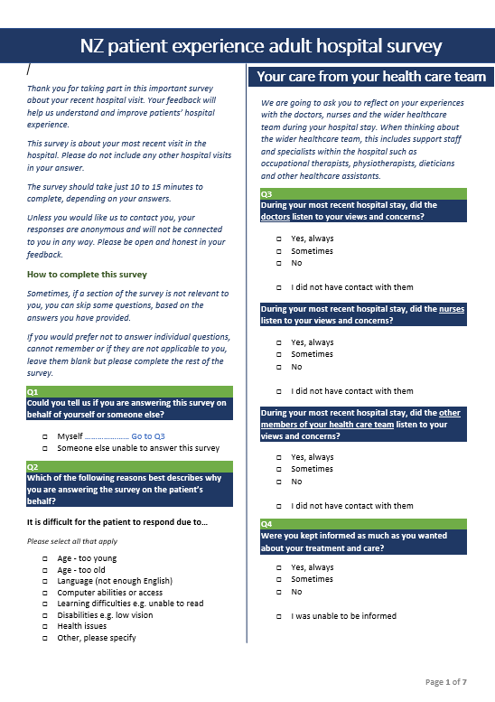
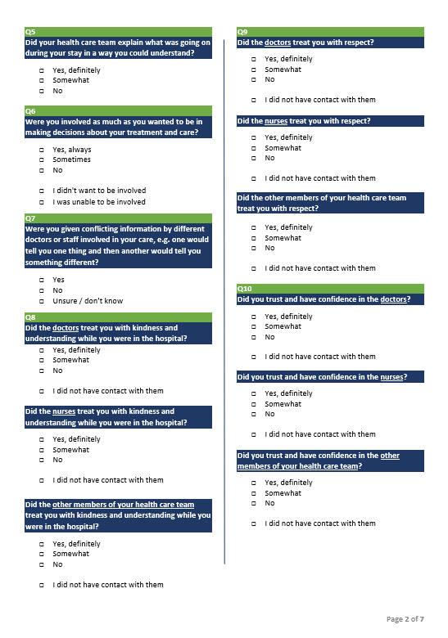

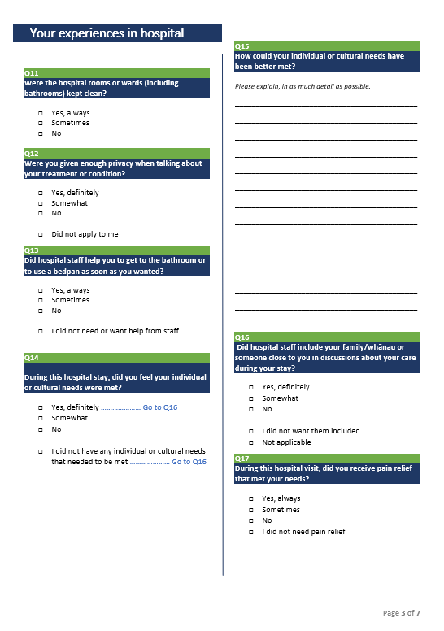

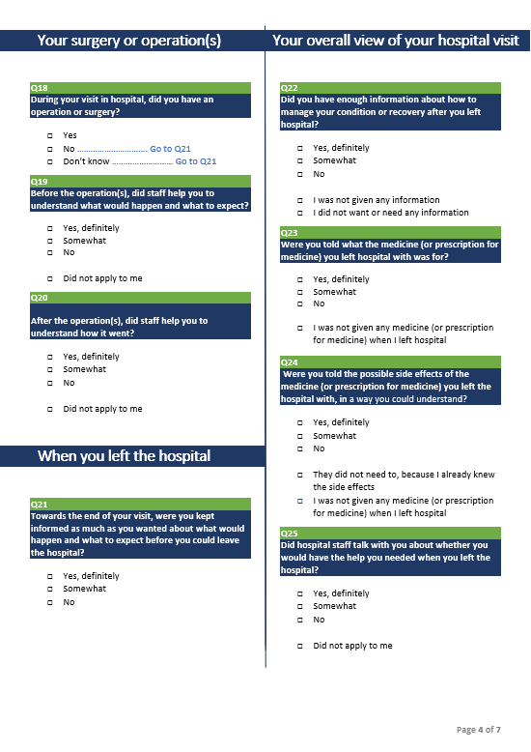

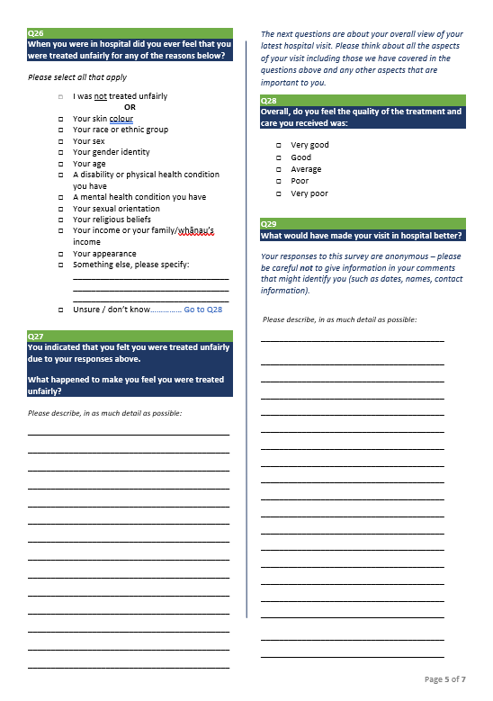

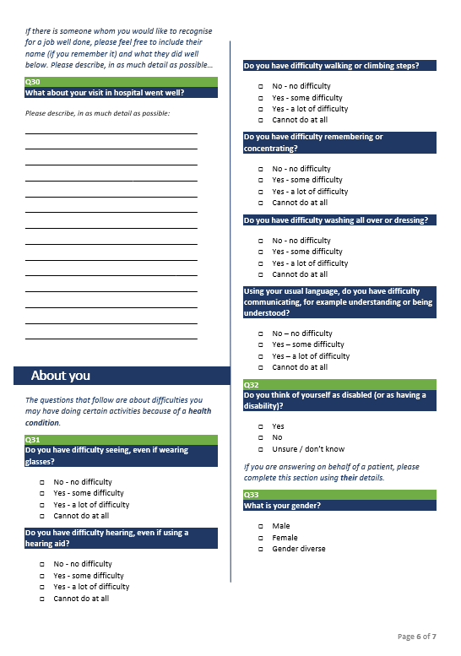

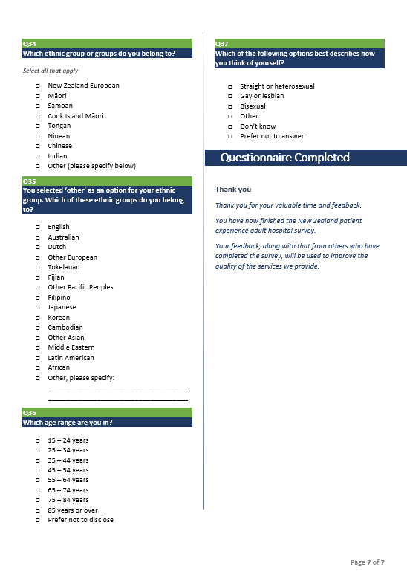

Appendix 3: Patient experience – import file
This document describes the rules surrounding the data extract and resulting file format required for importing patients’ information into the national system’s data warehouse.
Data extract rules
Each DHB is responsible for extracting the patient data to import into the data warehouse (for sending survey invitations and reminders and generating dashboard reports). The patient extract should include all inpatients discharged that satisfy the following rules:
- Frequency – minimum one fortnight per quarter according to the survey timetable. Extracted at approximately 9 am Tuesday (this allows for most public holidays, which fall on Mondays).
- Date range:
Patients discharged for 14-day period from Monday 00:01 to Sunday 23:59.
Example: Extract performed on Tuesday 18 August 2020 includes patients discharged from Monday 27 July 00:00 until Sunday 9 August 23:59.
Note: A means of generating an extract for a date range may be required in the event that the extract was not run successfully or needed to be re-run.
- The extract file should exclude any patients if they have been previously included in an extract file supplied in the last 12 weeks. The DHBs will exclude these patients using NHI numbers prior to FTP upload.
- Exclude patients who have had less than one overnight stay (eg, Day stay patients excluded) – [Discharge date] – [admission date] > 0).
- Exclude children under 15 – [Discharge date] – [Date of birth] > 15 years.
- The Event End Type codes to include are highlighted below:

This will therefore exclude groups of patients such as patients:
- who have died
- statistically discharged for transfer between specific care type (as they remain with us but under another visit)
- statistically discharged for change in funder (as they remain with us but under another visit)
- discharged for organ donation
- transferred to other DHBs.

Table source: http://www.health.govt.nz/nz-health-statistics/data-references/code-tables/common-code-tables/event-end-type-code-table

- Mental health – DHBs should exclude any patient who, within the admission in question, was either discharged from, or transferred to or from a mental health inpatient unit. Our intention is not to exclude patients who may have contact with the mental health service during their inpatient stay, but to exclude patients who had an inpatient mental health component during this admission.
The Health Speciality codes to be excluded commence with a “Y”. See the health specialty code table: http://www.health.govt.nz/nz-health-statistics/data-references/code-tables/common-code-tables/health-specialty-code-table

- All deceased patients should be excluded from the extract (as at the date that the extract is run, not the extract date range). This includes where the patient was discharged home or elsewhere and the DHB has been notified that the patient has subsequently died.
- Only the patient’s primary ethnicity is to be provided.
- Boarder patients – the New Zealand Casemix framework defines these patients as:
‘5.2.4 Non-treated Patients…
‘Events where no treatment is provided are excluded from casemix funding. These include Boarders who may be admitted or admitted patients whose procedure is subsequently cancelled … Boarders are tested for by checking that the principal diagnosis code is: Z763 Health person accompanying sick person or Z764 Other boarder in healthcare facility.’
DHBs will need to use a local exclusion process to remove Boarder patients from the extract if clinical coding is not complete by the time of the extract.
- Each patient should only appear once in the extract file – DHBs should check for and remove duplicates.
- Only the patient’s most recent discharge within the extraction period should be included.
- Patients treated by a private hospital (identifiable by the facility code) under a subcontract with the DHB should be included in the extract.
File format
The file received from the DHB is expected to meet the following requirements:
- The file must be in comma delimited format (conforming to http://tools.ietf.org/html/rfc4180 recommendation).
- All column headings must be provided as the first line and must match the Field name specified in the table below.
- Where required, use ‘0d0a’ as a record terminator. ‘0’ is a zero.
- The extract file must be named using the following convention. Example: BOPDHB_PE_From_yyyymmdd_To_yyyymmdd.csv, where ‘yyyymmdd’ is the formatted date/time of the date range used for the extract.
- Codes, as opposed to descriptions, will be used in columns wherever possible.
- DateTime values should be provided using yyyyMMdd hh:mm:ss.

Field | Data type | Mandatory  value | Allowed options  (if restricted) | Example data |  | Comment
NHI | Text |  | - | CHB2702
Salutation | Text | - | - | Mrs |  | Where salutation is provided, patients will be addressed ‘Dear Mrs Smith’; where not provided, ‘Dear Mary Smith’.
First name | Text |  | - | Mary
Last name | Text |  | - | Smith
Address1 | Text |  | - | 1 Story Street | 1 Story Street
Address2 | Text |  | - | Timaru | RD1
Address3 | Text | - | - |  | Waitahora
Address4 | Text | - | - |  | Dannevirke
Post code | Text | - | - | 0931
Cell phone | Text | - | - | 0279876543
Email address | Text | - | - | david@gmail.com
Gender | Text |  | F  I  M  U | F |  | Allowed codes from: http://www.health.govt.nz/nz-health-statistics/data-references/code-tables/common-code-tables/sex-type-code-table
Age | Integer |  | - | 38 |  | The patient’s age on admission.
Discharge date | Date |  | - | 20110816 22:14:00
Ethnicity | Integer |  | Only those codes in the Level 2 code table. | 21 |  | Allowed codes from: http://www.health.govt.nz/nz-health-statistics/data-references/code-tables/common-code-tables/ethnicity-code-tables
Health Specialty code | Text |  | Only those codes in the Health Specialty code table | S00 |  | Allowed codes from: http://www.health.govt.nz/nz-health-statistics/data-references/code-tables/common-code-tables/health-specialty-code-table
Facility code | Text |  | Only those codes in the Health Facility code table | D706 |  | Allowed codes from: http://www.health.govt.nz/nz-health-statistics/data-references/code-tables/common-code-tables/facility-code-table
Admission type | Text |  | Arranged  Acute  Waiting list | AC or AA or WN |  | Allowed codes from: http://www.health.govt.nz/nz-health-statistics/data-references/code-tables/common-code-tables/admission-type-code-table
DHB of domicile | Integer |  | DHB area codes | 123 or 011 |  | See DHB area codes below
DHB of service | Integer |  | DHB area codes | 123 or 011 |  | See DHB area codes below
Optional 1 | Text | - | - | - |  | Optional fields for local DHB analysis purposes to further drill down, eg, department, ward or area (a DHB may wish to analyse responses by areas within its district, while ensuring patients remain anonymous)
Optional 2 | Text | - | - | -
Optional 3 | Text | - | - | -

DHB area codes
011 Northland
021 Waitematā
022 Auckland
023 Counties Manukau
031 Waikato
042 Lakes
047 Bay of Plenty
051 Hauora Tairāwhiti
061 Hawke's Bay
071 Taranaki
081 MidCentral
082 Whanganui
091 Capital & Coast
092 Hutt Valley
093 Wairarapa
101 Nelson Marlborough
111 West Coast
121 Canterbury
123 South Canterbury
160 Southern
999 Overseas

Appendix 4: Survey invitation
These survey invitations, written for different forms of communication, are offered here for guidance. They contain important content developed through the testing process and DHB feedback. DHBs can edit these invitations to suit their needs.

Email correspondence
Feedback on your recent hospital experience
Kia ora Mrs Smith <or Mary Smith if no salutation provided>

[DHB name] values your feedback and would like to invite you to complete this survey about your recent hospital experience.

Your feedback will help us understand how to improve the health services provided to you and your whānau. It is likely to take about 10 to 15 minutes to complete.

Your Login Code is [login code].
Click here to begin

If the link does not work please copy the below URL into your browser.
http://myexperience.health.nz/Survey?CaseID=

You can read more about the NZ patient experience adult hospital survey here.
Your response is confidential and completely anonymous (unless you choose to identify yourself). This survey is voluntary, you are under no obligation to participate. No matter what you decide, it will not impact your access to health care in New Zealand.
Ngā mihi,

<name>
<Quality Manager title>
<DHB name> District Health Board
<Phone & email details>

[Click here to unsubscribe]
This survey is conducted by Ipsos New Zealand on behalf of your DHB. Your contact details have been provided by [DHB name] for the purpose of inviting you to take part in this survey only.

Reminder email
Reminder – Feedback on your recent hospital experience
Kia ora Mrs Smith <or Mary Smith if no salutation provided>

Recently you received an invitation to complete a survey about your recent hospital experience.

Thank you to all of those who have responded to date. If you have not yet had the chance to participate, please be sure to participate ahead of the deadline of [DEADLINE].

Your feedback will help us understand how to improve the health services provided to you and your whānau. It is likely to take about 10 to 15 minutes to complete.

Click here to begin

If the link does not work please copy the below URL into your browser.
http://myexperience.health.nz/Survey?CaseID=

You can read more about the New Zealand patient experience adult hospital survey here.

Your response is confidential and completely anonymous (unless you choose to identify yourself). This survey is voluntary, you are under no obligation to participate. No matter what you decide, it will not impact your access to health care in New Zealand.

If you have any technical questions or comments about the survey, please contact the survey provider directly at myNZhealthexperience@ipsos.com or 0800 121 650.

Ngā mihi,
<name>
<Quality Manager title>
<DHB name> District Health Board
<Phone & email details>

[Click here to unsubscribe]
This survey is conducted by Ipsos New Zealand on behalf of your DHB. Your contact details have been provided by [DHB name] for the purpose of inviting you to take part in this survey only.

SMS correspondence
Note that SMS correspondence is constrained by the number of characters per SMS (maximum 160) and associated costs.
Kia ora, [DHB name] wants to get your feedback on your recent hospital visit. Please visit http://myexperience.health.nz/Survey?CaseID=##AAAA
071234567

Mail

Printed on DHB letter head

Salutation First name Last name
Address1
Address2
Address3
Address4
Post code

Date

Dear Mrs Smith <or Mary Smith if no salutation provided>

Feedback on your recent experience as a patient in our hospital

I invite you to complete this survey on your recent experience as a patient in our hospital.

This is likely to take around 10 to 15 minutes. If you have something important to tell us that isn’t covered by our survey questions, there is space for further comments at the end of the survey. If you need some help to complete this survey, please ask a relative or friend. You have three weeks from the date of this letter to respond before the survey is closed.

We take your privacy very seriously. Unless you choose to provide your contact details in this survey, no one at the <DHB name> District Health Board will be able see your name or other contact details.

If you have access to the internet, you can complete the survey online by typing the following secure link into the browser https://myexperience.health.nz and entering this code xxxxx. Otherwise, please complete the enclosed survey as soon as possible and return it to us in the Freepost envelope provided.

The feedback you provide is a very valuable way for us to understand how we can improve our service so thank you in advance for your participation.

We may be unaware of changes in your circumstances since your discharge. If that is the case and you are unable to complete the survey, please accept our apology and throw away the survey.

Yours sincerely

<name>
<Quality Manager title>
<DHB name> District Health Board
<Phone & email details>

Reminder mail

Printed on DHB letter head

Salutation First name Last name
Address1
Address2
Address3
Address4
Post code

Date

Dear Mrs Smith <or Mary Smith if no salutation provided>

Reminder - Feedback on your recent experience as a patient in our hospital

Recently we sent you an invitation to complete a survey on your recent experience as a patient in our hospital. We’d really value your feedback. If your survey is on its way back to us, please accept our apology and throw away this reminder.

Completing this survey is likely to take around 10 to 15 minutes. If you have something important to tell us that isn’t covered by our survey questions, there is space for further comments at the end of the survey. If you need some help to complete this survey, please ask a relative or friend. You have 10 days from the date of this letter to respond before the survey is closed.

We take your privacy very seriously. Unless you choose to provide your contact details in this survey, no one at the <DHB name> District Health Board will be able see your name or other contact details.

If you have access to the internet, you can type the following secure link in the browser and complete the survey online https://myexperience.health.nz and enter this code xxxxx. Otherwise, please complete the enclosed survey as soon as possible and return it to us in the Freepost envelope provided.

The feedback you provide is a very valuable way for us to understand how we can improve our service so thank you in advance for your participation.

We may be unaware of changes in your circumstances since your discharge. If that is the case and you are unable to complete the survey, please accept our apology and throw away the survey.

Yours sincerely

<name>
<Quality Manager title>
<DHB name> District Health Board
<Phone & email details>

Appendix 5: Survey data file
The file sent to DHBs using the national system is expected to meet the following requirements.
- The file will be in comma delimited format (conforming to http://tools.ietf.org/html/rfc4180 recommendation).
- All column headings must be provided as the first line and must match the Field name specified in the table below.
- Where required, use ‘0d0a’ as a record terminator. ‘0’ is a zero.
- The extract file must be named using the following convention. Example: BOPDHB_PE_From_yyyymmdd_To_yyyymmdd_SURVEY.csv, where ‘yyyymmdd’ is the formatted date/time of the date range used for the extract.
- Codes as opposed to descriptions will be used in columns wherever possible.
Field | Data type | Mandatory  value | Allowed options  (if restricted) | Example data | Comment
ID | Text |  | - | Q1396  Q2001  Q3229 | A unique ID for each survey is to be allocated. This should identify the quarter it relates to and is numbered 001-400.
Gender | Text |  | F  I  M  U | F | Allowed codes from: http://www.health.govt.nz/nz-health-statistics/data-references/code-tables/common-code-tables/sex-type-code-table
Age group | Integer |  | 15–24  25–44  45–64  65–74  75–84  85+ | 15–24 | This is the patient’s age on admission. Age groups are proposed to ensure patients remain anonymous.
Survey period | Date |  |  | F012014 | The naming of the survey period may be amended but there will need to be a unique name for each fortnight.
Ethnicity | Integer |  | Only those codes in the Level 2 code table. | 21 | Allowed codes from: http://www.health.govt.nz/nz-health-statistics/data-references/code-tables/common-code-tables/ethnicity-code-tables
Health Specialty code | Text |  | Only those codes in the Health Specialty code table | M45 | Allowed codes from: http://www.health.govt.nz/nz-health-statistics/data-references/code-tables/common-code-tables/health-specialty-code-table
Facility code | Text |  | Only those codes in the Health Facility code table | D706 | Allowed codes from: http://www.health.govt.nz/nz-health-statistics/data-references/code-tables/common-code-tables/facility-code-table
Admission type | Text |  | Arranged  Acute  Waiting list | AC or AA or WN | Allowed codes from: http://www.health.govt.nz/nz-health-statistics/data-references/code-tables/common-code-tables/admission-type-code-table
DHB of domicile | Integer |  | DHB area codes | 123 or 011 | See DHB area codes
DHB of service | Integer |  | DHB area codes | 123 or 011 | See DHB area codes
Optional 1 | Text | - | - | - | Optional fields for local DHB analysis purposes to further drill down, eg, to department level
Behalf Yes or No | Text |  | Y  N
Why on behalf | Text | (if yes) | Free text field
Q1 | Integer |  | 1,2,3,4 |  | 1 = first option in list  2 = second option in list, etc
Q2 | Integer |  | 1,2,3,4 |  | 1 = first option in list  2 = second option in list, etc
Q3 doctor | Integer |  | 1,2,3,4 |  | 1 = first option in list  2 = second option in list, etc
Q3 nurse | Integer |  | 1,2,3,4 |  | 1 = first option in list  2 = second option in list, etc
Q3 other | Integer |  | 1,2,3,4 |  | 1 = first option in list  2 = second option in list, etc
Q4 | Integer |  | 1,2,3,4,5
Q5 | Integer |  | 0 - 10 |  | 0-10 (actual answer given)
Communication comments | Text | - | Free text field |  | Text – verbatim copy of comment given
Q6 | Integer |  | 1,2,3,4 |  | 1,2,3,4 (1 first option, 2 second option etc)
Q7 | Integer |  | 1,2,3,4,5 |  | 1,2,3,4,5 (1 first option, 2 second option etc)
Q8 | Integer |  | 0–10 |  | 0–10 (actual answer given)
Partnership comments | Text | - | Free text field |  | Text – verbatim copy of comment given
Q9 | Integer |  | 1,2,3 |  | 1,2,3 (1 first option, 2 second option etc)
Q10 | Integer |  | 1,2,3,4 |  | 1,2,3,4 (1 first option, 2 second option etc)
Q11 | Integer |  | 0–10 |  | 0–10 (actual answer given)
Coordination comments | Text | - | Free text field |  | Text – verbatim copy of comment given
Q12 | Integer |  | 1,2,3,4 |  | 1,2,3,4 (1 first option, 2 second option etc)
Q13 | Integer |  | 1,2,3,4 |  | 1,2,3,4 (1 first option, 2 second option etc)
Q14 | Integer |  | 1,2,3 |  | 1,2,3 (1 first option, 2 second option etc)
Q15 | Integer |  | 1,2,3 |  | 1,2,3 (1 first option, 2 second option etc)
Q16 | Integer |  | 1,2,3,4 |  | 1,2,3,4 (1 first option, 2 second option etc)
Q17 | Integer |  | 0–10 |  | 0–10 (actual answer given)
Physical and emotional needs comments | Text | - | Free text field |  | Text – verbatim copy of comment given
Surgery yes or no | Text |  | Y or N
Q18 | Integer | - | 1,2,3,4 |  | 1,2,3,4 (1 first option, 2 second option etc)
Q19 | Integer | - | 1,2,3 |  | 1,2,3 (1 first option, 2 second option etc)
Q20 doctor | Integer |  | 1,2,3,4 |  | 1,2,3,4 (1 first option, 2 second option etc)
Q20 Nurse | Integer |  | 1,2,3,4 |  | 1,2,3,4 (1 first option, 2 second option etc)
Q20 other | Integer |  | 1,2,3,4 | - | 1,2,3,4 (1 first option, 2 second option etc)
Hospital stay comment | Text | - | Free text field | - | Text – verbatim copy of comment given
Note: The rows in the file returned to DHBs will be in order of patient responses received, not in the same order as the patient data exported by DHBs to the national provider. This will further ensure patient responses are anonymous.

Appendix 6: Licensed software support services
The monthly fee includes:
- unlimited user licences – the sector can assign as many reporting system users as needed to undertake their work
- an initial survey email invitation plus up to two reminder emails per survey period per patient
- provision for 5,500 SMS of no longer than 160 characters per quarter, per survey (11,000 per quarter)
- the survey available in Māori (without any verbatim comment translations)
- continuous improvements to the data collection tools and reporting systems to the equivalent of approximately one small enhancement per month or one larger enhancement per quarter
- a shortened ‘lite’ survey (using exactly the same questions as the core survey tools) that asks non-responders only the key indicator questions to lift engagement and participation from under-represented groups
- in situ collection, with links to access the questionnaires for these respondents. The Supplier assumes this link will be loaded onto the tablets by the staff responsible at the patient touchpoint. The Supplier provides instructions for this process
- attendance of quarterly progress meetings and the Governance Group meetings.
The Supplier will:
- engage with DHBs, PHOs, practices, the Ministry of Health and the Commission to establish their service requirements in accordance with this agreement
- maintain and improve the customised Ipsos Voice data collection application, ensuring:
  - survey data collected and reported each quarter can be used for its intended purpose
  - the data collection tools are regularly maintained and updated as required
  - respondents are invited to participate via the best channel for them
  - respondents have an appropriate user experience when completing the survey tools
  - respondents can request a DHB or general practice team to contact them and elect whether to make their survey response accessible to the DHB or general practice team through a secure process
  - participation in the survey from under-represented groups (in particular Māori and Pacific peoples) increases
- maintain and improve the customised Ipsos Voice reporting platform, ensuring:
  - historical survey data is uploaded so that it can be presented alongside new data collected, where possible
  - sector users can access their respondent contact requests and all data via a web-based online reporting system that contains all historical data is user friendly and allows appropriate reporting and analysis of quantitative and qualitative results. The system is personalised and restricted by sector user type, in accordance with our data access guidelines
  - the sector can assign as many reporting system users as needed to undertake their work
  - PHOs, DHBs and the Commission have self-service access to quarterly data extracts
- provide the system users with real-time survey completion visibility by mode, survey type, and location
- continually improve the data collection and reporting system to reflect the changing environment
- run the national survey tools quarterly in accordance with the Customer’s requirements
- provide ongoing support (eg, a comprehensive helpdesk and/or support model) to enable the sector to meet its data collection requirements and to use the reporting system
- ensure the infrastructure and processes comply with all applicable health information privacy and security codes and standards. All health and disability service providers, agencies and organisations, as defined in the Health Information Privacy Code 1994, accessing or providing national data, are required to adhere to and comply with national information standards, definitions and guidelines
- be part of the Connected Health network
- uphold the principles of Māori data sovereignty; data must therefore be securely hosted in New Zealand in accordance with the Head Agreement.
The monthly fee does not include:
- open-ended answer coding or data weighting
- the cost for using questions other than the Core Survey Tools
- additional surveys other than the Core Survey Tools
- surveying more frequent than quarterly
- hard-copy survey printing, mailing or data entry
- provision of tablets or other hardware for in situ surveying, where used
- any SMS costs other than those outlined above
- additional data collection dashboard reports and charts, other than those agreed on at the project’s inception
- additional analysis, reporting or presentations other than those noted above
- data manipulation or cleansing if extracts do not meet specifications (the upload process has an in-built error-message for incorrectly formatted or empty fields)
- significant compliance activity that may be required over and above meeting the requirements of the Request for Proposal, specifically compliance activity at DHB, PHO or practice level.

Doyle C, Lennox L, Bell D. 2013. A systematic review of evidence on the links between patient experience and clinical safety and effectiveness. BMJ Open 3(1):e001570.
Balik B, Conway J, Zipperer L, et al. 2011. Achieving an Exceptional Patient and Family Experience of Inpatient Hospital Care. IHI Innovation Series white paper. Cambridge, MA: Institute for Healthcare Improvement. URL: www.IHI.org (accessed 7 September 2020).
https://www.stats.govt.nz/information-releases/internet-service-provider-survey-2018
Famously, the Literary Digest miscalled the 1936 US election as a victory for the Republican challenger Albert Landon, despite drawing its predictions from a sample of over 2 million voters, at least in part because it used a telephone directory as the basis of its sample at a time when telephones were a luxury item that many people did not own. URL: http://issuu.com/chilesoc/docs/why-the-1936-literary-digest-poll (accessed 7 September 2020).
Note that if you have multiple hospitals, you may need to include the name of the hospital the patient was discharged from for clarity, especially if a hospital name is in your letterhead.

