



Patient-reported outcome measures in New Zealand:
Results from the adult primary care patient experience survey

2026

Published February 2026 by Health Quality & Safety Commission Te Tāhū Hauora,
PO Box 25496, Wellington, 6146.
ISBN 978-1-991122-42-1 (online)
Available online at www.hqsc.govt.nz
Enquiries to: info@hqsc.govt.nz
This work is licensed under the Creative Commons AttributionNonCommercial-ShareAlike 4.0 International (CC BY-NC-SA 4.0). To view a copy of this licence, visit https://creativecommons.org/licenses/by-nc-sa/4.0




Contents
Executive summary 5
Background 8
Patient-reported measures programme 8
PROMs in New Zealand 9
Results 13
Respondents 13
EQ-5D-5L 13
EQ VAS 16
What these results mean in the context of other health measures 19
Hua Oranga 21
Appendix One: Respondent demographics 25

Figures
Figure 1: Prevalence of problems with each EQ-5D-5L dimension by survey wave, 2023 and 2024 data 14
Figure 2: Prevalence of problems with each EQ-5D-5L dimension by ethnicity, combined 2023 and 2024 data 14
Figure 3: Prevalence of problems with each EQ-5D-5L dimension by age, combined 2023 and 2024 15
Figure 4: Prevalence of problems with each EQ-5D-5L dimension by gender, combined 2023 and 2024 data 15
Figure 5: Prevalence of problems with each EQ-5D-5L dimension by disability status, combined 2023 and 2024 data 16
Figure 6: Frequency distribution of EQ VAS (self-rated health) scores, 2024 data 17
Figure 7: EQ VAS (self-rated health) mean score by ethnicity, 2024 data 17
Figure 8: EQ VAS (self-rated health) mean score by disability status and ethnicity, 2024 data 18
Figure 9: Prevalence of problems with each EQ-5D-5L dimension by cost as a barrier to picking up a prescription, combined 2023 and 2024 data 19
Figure 10: Cost as a barrier to picking up a prescription by ethnicity, combined 2023 and 2024 data 20
Figure 11: EQ VAS (self-rated health) mean score by cost as a barrier to picking up a prescription, 2024 data 21
Figure 12: Prevalence of challenges with each Hua Oranga taha, combined 2023 and 2024 data 22
Figure 13: Prevalence of challenges with the individual items of taha wairua, combined 2023 and 2024 data 23
Figure 14: Prevalence of challenges with each Hua Oranga taha by age, combined 2023 and 2024 data 23
Figure 15: Prevalence of challenges with each Hua Oranga taha by disability status, combined 2023 and 2024 data 24

Tables
Table 1: Prevalence of problems with each EQ-5D-5L dimension by cost as a barrier to picking up a prescription (percentage) , combined 2023 and 2024 data 20
Table 2: Number of people who completed EQ-5D-5L by ethnicity and survey wave, 2023 and 2024 25
Table 3: Number of Māori who completed Hua Oranga by survey wave, 2023 and 2024 25

Executive summary
To improve the quality of care, improve population health outcomes and control health care spending, many countries are redesigning their health systems to be more people-centred and integrated. To understand if health care is providing value, decision-makers in New Zealand’s health system need to know more about what patients and tāngata whaiora think about their health care outcomes.
For these reasons, the Health Quality & Safety Commission Te Tāhū Hauora (the Commission) is expanding its patient-reported measures programme to incorporate patient-reported outcome measures (PROMs). At present, New Zealand has no consistent approach to measuring, reporting and managing PROMs across the health system. Our goal is to improve understanding of patient outcomes and the factors influencing them.
This report provides a high-level overview of the early work to implement PROMs in New Zealand. We explain the objectives for collecting PROMs, and describe the process for selecting the area of focus, the rationale for selecting the tools we used and the collection method for the first phase of this project.
We also present results from two PROMs – EQ-5D-5L and Hua Oranga, – which were asked of a patient population who accessed general practice in August 2023 and August 2024.

EQ-5D-5L
The EQ-5D-5L is a generic measure of self-reported health in five dimensions: mobility, self-care, usual activities, pain/discomfort and anxiety/depression. Over the two survey waves, a total of 56,434 people completed the EQ-5D-5L.
Older respondents reported more problems with mobility, self-care, usual activities and pain/discomfort, while younger respondents reported more problems with anxiety/depression. All these differences were statistically significant.
Respondents were least likely to report problems with self-care (11 percent). They most frequently reported problems with pain/discomfort (62 percent).
Māori reported a higher rate of problems, to statistically significant levels, across all dimensions compared with other ethnic groups.
Respondents with a disability reported more problems than those with no disability.
The EQ visual analogue scale (EQ VAS) is a measure of overall health that asks the respondent to indicate how good or bad their health is on the day of the survey on a visual scale from 0, as the worst health they can imagine, to 100, as the best health they can imagine. Weighted EQ VAS data for the August 2024 survey wave found the average EQ VAS score was 75.6, which is in line with ratings from other countries.
Older respondents rated their health higher on the scale than younger respondents rated theirs.
Self-ratings for health were lower for respondents with a disability than for those with no disability.

Hua Oranga
Hua Oranga is a ‘by Māori, for Māori’ health outcome measure that includes four items to measure each of the four taha (domains) of Te Whare Tapa Whā: tinana (physical health), wairua (spiritual health), hinengaro (mental/emotional health) and whānau (social health). Hua Oranga was included only for Māori respondents and 9,964 Māori completed it over the two survey waves.
Older Māori reported fewer challenges than younger Māori on three taha: wairua, whānau and hinengaro. Taha tinana ratings did not change significantly with age. In contrast, the EQ-5D-5L results by age indicate a general increase in problems as respondents get older.
The analysis of the Hua Oranga tool highlights that its concept of Māori health differs from the EQ-5D-5L. The EQ-5D-5L and Hua Oranga provide different and arguably, complementary information about the self-reported health of Māori.

The future
EQ-5D-5L and Hua Oranga were included in the August 2025 wave of the adult primary care patient experience survey. Those results will be analysed and shared with primary health organisations. This data set becomes more valuable as a timeseries develops, because it allows monitoring of self-reported health status at the population level and helps to identify where this status varies.
The Commission has begun collecting EQ-5D-5L in other patient experience surveys to broaden understanding of PROMs in different patient populations, such as adults recently discharged from hospital and those receiving home and community support services. We will publish these results in due course.
The Hua Oranga results are being further analysed to better understand the Māori perspective of health and how patterns for Hua Oranga and EQ-5D-5L differ for Māori. These findings will be submitted for an academic peer-reviewed publication.
We will continue to explore the implications of our findings for providers. In particular, we will look at how the results from Hua Oranga might be applied to cultural, spiritual and relational investments or activities as part of service options, in order to better meet the holistic needs of Māori and to promote health, hauora and wellbeing.
In a separate phase of this project, the Commission is partnering on a pilot project to see whether patient portals can be used to collect PROMs in general practice. This is potentially a cost-effective method using an existing platform, which would give both patients and clinicians a way to complete a PROM and access to the results. If successful, this approach could enable a range of generic and condition-specific PROMs to be implemented and available at the point of care. We anticipate that the results from the pilot will be available in 2026.

Background
An effective approach to measuring health system quality involves regularly and consistently capturing patient- and client-reported measures, including their experience of care, using valid, reliable and robust methods. Moreover, following this approach itself is recognised as a good indicator that the health services are of high quality. Feedback helps drive quality improvement to deliver better care and mitigate inequity across all levels of the health system.
Documents that reinforce the expectation that providers will regularly capture and act on consumer feedback are:
the Ngā Paerewa Health and Disability Services Standard
the code of expectations for health entities’ engagement with consumers and whānau
requirements in funder contracts.
Under the Pae Ora (Health Futures) Act 2022, the Health Quality & Safety Commission Te Tāhū Hauora (the Commission) has the mandate ‘to lead and coordinate work across the health sector for the purposes of monitoring and improving the quality and safety of services’.

Patient-reported measures programme
The Commission collects patient-reported measures through validated and standardised surveys, which enable it to systematically collect, analyse and report data. It uses information gathered at local, regional and national levels to provide benchmarks across the country and improve services locally.
The Commission’s patient-reported measures programme is one of the largest public survey programmes in New Zealand. The programme consists of three national quarterly surveys:
the adult hospital inpatient experience survey
the adult hospital outpatient experience survey
the adult primary care patient experience survey.
Together, these surveys gather feedback from around 50,000 patients every quarter. Survey results are reported publicly on the Commission’s website and privately to providers on a secure website. These surveys report experience by ethnic group, age group, gender and disability status. The collection of data on disability status is particularly important as this information is often missing from national reporting and gives important insights into the experience of disabled people.
A patient-reported outcome is any report on the status of a patient’s health condition that comes directly from the patient, without any interpretation by a clinician or anyone else. A patient-reported outcome is usually captured using a patient-reported outcome measure (PROM). These ask questions about specific symptoms, physical or mental health, and quality of life. The Commission has begun early work to collect PROMs at the national level, supported by an expert advisory group.
The Patient Reported Measures Steering Group (the Steering Group) oversees the overall programme. It provides independent advice to the Commission on the patient-reported measures programme. This includes advice on the best ways to use the results of the surveys to improve health service delivery at local, regional and national levels. The Steering Group also provides governance on the collection, storage, access and use of the survey data.

PROMs in New Zealand
To improve the quality of care, improve population health outcomes and control health care spending, many countries are redesigning their health systems to be more people-centred and integrated. To understand if health care is providing value, decision-makers in New Zealand’s health system need to know more about what patients and tāngata whaiora think about their health care outcomes.
For both of these reasons, the Commission is expanding its patient-reported measures programme to incorporate PROMs. At present, there is no consistent approach to measuring, reporting and managing PROMs across the New Zealand health system. Our goal is to improve understanding of patient outcomes and the factors influencing them.

Deciding where to focus
In preparation for the PROMs expert advisory group’s decision-making on where to focus, the Commission undertook an analysis to identify where, based on areas of wide variation or inequity, the areas for greatest improvement from a PROMs programme might lie.
We reviewed published data on health outcomes. This review covered:
measures of life expectancy and amenable mortality from two reports: the Window on the quality of Aotearoa New Zealand’s health care 2019 – a view on Māori health equity and Bula Sautu – a window on quality 2021: Pacific health in the year of COVID-19
the quality dashboard
the quality and safety markers
domains of the Atlas of Healthcare Variation
feedback from the adult hospital inpatient experience and the primary care patient experience surveys.
This review concluded that a core and repeating issue is inequity in access to and poorer experience of general practice for Māori and Pacific peoples. Evidence indicates these groups experience poorer management of long-term conditions, which in turn contributes to higher rates of amenable mortality and lower life expectancy.
This review highlighted the importance of primary care in the prevention, early detection and management of long-term conditions and its role in contributing to equity of outcomes. In terms of scale, general practice in New Zealand delivers 14 million consultations per year, compared with around 1.2 million discharges from publicly funded hospitals per year.
For these reasons, the PROMs expert advisory group endorsed focusing the first new PROM in general practice, with the goal to improve equity for Māori and Pacific peoples through early detection and improving primary and secondary prevention of long-term conditions.

Selecting the PROM tool
A unique challenge in collecting PROMs data in New Zealand is how to collect data that adequately captures the health experiences of both Māori and non-Indigenous New Zealanders in ways that are meaningful to each group, while facilitating outcomes analysis and monitoring. This approach is particularly important as Māori are known to experience a range of health inequities and reducing and ultimately eliminating these is a central aspect of New Zealand’s health policy.
Following an evaluation of different PROMs tools, two were selected: Hua Oranga and EQ-5D-5L.
Hua Oranga is a ‘by Māori, for Māori’ health outcome measure that includes four items to measure each of the four taha (domains) of Te Whare Tapa Whā: tinana (physical health), wairua (spiritual health), hinengaro (mental/emotional health) and whānau (social health).
The EQ-5D-5L is a generic PROM – that is, it measures aspects of health that are common to most patients. The EQ-5D-5L is widely used internationally. It assesses a person’s subjective experience across five functional dimensions of health:
mobility: problems with walking about.
self-care: ability to wash or dress.
usual activities: ability to perform tasks relating to work, study or leisure.
pain/discomfort: the presence and severity of pain or discomfort.
anxiety/depression: the level of anxiety or depression.

Objectives
Patient-reported outcome data can help providers focus their efforts to improve health outcomes. With an Indigenous PROM, service providers will be able to incorporate aspects of te ao Māori models of health into their services to ensure equitable health outcomes.
The primary objectives of the national PROMs initiative were to:
- test the usefulness of PROMs tools that are appropriate to ask of a general patient population, and capture aspects of health that are important to Māori populations
- systematically collect and analyse PROMs to understand the factors that influence patient outcomes
- understand variation in self-reported outcomes
- understand how PROMs can be used to improve the quality of care for patients
- support sector capability and develop actionable insights from PROMs
- develop a national approach to PROMs that can be shared across the sector.

Implementing PROMs
Our review of the literature identified that PROMs are gathered and used in a variety of ways. For example, while they have traditionally been used at the individual provider level to facilitate patient interactions, particularly as part of clinical trials, they have also been used in national pay-for-performance programmes to assess the effectiveness of certain elective surgical procedures.
To begin the initial trial of PROMs in New Zealand, we made the pragmatic decision to implement PROMs within the existing primary care patient experience survey. The advantages of this approach were that the survey has comprehensive national coverage and an existing infrastructure that allowed us to collect PROMs from a large population.
In 2023, the August survey wave of the adult primary care experience survey was expanded to include PROMs in addition to the existing experience measures, and this was repeated in August 2024. This report provides results from the data collection for primary care as a whole over these two survey waves. We sent an individual report to each primary health organisation on its results in early 2025.
The methodology and other related reports for the primary care patient experience survey are available on the Commission’s website.
Results are reported separately by age group, disability status, ethnic group, and gender.

Defining ethnic group
Ethnic group is collected and reported in accordance with the Ethnicity New Zealand Standard Classification 2005 V2.1.0 and the HISO 10001:2017 Ethnicity Data Protocols. A person’s ethnic group is determined by self-report in the survey; if self-reported ethnicity is unknown then ethnic group is based on what is recorded in the sample file.
This report uses a prioritised classification of ethnic group. This means that people who report identification with more than one ethnic group are counted only in one of those groups, in the prioritised order of Māori, Pacific peoples, Asian and European/Other.

Defining disability status
Survey respondents are asked two sets of questions about whether they are disabled: the Washington Group Short Set on Functioning (WG-SS) and a self-identified question. A person is classified as being disabled if they indicate they could not do, or would have a lot of difficulty doing, any of the six activities included in the WG-SS, or if they self-identify as disabled.

Results
In this section, we report the main findings from the PROMs in visual form as graphs and tables. Most of the graphs show 95 percent confidence intervals. If two groups differ on a measure and their confidence intervals do not overlap, the difference is statistically significant.

Respondents
Across the two survey waves, a total of 56,434 people completed the EQ-5D-5L. Hua Oranga was only included for Māori respondents, and 9,964 Māori completed it.
Of the respondents who completed the survey, 21 percent were Māori, which is representative of the population (19.6 percent Māori), and 72 percent were non-Māori, non-Pacific. For more detail on respondents, see Appendix One.

EQ-5D-5L
Each dimension of the EQ-5D-5L has five levels of severity, ranging from no problems to extreme problems. For this report, we split responses into ‘no problems’ (the lowest level of severity) and ‘problems’ (all four higher levels of severity). This section presents respondents reporting ‘no problems’ in each EQ-5D-5L dimension compared with those reporting any problems.
Data is weighted to account for the influence that demographic differences have on the results. Weighting is done by district, ethnicity, age and gender.
Figure 1 shows that EQ-5D-5L responses in the two survey waves were very similar. For this reason, we combined the data for this analysis.
Respondents were least likely to report problems with self-care (11 percent). They most frequently reported problems with pain/discomfort (62 percent).
Figure 1: Prevalence of problems with each EQ-5D-5L dimension by survey wave, 2023 and 2024 data
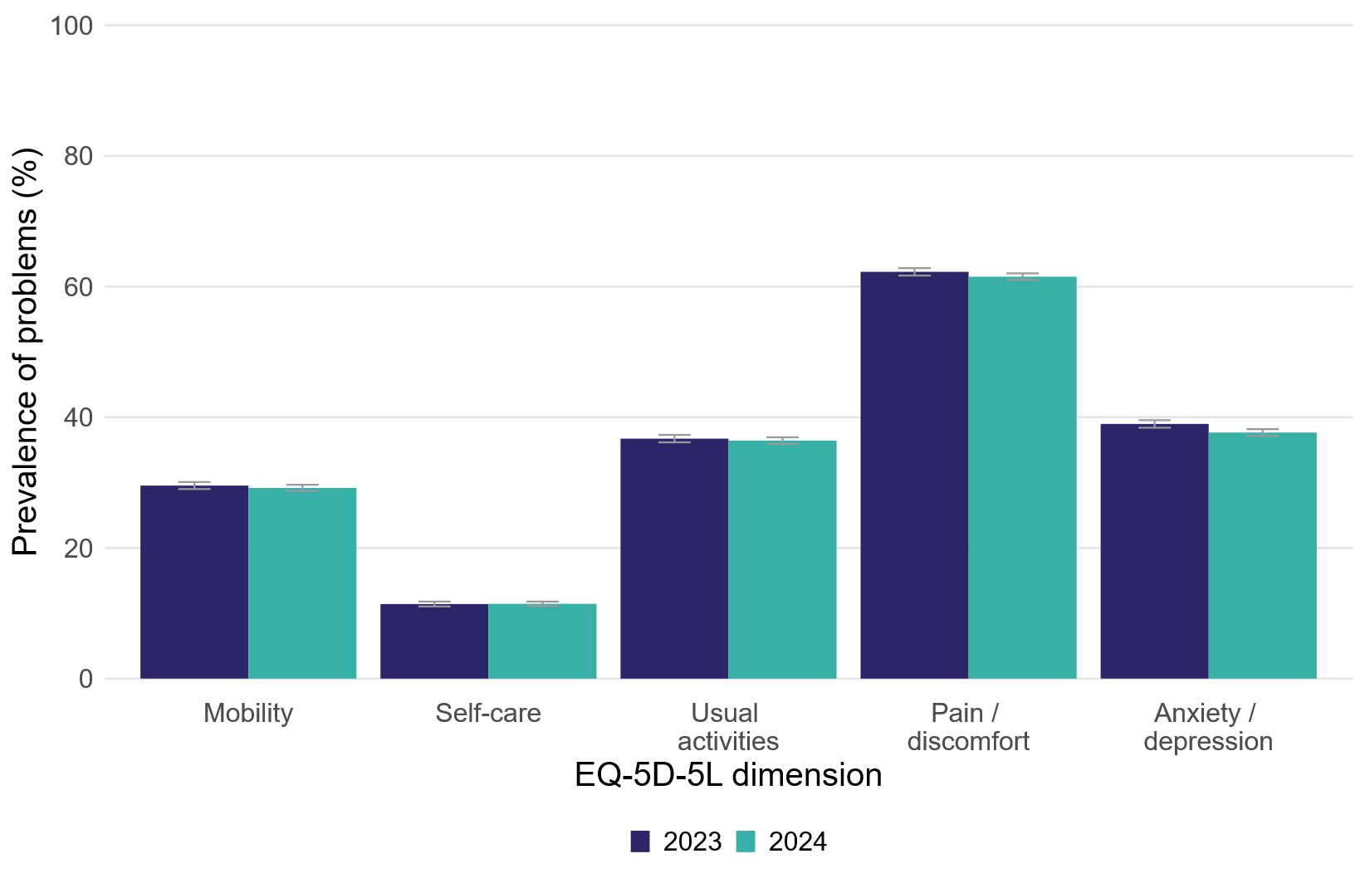
Across all dimensions, the rate of reported problems for Māori was higher than the rate for other ethnic groups, to a statistically significant level. The biggest difference was in the anxiety/depression dimension, with 45 percent of Māori reporting problems compared with 37 percent of non-Māori, non-Pacific peoples. Figure 2 breaks down the findings for different ethnic groups in more detail.
Figure 2: Prevalence of problems with each EQ-5D-5L dimension by ethnicity, combined 2023 and 2024 data
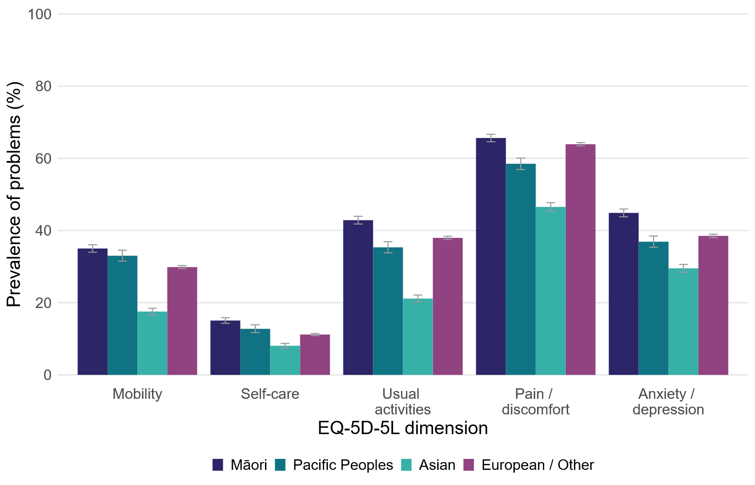
Older respondents reported more problems with mobility, self-care, usual activities and pain/discomfort. Younger respondents reported more problems with anxiety/depression (Figure 3). All of these differences were statistically significant.
Figure 3: Prevalence of problems with each EQ-5D-5L dimension by age, combined 2023 and 2024 data
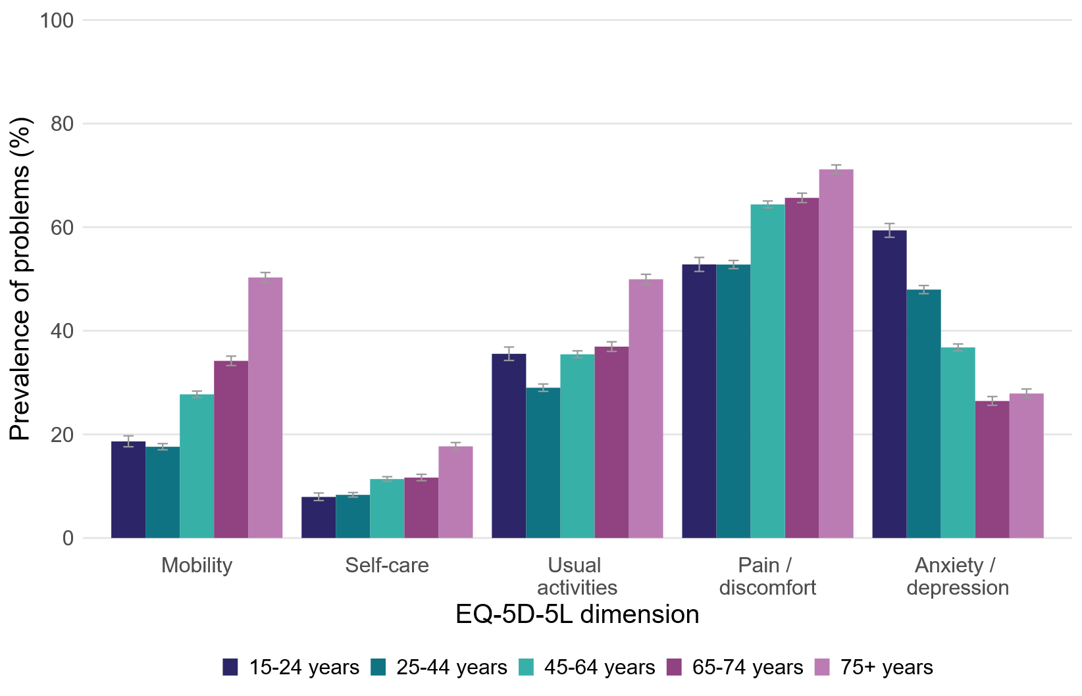
At a national level, statistically significant differences by gender were also evident. Male respondents reported more problems with mobility, self-care and usual activities, whereas more female respondents reported problems with pain/discomfort and anxiety/depression (Figure 4).
Figure 4: Prevalence of problems with each EQ-5D-5L dimension by gender, combined 2023 and 2024 data
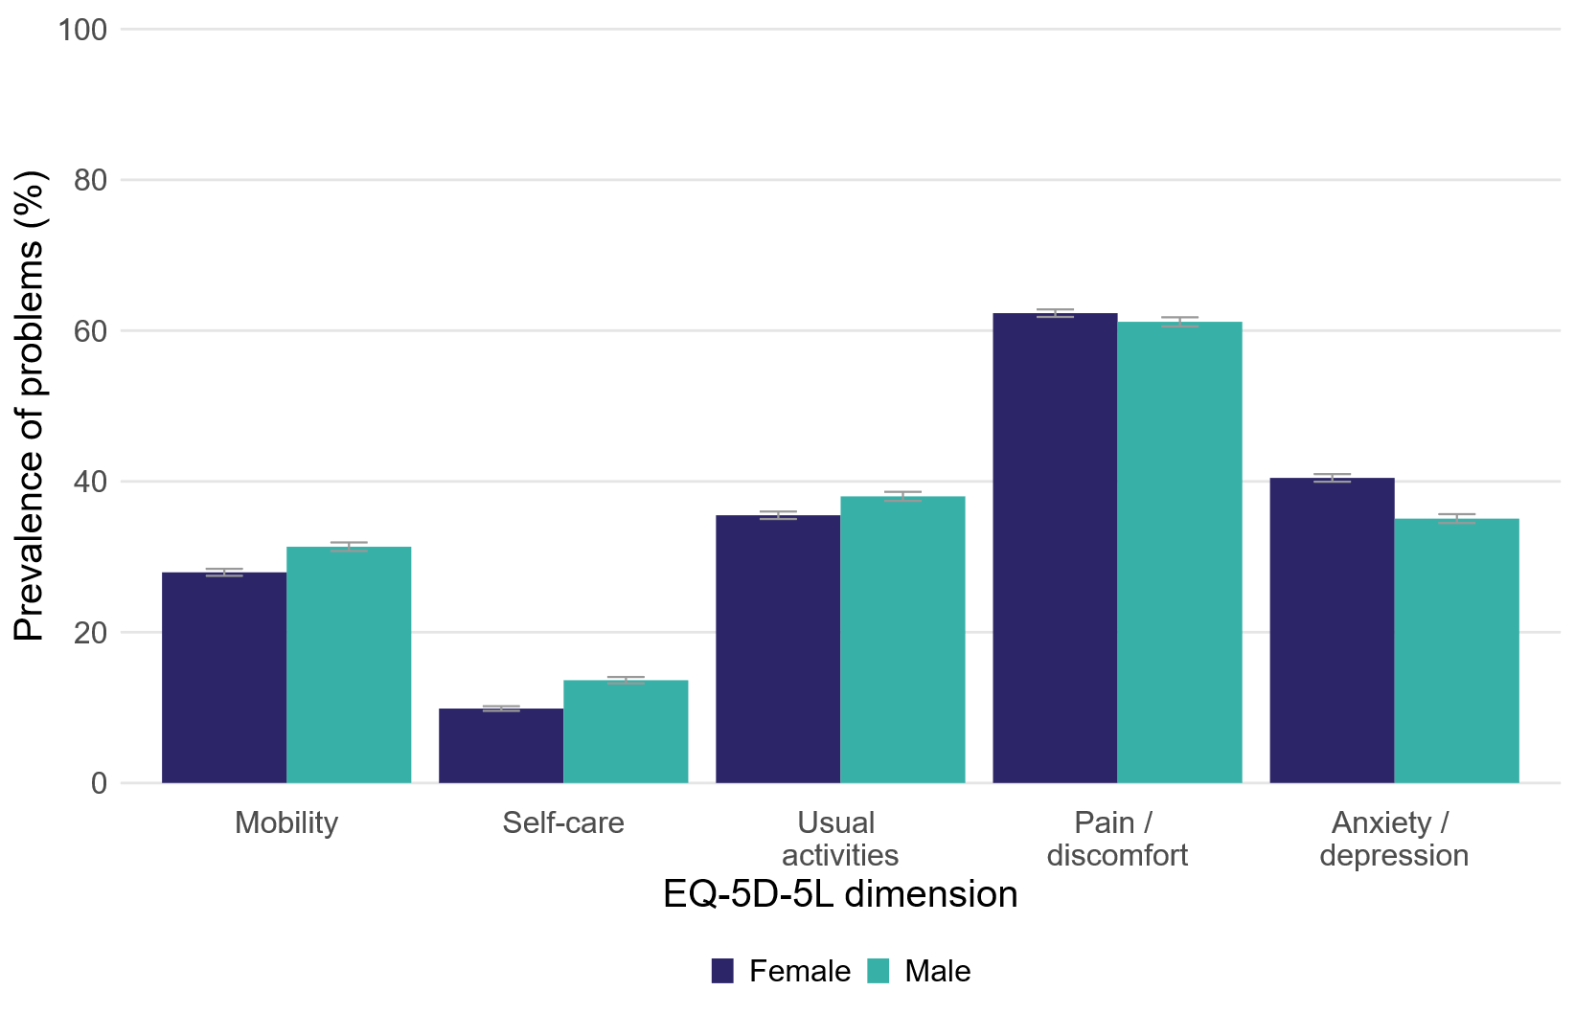
Respondents with a disability reported more problems across all EQ-5D-5L dimensions, at statistically significant levels (Figure 5).
Figure 5: Prevalence of problems with each EQ-5D-5L dimension by disability status, combined 2023 and 2024 data
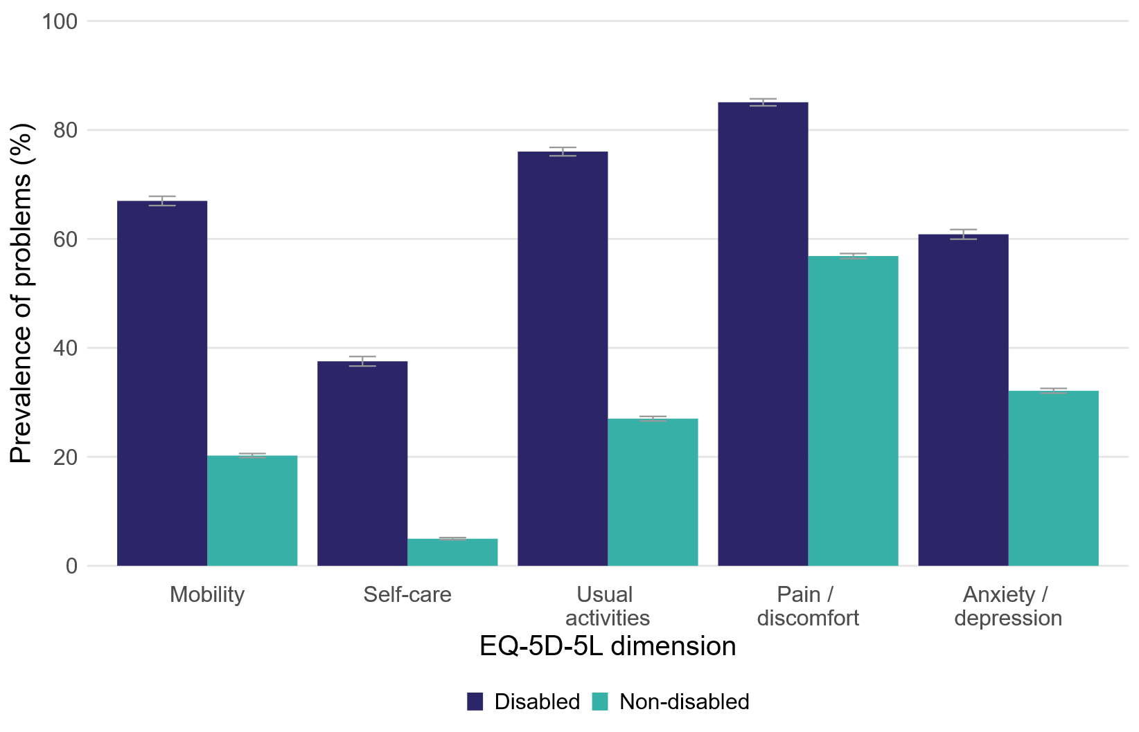

EQ VAS
The EQ VAS is a measure of overall self-rated health. It asks the respondent to indicate how good or bad their health is on the day of the survey on a visual analogue scale (VAS) from 0 ‘the worst health you can imagine’ to 100 ‘the best health you can imagine’. The VAS complements the EQ-5D-5L, which focuses on health problems in specific dimensions, by asking people to provide an overall score of their health. Like the EQ-5D-5L data, the EQ VAS data is weighted to account for the influence of demographic differences on the results. Weighting is done by district, ethnicity, age and gender. EQ VAS data is available only for the August 2024 survey wave.
The average EQ VAS score was 75.6 and the median was 80. These scores are comparable to the scores that previous research found in New Zealand’s general population. Figure 6 presents the frequency distribution of respondents’ EQ VAS scores.
Figure 6: Frequency distribution of EQ VAS (self-rated health) scores, 2024 data
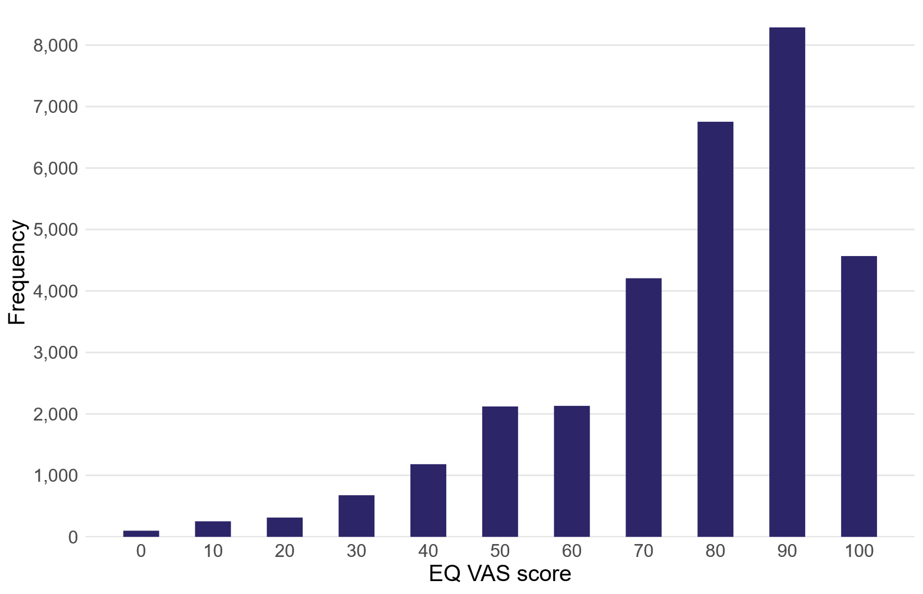
Note: Each column represents scores ranging from 5 points below to 4 points above the score shown. The exceptions are 0, which ranges from only 0 to 6, and 100, which ranges from only 95 to 100.
The mean score among Māori respondents (71.5) was lower than the mean scores of all other ethnic groups. Similarly, Pacific peoples (73.1) reported a lower mean score than the mean scores of European/Other (75.9) and Asian (79.7) respondents. All of these differences were statistically significant (Figure 7).
Figure 7: EQ VAS (self-rated health) mean score by ethnicity, 2024 data
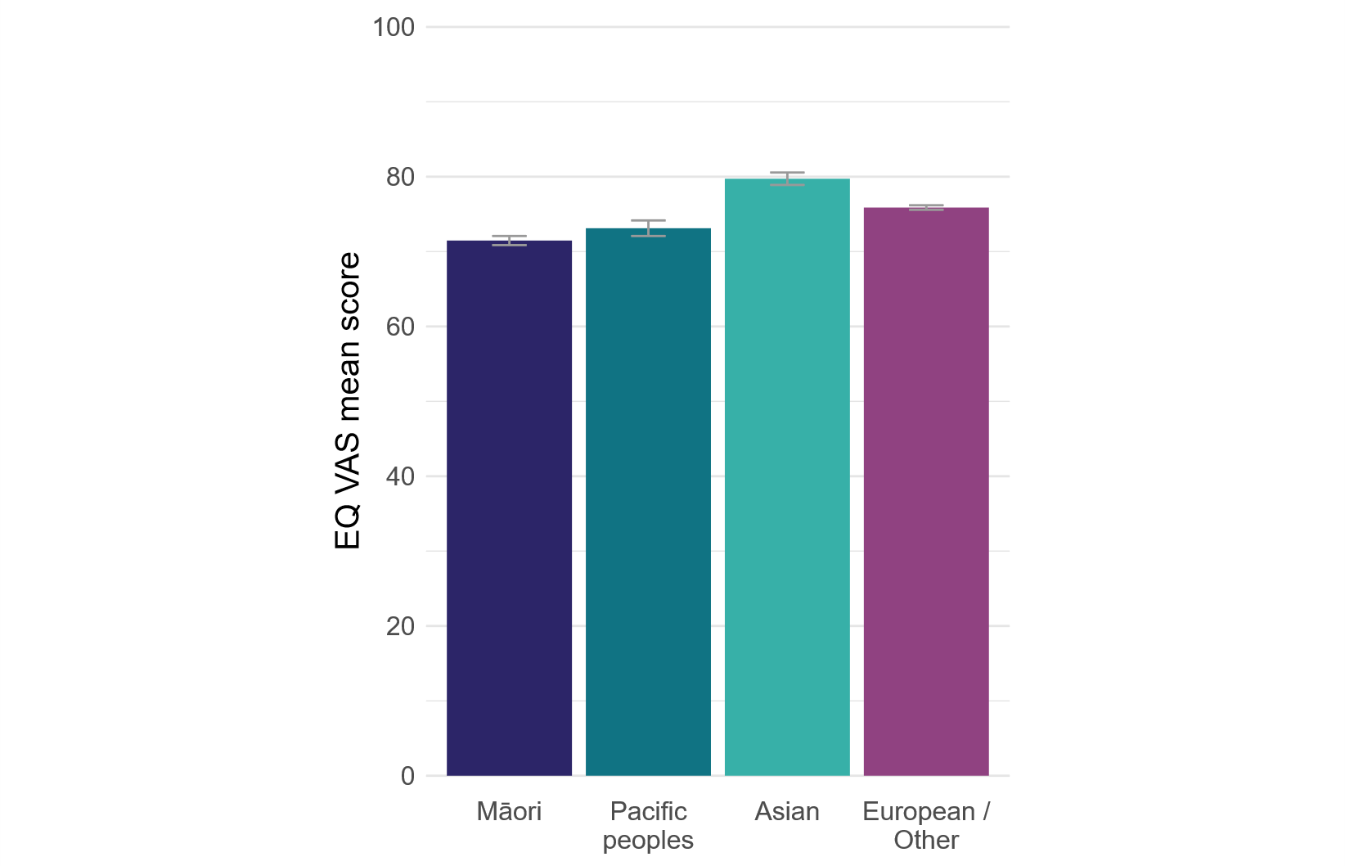
Māori reported low levels of health (VAS score under 60) at a disproportionately high rate. Of all respondents who reported low levels of health, 29 percent were Māori, which is approximately 1.5 times larger than the proportion of Māori who responded to the EQ VAS (20 percent). In contrast, while European/Other made up about 67 percent of respondents, of those who reported low levels of health only 58 percent were European/Other.
EQ VAS scores by age revealed an interesting pattern where people in older age groups rated their health more highly than younger respondents rated theirs (data not shown). This is consistent with findings in previous literature about New Zealand populations but is in contrast to results from other countries where older people report lower VAS scores. More research is needed to help in understanding and interpreting this result.
Disability status had a strong negative association with overall self-reported health. The mean VAS score of those with a disability was 60.2 percent, compared with 79.7 percent among those without a disability. Figure 8 shows the association of disability with self-reported health broken down by ethnicity. Across all ethnic groups, disabled respondents reported significantly worse overall health.
Figure 8: EQ VAS (self-rated health) mean score by disability status and ethnicity, 2024 data
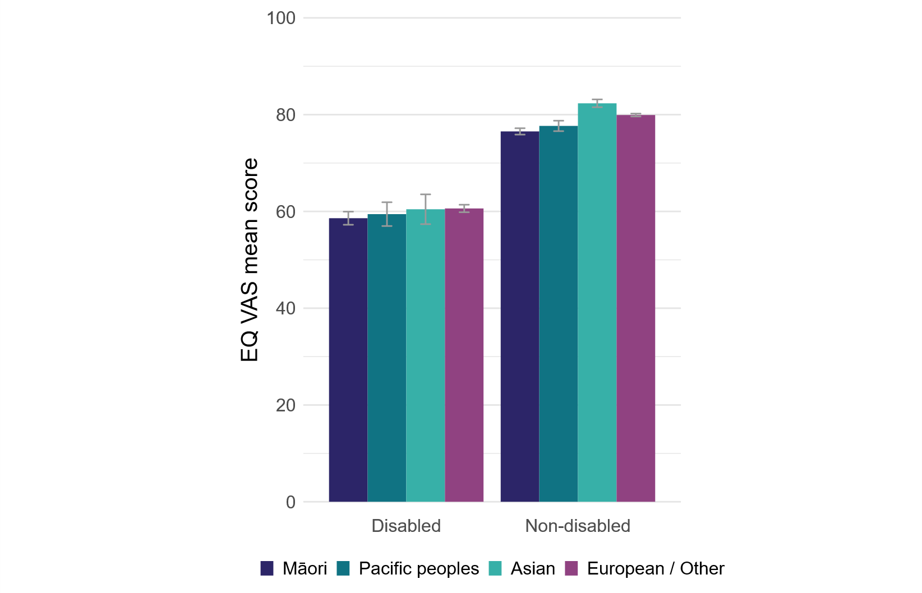

Some EQ-5D-5L dimensions impact self-reported health more than others
An analysis of the relationship between problems with specific EQ-5D-5L dimensions and overall EQ VAS scores showed that problems with anxiety/depression had the strongest association with a lower self-perceived health rating. Problems with usual activities had the second strongest association, and problems with pain/discomfort also had a strong association with a lower overall health rating. Self-care and mobility problems had a more moderate association with lower self-reported health.

What these results mean in the context of other health measures
For a broader context, we analysed the PROMs feedback against responses that the same respondents gave to patient-reported experience measures (PREMs). We looked for any associations between PROMs scores and PREMs. PREMs survey results are reported in the Adult Primary Care Patient Experience Explorer. In this section, we report on the results of this analysis.

People who reported problems on the EQ-5D-5L were more likely to report cost as a barrier to picking up a prescription
Analysis showed that responses to the question ‘Was there a time when cost stopped you from picking up a prescription?’ were strongly correlated with responses to the EQ-5D-5L (Figure 9 and Table 1).
Across all five EQ-5D-5L dimensions, respondents who reported problems were more likely to also report cost as a barrier to picking up a prescription (this only includes respondents who were prescribed medication in the previous 12 months). Those reporting problems with anxiety/depression were almost twice as likely to report experiencing prescription cost as a barrier compared with those reporting no problems with anxiety/depression.
Figure 9: Prevalence of problems with each EQ-5D-5L dimension by cost as a barrier to picking up a prescription, combined 2023 and 2024 data
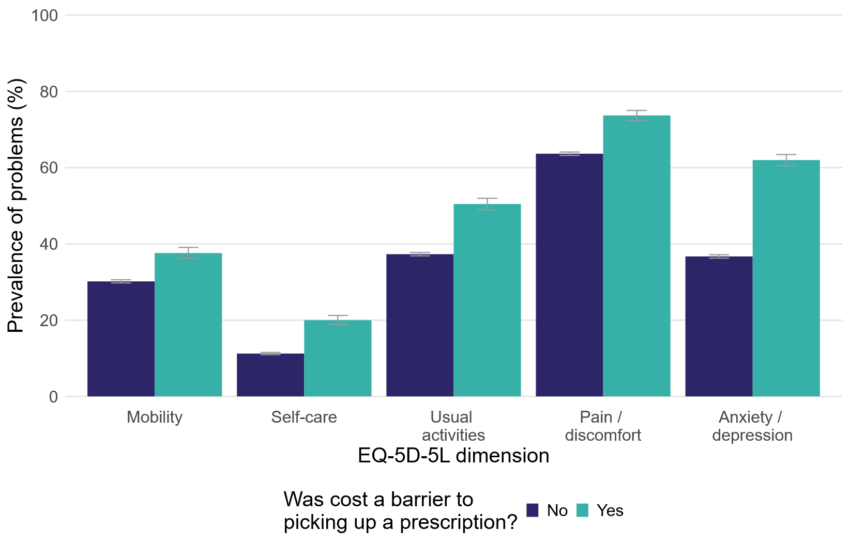
Note: Differences for all dimensions are statistically significant.
Table 1: Prevalence of problems with each EQ-5D-5L dimension by cost as a barrier to picking up a prescription (percentage), combined 2023 and 2024 data
Dimension | Was cost a barrier?
Dimension | No | Yes | Difference
Mobility | 30.2 | 37.6 | 7.4
Self-care | 11.2 | 20.0 | 8.8
Usual activities | 37.3 | 50.5 | 13.2
Pain/discomfort | 63.7 | 73.7 | 10.0
Anxiety/depression | 36.7 | 62.0 | 25.3
Note: Differences for all dimensions are statistically significant.
The association between problems with anxiety/depression and experiencing cost as a barrier to picking up a prescription particularly affected Māori and Pacific peoples. We have already shown (Figure 2) that 45 percent of Māori reported problems with anxiety/depression compared with 37 percent of non-Māori, non-Pacific. Figure 10 shows that the rate of reporting cost as a barrier to collecting a prescription was higher among Māori and Pacific peoples than among non-Māori, non-Pacific respondents to statistically significant levels.
Figure 10: Cost as a barrier to picking up a prescription by ethnicity, combined 2023 and 2024 data
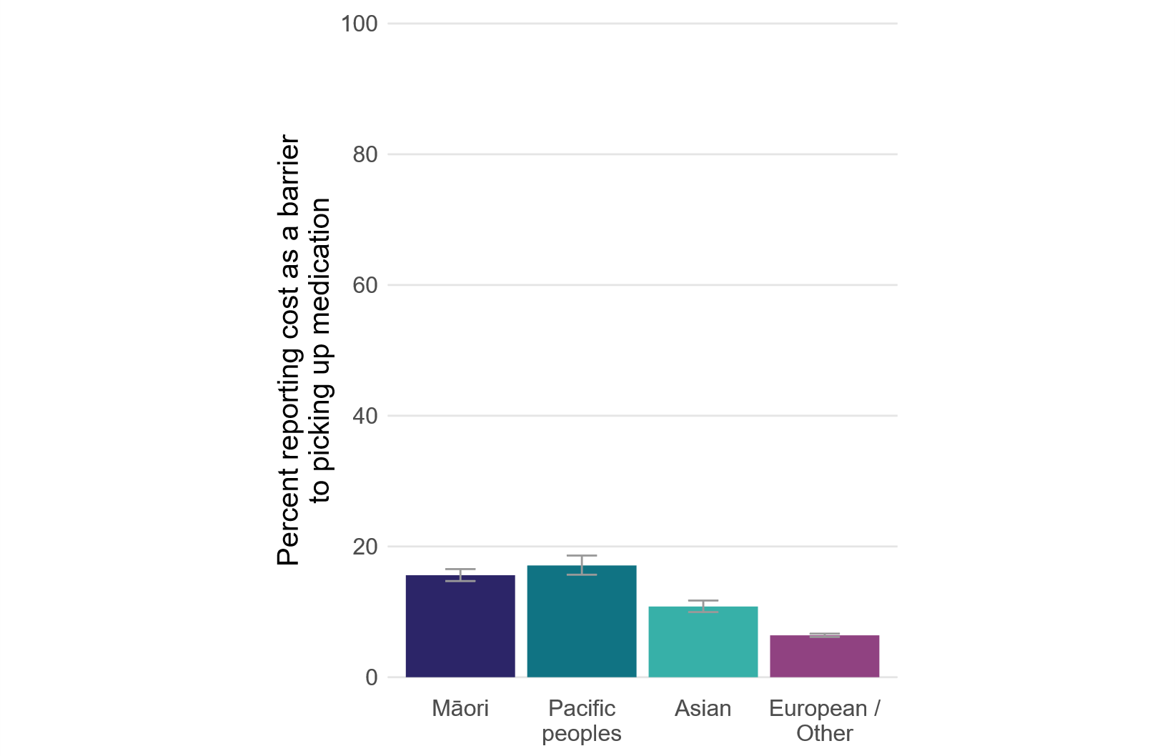
As with responses to the EQ-5D-5L, responses to the EQ VAS were strongly related to responses to the question ‘Was there a time when cost stopped you from picking up a prescription?’. Respondents who indicated that cost has stopped them from picking up a prescription reported lower levels of overall health compared with those for whom cost had not been a barrier to picking up a prescription (Figure 11).
Figure 11: EQ VAS (self-rated health) mean score by cost as a barrier to picking up a prescription, 2024 data
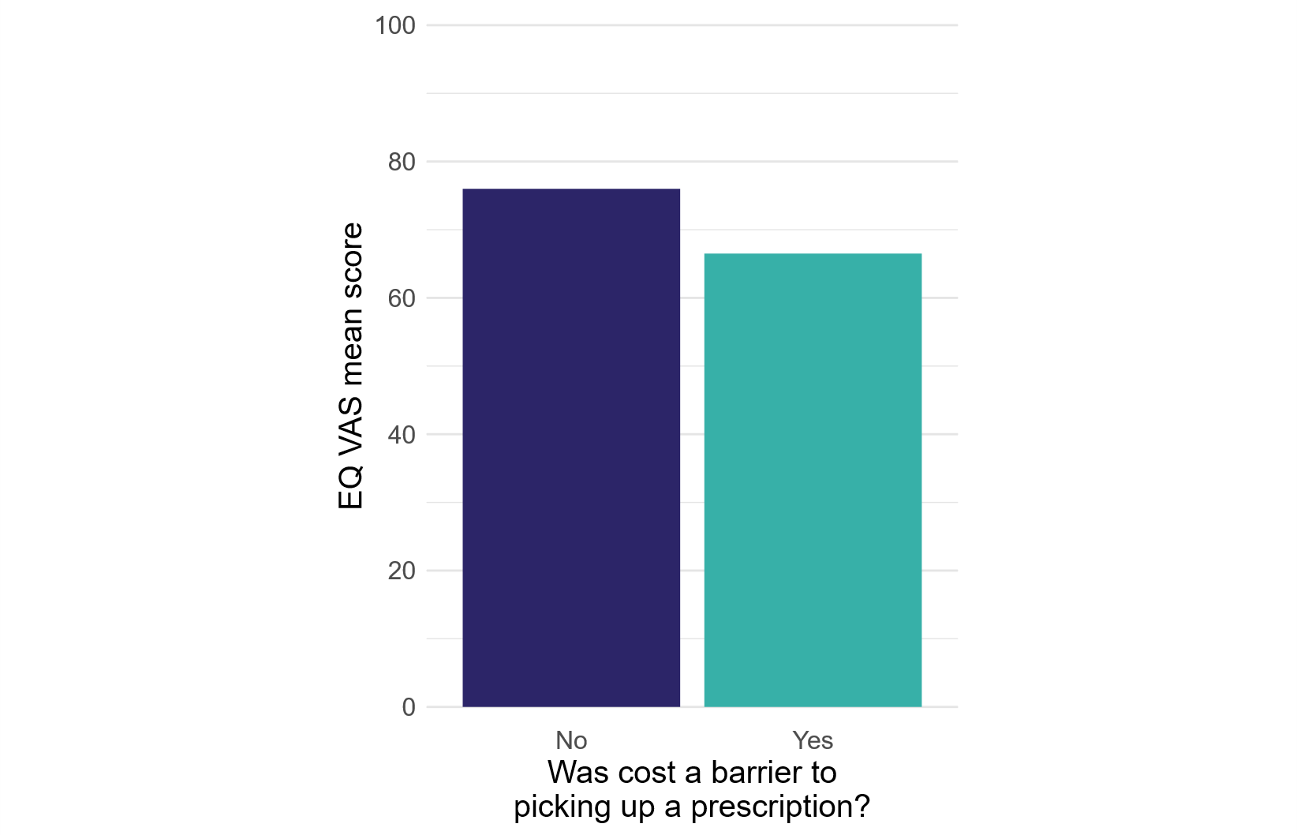
Note: The difference is statistically significant.

Summary
Those reporting worse health, as measured by both EQ-5D-5L dimensions and EQ VAS, were also more likely to report cost as a barrier to picking up a prescription This finding raises important questions about the appropriate system response. It is evidence of the inverse care law, which states that the availability of health care varies inversely with the population’s need for it, and sets a clear challenge for addressing inequity.

Hua Oranga
This section presents self-reported health outcomes from Hua Oranga. The analysis is mainly at the taha (domain) level.
Results are presented in tables and graphs as ‘strengths’ or ‘challenges’. Individual items are scored from 1 ‘strongly disagree’ to 5 ‘strongly agree’. The scores of the individual taha items can be totalled to provide overall scores for the five taha. We have classified respondents as reporting a ‘challenge’ if:
on an individual item, they score either of the two lowest options (1 or 2)
on a taha level, their taha score was at the mid-point or below.
This approach to scoring is different from our approach to EQ-5D-5L, where we classified respondents as having problems if they report any problem. If you are comparing results from the two PROMs, please keep this difference in mind as it may mean EQ-5D-5L results appear less positive than Hua Oranga results.
We weighted the data used in this section by age and gender. We did not weight by ethnicity as we collected Hua Oranga data for Māori respondents only. A total of 9,964 respondents completed Hua Oranga over the two survey waves.
The taha for which Māori seeking health care were least likely to report experiencing challenges with was taha hinengaro, with 8 percent reporting challenges. The most frequently reported challenges related to taha wairua (15 percent). Both of these findings were statistically significant differences from all other taha. Figure 12 shows the prevalence of challenges reported across all four taha of Hua Oranga.
Figure 12: Prevalence of challenges with each Hua Oranga taha, combined 2023 and 2024 data
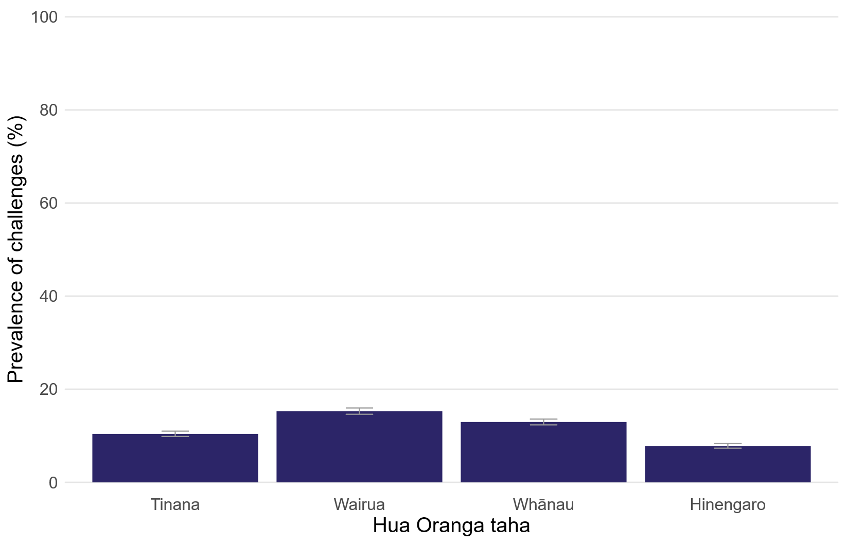
We broke down taha wairua further into the individual items to explore whether respondents reported challenges with one item in particular or with all items equally (Figure 13). The fewest challenges were reported with feeling their mana was intact and acknowledged/ respected, and the most challenges were reported with feeling connected and healthy from a spiritual perspective. Feeling strong in cultural identity and content within themselves scored in the middle.
Figure 13: Prevalence of challenges with the individual items of taha wairua, combined 2023 and 2024 data
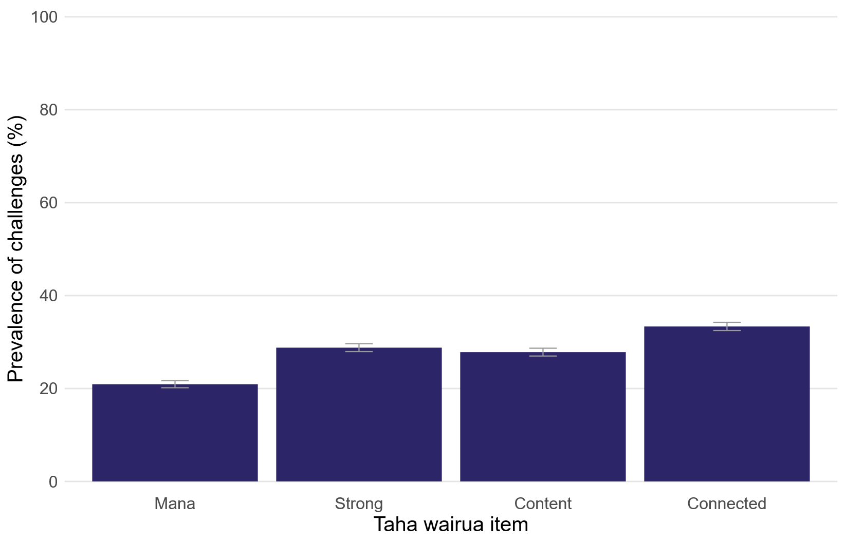
Older Māori reported fewer challenges on the taha wairua, whānau and hinengaro. The prevalence of challenges with taha tinana did not change significantly with age (Figure 14). This is in stark contrast to the EQ-5D-5L results by age, which indicate a general decline in self-reported health as respondents get older (Figure 3). This difference is statistically significant when the comparison is with EQ-5D-5L results of Māori respondents only.
Figure 14: Prevalence of challenges with each Hua Oranga taha by age, combined 2023 and 2024 data
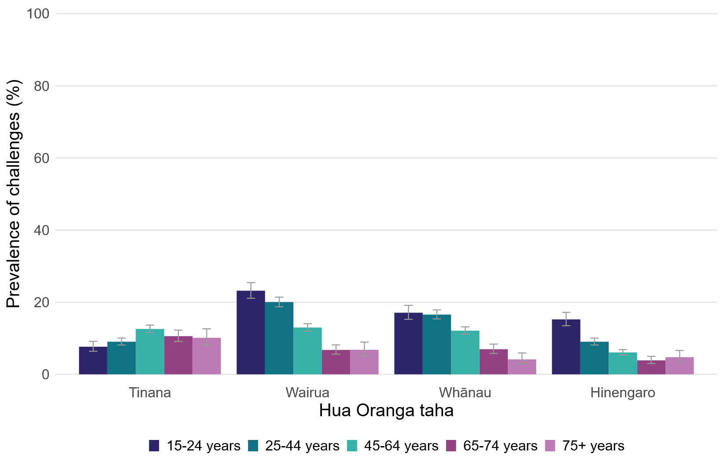
Lastly, more respondents with a disability have reported challenges across all Hua Oranga taha, compared with people with no disability (Figure 15). All differences are statistically significant.
Figure 15: Prevalence of challenges with each Hua Oranga taha by disability status, combined 2023 and 2024 data
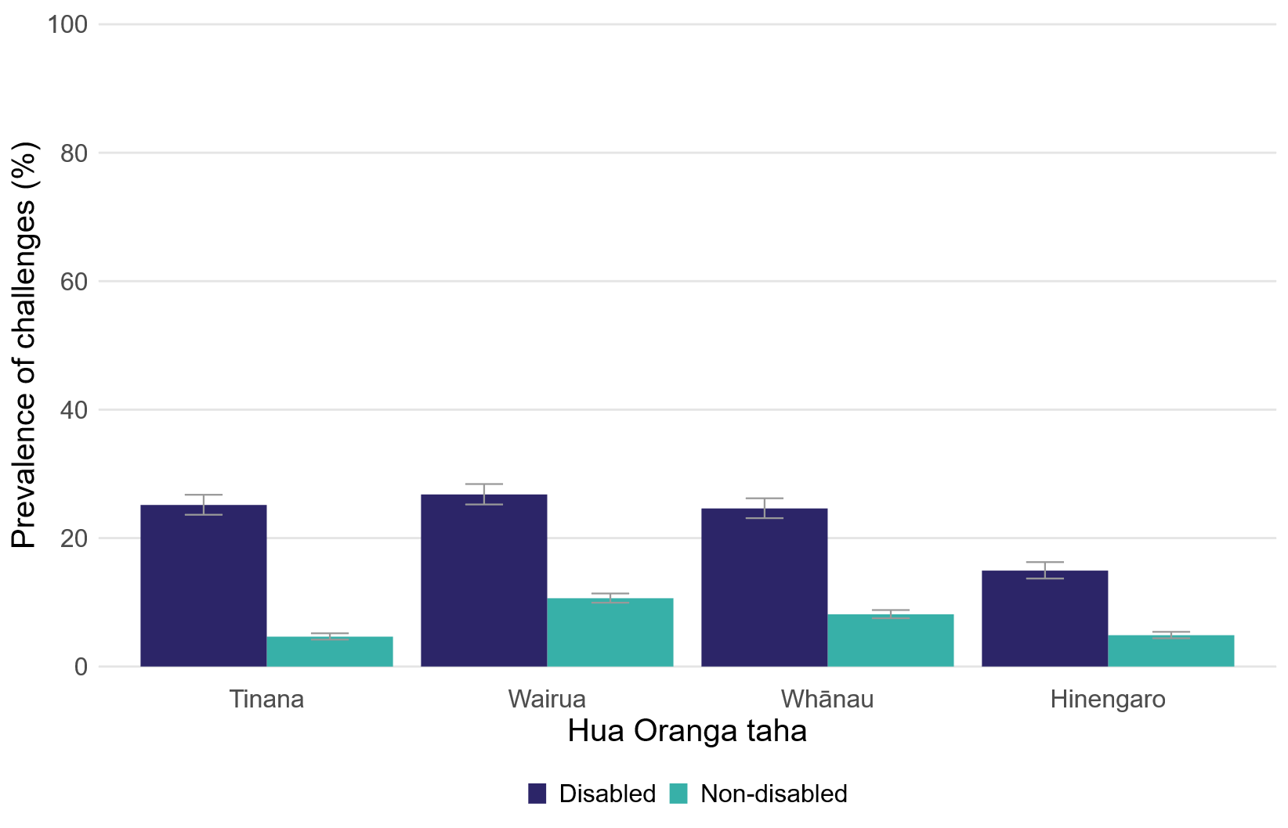
The analysis of the Hua Oranga results highlights the value of measuring health and wellbeing across a broad range of dimensions or domains. It further reveals that cultural and spiritual domains are especially relevant to Māori and may better reflect the holistic manner in which health and hauora is viewed. This is not to suggest that other indicators or measures of health are not important. Rather, that other measures of progress should also be considered so as to provide a more comprehensive assessment of what domains are valued or important.
This not only suggests that these types of cultural domains should be measured, but that they are also an opportunity to explore how cultural, spiritual and relational investments or activities might be promoted as a routine part of service delivery, in order to better meet the holistic needs of Māori and to promote enhanced levels of health, hauora and wellbeing.

Appendix One: Respondent demographics
Across the two survey waves, a total of 56,434 people completed the EQ-5D-5L. Of these, 21 percent of the respondents were Māori, which is representative of the population (19.6 percent Māori), and 72 percent were non-Māori, non-Pacific (Table 2).
Table 2: Number of people who completed EQ-5D-5L by ethnicity and survey wave, 2023 and 2024
Ethnicity | 2023 | 2024 | Total | %
Māori | 5,679 | 6,245 | 11,924 | (21.1)
Pacific peoples | 1,825 | 2,046 | 3,871 | (6.9)
Asian | 1,362 | 2,200 | 3,562 | (6.3)
European/Other | 16,199 | 20,878 | 37,077 | (65.7)
Total | 25,065 | 31,369 | 56,434 | (100.0)
By age, 42 percent of respondents were aged 65 years and over. This high percentage reflects that older people are more likely to attend general practice and so are more likely be invited to take part in the survey.
By gender, 64 percent of respondents were female and 36 percent male. This difference is likely to reflect that a higher proportion of women seek primary care compared with men. Response rates for men and women were similar.
Among respondents, 20 percent had a disability. A respondent was classified as having a disability if they had a functional disability based on the Washington Group Short Set on Functioning (WG-SS) and/or if they self-identified as disabled or as having a disability. The WG-SS classifies people as having a functional disability if they respond with ‘yes – a lot of difficulty or cannot do at all’ to any of the six basic functioning activities included in the WG-SS.
Across New Zealand over the two survey waves, 9,964 respondents completed all items of Hua Oranga (Table 3). Among those respondents, 25 percent were aged 65 years and over, 69 percent were female (30 percent were male) and 28 percent had a disability.
Table 3: Number of Māori who completed Hua Oranga by survey wave, 2023 and 2024
 | 2023 | 2024 | Total
Responses | 4,842 | 5,122 | 9,964

EuroQol Research Foundation. 2025. EQ-5D-5L User Guide. URL: https://euroqol.org/information-and-support/documentation/user-guides (accessed 16 December 2025).
Kingi TK. 2002. ‘Hua oranga’: Best health outcomes for Māori. PhD thesis, Massey University, Wellington.
McLachlan A. 2022. Hua Oranga: Whāngaihia te hua o oranga ki ō tatou whānau whānui: Ko te tikanga o te whakamahinga o hua oranga. URL: www.oradatabase.co.nz/files/hua_oranga_manual_low_res.pdf (accessed 16 December 2025).
Durie M. 1994. Whaiora: Māori health development (2nd ed). Oxford University Press.
Standards New Zealand. 2021. Ngā Paerewa Health and Disability Services Standard (NZS 8134:2021). URL: www.standards.govt.nz/shop/nzs-81342021 (accessed 17 December 2025).
Te Tāhū Hauora Health Quality & Safety Commission. 2022. Code of expectations for health entities’ engagement with consumers and whānau. URL: www.hqsc.govt.nz/consumer-hub/ engaging-consumers-and-whanau/code-of-expectations-for-health-entities-engagement-with-consumers-and-whanau/ (accessed 17 December 2025).
Part 3, subpart 3, Pae Ora (Health Futures) Act 2022. URL: www.legislation.govt.nz/act/public/2022/ 0030/latest/versions.aspx (accessed 17 December 2025).
Health Quality & Safety Commission Te Tāhū Hauora. 2023. Patient-reported measures. URL: www.hqsc.govt.nz/our-data/patient-reported-measures/ (accessed 17 December 2025).
Health Quality & Safety Commission Te Tāhū Hauora. 2023. Survey results. URL: www.hqsc.govt.nz/ our-data/patient-reported-measures/patient-experience/survey-results/ (accessed 17 December 2025).
Health Quality & Safety Commission. 2019. Window on the quality of Aotearoa New Zealand’s health care 2019 – a view on Māori health equity. Wellington: Health Quality & Safety Commission. URL: www.hqsc.govt.nz/resources/resource-library/a-window-on-the-quality-of-aotearoa-new-zealands-health-care-2019-a-view-on-maori-health-equity-2/ (accessed 20 December 2025).
Health Quality & Safety Commission. 2021. Bula Sautu – A window on quality 2021: Pacific health in the year of COVID-19. Wellington: Health Quality & Safety Commission. URL: www.hqsc.govt.nz/resources/resource-library/bula-sautu-a-window-on-quality-2021-pacific-health-in-the-year-of-covid-19-bula-sautu-he-mata-kounga-2021-hauora-pasifika-i-te-tau-covid-19/ (accessed 20 December 2025).
Health Quality & Safety Commission Te Tāhū Hauora. (nd). Dashboard of health system quality. URL: www.hqsc.govt.nz/our-data/dashboard-of-health-system-quality/ (accessed 20 December 2025).
Health Quality & Safety Commission Te Tāhū Hauora. 2021. Quality and safety markers. URL: www.hqsc.govt.nz/our-data/quality-and-safety-markers/ (accessed 20 December 2025).
Health Quality & Safety Commission Te Tāhū Hauora. 2021. Atlas of Healthcare Variation. URL: www.hqsc.govt.nz/our-data/atlas-of-healthcare-variation/ (accessed 20 December 2025).
Grimmond D, Martin G, Tu D. 2021. 2021 GP Future Workforce Requirements Report. Allen & Clarke. URL: www.rnzcgp.org.nz/gpdocs/new-website/publications/2021-GP-future-workforce-report-FINAL.pdf (accessed 17 December 2025).
Health New Zealand. 2025. Hospital events web tool. URL: www.tewhatuora.govt.nz/for-health-professionals/data-and-statistics/hospital-event/web-tool (accessed 17 December 2025).
A statistically significant difference is a difference that is highly unlikely to occur by chance alone.
Demographic weighting takes the local eligible population structure, compares this with the survey respondent structure and creates a coefficient that is applied to the results of the survey. This coefficient then increases or decreases a particular score and provides a weighted result. The effect of weighting is to adjust for different response rates between different demographic groups and adjust the results to reflect this. The more under-represented a particular group is among the respondents, the more actual patients each respondent represents. For this reason, the response of respondents from under-represented groups is up-weighted and the response of those from over-represented groups is down-weighted.
Sullivan T, Turner RM, Derrett S, et al. 2021. New Zealand population norms for the EQ-5D-5L constructed from the personal value sets of participants in a national survey. Value in Health 24(9): 1308–18. DOI: 10.1016/j.jval.2021.04.1280 (accessed 18 December 2025).
Wang Z, Luo N, Wang P. 2025. A comparative analysis of EQ-5D-5L general population norms across 23 countries: gender and age disparities. Pharmacoeconomics and Policy 1(1): 5–14. DOI: 10.1016/j.pharp.2025.03.001 (accessed 18 December 2025),
Health Quality & Safety Commission Te Tāhū Hauora. (nd). Adult Primary Care Patient Experience Explorer. URL: https://reports.hqsc.govt.nz/APC-explorer/ (accessed 18 December 2025).
Hart JT. 1971. The inverse care law. The Lancet 297(7696): 405–12.
Washington Group on Disability Statistics. 2022. The Washington Group Short Set on Functioning (WG-SS). URL: www.washingtongroup-disability.com/fileadmin/uploads/wg/ Washington_Group_Questionnaire__1_-_WG_Short_Set_on_Functioning__October_2022_.pdf (accessed 19 December 2025).

