



Experiences of people receiving care in an emergency department:

Results from the adult primary care patient experience survey module 2025

July 2026

Published July 2026, Health Quality & Safety Commission Te Tāhū Hauora,
PO Box 25496, Wellington 6146.

ISBN 978-1-991122-43-8 (online)
Available online at hqsc.govt.nz
Enquiries to: survey@hqsc.govt.nz

This work is licensed under the Creative Commons AttributionNonCommercial-ShareAlike 4.0 International (CC BY-NC-SA 4.0). To view a copy of this licence, visit https://creativecommons.org/licenses/by-nc-sa/4.0




Contents
National results 6
Background 7
The patient-reported measures programme 7
The adult primary care patient experience survey 7
The emergency department module 8
Interpreting the report 8
Respondents 10
Results 11
Did the emergency department staff you met on your arrival treat you with respect? 11
Did the emergency department health professionals treat you with respect? 15
Did the emergency department health professionals listen to your views and concerns? 19
Did the emergency department health professionals involve you as much as you wanted to be in making decisions about your treatment and care? 23
Did you have enough information about how to manage your condition or recovery after you left the emergency department? 27
Further information 31
References 32
Appendix 33

Figures
Figure 1: Treated with respect by emergency department staff on arrival (Percentage responding ‘Yes, definitely’ across all districts, May 2025) 11
Figure 2: Treated with respect by emergency department staff on arrival (Percentage responding ‘Yes, definitely’ by demographics, May 2025) 12
Figure 3: Treated with respect by staff on arrival (Percentage‑point difference between emergency department and general practice experience, by age and ethnicity, May 2025) 13
Figure 4: Treated with respect by staff on arrival (Percentage‑point difference between emergency department and general practice experience, by age and gender, May 2025) 14
Figure 5: Treated with respect by staff on arrival (Percentage‑point difference between emergency department and general practice experience, by ethnicity and gender, May 2025) 14
Figure 6: Treated with respect by emergency department health care professional (Percentage responding ‘Yes, definitely’ by district, May 2025) 15
Figure 7: Treated with respect by emergency department health care professional (Percentage responding ‘Yes, definitely’ by demographics, May 2025) 16
Figure 8: Treated with respect by health care professional (Percentage‑point difference between emergency department and general practice experience, by age and ethnicity, May 2025) 17
Figure 9: Treated with respect by health care professional (Percentage‑point difference between emergency department and general practice experience, by age and gender, May 2025) 18
Figure 10: Treated with respect by health care professional (Percentage‑point difference between emergency department and general practice experience, by ethnicity and gender, May 2025) 18
Figure 11: Listened to by emergency department health care professional (Percentage responding ‘Yes, definitely’ by district, May 2025) 19
Figure 12: Listened to by emergency department health care professional (Percentage responding ‘Yes, definitely’ by demographics, May 2025) 20
Figure 13: Listened to by health care professional (Percentage‑point difference between emergency department and general practice experience, by age and ethnicity, May 2025) 21
Figure 14: Listened to by health care professional (Percentage‑point difference between emergency department and general practice experience, by age and gender, May 2025) 22
Figure 15: Listened to by health care professional (Percentage‑point difference between emergency department and general practice experience, by ethnicity and gender, May 2025) 22
Figure 16: Involved in decisions about treatment and care at emergency department (Percentage responding ‘Yes, definitely’ by district) 23
Figure 17: Involved in decisions about treatment and care at emergency department (Percentage responding ‘Yes, definitely’ by demographics) 24
Figure 18: Involved in decisions about treatment and care (Percentage‑point difference between emergency department and general practice experience, by age and ethnicity, May 2025) 25
Figure 19: Involved in decisions about treatment and care (Percentage‑point difference between emergency department and general practice experience, by age and gender, May 2025) 26
Figure 20: Involved in decisions about treatment and care (Percentage‑point difference between emergency department and general practice experience, by ethnicity and gender, May 2025) 26
Figure 21: Had enough information to manage condition after leaving emergency department (Percentage responding ‘Yes, definitely’ across all districts) 27
Figure 22: Had enough information to manage condition after leaving emergency department (Percentage responding ‘Yes, definitely’ by demographics) 28
Figure 23: Had enough information to manage condition after discharge (Percentage‑point difference between emergency department and inpatient stay experience, by age and ethnicity, May 2025) 29
Figure 24: Had enough information to manage condition after discharge (Percentage‑point difference between emergency department and inpatient stay experience, by age and gender, May 2025) 30
Figure 25: Had enough information to manage condition after discharge (Percentage‑point difference between emergency department and inpatient stay experience, by ethnicity and gender, May 2025) 30

Tables
Table 1: Responses to question ‘In the last 12 months, have you been to the emergency department at a hospital for your own health?’ 11
Table 2: Responses to question ‘What were all the reasons you went to a hospital emergency department?’ 11

National results
This report presents results for people who completed the Health Quality & Safety Commission Te Tāhū Hauora (the Commission) adult primary health care experience survey and who selected that they had visited an emergency department (ED) at a hospital for their own health in the last 12 months. Nearly 8,000 people answered the ED questions in May 2025.
The survey asked patients five questions about their ED experience. Key results were as follows.
- 85 percent of respondents felt they were definitely treated with respect by ED health care professionals (this was the highest-scoring question).
- 67 percent of respondents felt they were definitely informed about how to manage their condition or recovery after they left the ED (this was the lowest-scoring question).
People aged 65 years and older, non-disabled people, males and Asian and Pacific people reported having consistently better experiences at EDs.
Young people reported having a notably worse ED experience; for example, 58 percent of those aged 15–24 years felt ED health professionals definitely listened to their views and concerns, compared with 88 percent of those aged 65 years and over.
Data shows that younger people are more likely to present to ED with mental health-related conditions compared with older people. It also shows that mental health patients experience longer waits for care (Kuehl et al 2024). This may partly explain why younger people have worse experience and raises the question as to how we can better resource EDs to care for those presenting with complex mental health problems.
We have developed this report to help EDs understand what they are doing that benefits their patients the most and to identify opportunities for improvement.

Background

The patient-reported measures programme
The Commission aims to regularly and consistently capture patient- and client-reported measures using valid, reliable and robust methods, including experience of care. This is recognised as a good indicator of the quality of health services. Feedback helps drive quality improvement, to deliver better care and mitigate inequity across all levels of the health system.
The Commission is mandated under part 3 subpart 3 of the Pae Ora (Healthy Futures) Act 2022 ‘to lead and co-ordinate work across the health sector for the purposes of monitoring and improving the quality and safety of services’.
The Commission collects patient-reported measures through validated and standardised surveys, which enable systematic collection, analysis and reporting. We use information gathered at local, regional and national levels to benchmark results across the country and improve services locally.
The Commission’s patient-reported measures programme is one of the largest public survey programmes in Aotearoa New Zealand. It consists of three national quarterly surveys: the adult hospital inpatient experience survey, the adult hospital outpatient experience survey and the adult primary care patient experience survey. These surveys gather feedback from around 50,000 patients every quarter. We report survey results publicly on our website and privately to providers on a secure website. These surveys report experience by ethnic group, age group, gender and disability status. The collection of disability status information is particularly important, as this information is often missing from national reporting and gives important insights into the experience of disabled people.

The adult primary care patient experience survey
The adult primary care patient experience survey provides information about the experience of care received by a selection of adults aged 15 years and over who were enrolled with and had a consultation or other contact with their general practice during the survey period. The survey covers different aspects of primary care patient experience, including communication, partnership, physical and emotional needs, cultural safety and access to care.
Respondents complete the survey online, in either English or te reo Māori. Invitations are sent by email and/or SMS. Participation is voluntary. Survey responses are anonymous unless people choose to provide their contact details.

The emergency department module
In May 2025, we introduced an expanded ED module into the adult primary care patient experience survey. This module will be included annually in the May survey wave. The questions in the new module are for people who answer ‘Yes’ to the question ‘have you been to a hospital emergency department in the last twelve months for your own health?’ The module asks about the reason for their ED visit and covers core areas of their experience that we considered amenable for improvement.
a) Did the emergency department staff you met on your arrival treat you with respect?
b) Did the emergency department health professionals treat you with respect?
c) Did the emergency department health professionals listen to your views and concerns?
d) Did the emergency department health professionals involve you as much as you wanted to be in making decisions about your treatment and care?
e) Did you have enough information about how to manage your condition or recovery after you left the emergency department?
The full questionnaire, including answer options, is available on our website. This report presents the national results. For district results, email survey@hqsc.govt.nz.

Interpreting the report

Defining ethnic group
We collect and report on ethnic group information in accordance with the Ethnicity New Zealand Standard Classification 2005 V2.1.0 and the HISO 10001:2017 Ethnicity Data Protocols. A person’s ethnic group is determined by self-report in the survey; if self-reported ethnicity is unknown, ethnic group is assigned using what is recorded in the national enrolment service, which draws from general practice patient management systems.
This report uses a prioritised classification of ethnic group. This means that people who identify with more than one ethnic group are counted in only one of those groups, in the prioritised order of Māori, Pacific peoples, Asian and European/Other.

Defining disability status
The survey asks respondents two sets of questions about whether they are disabled: the Washington Group Short Set on Functioning (WG-SS) and a self-identified question. We classify a person as being disabled if they indicate they could not do, or would have a lot of difficulty doing, any of the six activities included in the WG-SS, or if they self-identify as disabled.

Understanding the percentages
This report presents results as the percentage of people who selected the most positive response to the respective question, representing the best-case scenario for them.

Bar charts
In the bar charts, the national result is shown in blue. Breakdowns by district and demographics are shown in mint. Confidence intervals (CIs) are indicated by grey lines. The number of people who answered the question is indicated by ‘n’.

Heatmaps
The heatmaps (for example, Figure 4) display the percentage point difference in the most positive response between ED experience and either general practice or inpatient experience, with the percentage giving the most positive response shown in brackets. Negative values indicate a worse experience in ED, a value of 0 indicates no difference between experiences and positive values indicate a more positive experience in ED.
For example, if 80 percent of respondents reported a positive ED experience and 90 percent reported a positive general practice experience, the percentage point difference is −10, indicating a worse experience in ED.
Heatmap shading reflects the magnitude of the difference, ranging from white (no meaningful difference or a more positive ED experience) to progressively darker colours (larger negative differences).

Identifying significant differences
Confidence intervals are calculated at 95 percent confidence level. If the lower or upper limits do not overlap with other groups, the difference is considered statistically significant.
In the bar charts, a darker colour is used to denote significantly better experience, and a lighter colour is used to denote significantly worse experience. The reference group for significant differences is the national result, for reporting both by district and by demographic groups.

Weighting the survey sample
Survey results are weighted to ensure they better reflect the demographic and geographic structure of the patient population. This is achieved by comparing the distribution of survey respondents with the distribution of the population across key groups, and applying adjustment factors (weights) to correct for differences in representation.
Weighting accounts for both the survey sampling design and differences in response rates across groups. It includes adjustment for age group, gender, prioritised ethnicity, and geographic location (district of domicile), ensuring that results appropriately reflect variation across these characteristics.

Respondents
This section shows who accessed general practice in May 2025 and visited an ED for their own health in the previous 12 months.
Table 1: Responses to question ‘In the last 12 months, have you been to the emergency department at a hospital for your own health?’
(Number of people responding 'Yes’)
Age | Māori | Pacific peoples | Asian | European/Other | Total
15–24 years | 87 | 17 | 7 | 128 | 239
25–44 years | 365 | 150 | 149 | 507 | 1,171
45–64 years | 854 | 238 | 120 | 1,495 | 2,707
65–74 years | 378 | 85 | 57 | 1,342 | 1,862
75+ years | 170 | 36 | 45 | 1,746 | 1,997
Total | 1,854 | 526 | 378 | 5,218 | 7,976
Percent | 23.2% | 6.6% | 4.7% | 65.4% | 100.0%

Table 2: Responses to question ‘What were all the reasons you went to a hospital emergency department?’
(Multiple responses possible)
 | Responses | Percentage of respondents
Condition was serious/life threatening or sent by a health professional | 5,960 | 74.7%
General practice or after-hours was too expensive | 267 | 3.3%
Time of day/day of week | 1,240 | 15.5%
Waiting time too long at usual medical clinic | 654 | 8.2%
Other | 1,442 | 18.1%

Results

Did the emergency department staff you met on your arrival treat you with respect?
The first point of contact for patients coming to an ED is an important determinant of their overall experience (Janerka et al 2024). Commonly cited themes of negative ED experiences include long wait times, overcrowding, inadequate communication, lack of privacy and uncomfortable environments. Key themes that contribute to positive experience are good staff-patient communication, shorter wait times and staff empathy and compassion (Price et al 2022).
Figure 1: Treated with respect by emergency department staff on arrival (Percentage responding ‘Yes, definitely’ across all districts, May 2025)
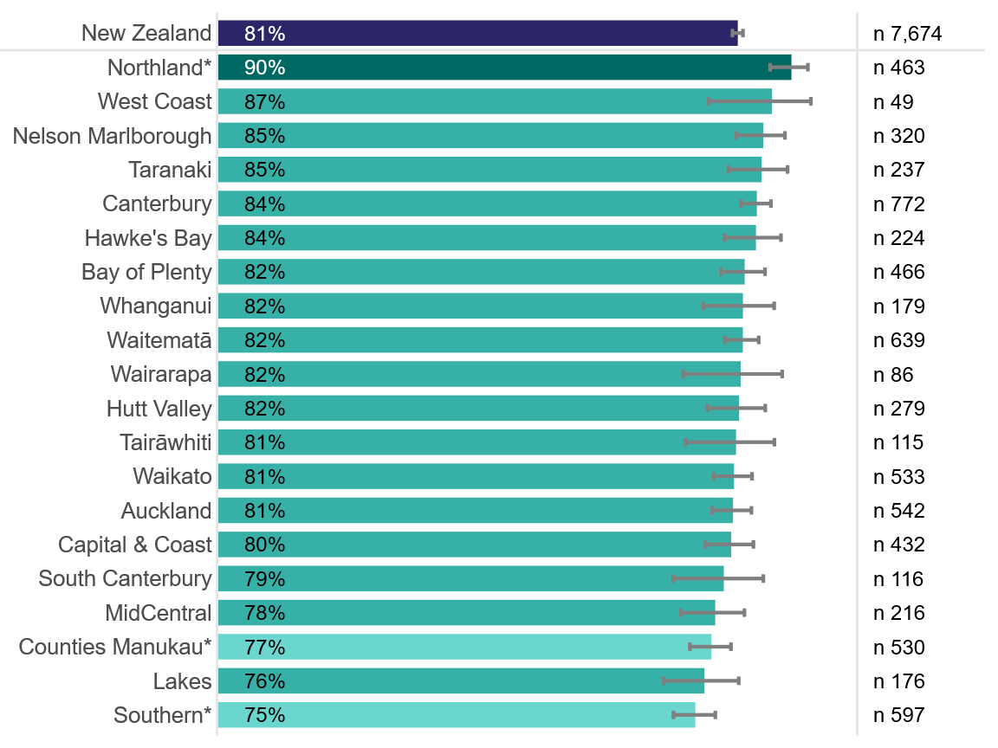
Figure 2: Treated with respect by emergency department staff on arrival (Percentage responding ‘Yes, definitely’ by demographics, May 2025)
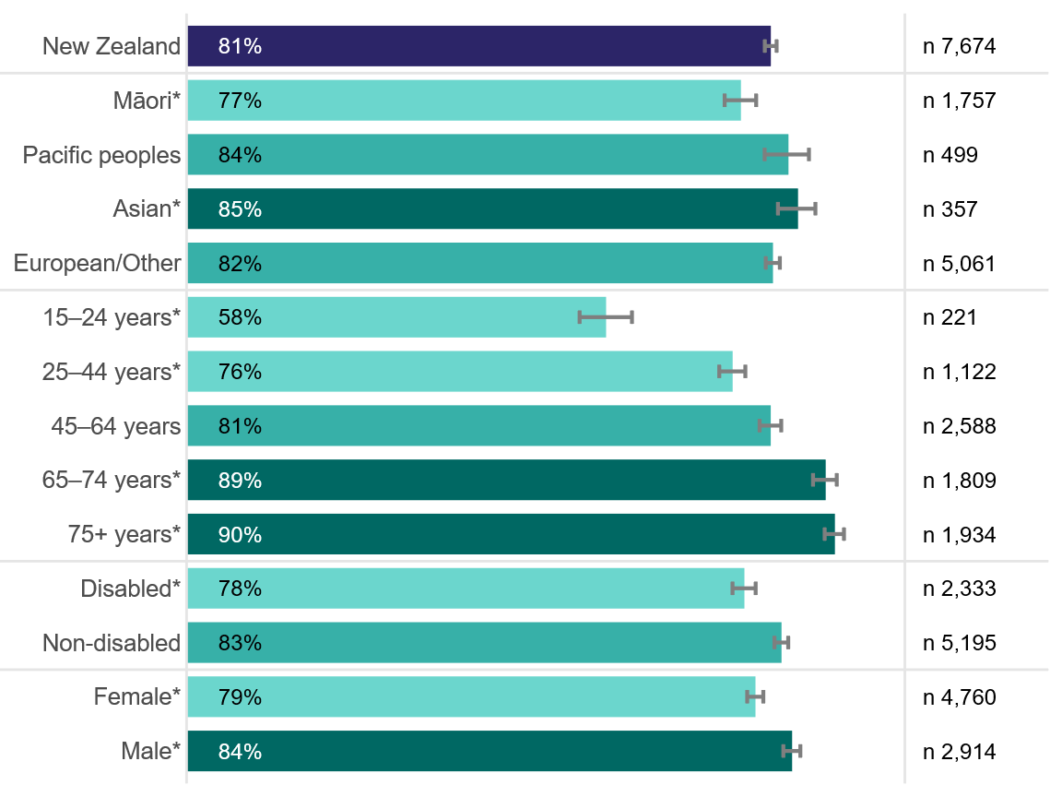

Treated with respect on arrival: emergency department compared with general practice
This section presents results by demographic group and compares responses with responses to a similar question asked of the same cohort about their experience at general practice.
Overall, the same people reported a significantly more positive experience at their general practice than at the ED. Specifically, 81.3 percent of respondents responded ‘Yes, definitely’ to feeling treated with respect on arrival at the ED, compared with 91.4 percent at their general practice. The difference was particularly pronounced among young people and Māori females.
See information in ‘Interpreting the report’ on page 9 on how to interpret the heatmaps.
Figure 3: Treated with respect by staff on arrival (Percentage‑point difference between emergency department and general practice experience, by age and ethnicity, May 2025)
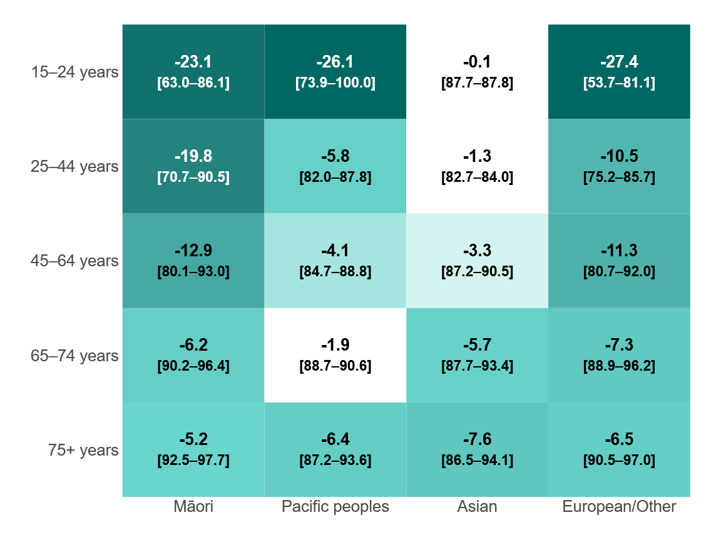
Note: Negative values indicate worse reported experience in ED. Percentages of respondents selecting the most positive response are shown in brackets (ED – general practice).
Figure 4: Treated with respect by staff on arrival (Percentage‑point difference between emergency department and general practice experience, by age and gender, May 2025)
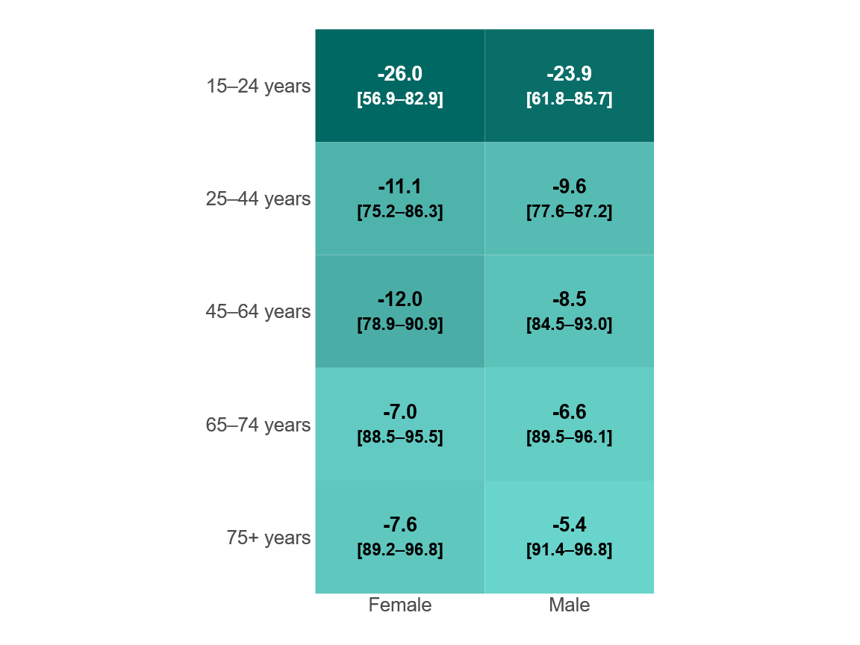
Note: Negative values indicate worse reported experience in ED. Percentages of respondents selecting the most positive response are shown in brackets (ED – general practice).
Figure 5: Treated with respect by staff on arrival (Percentage‑point difference between emergency department and general practice experience, by ethnicity and gender, May 2025)
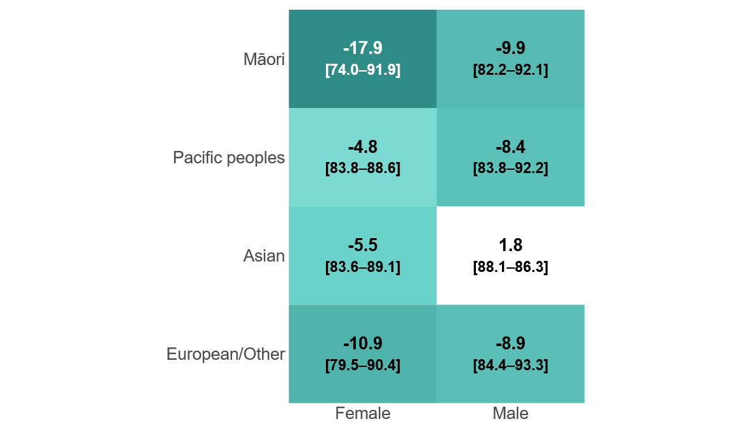
Note: Negative values indicate worse reported experience in ED. Percentages of respondents selecting the most positive response are shown in brackets (ED – general practice).

Did the emergency department health professionals treat you with respect?
Being treated with respect by health professionals is core to a patient-centred and culturally safe experience. Patients who have a better care experience are more likely to adhere to prevention and treatment processes, more likely to have better clinical outcomes and less health care utilisation (Anhang Price et al 2014).
Figure 6: Treated with respect by emergency department health care professional (Percentage responding ‘Yes, definitely’ by district, May 2025)
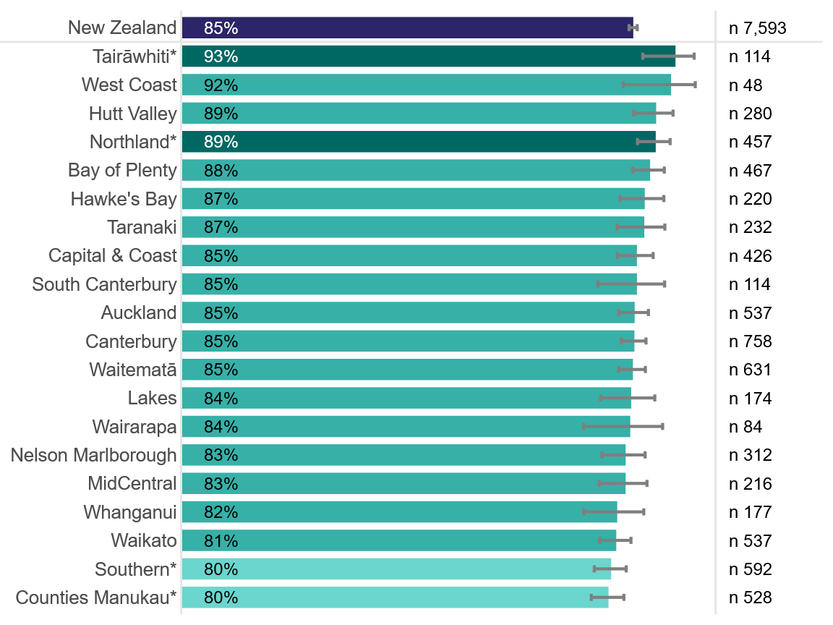

Figure 7: Treated with respect by emergency department health care professional (Percentage responding ‘Yes, definitely’ by demographics, May 2025)
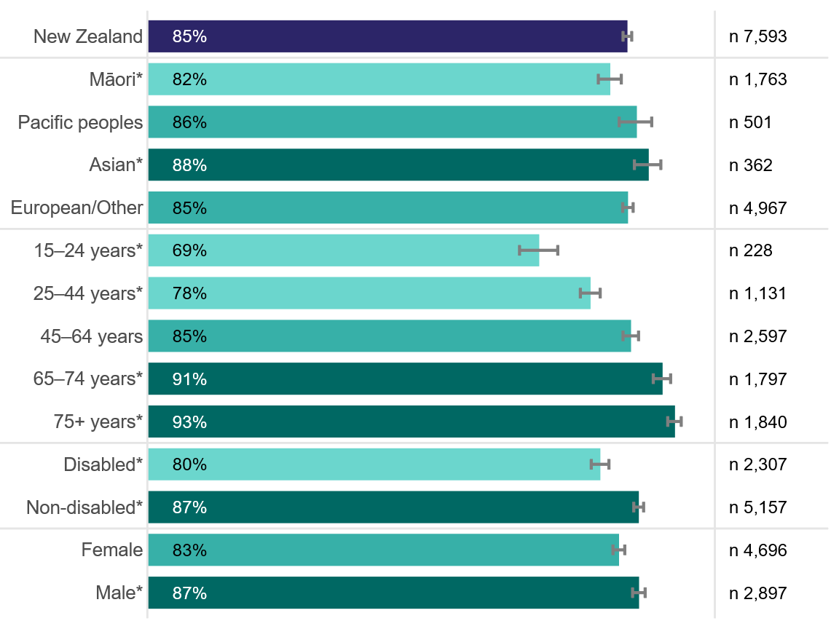

Treated with respect by health care professional: emergency department compared with general practice
This section presents results by demographic group and compares responses with responses to a similar question asked of the same cohort about their experience at general practice.
Overall, within cohorts, people reported a significantly more positive experience at their general practice than at the ED. Specifically, 84.6 percent of respondents responded ‘Yes, definitely’ to feeling treated with respect by ED health care professionals, compared with 95.3 percent who felt treated with respect by general practice health care professionals. The difference was particularly pronounced among younger people.
See information in ‘Interpreting the report’ on page 9 on how to interpret the heatmaps.
Figure 8: Treated with respect by health care professional (Percentage‑point difference between emergency department and general practice experience, by age and ethnicity, May 2025)
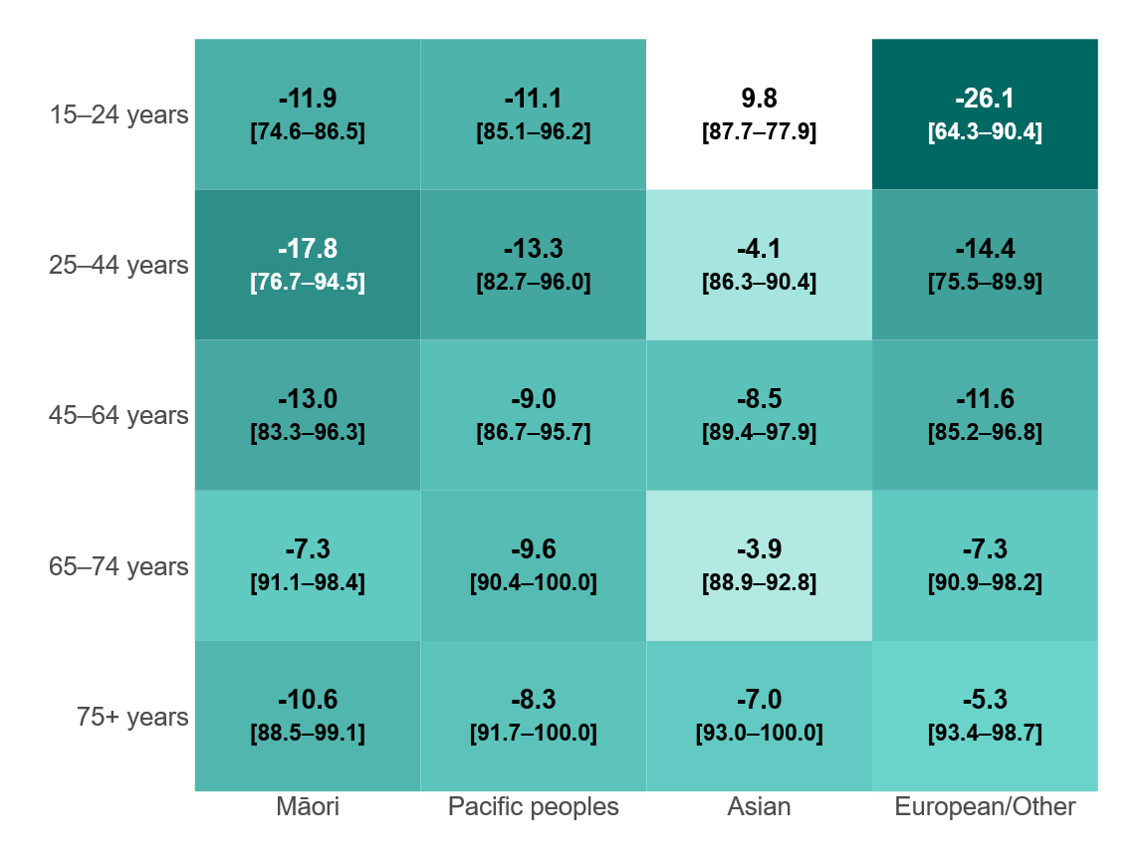
Note: Negative values indicate worse reported experience in ED. Percentages of respondents selecting the most positive response are shown in brackets (ED – general practice).
Figure 9: Treated with respect by health care professional (Percentage‑point difference between emergency department and general practice experience, by age and gender, May 2025)
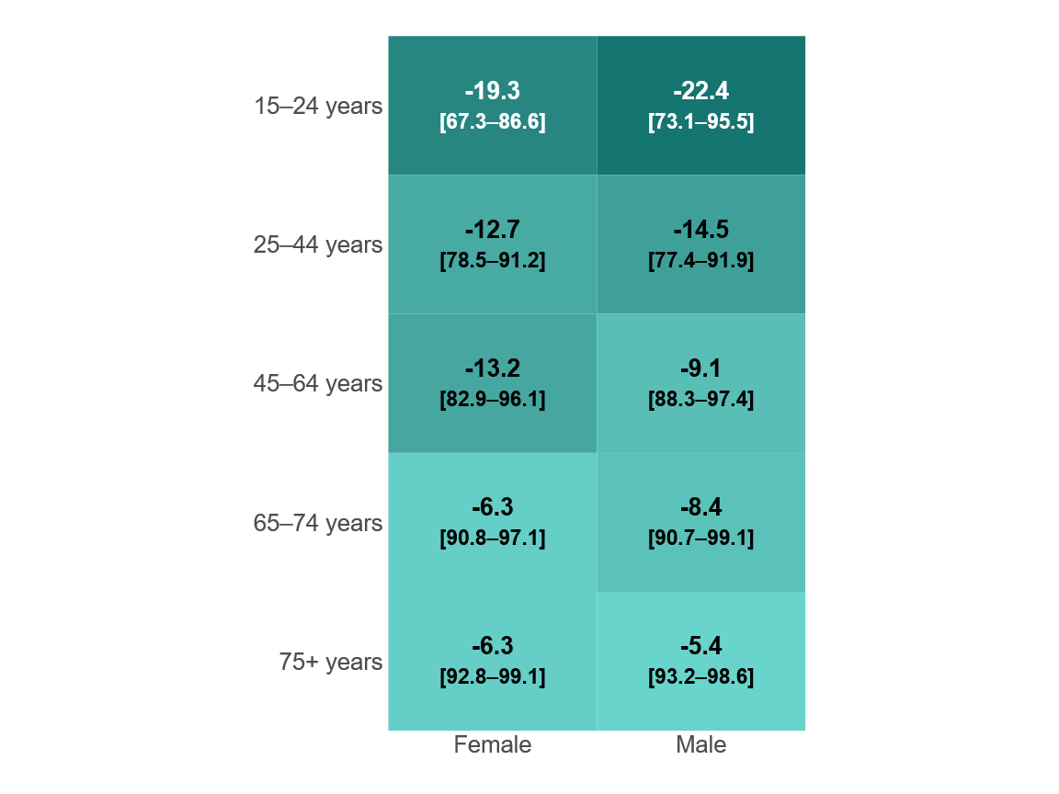
Note: Negative values indicate worse reported experience in ED. Percentages of respondents selecting the most positive response are shown in brackets (ED – general practice).
Figure 10: Treated with respect by health care professional (Percentage‑point difference between emergency department and general practice experience, by ethnicity and gender, May 2025)
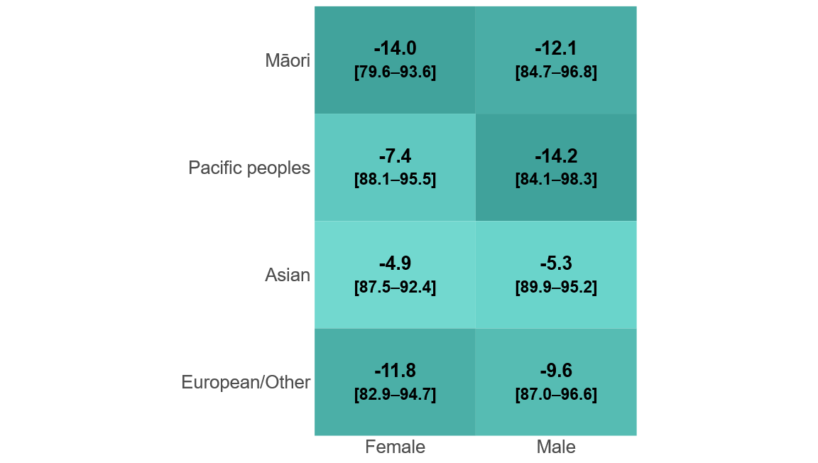
Note: Negative values indicate worse reported experience in ED. Percentages of respondents selecting the most positive response are shown in brackets (ED – general practice).

Did the emergency department health professionals listen to your views and concerns?
Allowing a patient time to tell their story is a pivotal part of the medical encounter. When patients are allowed to talk without interruption, they are more likely to report feeling listened to. Research shows that health care practitioners often interrupt patients when they are telling their story and that, if they are allowed to continue, most patients talk for a median of 6 seconds more (Phillips et al 2019).
Figure 11: Listened to by emergency department health care professional (Percentage responding ‘Yes, definitely’ by district, May 2025)
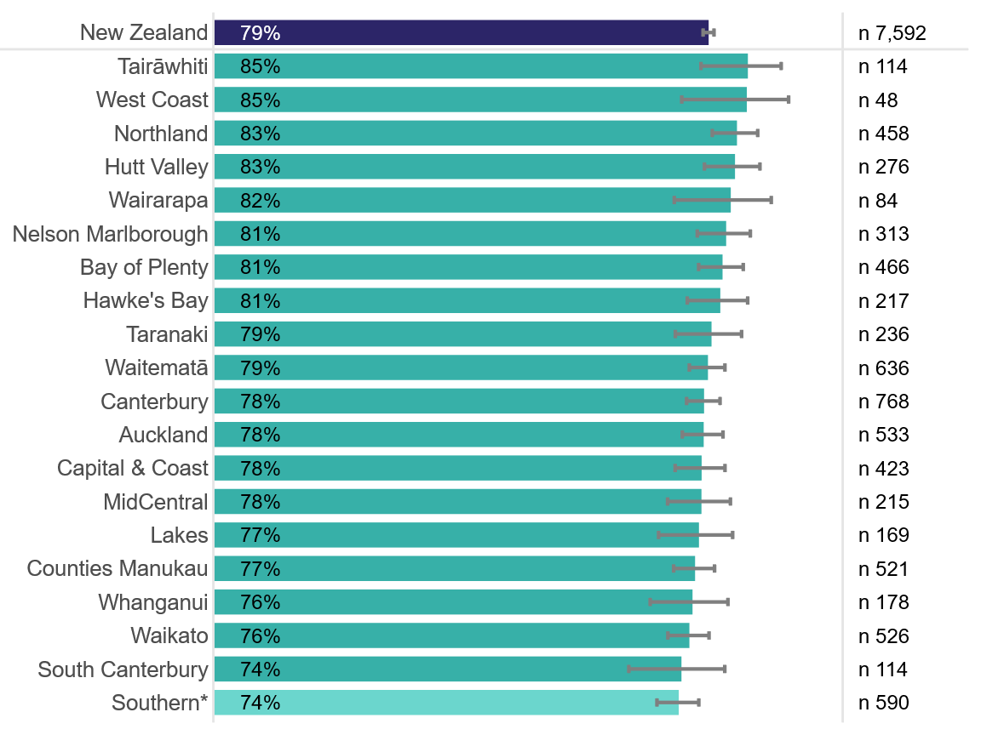

Figure 12: Listened to by emergency department health care professional (Percentage responding ‘Yes, definitely’ by demographics, May 2025)
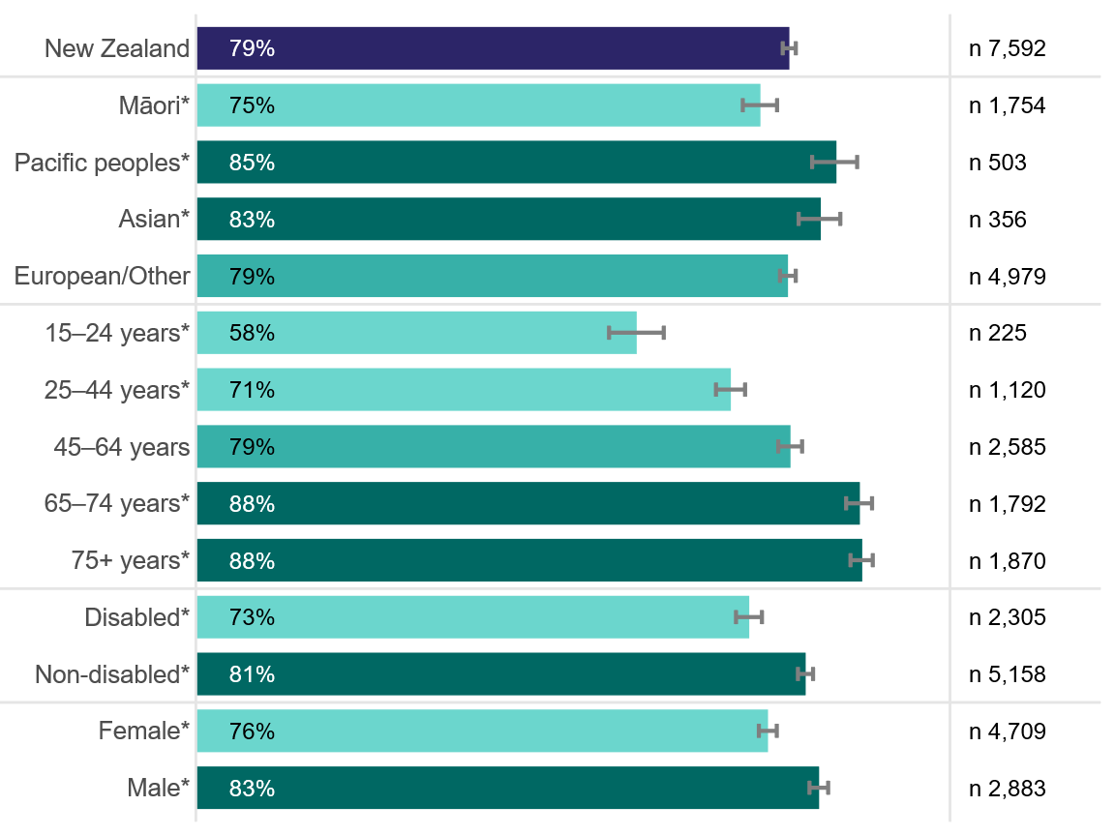

Views and concerns listened to: emergency department compared with general practice
This section presents results by demographic group and compares responses with responses to a similar question asked of the same cohort about their experience at general practice.
Overall, within cohorts, people reported a significantly more positive experience at their general practice than at the ED. Specifically, 78.7 percent of respondents responded ‘Yes, definitely’ to being listened to at the ED, compared with 90.9 percent at their general practice. The difference was particularly pronounced among young people; especially young Asian people and young females.
See information in ‘Interpreting the report’ on page 9 on how to interpret the heatmaps.
Figure 13: Listened to by health care professional (Percentage‑point difference between emergency department and general practice experience, by age and ethnicity, May 2025)
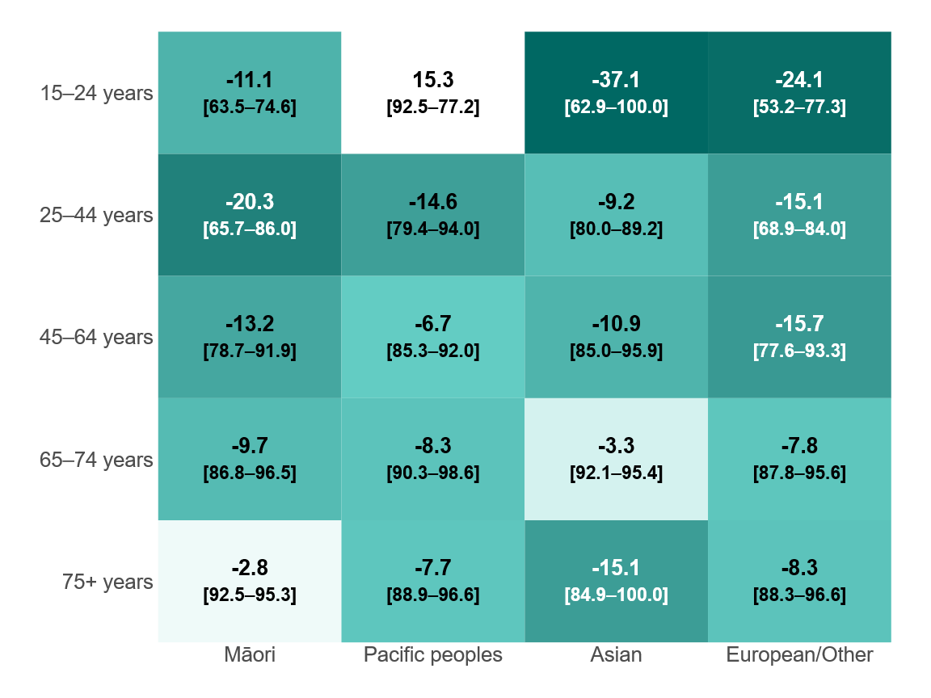
Note: Negative values indicate worse reported experience in ED. Percentages of respondents selecting the most positive response are shown in brackets (ED – general practice).
Figure 14: Listened to by health care professional (Percentage‑point difference between emergency department and general practice experience, by age and gender, May 2025)
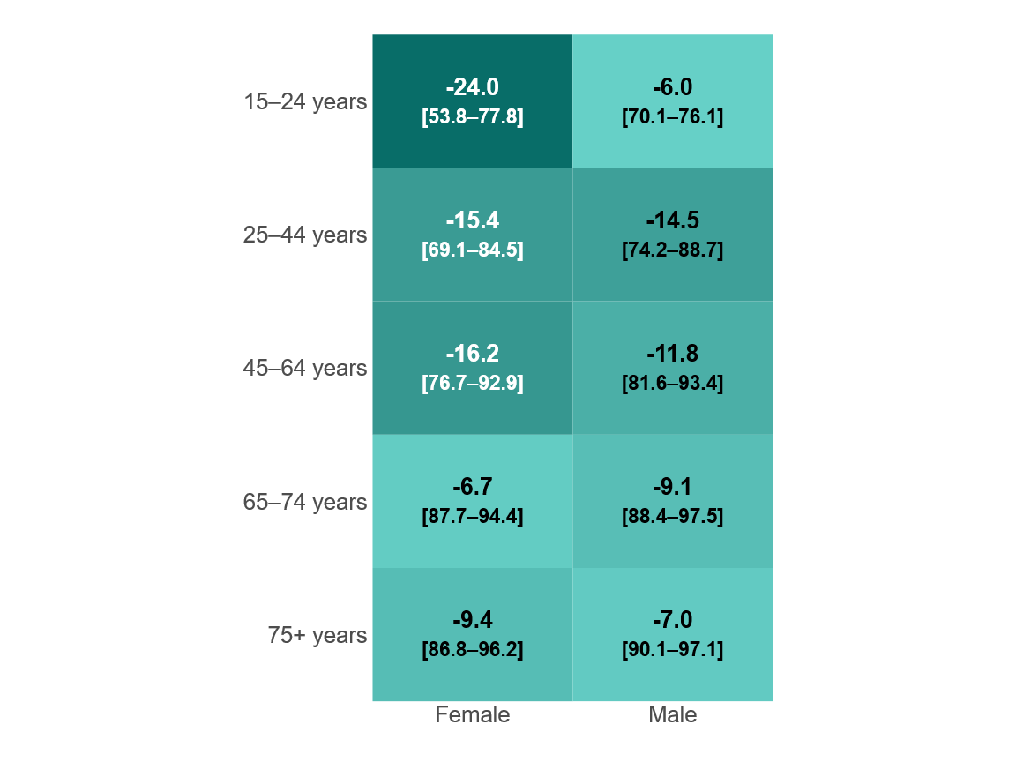
Note: Negative values indicate worse reported experience in ED. Percentages of respondents selecting the most positive response are shown in brackets (ED – general practice).
Figure 15: Listened to by health care professional (Percentage‑point difference between emergency department and general practice experience, by ethnicity and gender, May 2025)
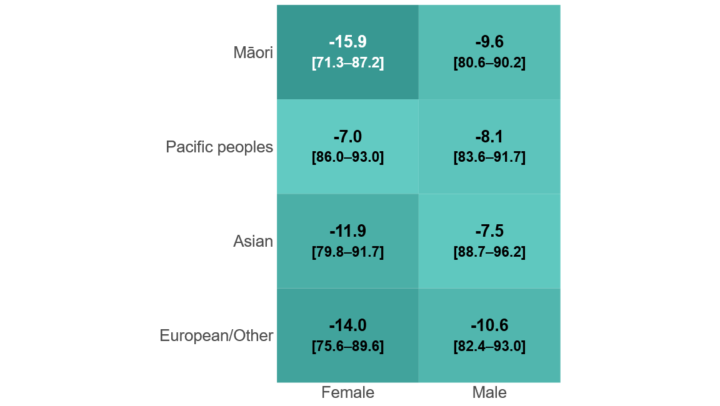
Note: Negative values indicate worse reported experience in ED. Percentages of respondents selecting the most positive response are shown in brackets (ED – general practice).

Did the emergency department health professionals involve you as much as you wanted to be in making decisions about your treatment and care?
A patient’s involvement in decisions about care and treatment to the extent they want it is a critical component of ensuring patients accept practitioners’ advice. Research shows that people who participate in decision-making about their health care report higher satisfaction with care; have higher knowledge of their health, tests and treatment; have more realistic expectations about benefits and harms; are more likely to adhere to screening, diagnostic or treatment plans; and have reduced decisional conflict and anxiety (Doyle et al 2013).
Figure 16: Involved in decisions about treatment and care at emergency department (Percentage responding ‘Yes, definitely’ by district)
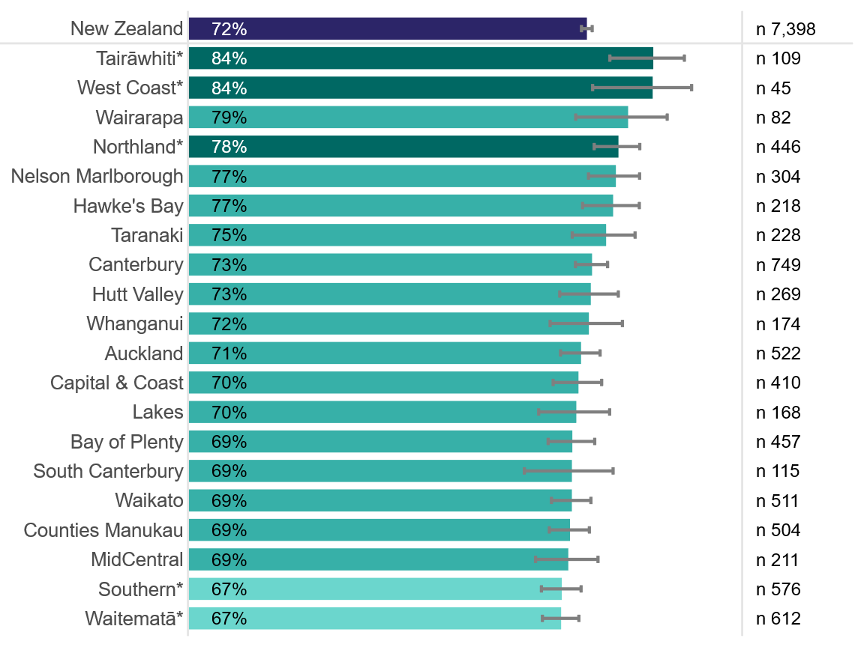
Figure 17: Involved in decisions about treatment and care at emergency department (Percentage responding ‘Yes, definitely’ by demographics)
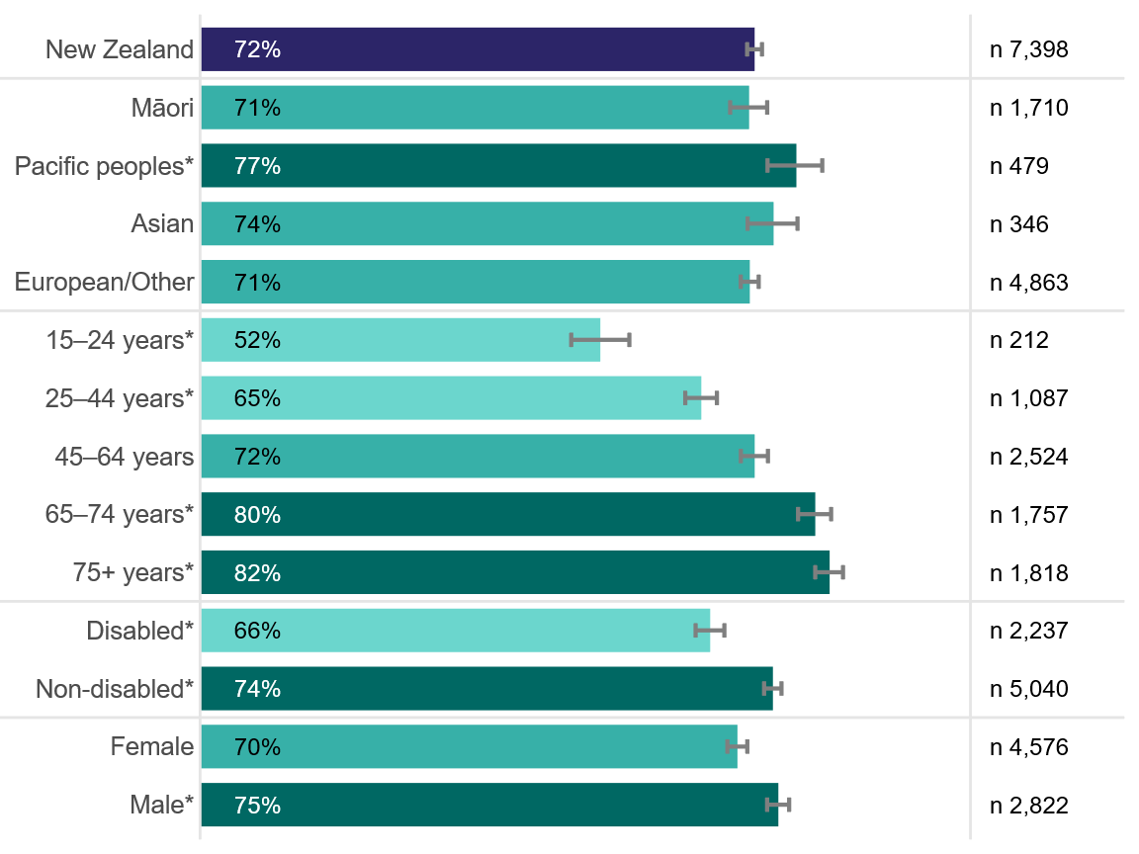

Involved in decisions about treatment and care: emergency department compared with general practice
This section presents results by demographic group and compares responses with responses to a similar question asked of the same cohort about their experience at general practice.
Overall, within cohorts, people reported a significantly more positive experience at their general practice than at the ED. Specifically, 72 percent of respondents responded ‘Yes, definitely’ to being involved in decisions about care and treatment at the ED, compared with 87.3 percent at their general practice. The difference was particularly pronounced among young people and females.
See information in ‘Interpreting the report’ on page 9 on how to interpret the heatmaps.
Figure 18: Involved in decisions about treatment and care (Percentage‑point difference between emergency department and general practice experience, by age and ethnicity, May 2025)
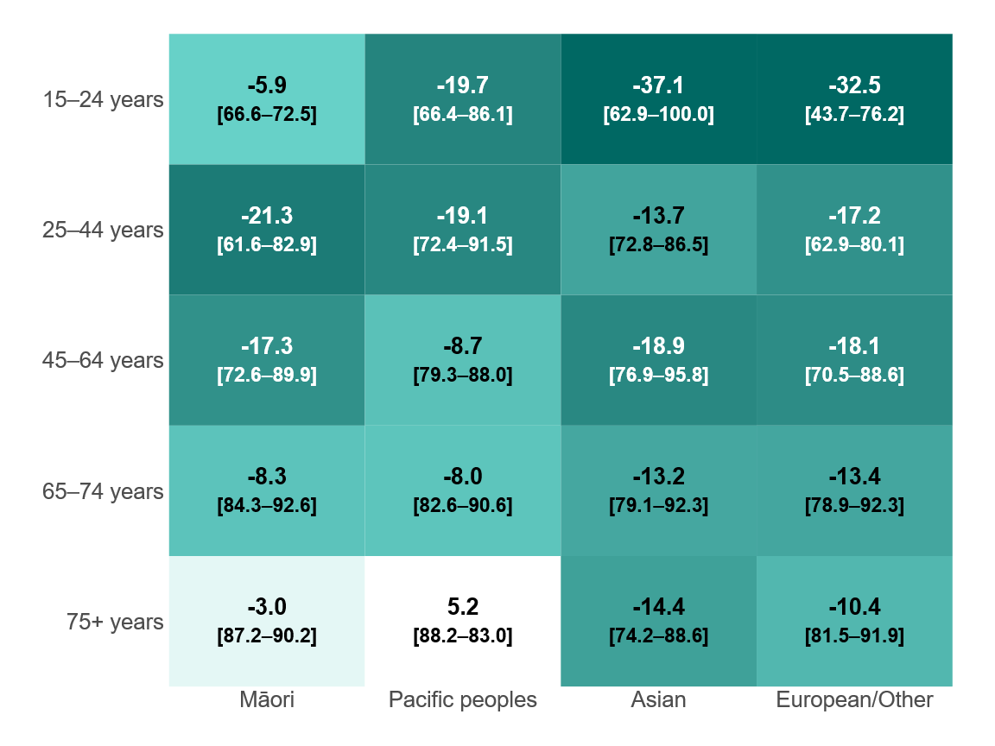
Note: Negative values indicate worse reported experience in ED. Percentages of respondents selecting the most positive response are shown in brackets (ED – general practice).
Figure 19: Involved in decisions about treatment and care (Percentage‑point difference between emergency department and general practice experience, by age and gender, May 2025)
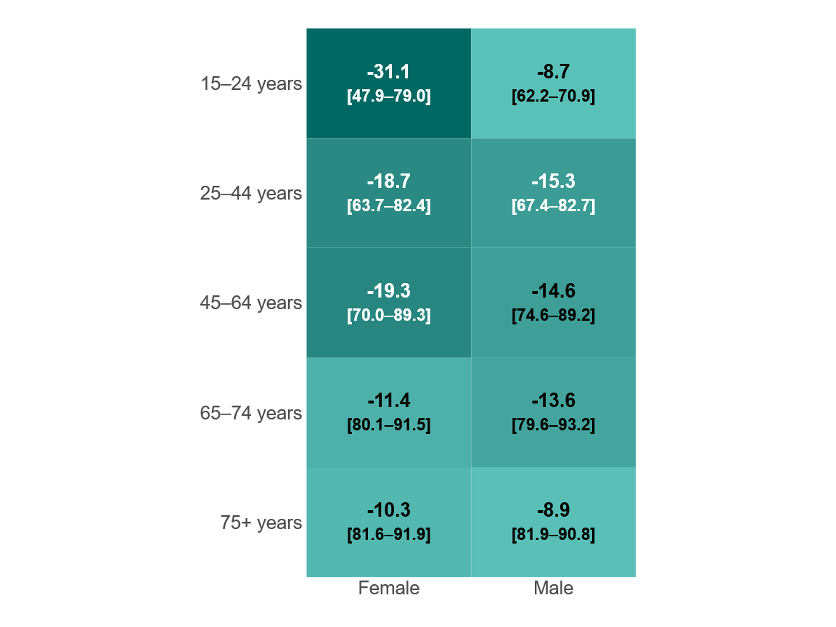
Note: Negative values indicate worse reported experience in ED. Percentages of respondents selecting the most positive response are shown in brackets (ED – general practice).
Figure 20: Involved in decisions about treatment and care (Percentage‑point difference between emergency department and general practice experience, by ethnicity and gender, May 2025)
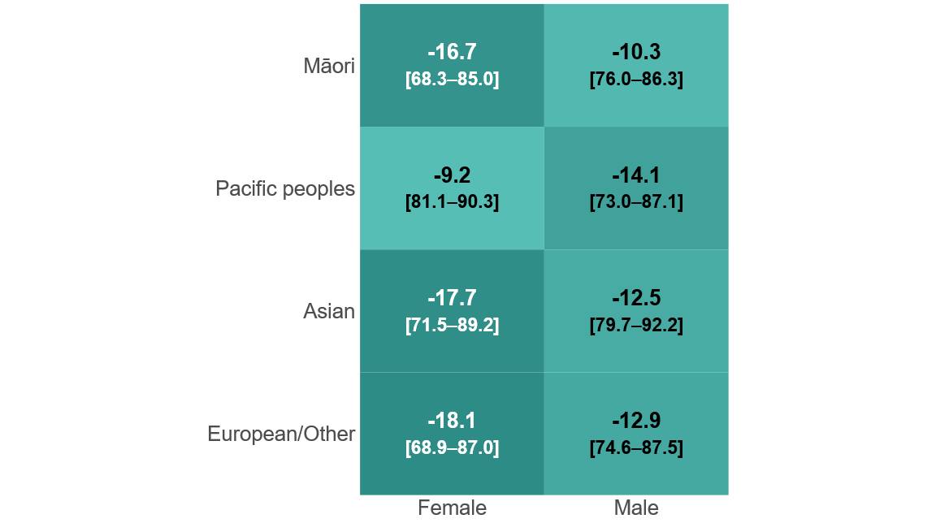
Note: Negative values indicate worse reported experience in ED. Percentages of respondents selecting the most positive response are shown in brackets (ED – general practice).

Did you have enough information about how to manage your condition or recovery after you left the emergency department?
This question aimed to determine whether the health care team ensured that people felt they had enough information to manage their health and recovery at home. This question is historically low scoring in the adult hospital inpatient experience survey. A project aiming to understand factors influencing how patients answer this question found four key factors that influenced responses:
- the quality of the explanation given
- the patient’s ability to absorb information
- a patient having unclear or unmet expectations about their condition or recovery
- the quality of follow-up care.
The Commission’s report on the project provides recommendations for improving discharge experience.
Figure 21: Had enough information to manage condition after leaving emergency department (Percentage responding ‘Yes, definitely’ across all districts)
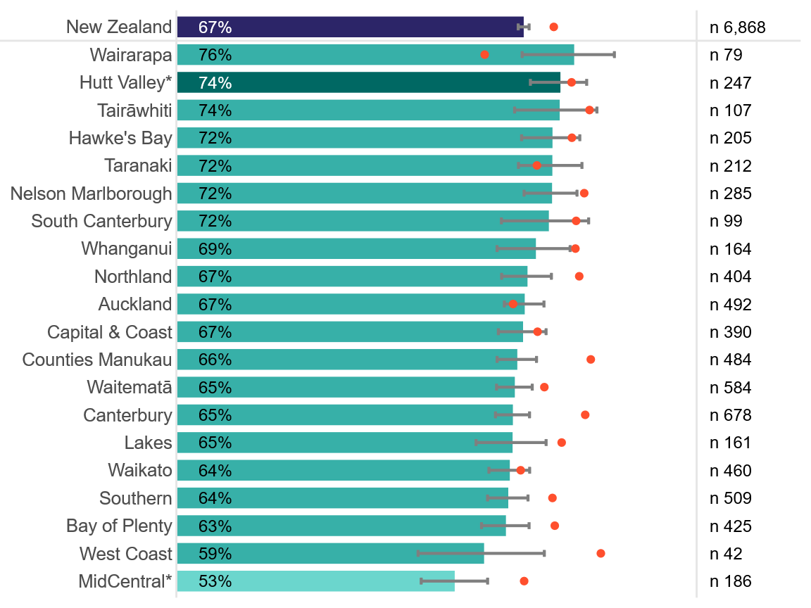
Note: Orange dots represent the responses to the same questions from hospital inpatients.
Figure 22: Had enough information to manage condition after leaving emergency department (Percentage responding ‘Yes, definitely’ by demographics)
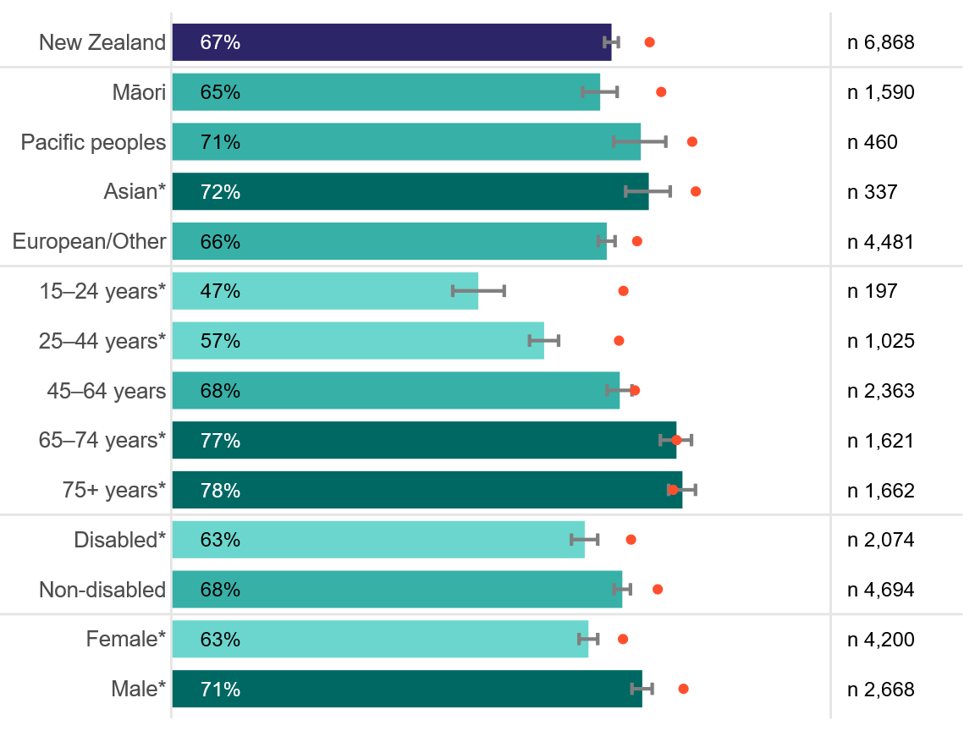
Note: Orange dots represent the responses to the same questions from hospital inpatients.

Had enough information to manage condition after discharge: emergency department compared with inpatient stay
This section presents results by demographic group and compares responses with responses to a similar question asked of people who participated in the May 2025 wave of the adult hospital inpatient experience survey.
Overall, people discharged from a hospital ward reported a significantly more positive experience than those discharged from an ED. Specifically, 66.8 percent of respondents responded ‘Yes, definitely’ to having enough information to manage their condition after leaving ED, compared with 72.5 percent after leaving a hospital ward. The difference was particularly pronounced among younger people.
See information in ‘Interpreting the report’ on page 9 on how to interpret the heatmaps.
Figure 23: Had enough information to manage condition after discharge (Percentage‑point difference between emergency department and inpatient stay experience, by age and ethnicity, May 2025)
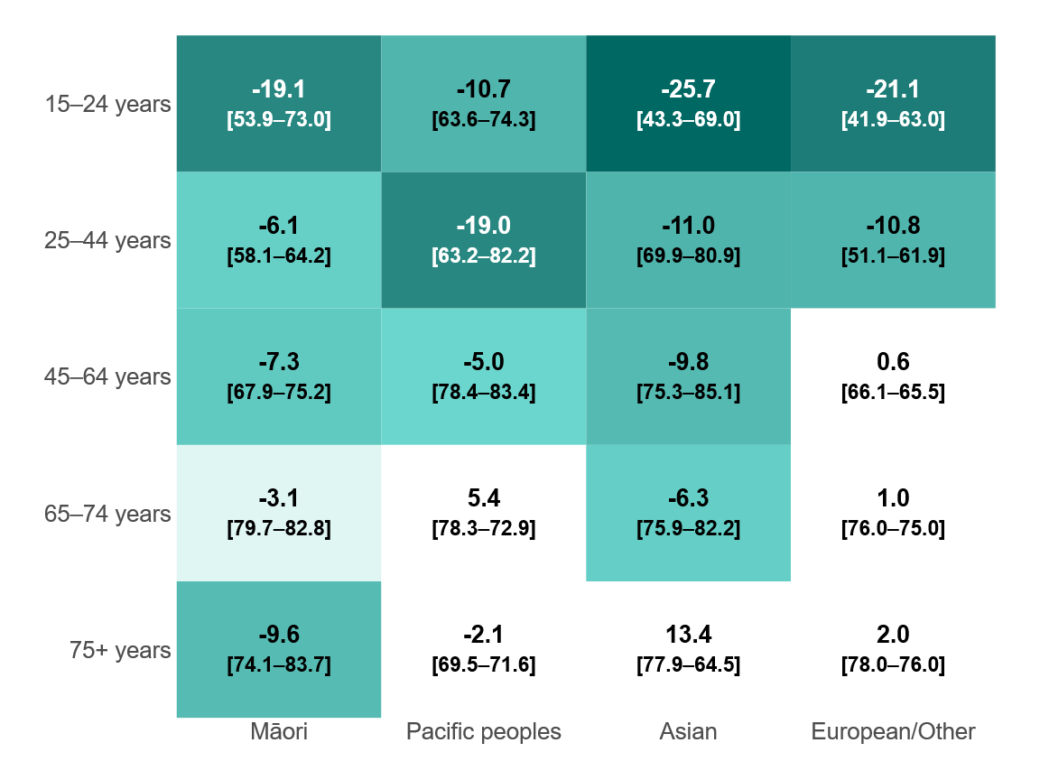
Note: Negative values indicate worse reported experience in ED. Percentages of respondents selecting the most positive response are shown in brackets (ED – inpatient stay).
Figure 24: Had enough information to manage condition after discharge (Percentage‑point difference between emergency department and inpatient stay experience, by age and gender, May 2025)
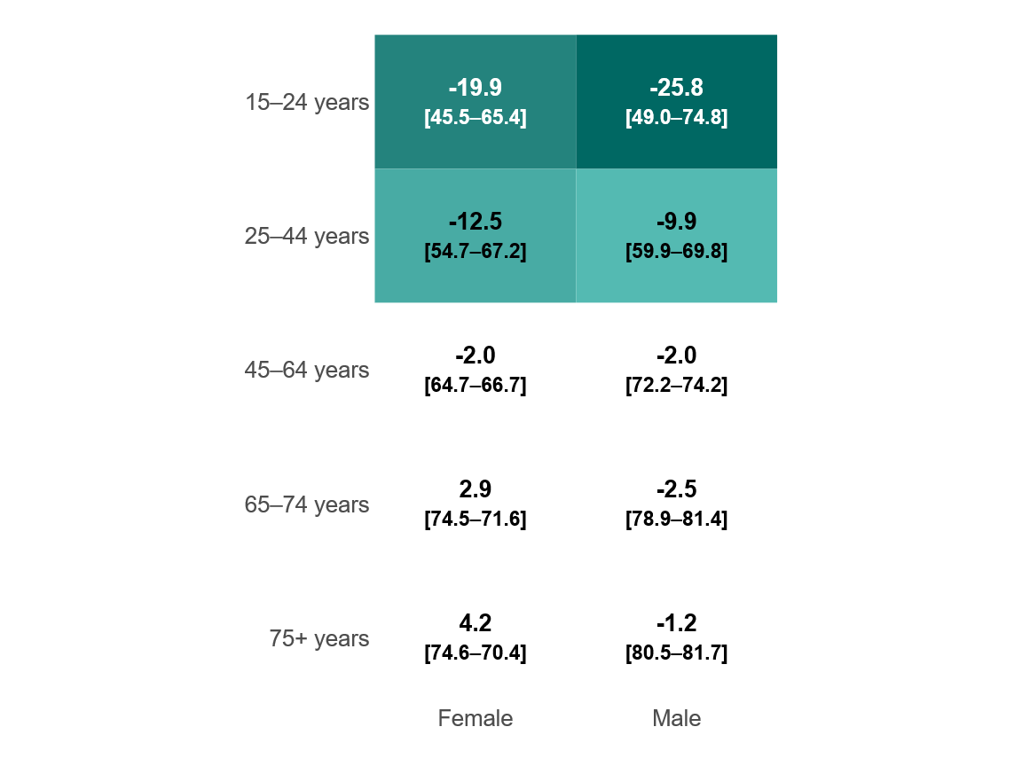
Note: Negative values indicate worse reported experience in ED. Percentages of respondents selecting the most positive response are shown in brackets (ED – inpatient stay).
Figure 25: Had enough information to manage condition after discharge (Percentage‑point difference between emergency department and inpatient stay experience, by ethnicity and gender, May 2025)
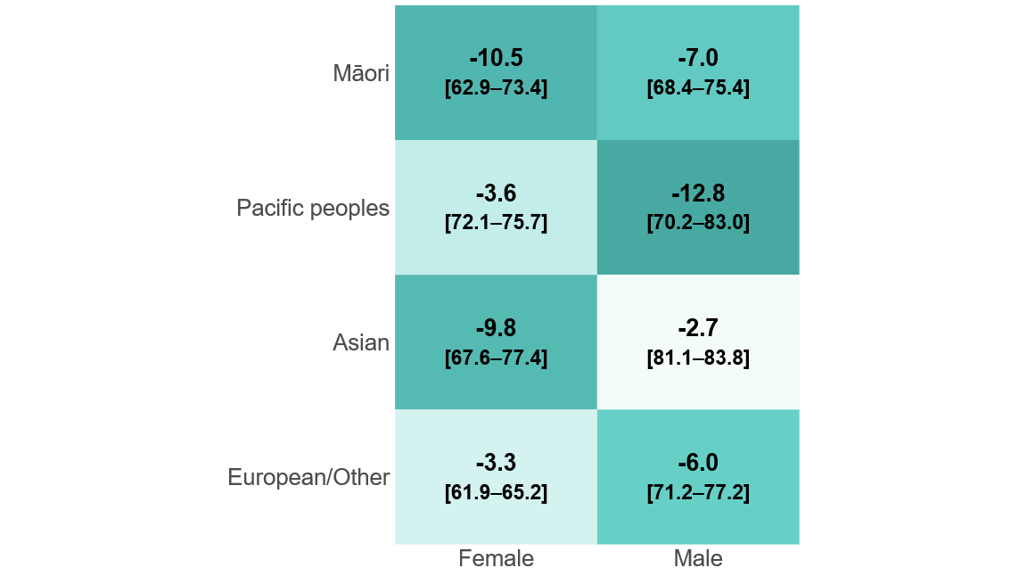
Note: Negative values indicate worse reported experience in ED. Percentages of respondents selecting the most positive response are shown in brackets (ED – inpatient stay).

Further information
The following information can be accessed on the Commission’s website:
- From PES to PDSA – Workbook: Using adult hospital inpatient experience survey data for quality improvement: hqsc.govt.nz/resources/resource-library/from-pes-to-pdsa-workbook-using-adult-hospital-inpatient-experience-survey-data-for-quality-improvement
- About the hospital patient experience surveys and questionnaire: hqsc.govt.nz/our-data/patient-reported-measures/patient-experience/about-our-patient-experience-surveys/adult-hospital-patient-experience-surveys
- About the primary care patient experience survey and questionnaire: hqsc.govt.nz/our-data/patient-reported-measures/patient-experience/about-our-patient-experience-surveys/adult-primary-care-patient-experience-survey/
- Methodology and procedures of the adult primary care patient experience survey: hqsc.govt.nz/resources/resource-library/adult-primary-care-patient-experience-survey-methodology-and-procedures/
- Privacy impact assessment report of the patient experience surveys: hqsc.govt.nz/resources/resource-library/patient-experience-surveys-privacy-impact-assessment-report

References
Anhang Price R, Elliott MN, Zaslavsky AM, et al. 2014. Examining the role of patient experience surveys in measuring health care quality. Medical Care Research and Review 71(5): 522–54.
Doyle C, Lennox L, Bell D. 2013. A systematic review of evidence on the links between patient experience and clinical safety and effectiveness. BMJ Open 3(1): e001570.
Janerka C, Leslie GD, Gill FJ. 2024. Patient experience of emergency department triage: An integrative review. International Emergency Nursing 74: 101456.
Kuehl S, Freeland A, Stanley J, et al. 2024. Almost one in five emergency department presentations are by mental health clients: A secondary data analysis. New Zealand Medical Journal 137(1595): 13–38.
Phillips KA, Ospina NS, Montori VM. 2019. Physicians interrupting patients. Journal of General Internal Medicine 34(10): 1965.
Price D, Edwards M, Davies F, et al. 2022. Patients’ experiences of attending emergency departments where primary care services are located: Qualitative findings from patient and clinician interviews from a realist evaluation. BMC Emergency Medicine 22(1): 12.

Appendix

Full question wording
Emergency department module question | Comparator question
from adult primary care patient experience survey
Did the emergency department staff you met on your arrival treat you with respect? | And on this occasion, did the reception and/or admin staff treat you with respect and kindness?
Did the emergency department health professionals treat you with respect? | Did the health care professional treat you with respect and kindness?
Did the emergency department health professionals listen to your views and concerns? | Did the health care professional listen to you?
Did the emergency department health professionals involve you as much as you wanted to be in making decisions about your treatment and care? | Did the health care professional involve you as much as you wanted to be in making decisions about your treatment and care?
from adult hospital inpatient experience survey
Did you have enough information about how to manage your condition or recovery after you left the emergency department? | Did you have enough information about how to manage your condition or recovery after you left hospital?

hqsc.govt.nz/our-data/patient-reported-measures
hqsc.govt.nz/our-data/patient-reported-measures/patient-experience/survey-results
hqsc.govt.nz/resources/resource-library/new-zealand-adult-primary-care-patient-experience-survey-questionnaire
More detailed information about the weighting methodology is available in the methods and procedures documents hqsc.govt.nz/resources/resource-library/adult-primary-care-patient-experience-survey-methodology-and-procedures/
See appendix.
HQSC. 2017. Raising the Bar on the National Patient Experience Survey: Report findings and recommendations. Wellington: Health Quality & Safety Commission Te Tāhū Hauora (HQSC). URL: hqsc.govt.nz/assets/Consumer-hub/Partners-in-Care/Publications-resources/Raising-the-bar-on-the-National-Patient-Experience-Survey-Final-REVIEWED-Report-19-05-2017.pdf (accessed 22 March 2026).

