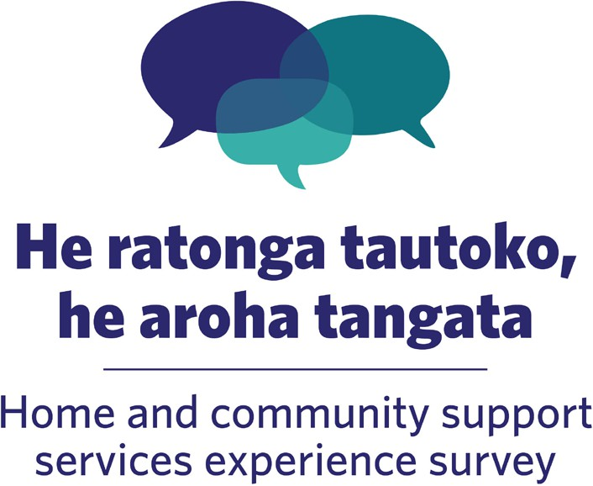

Home and community support services experience survey:
National results 2025
June 2026



Published June 2026 by Health Quality & Safety Commission Te Tāhū Hauora, PO Box 25496, Wellington, 6146.

ISBN 978-1-991122-48-3
Available online at hqsc.govt.nz
Enquiries to: info@hqsc.govt.nz

This work is licensed under the Creative Commons Attribution 4.0 International Licence (CC BY-NC-SA 4.0).
To view a copy of this licence, visit https://creativecommons.org/licenses/by-nc-sa/4.0


Contents
Background 5
Patient-reported measures programme 5
Introduction 6
Key findings 6
Related reports 8
Top three and bottom three scoring questions 9
Top three highest performing results 9
Bottom three lowest performing results 10
Interpreting this report 11
Results by theme 11
Tip: Interpreting confidence intervals 11
Tip: Low sample sizes 12
Survey reference period 12
Comparing results with other patient experience surveys 12
Results by theme 13
Theme 1: Effective communication 13
Theme 2: Effective scheduling 16
Theme 3: Treated with respect 19
Theme 4: Ease of contact 23
Case-mix adjusted survey results 27
Patient-reported outcome measure 31
Respondent profile 34
Who responded to the survey? 34
Response rates 35
Feedback on the survey 36
More information 36
Appendix 1: Participating providers 37
Appendix 2: Case-mix adjustment methodology 38

Figures
Figure 1: Listened to by support worker 13
Figure 2: Knew in advance what time to expect support 14
Figure 3: Knew who support worker would be in advance 14
Figure 4: Advised of changes in advance 15
Figure 5: Support arrived at expected time 16
Figure 6: No occasion when support did not turn up 16
Figure 7: Support times worked for people 17
Figure 8: Support workers had the necessary knowledge and skills 17
Figure 9: Why support workers lacked necessary knowledge and skills 18
Figure 10: Name pronounced properly 19
Figure 11: Treated with respect and kindness 19
Figure 12: Culture respected 20
Figure 13: Spirituality and beliefs respected 20
Figure 14: Able to attend activities 21
Figure 15: Needs assessment includes support to attend activities 21
Figure 16: Asking questions or requesting changes 23
Figure 17: Got help or change needed 23
Figure 18: Would raise a concern or complaint 24
Figure 19: Why not raise a concern or complaint 24
Figure 20: Did raise a concern or complaint 25
Figure 21: Concern or complaint taken seriously 26
Figure 22: Case-mix adjusted results for anonymised providers, selected questions 29
Figure 23: Prevalence of reported problems across EQ-5D-5L dimensions among HCSS respondents 31
Figure 24: Prevalence of reported problems with each EQ-5D-5L dimension among HCSS respondents by age 32
Figure 25: Prevalence of reported problems with each EQ-5D-5L dimension among respondents aged 65–74: comparison between surveys 32
Figure 26: Survey performance feedback 36
Figure 27: Case-mix adjusted results by demographic variables and groups, selected question 40

Tables
Table 1: Percentage of people who selected the most positive response to each question by demographic variables and groups (rows) and survey questions (columns) 7
Table 2: Case-mix adjusted results for providers, by provider variation and statistically significant difference detected (rows) and survey questions (columns) 28
Table 3: Summary demographics 34
Table 4: Percentage of those invited who responded to the survey by ethnicity and invitation method (count of those who responded in brackets) 35
Table 5: Percentage of those invited who responded to the survey by age group (count of those who responded in brackets) 35

Background
Regularly and consistently capturing patient- and client-reported measures using valid, reliable and robust methods, including experience of care, provides a good indicator of the quality of health services. Feedback helps drive quality improvement to deliver better care and mitigate inequity across all levels of the health system.
The Ngā paerewa Health and disability services standard, the code of expectations for health entities’ engagement with consumers and whānau and requirements in funder contracts raise the expectations that providers regularly capture and act on consumer feedback. This includes using experience data to inform improvements in health services with a focus on reducing health inequities, particularly for Māori, Pacific peoples and disabled people. Consumers are expected to be involved in the design, delivery and evaluation of health services.
The Health Quality & Safety Commission Te Tāhū Hauora (the Commission) is mandated under Part 3 Subpart 3 of the Pae Ora (Healthy Futures) Act 2022 ‘to lead and co-ordinate work across the health sector for the purposes of monitoring and improving the quality and safety of services’.

Patient-reported measures programme
We collect patient-reported measures through validated and standardised surveys, which enable systematic collection, analysis and reporting. We use information gathered at local, regional and national levels to benchmark across the country, supporting improvements in services locally.
Our patient-reported measures programme is one of the largest public survey programmes in New Zealand. The programme consists of three national quarterly surveys: the adult hospital inpatient experience survey, the adult hospital outpatient experience survey and the adult primary care patient experience survey. These surveys gather feedback from around 50,000 patients every quarter. We report survey results publicly on our website and privately to providers on a secure website. We report results by ethnic group, age group, gender and disability status. The collection of information on disability status is particularly important as this information is often missing from national reporting and gives important insights into the experience of disabled people.
The Patient Reported Measures Steering Group (the Steering Group) oversees this programme and provides us with independent advice. This includes ensuring the results of the surveys are best used to improve health service delivery at local, regional and national levels. The Steering Group also provides governance on the collection, storage, access and use of the survey data.
In 2023, we expanded the programme to include development of a new annual survey on the experiences of people receiving home and community support services (the home and community support services experience survey, HCSS survey).

Introduction
The aim of the home and community support services experience survey (HCSS survey) is to capture people’s experiences of their home and community support services. The survey intends to help HCSS providers understand how well they are meeting people’s needs and how they can improve their services.
We developed the survey in partnership with the Home and Community Health Association, the New Zealand Health Group and HCSS providers that opted to participate. Additional funding was provided by Health New Zealand | Te Whatu Ora. The results offer useful insights for participating providers and their clients, as well as for funders, policy makers and advocates.
The survey started in 2024 and is run annually. We developed the questionnaire in partnership with consumers and providers. Themes for the questionnaire were informed by the Ngā paerewa Health and disability services standard, the National Framework for Home and Community Support Services and the principles of the Ministry of Health Manatū Hauora's approach to supporting disabled people, Enabling Good Lives. The survey covers different parts of the home and community support service experience, including scheduling, communication, partnership, coordination, physical and emotional needs and cultural safety.
In the first year (2024), 16 providers chose to participate. These providers sent around 23,000 invitations to the survey to their clients. They received responses from 5,517 people. In the second year, 15 providers participated, nearly 28,000 invitations were sent to clients and 6,545 responses were received. Appendix 1 lists participating providers in the first two years of the survey.

Key findings
Results from the second year of the survey were largely consistent with those from the first. Responses to only two questions showed a statistically significant change at the national level: a reduction between 2024 and 2025 for ‘support arrived at expected time’ (of 3 percent) and a reduction for ‘able to attend activities’ (of 4 percent).
The highest-scoring questions in the 2025 survey related to people being treated with respect; the lowest-scoring related to communication and scheduling. The highest- and lowest-scoring questions were largely unchanged between 2024 and 2025.
Overall, people in the 2025 survey, as in 2024, reported that services and support were provided in an inclusive way that respected their identity and circumstances. Areas identified for improvement were communication, being able to contact providers, and scheduling.
Table 1 presents overall results from the 2025 HCSS survey.
Table 1: Percentage of people who selected the most positive response to each question by demographic variables and groups (rows) and survey questions (columns)
 |  | Effective communication |  |  |  | Effective scheduling |  |  |  | Treated with respect |  |  |  |  | Ease of contact
 |  | Listened to by support worker | Knew in advance what time to expect support | Knew who support worker would be in advance | Advised of changes in advance | Support arrived at expected time | No occasion when support did not turn up | Support times worked for people | Support workers had the necessary knowledge and skills | Name pronounced properly | Treated with respect and kindness | Culture respected | Spirituality and beliefs respected | Able to attend activities | Got help or change needed | Concern or complaint taken seriously
New Zealand 2025 |  | 76 | 50 | 52 | 42 | 54 | 81 | 59 | 73 | 89 | 90 | 94 | 92 | 28 | 68 | 52
New Zealand 2024 |  | 76 | 53 | 54 | 40 | 57 | 81 | 61 | 75 | 90 | 90 | 94 | 93 | 32 | 66 | 53
Ethnicity | Māori | 82 | 65 | 65 | 50 | 67 | 80 | 68 | 77 | 90 | 91 | 91 | 90 | 25 | 65 | 53
 | Pacific peoples | 75 | 66 | 65 | 49 | 53 | 74 | 62 | 71 | 83 | 88 | 88 | 91 | 28 | 60 | 46
 | Asian | 73 | 59 | 60 | 53 | 60 | 81 | 64 | 74 | 86 | 87 | 88 | 88 | 18 | 72 | 52
 | European/Other | 75 | 48 | 49 | 40 | 52 | 81 | 58 | 73 | 89 | 90 | 95 | 93 | 29 | 68 | 52
Disability | Disabled | 74 | 50 | 51 | 41 | 53 | 80 | 58 | 72 | 89 | 89 | 93 | 91 | 20 | 66 | 51
Age | Under 65 | 76 | 63 | 64 | 44 | 66 | 76 | 66 | 73 | 90 | 88 | 92 | 91 | 26 | 64 | 50
 | 65 years or over | 75 | 48 | 49 | 41 | 52 | 81 | 58 | 73 | 89 | 90 | 94 | 92 | 28 | 69 | 53
Top three highest (1, 2, 3) and bottom three lowest scoring (12, 13, 14) questions 2025 |  |  | 13 | 12 | 14 |  |  |  |  |  | 3 | 1 | 2
A green cell indicates that the result is significantly higher than the 2025 national result; a red cell indicates a significantly lower result.
This update presents case-mix adjusted (expected) results for providers. These show little variation across questions, indicating that once differences in client mix are accounted for, providers are expected to have broadly similar outcomes. Actual results show much wider provider variation than expected results, particularly across the themes of communication, contact and scheduling. For example, actual results recording a response of ‘yes, always’ to ‘knew who support worker would be in advance’ ranged from 14 to 96 percent. This contrasts sharply with the range for expected results (50–65 percent).
We also undertook a detailed case‑mix analysis of demographic variables and groups. This analysis found that while differences in population composition (statistical confounding) can affect comparisons between demographic groups, the estimated impact of that on the observed differences is small for most questions. This indicates that the 2025 survey results summarised in Table 1 above, and the detailed results presented in the ‘Results by theme’ section of this report, provide a reliable basis for insights and interpretation.
In 2025, we introduced a patient-reported outcome measure, EQ-5D-5L, into the survey questionnaire. The EQ-5D-5L is a generic measure of self-reported health in five dimensions: mobility, self-care, usual activities, pain/discomfort and anxiety/depression. National results show a high prevalence of reported problems across the EQ-5D-5L dimensions among HCSS client respondents. Respondents reported the most problems with carrying out usual activities and the fewest problems with anxiety/depression. The prevalence of reported problems increased with age for mobility, self-care, usual activities and pain/discomfort and decreased with age for anxiety/depression.
These results provide valuable insights into which groups may benefit from targeted improvement efforts. They also suggest that there is an opportunity to learn from groups or providers whose outcomes are consistently higher than expected or above the benchmark, particularly in the context of accessibility, communication and support processes.
As in the first year of the survey, we have separately shared the results from the second year with the participating HCSS providers, who can then compare their organisations’ results to national results. We developed these reports to help providers understand what they are doing that benefits their clients the most and to identify where opportunities exist for improvement. The reports also support HCSS providers to understand how well the care they are providing links to best practice.

Related reports
The following documents can be accessed on our website:
Methodology and procedures: hqsc.govt.nz/resources/resource-library/hcss-experience-survey-methodology-and-procedures
Survey questionnaire: hqsc.govt.nz/resources/resource-library/new-zealand-home-and-community-support-services-experience-survey-questionnaire
Privacy impact assessment: hqsc.govt.nz/resources/resource-library/home-and-community-support-services-experience-survey-privacy-impact-assessment-report

Top three and bottom three scoring questions
Results are reported as the percentage of people who selected the most positive response to each question, representing the best-case scenario for them. The number of people who answered the question is also shown (n).

Top three highest performing results
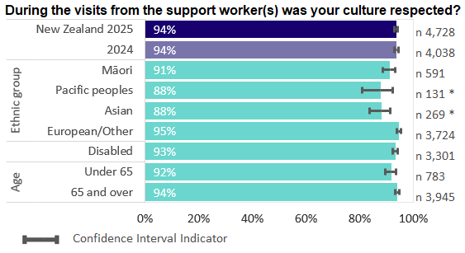
Note: An asterisk means the result is significantly different from the 2025 national result.
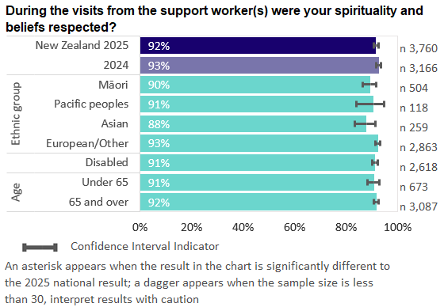
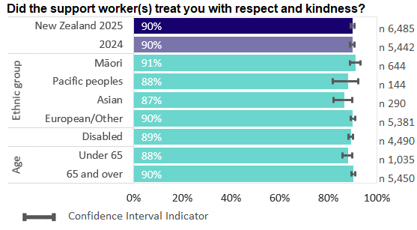

Bottom three lowest performing results
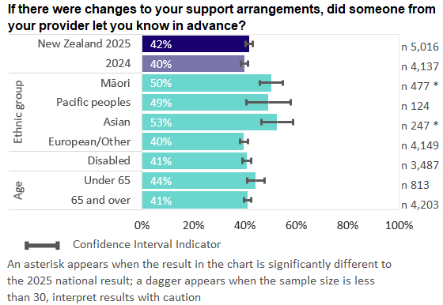
Note: An asterisk means the result is significantly different from the 2025 national result.
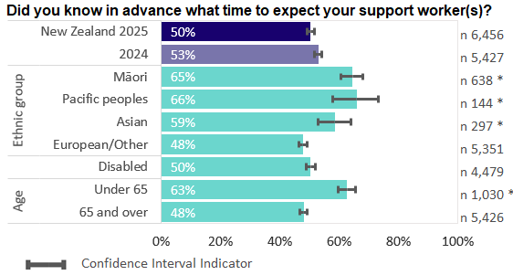
Note: An asterisk means the result is significantly different from the 2025 national result.
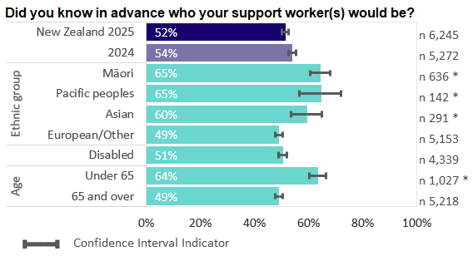
Note: An asterisk means the result is significantly different from the 2025 national result.

Interpreting this report

Results by theme
The ‘Results by theme’ section of this report presents results from the 2025 survey for each question by ethnic group; by disability status; and for clients aged under 65 and 65 years or over. It includes the 2024 and 2025 national results. Where differences are statistically significant from the 2025 national result, this is indicated by an asterisk.

Interpreting differences between demographic groups
In this report, demographic variables are age, gender, ethnicity and disability status. Demographic groups mean specific groups within these demographic variables. For example, for the demographic variable ethnicity, the groups are Māori, Pacific peoples, Asian and European/Other.
In both the 2024 and 2025 surveys, Māori, Pacific and Asian respondents were younger on average, and older clients were more likely to have a disability. In addition, we noticed a trend for younger people to answer some questions more positively, and disabled people to answer less positively. This can cause an issue when interpreting group results, known as statistical confounding. It is caused by the combination of variations in population characteristics between the groups (such as age) and the link between the same population characteristics and the outcome. For example, we would naturally expect Māori, Pacific and Asian groups to rate their experiences more positively on average, as these groups have a younger respondent profile.
Our detailed analysis, described in ‘Case-mix adjusted survey results’ later in this report, found that while statistical confounding can affect comparisons between demographic groups, its estimated impact on the observed differences (for example, comparisons between Māori and European/Other) was small for most questions.

Defining ethnic group
Ethnic group is collected and reported in accordance with the Ethnicity New Zealand Standard Classification 2005 V2.1.0 and the HISO 10001:2017 Ethnicity Data Protocols. A person’s ethnic group is determined by self-report in the survey.
If self-reported ethnicity is unknown, ethnic group is based on what is recorded in the provider’s client sample file.
This report uses a prioritised classification of ethnic group. This means that people who report identification with more than one ethnic group are counted only in one of those groups, in the prioritised order of Māori, Pacific peoples, Asian and European/Other.

Defining disability status
Survey respondents are asked two sets of questions about whether they are disabled: the Washington Group Short Set on Functioning (WG-SS) and a self-identified question. A person is classified as being disabled if they indicate they could not do, or would have a lot of difficulty doing, any of the six activities included in the WG-SS, or if they self-identify as disabled.

Tip: Interpreting confidence intervals
Confidence intervals give a range of values that are used to estimate the true value. For this report, the confidence intervals are calculated at 95 percent confidence level. This means we are 95 percent confident that the true value lies somewhere within the given range. If the lower or upper limits do not overlap with other groups, the difference is considered statistically significant.

Tip: Low sample sizes
When the sample size is fewer than 30 respondents, interpret results with caution, because there may be more random variation in the results – as reflected by the wider confidence intervals.

Survey reference period
The survey questions ask about people’s experience of their home and community support services over the four-week reference period before they completed the survey (questions asked people ‘in the last four weeks …’).

Comparing results with other patient experience surveys
Some of the questions included in this survey are similar to those in the adult hospital inpatient experience survey and the adult primary care patient experience survey. Where this is the case, we have included weighted results from these surveys for the four 2025 survey reporting rounds combined for benchmarking purposes, acknowledging that the care context is very different. Note that the HCSS survey does not have survey weights.
Results for these surveys are available on our website.

Results by theme
The survey questions and themes for reporting were informed by the Ngā paerewa Health and disability Services Standard and the principles of Enabling Good Lives. Responses to the questions are reported under four main themes:
1. effective communication
2. effective scheduling
3. treated with respect
4. ease of contact.

Theme 1: Effective communication
Questions under this theme seek to understand the quality of communication from providers to clients. Effective communication was one of the most common themes emerging from people’s responses to open-ended questions about what would have made their support service better. Effective communication means that people receiving services feel listened to and that what they say is valued. It means service providers ensure communication is clear and open. Effective communication is essential for a functional partnership. Figures 1–4 present results to questions about effective communication.
Figure 1: Listened to by support worker
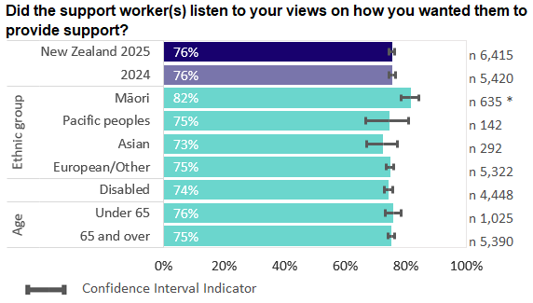
Note: An asterisk means the result is significantly different from the 2025 national result.
Seventy-six percent of people reported that, in the last four weeks, their support workers always listened to their views on how they wanted those support workers to provide support, with no change between 2024 and 2025.
A similar question is asked in the adult hospital inpatient experience survey and the adult primary care patient experience survey. HCSS clients responded less positively than hospital inpatients (among whom the reported percentage for views and concerns always listened to was 85 percent for doctors, 85 percent for nurses and 84 percent for other members of the health care team) and primary care patients (93 percent reported that their health care professional definitely listened to them). This may reflect the different context in which care is provided for HCSS clients compared with other health services.
Figure 2: Knew in advance what time to expect support
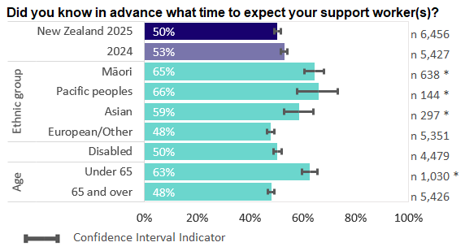
Note: An asterisk means the result is significantly different from the 2025 national result.
Fifty percent of people reported that in the last four weeks they always knew in advance what time to expect their support worker(s). Responses to this question varied between providers, from 29 to 88 percent.
Figure 3: Knew who support worker would be in advance
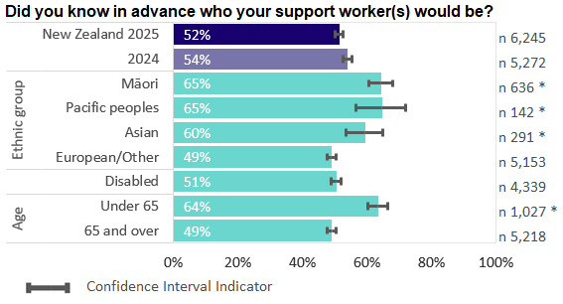
Note: An asterisk means the result is significantly different from the 2025 national result.
Fifty-two percent of people reported that in the last four weeks they always knew in advance who their support worker(s) would be. Responses to this question varied widely by provider. For the lowest-scoring provider, only 19 percent of their clients reported always knowing in advance who their support worker would be, compared with 96 percent for the highest-scoring provider.
Figure 4: Advised of changes in advance
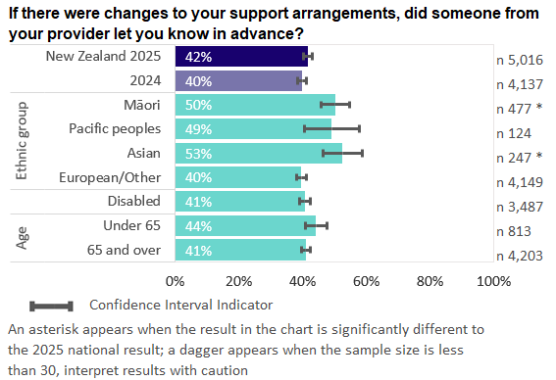
Note: An asterisk means the result is significantly different from the 2025 national result.
If changes had been made to their support arrangements in the last four weeks, 42 percent of people reported their providers always let them know in advance. This includes, for example, being informed ahead of time if the support time was changed, that the support worker could not make it or that the support worker would be a different person.
The denominator excludes people who did not have changes to their support arrangements in the past four weeks.

Qualitative comments about effective communication
Effective communication was one of the most common themes that emerged in response to the survey’s open-ended questions. Elements of effective communication that were mentioned included:
access to rosters
being informed about schedule changes
internal communication between coordinators and support workers
being listened to
language barriers between support workers and clients.

Theme 2: Effective scheduling
Questions on effective scheduling asked about the degree to which the scheduling and delivery of support was person-centred and tailored to needs over the four-week reference period. Part of providing respectful support includes support workers arriving as expected and on time and support being delivered in a way that meets people’s specific needs. Disruption and cancellations should be minimised. People providing support need to be appropriately informed about what support is required and how to provide it. Figures 5–9 present results on questions relating to effective scheduling.
Figure 5: Support arrived at expected time
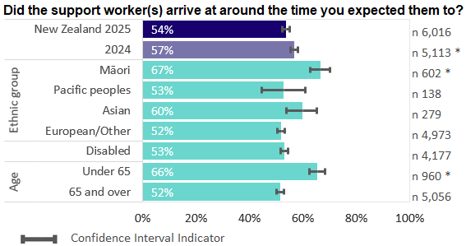
Note: An asterisk means the result is significantly different from the 2025 national result.
Fifty-four percent of people reported that in the last four weeks their support workers always arrived at around the time expected. This question was only asked of those who had previously answered that, in the past four weeks, they always, usually or sometimes knew in advance when to expect their support workers. For clients of the highest-scoring provider, this happened 84 percent of the time, compared with 37 percent of clients with the lowest-scoring provider.
Figure 6: No occasion when support did not turn up
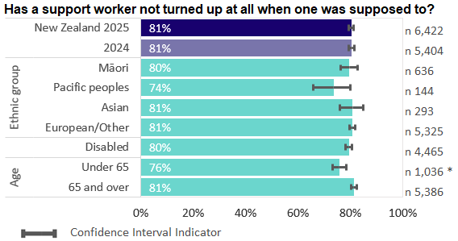
Note: An asterisk means the result is significantly different from the 2025 national result.
Eighty-one percent of people reported that in the last four weeks there was no occasion when their support worker did not turn up when supposed to. This means that 19 percent, around one in five people, experienced a time when their support worker did not turn up when supposed to.
A common reason why this might occur is that the usual support worker is unavailable, either through planned or unplanned leave. We encourage providers to understand what their absence rate is and what processes they have in place to manage unplanned absences.
Figure 7: Support times worked for people
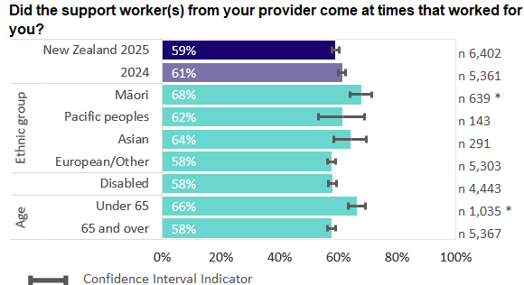
Note: An asterisk means the result is significantly different from the 2025 national result.
Fifty-nine percent of people reported that in the last four weeks their support workers always came at times that worked for them.
The wording of this question was framed to find a balance between the times of day that people needed support and the constraints within which providers were working. Although providers may not always be able to deliver support at times that work for people, this represents a gap at a national level.
Figure 8: Support workers had the necessary knowledge and skills
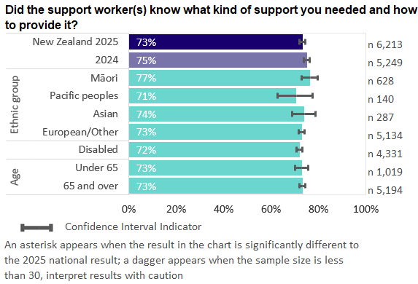
Seventy-three percent of people reported that in the last four weeks their support workers always knew what kind of support they needed and how to provide it. For example, support workers knew what was in people’s support plans and had the right skills and training.
Note: In the 2025 survey question instruction, ‘care plan’ was changed to ‘support plan’ for consistency with the new follow-up question (see ‘Why support workers lacked necessary knowledge and skills’ below).
Figure 9: Why support workers lacked necessary knowledge and skills
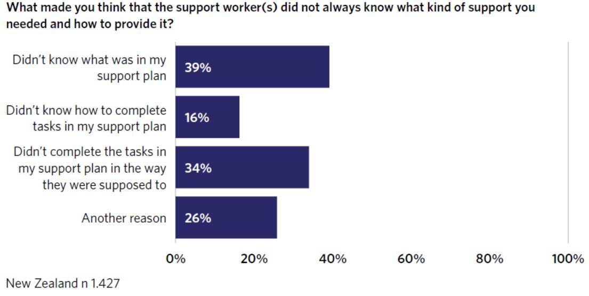
This is a new closed-ended multiple response question to replace the 2024 open-ended qualitative question, with the intention of making it easier both to respond to the survey and to interpret the results. The response option categories in 2025 were based on the open-ended comments we received in 2024.
This question was only asked if the response to the preceding survey question ‘Did the support worker(s) know what kind of support you needed and how to provide it?’ was ‘Usually’, ‘Sometimes’ or ‘No, never’.
Most people who answered this question selected a single response option. Only around one in ten selected more than one response.

Qualitative comments about effective scheduling
The timing and standard of support provision was a common theme in response to the open-ended questions. Elements of effective scheduling that clients noted included:
reliable support
regular support workers and regular times
consideration of travel time for support workers
the fact that, while regular support workers tended to know what kind of support was needed and how to provide it, new or relief workers did not
the need for pre-preparation for support workers, in terms of reading care plans and receiving briefing from coordinators
scheduling that enables social participation
the standard of support provided and tasks completed.

Theme 3: Treated with respect
Questions around this theme provide indicators of people being treated with respect; that is, of services and support being provided in an inclusive way that respects people’s identity and circumstances. Correct name pronunciation is an aspect of this; it is important for building trust and respect and providing culturally safe care. Figures 10–15 present results relating to being treated with respect.
Figure 10: Name pronounced properly
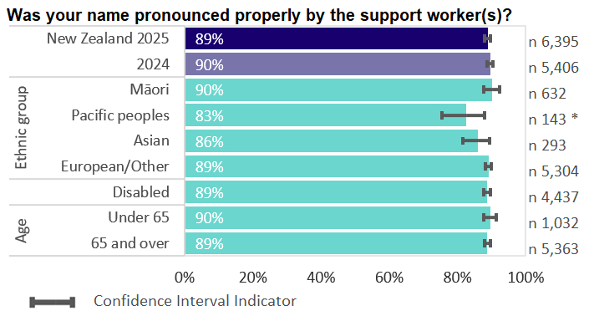
Note: An asterisk means the result is significantly different from the 2025 national result.
The most positive responses to this question were ‘Yes, always’ and ‘They addressed me appropriately without using my name’.
Eighty-nine percent of people reported that in the past four weeks their support worker(s) had either always pronounced their name properly or addressed them appropriately without using their name. While this was one of the high-scoring questions, it does mean that 11 percent did not always have their name pronounced properly or were not always addressed appropriately.
This compares favourably with responses to the adult hospital inpatient experience survey, where 89 percent of people responded ‘yes, always’ to this question, and less favourably with responses to the adult primary care patient experience survey, where 95 percent of respondents answered ‘yes, always’.
Figure 11: Treated with respect and kindness
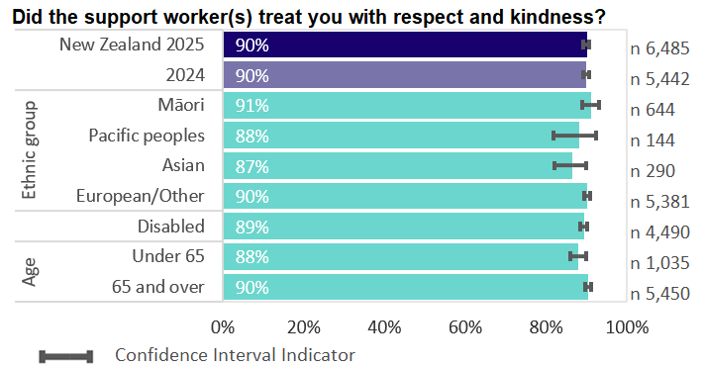
Ninety percent of people reported that in the last four weeks their support workers had always treated them with respect and kindness. While this appears high overall, it highlights that one in ten people did not always feel they were treated with respect and kindness.
A similar question is asked in the adult hospital inpatient experience survey and the adult primary care patient experience survey. HCSS clients responded similarly to hospital inpatients (among whom 92 percent reported that they were definitely treated with respect and kindness by doctors, 91 percent by nurses and 91 percent by other members of the health care team), and slightly less positively than primary care patients (96 percent reported that their health care professional definitely treated them with respect and kindness).
Figure 12: Culture respected
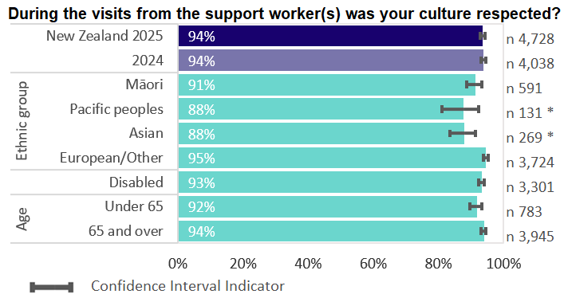
Note: An asterisk means the result is significantly different from the 2025 national result.
Ninety-four percent of people reported that during visits from support workers in the last four weeks their culture was always respected. The denominator excludes people who responded that the question did not apply to them.
A similar question is asked in the adult hospital inpatient experience survey and the adult primary care patient experience survey. HCSS clients responded more positively than hospital inpatients (88 percent reported that their cultural needs were definitely met), and slightly more positively than primary care patients (91 percent reported that their cultural needs were definitely met).
Figure 13: Spirituality and beliefs respected
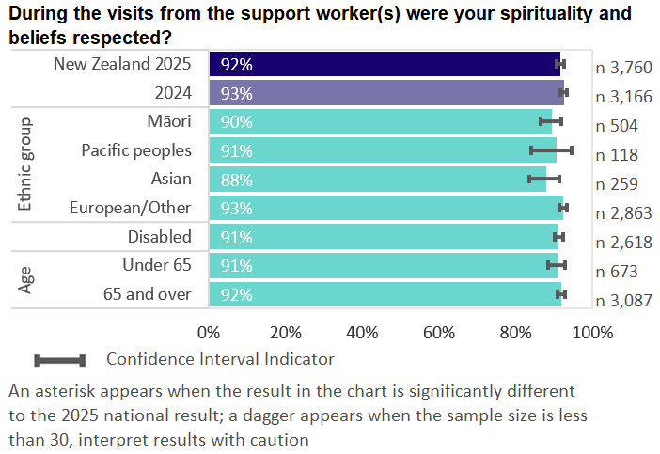
Ninety-two percent of people reported that during visits from support workers in the last four weeks their spirituality and beliefs were always respected. The denominator excludes people who responded that the question did not apply to them.
A similar question is asked in the adult hospital inpatient experience survey and the adult primary care patient experience survey. HCSS clients responded more positively than hospital inpatients (81 percent reported that their spiritual needs were definitely met), and more positively than primary care patients (85 percent reported that their spiritual needs were definitely met).
Figure 14: Able to attend activities
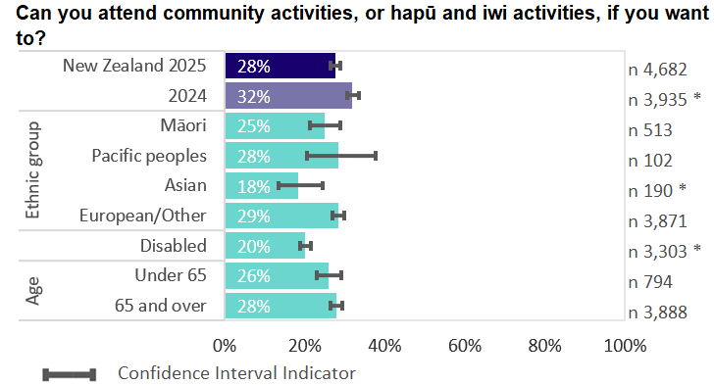
Note: An asterisk means the result is significantly different from the 2025 national result.
Twenty-eight percent of people reported that they were definitely able to attend community activities, or hapū and iwi activities, if they wanted to. The denominator excludes people who responded that they did not want or need this. The question asked about attendance in general and was not tied to the four-week reference period. Although providers may not be able to provide this type of support if care plans do not include arrangements for it, these results represent a clear gap at a national level and have a flow-on effect for social isolation.
Being an older adult or having a mental or physical challenge puts people at a higher risk of social isolation, which in turn increases their risk of developing serious mental and physical health conditions.
Figure 15: Needs assessment includes support to attend activities
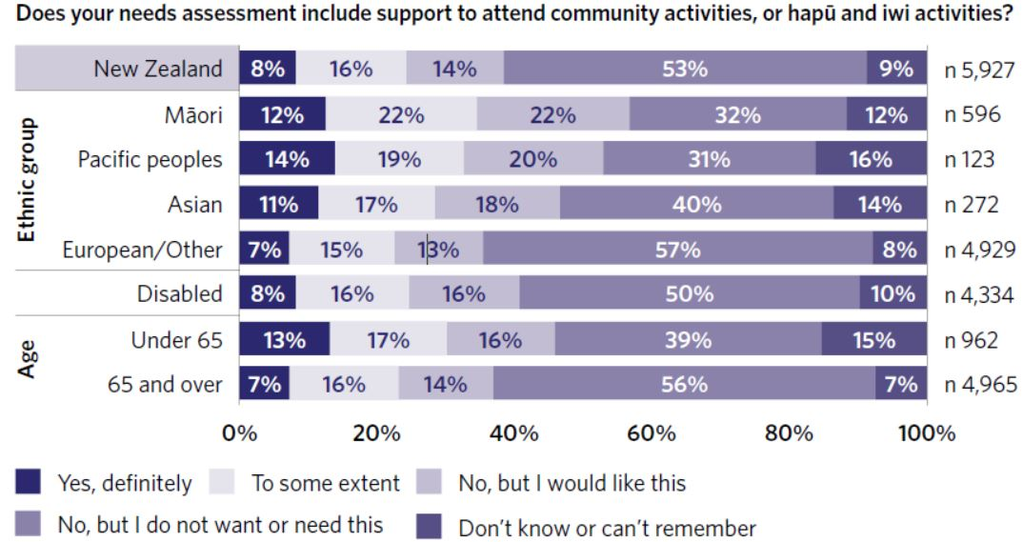
The 2025 survey asked a new question: ‘Does your needs assessment include support to attend community activities, or hapū and iwi activities?’
Nationally, 8 percent of people reported that their needs assessment included support to attend community activities or hapū and iwi activities, and 16 percent said it included it to some extent. Fourteen percent said it was not included but they would have liked it to be, while 53 percent said it was not included and they did not want or need this support. Nine percent said they did not know or could not remember.

Qualitative comments about being treated with respect
Comments people made about being treated with respect were mostly positive but highlighted areas for improvement. Elements of being treated with respect that appeared in the comments included:
kindness, care, helpfulness
being talked to respectfully
respect for household rules and tikanga
privacy
keeping things sanitary
focusing on people’s individual needs.

Theme 4: Ease of contact
The ‘ease of contact’ theme looks at whether clients were easily able to contact their provider to have a question or request answered, including to make a complaint. Standard 1.8 of Ngā paerewa interprets the right to complain as meaning that people feel it is easy to make a complaint and that, when they do, they are taken seriously and receive a timely response. Figures 16–21 present results relating to how easily clients could contact their providers to ask a question or request changes.
Figure 16: Asking questions or requesting changes
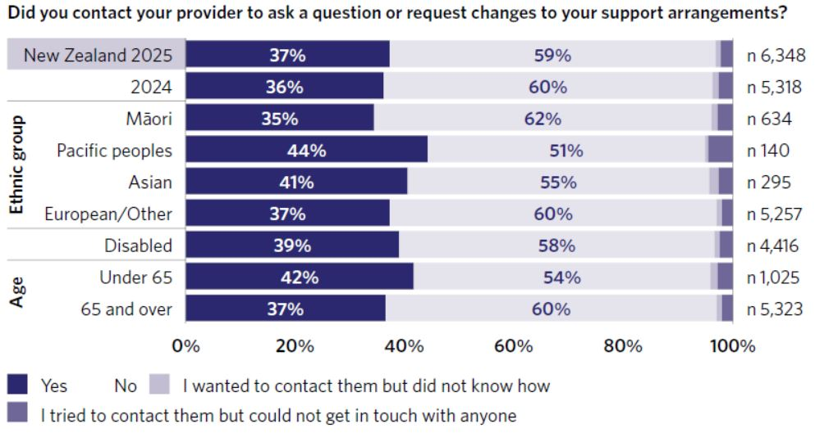
Thirty-seven percent of people reported that in the last four weeks they had contacted their provider to ask a question or request changes to their support arrangements. Fifty-nine percent had not done this, 1 percent reported wanting to contact their provider but not knowing how, and 2 percent said that they had tried to contact their provider but could not get in touch with anyone.
This question does not have a ‘most positive’ response. It was used to provide branching logic to the following survey question (‘Did you get the help or change you needed?’). However, the responses ‘I wanted to contact them but did not know how’ and ‘I tried to contact them but could not get in touch with anyone’ are indicators of people being insufficiently informed about processes and ineffective communication.
Figure 17: Got help or change needed
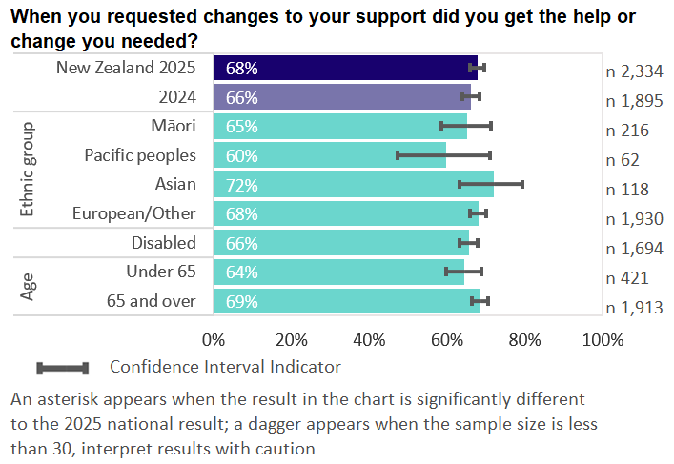
Sixty-eight percent of people reported they definitely got the help or change they needed when they contacted their provider to ask a question or request changes to their support arrangements. Only those people who had contacted their provider for this purpose in the last four weeks were asked this question.
Figure 18: Would raise a concern or complaint
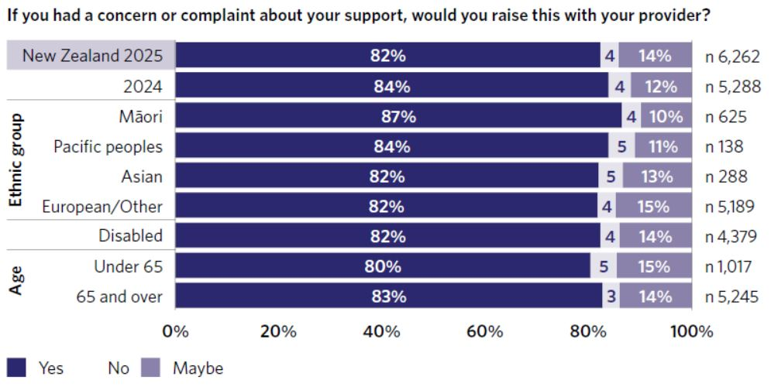
Eighty-two percent of people reported that, if they had a concern or complaint about their support, they would raise it with their provider. Four percent reported they would not raise it and 14 percent reported they would maybe raise it.
This question does not have a ‘most positive’ response. It was used to provide branching logic to the following survey questions:
‘What makes you say you would not or maybe raise a concern or complaint?’: only asked if the respondent indicated that they would not or would maybe raise a complaint
‘Did you contact your provider to raise a concern or make a complaint about your support?’: only asked if the respondent indicated that they would raise or would maybe raise a complaint.
Figure 19: Why not raise a concern or complaint
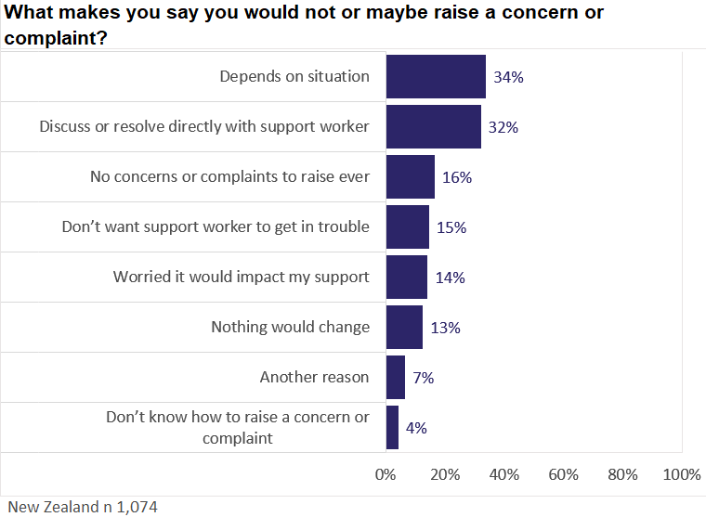
This is a new closed-ended multiple response question to replace the 2024 open-ended qualitative question, with the intention of making it easier both to respond to the survey and to interpret the results. The response option categories in 2025 were based on the open-ended comments received in 2024.
This question was only asked if the response to the preceding survey question ‘If you had a concern or complaint about your support, would you raise it with your provider?’ was ‘No’ or ‘Maybe’. National results show that for people answering this question:
The two most common reasons, each selected by around one-third of respondents, related to situational judgement or preference for informal resolution.
Sixteen percent selected ‘I don’t think I would ever have any concerns or complaints to raise’.
Between 13 and 15 percent of people selected reasons that reflected perceived barriers to raising concerns.
A small percentage of respondents selected ‘Another reason’ (7 percent) or ‘I don’t know how to raise a concern or complaint’ (4 percent).
Most people who answered this question selected a single response option. Only around one in five selected more than one response.
Figure 20: Did raise a concern or complaint
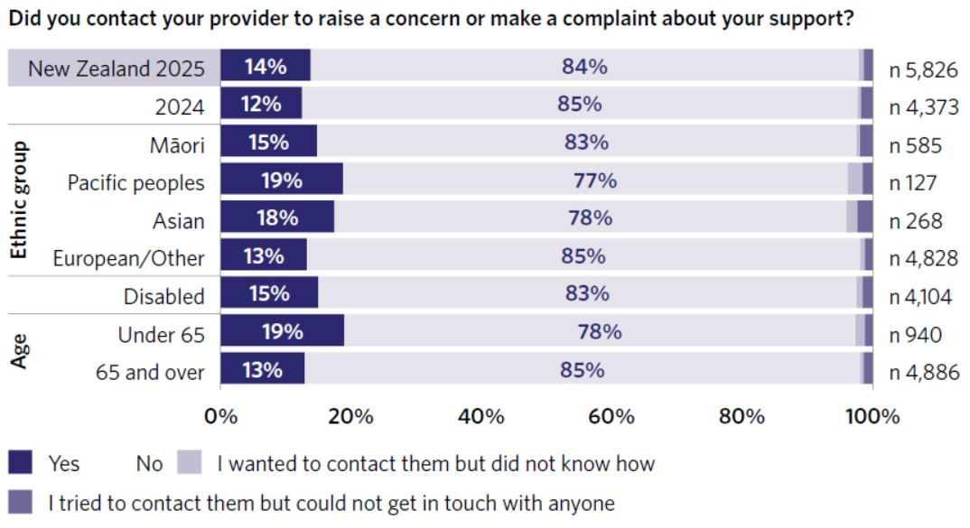
Fourteen percent of people reported they had contacted their provider to raise a concern or complaint about their support in the last four weeks. Eighty-four percent had not done so, 1 percent reported wanting to contact their provider but not knowing how and 1 percent said that they had tried to contact their provider but could not get in touch with anyone.
Only those people who said ‘Yes’ or ‘Maybe’ they would raise a concern or complaint about their support with their provider were asked this question. The routing was expanded from that we used for the 2024 survey, when only people who said ‘Yes’ they would raise a concern or complaint were asked this question.
This question does not have a ‘most positive’ response. It was used to provide branching logic to the following survey question (‘Did your provider take your concern or complaint seriously?’). However, the responses ‘I wanted to contact them but did not know how’ and ‘I tried to contact them but could not get in touch with anyone’ are indicators of people being insufficiently informed about processes and ineffective communication.
Figure 21: Concern or complaint taken seriously
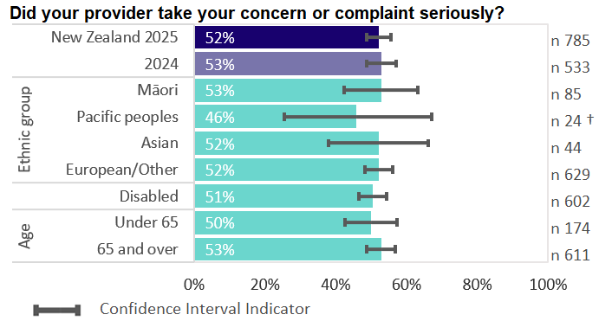
Note: A dagger means the sample size is less than 30. Please interpret this result with caution.
If people had raised more than one concern or complaint in the last four weeks, they were advised to think about the most recent occasion when answering the question.
Of those who had contacted their provider to raise a concern or complaint in the last four weeks, 52 percent reported that their provider had definitely taken their concern or complaint seriously. Around one-third of respondents said their concern or complaint was partly taken seriously.

Qualitative comments about ease of contact
Elements of ease of contact that appeared in the comments at a national level included:
getting in touch with providers and getting a response in return
knowing who to contact
fear of consequences for themselves or their support workers
not wanting to be a bother
concerns being dismissed or nothing changing.

Case-mix adjusted survey results
This section of the report presents case-mix adjusted survey results across the questions. Appendix 2 provides further detail on the case‑mix adjustment methodology used in this report. This work builds on the 2024 survey results summarised below.

2024 survey results for provider variation and demographic variables and groups
In the 2024 report we reported as follows.
Wide variation was evident between providers in responses to questions relating to support worker scheduling and communication.
In general, no consistent statistically significant differences were evident in response by ethnic group, disability status or age group. Few instances were evident where responses were significantly different by gender. We noted that we would repeat these analyses when year two results are available, pooling with the year one results. The higher combined sample size may enable us to identify consistent sub-group differences, especially for groups with small sample sizes, such as Māori, Pacific and Asian clients responding to the survey in the younger age bands.

Multivariate case-mix adjustment
We introduced multivariate case-mix adjustment using pooled 2024 and 2025 survey data as a new analytical approach for the 2025 report. Case-mix adjustment is an internationally standard method used for reporting on patient experience measures. For example, the English General Practice Patient Survey uses case‑mix adjustment for all patient‑experience indicators.
In the 2025 report, we used this approach to:
make fair comparisons between providers by comparing actual provider results by question to those expected given each provider’s client mix (see detailed provider results below)
assess whether differences between demographic groups shown elsewhere in the report are materially influenced by population composition, by comparing actual and case‑mix adjusted results as a diagnostic check for statistical confounding in comparisons between demographic groups (see ‘Interpreting this report’ for an explanation of statistical confounding).

Case-mix adjusted results for providers
We derived case-mix adjusted results using a national multivariate prediction model for each question. The model per question includes positive responses to the question as the binary outcome and predictor variables for age, gender, ethnicity and disability status (see below for the exact demographic variables and groups used). The models are fitted on pooled 2024 and 2025 survey data. In the provider application of the model, case-mix adjusted (expected) results are calculated for each provider using each provider’s client mix for the predictor variables across 2024 and 2025.
Table 2 presents results for 17 anonymised providers across the questions, showing the minimum, maximum and range of actual and expected provider results, as well as the number of providers for whom statistically significant differences were detected.
Our key findings from analysis across the questions included the following.
Case‑mix adjusted results for providers varied only within a narrow band for all questions, indicating that once differences in client mix were accounted for, providers were expected to have broadly similar outcomes.
Actual results showed wider variation – often several times larger than expected ranges – reflecting real differences in people’s experiences across providers. This variation reflects differences across providers that remained after accounting for client mix, including provider size, local context and service characteristics.
The number of providers for whom there were statistically significant differences between actual and expected results varied by question, ranging from two to twelve. However, some providers had small respondent numbers even after pooling across two years. As a result, their confidence intervals may be wide, reducing our ability to detect statistically significant differences.
Across communication and scheduling questions, variation in actual results between providers was much wider than for case-mix adjusted results. For example, actual provider results for ‘Knew who support worker would be in advance’ ranged from 14 percent to 96 percent positive outcome. This contrasts sharply with the narrow range of case-mix adjusted results for providers (50–65 percent).
Table 2: Case-mix adjusted results for providers, by provider variation and statistically significant difference detected (rows) and survey questions (columns)
 |  | Effective communication |  |  |  | Effective scheduling |  |  |  |  | Treated with respect |  |  |  |  |  |  |  |  |  | Ease of contact
 |  | Listened to by support worker | Knew in advance what time to expect support | Knew who support worker would be in advance | Advised of changes in advance | Support arrived at expected time | No occasion when support did not turn up | Support times worked for people | Support workers had the necessary knowledge and skills |  | Name pronounced properly |  | Treated with respect and kindness |  | Culture respected |  | Spirituality and beliefs respected |  | Able to attend activities |  | Got help or change needed |  | Concern or complaint taken seriously
Actual results | Min | 64% | 29% | 14% | 22% | 38% | 76% | 43% | 62% |  | 82% |  | 81% |  | 76% |  | 80% |  | 24% |  | 53% |  | 35%
Actual results | Max | 91% | 89% | 96% | 71% | 85% | 90% | 87% | 91% |  | 98% |  | 99% |  | 99% |  | 98% |  | 43% |  | 100% |  | 100%
Actual results | Range | 27% | 60% | 83% | 49% | 47% | 15% | 44% | 29% |  | 16% |  | 17% |  | 23% |  | 18% |  | 19% |  | 47% |  | 65%
Case-mix adjusted (expected) results | Min | 75% | 49% | 50% | 40% | 53% | 76% | 58% | 74% |  | 86% |  | 88% |  | 89% |  | 91% |  | 24% |  | 61% |  | 48%
Case-mix adjusted (expected) results | Max | 79% | 64% | 65% | 51% | 65% | 82% | 67% | 77% |  | 92% |  | 92% |  | 95% |  | 93% |  | 37% |  | 69% |  | 56%
Case-mix adjusted (expected) results | Range | 4% | 15% | 14% | 11% | 12% | 5% | 9% | 4% |  | 5% |  | 3% |  | 6% |  | 3% |  | 12% |  | 9% |  | 8%
Providers with statistically significant difference detected (n=17 providers) | Above expected | 3 | 7 | 7 | 7 | 6 | 3 | 8 | 5 |  | 2 |  | 2 |  | 2 |  | 2 |  | 2 |  | 5 |  | 2
 | Below expected | 2 | 3 | 5 | 4 | 3 | 1 | 3 | 4 |  | 3 |  | 2 |  | 1 |  | 2 |  | 0 |  | 1 |  | 0
 | No difference | 12 | 7 | 5 | 6 | 8 | 13 | 6 | 8 |  | 12 |  | 13 |  | 14 |  | 13 |  | 15 |  | 11 |  | 15
National benchmark |  | 75.6 | 51.7 | 52.8 | 41 | 55.2 | 80.7 | 60.2 | 74.5 | 89.4 |  | 90.3 |  | 93.9 |  | 92.3 |  | 29.6 |  | 67.1 |  | 52.4
The national benchmark is the case‑mix adjusted national result for each question, estimated using a national prediction model and the overall client mix of survey respondents across 2024 and 2025 survey years.
Figure 22 shows the variation across providers described above for a small sample of questions.
Figure 22: Case-mix adjusted results for anonymised providers, selected questions
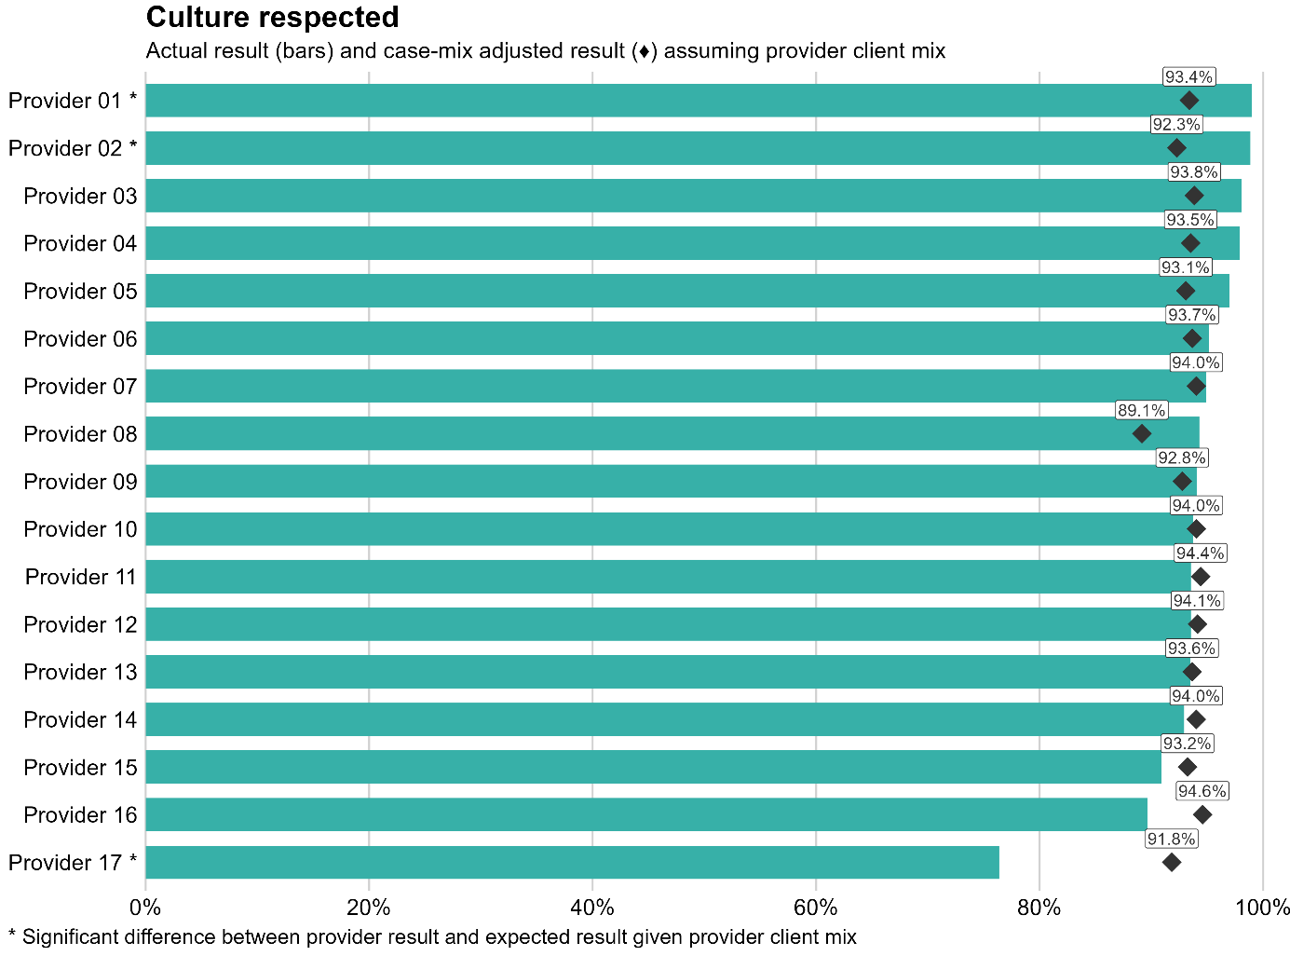
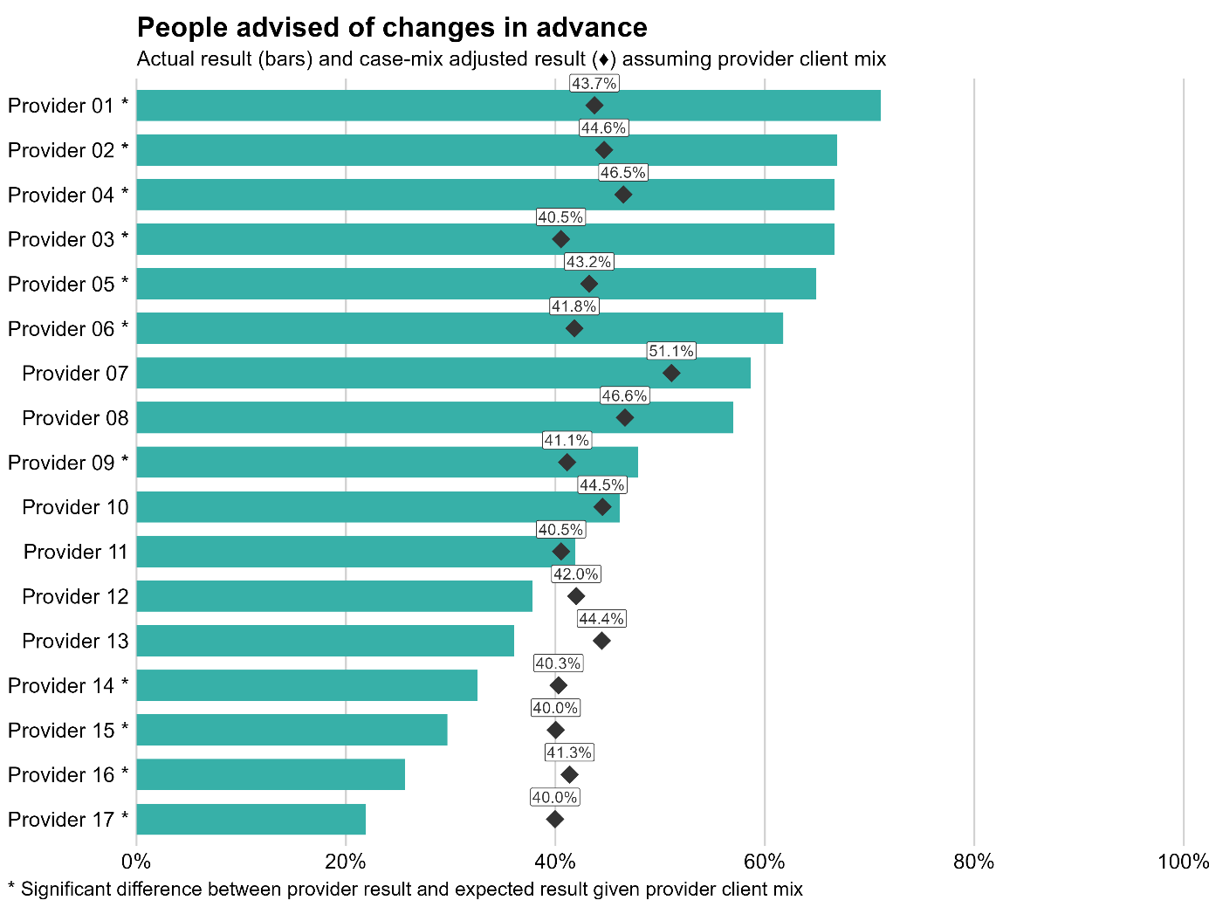
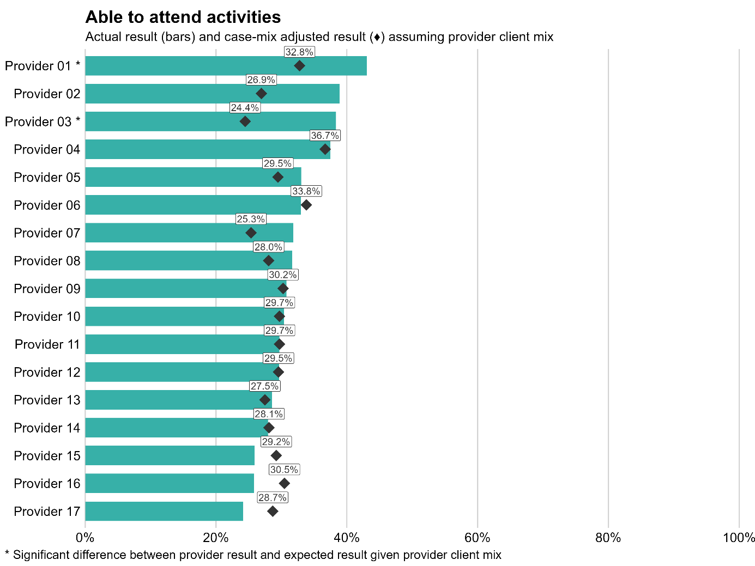

Case-mix adjusted results for demographic variables and groups
We derived case-mix adjusted results using the same national multivariate prediction model for each question described above. In the demographic variables and groups application of the model, case-mix adjusted results were calculated using pooled 2024 and 2025 survey data for the following groups:
age bands: under 65, 65–74 years, 75–84 years, 85 years or over
gender: male, female
ethnicity: Māori, Pacific peoples, Asian, European/Other
disability status: disabled, non-disabled.
See Figure 27 in Appendix 2 (Case‑mix adjustment methodology) for an example of case‑mix adjusted results by demographic group.
Key findings from our analysis across the questions included the following.
Case-mix adjusted results were very close to the actual results. This indicates that while statistical confounding (see ‘Interpreting this report’) can affect comparisons between demographic groups, its estimated impact on the observed differences (for example, comparisons between Māori and European/Other) is small for most questions.
There were no statistically significant differences by gender compared with the national benchmark.
In general, when a case-mix adjusted result was statistically significantly different from the national benchmark (using pooled 2024 and 2025 survey data), the corresponding actual result from the 2025 survey was also statistically significantly different from the national result in 2025.
In light of these findings, this report does not present the detailed case-mix adjusted results for demographic variables and groups, since they are very similar to those from the 2025 survey, presented in Table 1 and ‘Results by theme’.

Patient-reported outcome measure
This section presents results from a patient-reported outcome measure, EQ-5D-5L. We included the EQ-5D-5L14 in the 2025 survey to gather insights on the health-related problems that HCSS clients experience. A patient-reported outcome is any report of the status of a person’s health condition that comes directly from the person, without any interpretation by a clinician or anyone else. Patient-reported outcome measures ask questions about specific symptoms, physical or mental health and quality of life.
The EQ-5D-5L measures aspects of health that are common to most people. It is widely used internationally and assesses a person’s subjective experience across five dimensions of health:
mobility: problems with walking about
self-care: ability to wash or dress
usual activities: ability to perform tasks relating to work, study or leisure
pain/discomfort: the presence and severity of pain or discomfort
anxiety/depression: level of anxiety or depression.
For each dimension, there are five levels of severity, ranging from ‘no problems’ to ‘extreme problems’. For this report, we split responses into ‘no problems’ and ‘problems’ (all four other levels of severity).
EQ-5D-5L data gives us a better understanding of where HCSS clients report the most problems with these five health dimensions.
Figures 23–25 show the percentage of respondents reporting ‘problems’ on the EQ-5D-5L health dimensions. The coloured bars and grey confidence intervals show the national results.
Because the results are not weighted or adjusted to account for age differences between ethnic groups, we have not reported results by ethnicity. This is because Māori, Pacific peoples and Asian groups have a younger respondent profile, and there is a strong association between increasing age and increasing prevalence of reported problems.
Figure 23: Prevalence of reported problems across EQ-5D-5L dimensions among HCSS respondents
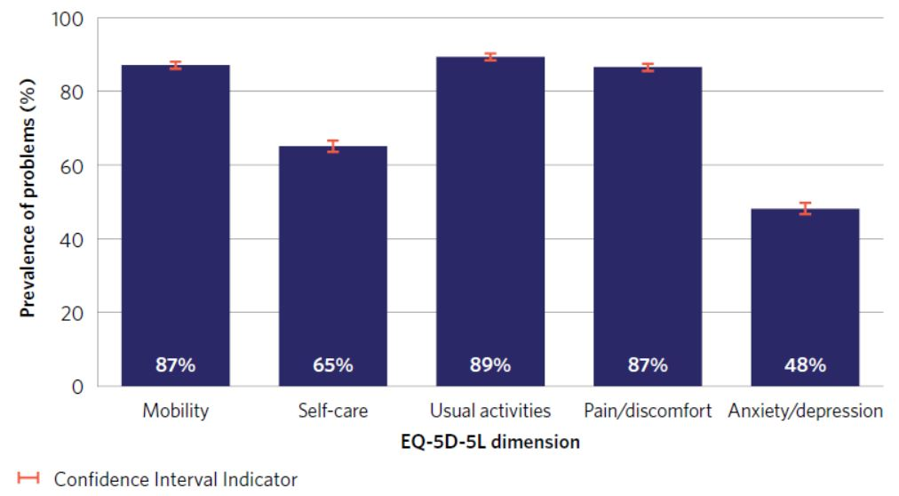
National results show a high prevalence of reported problems across the EQ-5D-5L dimensions for HCSS clients responding to the survey. Respondents reported the highest prevalence of problems with carrying out usual activities and the lowest prevalence of problems with anxiety/depression.
Figure 24: Prevalence of reported problems with each EQ-5D-5L dimension among HCSS respondents by age
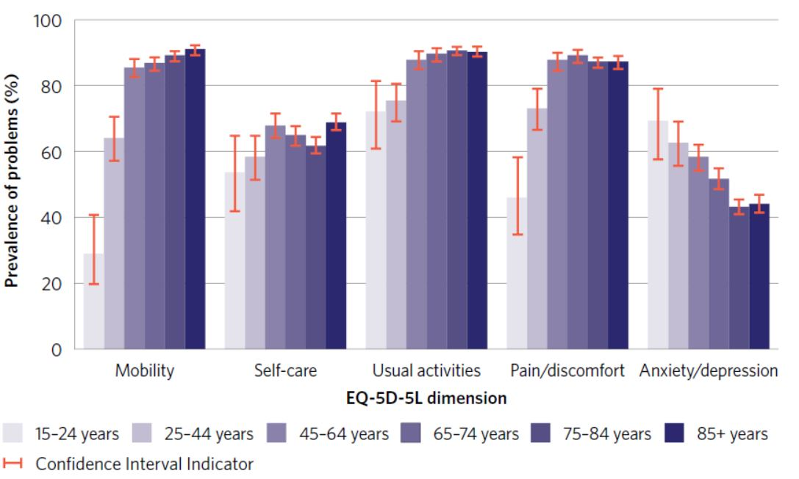
National results by age show a strong association between increasing age and a higher prevalence of reported problems across the EQ‑5D‑5L dimensions of mobility, self‑care, usual activities and pain/discomfort. In contrast, younger respondents reported a higher prevalence of problems with anxiety/depression than older respondents.
Figure 25: Prevalence of reported problems with each EQ-5D-5L dimension among respondents aged 65–74: comparison between surveys
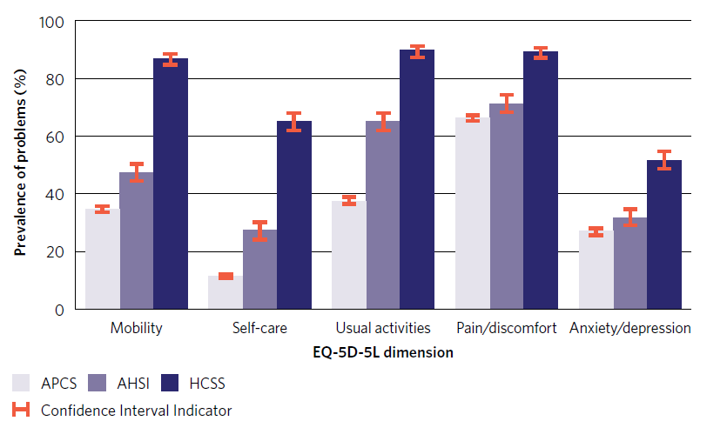
Note: APCS = Adult primary care patient experience survey; AHSI = Adult hospital inpatient experience survey; HCSS = Home and community support services experience survey.
Comparing the prevalence of problems across the EQ-5D-5L dimensions between HCSS survey respondents and respondents to the adult primary care survey and adult hospital inpatient survey highlights some health challenges faced by HCSS clients. To enable valid comparisons, either age-standardisation or age-specific comparisons are required. This is because the respondent profile of HCSS clients is significantly older than that of patients responding to the other two surveys. We used the 65–74 age group for the comparison, as this age band has a sufficient spread of responses across all three surveys. The EQ-5D-5L questions are rotated into the adult hospital inpatient survey and adult primary care survey each August, so the prevalence figures for these two surveys are for August 2025.
Across all five EQ-5D-5L dimensions, HCSS survey respondents aged 65–74 reported a substantially higher prevalence of problems than those responding to the adult primary care survey and adult hospital inpatient survey. The differences were most pronounced in the mobility and self-care dimensions.
For the pain/discomfort and anxiety/depression dimensions, respondents to the adult primary care survey and adult hospital inpatient survey surveys report similar prevalence of problems, whereas HCSS survey respondents report a statistically significantly higher prevalence of problems.
These findings indicate that, even within the same age group, people receiving home and community support services experience a higher burden of health-related quality-of-life challenges.

Respondent profile

Who responded to the survey?
The respondent profile for the HCSS survey was as follows.
Most respondents (84 percent) were aged 65 and over, and most were female (67 percent). This was similar to the 2024 survey, when 82 percent of respondents were aged 65 and over and 67 percent female.
Of respondents, 9.9 percent identified as Māori, 2.2 percent Pacific peoples, 4.6 percent Asian and 83 percent European/Other. These figures were similar to those from the 2024 survey (9.4 percent, 2.2 percent, 4.5 percent and 84 percent respectively).
A higher proportion of Māori (34 percent), Pacific peoples (35 percent) and Asian (24 percent) respondents were aged less than 65 compared with those of European/Other ethnicities (13 percent). This pattern was similar in the 2024 survey, when 37 percent, 44 percent, 27 percent and 15 percent of these ethnic groups respectively were aged less than 65.
Of respondents, 74 percent had a functional disability based on the WG-SS and/or self-identified as disabled or as having a disability. This was similar to the equivalent 2024 survey figure, 76 percent. Note that for these figures, the denominator is people with a known disability status.
Of respondents, 79 percent completed the survey for themselves, and 21 percent had someone else complete the survey on their behalf. The proportion of surveys completed on someone’s behalf was much higher for Pacific peoples and Asian respondents, at 45 percent and 48 percent respectively. This pattern was similar in the 2024 survey (40 percent and 46 percent respectively).
Household management was the most common type of support received, with 66 percent of respondents receiving this type of support, followed by personal care at 53 percent (noting that respondents may have been receiving more than one support type). These figures are similar to those in the 2024 survey (68 percent and 53 percent respectively)
The typical (median) completion time for the HCSS survey was 13.4 minutes in 2025, compared with 10.7 minutes in 2024. This is likely due to the inclusion of the new questions. It remains within our estimated survey completion time of 10–15 minutes.
Most respondents who completed the first question went on to complete the final question. The completion rate was 90 percent in the 2025 survey: slightly lower than the 2024 survey completion rate of 92 percent.

Demographics of survey respondents
Table 3 provides a summary of the demographics of respondents to the HCSS survey.
Table 3: Summary demographics
Age band | Māori |  | Pacific peoples |  | Asian |  | European/Other |  | Total |  | Percent of total
Age band | 2024 | 2025 | 2024 | 2025 | 2024 | 2025 | 2024 | 2025 | 2024 | 2025 | 2024 | 2025
14 years or under | 7 | 11 | <5 | 0 | 5 | 5 | 23 | 18 | 38 | 35 | 1 | 1
15–44 years | 50 | 69 | 15 | 18 | 30 | 41 | 192 | 185 | 288 | 317 | 5 | 5
45–64 years | 137 | 145 | 36 | 33 | 32 | 25 | 481 | 489 | 688 | 696 | 12 | 11
65–74 years | 145 | 192 | 19 | 32 | 58 | 62 | 796 | 929 | 1,020 | 1,218 | 18 | 18
75–84 years | 130 | 157 | 29 | 40 | 76 | 105 | 1,795 | 2,177 | 2,036 | 2,489 | 37 | 38
85 years or over | 53 | 81 | 19 | 22 | 47 | 63 | 1,371 | 1,683 | 1,491 | 1,854 | 27 | 28
Total | 522 | 655 | 120 | 145 | 248 | 301 | 4,658 | 5,481 | 5,561 | 6,609
Percent of total | 9.4 | 9.9 | 2.2 | 2.2 | 4.5 | 4.6 | 83.8 | 82.9 | 100 | 100
The rows do not always sum to the total because those of unknown ethnicity are not reported separately.

Response rates
Tables 4 and 5 show response rates, with counts of those who responded included in brackets. Response rates varied by provider, from 9 percent to 44 percent. In part, this reflects the quality of the sample file: providers differed in the availability of email and phone contact details, and where more complete contact information was available multiple contact methods (SMS and email) could be used, which tended to result in higher response rates, while more limited digital contact information led to reliance on a single mode or hard copy invitations, resulting in lower or more variable response rates.
Looking at the response rates by invitation method shows that the highest response rate was achieved when people were invited by both email and SMS. This was only possible where the sample uploaded by the provider contained both of these contact details. When interpreting the response rates, be aware that the New Zealand total is largely driven by those of the European/Other ethnic group.
Table 4: Percentage of those invited who responded to the survey by ethnicity and invitation method (count of those who responded in brackets)
 |  | Invitation method
 | Total | Via SMS | Via email | Via email and SMS | Via hard copy
Māori | 22% (508) | 18% (221) | 20% (8) | 26% (223) | (56)
Pacific peoples | 14% (152) | 12% (57) | 15% (6) | 21% (84) | (5)
Asian | 14% (247) | 8% (64) | 16% (10) | 22% (172) | (1)
European/Other | 27% (5,292) | 18% (1,670) | 25% (256) | 35% (3,303) | (63)
Total 2025 | 25% (6,540) | 17% (2,148) | 23% (288) | 33% (3,979) | (125)
Total 2024 | 24% (5,514) | 15% (1,597) | 23% (321) | 32% (3,347) | (249)

Table 5: Percentage of those invited who responded to the survey by age group (count of those who responded in brackets)
 | Total
Under 65 | 20% (1,025)
65–75 years | 26% (1,229)
75–84 years | 28% (2,489)
85 years or over | 23% (1,797)
Total | 25% (6,540)

Feedback on the survey
As part of monitoring survey performance, we invite respondents to provide feedback on the HCSS survey. Figure 26 shows that in this sense the HCSS survey performed similarly to the other patient experience surveys the Commission runs. This is a pleasing result, given the high proportion of disabled people responding to the survey.
Figure 26: Survey performance feedback
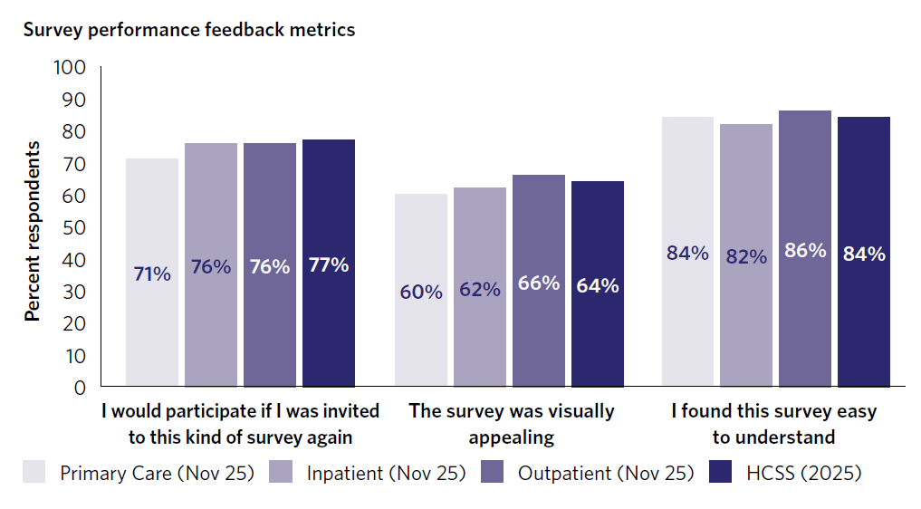

More information
Information on the survey, including the questionnaire, data dictionary and methodology and procedures report: hqsc.govt.nz/our-data/patient-reported-measures/patient-experience/about-our-patient-experience-surveys/home-and-community-support-services-experience-survey
Information for people who have been invited to take part: hqsc.govt.nz/our-data/patient-reported-measures/patient-experience/taking-part/home-and-community
Survey resources for home and community support services staff: hqsc.govt.nz/our-data/patient-reported-measures/patient-experience/survey-resources-for-home-and-community-support-services-staff

Appendix 1: Participating providers
We recognise the following providers for supporting this national work from its inception and seeing the value of a national approach that allows services to better understand and benchmark their performance. We thank each provider for their contribution to the survey development process and commend them for the time they have taken to understand their clients’ experiences for the purpose of improving the quality of their services:
Drake Medox
Geneva Healthcare
HealthCare NZ
Life Plus
Lifewise Health and Disability Services
Nurse Maude
NZCL Whānau Support
Pacific Homecare
Pirirākau Hauora
Presbyterian Support East Coast
Presbyterian Support (Northern) (Enliven)
Royal District Nursing Service (RDNS) NZ
Te Kōhao Health
Te Puna Ora o Mataatua
Tuwharetoa Health Charitable Trust
Visionwest Community Trust
Whaioranga Trust.

Appendix 2: Case-mix adjustment methodology

Purpose of case‑mix adjustment
We have used case‑mix adjustment in this report to support fair interpretation of survey results. People receiving home and community support services differ in characteristics such as age, disability status and ethnicity, and these characteristics are associated with survey responses. Case‑mix adjustment helps account for these differences so that comparisons focus on outcomes rather than differences in who responded.
In the 2025 HCSS report, we used case‑mix adjustment to:
support fair comparisons between providers
assess whether differences between demographic variables and groups are materially influenced by population composition.
Case‑mix adjusted results complement, rather than replace, the observed survey results presented elsewhere in the report.

Data used
We based case-mix adjustment on pooled data from the 2024 and 2025 HCSS survey waves.
For each survey question, the following applies.
We coded responses as a binary outcome indicating whether the respondent selected the most positive response (for example, 'Yes, definitely') or, where applicable, responses if more than one (for example, ‘Yes, always’ or ‘They addressed me appropriately without using my name’), representing the best-case scenario for them.
We excluded non-responders to particular questions, along with any respondents not shown the question (for example, due to routing or survey drop-out).
We also excluded responses indicating that an answer was not applicable (for example, ‘Does not apply to me’).

Variables included in adjustment
For each survey question, a single national prediction model is fitted that includes the following variables:
survey year (2024 or 2025)
age band (under 65; 65–74; 75–84; 85 years or over)
gender (male; female)
prioritised ethnicity (Māori; Pacific peoples; Asian; European/Other)
disability status (disabled; non‑disabled)
We did not include provider in the prediction model, so that the model represents an average national provider after accounting for differences in respondent characteristics.
We applied the same modelling approach separately to each survey question.

National prediction model
For each question, we fitted a national multivariate prediction model using pooled 2024 and 2025 survey data. Inclusion of survey year as a variable allowed us to account for differences between 2024 and 2025 without fitting separate models for each year.
The model estimates the likelihood of a positive response given a respondent’s characteristics and their survey year of participation.

Provider‑level case‑mix adjustment
For provider reporting, case‑mix adjustment uses an indirect standardisation approach.
For each provider, we applied the national prediction model to that provider’s observed client mix, based on the age, gender, ethnicity, disability status and survey year of their respondents. This produced an expected case‑mix adjusted result for the provider.
The expected result represents the outcome that an average national provider would be expected to achieve if it served the same mix of clients as the provider. We have presented observed (unadjusted) results alongside expected results to support interpretation.
We included providers that participated in only one survey year (2024 or 2025) using data from the year in which they participated.
See Figure 22 in the main report for sample charts illustrating this approach.

Demographic variables and groups case‑mix adjustment
For demographic variables and groups, case‑mix adjustment supports like‑with‑like comparisons between groups and comparison with a common national reference using a marginal standardisation approach.
To illustrate the approach, the steps below describe how the case‑mix adjusted result for Māori is calculated.
1. Treat all respondents in the analysis as Māori for the purposes of prediction.
2. Use the national prediction model to calculate the predicted probability of a positive response for Māori respondents across all 32 combinations of age band, gender, disability status and survey year observed in the survey data.
3. Combine these 32 predicted probabilities using weights that reflect the national mix of respondents across age band, gender, disability status and survey year in 2024 and 2025.
This process produces a case‑mix adjusted result for Māori that represents the expected outcome if Māori respondents had the same overall demographic profile and mix of survey years as the survey population nationally.
A similar process is used for all demographic variables and groups.
The case‑mix adjusted result for each demographic group is directly comparable with other groups and with the national benchmark.
In this report, case-mix adjusted demographic results are used primarily as a diagnostic tool to assess whether observed differences between demographic groups are materially influenced by statistical confounding, as described in the main report.
Figure 27 shows the variation across demographic variables and groups for a selected question.

National benchmark
For each survey question, a national benchmark is produced using the same national prediction model and the overall mix of survey respondents across 2024 and 2025.
The national benchmark represents the expected national result after accounting for age, gender, prioritised ethnicity, disability status and survey year. It is used as a common reference point for interpreting:
provider‑level expected results
adjusted results for demographic variables and groups.

Interpretation and limitations
Case‑mix adjusted results are subject to statistical uncertainty, particularly where numbers of respondents are small. Confidence intervals are used to reflect this uncertainty.
Case‑mix adjustment cannot account for unmeasured factors and does not explain why differences occur. Adjusted results are intended to support interpretation and discussion and should not be used in isolation as measures of performance.
Figure 27: Case-mix adjusted results by demographic variables and groups, selected question
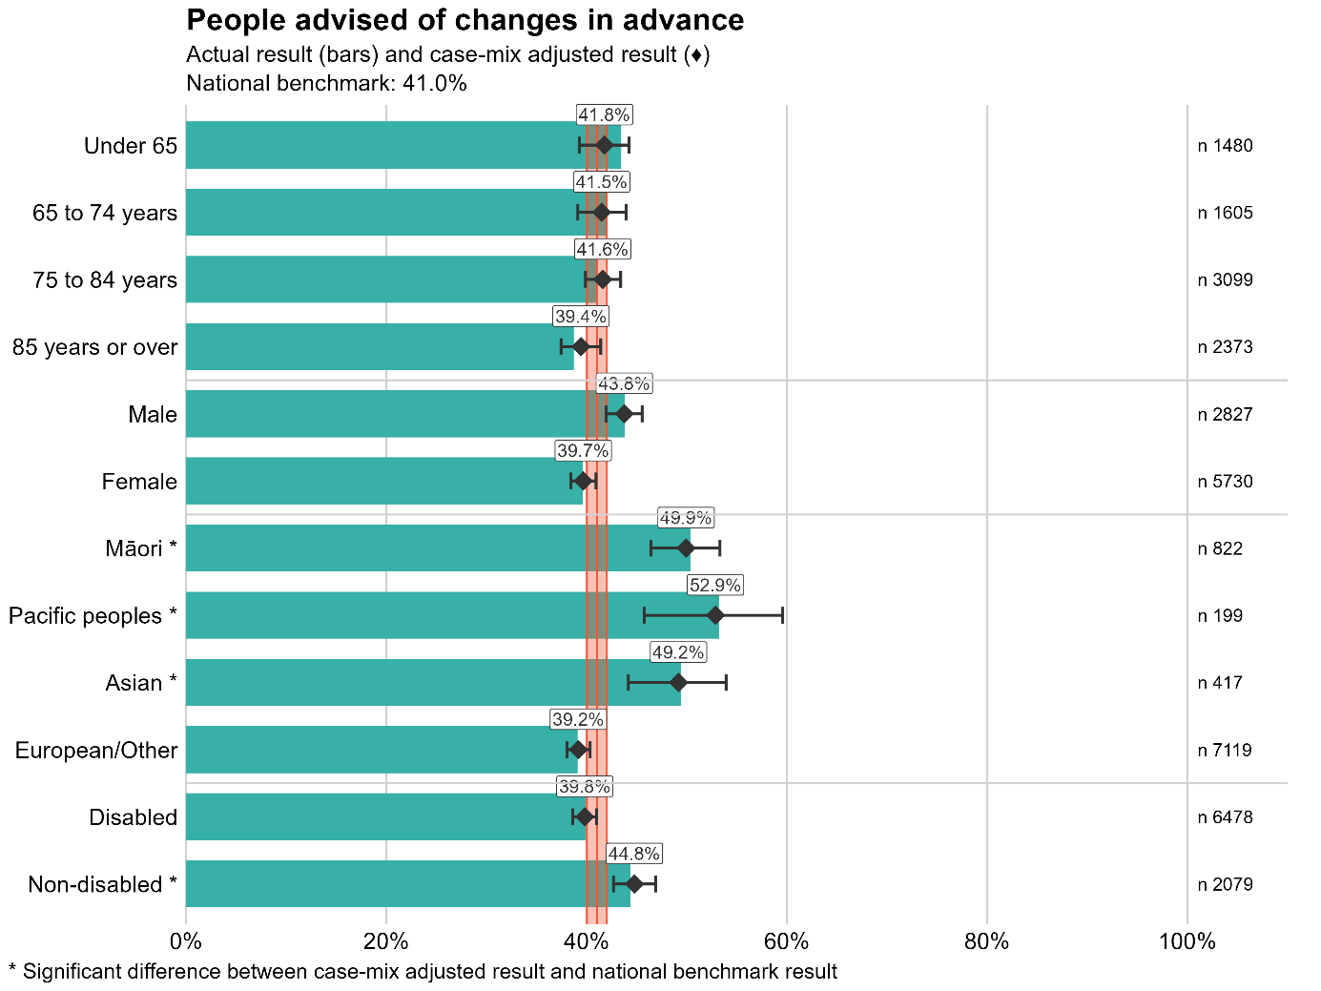

standards.govt.nz/shop/nzs-81342021
hqsc.govt.nz/consumer-hub/engaging-consumers-and-whanau/code-of-expectations-for-health-entities-engagement-with-consumers-and-whanau
hqsc.govt.nz/our-data/patient-reported-measures
hqsc.govt.nz/our-data/patient-reported-measures/patient-experience/survey-results
For the full Ngā paerewa Health and disability services standard, see: standards.govt.nz/shop/nzs-81342021
The National Framework for Home and Community Support Services is available at: health.govt.nz/publications/national-framework-for-home-and-community-support-services-hcss
For more information, see: enablinggoodlives.co.nz
Available at: hqsc.govt.nz/assets/Our-data/Publications-resources/Surveys/Home-and-community-support-services-experience-survey-national-results-2024.pdf
Weighting adjusts for under- or over-representation in responses by age, gender and ethnic group and means the results account for differences in response rates within a population.
hqsc.govt.nz/our-data/patient-reported-measures/patient-experience/survey-results
For more information, see: cdc.gov/social-connectedness/risk-factors/index.html
https://qualitysafety.bmj.com/content/21/8/634
euroqol.org/information-and-support/documentation/user-guides

