

[Practice name] Practice Report

Results for May 2025–February 2026
This report summarises results from the adult primary care patient experience survey. It is intended to provide meaningful, actionable information from your patients’ experiences.

What’s in this report
- Performance summary
  - Top three highest performing results
  - Bottom three lowest performing results
- Results by theme
  - Accessing care and services
  - Cultural safety
  - Communication / relational aspects
  - Overall experience
- Responses
- Further information
- References

How to use this report
Reviewing patient feedback:
- Helps you understand what benefits your patients the most and where opportunities exist for improvements.
- Helps you maintain a strong relationship with your patients by listening to and responding to feedback. This encourages patients to seek care when they need it and to remain with your practice.
- Respects and honours the time patients have taken to provide feedback.
You can use this:
- As part of the evidence to meet indicator 8.2 of the RNZCGP Foundation Standard.
- As an aid for personal and professional development through reflective activity.
- To provide feedback to patients on what you did in response to their feedback.
Page 43 of the From PES to PDSA workbook has a template you may wish to use.
Available at: https://www.hqsc.govt.nz/resources/resource-library/from-pes-to-pdsa-workbook-using-adult-primary-care-patient-experience-survey-data-for-quality-improvement/

Interpreting this report
This report presents a subset of the questions from the full survey, chosen because they: are core questions; are persistently low scoring; show high variation between populations; or are aligned to priority areas.

Horizontal bar charts
Results show a 12-month average displayed as the percent of patients who selected the most positive response to the question — representing the best-case scenario for them. The number of patients who answered the question is shown as (n).
The bar charts show where your practice is doing well and where there is room for improvement, compared to national results and your practice’s district.
Your practice’s results are shown separately by ethnic group (Māori, Pacific peoples, Asian, European/Other; prioritised), and for disabled and non-disabled people.
Suppression rules protect respondents' privacy. Results are suppressed where fewer than 5 respondents answered a question within a group. This is indicated by "Suppressed" in the charts. "No respondents" indicates that no survey responses were received for that question and group during the reporting period.

Tip: Interpreting confidence intervals
The bar charts include confidence intervals (CI). These are calculated at 95 percent confidence interval. If the lower or upper limits do not overlap with other groups, the difference is considered statistically significant. Smaller sample sizes are associated with greater random variation, which is reflected in wider confidence intervals. For more information see “Interpreting confidence intervals” in the Practice Report – Resources and Technical Notes.

Time-series charts
These show change over time. The reference line on the chart is the baseline value for your practice, which is the median from the first six quarters. We use a method from statistical process control (SPC) to detect meaningful changes. A change is identified when there are six consecutive quarterly results either above or below the baseline. See “Explanation of data displayed in time-series charts” in the Practice Report – Resources and Technical Notes.

Tip: Weighting the survey sample
Survey results are weighted so that they are representative of the adult enrolled general practice population who had a qualifying encounter in the relevant survey period. The weights adjust for the survey sampling design and differences in response rates across demographic groups and districts. For example, weighting helps to correct for under-representation in groups, including younger adults, males, and certain ethnic groups. See “Further information on weighting the survey sample results” in the Practice Report – Resources and Technical Notes.

Performance Summary: [Practice name]

Top and bottom three scoring questions

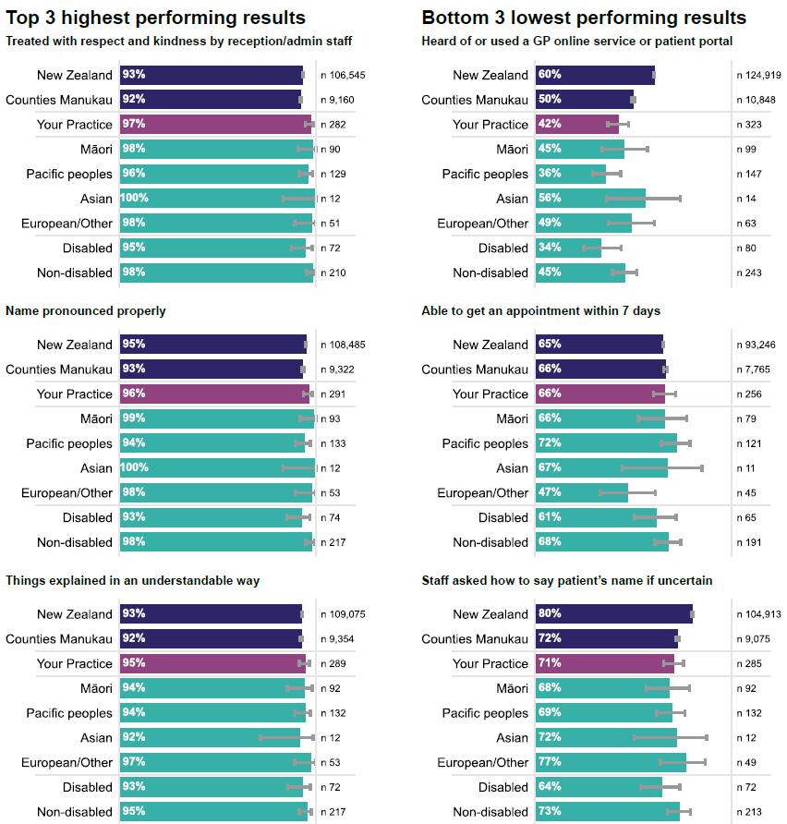

Results by theme: [Practice name]

Accessing care and services

Could get primary care when wanted
Nationally, Māori, Pacific peoples and disabled people are consistently more likely to report a time in the last 12 months when they wanted health care from a GP or nurse but could not get it. Poor access to primary care is associated with inadequate prevention and management of chronic diseases, delayed diagnoses and incomplete adherence to treatments.¹
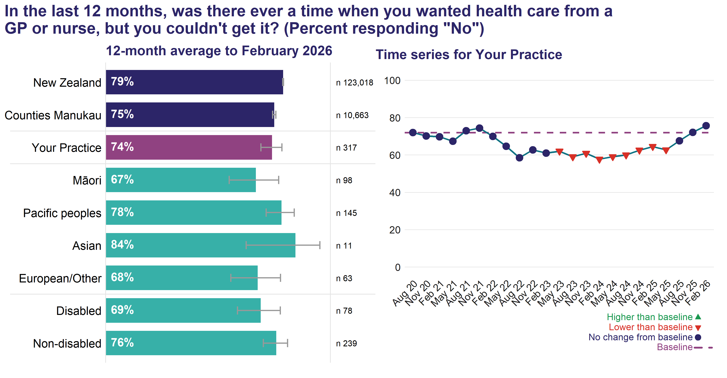
The n value shown in the chart is the actual number of respondents answering this question. An exponentially weighted moving average of your practice's results from the most recent four quarters is shown by a circle or triangle at each point in the time-series.
In the 12 months to February 2026, 74.0 percent of patients at your practice reported they could get health care from a GP or nurse every time they wanted to (that is, answered “No” to this question).

Reasons why patients could not get care
Nationally, the most common reason selected for not being able to access care is that wait times to get an appointment are too long. Other issues include preferred GP or nurse not being available, clinic was closed (for example, after-hours, weekend or public holiday), difficulty in contacting the clinic to make an appointment, difficulty taking time off work, and appointments being too expensive or patients owing money to the practice. In a resource-constrained environment these are difficult problems to address.
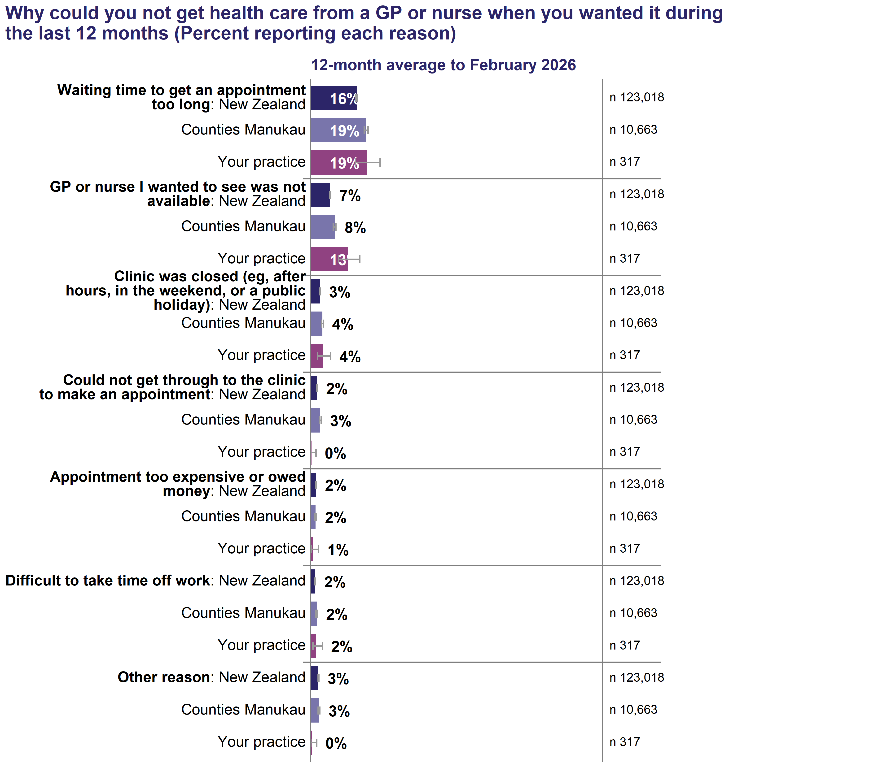
The n value shown in the chart is the actual number of respondents answering this question. Respondents could select more than one reason.
Patients who said they could not always get health care from a GP or nurse when they wanted it during the last 12 months were asked ‘Why could you not get health care from a GP or nurse when you wanted it during the last 12 months?’.
In the 12 months to February 2026, 19.3 percent of patients at your practice reported waiting time to get an appointment was a reason why they could not always get health care from a GP or nurse when they wanted it, 12.8 percent reported the GP or nurse they wanted to see was not available, 4.1 percent reported the clinic was closed and 0.3 percent reported they could not get through to the clinic to make an appointment.
This question is multiple-choice, allowing patients to select all reasons that apply from a predefined list, including an ‘other’ option. In May 2025, the list of reasons presented to patients was updated to reflect the most common reasons provided in the open-ended ‘other’ responses. Three new response options were added: ‘the clinic was closed’, ‘the GP or nurse I wanted to see was not available’, and ‘could not get through to the clinic to make an appointment’. The addition of these options has influenced the frequency with which some previously available reasons are selected. We will continue to monitor.

Why could you not get health care from a GP or nurse when you wanted it during the last 12 months?
Selection of comments from your patients selecting ‘Other (please tell us why)’ in the 12 months to February 2026
[ Comments removed ]

See the Practice Report – Resources and Technical Notes sections “Accessing your full results – Free-text patient comments” and “Method to select comments from your practice’s patients” for information on how to access all your free-text patient comments and how the comments shown above were selected for inclusion in this report.

What practices offered when an appointment was unavailable
In May 2025 a new question on access alternatives provided by a GP practice was introduced to the survey. The question is only asked of patients who said that there was a time in the last 12 months when they wanted care but could not get it because the waiting time to get an appointment was too long or the GP or nurse they wanted to see was not available. Patients were instructed to select all alternatives that applied. They were also instructed to think about the last time this happened if this has happened more than once in the last 12 months.
Nationally in the 12 months to February 2026, 66.3% of patients answering the access alternatives question reported that their practice offered one or more access alternatives.
- 21.7% said that a GP or nurse talked to them to assess their needs
- 28.5% said that they were offered an appointment with another GP or nurse, different from the one they wanted to see
- 19.0% said that they were referred somewhere else, e.g. an urgent care clinic or emergency department
- 10.1% said that they were offered something else
- 33.7% said that none of the above applied.
The corresponding figures for your practice are provided in the chart below.
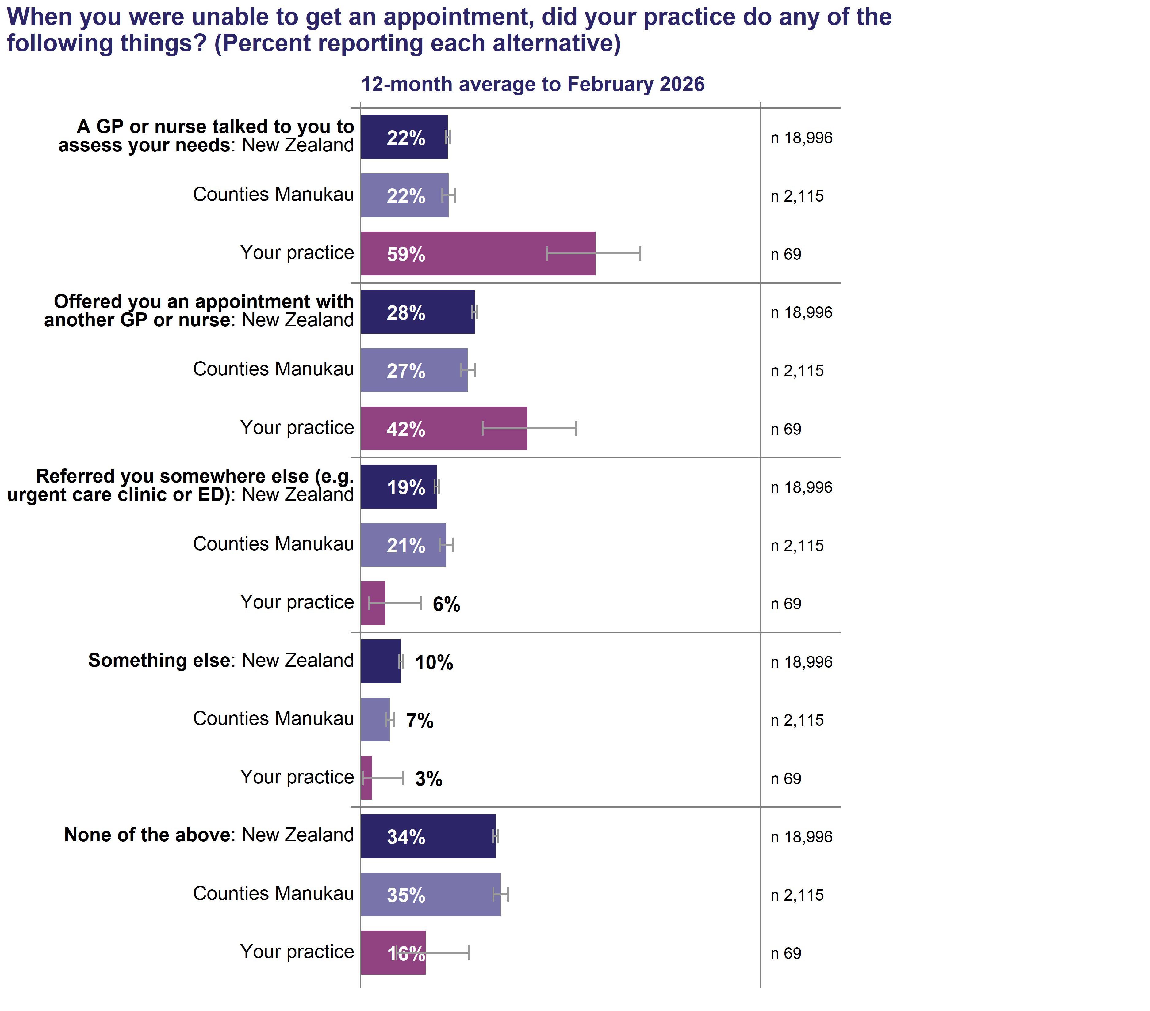
Respondents could select more than one option; therefore, percentages may sum to more than 100%. This question was only asked of patients who reported that waiting time to get an appointment was too long or that the GP or nurse they wanted to see was not available. The n value shown in the chart is the actual number of respondents answering this question. Some practices may have very small numbers of responses or no respondents.

Please tell us what happened when you were unable to get an appointment?
Selection of comments from your patients in the 12 months to February 2026
Patients were asked to describe what happened next when they said there was a time in the last 12 months when they wanted health care from a GP or nurse but couldn’t get it. They were provided with examples: Did you make an appointment for another day? Did you get care from somewhere else? Did your symptoms or condition get better or worse?
[ Comments removed ]

See the Practice Report – Resources and Technical Notes sections “Accessing your full results – Free-text patient comments” and “Method to select comments from your practice’s patients” for information on how to access all your free-text patient comments and how the comments shown above were selected for inclusion in this report.

Tip
- Having the patient access the right professional for their problem is helped by having a formal planned system for triage. Is your system working well?
- Each team member has special skills to bring to patient care, is all your team being used to best effect?
There is evidence that GP triage can free up appointments for those who really need it and increase patient satisfaction: GP triage for healthcare providers – Healthify.
Available at: https://healthify.nz/healthcare-providers/g/gp-triage-hcps
Support for improving triage and expanding roles can be found through PHOs, RNZCGP and Collaborative Aotearoa.
Available at: https://collab.org.nz/

Wait for next available appointment
This question shows how long respondents reported waiting for their most recent appointment. Nationally, the proportion of patients reporting they were able to get an appointment within seven days of booking has declined substantially since August 2020. Disabled people have consistently been more likely than other patients to report waiting longer than seven days for a booked appointment.
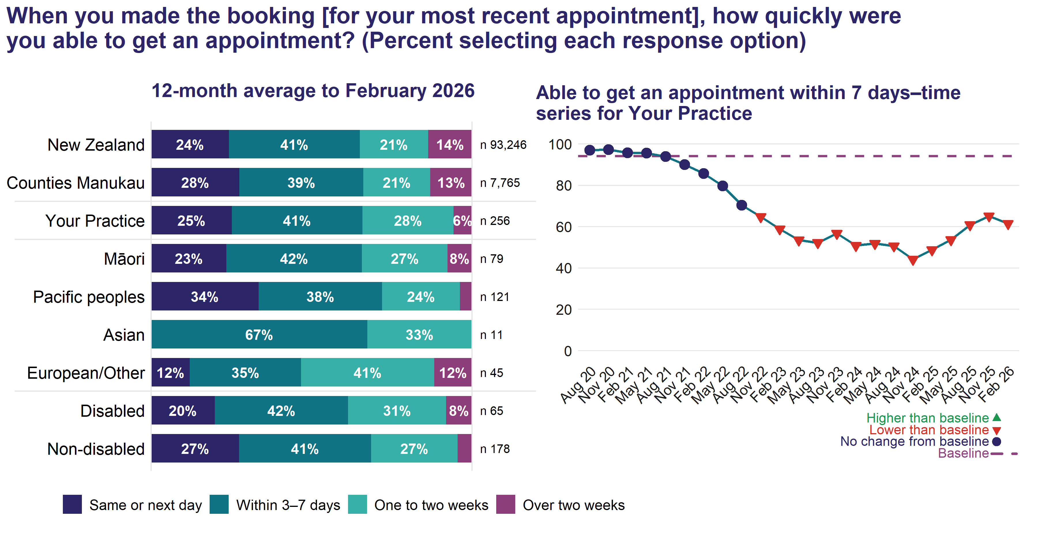
The n value shown in the chart is the actual number of respondents answering this question. An exponentially weighted moving average of your practice’s results from the most recent four quarters is shown by a circle or triangle at each point in the time-series.
In the 12 months to February 2026, 65.9 percent of patients at your practice reported they were able to get an appointment within 7 days. 6 percent reported they had to wait over two weeks.
Patients who had booked their appointment well in advance or attended a regular appointment can select ‘not applicable’ and are excluded from the percentage calculations.

How patient felt about the wait for next available appointment
National data consistently show that most people who waited 3–7 days for an appointment did not mind the wait. However, for some patients, even a 3–7 day wait is considered a bit too long or far too long. Note, respondents who are able to get an appointment on the same or next day are not asked this question.
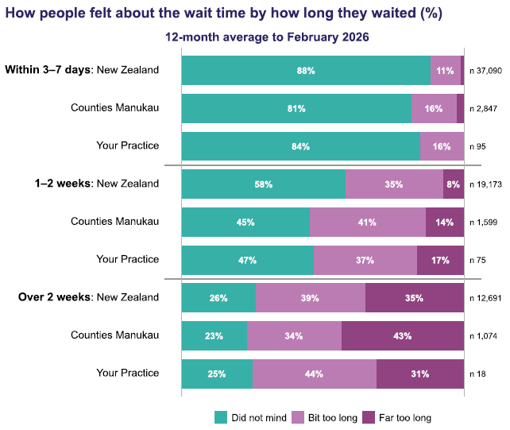
This question was only asked of patients who reported waiting longer than the same or next working day for a booked appointment. It was not asked of patients who indicated their appointment was booked well in advance or was a regular appointment. The n value shown for each waiting-time category is the actual number of respondents in that category who answered the question about how they felt about the wait.
In the 12 months to February 2026, 84.3 percent of patients at your practice who were able to get an appointment within 3–7 days reported that they did not mind the wait. However, 15.7 percent felt that even a 3–7 day wait was a bit too long or far too long.
See the section “Resources” in the Practice Report – Resources and Technical Notes for resources related to primary care access and appointment waiting times.

Treated with respect and kindness by reception/admin staff
Reception and admin staff are typically the first point of health care contact for most patients. This interaction from making the appointment, juggling appointment availability, greeting patients on arrival and managing payment is a key aspect of making sure patients feel at ease. Research has highlighted that the role of reception staff is particularly important for patients with high health and social needs² and can be a barrier to care.

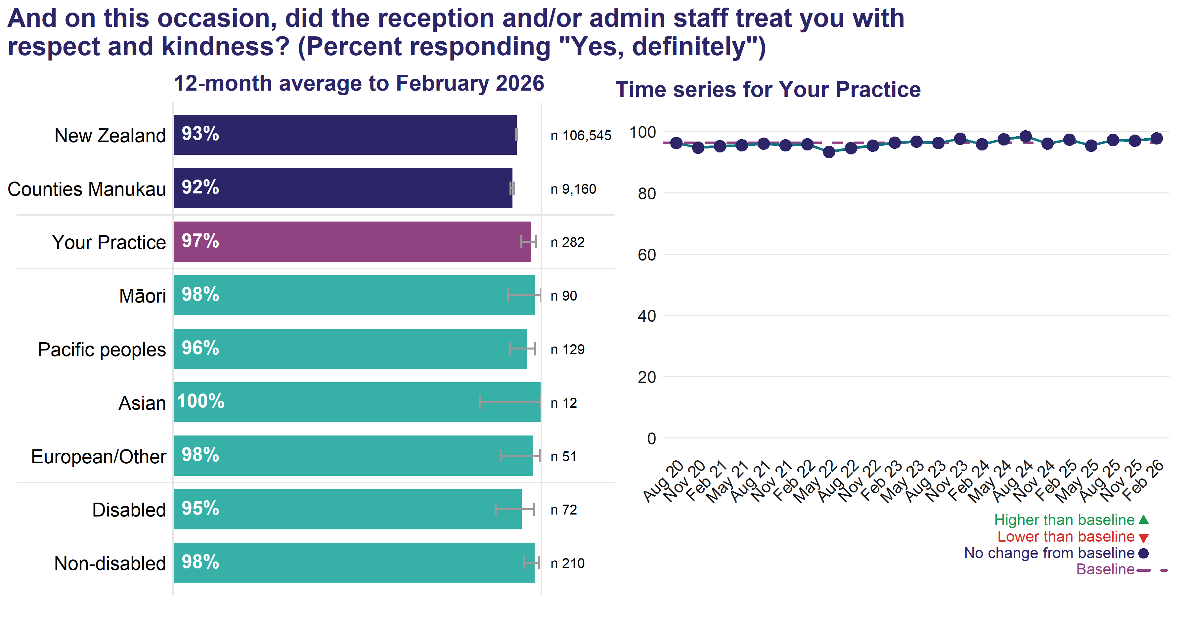

The n value shown in the chart is the actual number of respondents answering this question. An exponentially weighted moving average of your practice’s results from the most recent four quarters is shown by a circle or triangle at each point in the time-series
In the 12 months to February 2026, 97.2 percent of patients at your practice reported the reception/admin staff definitely treated them with respect and kindness at their most recent consultation.

Tip
While most patients report that reception and admin staff always treat with them respect, patient comments highlight the impact when this is not the case.
- What training do you have for your reception staff?
- Does it have a cultural safety element?

Heard of or used a GP online service or patient portal
Nationally, there is a consistent equity gap in the percent of people who have heard of or used a general practice online service or patient portal. Pacific peoples are consistently the least likely to have heard of or used a GP online service or patient portal, while European/Other people are consistently the most likely. Māori, Asian and disabled people are also less likely to have heard of or used a GP online service or patient portal.
Patient portals offer convenience to patients and can improve access to care, help patients play a greater role in managing their own care, and support a patient-centred approach within the practice.
For practices, benefits include saving time for practice staff, enabling GPs to focus on patients who most need face-to-face appointments, reducing phone calls and phone tag, and improving safety by patients being able to view a written record of clinical instructions.
Most practices in New Zealand now offer patient portals, and the College is of the view that these should be included as a business-as-usual feature of general practice (RNZCGP, Position statement: Specialist GP telehealth consultations. March 2024).
Evidence from the OpenNotes initiative highlights multiple benefits of sharing medical record visibility with patients, including improved self-management, which may help relieve pressure on services in a constrained workforce environment.
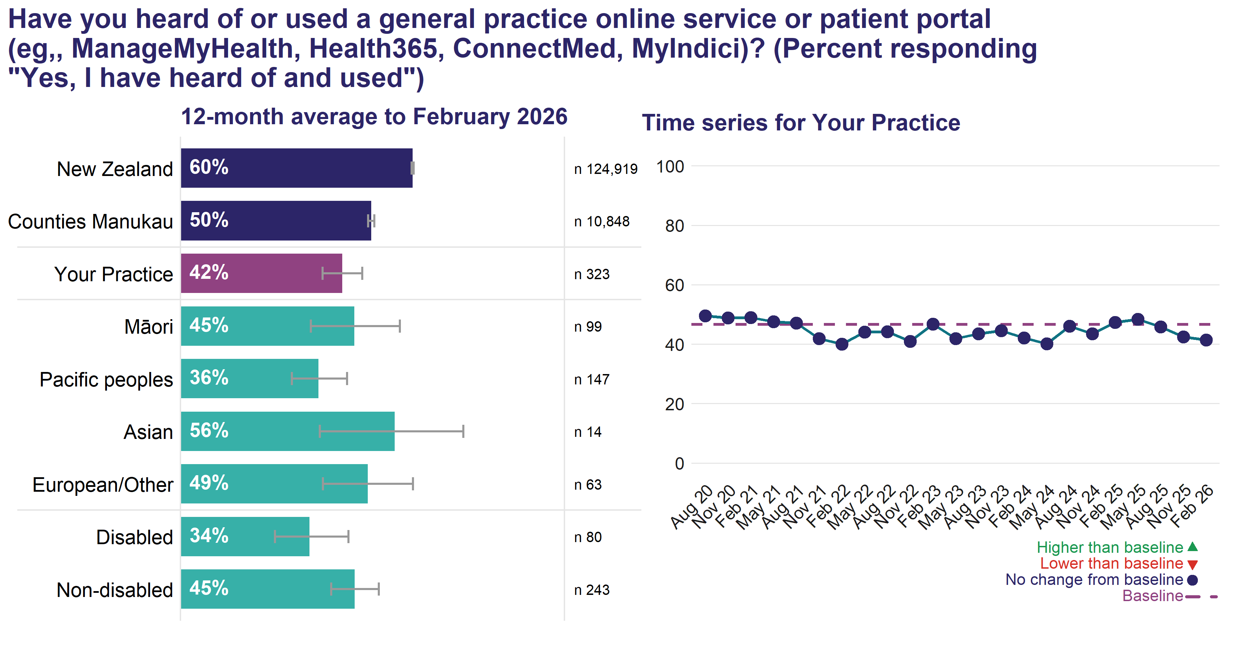

The n value shown in the chart is the actual number of respondents answering this question. An exponentially weighted moving average of your practice’s results from the most recent four quarters is shown by a circle or triangle at each point in the time-series.
In the 12 months to February 2026, 42.1 percent of patients at your practice reported they had heard of and used a GP online service or patient portal.

Tip
- How many of your patients are activated on the portal?
- Do you allow patients to message you through the portal? If so, do you have clear information for patients on how to use this function and associated charges?
- Do you have staff allocated to manage portal requests?
See the section “Resources” in the Practice Report – Resources and Technical Notes for resources on this question.

Accessibility needs met
Nationally, Māori, Pacific peoples, Asian and disabled people are less likely to report having their accessibility needs met. The adult primary care patient experience survey has found long-standing disparities in access to primary care for disabled people, and more so if they are younger³.
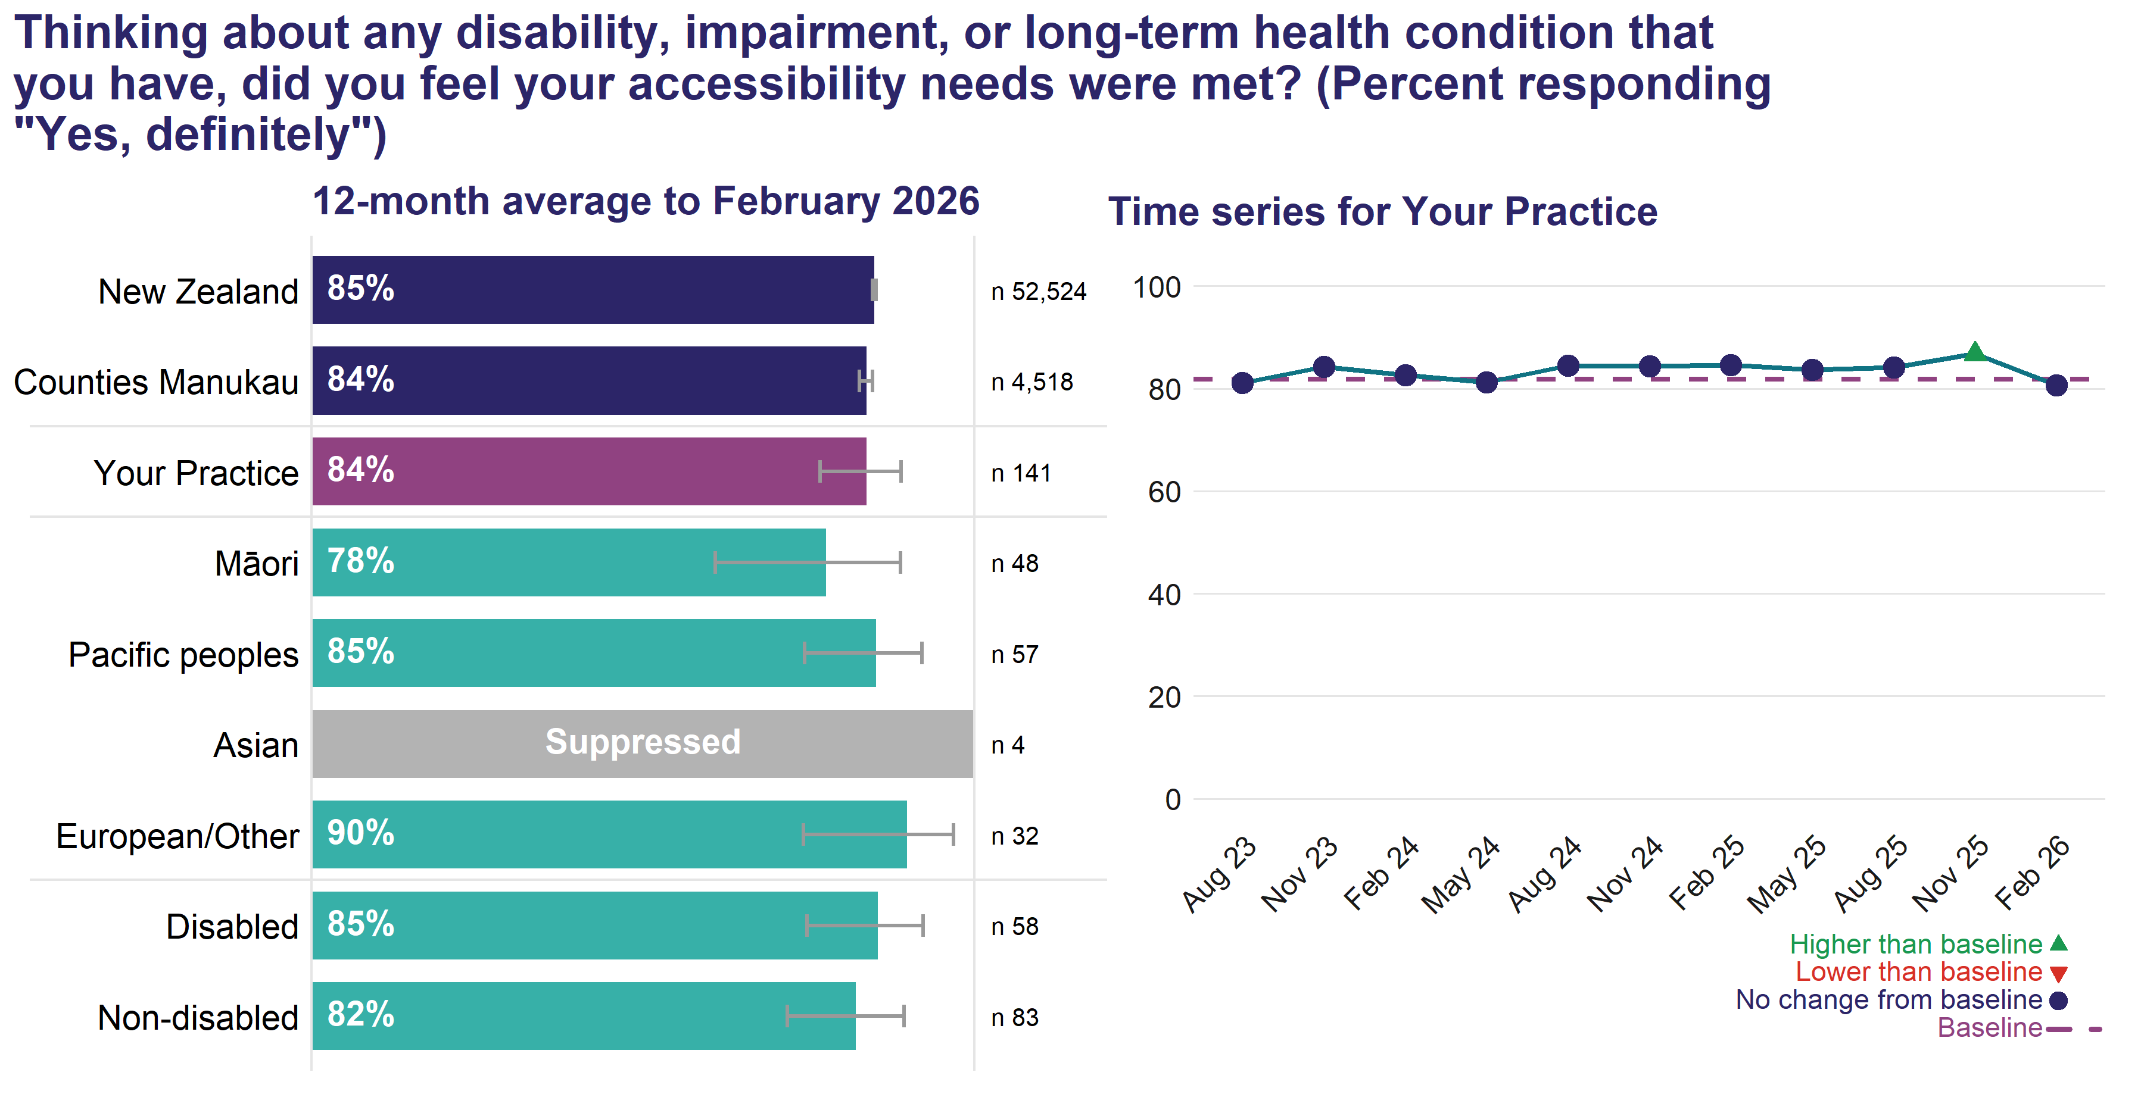
The n value shown in the chart is the actual number of respondents answering this question. An exponentially weighted moving average of your practice’s results from the most recent four quarters is shown by a circle or triangle at each point in the time-series.
In the 12 months to February 2026, 83.7 percent of patients at your practice with a disability, impairment or long-term health condition reported they definitely felt their accessibility needs were met at their most recent consultation.

Tip
- Do you offer alternatives to phone bookings for appointments?
- Is your clinic accessible for disabled people? Consider physical access, mental access (addressing fear/anxiety), communication and sensory barriers.
- Are you offering a patient portal to all patients? Do you use OpenNotes? Do you offer email via the portal? Can patients book appointments via the portal?
- Have you considered prioritising disabled people for consultations with their usual GP?
- How accessible are the resources and information you provide in your practice for disabled people? Are resources available in a range of formats?

Cultural safety

Name pronounced properly
In their cultural safety baseline report⁴ the Medical Council notes the importance of correct name pronunciation as part of welcoming patients into the practice. The Ngā Paerewa Standard 1.4.3 also signals the value of correct name pronunciation.
National results consistently show that Māori, Pacific peoples, Asian and disabled people are less likely to have their name pronounced correctly or to be asked how to say their name if the health care provider is uncertain, with Pacific peoples the least likely.
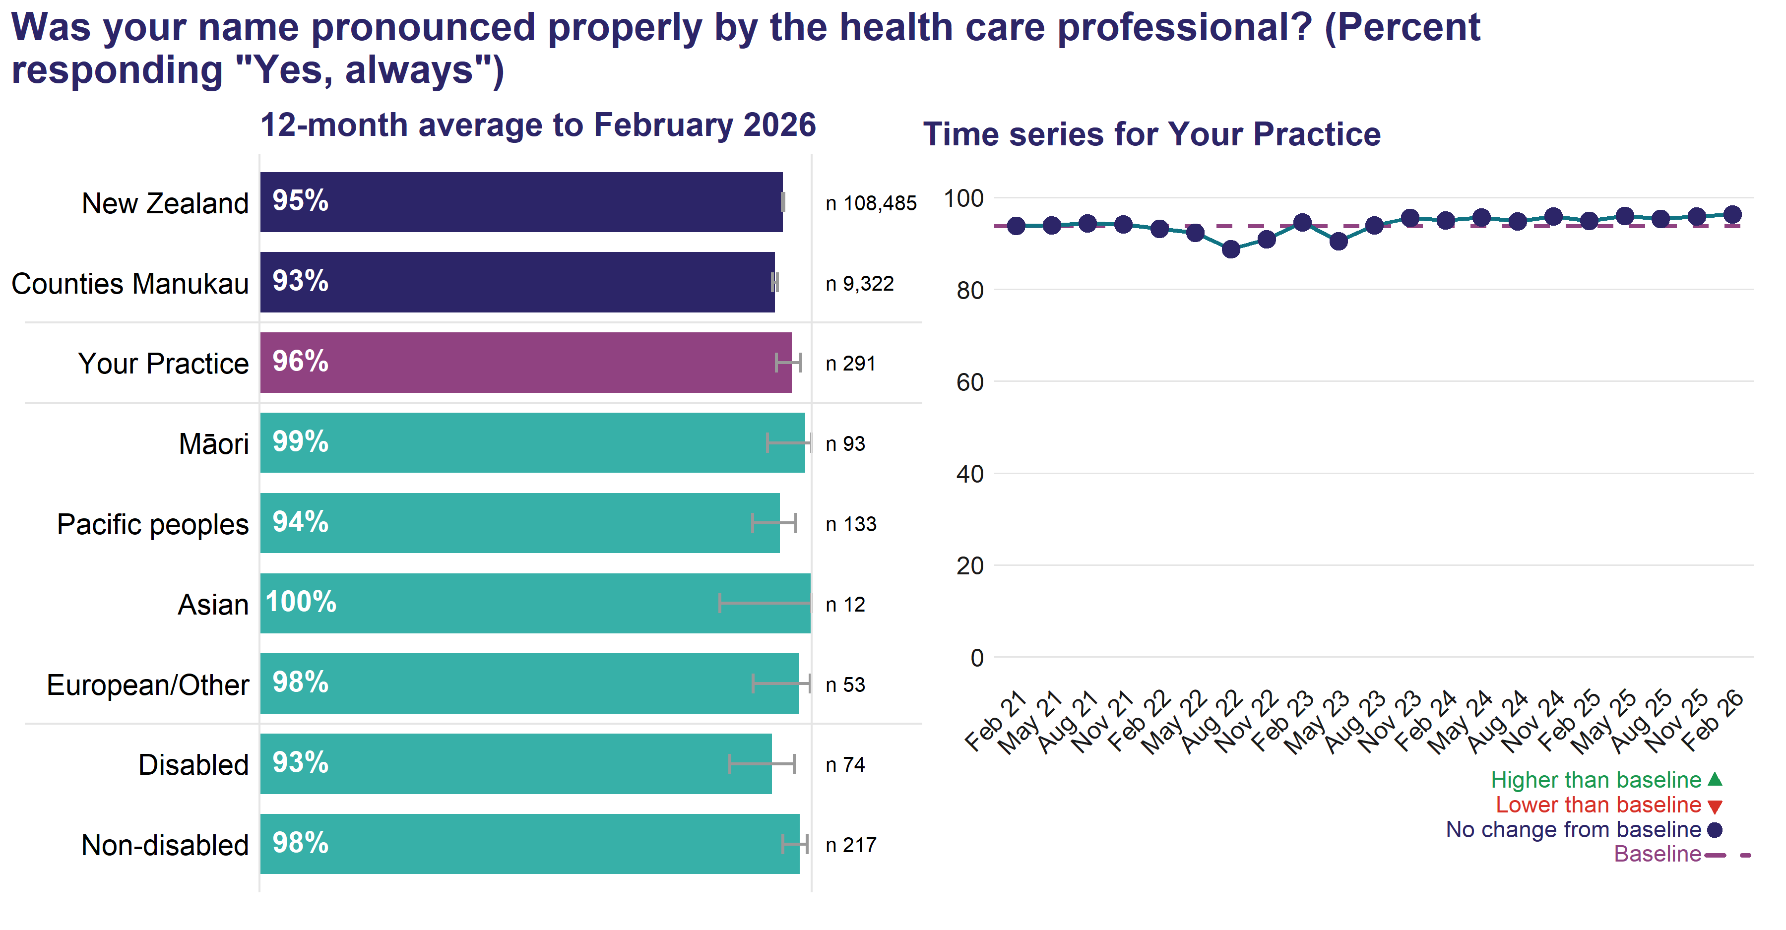
The n value shown in the chart is the actual number of respondents answering this question. An exponentially weighted moving average of your practice’s results from the most recent four quarters is shown by a circle or triangle at each point in the time-series.
In the 12 months to February 2026, 96.4 percent of patients at your practice reported during their most recent consultation their name was always pronounced properly by the health care professional.

Staff asked how to say patient’s name if uncertain
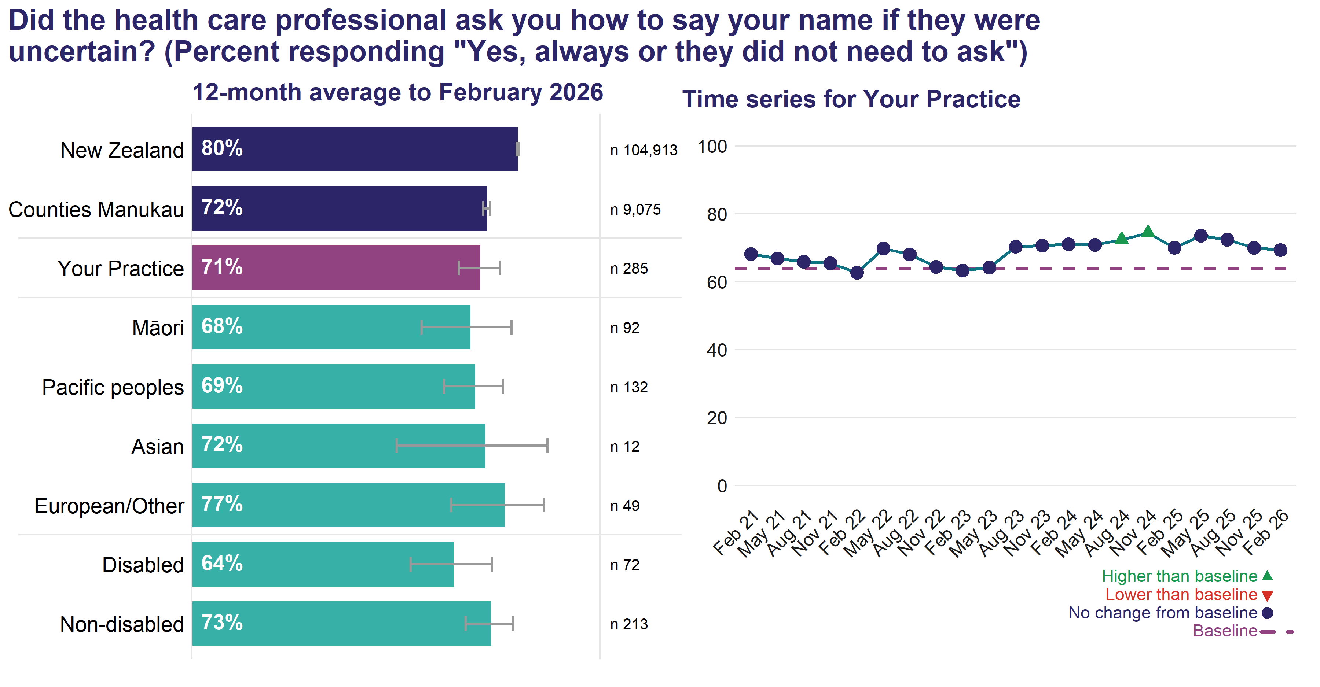
The n value shown in the chart is the actual number of respondents answering this question. An exponentially weighted moving average of your practice’s results from the most recent four quarters is shown by a circle or triangle at each point in the time-series.
In the 12 months to February 2026, 70.7 percent of patients at your practice reported during their most recent consultation the health care professional always asked how to say their name when uncertain or did not need to ask.

Family and whanau involved in discussions
Family and whānau involvement in treatment and care helps support self-management and promoting active partnership. Nationally, Māori, Pacific peoples, Asian and disabled people consistently report less involvement of their family and whānau in discussions about their treatment and care, with Pacific peoples reporting the lowest levels of involvement.
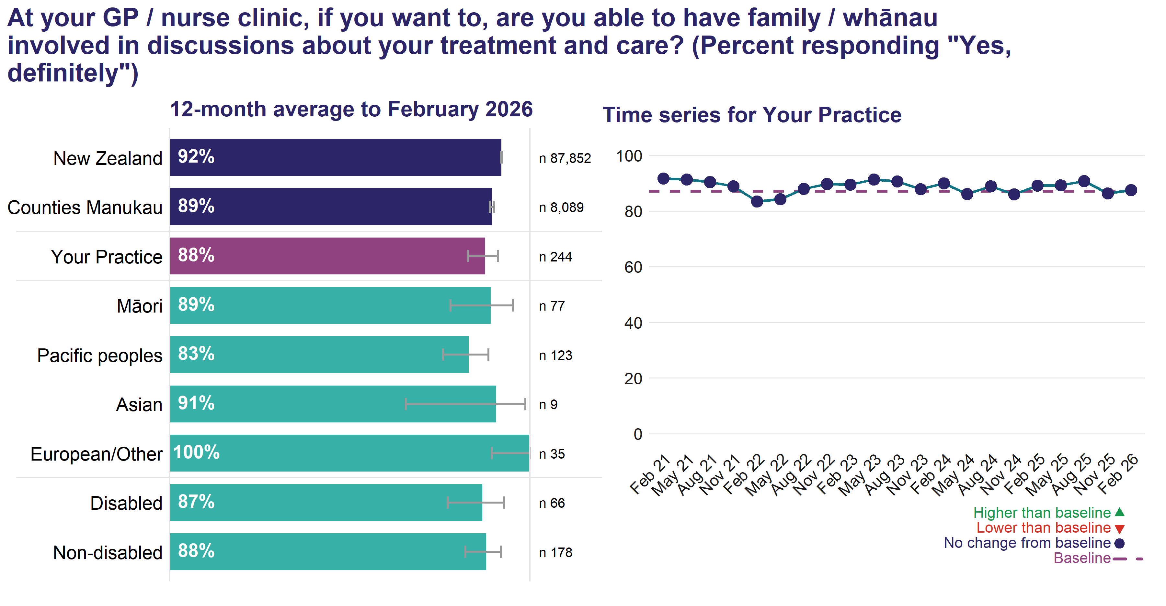
The n value shown in the chart is the actual number of respondents answering this question. An exponentially weighted moving average of your practice’s results from the most recent four quarters is shown by a circle or triangle at each point in the time-series.
In the 12 months to February 2026, 87.5 percent of patients at your practice reported they were definitely able to have family and whānau involved in discussions about their treatment and care, if they wanted this.

Cultural needs met
This question is a useful way to monitor how well patients’ cultural needs are being met in your practice. A related question asks whether spiritual needs were met, and responses to both questions are usually the same. Recent research in New Zealand suggests that interventions that improve patient perceptions of cultural respect may be linked to improved healthcare utilisation.⁵
The Medical Council’s report⁴ on cultural safety identifies the value of including wairuatanga in health care. They state: ‘it was strongly expressed that health care providers need to consider the specific practices, values and beliefs associated with an individual’s connection to people and place and include this in the caring of whānau Māori’.
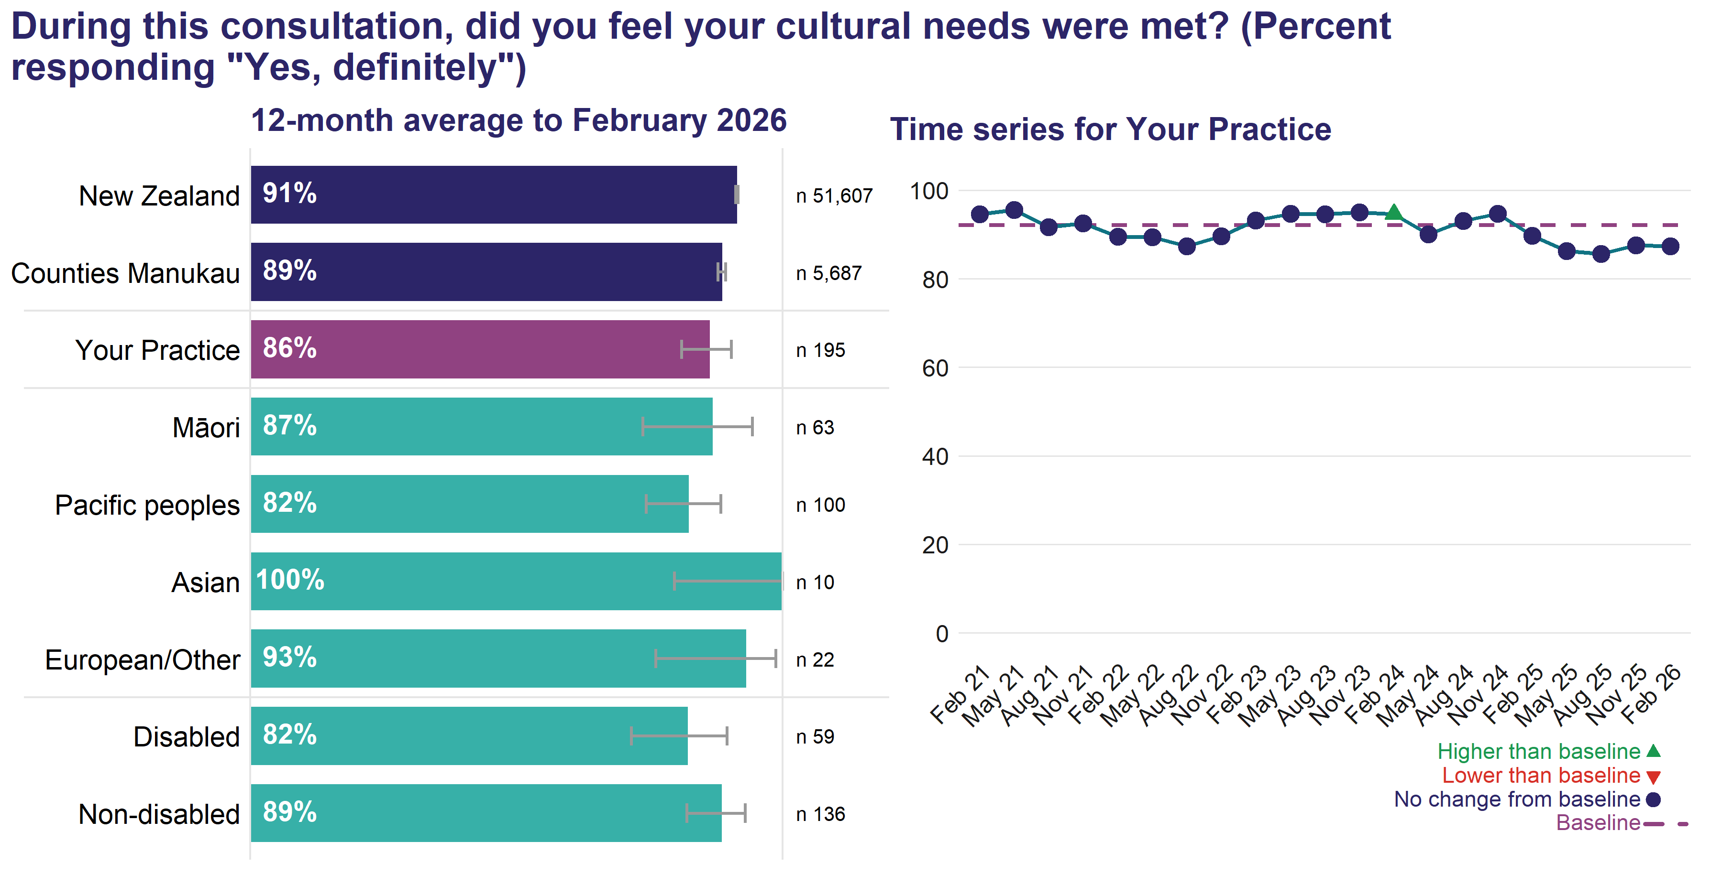
The n value shown in the chart is the actual number of respondents answering this question. An exponentially weighted moving average of your practice’s results from the most recent four quarters is shown by a circle or triangle at each point in the time-series.
In the 12 months to February 2026, 86.3 percent of patients at your practice reported, if they had cultural needs, these were definitely met during their most recent consultation.

Not treated unfairly
Overall, most patients generally reported they are treated fairly, however the goal might be that no patient ever feels unfairly treated. Nationally, Māori, Pacific peoples, Asian and disabled people are consistently more likely to report feeling they were treated unfairly during their most recent consultation, with Pacific peoples generally reporting the highest level of being treated unfairly. One of the outcomes set out in Pae Tū: Hauora Māori Strategy is that the health system addresses racism and discrimination in all its forms.
Available at: https://www.health.govt.nz/publication/pae-tu-hauora-maori-strategy
When asked about what made people feel unfairly treated, common themes at a national level were not feeling listened to, feeling the appointment was rushed, and their concerns were not heard.
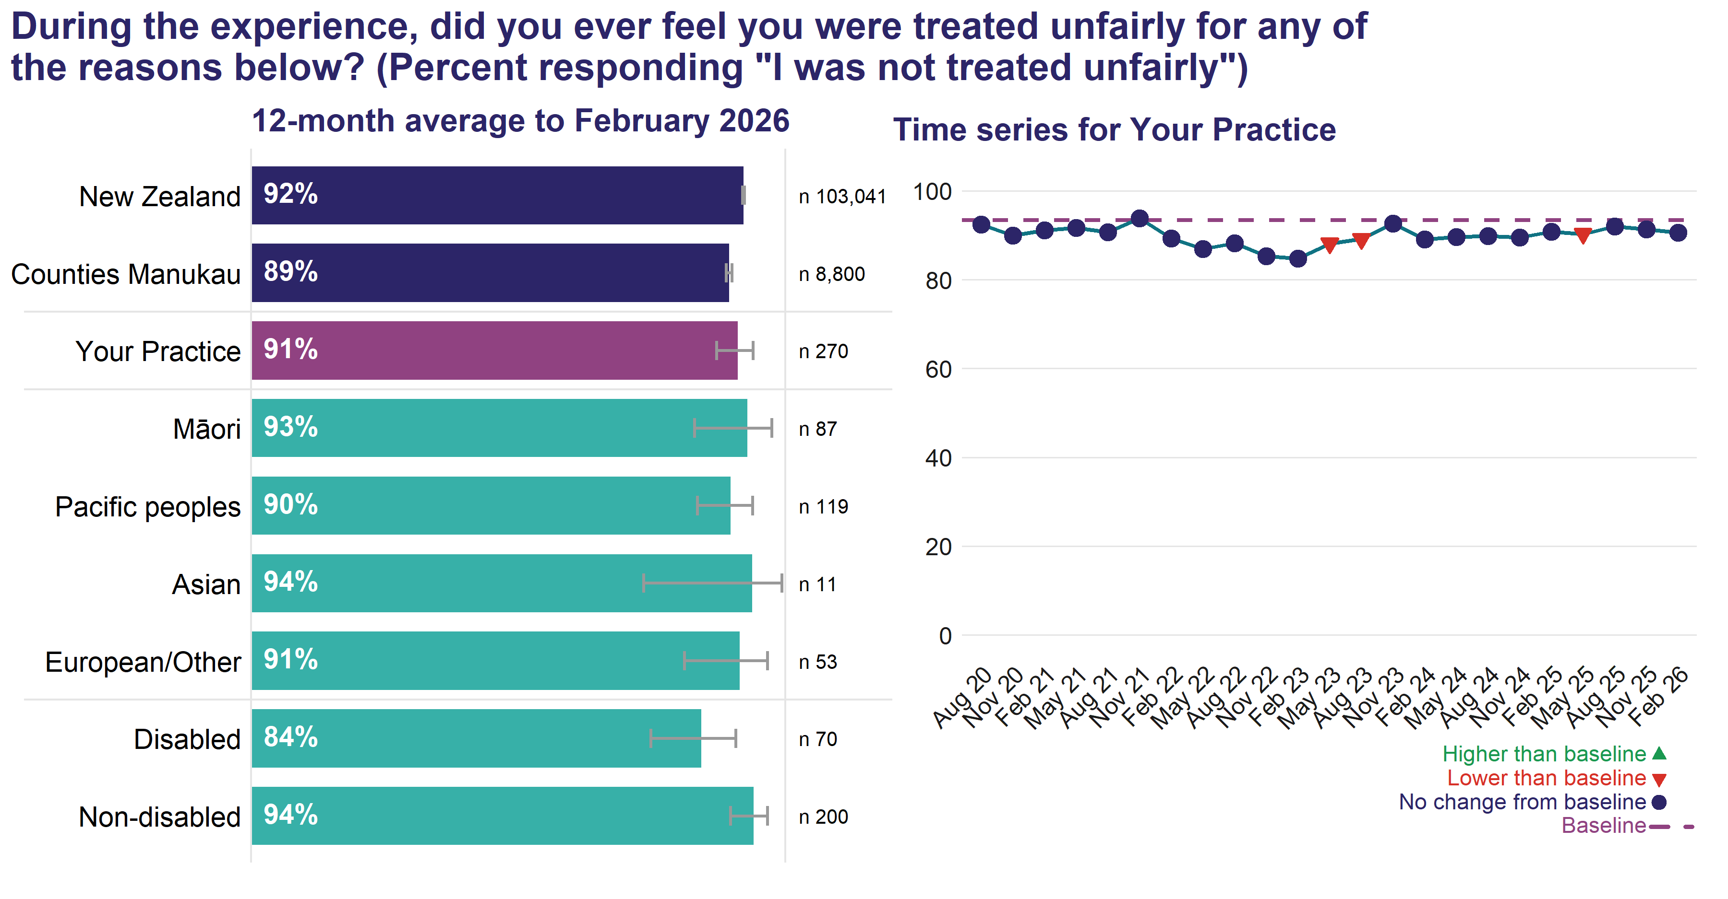
The n value shown in the chart is the actual number of respondents answering this question. An exponentially weighted moving average of your practice’s results from the most recent four quarters is shown by a circle or triangle at each point in the time-series.
For this question, patients were shown a list of reasons for why they might have felt treated unfairly, such as their skin colour, age, disability, physical or mental health condition. The list included “I was not treated unfairly”.
In the 12 months to February 2026, 91.1 percent of patients at your practice reported they did not feel unfairly treated at their most recent consultation.
See the section “Resources” in the Practice Report – Resources and Technical Notes for resources on the questions included in the Cultural Safety theme.

Communication/Relational Aspects
These questions seek to understand the quality of communication between the patient and their health care provider. There is strong evidence that patients who feel treated with respect, feel listened to, trust their health care provider and are involved in decision-making are more likely to follow practitioner’s advice. This includes better adherence to prescribed medications and better uptake of preventive care such as health-promoting behaviour, use of screening services and immunisation.⁶⁷

Listened to by health care professional
Allowing the patient time to tell their story is a pivotal part of the medical encounter. When patients are allowed to talk without interruption, they are more likely to report feeling listened to. Research shows that health care practitioners often interrupt patients when they are telling their story, and if allowed to continue most patients talk for a median of six seconds more.⁸
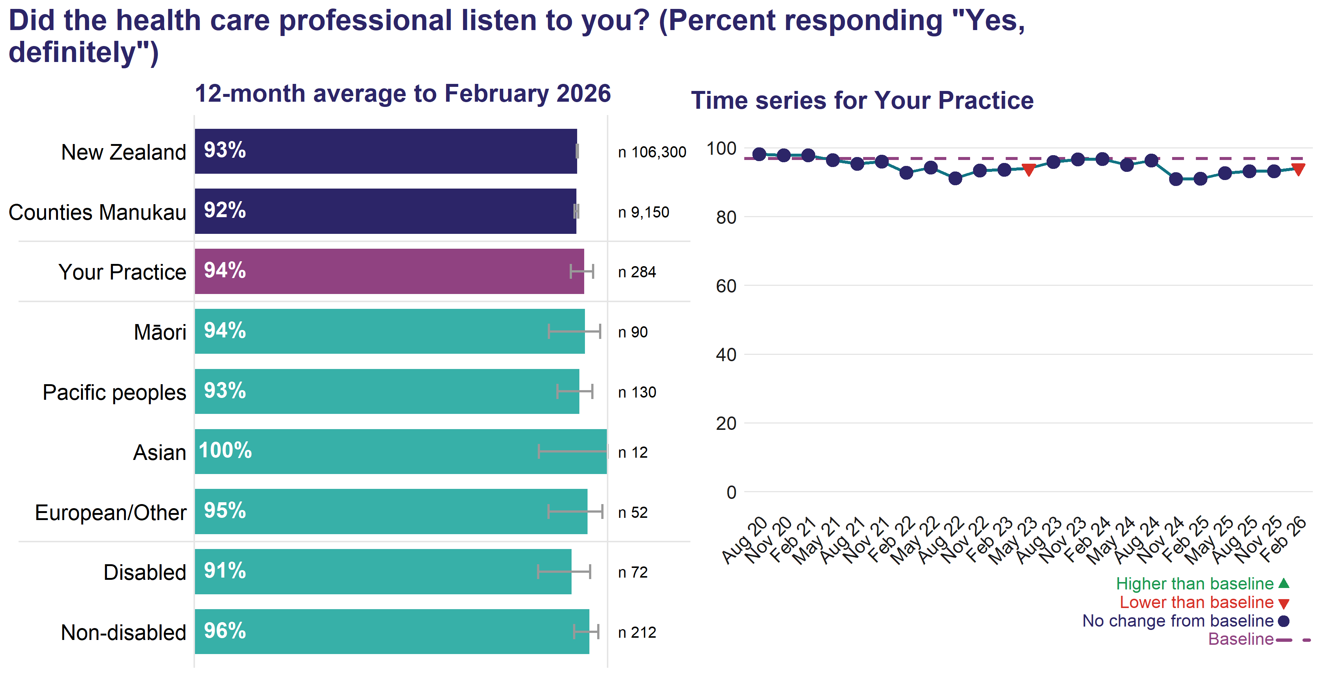
The n value shown in the chart is the actual number of respondents answering this question. An exponentially weighted moving average of your practice’s results from the most recent four quarters is shown by a circle or triangle at each point in the time-series.
In the 12 months to February 2026, 94.3 percent of patients at your practice reported the health care professional definitely listened to them during their most recent consultation.

Things explained in an understandable way
Presenting health information in a way that a person can understand is a responsibility for health care professionals. Health literacy is the foundation for consumer and whānau engagement. Health literate patients are able to obtain, understand and use basic health information to navigate health services and make appropriate health decisions.
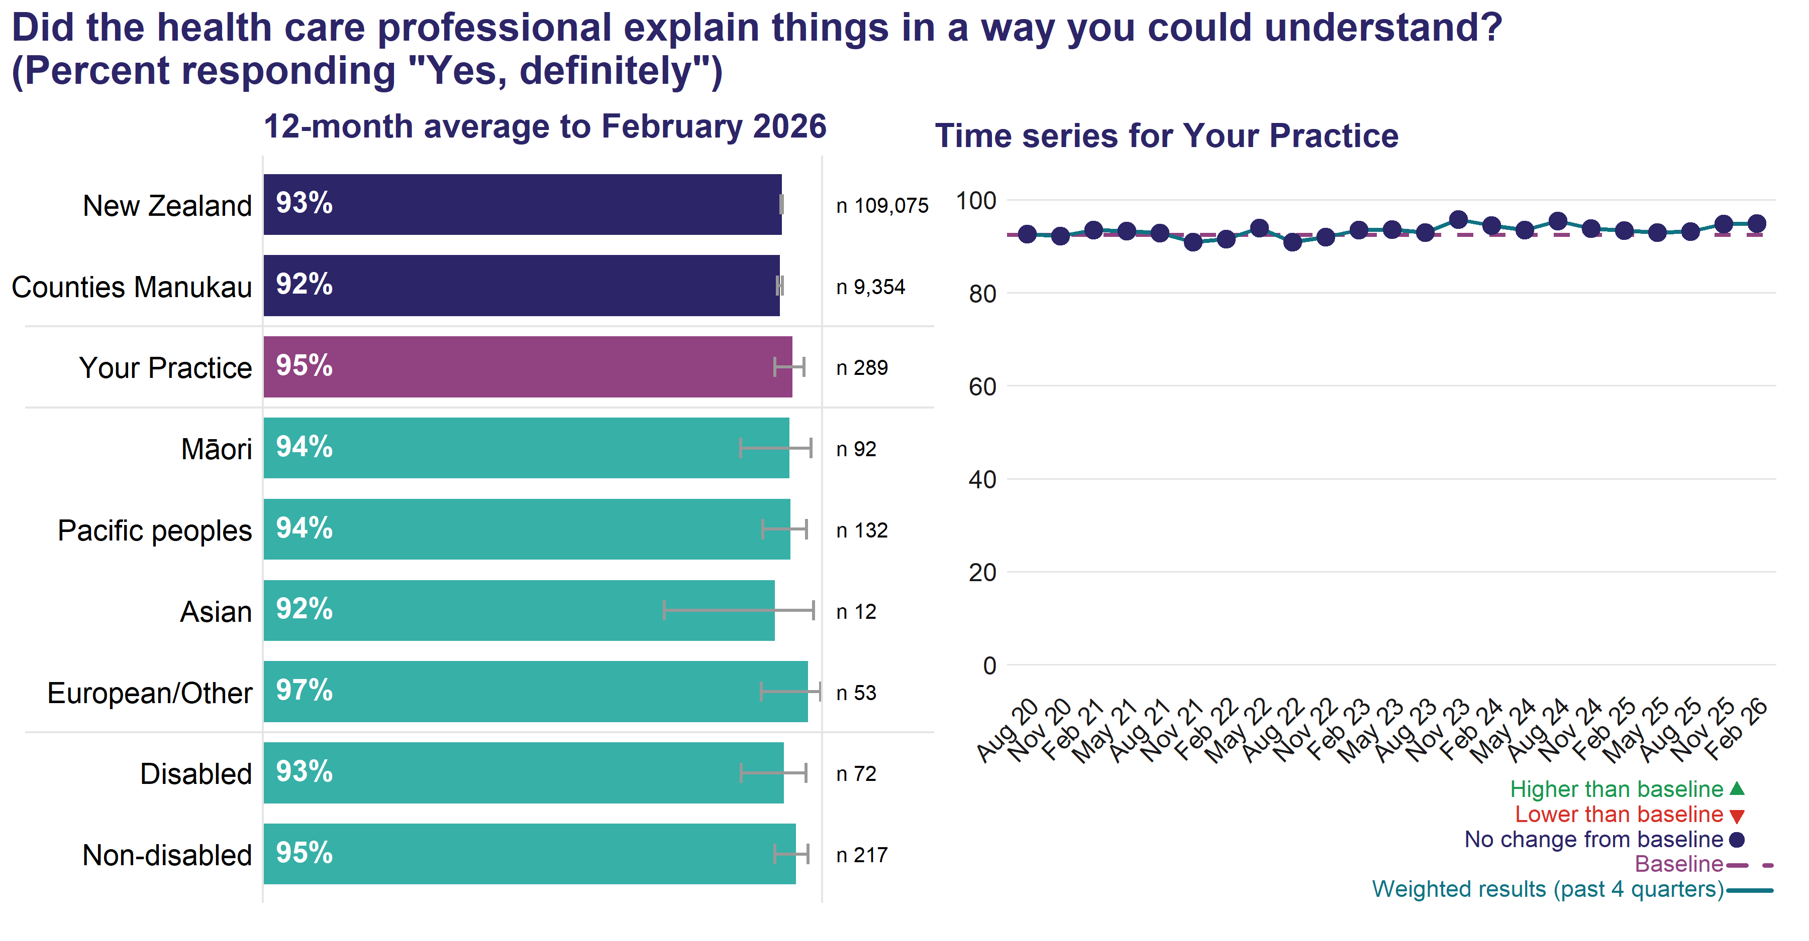
The n value shown in the chart is the actual number of respondents answering this question. An exponentially weighted moving average of your practice’s results from the most recent four quarters is shown by a circle or triangle at each point in the time-series.
In the 12 months to February 2026, 94.7 percent of patients at your practice reported the health care professional definitely explained things in a way they could understand during their most recent consultation.

Comfortable to ask questions
Patients feeling comfortable to ask their health care provider questions is a component of effective patient engagement and shared decision making. It is useful to compare responses to this question to the question on being involved in decisions about treatment and care.
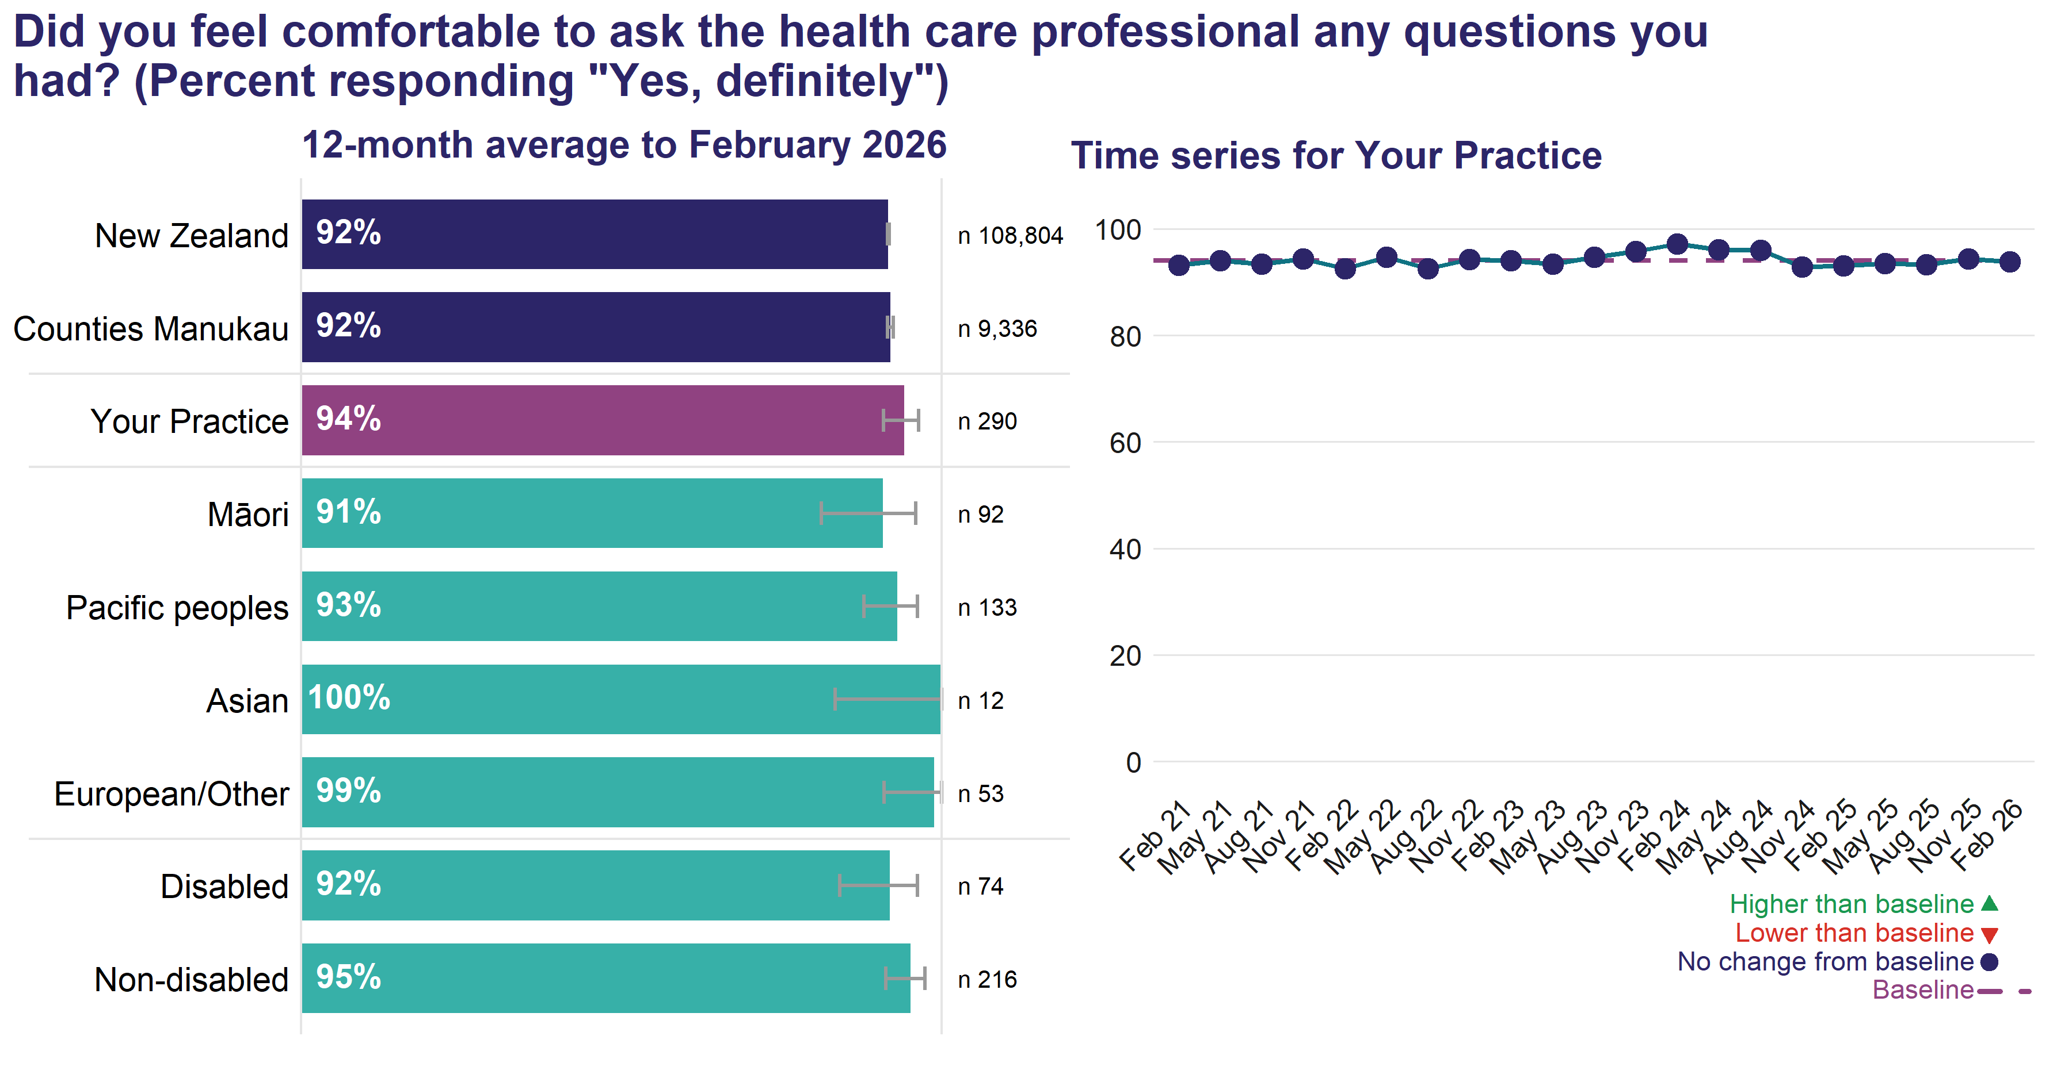

The n value shown in the chart is the actual number of respondents answering this question. An exponentially weighted moving average of your practice’s results from the most recent four quarters is shown by a circle or triangle at each point in the time-series.
In the 12 months to February 2026, 94.2 percent of patients at your practice reported they definitely felt comfortable to ask questions they had during their most recent consultation.

Involved in decisions about treatment and care
Being involved in decisions about care and treatment as much as is wanted, is a critical component of ensuring patients accept practitioner’s advice. Patients who participate in their decisions report higher satisfaction with care; have higher knowledge of their condition, tests, and treatment; have more realistic expectations about benefits and harms; are more likely to adhere to screening, diagnostic, or treatment plans; and have reduced decisional conflict and anxiety.⁸
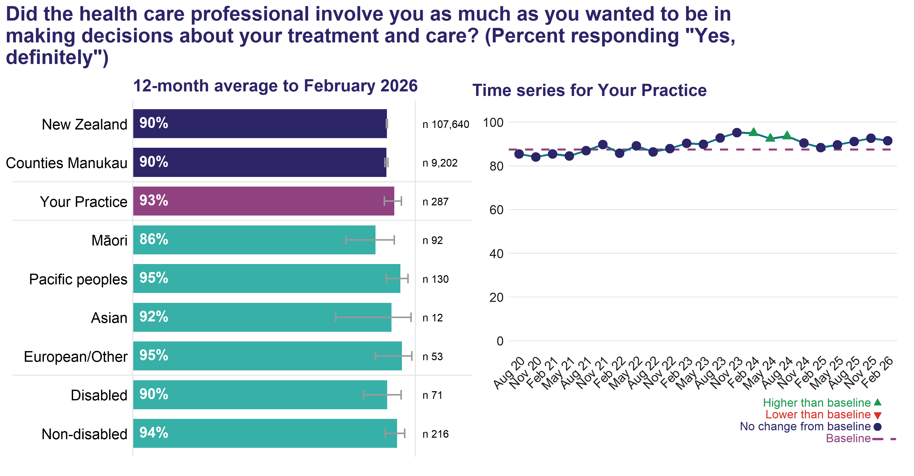
The n value shown in the chart is the actual number of respondents answering this question. An exponentially weighted moving average of your practice’s results from the most recent four quarters is shown by a circle or triangle at each point in the time-series.
In the 12 months to February 2026, 92.5 percent of patients at your practice reported the health care professional involved them as much as they wanted to be in decisions about their treatment and care at their most recent consultation.
See the section “Resources” in the Practice Report – Resources and Technical Notes for resources on the questions included in the Communication/relational aspects theme.

What could have been done better to involve you in decisions about your treatment and care?
Selection of comments from your patients in the 12 months to February 2026
[ Comments removed ]

See the Practice Report – Resources and Technical Notes sections “Accessing your full results – Free-text patient comments” and “Method to select comments from your practice’s patients” for information on how to access all your free-text patient comments and how the comments were selected.

Overall experience
The free-text comments below are a sample of people’s overall view of their most recent experience with your practice in the 12 months to February 2026

What do you think would have made your visit/video call/phone call appointment better?
[ Comments removed ]

What do you think went well about your visit/video call/phone call?
[ Comments removed ]

See the Practice Report – Resources and Technical Notes sections “Accessing your full results – Free-text patient comments” and “Method to select comments from your practice’s patients” for information on how to access all your free-text patient comments and how the comments were selected.

Responses
The table shows the number of respondents for your practice by survey quarter.

Tip
Fewer than 30 responses mean the results are less generalisable. To improve response rates for Māori and Pacific peoples, they are invited by both email and SMS, where both contact details are available. This approach means that nationally, the response rates for Māori are the same as non-Māori, non-Pacific peoples.

Ways to improve response rates (resources are available via the link below):
- Inform and promote the survey to patients during the sample period. This includes putting up posters, playing the video and making flyers available.
- Ensure reception staff are prepared to answer questions.
- Each quarter ensure email addresses are collected and are current. Undertaking an audit to see what proportion of patients have an email address collected is a useful way to know whether as many patients as possible are invited.

Resources:
- Survey resources for healthcare staff
Available at: https://www.hqsc.govt.nz/our-data/patient-reported-measures/patient-experience/survey-resources-for-health-care-staff/

Further information

Useful links
Information on the survey, including the questionnaire:
Patient experience | Te Tāhū Hauora Health Quality & Safety Commission
Available at: https://www.hqsc.govt.nz/our-data/patient-reported-measures/patient-experience/
Using adult primary care patient experience survey data for quality improvement:
From PES to PDSA – Workbook
Available at: https://www.hqsc.govt.nz/resources/resource-library/from-pes-to-pdsa-workbook-using-adult-primary-care-patient-experience-survey-data-for-quality-improvement/

References
1. Schneider, E. C., Sarnak, D. O., Squires, D., et al. (2017). Mirror, mirror 2017: International comparison reflects flaws and opportunities for better U.S. Health care. Commonwealth Fund. https://www.commonwealthfund.org/publications/fund-reports/2017/jul/mirror-mirror-2017-international-comparison-reflects-flaws-and
2. Neuwelt, P. M., Kearns, R. A., & Cairns, I. R. (2016). The care work of general practice receptionists. Journal of Primary Health Care, 8(2), 122–129. https://doi.org/10.1071/HC15059
3. A window on quality 2022: COVID-19 and impacts on our broader health system (part 2). (2022). Te Tāhū Hauora Health Quality & Safety Commission. https://www.hqsc.govt.nz/assets/Our-data/Publications-resources/COVIDWindow2022Part2-final-web.pdf
4. Medical Council of New Zealand. (2020). Cultural safety baseline data report: FINAL september 2020. Medical Council of New Zealand. https://www.mcnz.org.nz/assets/Publications/Reports/f5c692d6b0/Cultural-Safety-Baseline-Data-Report-FINAL-September-2020.pdf
5. Lee, C. H. J., & Sibley, C. G. (2023). Ethnic group differences in patient satisfaction with GP services: Findings from the new zealand attitudes and values study [abstract only-full article available to subscribers]. New Zealand Medical Journal, 136(1578). https://nzmj.org.nz/journal/vol-136-no-1578/ethnic-group-differences-in-patient-satisfaction-with-gp-services-findings-from-the-new-zealand-attitudes-and-values-study
6. Anhang Price, R., Elliott, M. N., Zaslavsky, A. M., Hays, R. D., Lehrman, W. G., Rybowski, L., Edgman-Levitan, S., & Cleary, P. D. (2014). Examining the role of patient experience surveys in measuring health care quality. Medical Care Research and Review, 71(5), 522–554. https://www.ncbi.nlm.nih.gov/pmc/articles/PMC4349195/
7. Doyle, C., Lennox, L., & Bell, D. (2013). A systematic review of evidence on the links between patient experience and clinical safety and effectiveness. BMJ Open, 3(1), e001570. https://bmjopen.bmj.com/content/3/1/e001570.full.pdf
8. Krist, A. H., Tong, S. T., Aycock, R. A., & Longo, D. R. (2017). Engaging patients in decision-making and behavior change to promote prevention. Information Services and Use, 37(2), 105–122. https://doi.org/10.3233/ISU-170826

