

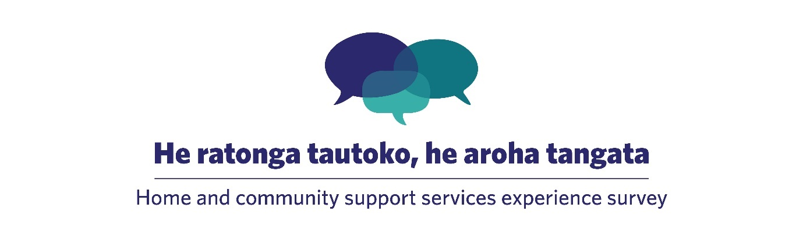

**Using home and community support services experience survey data for quality improvement**

July 2025

Published July 2025 by Te Tāhū Hauora Health Quality & Safety Commission,   
PO Box 25496, Wellington, 6146.

ISBN: 978-1-991122-33-9

Available online at [www.hqsc.govt.nz](http://www.hqsc.govt.nz)

Enquiries to: [info@hqsc.govt.nz](mailto:info@hqsc.govt.nz)

This work is licensed under the Creative Commons AttributionNonCommercial-ShareAlike 4.0 International   
(CC BY-NC-SA 4.0). To view a copy of this licence, visit <https://creativecommons.org/licenses/by-nc-sa/4.0>



Contents

Purpose 5

Finding your quality improvement opportunity 5

Before you start 8

Model for Improvement 9

Plan 13

Do 13

Study 13

Act 14

Tell everyone 14

Appendix 1: PDSA template 15

Appendix 2: PDSA example (Plan) 17

Appendix 3: Provider A improvement plan 23

Appendix 4: ‘You said, we did’ poster 27

Appendix 5: Resources 28

Figures

Figure 1: Lowest-scoring question nationally, 2024 7

Figure 2: Second lowest-scoring question nationally, 2024 7

Figure 3: Third lowest-scoring question nationally, 2024 7

Figure 4: Model for Improvement 9

Table 1: Example problem statements 10

Table 2: Define your aim 11

Table 3: Example change ideas 12

Figure 5: Change prioritisation matrix 13

Tables

Table 1: Example problem statements 10

Table 2: Define your aim 11

Table 3: Example change ideas 12

Purpose

This document is designed to help you engage with your data from the home and community support services experience survey (HCSS survey) and to conduct quality improvement initiatives and track their progress.

Reasons for reviewing experience survey feedback include the following.

It helps providers understand what they are doing that benefits their clients the most and identify where opportunities exist for improvement.

It helps providers to maintain a strong client–provider relationship by listening and responding to feedback. This can encourage people to remain with the provider and help maintain the provider’s reputation in the community.

It respects and honours the time people have taken to give feedback.

* It enhances performance aligned to the Ngā Paerewa Health and Disability Support Services Standard,[1] the National Framework for Home and Community Support Services[2] and the principles of Enabling Good Lives.[3]

It helps to generate data that can be used as evidence to meet contractual requirements, for example, for the Accident Compensation Corporation and Health New Zealand | Te Whatu Ora.

Finding your quality improvement opportunity

Working with clients, whānau and the community from the start can help you identify topics for improvement that are important to them. You may already know the area you wish to focus on, or you may be relying on your survey results. The survey results summary report sent to you by Te Tāhū Hauora Health Quality & Safety Commission gives you an immediate snapshot of where to focus. You can quickly see where you are doing well and areas to work on. Topics for improvement can come in many forms. You may want to look at:

a low-scoring question

variation between your service and the national average

variation between groups of people (if you are a small provider, you can look at the national trends to understand what it might look like for your client groups)

themes or improvement suggestions emerging from your qualitative comments.

**Example 1: Identify your improvement opportunity from the three bottom-scoring questions**

The *Home and community support services: National results 2024* report[4] shows the national average for the three top-scoring questions and the three bottom-scoring questions. The three highest-scoring questions show the respect of support workers for their clients, their culture, spirituality and beliefs, and this should be recognised and celebrated. This is directly related to Right 1 of the Code of Health and Disability Consumers’ Rights: the ‘Right to be treated with respect’.

The following figures show the lowest-scoring question results from the national survey in 2024. These questions all directly relate to the Code of Health and Disability Consumers’ Rights, specifically: Right 6, the ‘Right to be fully informed’; and Right 10, the ‘Right to complain’. This means several standards and criteria within the Ngā Paerewa Health and Disability Services Standard ‘Section 1.6: Effective communication occurs’ are directly applicable.

Figure 1: Lowest-scoring question nationally, 2024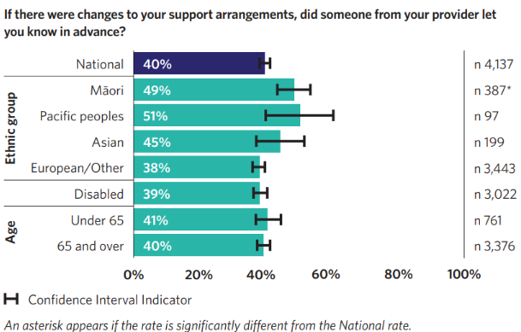

Figure 2: Second lowest-scoring question nationally, 2024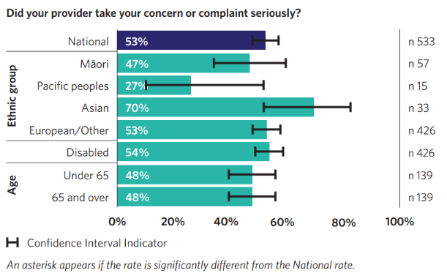

Figure 3: Third lowest-scoring question nationally, 2024

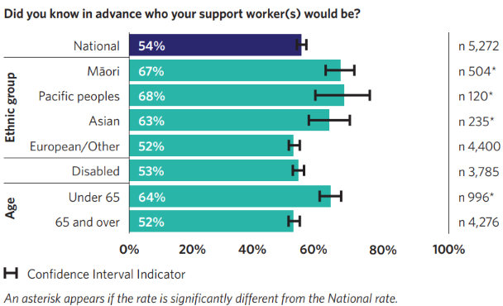

Qualitative comments from the surveys support the concerns shown in these results. For example:

‘Carers are great. Support staff in [the] office need to sort themselves out. I often have to ring several times and still no one gets the notes left or carers turn up when cancelled or instructions given so many times are overlooked.’

**Benchmarking**. Within these results, variation is evident above and below the national average for individual service providers, and it may be possible to learn from higher performing providers. That said, even high performing providers may still have room for improvement.

**Equity.** These questions show little variation between the different demographic groups (age, gender, ethnicity and disability status), but individual providers may find some differences between groups. When undertaking improvement, you need to be careful you do not improve services for one group more than for any other and create or widen an equity gap. You will need to monitor the results from these groups throughout any improvement project.

Before you start

Before you start, think about how you will manage any potential ethical risks for the staff and clients involved and how you will manage the use of new or existing data. When involving clients in quality improvement efforts, be respectful of them, their time and their data. People need to know what you are asking of them and what is involved. Is this new or existing data? If you are using existing data, are you using it for its intended purposes as agreed to by clients? If they are sharing new data and information, what use will be made of that data and how will it be managed? While quality improvement projects usually do not require a full ethical review, you do still need to consider ethical risks and plan how to eliminate or minimise them for participants. Team discussions and consulting professional peers are a good basis to start from.

The full guidance on ethical review of quality improvement activities is available within the 2019 National Ethical Standards for Health and Disability Research and Quality Improvement.[5]

Model for Improvement

The Model for Improvement (Figure 4). provides a common and consistent approach to improving the quality of care and can be a useful model to improve your processes and implement change. The quality improvement project process first asks three fundamental questions.

1. What are we trying to accomplish?
2. How will we know that a change is an improvement?
3. What changes can we make that will result in an improvement?

This is followed by the iterative testing to learn, action-oriented Plan–Do–Study–Act (PDSA) cycles. It is important to include clients in the process to get feedback It is also important to assess the impact of changes to verify that interventions have made a difference.

Figure 4: Model for Improvement[6]

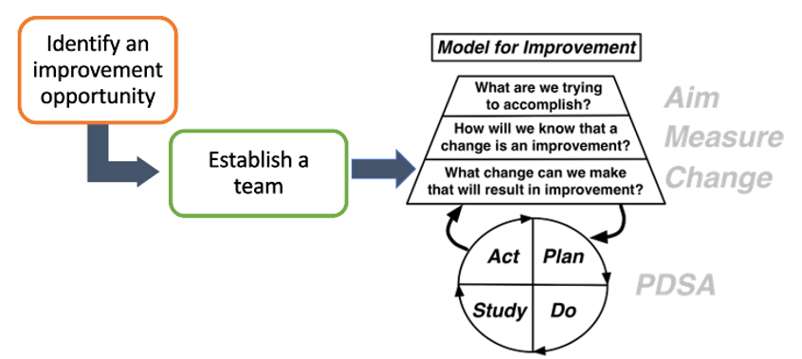

Gather your team

Now that you have clearly identified an opportunity for improvement and found data to support it, gather a team to help you understand and solve the problem. Developing a short description of what you have found, why it is important to address (called a problem statement) and why you need people to work with you on this (sometimes called an ‘elevator pitch’) can help you engage participants more easily.

Having staff, clients, family and whānau working together can create ideas that will work for both clients and staff because they are not based on assumptions. If you want to learn more about co-design and developing an ‘elevator pitch’ to engage others, you can complete a free online learning programme at Ko Awatea Learn.[7]

Finally, assign a leader for your project, to ensure follow-up and check on progress. This might be you.

Two providers (A and B) have both decided to work on the lowest-scoring question in the national survey: ‘If there were changes to your support arrangements, did someone from your provider let you know in advance?’. This question was identified as the lowest scoring area in their results along with two other similar, but different, questions related to communication between the provider and the client. Provider A scored much higher (60%) than provider B (29%), but they both identified the need for improvement. Have a look at their problem statements in Table 1. Do these clearly explain what is occurring and why it is important to address, despite their different scores? Do you see how they can use these to ask others to help them work on this problem?

Table 1: Example problem statements

|  |  |
| --- | --- |
| **Provider A** | **Provider B** |
| Survey results indicate that only 60% of service users were informed in advance when their support arrangements changed. This means 40% of whānau experienced unexpected disruptions in their care, affecting their ability to plan and maintain their routines. Poor communication around changes can lead to distress, loss of trust, and a breakdown in whanaungatanga (relationships). | The survey results indicated 71% of our service users, were NOT informed in advance of any changes to their support arrangements. This meant the majority of the clients we supported were most likely affected by the unexpected disruption or changes to their regular care. This poor communication not only leads to distress and upset clients but unnecessarily creates additional work in having to deal with complaints that could have been avoided in the first place. |

Both problem statements clearly and succinctly identify the problem or improvement opportunity and the impact it has on service users, the organisation and its workers. The statements explain WHY the topic is important to address and can be used to engage others to support improvement initiatives.

Define your aim

Next, create an aim statement to clearly define what you are hoping to achieve. This is the answer to the first question from the Model for Improvement: ‘What are we trying to accomplish?’. It will help you set a clear outcome measure for the project. The aim should focus on the outcome for clients. The aim statement will answer four questions shown in Table 2.

Table 2: Define your aim

|  |  |  |  |
| --- | --- | --- | --- |
|  | **Elements of aim** | | **Example** |
| 1. **For whom?** | Who? | Population focus | Service users |
| Where? | Location | Our organisation |
| When? | During what part of the process? | Notification of changes to support arrangements |
| 1. **What?** | What is it about? | | Improving communication |
| 1. **How much?** | Baseline | | 60% |
| Target | | 95% |
| Metric used | Eg, percentage, average | Percentage |
| 1. **When?** | Timeline | | One year from start of project |

Ideally, we start as small as possible to learn and then increase the size of the project as we build knowledge. Start with a small group of clients, family and whānau and gradually roll out across the whole of the organisation. This increases the likelihood that the change will produce an improvement and reduces the risk of unsuccessful action as you learn about what does and does not work. Following our examples, the aim statement could be:

To increase the percentage of [our] clients reporting that they always know in advance of changes to their support arrangements from 60% to 95% by [date in the future].

Plan to measure your progress

Now that you and your team are clear about your aim, you will need to answer the second question from the Model for Improvement: ‘How will we know that a change is an improvement?’.

Start with real-time and focused feedback to help you rapidly test changes, identify progress quickly and sustain motivation. Staff can get feedback from clients using verbal feedback and a check sheet or other simple tools developed by your team for this purpose.

Because the HCSS survey repeats each year, you may be able to look at time series charts to see whether changes have occurred to the baseline of X percent from year to year. You may also see differences in the themes emerging from your qualitative comments.

What changes can you make that will result in improvement?

Next, determine what your intervention is going to be, that is, what you are going to do differently to try to achieve your aim. Try brainstorming ideas with your team, clients, family and whānau using survey feedback (including the comments) or ask other people from outside your service who might provide valuable insight. Are there other providers who scored well in this area who can share their approach? Is there any literature on this topic? This is the third question from the Model for Improvement.

Propose ideas and resources that could be used. You will need multiple ideas because it is unlikely just one, no matter how clever, will achieve the desired result. Engaging clients, family and whānau in your project can generate practical ideas for change that will affect the things that matter most to them. Clients, family and whānau provide a different way of looking at things that can be useful for generating change ideas. They can provide guidance about what is important from the community, client, family and whānau perspective.

We should apply a Te Tiriti o Waitangi and equity ‘lens’ to our improvement ideas. Apply frameworks such as the Wai 2575 principles[8] and Enabling Good Lives[9] to reflect on, if the changes you are considering will create more of the same or reduce inequities. Do you have local frameworks you can use to help expand your thinking?

Review your change ideas and think about which ones will have the most effect and are easiest for you to test. Testing quick, simple change ideas is a good place to start while you work on developing high impact but more complex change ideas. Table 3 shows some change ideas from our examples.

Table 3: Example change ideas

|  |  |
| --- | --- |
| **Provider A** | **Provider B** |
| 1. Prioritise personal phone calls or video calls for significant changes, rather than just emails or texts. 2. Introduce text, email and phone alerts to notify service users immediately when changes occur. 3. Develop clear protocols for staff on when and how to notify users of changes. 4. Ensure changes are communicated in a mana-enhancing way, with reassurance and support offered. 5. If a change is unexpected, offer solutions first (eg, replacement caregivers, alternative timing). | 1. Share survey results and take the team on a journey of service improvement 2. Develop a protocol and process to ensure staff communicate any change to clients in advance of their scheduled service. 3. Provide refresher training for all coordinators focused on:    1. using all tools for rostering    2. communicating with clients about change, using phone, text, email. |

Multiple change ideas are desired but implementing too many can be confusing and overload staff. Figure 5 shows a useful matrix to prioritise change ideas. Major projects will take more time to implement and show an impact but will often be what ensures the sustainability of improvement efforts. Quick wins help sustain motivation and gain momentum for improvement. Fill-ins should not be discounted either, if they do not entail much effort or cost, because they may have more impact than initially predicted.

Figure 5: Change prioritisation matrix

|  |  |  |
| --- | --- | --- |
|  | **Low impact** | **High impact** |
| **High effort** | *Thankless tasks* | *Major projects*  A2 |
| **Low effort** | *Fill-ins* | *Quick wins*  A3  A1  A5  A4 |

Plan

Now that you have answered the first three questions in the Model for Improvement, the thinking part of the model, the action starts with testing your ideas through PDSA cycles. A template for planning your PDSA cycles is provided in Appendix 1 and a completed example is given in Appendix 2. Multiple PDSA cycles are likely to occur within any one improvement project and this template will help you to plan these and assess the effectiveness of the changes tested. It is important to think about what you expect (or hope) will happen and ensure you have a way of assessing this. Plan who will be doing what differently and when they will start. Also plan what data will be collected, how, by whom, from what source and how frequently, so you can assess the effectiveness of each PDSA cycle.

Do

As you implement an intervention, that is, what it is you will be doing differently, you will want to make sure the change is occurring. Because the survey runs annually, the intervention your service chooses will need to be implemented over a year before the results show in the survey. To make sure the change is occurring in the meantime and assess the results, you will need to look at what is happening and ensure you have local feedback processes in place. Is the new procedure being followed? Does everyone know what they are meant to be doing? Try scheduling regular meetings with the people involved to see how the quality improvement activity is going. It could be quite demotivating to find out after a year that the intervention had unintentionally been forgotten within the first two weeks. Changing processes is not always easy and you will need to undertake multiple PDSA cycles.

Study

Track the progress of your initiative at regular team meetings through the local feedback mechanisms you have set up. This could be a check sheet, staff, client, whānau and community feedback, audits, administrative system data or whatever works best in your context and for your specific initiative. Regularly compare what you thought might happen with what actually happened.

1. What happened? Check with your staff to find out how the new system is going. Has it been implemented as planned or do people need extra support?
2. What is the information telling you? Did any clients, family or whānau talk about the new system? Did they provide any extra feedback?
3. Is the latest survey information telling you different things for different people?
4. What did and didn’t work? Did this work for all groups or just for some? Was the intervention too difficult to implement? What were the barriers to implementation?
5. What should be adopted, adapted or abandoned?

As you look to improve your service, try to identify any changes throughout the year as well as when the annual survey results arrive. For larger providers, pay attention to the equity gap within your client base: has this decreased? A reduction in an equity gap is considered an improvement, even if the overall level has not changed.

Act

At the end of the PDSA test of change, act on the feedback and data results by deciding whether you should abandon the change, if modifications are needed, or you are ready to embed the change into business as usual. Keep testing different change ideas as frequent PDSA cycles until you have achieved your aim. To see how Provider A worked on the low-scoring example provided, see the improvement plan in Appendix 3. The end of your quality improvement activity is also an important point for determining the next step. Consider the following questions.

1. Did your action plan achieve its desired results?
2. Are you going to embed the new practice into long-term business as usual? How will you ensure the gains made can be sustained?
3. Summarise changes that took place and how they are a result of client feedback.

Whatever happens, let your clients, whānau and colleagues know you will or will not be implementing the changes tested in your PDSA cycles. Let everyone know the changes to your services are a direct result of patient and whānau feedback.

Tell everyone

Once you know what you are going to do and have perhaps started doing it, let other staff and your clients and their whānau know about the changes your service is incorporating as a result of feedback collected by the HCSS survey. Telling clients and their whānau what you are doing may even prompt them to talk to their support workers and help to embed the change.

You can communicate through newsletters, your website, or other communication channels that you have. An example ‘You said, we did’ poster that you could print and fill out is provided in Appendix 4. Highlighting the work you are doing will signal to clients and their whānau who have completed the survey that their voice is being heard, and for those yet to take the survey that their voice will be heard.

Appendix 1: PDSA template

This template can be used to document one complete PDSA cycle and plan the next stage of the PDSA cycle. This is also available at [www.hqsc.govt.nz/assets/Our-data/Publications-resources/Surveys/Plan-Do-Study-Act-Template-example.pptx](http://www.hqsc.govt.nz/assets/Our-data/Publications-resources/Surveys/Plan-Do-Study-Act-Template-example.pptx)

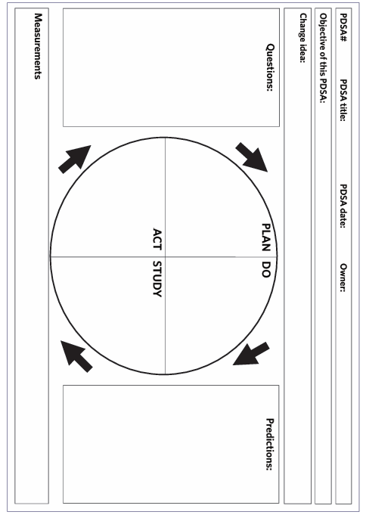

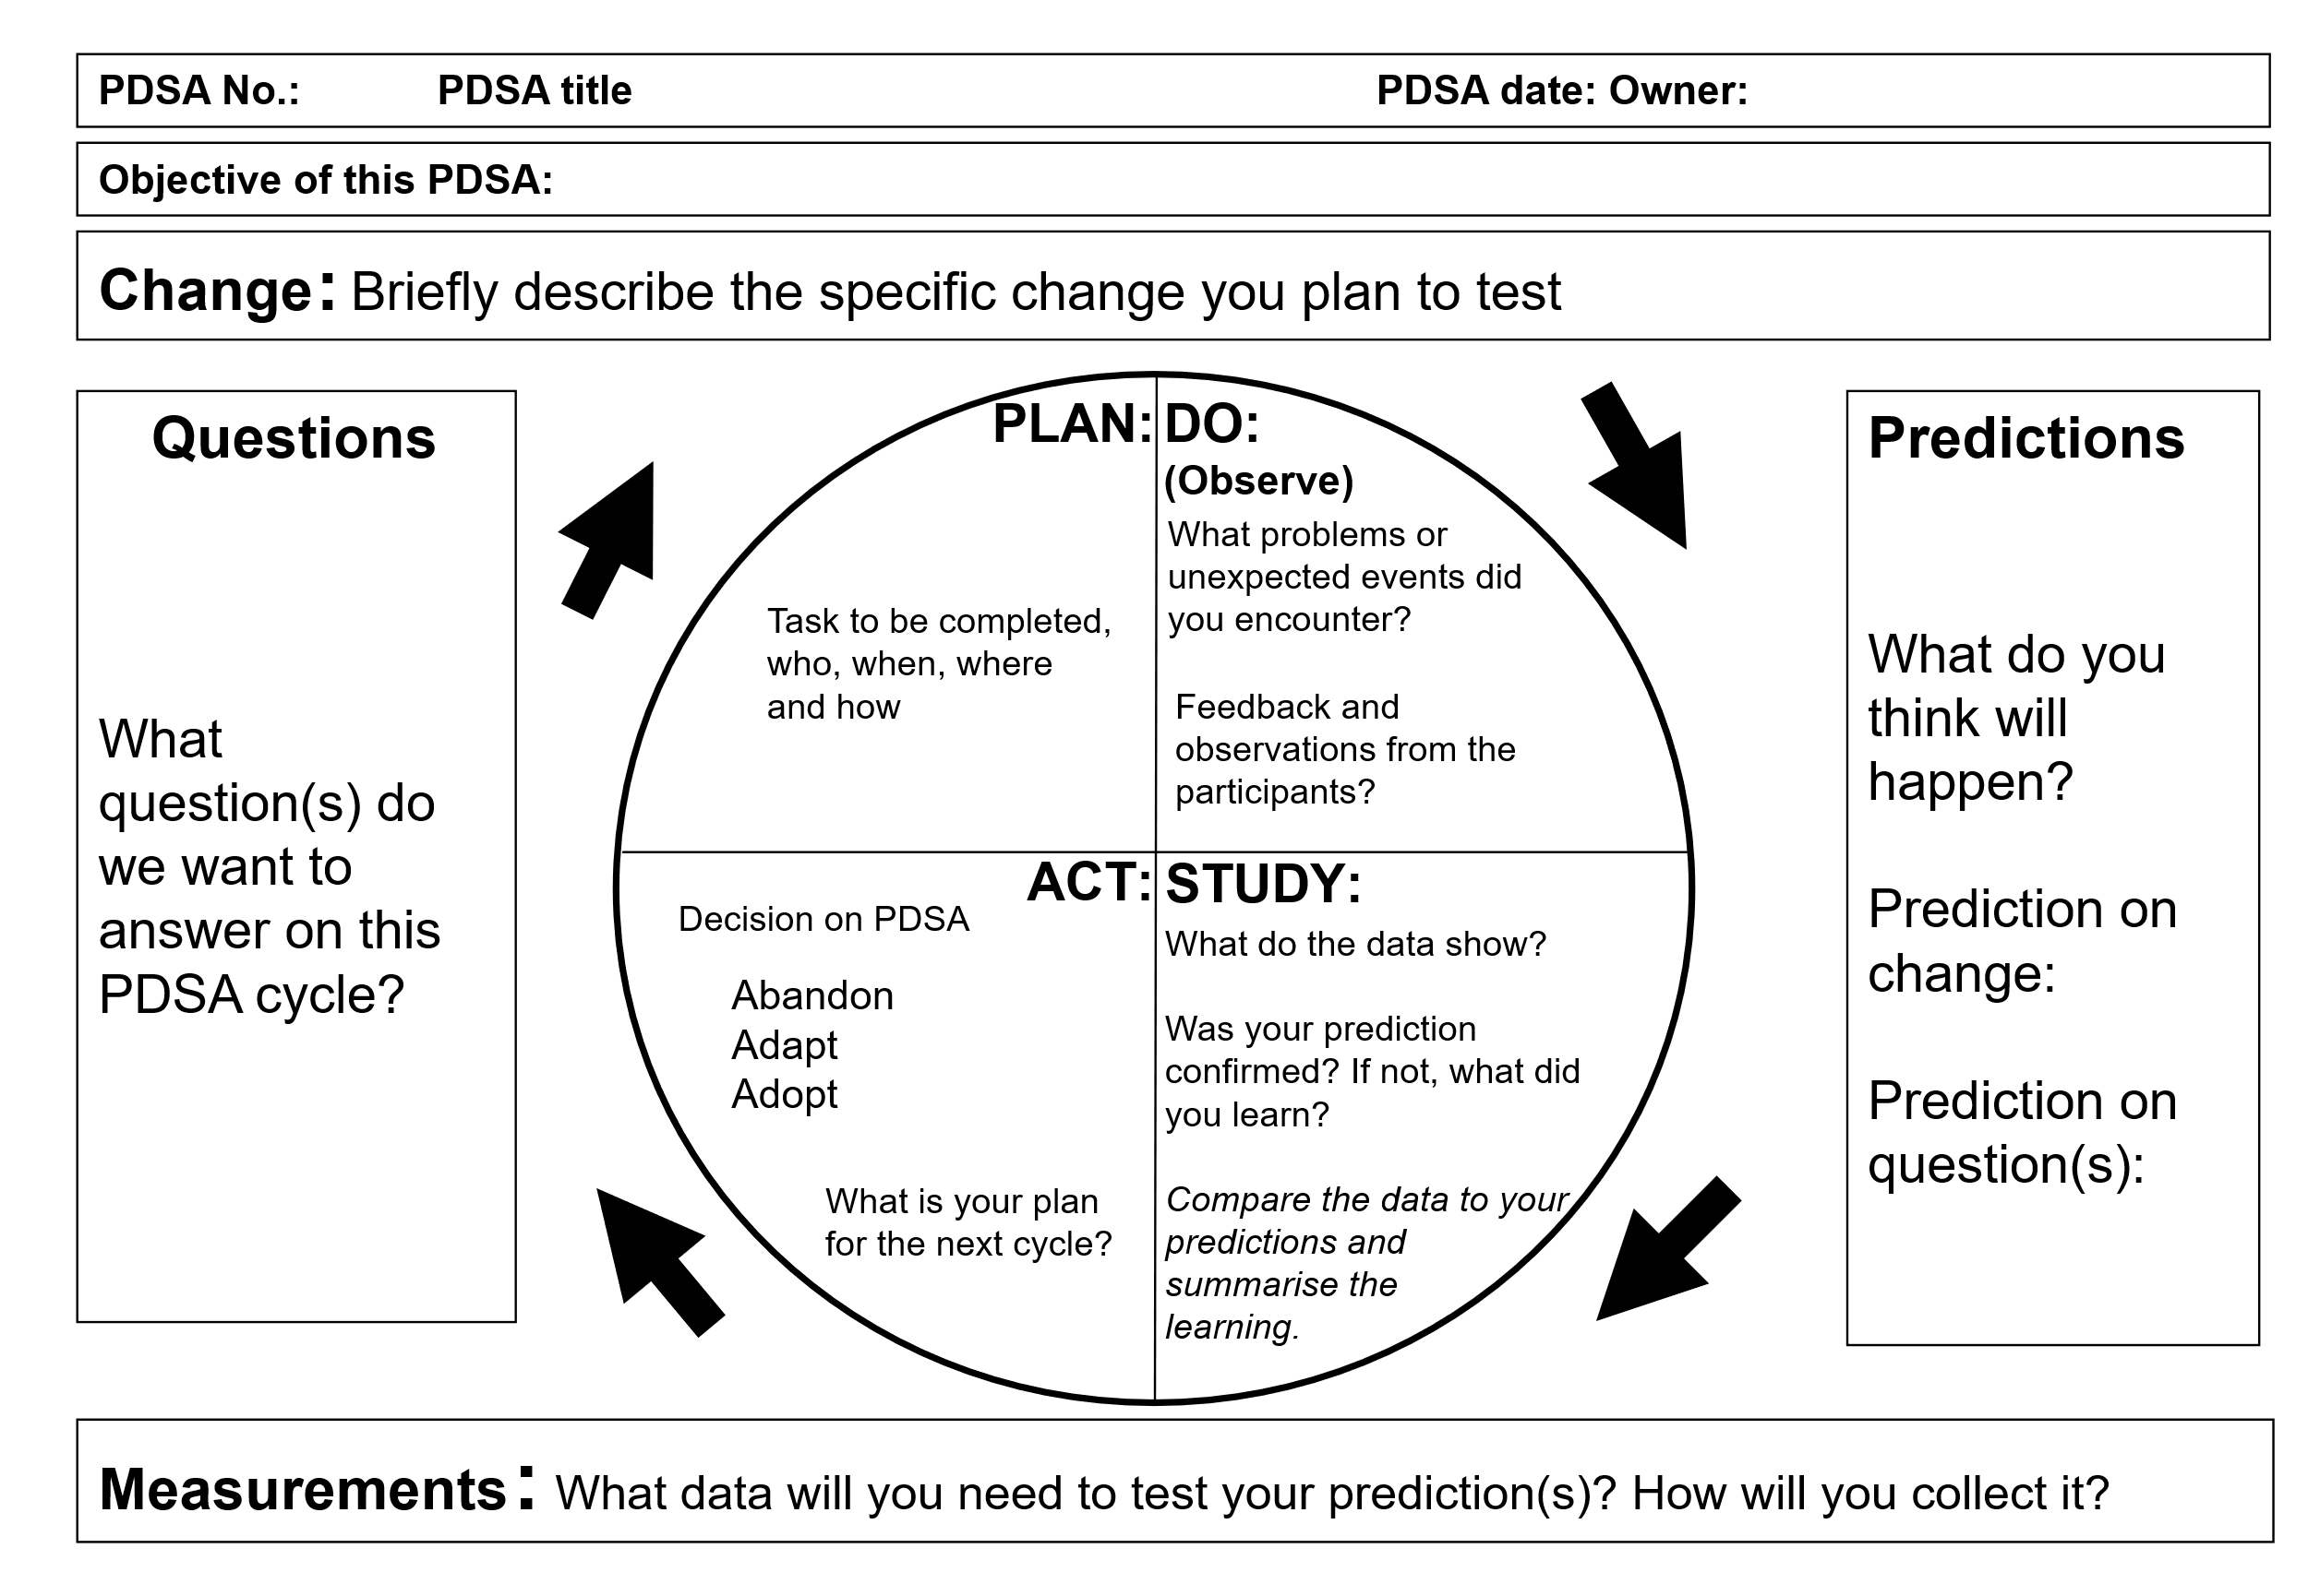

Appendix 2: PDSA example (Plan)

This example shows how to document one complete PDSA cycle and plan the next stage of the PDSA cycle. Because the survey is annual, organisations will need to develop ways to collect data from their service users more frequently, to inform them of the effect of any change ideas. One way may be to develop an internal survey based on the questions from the national survey. This example of the PDSA cycle is testing to see if a text messaging survey will generate enough responses, so the feedback can be used to monitor the effectiveness of the intervention.

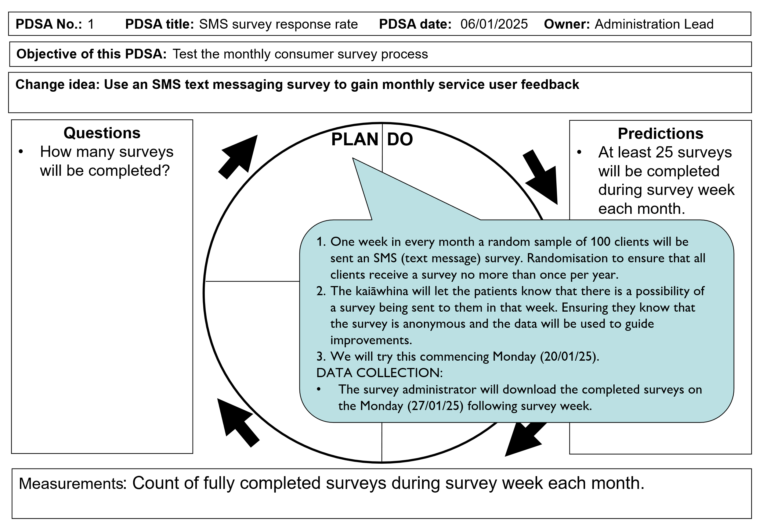

PDSA example continued (Do)

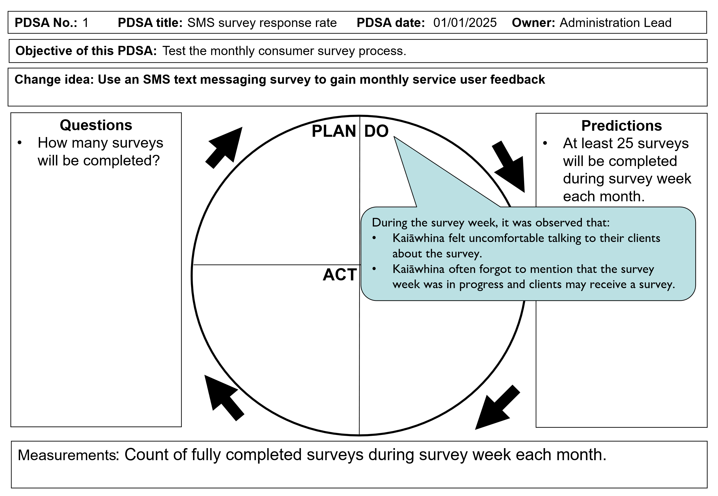

PDSA example continued (Study)

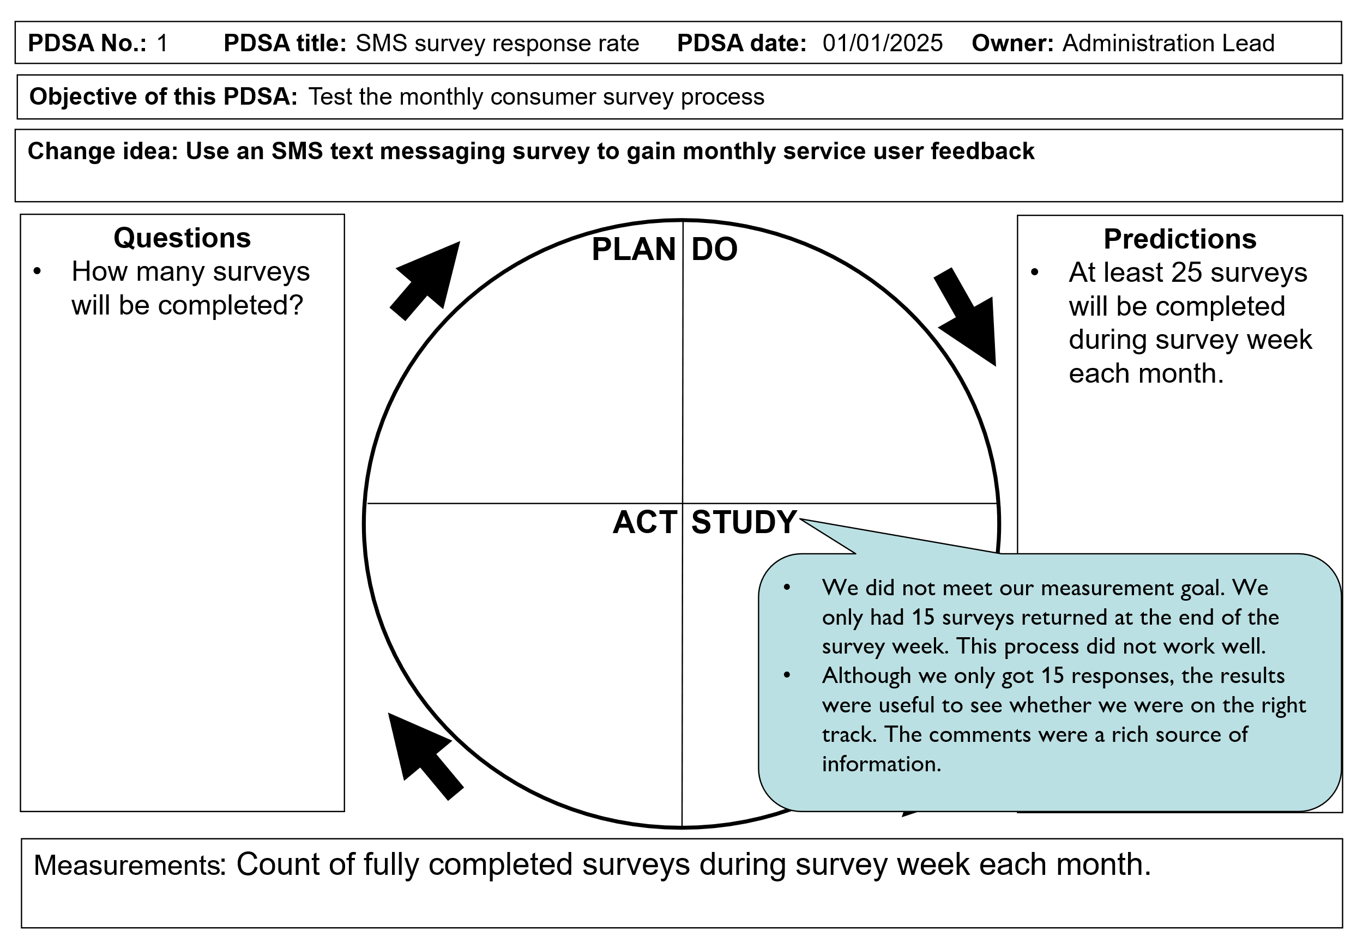

PDSA example continued (Act)

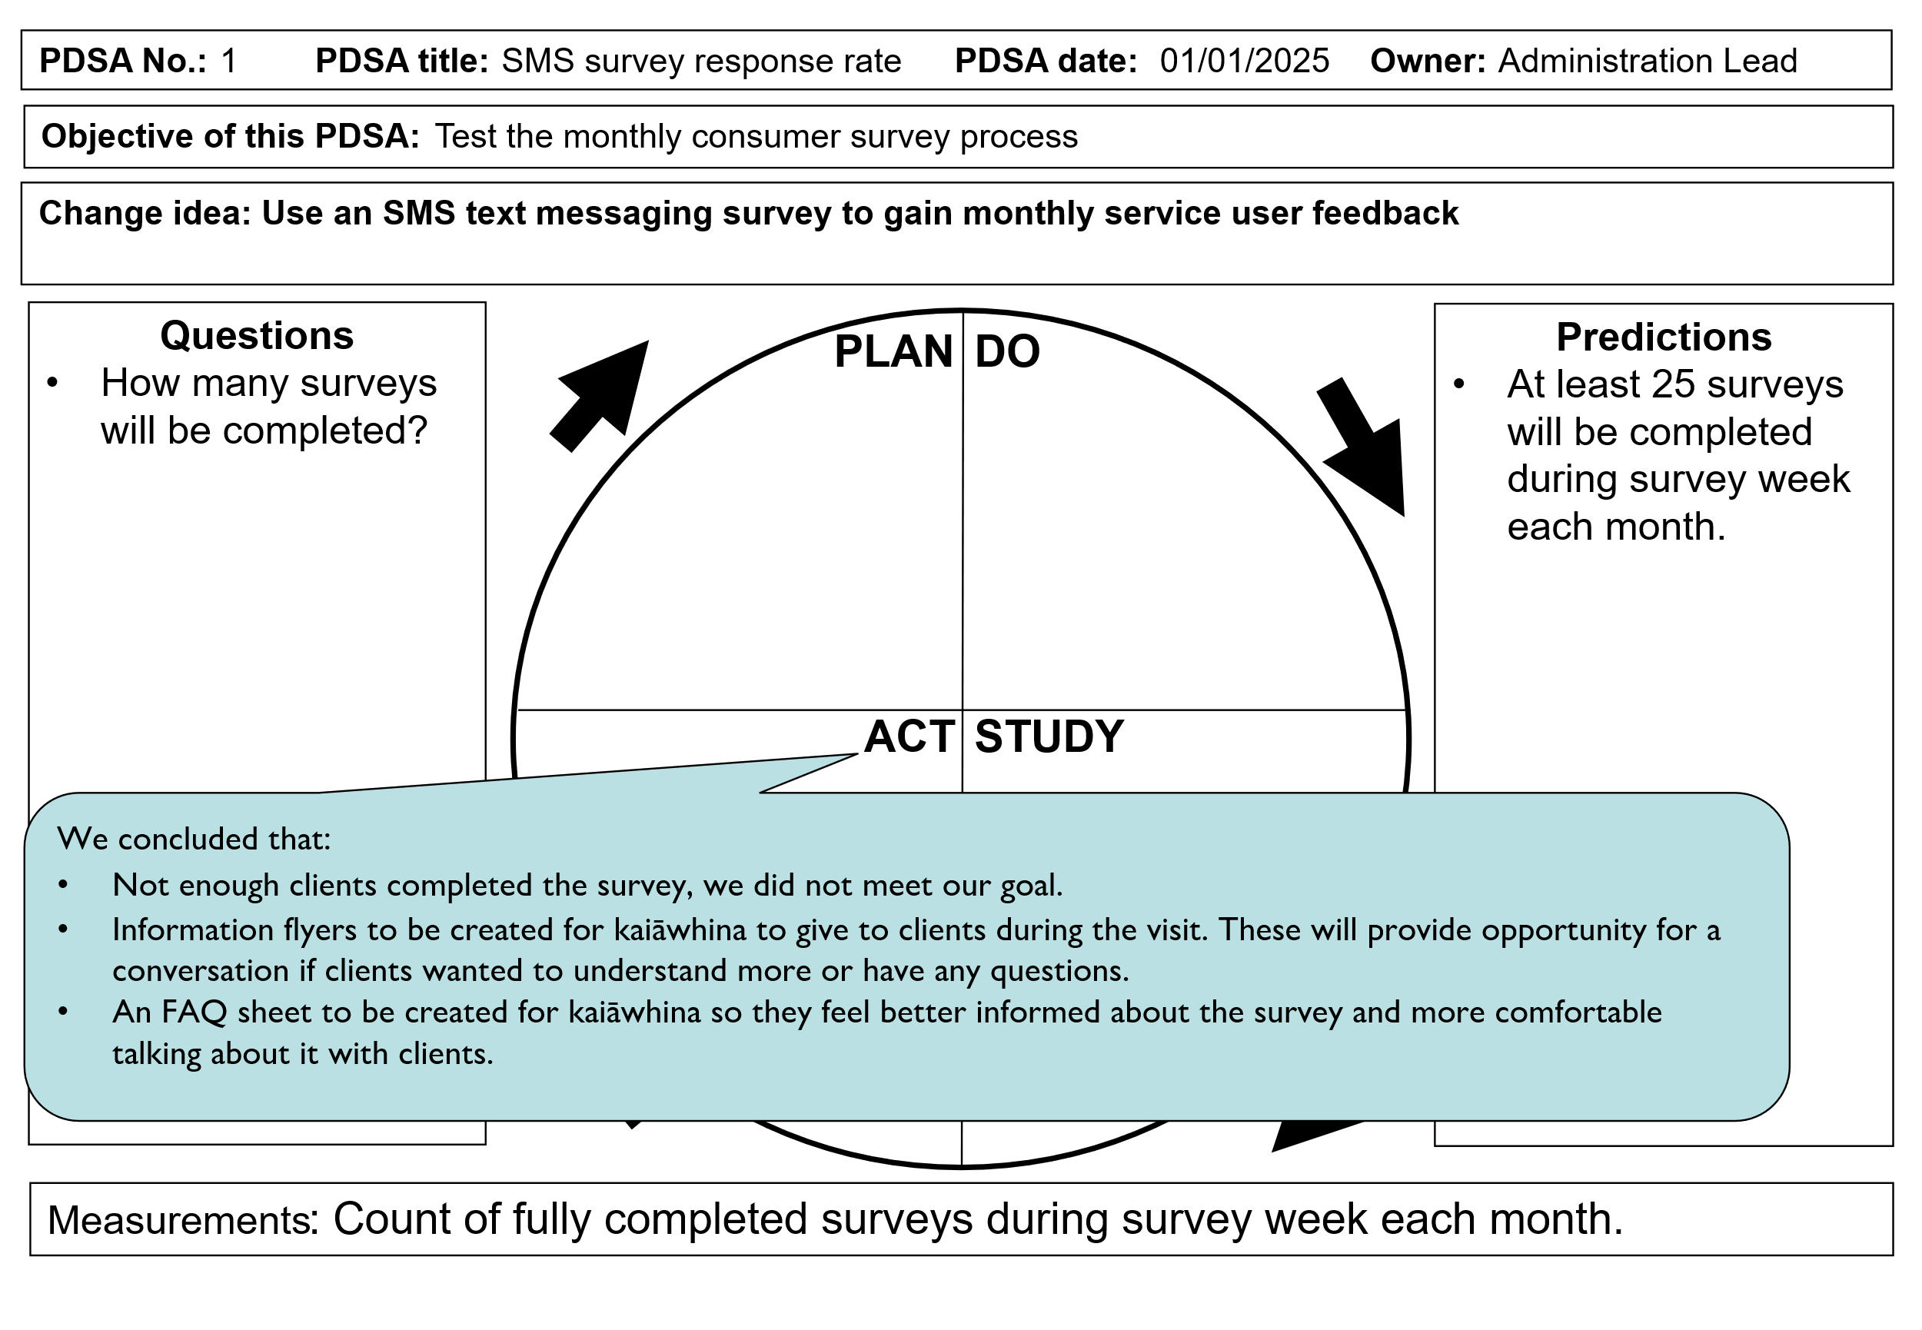

PDSA example continued (Cycle 2 Plan)

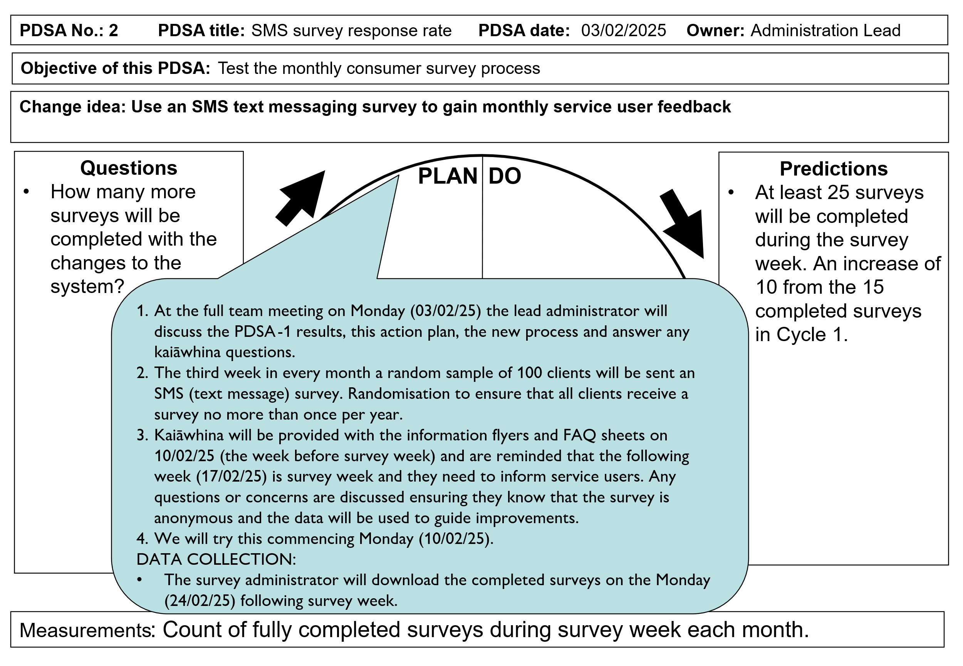

Appendix 3: Provider A improvement plan

Define the problem

Survey results indicate that only 60% of service users were informed in advance of when their support arrangements changed. This means 40% of whānau experienced unexpected disruptions in their care, affecting their ability to plan and maintain their routines. Poor communication around changes can lead to distress, loss of trust and a breakdown in whanaungatanga (relationships).

Rationale (why change is needed)

Applying the Te Whare Tapa Whā model, poor communication about changes affects multiple aspects of wellbeing.

* **Taha Wairua (spiritual wellbeing):** Uncertainty about care disrupts the sense of stability and mana (dignity) of the individual.
* **Taha Hinengaro (mental and emotional wellbeing):** Anxiety and stress arise when support arrangements change without notice.
* **Taha Tinana (physical wellbeing):** Unexpected changes may result in missed medication, meals or personal care, affecting overall health.
* **Taha Whānau (social wellbeing):** Family members may struggle to make alternative arrangements when they are not informed in time.

Baseline data and benchmarks

* **Current baseline:** Only 60% of users were informed in advance of changes.
* **Industry benchmark:** Best practice is 95%+ proactive communication for all changes affecting care.

Expected outcomes and benefits

* **Increased trust and reliability:** Whānau know what to expect and can plan accordingly.
* **Better continuity of care:** Service users are not left without support due to miscommunication.
* **Stronger whanaungatanga:** A transparent, respectful relationship between providers and whānau.
* **Improved service coordination:** More structured processes for notifying changes reduce confusion.

Aim statement

Ensure that 95% or more of service users receive timely and clear communication about any changes to their support arrangements by [target date], using a kaupapa Māori approach that upholds manaakitanga (respect and care).

How will we know a change is an improvement?

**Outcome measures**

* Percentage of service users who report being notified in advance of any support arrangement changes (goal: 95%+).
* Service user satisfaction with the clarity and timeliness of communication.

**Process measures**

* Percentage of changes logged with a confirmed notification timestamp.
* Percentage of cases where alternative arrangements were proactively offered if a change affected care.
* Percentage of whānau members included in communication where applicable.

**Balancing measure(s)**

* Percentage of workers reporting their schedule allows time for both travel and care delivery.

Changes to improve the process (Whakawhanake – Development)

**Change ideas (Mahi Tahi – Collaborative solutions)**

1. Kanohi-ki-te-kanohi (face-to-face or direct contact first)
   1. Prioritise personal phone calls or video calls for significant changes, rather than just emails or texts.
   2. Where possible, involve a trusted whānau member in communication.
2. Whānau-centred notification system
   1. Introduce text, email and phone alerts to notify service users immediately when changes occur.
   2. Provide bilingual communication (te reo Māori and English) where needed.
3. Kaitiakitanga (guardianship and responsibility for information)
   1. Implement a real-time communication tracking system to ensure every user receives timely updates.
   2. Develop clear protocols for staff on when and how to notify users of changes.
4. Manaakitanga (enhancing care and dignity through communication)
   1. Ensure changes are communicated in a mana-enhancing way, with reassurance and support offered.
   2. If a change is unexpected, offer solutions first (eg, replacement caregivers, alternative timing).

Key stakeholders (Mahi Tahi – Working together)

* Service users and whānau must receive clear and timely updates about changes.
* Kaiāwhina (support workers) need to be informed early to adjust their schedules accordingly.
* Service coordinators and managers need to be responsible for tracking changes and ensuring notifications happen.
* Māori health providers and community leaders can provide guidance on effective whānau-centred communication.
* Funders and regulatory bodies can support improvements in service communication and responsiveness.

**Barriers and solutions (Ngā Piringa – Challenges and ways forward)**

|  |  |
| --- | --- |
| **Barrier** | **Proposed solution (kaupapa Māori approach)** |
| Last-minute staff changes causing communication delays | Establish a real-time notification system with immediate alerts. |
| Service users feeling disconnected from providers | Build whanaungatanga through direct, personal communication methods. |
| Lack of consistent procedures for notifying users | Implement standardised notification protocols to ensure consistency. |
| Language or cultural barriers affecting understanding | Offer bilingual (te reo and English) notifications and culturally appropriate communication. |

Timeline for implementation (Mahere Whakamahi – Action plan)

|  |  |  |
| --- | --- | --- |
| **Task** | **Start date** | **Completion date** |
| Develop real-time notification system | Week 1 | Week 4 |
| Train staff on kaupapa Māori-based communication | Week 2 | Week 6 |
| Establish whānau-centred protocols for notifications | Week 3 | Week 7 |
| Pilot programme in select regions | Week 8 | Week 12 |
| Full rollout and ongoing review | Week 13 | Ongoing |

**Expected outcomes and benefits (Ngā Hua – Positive impacts)**

* Notification rate increases to 95%+ with fewer disruptions and unexpected changes for whānau.
* Whānau feel more engaged and valued because communication is mana-enhancing and respectful.
* Service providers build trust and accountability resulting in strengthened relationships with users.
* Care continuity improves with fewer missed or disrupted support sessions.

Final thoughts

By embedding te ao Māori values into communication strategies, we ensure that service users feel respected, valued and well-informed. This approach strengthens whānau resilience and builds a care system grounded in manaakitanga, whanaungatanga and kaitiakitanga.

Appendix 4: ‘You said, we did’ poster

|  |
| --- |
| Example of 'You said, we did' poster |

This is also available on the Te Tāhū Hauora website: <https://www.hqsc.govt.nz/resources/resource-library/hcss-survey-you-said-we-did-poster/>

Appendix 5: Resources

Useful links:

About our patient experience surveys | Home and community support services experience survey: <https://www.hqsc.govt.nz/our-data/patient-reported-measures/patient-experience/about-our-patient-experience-surveys/home-and-community-support-services-experience-survey/>

Survey resources for home and community support services experience staff: <https://www.hqsc.govt.nz/our-data/patient-reported-measures/patient-experience/survey-resources-for-home-and-community-support-services-staff/>

Using survey data for quality improvement: <https://www.hqsc.govt.nz/our-data/patient-reported-measures/patient-experience/using-survey-data-for-quality-improvement/>

Code of expectations for health entities’ engagement with consumers and whānau: [www.hqsc.govt.nz/consumer-hub/engaging-consumers-and-whanau/code-of-expectations-for-health-entities-engagement-with-consumers-and-whanau/](http://www.hqsc.govt.nz/consumer-hub/engaging-consumers-and-whanau/code-of-expectations-for-health-entities-engagement-with-consumers-and-whanau/)

Measuring culturally safe care through the patient experience surveys: [www.hqsc.govt.nz/resources/resource-library/measuring-culturally-safe-care-through-the-patient-experience-surveys/](http://www.hqsc.govt.nz/resources/resource-library/measuring-culturally-safe-care-through-the-patient-experience-surveys/)

Wai 2575 principles: [Hauora: Report on Stage One of the Health Services and Outcomes Kaupapa Inquiry](https://forms.justice.govt.nz/search/Documents/WT/wt_DOC_195476216/Hauora%202023%20W.pdf) and <https://www.health.govt.nz/maori-health/wai-2575-health-services-and-outcomes-inquiry>

Engaging consumers and whānau: [www.hqsc.govt.nz/consumer-hub/engaging-consumers-and-whanau/](http://www.hqsc.govt.nz/consumer-hub/engaging-consumers-and-whanau/)

Understanding co-design. Open access to co-design learning modules: [Co-design in Health (HQSC)](https://koawatealearn.co.nz/enrol/index.php?id=9540) and [Co-design in health - How you can get involved](https://aus01.safelinks.protection.outlook.com/?url=https%3A%2F%2Fkoawatealearn.co.nz%2Fcourse%2Fview.php%3Fid%3D11499&data=05%7C02%7CJane.Cullen%40hqsc.govt.nz%7Cb0325da19fe94e6cb17a08dd9f24c901%7C701cefdf35f44444863855f0e12ab1c4%7C0%7C0%7C638841702590533847%7CUnknown%7CTWFpbGZsb3d8eyJFbXB0eU1hcGkiOnRydWUsIlYiOiIwLjAuMDAwMCIsIlAiOiJXaW4zMiIsIkFOIjoiTWFpbCIsIldUIjoyfQ%3D%3D%7C0%7C%7C%7C&sdata=rxcmHhWk408DOJT6YwpZrvw1LG%2FZvKGWZ3ThXkZrsrw%3D&reserved=0)

Patient Experience Agency (Australia) with free webinars and blogs with practical tips for engaging with consumers, patient experience and co-design: [Patient Experience Agency](https://www.patientexperienceagency.com.au/)

Healthcare Excellence Canada with webinars and resources to support patient engagement and equity: <https://www.healthcareexcellence.ca/en/resources/>

Learn about quality improvement: <https://koawatealearn.co.nz/course/search.php?category=870&search=improve>

Other websites with information, tools and resources for quality improvement:

* QI Hub: [About QI | theqihub](https://www.theqihub.com/about-qi)
* NSW Clinical Excellence Commission: [Improve quality - Clinical Excellence Commission](https://www.cec.health.nsw.gov.au/improve-quality)

Useful articles:

Davies, D. J. (2015). Quality improvement initiatives in a case management service: case study. *Australian Journal of Primary Health*, *21*(1), 14-21.

Elliott, J., Gordon, A., Tong, C. E., & Stolee, P. (2020). “We’ve got the home care data, what do we do with it?”: understanding data use in decision making and quality improvement. *BMC health services research*, *20*, 1-8.

Gerard, C., O'Brien, I., Shuker, C., Swanson, J., & Hamblin, R. (2024). Patient experience surveys are vital in the twenty-first century: let's put some myths to rest. *The New Zealand Medical Journal (Online)*, *137*(1588), 80-89.

Kumah, E., Osei-Kesse, F., & Anaba, C. (2017). Understanding and using patient experience feedback to improve health care quality: systematic review and framework development. *Journal of patient-centered research and reviews*, *4*(1), 24.

Locock, L., Graham, C., King, J., Parkin, S., Chisholm, A., Montgomery, C., ... & Ziebland, S. (2020). Understanding how front-line staff use patient experience data for service improvement: an exploratory case study evaluation. *Health Services and Delivery Research*, *8*(13).

McKay, S., Konan, M., Tedesco, S., Turriff, T., Michener, M., & King, E. C. (2024). Optimizing weekend schedules in home health care: The essential care on weekends for personal support quality improvement project. Home Health Care Management & Practice, 36(2), 81-87.

Miller, P., Gill, C., Mazza, K., Pilon, C., & Hill, M. (2019). Learning What is Important: A Quality Improvement Initiative to Enhance Patient-Centred Care in Home Care. Physical & Occupational Therapy In Geriatrics, 37(1), 3-15.

Miller, W., Asselbergs, M., Bank, J., Cass, M., Flintoft, V., & Henningsen, N. (2020). Homecare safety virtual quality improvement collaboratives. Healthc Q, 22, 100-11.

World Health Organization. (2025). Setting the Foundation for Quality Management in Home-And Community-Based Long-Term Care. [WHO-EURO-2025-12064-51836-79440-eng.pdf](https://iris.who.int/bitstream/handle/10665/381334/WHO-EURO-2025-12064-51836-79440-eng.pdf?sequence=1)

1. See Standards New Zealand <https://www.standards.govt.nz/shop/nzs-81342021>, for the full Ngā Paerewa Health Disability Services Standard.
2. See Ministry of Health <https://www.health.govt.nz/publications/national-framework-for-home-and-community-support-services-hcss>, for the National Framework for Home and Community Support Services.
3. See Enabling Good Lives <https://www.enablinggoodlives.co.nz/>, for more information.
4. [https://www.hqsc.govt.nz/resources/resource-library/hcss-experience-survey-results-2024/](https://aus01.safelinks.protection.outlook.com/?url=https%3A%2F%2Fwww.hqsc.govt.nz%2Fresources%2Fresource-library%2Fhcss-experience-survey-results-2024%2F&data=05%7C02%7CJoanna.Swanson%40hqsc.govt.nz%7C68e3e4ae5a4147ec4cdb08ddc0092535%7C701cefdf35f44444863855f0e12ab1c4%7C0%7C0%7C638877867727091413%7CUnknown%7CTWFpbGZsb3d8eyJFbXB0eU1hcGkiOnRydWUsIlYiOiIwLjAuMDAwMCIsIlAiOiJXaW4zMiIsIkFOIjoiTWFpbCIsIldUIjoyfQ%3D%3D%7C0%7C%7C%7C&sdata=Rh5uiJV7%2Bnqs7Rq8wEc208jNPiyCDordrZNKgSwpCqw%3D&reserved=0)
5. <https://neac.health.govt.nz/assets/Uploads/NEAC/publications/national-ethical-standards-health-disability-research-quality-improvement-2019-v3.pdf>
6. Adapted from Langley, G. J., Moen, R. D., Nolan, K. M., Nolan, T. W., Norman, C. L., & Provost, L. P. (2009). The improvement guide: a practical approach to enhancing organizational performance. John Wiley & Sons.
7. Codesign online courses at Ko Awatea Learn: [Co-design in health](https://aus01.safelinks.protection.outlook.com/?url=https%3A%2F%2Fkoawatealearn.co.nz%2Fcourse%2Fview.php%3Fid%3D9540&data=05%7C02%7CJane.Cullen%40hqsc.govt.nz%7Cb0325da19fe94e6cb17a08dd9f24c901%7C701cefdf35f44444863855f0e12ab1c4%7C0%7C0%7C638841702590504429%7CUnknown%7CTWFpbGZsb3d8eyJFbXB0eU1hcGkiOnRydWUsIlYiOiIwLjAuMDAwMCIsIlAiOiJXaW4zMiIsIkFOIjoiTWFpbCIsIldUIjoyfQ%3D%3D%7C0%7C%7C%7C&sdata=mR4QUvpmm5Sd%2BKjZyTeKxPD58QvW2Etdh5cpa4GR%2BMg%3D&reserved=0) and [Co-design in health - How you can get involved](https://aus01.safelinks.protection.outlook.com/?url=https%3A%2F%2Fkoawatealearn.co.nz%2Fcourse%2Fview.php%3Fid%3D11499&data=05%7C02%7CJane.Cullen%40hqsc.govt.nz%7Cb0325da19fe94e6cb17a08dd9f24c901%7C701cefdf35f44444863855f0e12ab1c4%7C0%7C0%7C638841702590533847%7CUnknown%7CTWFpbGZsb3d8eyJFbXB0eU1hcGkiOnRydWUsIlYiOiIwLjAuMDAwMCIsIlAiOiJXaW4zMiIsIkFOIjoiTWFpbCIsIldUIjoyfQ%3D%3D%7C0%7C%7C%7C&sdata=rxcmHhWk408DOJT6YwpZrvw1LG%2FZvKGWZ3ThXkZrsrw%3D&reserved=0)
8. See [Wai 2575 Health Services and Outcomes Inquiry | Ministry of Health NZ](https://www.health.govt.nz/maori-health/wai-2575-health-services-and-outcomes-inquiry) and [Hauora: Report on Stage One of the Health Services and Outcomes Kaupapa Inquiry](https://forms.justice.govt.nz/search/Documents/WT/wt_DOC_195476216/Hauora%202023%20W.pdf) for information on the Wai 2575 principles.
9. See <https://www.enablinggoodlives.co.nz/about-egl/>, for more information on Enabling Good Lives.