Kia kōrero | Let’s talk advance care planning campaign evaluation | Kia kōrero, he arotake i te kaupapa whakatairanga i ngā whakamāherehere manaakitanga tōmua

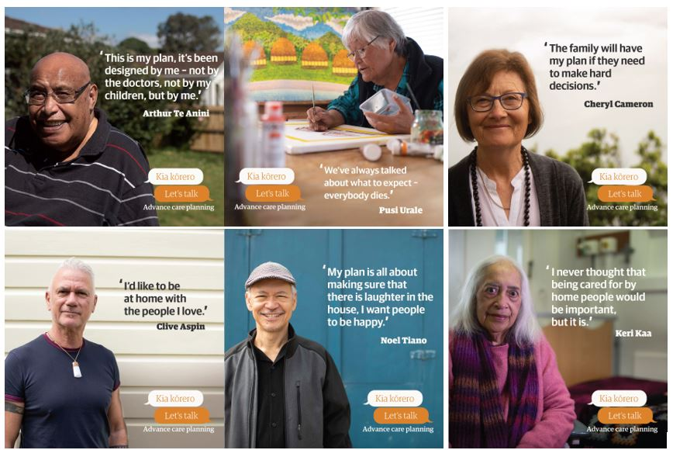
Prepared by the advance care planning team

June 2019

Contents | Rārangi take
Background | Kōrero whakatakoto 3
Purpose | Ngā kaupapa 4
Key messages | Ngā kōrero matua 4
Audiences | Ngā kaimātakitaki 4
Consumer spokespeople | Ngā kaikōrero kiritaki 5
Promoting the campaign | Te whakatairanga i te kaupapa 5
Communications reach | Te toronga o ngā tauwhitiwhitinga 6
Conclusion | Whakakapinga 7
Appendix 1: Kia kōrero | Let’s talk resources | Āpitihanga 1: Kia Kōrero ngā rauemi 10
Appendix 2: Kia kōrero | Let’s talk media coverage | Āpitihanga 2: Kia kōrero
ngā pāhotanga 14
Appendix 3: Facebook summary | Āpitihanga 3: Whakarāpopoto Pukamata 16

© Health Quality & Safety Commission New Zealand 2019
Available online at www.hqsc.govt.nz | Enquiries to: acp@hqsc.govt.nz

Background | Kōrero whakatakoto
Vision: empower New Zealanders to participate in planning their future care
Matakitenga: te whakamana i ngā tāngata o Aotearoa kia uru mai ki ngā mahi whakariterite i ngā manaakitanga ā muri ake mō rātau
The advance care planning (ACP) programme came under the umbrella of the Health Quality & Safety Commission in 2016, following a request by district health boards (DHBs). The programme was previously managed within Auckland DHB, with support from the Northern Regional Alliance. The Commission now leads a five-year strategy of ACP supported by DHBs. Initial funding has been secured to the end of 2019 and further funding is being sourced to continue the work to 2022.
The programme’s five areas of focus are:
- promotions
- resources
- training
- monitoring and evaluation
- implementation.

Kia kōrero | Let’s talk campaign overview
The first public-facing ACP campaign in New Zealand, Kia kōrero | Let’s talk, was launched on 19 February 2019 and ran for six weeks, finishing with the national ACP day on 5 April.
The campaign was designed to inspire people to have a conversation with their loved ones and their health care team about what matters to them if they become unwell, to discuss what kind of care they would or wouldn’t want and to write these things down.
It featured the diverse voices of people at different stages of life and wellness, incorporating Māori, Pacific, Asian, Pākehā and LGBTTI+ communities.

Purpose | Ngā kaupapa
The goal of the campaign was to:
- raise awareness about advance care planning
- promote future health care planning
- encourage consumers and health care professionals to routinely talk about future health care planning, recognising different cultures and experiences
- encourage death to be considered as the conclusion of the life cycle and not a ‘failure’ of care.
Measures of success included:
Media | Specific | Comment
TV One | Prime time news item featuring Pusi Urale and Keri Kaa stories with interview with Chair of HQSC, Professor Alan Merry | General demographic of and 65+ reached
Māori Television | TVC (ad) featuring Keri Kaa’s story played over a two week period before programmes | Targeted Māori and Pacific demographic
Radio NZ | Ria Earp and Cheryl Cameron were interviewed by Kathyrn Ryan on Nine to Noon show, Radio NZ. | National coverage of demographic
Social Media | Push media working with The Digital Café to reach target audiences across Facebook, Twitter and Instagram to targeted groups | Feedback from statistics show above average reach and engagement across social media sites and increased hits to the HQSC ACP website.
Newsletter articles | Fetu Pasifika, Age Concern, Super Seniors, Kaitiaki, Eldernet. | Stakeholder engagement and support across government, DHBs and PHOs, the NGO sector and communities of interest.

Key messages | Ngā kōrero matua

Stakeholders
This is an innovative campaign about an important topic; we would really appreciate your support.

The public
Have the difficult conversation with your loved ones. Complete an advance care plan.

Audiences | Ngā kaimātakitaki
The consumer target audience included:
- Māori and Pacific populations aged over 55 years
- Pakeha, Asian and other ethnicities aged over 65 years
- LGBTTI+ community
- community groups
- support networks of the above audiences.
The stakeholder audience included:
- ACP facilitators
- all health care workers
- DHBs – chief executives, clinical directors, Māori directors of health, communications managers, quality managers, directors of nursing and allied health
- private health organisations
- Ministry of Health – Director-General, Māori and Pacific leaders and directorates, communication team, planning and funding
- aged care services
- medical colleges and associations
- regional aged care networks
- primary care providers, including general practitioners
- non-government organisations
- medical media, general media, Māori, Pacific and Asian media.

Consumer spokespeople | Ngā kaikōrero kiritaki
The campaign featured a diverse range of stories about six New Zealanders at different stages of life and wellness.
- Arthur Te Anini, (Ngati Marū ki Hauraki ko Ngati Whaanaunga te hapu) has chronic obstructive pulmonary disease and is a strong advocate for ACP
- Samoan artist and mother of six Pusi Urale shared her view on ACP with her daughter Sima
- Cheryl Cameron became interested in ACP after being diagnosed with Parkinson’s disease 11 years ago
- Noel Tiano is a social worker at Mary Potter Hospice, and is originally from the Philippines
- Clive Aspin (Ngāti Maru) brings a takatāpui (LGBTTI+) perspective to the campaign
- Keri Kaa (Ngāti Porou/Ngāti Kahungunu) is currently in palliative care at Te Puia Springs Hospital on the East Coast.

Promoting the campaign | Te whakatairanga i te kaupapa

Resources
The Commission, together with creative agency STORYBOX, produced several resources to support Kia Kōrero | Let’s talk. These included:
- A3 posters available in English, te reo Māori, Samoan, Tongan, traditional Chinese and simplified Chinese
- video vignettes edited into short and longer formats for different mediums, translated into te reo Māori, Samoan, Tongan, traditional Chinese and simplified Chinese
- written profiles for use in the media and for social media posts.
The resources were user tested by an independent consumer group brought together by STORYBOX.
Users requested more clarity of the message, which was adapted by adding ‘Plan for your future health care’ on each poster and video credit. See all stories at www.myacp.org.nz
For visuals of the resources, see Appendix 1.

Quantities ordered
ACP print resources | Number ordered January – May 2019
ACP guide (pre-existing) | 28,383
ACP brochure (pre-existing) | 33,066
A3 posters in all languages | 1,149

Promotion and activities in the health care community
In addition to the Kia korero | Let’s talk resources, health care providers were sent a communications toolkit, which included key messages, graphics, activities and suggested social media posts. Activities included the following:
- Make contact with the local divisions of the national organisations and stakeholders we have connected with to promote the campaign.
- Organise a ‘Morning tea with ACP’ to talk to your colleagues about ACP.
- Book your local health centre, hospital or hospice facility’s notice board and use it to display the campaign posters. Play the campaign videos in waiting rooms if possible.
- Organise ACP champions from your area to present to local community groups, with a focus on Māori and Pacific peoples.
- Approach local aged residential care villages and see if they are happy to put up the campaign posters. Organise a talk at the facility to give them more understanding and context.
- Start collecting real-life ACP stories for patients and families. You might be surprised how many people are happy to talk about their experiences.
- Share our resources from the campaign on the day with your organisation’s newsletter.
- Share your ideas and our resources on your website and social network platforms.

Media promotion
- Media releases
- Website and newsletter updates
- Written articles
- Advertising slots with Māori Television
- Radio advertising
- Social media posts

Communications reach | Te toronga o ngā tauwhitiwhitinga

Media coverage
The campaign was featured several times on television, along with radio interviews, several news articles and industry publications/newsletters.
See Appendix 2 for a summary of media coverage.

Commission website visits
There was a significant increase in visits to the ACP section of the Commission website with a total of 27,362 ACP page views over the campaign period. There were 2,952 visits to the ACP section of the website for the same period in 2018.
On ACP Day and throughout the week after (5–11 April) there were 1,801 views of the ACP section of the website. There were 475 views for the same period in 2018.

Social media
The Commission promoted both static and video posts featuring the spokespeople’s stories extensively on social media.

Organic social media
Over six weeks the Commission posted one static post and one video each week on Twitter, Facebook and LinkedIn, achieving a total of 93,047 impressions.
The Commission shared social media posts from various DHBs and news outlets during the campaign.
Channel | Reach | Engagement
Facebook | 57,479 impressions | 2,518 clicks and 876 reactions, comments and shares
Twitter | 28,933 impressions | 435 clicks, retweets and replies
LinkedIn | 6,635 impressions | 144 clicks, comments and likes
YouTube | 104,974 views | N/A

Paid social media promotion
Over six weeks the campaign material was promoted on Facebook and YouTube.
- The static and video ads were displayed a total of 2,207,833 times.
- Videos were watched 243,613 times for at least 10 seconds.
- Facebook ads were seen by 221,475 people on average eight times.

Radio advertising
Nelson Marlborough Health funded radio advertisements in the lead-up to ACP Day, encouraging listeners to go to the myacp.org.nz website.

Conclusion | Whakakapinga
The Commission is pleased with the engagement with Kia kōrero | Let’s talk ACP campaign.

What worked well
The target audiences of Māori/Pacific aged 55+ and others aged 65+ connected strongly with the personal and diverse consumer stories in the campaign. People not only viewed the stories, but also left comments and shared them across their own social networks. These stories were seen on mainstream television (One News) and Māori Television.
All stories were viewed many times across the country. See full details in Appendix 3.
All media achieved higher-than-average engagement, which means people viewed the stories (sometimes more than once), shared the stories across their social networks and also made comments on sites such as Facebook and Twitter.
The decision to translate the videos and the posters in the top six languages in New Zealand resulted in engagement with Māori, Pacific and Asian communities.
The resources can be repurposed for other opportunities, such as Māori Language Week, Samoan Language Week, Hospice Week, Matariki (Māori new year) and Patient Safety Week.
DHBs and primary health organisations shared the videos in hospital foyers and meeting places, and the videos have also been used across the country in workshops and seminars (apart from Christchurch which was coping with the trauma of the shootings at the Mosques during the campaign).
Overall, there was a high demand for the campaign resources. We also received requests for the resources to be made available in other languages.
The majority of the facilitators found it useful to have a broad range of posters and videos available to use, especially for ACP Day.
The proactive stance of strong and diverse Māori, Pacific, Asian and LGBTTI+ content resonated with many and the rich storytelling suited the medium of social media in particular.

Lessons learned
We need to ensure we work with organisations who understand the importance of cultural diversity and equity, and be vigilant about this at each stage of the production process. There were some challenges with the translation service used. We also realised it is important to work with a creative agency familiar with government processes.
Some felt that the messaging on posters was difficult to understand without the context of the video stories. This feedback will be taken on board for any future related activities.
In future, we will provide more lead-in time for ACP Day, although ACP facilitators welcomed the social media messaging, content and resources that were made available at that time.
For the first time, the Commission used a specialist social media company to push the media to our targeted audience. This focused the reach of the campaign to targeted sectors, however in future we need to ensure the tone and cultural context of messaging stays with the Commission communications staff.
There were issues along the way with continuity so creating a production system that can be cross-checked by more than one person in the team is something that has already been implemented.
Contractors could be briefed earlier in the process about our requirements as a Crown entity.
Final delivery dates need to be discussed and agreed upfront to give time for the Commission communications team to manage signoff, print and delivery of resources in a timely fashion. Dates should also allow enough time for DHBs and PHOs to upload resources to their own systems.
Delivery formats also need to be agreed up front with the external creative team and the Commission communications team.

Recommendations
- In the next phase of the campaign and in all future campaigns, use an approach with the media (both mainstream and social) that embraces diversity and storytelling, and has a strong Māori focus.
- Reuse and extend the stories already filmed to add value to and strengthen the next phase of the campaign.
- User test the ACP messaging with those at the coalface, such as clinicians and consumers, for their vital input.
- Make targeted approaches to magazines (eg, Mana, Spacific, Women’s Weekly, The Listener, Metro, North and South) and a variety of other lifestyle magazines to keep the campaign alive and ACP in the public eye.
- Design content for other ethnic communities and source new funding to meet the needs of those communities in the future.
- Enrich and strengthen stakeholder engagement across government, in the NGO sector, in grassroots communities, and particularly in primary health.
- Broker new relationships with stakeholders outside the health sector to expand the reach of ACP and spread the word across communities.

Appendix 1: Kia kōrero | Let’s talk resources | Āpitihanga 1: Kia Kōrero ngā rauemi

ACP campaign profiles
Arthur Te Anini spent his working life as a driver in the New Zealand Army and overseas. He has two children. He has chronic obstructive pulmonary disease (COPD), which is how he learnt about advance care planning. Arthur has been a strong advocate of advance care planning since the early days of the programme. | 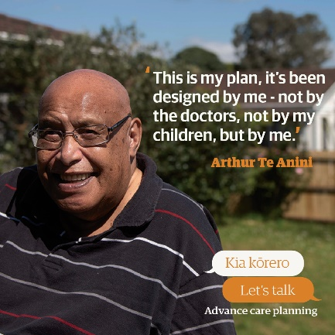
Pusi Urale is an artist and mother of six. All her children are involved in arts, music, media and filmmaking. Her children, including daughter Sima, supported and helped out their elderly parents when their father had dementia, and after Pusi’s husband passed away. Pusi was a teacher and only took up art in her late 50s. She has had several exhibitions. | 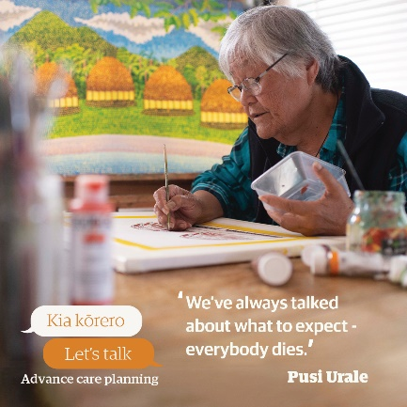
Cheryl Cameron is a retired documentary filmmaker. Since being diagnosed with Parkinson's disease 11 years ago she has taken up dancing the tango. She now helps run therapeutic tango classes for people with neurological conditions. Part of her advance care plan focuses on her choices to continue with tests and treatments, or not. | 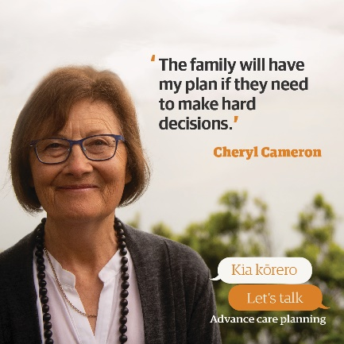
Noel Tiano is a social worker at Mary Potter Hospice. He completed his Master’s degree at Otago University interviewing older people from faith-based communities about advance care planning. He is originally from the Philippines and was an advocate for advance care planning in the United States of America for a number of years. | 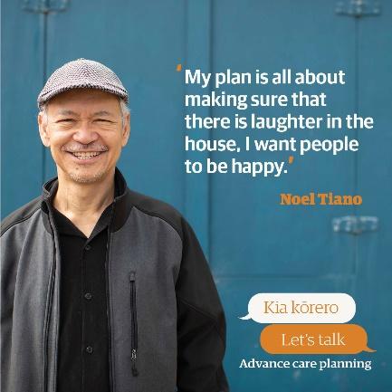
Clive Aspin (Ngāti Maru) brings a takatāpui (LGBTQI+) perspective to the campaign with his partner of 20 years, Terry. He works with the Health Quality & Safety Commission in the mortality review committee team. He has been a strong advocate for communities and people affected by HIV through his public health research work in HIV and AIDS over many years. | 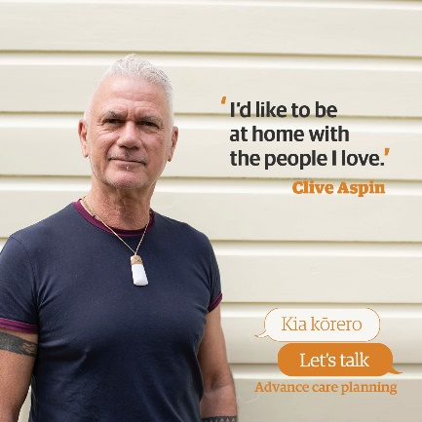
Keri Kaa (Ngāti Porou/Ngāti Kahungunu) is currently in care at New Zealand’s only iwi-administered hospital, Te Puia Springs Hospital. Keri lectured for many years at Wellington Teachers’ College. She is also a poet, writer and advocate of Māori arts, culture and political rights. | 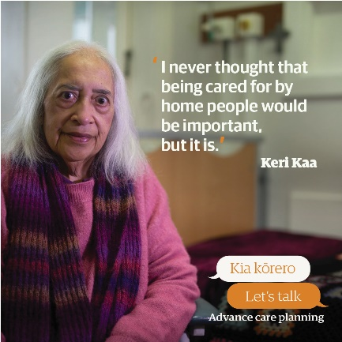

Posters
Six different A3 posters are available in English, te reo Māori, Samoan, Tongan, Traditional Chinese and Simplified Chinese.
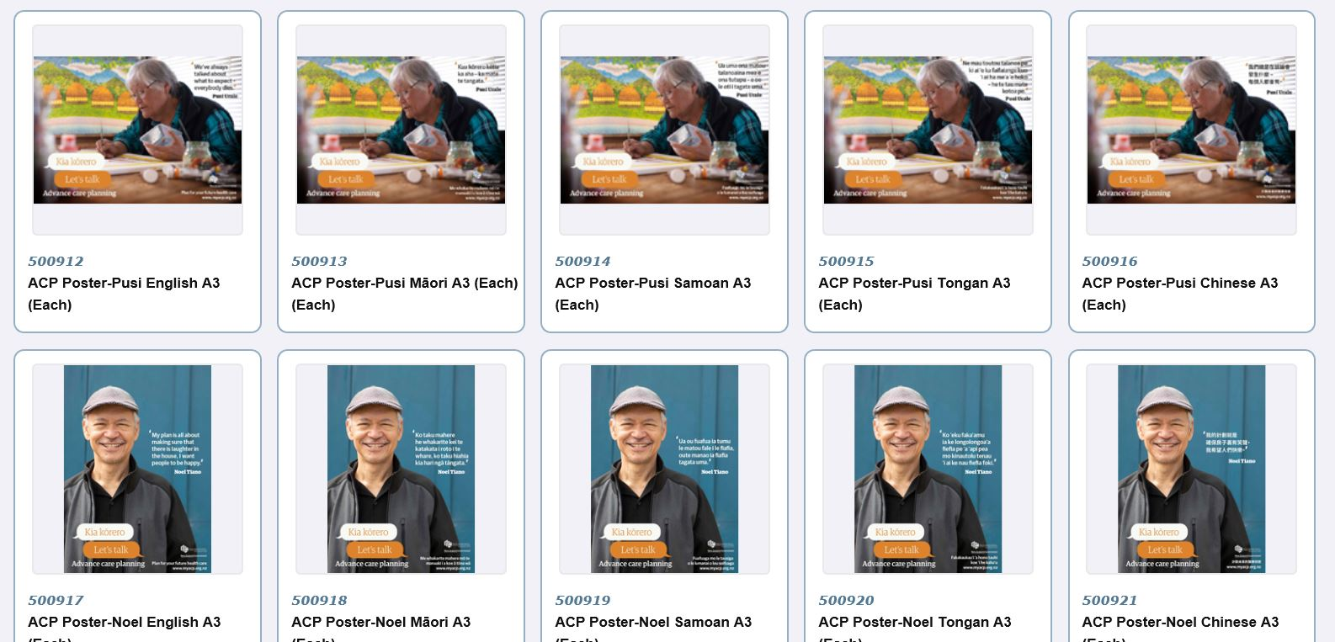

Static social media images
Static images for social media were created in 1200x628px and 1200x1200px.
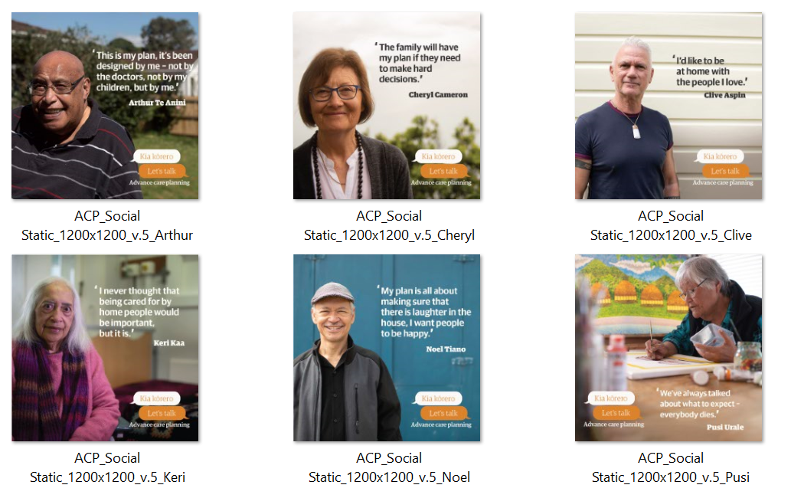

Videos
Six videos following each consumer story were subtitled in English, te reo Māori, Samoan, Tongan, Traditional Chinese and Simplified Chinese.
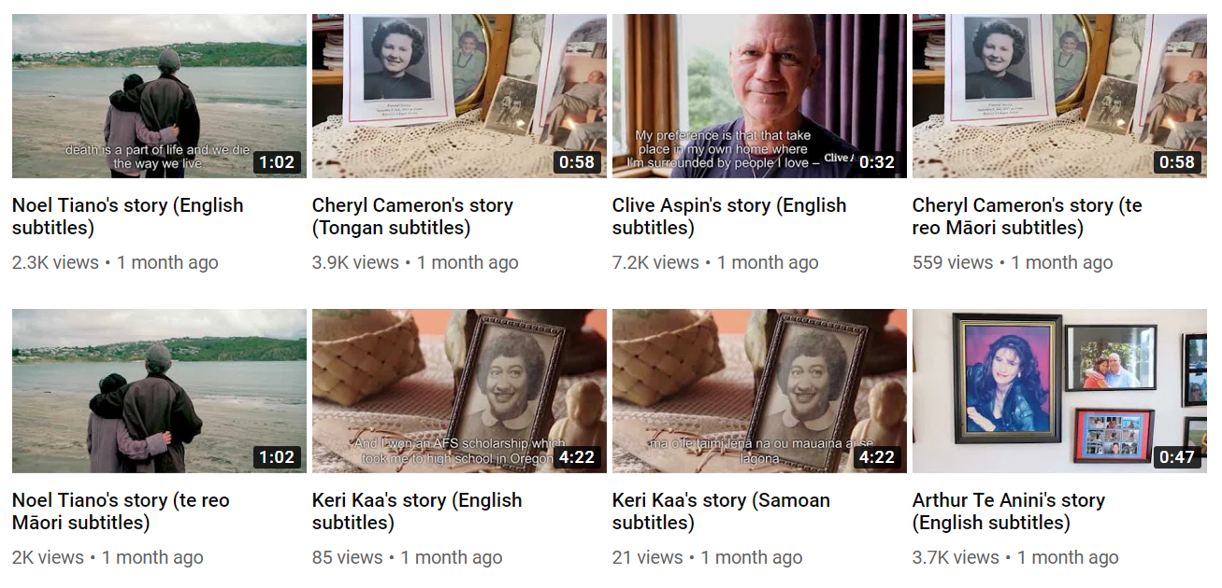

Appendix 2: Kia kōrero | Let’s talk media coverage | Āpitihanga 2: Kia kōrero ngā pāhotanga

Television coverage
Māori Television featured Keri’s four-minute video on Saturday 27 March during the 8pm movie break as well as other off-peak times. They also ran Keri’s 30-second clip 39 times between 23 March and 5 April.
One News featured the campaign on the 6pm news.
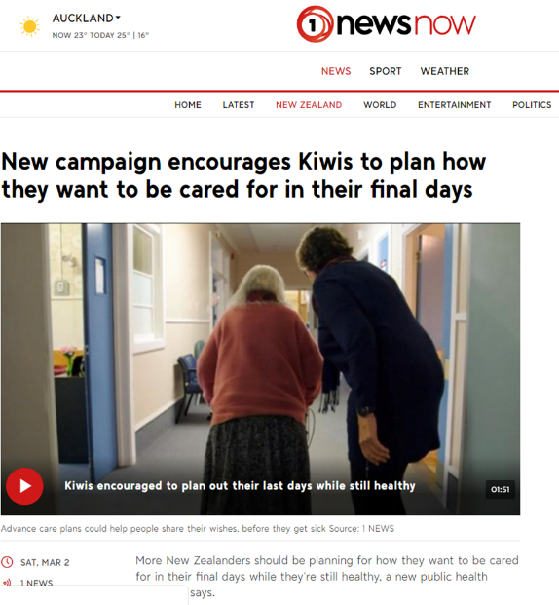

Media articles
Media covered the campaign in articles including Stuff and Health Central.
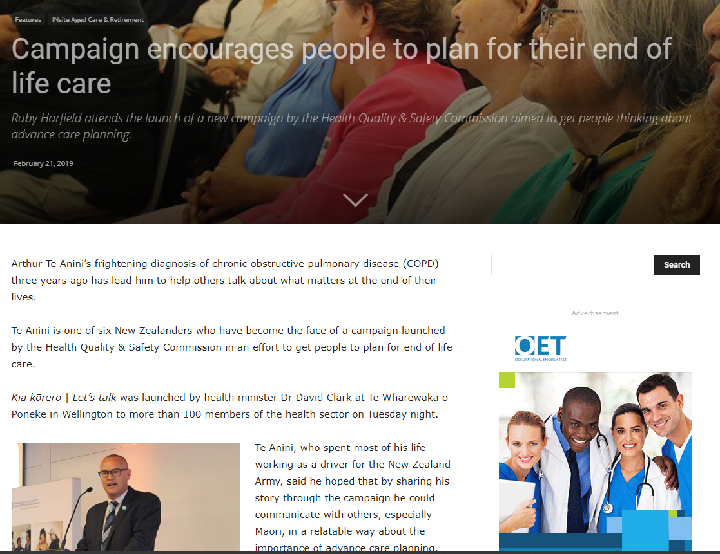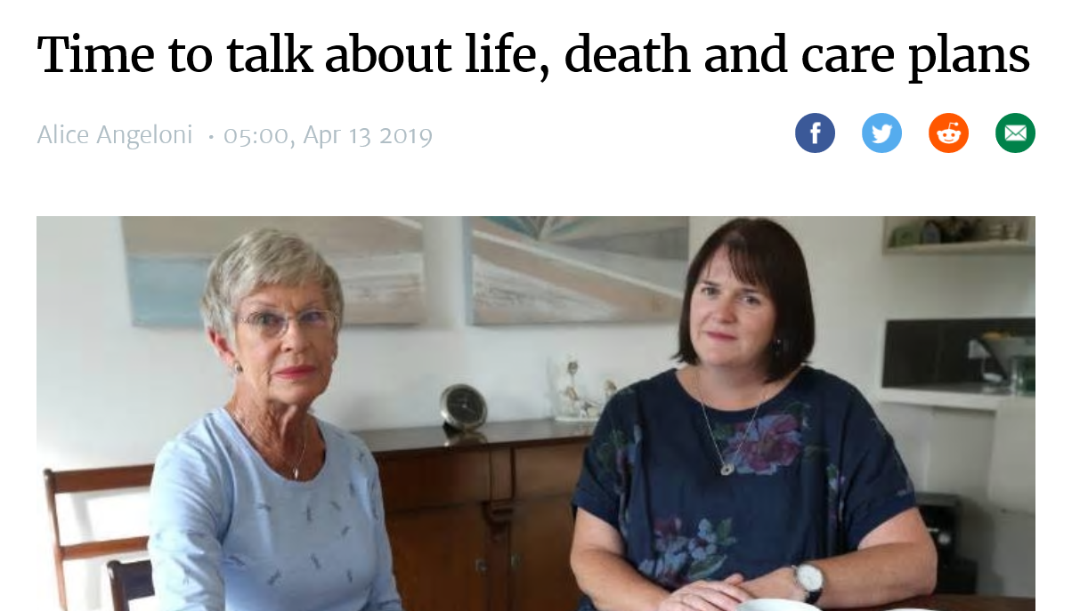

Kai Tiaki, the New Zealand Nurses Organisation (NZNO) publication, featured an article focusing on their role as advocates and facilitators of ACP for their 30,000 nurses (4,000 Māori nurses in NZNO).
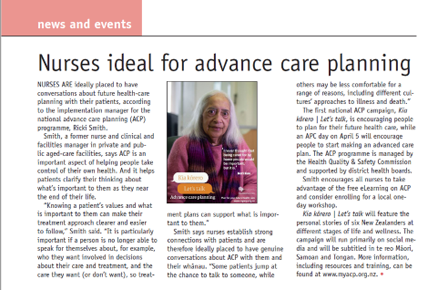

Radio coverage
Radio New Zealand and Waatea News both featured the campaign on radio and online.
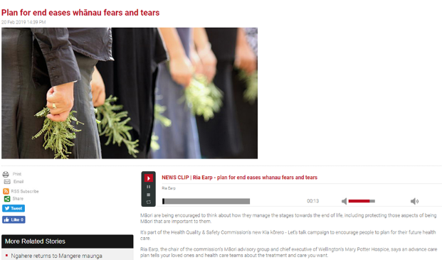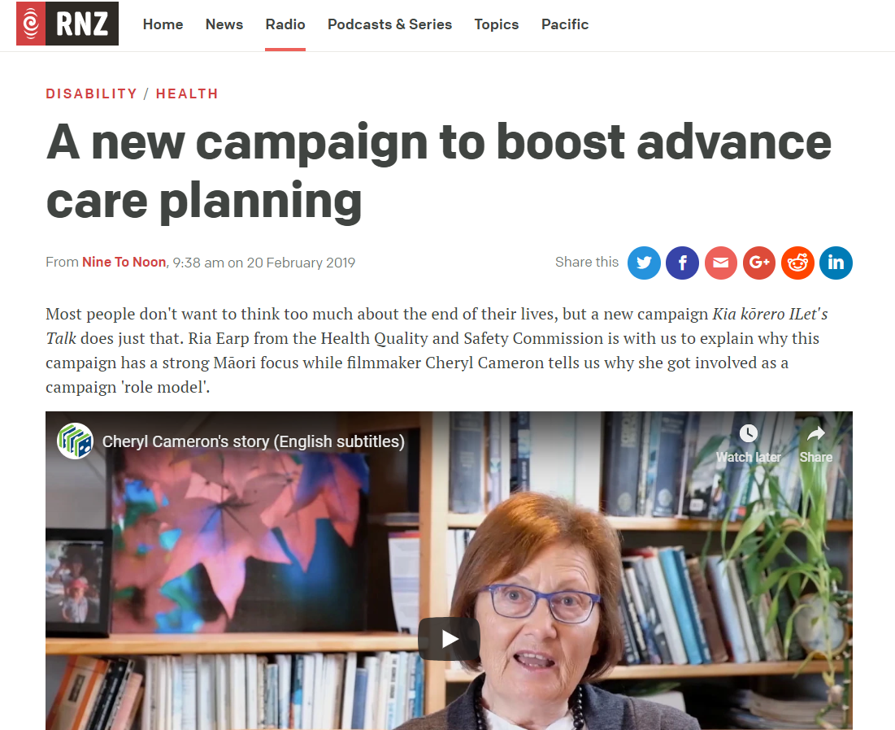

Newsletters
- Super Seniors featured an article on the campaign for their 300,000 subscribers.
- Pharmacy Today featured an article about the role pharmacists could have in facilitating ACP plans with people in the community.
- Fetu Pasifika, the Ministry of Pacific Peoples’ e-newsletter, featured an article about Pusi and Sima Urale in March.
- Medic Alert also put out a small story featuring the campaign to their 30,000 readers.

Social media coverage
The content created was shared by a large range of organisations online including:

- NZ Medical Association
- Northland DHB
- Auckland DHB
- The Pharmacy Guild of NZ
- Vaka Tautua
- Hospice NZ
- Age Concern NZ
- Health Central
- Your community pharmacist
- Mary Potter Hospice
- Waikato Hospital

Appendix 3: Facebook summary | Āpitihanga 3: Whakarāpopoto Pukamata
