Te whakamahere tiaki i mua i te wā taumaha
Advance care planning

Legal case studies with notes for DHB Trainers

Version 4.0 April 2021

Choose three case studies – there are five to choose from.
The notes in italics might be helpful to consider when facilitating the feedback and brief group discussion.

Lillian – Case Study
This case study highlights the issues related to interpretation of an Advance Directive, particularly in the absence of an advance care planning
Background
Lillian is admitted to the emergency department. She is a 61 year-old lady who has a blocked Ventro Peritoneal shunt, needing surgery. She is stable but unconscious. Medical assessment on admission reveals no major cardiovascular or respiratory problems and there is a clear clinical picture of the required course of action. “Directive” on record noted:

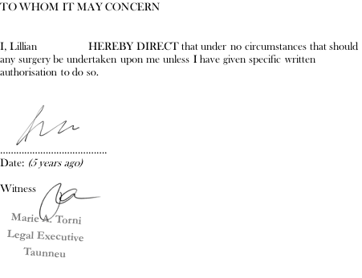
Medical history on record:
- Congenital aqueduct stenosis ventro peritoneal shunt done 7 years ago. Spent 5 weeks in hospital.
- Extract from a clinic letter 2 months after surgery “…She was extraordinarily angry today. Apparently, she would have refused medical treatment at the time of her incident and is very upset that she was treated…”
- Last clinic notes 6 months ago: recurrent falls, alcoholism, cognitive decline, obesity, deafness, hypertension and hypercholesterolemia

Additional information discovered:
- The legal executive who witnessed the “directive” 5 years ago is unable to recall or reproduce another record of it
- Told that she lived alone and was independent
- Family are upset by the idea that we would do nothing and let her die. When asked if they thought she would agree to an operation – “she probably would, but I am not sure…”

Issues for discussion
- Is it a valid advance directive?
  - Ask why? Or why not?
  - Make reference to the legalities re ADs including the requirements for validity.

Tip: there is no right answer to this question, the debate about whether it is valid or not highlights that the clinicians asked to validate an advance directive have some discretion. So, to ensure that an AD is found to be valid (that there is no reasonable grounds not to find it valid – it is important to make it very clear, specific, sign it, date it, talk about it with your healthcare team and family, and wrap it into an advance care planning that spells out what is important and why you are refusing treatment.
The discomfort with this particular example is that the surgery that needs doing is simple and if they find the AD to be valid they cannot do the procedure and save her life. It creates an ethical dilemma where consumer autonomy could be seen as being in direct conflict with do no harm.
- If it is not, do you need to consider it?
  - Aim for ‘yes’ – remember decision-making cascade. Even invalid AD is part of the info gathered in order to make decisions. The clinician must step into the shoes of the person (gather and consider all information) and do what they believe the person would have wanted.
- What should the treating clinician do in this case (if he does nothing Lillian will die)?
  - If valid advance directive then treatment would be to make her comfortable – no surgery. If time, and you wish to explore further with group, could ask ‘what if it wasn’t valid?’
  - If not valid then explore group’s responses - why should the treating clinician unblock the shunt?
- What would you do if Lillian was your mother?
  - No right or wrong. Ask ‘why?’
  - Consider reference to trying to find out what is in Lillian’s best interests – what do we need to consider?

What really happened?
Lillian was a case that an Anaesthetist was faced with. He moved her down the theatre list and spent a substantial amount of time trying to get more information to help the team make a call about the validity of the AD. After due consideration and consultation with colleagues he decided that he could not comfortably confirm the validity of the AD and so they performed a temporary procedure to allow Lillian to regain consciousness, so they could then ask her for her consent. She initially consented to the required surgery though expressed regret subsequently.
If the anaesthetist, and other members of the healthcare team, had access to documented, clear notes about what her concerns were when she decided she did not want surgery (in the form of an advance care planning or clinic notes) they would not have found themselves in the position they did – they would have had content and context for better decision-making. Instead we left the clinician in a very difficult position.

Evan – Case Study
This case study highlights the impact of ambiguous documentation and discusses the interpretation of advance care planning and advance directive documentation.
Presenting situation
Evan is transferred to ED by ambulance after his daughter, Sally, finds him unresponsive at home in bed; he is breathing. The treating clinician tells Sally that he has had a cardiac event and that he is seriously ill; with treatment he may recover, although this is uncertain. They ask Sally (who is appointed EPA) what approach Evan would want them to take with his treatment. Sally remembers her dad has completed an advance care plan and hands it to the team. She says she was not part of the conversation when he documented the advance care plan, and they have not discussed it.
Extracts from Evan’s advance care plan (signed by Evan and his GP):
Section 2 What matters to me – left blank. What worries me – nothing worries me
Section 3 This is why I am making an advance care plan - I am making this plan because I am already very old and cannot last forever. Resuscitation should not be prolonged if brain damage is likely.
Section 5 As I am dying: My quality of life means – left blank.
In addition, I would like you to: let the people who are important to me be with me and stop medications and treatments that don’t add to my comfort. The place I die is not important to me. I don’t mind where I am cared for.

Section 6 Treatment and care choices
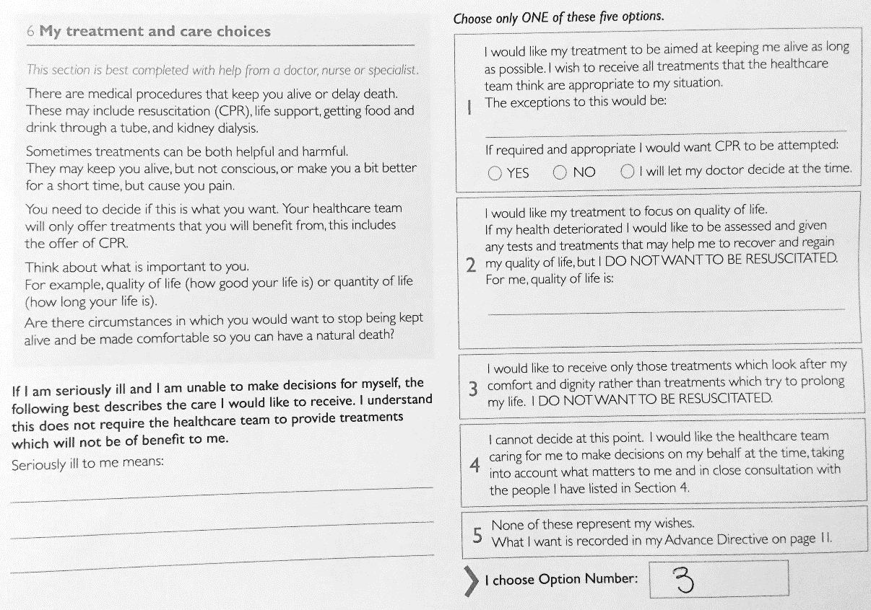
Section 6: My Advance Directive
In the following circumstances: | I would like my care to focus on: | I would accept the following treatments: | I would wish to refuse or stop the following treatments:
Cardiac arrest | Active resuscitation if full recovery likely | CPR | Resuscitation if brain damage is likely
Stoke or brain injury |  |  | Not for active resuscitation
Section 7 After my death – If my organs and or tissues could be made available or donated I would wish this to happen, glad to give anything useful. I would like to be cremated. For my funeral or tangi I would like simple and short Christian ceremony. I don’t mind what my last resting place is, my daughter can decide.
Issues for discussion
- Do you think Evan would want life-prolonging measures to be attempted? Why? Why not?
Ensure group notes the discrepancy between “option 3” where he is refusing life-prolonging measures if he is seriously ill, and the written statements requesting resuscitation in Section 6 advance directive together with the statement in Section 3 where he says “resuscitation should not be prolonged if brain damage likely”.
Discussion about limitations to life-prolonging measures may come up.
- Does the information in sections 1-5 help with understanding Evan’s wishes? If yes, in what way?
Promote discussion about the background information providing potentially useful insight into the person, and therefore may help to understand what’s behind his decisions in section 6.
E.g. we get the sense he wants input into decision making and some control about what happens to him, and that avoidance of brain damage is important to him so his brain function seems to be important to him. More information could have been helpful, e.g. about what constitutes quality of life for him, and anything else other than avoiding brain damage is important (e.g. is physical function important?)
- What aspects of the current plan would you want to clarify and potentially re-write with Evan if you had the opportunity before he became unwell?
Include:
- Quality of life
- Clarification of goals of care and treatment in the face of serious illness or injury (the OPTIONS in section 6)
- Wording of the specific treatment preferences

Reg – Case Study
Useful for aged care staff, or staff dealing with cognitive impairment.

Background
Reg is a 74 year-old man with late stage dementia, living in a residential dementia unit. His EPA is his wife, Marg. He is mobile, can bathe and dress with prompting, and eats independently. He has limited ability to express himself verbally. He used to walk around the unit most of the day, seemingly content. Recently he has started to lose weight, has become more fatigued. A locum GP ordered blood tests, which indicated anaemia. On obtaining the blood results the locum GP rang the Registered Nurse and asked her to ask the family if they wanted Reg sent to hospital for investigations. This she did, and Reg’s wife said, “yes of course!” ED found nothing acute, and suggested the GP refer him for outpatient investigations. In ED Reg had had to be sedated as he was very distressed.
Current situation
The next day, Marg and her son Paul came into the unit demanding to speak with whoever is in charge, as they wanted Reg sent back to hospital. His condition was stable and he was undistressed.
- They wanted a diagnosis, even if it meant distress for Reg and no change in outcome.
- The Registered Nurse had heard staff saying previously that Reg had said on several occasions that he does not want to live like this and he doesn’t want to “end up like those in there” [hospital level dementia unit]. The Registered Nurse could find no documentation to this effect.
The nurse attempted to discuss with Reg to no avail.

Issues for discussion
- Do the family have a right to demand that Reg be transferred back to hospital?
  - Make reference to legal rights of family/EPOA - family have no legal right to demand treatment. That is not to say that it is easy for clinicians in these situations to deal with family demands.
  - Consider ethical issues – right of RN to decline what family are wanting for Reg; hospital already sent him back with no acute treatment needed
- Would going back to hospital at this time likely be in Reg’s best interests?
  - Consider previous distress in ED;
  - indicators that he may not want his life prolonged (although no written evidence);
  - generally accepted that moderate to severe dementia requires palliative care (White paper 2013, EAPC)
  - What are we trying to achieve?
- How would you approach the next part of the conversation with Marg and Paul?
  - Explore reasons for wanting hospital investigations
  - Acknowledge wanting to do what’s best for him
  - Explore what they feel his priorities would be (survival/prolongation of life? Comfort/allow nature to take its course)
- What might have made this situation easier?
  - advance care planning conversations before Reg lost capacity
  - advance care planning conversations with Reg and family prior to this event

What really happened?
The Nurse Practitioner spoke with the family. She asked about what they felt Reg’s priorities would be. They were very clear that he would not want to live like this, that he would hate to end up with even more advanced dementia where he couldn’t feed himself or know his family. They felt his main priority would be to be without pain. When asked what they felt investigations would achieve, they replied, “how can you take care of him if you don’t know what’s wrong with him?” Marg was also receiving pressure from other family members to have a diagnosis and she was worried that they would think she wasn’t doing a good job of caring for him if “nothing was done”. With gentle explanations and clarification, they realised that sending him back to hospital would be distressing for him and that what he would really want would be to stay in the unit surrounded by people he knows, with measures to keep him comfortable. He never did have any further investigations and end of life plans were put in place. A month later he had what appeared to be an acute bowel bleed which ended his life within 24 hours; he remained in the unit, pain and distress were addressed promptly and family were prepared and very grateful for the care he received.

Sione – case study
Useful as a basis to discuss cultural aspects of advance care planning.

Background
Sione is a 71 year old Samoan man with Chronic Obstructive Pulmonary Disease who has been living in New Zealand for 8 years due to his health. He and his wife have 6 children, 5 of whom live in Samoa with his wife. He lives with his daughter and her respective family here in NZ. His family in Samoa hold very strong traditional Samoan views on life and his family with whom he lives here in NZ are quite Western in their perspectives and lifestyle.

Current situation
One of the advance care planning facilitators was scheduled to give a talk on advance care planning to a Better Breathers group. Usually about 12-15 people attend the group, and there is a mix of genders and cultures, often predominately Pacifica. Pacifica clients frequently attend with a spokesperson.

The Physiotherapist was approached by Sione’s spokesperson – his grand-daughter – prior to the session. She informed her that her grandfather did not want CPR if he was to ‘go down’. At this point Sione does not have a written advance care plan or advance directive.

The Physiotherapist asks the advance care planning facilitator, “So what happens if Sione arrests in the hall today?”

Issues for discussion
- Does Sione’s expressed wish for no CPR constitute a valid advance directive? Why/why not?
  - Make reference to legalities re ADs including requirements for validity – get group to name them perhaps
  - Consider difficulties in ascertaining validity – e.g. language barrier; does Sione understand what he has asked for? Has he actually asked for no CPR? Etc.
  - If there is time you might also explore with the group what challenges they might foresee (or have experienced) having family members acting as interpreters?
- What legal or other responsibilities does the Physiotherapist have, once she has been given this information?
  - Consider code of rights – we have a responsibility to find out and act on people’s preferences and the right to make an AD. Physio needs to enable this
- Given the collective decision-making of traditional Samoan culture, would there be a need to involve his family back in Samoa before making a decision about CPR? How does that impact on this situation?
  - Make reference to legalities of ADs and code of rights
  - Does the cultural requirements impact on the legal right for someone to make an AD (independently if they wish)?
- If Sione did arrest in the hall today, what would your response be?
  - No right or wrong answer – let the group tell you what they think.
  - Ask for their rationale.

Hone – case study
Useful to explore legal framework in the context of Maori whānau.
Whānau – support networks and history
Hone is a 54 year-old man of Ngāti Kahungungu descent, who lives with his wife Mere and their two adult children. Hone teaches whakairo (Māori carving), at the local kura (school). Both Hone’s parents and his two siblings are deceased.
Wairua – cultural identity
Both Hone and Mere whakapapa (have genealogy) to the local iwi (tribe) and hold mana on their marae. Hone and his whānau have a fear and distrust of health services, largely due to experiences of racism and perceived lack of care experienced in the past.
Tinana – physical health and functioning
Hone was diagnosed with congestive heart failure 3-years ago. He started the prescribed medications but stopped as they made him feel worse. Hone is registered with a general practice but does not feel a connection with any GP as he sees a different one each time.
When unwell, Hone visits either his acupuncturist or rongoā (traditional Māori medicine) practitioner. He has been seeing his rongoā practitioner more frequently recently, as he has been experiencing increasing fatigue, weakness, leg swelling and shortness of breath. He knows and accepts that his health is deteriorating.
Hinengaro – tikanga, mana protection, emotional well-being
Hone has refused to be considered for a heart transplant. He told Mere, “I absolutely do not want a stranger’s heart placed in my chest”. Hone and Mere have made a verbal agreement to always protect each other and be each other’s Enduring Power of Attorney for health and welfare.
Current Concern
Hone entered the hospital emergency department via ambulance. He is unconscious, following a fall from a tree that he was pruning. He has a head injury and an unstable hip fracture which requires surgery. His wife and children are with him.
The treating clinician has asked Mere and their children what Hone has previously told them about his care and treatment preferences. Their son Matt has taken the role of key whānau spokesperson. He has advised the healthcare team that Hone requested that their whānau decide what was to be done for him if he was unable to speak for himself. Mere says Hone has always been adamant that he doesn’t want ‘anyone cutting him up’.
Issues for discussion
- Can Hone’s reported statements about not wanting surgery, be regarded as a valid advance directive? (He needs surgery to fix his hip fracture.) Why? / Why not?
- Ensure exploration of criteria for validity for ADs as relates to this situation
- If it doesn’t come up in feedback, ask: “do you think he meant no surgery for this specific situation (i.e. hip fracture)?” (Last of the validity criteria).
- The group may bring up the fact that even if it was considered a valid AD, to forego surgery for a fractured hip would be problematic in terms of pain, loss of mobility, other complications – which may pose an ethical dilemma. Avoid getting too bogged down in this discussion – acknowledge the concerns and relate to the importance of adequate ACP conversations and clear documentation including specific circumstances for ADs.
- If not, who decides whether to proceed with the surgery?
- Ensure reference to the decision-making cascade
- In this case, the treating clinician will decide using all the information s/he can find, to determine Hone’s preferences.
- What is his whānau’s role in deciding whether to proceed?
- Make reference to EPoA: verbally agreeing to have someone be your EPoA does not meet the legal requirements for appointing an EPoA
- Explore collective vs individual decision-making approaches – highlight the constraints in the current law which says only the individual can decide for themselves, and whānau have no legal right to decide – with the exception of an enacted EPoA
- Ultimately, the role of whānau is to inform the medical decision.

