Shared goals of care data collection tool
Version 1.5| July 2022
This spreadsheet uses macros to aid refreshing graphs as well as when adding new wards and weeks to enter data from audits. However, most IT groups in hospitals will block a file with macros coming via email. You will need to work with your IT group to be able to load the spreadsheet into your organisations files and start using it with the macros enabled.
Please discuss this with your IT group to identify the best location for storing this file.
A Setting up the tool
1. Select 'Enable Content' before you start. This will be a message generated by your Excel programme and will be displayed in a yellow bar at the top of the spreadsheet.
On the 'ControlPage' tab:
2. Enter your hospital name in the yellow highlighted field.
3. Enter the start date for audits in the yellow highlighted field. This will affect all worksheets in this tool automatically.
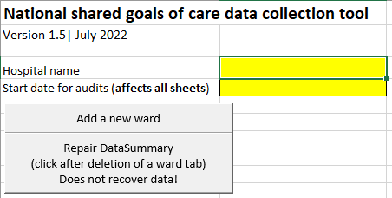
5
4
2
3
4. To add a new ward for data collection, click the 'add a new ward' button. You can rename the tab with the ward name. Please note that this spreadsheet has been limited to 15 wards. If you need more wards to be added, please contact acp@hqsc.govt.nz
5. To add a new week to the end of all ward data collection sheets, click 'add week to end' button.
6. Save the file, ensure you have the name of your organisation in the file name.

Please note, the control panel tab has other information about using the remaining tabs on the spreadsheet. We recommend reviewing this before you start using it the data collection tool.

