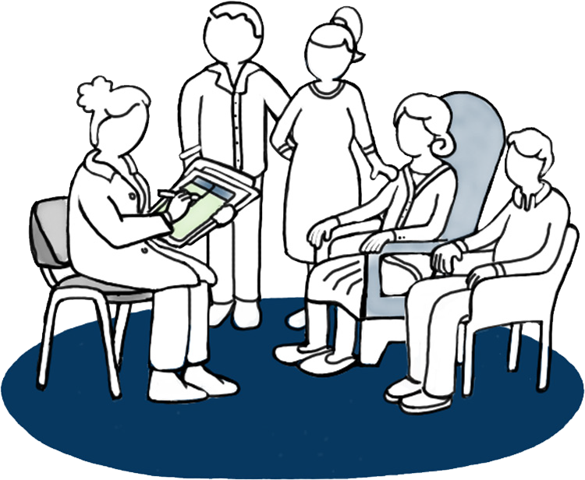
Factsheet

Shared goals of care discussion
Tell us what matters to you, because it matters to us.
As part of your move to our facility, we would like to talk with you, your family and whānau about your goals of care.
The goals of care discussion will help you get the care and treatment you want while you are living here. We will regularly review the goals of care with you during your stay.
No one knows you and your body like you do. But it’s not just your physical health we would like to hear about – it’s also your hopes, worries, values and plans for the future.

About ‘shared goals of care’
If something happened while you were living here and you were not able to tell us what you would like, have you thought about what you would want the main goal of your care to be?
Goals you might consider include going to hospital, having specific treatments or staying where you are and continuing with the best care we can offer. This may include treatment to ensure you are comfortable.
- Would you want us to try all treatments, which may also include transferring you to hospital?
- Would you accept treatments if you thought it would give you more time to be with your family and whānau?
- Would you want to let your body decide its own natural pathway and stay where you are at the moment?
It is different for everyone, and there are times when what we want is just not possible, but we need to talk about it. That’s what shared goals of care are about.

Who will be talking to you
In most cases, with your permission, your usual doctor or registered nurse will talk with you. This is an opportunity for you, your family and whānau to reflect on what is important to you.

What we would like to know
We will ask you about what is most important to you. This is a chance to talk about:
- your understanding of any current medical condition/s and anything else you would like to know about it/them
- your priorities if your health did change
- what worries you and what gives you strength
- what abilities are so important to you that you could not imagine life without them
- how much you would be willing to go through for more time.

Who you can include in the discussion
This is a discussion about you – your thoughts and decisions. You can include anyone you want, such as members of your family and whānau or your nurse or caregiver. Or you may prefer to have the discussion on your own. You are free to choose who is involved and where you want to have the discussion.

Where the discussion will take place
Let the doctor or nurse caring for you know what is a comfortable and safe space to have the discussion and they will try their best to provide this for you.

Who to contact if you have more questions
Talk with the doctor or nurse caring for you.

This is not a ‘forever’ decision
This goal of care decision records your current wishes. We will regularly review it during your stay with us and make any necessary changes together.

It is ok to change your mind
Just let us – or the doctor or nurse caring for you – know and together you can all decide on a new plan.

Space for notes

