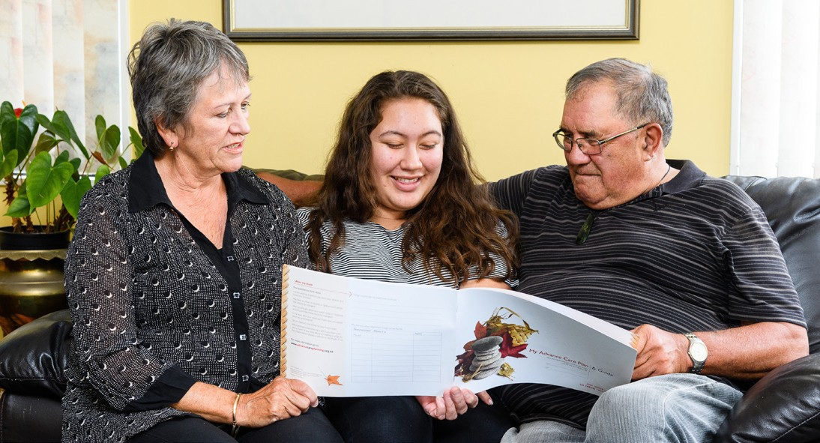

Advance care planning
Level 1A one-day workshops
Are you passionate about advance care planning (ACP)? We are looking for health professionals who want to:
- help grow the use of ACP
- learn how to translate an individual’s wishes into written documentation for their advance care planning
- gain experience in supporting patients with ACP.
Course pre-requisite: ACP e-learning needs to be completed before attending the workshop. https://acp.elearning.ac.nz

