National vital signs chart with early warning score coming soon
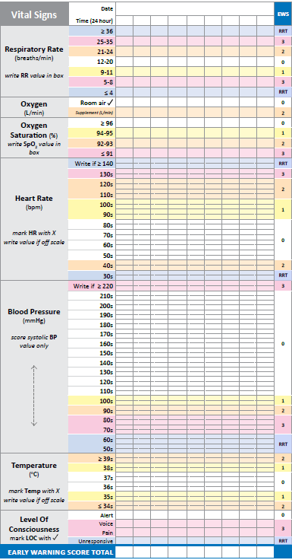
2 weeks to go!

Replace this text to insert your text – keep it brief. Eg, training on date at venue
Don’t overlap with the chart picture -you can replace with an image from your own chart
For more information contact name and number

