National vital signs chart with early warning score coming soon
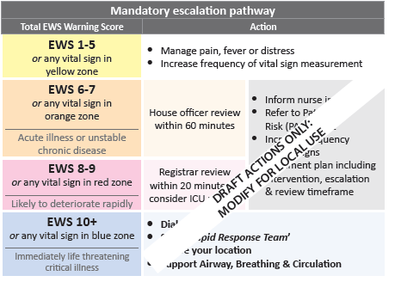
3 weeks to go!
Replace this text to insert your text – keep it brief. Eg, training on date at venue
Don’t overlap with the picture – you will need to replace it with an image of your own escalation pathway
For more information contact name and number

