MEWS escalation mapping tool
Your hospital needs to develop response processes for each level of physiological abnormality that triggers escalation of care. To support you in this work, we have adapted a template from the tool used by the adult patient deterioration programme (Figure 3). It offers a structured way to identify who will respond to each level of physiological abnormality in your hospital, which helps you to develop your local escalation pathway. You may need to repeat the exercise for different clinical areas where pregnant women receive care – for example, the orthopaedic ward may need to have a different escalation pathway from the postnatal ward.
The maternity vital signs chart (MVSC) and maternity early warning system (MEWS) score together identify multiple levels of worsening abnormality, which trigger a graded response based on the seriousness of deterioration in a woman’s vital signs. Graded response systems may involve calling the lead maternity carer, a senior midwife or senior nurse and/or the team doctors for low or medium levels of abnormality, and a rapid response provider for high levels of abnormality. Response processes will vary depending on the local context of your hospital. For example, a small rural hospital will have quite different processes from a large tertiary hospital.
All clinicians will need education in how to use your recognition and response system and in the essential clinical skills and capabilities for recognising and managing acute physiological deterioration. If you would like an eLearning module about using the MVSC, you can request it by emailing mews@hqsc.govt.nz. District health board midwifery educators also have an education package available. You may find it useful to consider several existing courses designed to teach essential clinical skills for managing deterioration, such as:
- Local DHB Practical Obstetric Multi-Professional Training (PROMPT) courses www.promptnz.org
- Managing Obstetric Emergencies and Trauma (MOET) http://moetaustralia.com/
- ALERT course www.ccdhb.org.nz/working-with-us/capability-development/course-information/alert-course-information/
- the BASIC suite of courses, including VeryBASIC and BASIC4NOW, which a collaboration of intensive care clinicians designed to teach medical students, doctors and nurses. www.aic.cuhk.edu.hk/web8/courses.htm
It is essential that responders have specific education to give them the clinical and non-technical skills they need to manage acute deterioration and understand their responsibilities for communication and documentation. Such education is particularly important for tertiary responders who may not have critical care or maternity experience (eg, for duty nurse managers who work as responders in small hospitals or patient at risk nurses). This MEWS compendium includes a factsheet about capabilities for responders.
You should carry out the escalation mapping exercise for each level of physiological abnormality in your escalation protocol. Developing your escalation process should involve multidisciplinary input, including from lead maternity carers. You should also consider what related policy and guidance you need to develop, review or update to support the process (eg, guidance around clinical documentation, referral, handover and communication). Figure 1 illustrates the overall escalation mapping process. Follow the steps in the template to help you to identify responses that are appropriate for your facilities. For a worked example, see Figure 2.
Figure 1: Escalation mapping process
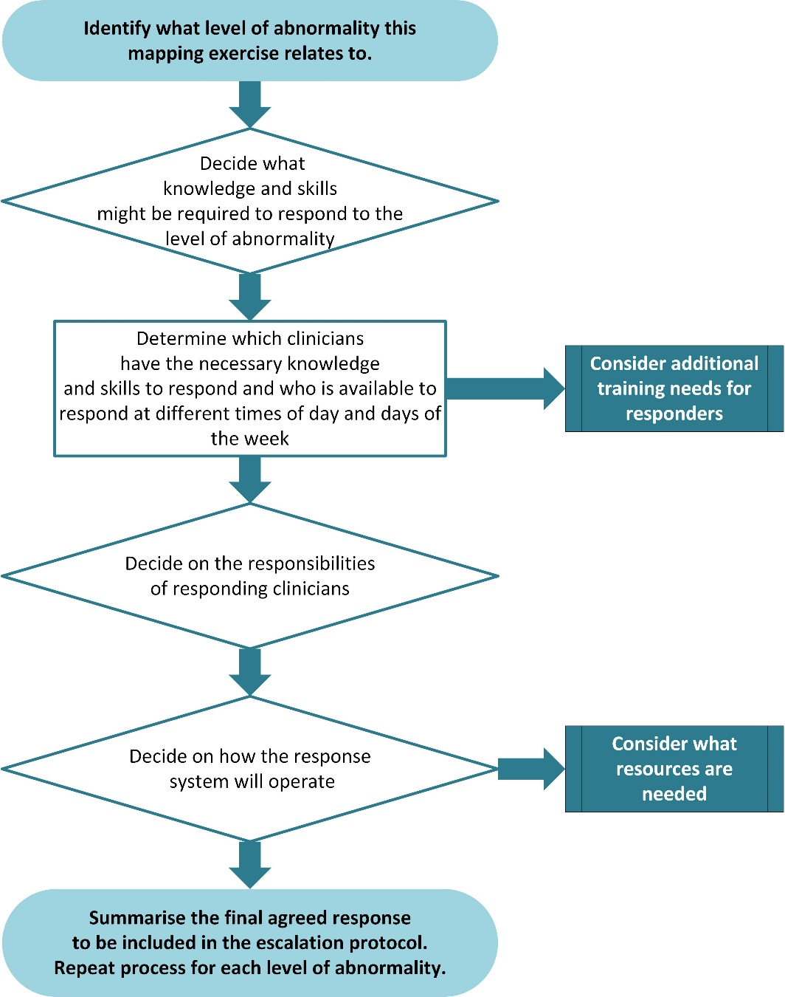
This worked example illustrates how to work through the process of planning appropriate responses to each level of physiological abnormality. The content may not be relevant in every context as hospitals of different sizes will have different resources available.
Figure 2: Worked example
Level of physiological abnormality: High
Total MEWS score 8–9 or single parameter trigger thresholds triggering pink zone actions
(Note: Total MEWS score of 10+ triggers a rapid response call)
Respiratory rate | 6−9 or  26−30 | Heart rate | 40−49 or  130−139 | Temperature | ≥ 39 °C or ≤ 34°C | Oxygen | Not a trigger
Systolic blood pressure | 70−79 or  160−199 | Diastolic blood pressure | ≥ 110 | Level of consciousness | Abnormal | Oxygen saturation | ≤ 91%
Skills and knowledge that health professionals may or will need to respond to EACH abnormality
- Basic airway management  - Oxygen therapy  - Systematic physical assessment of the woman and fetus  - Auscultation of chest  - ABG and interpretation  - CXR and interpretation  - ECG and interpretation, treatment of dysrhythmia  - Urinary catheter insertion |  |  |  | - IV access  - Collection of pathology samples (UEC, FBC, blood cultures, U/A etc)  - Prescription and administration of drugs, IV fluids, blood and blood products  - Ordering of CT, USS and/or other tests  - Referral to other specialities  - Communication with woman, family, whānau or carer and clinical team
Responding health professional(s) and number required  - On-call obstetric registrar and senior house officer  - Midwife or RN caring for the woman  - Midwife or RN in charge of ward  - Duty nurse manager |  |  |  | Times these health professionals are available to respond  - On-call obstetric registrar: 24/7  - On-call obstetric SHO Mon-Fri 8am-5pm  - Ward midwife, RN and midwife or nurse in charge: 24/7  - Duty nurse manager: outside Mon–Fri 8am–5pm  - Alternative response: escalate to rapid response team

Responsibilities of attending health professionals:
Doctor, midwife or RN caring for the woman and duty nurse manager (or outreach nurse):
- undertake targeted physical assessment of the woman
- provide urgent treatment (in consultation with admitting or on-call specialist obstetrician)
- document plan for further treatment and review
- refer for further specialty input if required (eg, haematology, anaesthesia, intensive care, neonatology or radiology).
Midwife or nurse in charge:
- supports midwife or RN caring for the woman to undertake further assessments and treatments as required
- contacts the lead maternity carer to update on woman’s condition (appropriately timed)
- ensures other women (or patients in area outside of maternity) are attended to.
What is the required timeframe for response given this level of abnormality?
As soon as possible but within maximum 20 minutes. If caller considers a more urgent response is required, they should call the rapid response team.
How will the health professional(s) be contacted?
Obstetric registrar via mobile phone – advise woman’s name, location and admitting team.
Obstetric SHO – via locator.
Midwife or RN caring for the woman and midwife or RN in charge – if unable to locate, use assist call button.
Duty nurse manager via locator – advise woman’s name and location.
Other than those attending the woman, who else should be notified?
Registrar to contact on-call specialist obstetrician once the woman has been assessed.
Midwife or nurse in charge of ward to be notified of the woman’s deterioration.
Family and whānau updated in line with the woman’s wishes.
What are the alternative or back-up options for getting a response?
Call rapid response team if the woman deteriorates further or you are worried.
Is the necessary equipment available in the clinical area to undertake this treatment?
Yes No → Consider purchasing equipment or develop process for bringing equipment to area
Final agreed response to include in escalation protocol/policy and display on vital signs chart:
- Registrar review within 20 minutes.
- Notify midwife or RN in charge and duty nurse manager or outreach nurse.
- Fetal assessment.
- Repeat observations in 15 minutes.
- Call rapid response if the woman deteriorates further or you are worried.
Figure 3: Maternity early warning system mapping tool
Level of physiological abnormality: Low |  | Total MEWS score: 1−4
List skills and knowledge that health professionals may or will need to respond

List responding health professional(s) and number required | List the times these health professionals are available to respond
Responsibilities of attending health professionals:

What is the required timeframe for response given this level of abnormality?

How will the health professional(s) be contacted?

Other than those attending the woman, who else should be notified?

What are the alternative or back-up options for getting a response?

Is the necessary equipment available in the clinical area to undertake this treatment?
Yes
No → Consider purchasing equipment or develop process for bringing equipment to area
Final agreed response to include in escalation protocol/policy and display on vital signs chart:

Level of physiological abnormality: Medium | Total MEWS score: 5−7
List skills and knowledge that health professionals may or will need to respond

List responding health professional(s) and number required |  | List the times these health professionals are available to respond
Responsibilities of attending health professionals:

What is the required timeframe for response given this level of abnormality?

How will the health professional(s) be contacted?

Other than those attending the woman, who else should be notified?

What are the alternative or back-up options for getting a response?

Is the necessary equipment available in the clinical area to undertake this treatment?
Yes
No → Consider purchasing equipment or develop process for bringing equipment to area
Final agreed response to include in escalation protocol/policy and display on vital signs chart:

Level of physiological abnormality: High |  |  |  | Total MEWS score 8−9 or single parameter trigger for pink zone actions (listed below)
(Note: A total MEWS score of 10+ triggers a rapid response call)
Respiratory rate | 6−9 or  26−30 | Heart rate | 40−49 or  130−139 | Temperature | ≥ 39 °C or  ≤ 34°C | Oxygen | Not a pink single parameter trigger
Systolic blood pressure | 70−79 or  160−199 | Diastolic blood pressure | ≥ 110 | Level of consciousness | abnormal | Oxygen  saturation | ≤ 91%
List skills and knowledge that health professionals may or will need to respond to EACH abnormality

List responding health professional(s) and number required |  |  |  | List the times these health professionals are available to respond
Responsibilities of attending health professionals:

What is the required timeframe for response given this level of abnormality?

How will the health professional(s) be contacted?

Other than those attending the woman, who else should be notified?

What are the alternative or back-up options for getting a response?

Is the necessary equipment available in the clinical area to undertake this treatment?
Yes
No →Consider purchasing equipment or develop process for bringing equipment to area
Final agreed response to include in escalation protocol/policy and display on vital signs chart:

Level of physiological abnormality:  Emergency/rapid response |  |  |  | Total MEWS score 10+ or single parameter trigger for blue zone actions (listed below)
Respiratory rate | ≤ 5 or  ≥ 31 | Heart rate | ≤ 39 or  ≥ 140 | Temperature | Not a blue single parameter trigger | Oxygen | Not a blue single parameter trigger
Systolic blood pressure | ≤ 69 or  ≥ 200 | Diastolic blood pressure | Not a blue single parameter trigger | Level of consciousness | Unresponsive | Oxygen saturation | Not a blue single parameter trigger
List skills and knowledge that health professionals may or will need to respond to EACH abnormality

List responding health professional(s) and number required |  |  |  | List the times these health professionals are available to respond
Responsibilities of attending health professionals:

What is the required timeframe for response given this level of abnormality?

How will the health professional(s) be contacted?

Other than those attending the woman, who else should be notified?

What are the alternative or back-up options for getting a response?

Is the necessary equipment available in the clinical area to undertake this treatment?
Yes
No → Consider purchasing equipment or develop process for bringing equipment to area
Final agreed response to include in escalation protocol/policy and display on vital signs chart:

