Recognising and responding to
paediatric deterioration

A guide to preparing for and implementing
a paediatric early warning system

October 2022

Contents

Document purpose 2
Introduction 3
The case for change 4
Paediatric recognition and response programme aim 5
Programme driver diagram 6
Critical factors for successful implementation 7
Tools, guidance and support for hospitals 8
Support for sites 9
Implementation preparation activities 9
1. Plan what you will be doing and how you will do it 10
2. Prepare for implementation 13
3. Countdown to implementation 16
Implementation and sustainability activities 16
Appendix A: Quality improvement approach 18
Endnotes 20

Published in October 2022 for implementation by the Health Quality & Safety Commission,
PO Box 25496, Wellington, New Zealand.
Published under Creative Commons License CC BY-NC 4.0. This means you may share and adapt the material provided you give the appropriate credit, provide a link to the licence, and indicate if changes were made. You may not use the material for commercial use. For more information about this licence, see: https://creativecommons.org/licenses/by-nc/4.0/
Document available online at: www.hqsc.govt.nz
Enquiries to: info@hqsc.govt.nz

Document purpose
This guide is intended to help project leads and teams prepare for and implement a nationally consistent paediatric early warning system. It sets out the aim of the system, components to be implemented, available support and recommended activities during the preparation, implementation and sustain periods.

Introduction
There is limited published evidence about the degree or extent of failures to recognise or respond to acute deteriorating tamariki in Aotearoa New Zealand hospitals or in the international literature. However, use of paediatric early warning tools and a systematic approach to escalation and response to tamariki at risk of deterioration is widely recommended.,,,
Over the next eight months, the Health Quality & Safety Commission (the Commission) will work with all health districts to implement the national paediatric early warning system (PEWS).
The implementation will focus on understanding the sites’ current state and identifying a consistent approach to the clinical, local measurement and governance components of the system in place. Linking these components to the wider hospital deteriorating adult and maternity recognition and response governance will be critical to care for tamariki who receive services outside of the main paediatric ward, such as in the emergency department or paediatric assessment unit.
We are asking these hospitals to prepare for and implement PEWS between October 2022 and May 2023 (Figure 1).

Figure 1: Preparation and implementation timeline of the national PEWS programme
Oct/Nov 2022 ‒ April/May 2023

Oct – Dec 2023 onwards

Engaging with and involving clinical, operational and executive staff is critical to establishing a successful and sustainable PEWS.
Paediatric early warning systems should not be viewed in isolation; they are also part of the broader organisational patient safety systems. They interact with many other organisational and hospital policies, programmes and processes, for example:
- programmes for improving hospital safety after hours
- clinical orientation and education programmes
- audit, measurement and quality improvement processes
- policies outlining expectations for patient monitoring, clinical communication and documentation.

The case for change
Serious adverse events, including death, affect paediatric patients in hospital. Some of these events, or their outcomes, are preventable.
While there is limited published evidence of the exact frequency or consequence of failure to recognise or respond to acute deterioration in tamariki in Aotearoa New Zealand hospitals, it is widely recommended that hospitals use paediatric early warning tools and a systematic approach to escalation and response to tamariki at risk of deterioration.,, Available evidence suggests opportunities for improvement in care processes include vital signs recording, escalation to experienced clinicians, timely senior review and documentation and communication around episodes of acute paediatric deterioration. ,,,
A 2017 literature review and environmental scan of hospital inpatient paediatric services in Aotearoa New Zealand recognised that many inpatient paediatric services have paediatric vital signs charts and escalation processes but not many are the same. This means there is an opportunity to have a national, consistent approach to recording and interpreting vital signs. Having a ‘common language’ would be helpful when tamariki travel between locations and when staff move from one place to another to work.
Patients and whānau often recognise subtle signs of patient deterioration, even if vital signs are normal, but clinicians respond in different ways to these concerns. There have been reported events where concerns have not been responded to, resulting in significant harm to patients. A recent report by the Health and Disability Commissioner about a pattern of poor care of a tamariki is an example.
The Commission has worked with health districts to implement nationally standardised systems for recognising and responding to acute deterioration among adult and maternity patients in Aotearoa New Zealand hospitals. Aligning with these, where appropriate, will help hospitals implement a national PEWS for inpatient tamariki.

Paediatric recognition and response programme aim
The Commission and the Paediatric Society of New Zealand agreed to develop four nationally consistent, paediatric vital signs charts during 2020/21 as part of a paediatric recognition and response programme. The Commission has included the four charts in a standardised approach to recognising and responding to acute deterioration in inpatient tamariki. These were subsequently tested in three districts and refined after evaluation of the testing.
The aim of the programme is to reduce adverse outcomes by improving the early recognition of and response to acutely deteriorating tamariki in hospitals. The adverse outcomes include:
- variation in the recognition of deterioration across the country
- unplanned admissions to higher levels of care (eg, to intensive care units, high-dependency units, another hospital)
- death and cardiopulmonary arrest (acknowledging these are few already)
- poor patient and whānau experience of care
- inequities between patient groups.

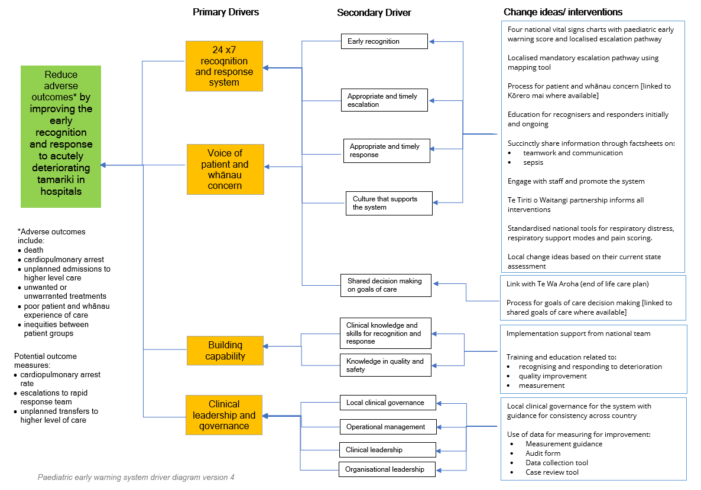
Programme driver diagram

Critical factors for successful implementation
The national patient deterioration programme found the following four factors were important for successful implementation:
Clinical engagement | Improvements impact the way clinicians recognise and respond to patient deterioration. Ensure that clinicians are aware of proposed changes and can share their concerns and be listened to. Use data and stories to overcome any scepticism and embrace a patient and staff safety approach.
Clinical governance and leadership | Recognition and response systems need a whole-of-hospital approach for sustained improvement. A clinical governance group ensures the system is adequately supported and functioning successfully and that there are linkages to the adult and maternity patient deterioration clinical governance in the district.  Having strong and visible clinical lead(s) helps with reaching agreements, resolving issues and raising awareness. We recommend a clinical lead for both nursing and medical.
Measurement | Measuring helps teams and clinical governance groups understand how successful the implementation of the new system is and identify areas for quality improvement. Agreeing what will be measured and when and how it will be used is the first step.
Clinical and quality improvement capability | Clinical governance groups need to ensure recognisers and responders have the right capabilities for managing acute deterioration in paediatric patients. Building quality improvement capability within teams helps to implement improvements and understand how to use the data collected. (See Appendix A.)

We are asking all districts to put in place the following before they begin implementation:
- a project lead, clinical lead(s) and identified shift champions, quality improvement advisor and a multi-disciplinary project team that includes decision-support assistance (where available), Māori and Pacific peoples advisors and consumers that represent whānau who regularly access the paediatric service
- an agreed project charter that includes what will be implemented, the approach to be taken, who will be involved, a data measurement and collection plan and strategies for engaging key stakeholder groups
- a demonstrated link to the wider hospital adult and maternity patient deterioration clinical governance structure that has clinical leaders accountable for ongoing oversight, sustaining and improving the wider hospital recognition and response system
- a localised escalation pathway that has been agreed by the appropriate clinical governance group(s)
- education of staff on the four national paediatric vital signs charts, early warning score and localised escalation pathway
- updated and agreed related policies that impact on the PEWS
- where the testing occurs within specific ward areas and excludes others, a clear risk mitigation of having different paediatric vital signs charts in clinical practice.

Tools, guidance and support for hospitals
Specific tools and guidance have been developed to help hospitals prepare for and implement the clinical, local measurement and governance components of the recognition and response system.

Table 1: Recognition and response system components with supporting tools and guidance
System component | Supporting tools and guidance
Recognition  Four national paediatric vital signs charts with PEW score (or electronic equivalent) | - Master version of charts (writable PDF)  - User guide  - Escalation mapping tool
Response  Localised escalation pathway is mandatory and outlines what to do for each PEW score trigger and who to escalate to | - Escalation mapping tool  - Factsheet on sepsis
Clinical governance  Patient deterioration clinical governance group, which includes adult and maternity services | - PEWS – clinical governance recommendations  - Recommendation to adult and maternity patient deterioration governance that paediatric clinical leads are included in the wider hospital clinical governance
Education  Clinical and non-technical education of recognisers and responders to acute deterioration in the paediatric inpatient | - Paediatric vital signs chart user guide and quick reference guide and education material (PowerPoint)  - Factsheet for senior clinicians and clinical leads  - Factsheet with frequently asked questions
Measurement  Agreed measures, collection processes, reporting to clinical governance and operational management and feedback mechanisms to wards and areas | - Measurement guidance  - Paediatric vital signs chart audit form  - Paediatric data collection tool  - Paediatric case review tool

Other materials available to support initial implementation include:
- project charter template and stakeholder analysis sheet
- countdown to launch posters (if needed)
- current state assessment template
- escalation and response stickers for documentation (if needed).

Support for sites
Our support to hospitals will include:
- initial preparation workshop
- tools, advice and guidance to support preparation and implementation
- monthly Zoom meetings
- national clinical expertise and advice for clinical leads and teams.
- additional support to sites as needed, eg, support with education, troubleshooting.
John Garrett, a paediatrician at Te Whatu Ora Waitaha, and Jane Craig-Pearson, a recent paediatric clinical nurse educator at Te Whatu Ora Southern, are the clinical leads for the programme. They can advise district clinical leads and teams and present at relevant paediatric meetings and grand rounds or equivalent.
The clinical leads are supported by the following Commission staff:
- Leona Dann, specialist patient safety (regional workshops)
- Katrina Hutching, quality improvement advisor
- Mahashweta Mistry, project manager
- Lauagia (Cat) Jefferies, consumer engagement advisor, Pacific Partners in Care
- DJ Adams, consumer engagement advisor, Māori Partners in Care
- Matt Coulson, project co-ordinator
- Marie Talbot, project co-ordinator (regional workshops)
- Nikki Grae, senior manager, Quality Systems

Implementation preparation activities
The activities below will help hospitals prepare for implementation. They are grouped by three main topics:
- plan what you will be doing and how you will do it
- prepare for implementation
- countdown to implementation.
Some activities can be done during project team meetings. You may already have made progress in some areas. We recommend you review all activities to make sure you haven’t missed something.
- Plan what you will be doing and how you will do it
Establish the project team and executive sponsor(s)
Consider what skills, networks and knowledge you need to complete the project, such as:
- quality improvement
- data analysis
- organisational networking and strategic leadership
- project management
- clinical knowledge and leadership from both ward and responder perspectives.
Make sure the team represents a range of paediatric clinicians, at least two whānau representatives and Pacific and Māori health advisors. Having a designated quality improvement advisor will help with the implementation. The team will be responsible for the weekly auditing, capturing outcome data and feedback from staff and whānau, engaging staff and feeding back on the project.
Assign specific activities to team members to lead and contribute to. You may need to establish smaller working groups to tackle specific issues highlighted by this work. Consider how long the project team will be in place and how they can be supported.
Having an executive sponsor raises the profile of the project and communicates to other staff that the project is a priority for the organisation. Confirm with your executive sponsor(s) what dedicated time the team and other staff can commit to the project. Find out what other resources are available.
Agree project governance and reporting project progress
Work with your executive sponsor(s) to agree project governance. There may already be a related committee or group into which the project could fit. Link to ongoing system clinical governance – this has been set up as part of the patient deterioration programme. We can provide you with the key project lead contact in your district for the national adult governance group.
Reporting progress raises the profile of the work you are doing and keeps you focused on what needs to be done and when. It also allows you to raise risks, challenges and issues you need help with.
Align the project with your organisation’s aim
Aligning the project with your organisation’s aim, values and strategic plan helps you engage with senior members of staff. You can communicate how your project relates to and benefits the organisation.
Know your starting point
Your organisation may have components of the PEWS already established. Understanding how effective your current system is will help you understand what improvements need to be made.
- Document the system you currently have, its strengths and challenges.
- Describe what vital signs charts are currently being used, where they are used and what they capture. Compare these with the national charts and identify if there is anything you will need to capture elsewhere.
- Describe what outcome, process and balance measures are being used.
- Describe what data is already collected about the current system – audits, national minimum dataset reports, complaints, compliments, adverse event reporting and intensive care data, including how often care is escalated to 1:1 on the ward.
- Describe what recent results have highlighted where further improvements are needed, how staff are made aware of the results and which groups receive reports from this data.
- Identify how patients, whānau and staff find using the system, what is working well and not so well and what ideas for improvement they have.
Is the data telling you what you need to know about your system from a process, outcome and balance perspective? For instance:
- what are the rates of rapid response team calls (per 1,000 admissions)?
- what are the rates of responses to PEW scores of 8+?
- what is the rate of unplanned transfers to higher levels of care from ward environments (such as transfers to intensive care or to another hospital)?
- is your current escalation pathway used as intended?
Agree what you are trying to achieve
It is important to know what you want to achieve. Use the programme’s driver diagram as a starting point. With your team, create a clear statement of your aim for making improvements to your PEWS. Use the project charter template to help develop your aim. This helps you confirm the scope of your project. You may need to clarify the terms and definitions you use so there is a common language within your team and organisation.
Agree how you will know you have been successful
Develop and agree how you will measure successful implementation with your team. Creating agreed outcome and process measures will also help you monitor implementation and track system improvements. There are some measures we want you to collect and report at various stages. Your organisation may want other measures collected to inform local evaluation and improvement.
Use the measurement guidance, paediatric vital signs charts audit form, paediatric case note review and audit data collection tool to develop a data collection plan.
Confirm what improvements to your system you will be implementing and when and how
Based on your current system assessment and your aim, get agreement on what you will be implementing, how you will do this and when it be done. Set a realistic launch date. Build in time to prepare and:
- engage with clinicians to develop your local escalation pathway
- identify staff who can be champions in their clinical areas and provide help to their colleagues during preparation and implementation, including supporting audit data collection
- provide education about using the system
- consider what extra clinical education responders may need so they have the right capabilities for managing acutely deteriorating patients.
We recommend using a quality improvement approach and having support from a quality improvement advisor in your district. (See Appendix A.)
Build in sustainability
Consider at this planning stage how the changes you introduce will be sustained over time. Ongoing clinical leadership and governance structures for the system are critical, as project teams are generally short term with a focus on initial implementation. Don’t forget to consider how your champions will continue their roles.
We suggest using the NHS sustainability model to guide your planning and identify areas where you need to focus for successful and sustained system improvement.
Know who you need to engage with to reach your goal
Engaging with staff and other stakeholders will be crucial to the success of implementation. Below is a process you can follow with your project team.
- Identify who your stakeholders are (we’ll explore these during the initial planning workshop):
- What are the key clinical groups? Do you know how many in each group you have? Do you know how you can best access members of these different groups (ie, are there key meetings where you can present and seek input into your work)?
- What staff groups outside the implementation areas will be affected? For example, emergency or intensive care nurses, doctors or members of the resuscitation team or allied health should be aware of the system and how to escalate care. Nurse educators, switchboard staff, orderlies and stock control staff may also have a role in supporting implementation. Think about what operational and senior management groups to engage with.
- Consider how you can engage tamariki and their whānau or legal guardians.
- Assess how much influence these groups have on the success of the project and how much interest they have. Use the stakeholder assessment template.
- Once you have assessed the groups, identify champions who can help you (high impact and high interest) and those groups you need to engage with directly to increase their level of interest and involvement (high impact and low interest).
Agree how you will engage with staff and other groups
Now you have agreed who you need to engage with, work out how you will do this. Every member of the project team will have a part to play in this. Look at where there are existing staff meetings, networks or communication pathways. Use a mixture of formal meeting presentations and informal discussions.
Consider how the messages should be framed to influence and engage staff. Think about who will be the right people to do the engagement. There may be groups with which an enthusiastic peer or champion will need to speak. Direct peer-to-peer engagement is often needed to communicate your key messages effectively. Ask your communications team to help you reach the wider staff group through the intranet or existing newsletters.
Engagement activities will be needed throughout preparation and implementation. The messages you give may change to reflect the progress you have made. Consider what data (for example, audit data, case review findings and outcome measures) should be reported to different groups and in different forums (for example, at medical rounds, ward or morbidity/mortality meetings).
Use the senior clinicians and clinical leads factsheets to support your engagement work.
Document agreements
Bring all the agreements you have made into one document – the project charter. This will help guide the work you do. Use the project charter template if you need one.
- Prepare for implementation
Establish clinical governance for your system
See the paediatric clinical governance recommendations.
Identify what you need to do to establish the ongoing clinical governance group for your early warning system – it could be incorporated into the terms of reference for an existing clinical governance group or you may want to establish a new group. The clinical governance group membership needs to include people who can make decisions and act to continually improve your system. Consider how clinical governance aligns with the operational management of the system.

Agree your local escalation pathway by completing the mapping tool
Work through the escalation mapping tool. This helps you decide what level of response is needed for each level of clinical abnormality represented by different PEW score ranges. If you have different types of hospital, each may need different escalation pathways to reflect the time needed to transfer tamariki to a higher level of care. You may need to develop local variations to your escalation pathway for specialist areas such as emergency departments. Remember that the amount of information in escalation pathways on the paediatric vital signs charts needs to be succinct. It does not need to include information that routinely would be covered in care plans, education and orientation.
Find opportunities to discuss the proposed escalation pathway with different clinical groups so they understand the implications for their work.
Once your clinical governance group has agreed the escalation pathway, enter it on the paediatric vital signs charts. See the user guide for instructions on how to do this.
Assess the challenges and opportunities for the PEWS
Changing your current PEWS will present both challenges and opportunities. With the team, brainstorm what these could be. Think about how staff currently interact with the system and the team cultures and processes that underpin their actions. Identify what you will do to make the most of the opportunities and address the challenges. Use the list below as a prompt:
- parents and whānau
- staff
- environment
- processes
- tasks
- time
- team
- communication and documentation
- education
- equipment and resources.
Update your local policies
Do a stocktake of policies that relate to your PEWS. Review and update the policies to reflect the four national paediatric vital signs charts with national paediatric early warning score, modification rules and escalation pathway.
Do a stocktake of your existing vital signs chart stocks
Make sure there will be enough stocks of your current charts for use until you launch. Talk with the person who manages the printing to stop further production of your current charts as appropriate. Agree the date and time when old stocks removed.

Update the electronic charting tool (if using instead of paper)
Work with your digital hospital lead on making changes to the tool. Testing of the national PEWS showed making changes to the electronic system can be time consuming. Involving an IT support member from the start is helpful. Incorporate this into your project charter.
Communicate your project to the organisation
Share what you are doing with the wider organisation and create opportunities for staff to give feedback. This will raise awareness, generate interest in the project and make it visible at all levels of the organisation. You could include items in internal communications and reports to the board and senior-level groups.
Engage with staff and whānau at every opportunity
Having already identified how you want to engage with staff and whānau, use these strategies to share key messages to ‘take the team with the project’. As well as planned activities, other opportunities may present themselves. Listen to concerns, suggestions and what works well.
You could put up poster boards for staff to give feedback and ask questions. Collate feedback and report to the project team. Questions should then be answered in the ward meetings or incorporated into education sessions.
Educate staff on the new system
We have developed an education PowerPoint for the paediatric vital signs charts.
You will need to arrange ward-based education sessions. Early implementer sites for both the adult and maternity recognition and response programmes reported that face-to-face education offered rewarding opportunities for discussion, feedback and correcting any misconceptions about the system.
Spend time with your champions so they can get familiar with the system and roster them on every shift for the initial implementation period. In the maternity early warning testing, champions were identified as key enablers of the change and could have helped significantly in the earlier implementation period if rostered across all shifts.
Decide who will provide the education and develop appropriate materials. Ensure your local escalation pathway is included. Consider providing communication (like ISBAR [Identify, Situation, Background, Assessment and Recommendation) and teamwork tools during this training. One of the project team’s roles will be to collaborate with clinical educators and coordinators to find suitable venues, promote the education and enable staff to attend.
Decide:
- which staff will need ongoing education to fulfil their roles as recognisers and/or responders
- how new staff will be oriented and educated on the system (especially new or agency nurses and junior doctors – consider including this information in position descriptions)
- how existing staff will receive ongoing education.
- Countdown to implementation
Final countdown
Use the countdown posters in key locations to let staff and whānau know when the new system will be introduced. You could create posters or lanyards featuring your escalation pathway to act as reminders.
Report progress to your executive sponsor(s) and clinical governance group
Continue to give regular progress updates to your executive sponsor(s) and clinical governance group.
Engage with staff and whānau at every opportunity
Continue to engage with staff and whānau about the project and what you are doing.
Communicate your project to the organisation
Continue to share what you are doing with the wider organisation. Make sure people are aware of your launch date. We encourage you to have a celebration to mark the occasion.
Check staff are prepared
Meet with staff to make sure they are ready to begin using the system and answer any questions they may have. Check they have attended education. Make sure project team members are visible and can answer queries.
Put new charts into your agreed area(s)
Put new chart stocks into your agreed area(s). Make sure older chart stocks have been removed.

Implementation and sustainability activities
Below are some activities to incorporate into your implementation plan.
Monitor progress and make small steps of change
Make sure project team members are visible and available to troubleshoot, answer questions and provide support during the initial days and weeks of implementation.
Check in with areas regularly to see how they are doing, answer questions, resolve issues and collect information. Work with area champions to help staff in their area.
If staff have identified related change ideas to test through plan–do–study–act (PDSA) cycles, work with them to make small steps of change until they and your team feel you are ready to spread the change idea further.

Measure for improvement
Use the measures and data collection processes you identified during the preparation period to monitor your progress towards achieving your aim(s). Use the measurement guidance, audit tool, data collection tools and case review tool.
We are available to go through your data with you (as teams identify the need) and discuss how you can use the data for improvement. Measurement issues or topics can be discussed at monthly zoom meetings.
Report on progress to your executive sponsor(s) and clinical governance group
Continue to give regular progress updates to your executive sponsor(s) and clinical governance group.
Educate new staff and provide ongoing education
Educate staff in line with the decisions made during the implementation preparation stage. Early implementation sites for the adult and maternity recognition and response programme found that ongoing education was needed during the first three months. Doing audits provided an opportunity for one-to-one education as well as deciding what additional education was needed.
Take part in the regular Zoom meetings
This is an opportunity for you to share your progress with other test site leads, project teams and the national team and discuss challenges and potential solutions. We’ll send you information on how to join and the agenda.
Celebrate achievements by the team and those implementing
Take time to celebrate achievements and the efforts of team members and areas that are implementing the system. Positive feedback and reinforcement combined with public recognition will help keep everyone motivated and focused.
Handover to those responsible for the ongoing sustainability of the system
Meet with those who will be responsible for ongoing training, measurement and monitoring of the system. Ensure they are aware of how they need to continue to report progress and measures to the clinical governance group.

Appendix A: Quality improvement approach
The Model for Improvement was developed by the Associates for Process Improvement (www.apiweb.org) and has been used in several quality improvements for health care organisations. It is a framework for structured improvement activity to help you achieve your goals and support the spread for wider adoption. It is based on three key questions used with small-scale testing:
- What are we trying to achieve?
- How will we know that a change is an improvement?
- What changes can we make that will result in an improvement?
You will need a clear goal, to agree measures and how to collect them, and have ideas and interventions to improve.
Improvement cycles are often referred to as PDSA cycles (see Figure 2).

Figure 2: PDSA cycle
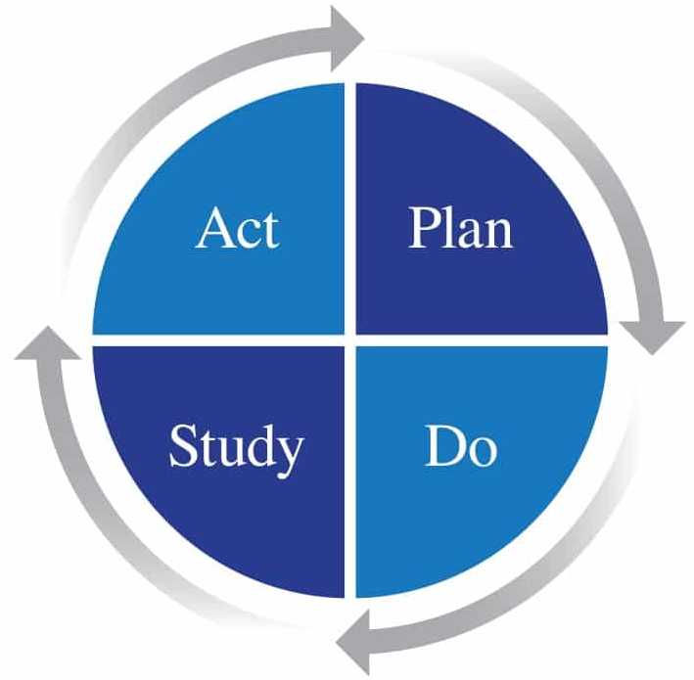
Image source: Figure reproduced from W Edwards Deming, The New Economics for Industry, Government, Education, third edition, figure 13, page 91. Reprinted courtesy of The MIT Press and the Deming Institute.
During implementation, you can use the PDSA cycles to test related change ideas, using these four steps:
- Plan the activity, predict what will happen
- Do the activity, observing what happens
- Study what happened and why
- Act by making amendments or considering expanding the testing (dependent on the outcome).
Then move to another cycle.
Some tips for doing PDSA cycles include:
- expect the test not to work the first time
- start with one patient and one team so there is minimum delay to starting, change can be observed easily and the impact is minimal if it doesn’t work
- spread slowly. Once it works for one, test with three and then five. This will help you resolve issues and give you confidence
- work with the willing. Find a team that wants the change to work – they will have the required patience
- use simulation if you are concerned about the impact – this could be as a desk review and/or a walk-through with colleagues
- assess whether testing will have an impact on people or processes beyond the area. Include those people in the plan and study stages of the cycle. We recommend assessing the challenges and opportunities during the preparation period.
Other improvement methods like Lean and Six Sigma can be used if your organisation has a stated preference for one over another. Nearly every district has quality improvement advisors you can contact for support and guidance.
The Commission has released a free online learning programme that introduces quality improvement: https://learnonline.health.nz/course/view.php?id=459.
The national team will also be available to provide support and guidance.

Endnotes

Australian Commission on Safety and Quality in Health Care. 2012. National Safety and Quality Health Service Standards (September 2012). Sydney: Australian Commission on Safety and Quality in Health Care.
National Confidential Enquiry into Patient Outcome and Death. 2011. Are we there yet? A review of organisational and clinical aspects of children's surgery. London: National Confidential Enquiry into Patient Outcome and Death.
Royal College of Paediatrics and Child Health. 2016. A safe system for recognising and responding to children at risk of deterioration. London: NHS Improvement.
Roland D, Tilwelee P, Fortune P, et al. 2021. Case for change: a standardised inpatient paediatric early warning system in England. Archives of Disease in Childhood 106(7): 1–4. DOI: 10.1136/archdischild-2020-320466.
Australian Commission on Safety and Quality in Health Care 2012, op. cit.
National Confidential Enquiry into Patient Outcome and Death 2011, op. cit.
Royal College of Paediatrics and Child Health 2016, op. cit.
Roland D, Powel C, Lloyd A, et al. 2022. Paediatric early warning systems: not a simple answer to a complex question. Archives of Disease in Childhood. doi: 10.1136/archdischild-2022-323951.
Tume L. 2007. The deterioration of children in ward areas in a specialist children’s hospital. Nursing in Critical Care 12: 12‒9.
Health and Disability Commissioner. 2009. Case 08HDC04311 Paediatric House Officer, Dr B; Bay of Plenty District Health Board. Wellington: Health and Disability Commissioner.
Health and Disability Commissioner. 2015. Case 13HDC00482 Anaesthetist, Dr B; Registered Nurse, RN D; Registered Nurse, RN C; West Coast District Health Board. Wellington: Health and Disability Commissioner.
Health and Disability Commissioner. 2021. Case 18HDC01075. Counties Manukau District Health Board. Wellington: Health and Disability Commissioner.
NHS Institute for Innovation and Improvement. 2010. Sustainability Model and Guide. 2010. Coventry: NHS Institute for Innovation and Improvement. URL: http://webarchive.nationalarchives.gov.uk/20160805122021/http://www.nhsiq.nhs.uk/media/2757778/nhs_sustainability_model_-_february_2010_1_.pdf (accessed 15 September 2021).
Patient Safety First. 2008. The quick guide to implementing improvement. NHS England. URL: http://webarchive.nationalarchives.gov.uk/20091118133206/http://patientsafetyfirst.nhs.uk/ashx/Asset.ashx?path=/How-to-guides-2008-09-19/Quick%20Guide%201.1_17sept08.pdf (accessed 15 September 2021).

