Aotearoa New Zealand national
paediatric early warning system
and paediatric vital signs chart
User guide

October 2022

Contents
Document purpose 4
1. Introduction and scope 5
2. Chart overview 5
2.1. Recording vital signs: scoring area 7
2.2. Recording vital signs: non-scoring area 8
2.3. Mandatory escalation pathway 8
2.4. Modifications box 8
2.5. National and local tools 8
3. Clinical use of the PVSC 10
3.1. Documenting scoring vital signs 10
3.2. Documenting vital signs that do not contribute to the PEWS 16
3.3 Partial PEWS 20
3.4. Accountability 20
3.5. Modifying PEWS triggers 20
3.6. Calculating the total score and using single-parameter triggers 21
3.7. Escalating care 26
4. Design and printing information 27
4.1. Required amendments 27
4.2. Allowable amendments 27
4.3. Print specifications 28
4.4. Colour specifications 29

Figures
Figure 1: Overview of the front of the draft paediatric vital signs chart 5
Figure 2: Overview of the back of the draft paediatric vital signs chart 5
Figure 3: Paediatric early warning score colour key 6
Figure 4: Respiratory rate (example taken from 12+ years PVSC) 9
Figure 5: Assessment of respiratory distress guide from the back of the PVSC 10
Figure 6: Example of documenting respiratory distress 10
Figure 7: Oxygen 11
Figure 8: Respiratory support mode key as it appears on the back of all four PVSC 11
Figure 9: Examples of oxygen documentation 11
Figure 10: Oxygen saturation examples 13
Figure 11: Heart rate examples 14
Figure 12: Example of documentation of a central capillary refill of 3 or more seconds 14
Figure 13: Blood pressure examples 15
Figure 14: Level of consciousness examples 16
Figure 15: Temperature example 16
Figure 16: Assessment of pain tools on each chart 17
Figure 17: PEWS recorded from an incomplete set of observations 19
Figure 18: Initialling the chart 19
Figure 19: Example of modification due to chronic condition 20
Figure 20: Example of modification for a teenager with athletic bradycardia 20
Figure 21: Space to indicate if a tamariki has an end-of-life pathway plan 20
Figure 22: Escalation pathway 25
Figure 23: Z-fold demonstrated with the PVSC 27
Tables
Table 1: PEWS score matrix 23
Table 2: Allowable amendments to the PVSC 28
Table 3: Colour specifications for the PVSC 30

Published October 2022 by the Health Quality & Safety Commission,
PO Box 25496, Wellington, New Zealand.
Published under Creative Commons License CC BY-NC 4.0. This means you may share and adapt the material provided you give the appropriate credit, provide a link to the licence, and indicate if changes were made. You may not use the material for commercial use. For more information about this licence, see: https://creativecommons.org/licenses/by-nc/4.0/
Document available online at: www.hqsc.govt.nz
Enquiries to: info@hqsc.govt.nz

Document purpose
This user guide is for any health professional implementing and improving paediatric early warning systems within Aotearoa New Zealand hospitals. It explains how to complete and use the draft paediatric vital signs chart.

Introduction and scope
The national paediatric vital signs chart (PVSC) and paediatric early warning system (PEWS) are tools for detecting clinical deterioration in tamariki receiving hospital care in Aotearoa New Zealand. This user guide explains how to complete and use the PVSC correctly.
Begin the PVSC for any tamariki who is assessed as requiring measurement and recording of vital signs.
Tamariki physiology alters as they age, impacting on the normal ranges for vital signs. As such there are four age-based PVSCs, which must be used for the correct age group:
- 0–11 months
- 1–4 years
- 5–11 years
- 12+ years.
Tamariki who need to receive care in an intensive care unit or high dependency unit may not require a PVSC because these units usually have their own specific charts. The PVSC can be used in these settings, however for consistency the same parameters and scoring cut-offs for each vital sign should be used.
Before a tamariki is transferred from an intensive care unit or high dependency unit to a ward area, chart the most recent set of vital signs on an age-appropriate PVSC and include a plan to address any ongoing abnormalities in a set timeframe.
The total paediatric early warning score (PEW score) is calculated using measurements taken across seven vital sign parameters. The score increases as the vital signs deviate further from the normal zone. The total score triggers an escalating clinical response, so clinicians with the right skills can intervene and manage the tamariki’s deterioration promptly.
The Health Quality & Safety Commission developed the PVSC, and paediatric early warning system based on the best available human factors and clinical evidence.

Chart overview
The PVSC is a two-sided document, printed front and back. Figures 1 and 2 illustrate the main areas of both sides. The four age-based PVSC all have the same layout. The vital sign parameter ranges differ by age, as does some of the content on the back.
This section provides a brief overview of each chart area. For more detail about the clinical use of the PVSC, see section 3 of this guide.

Figure 1: Overview of the front of the draft paediatric vital signs chart
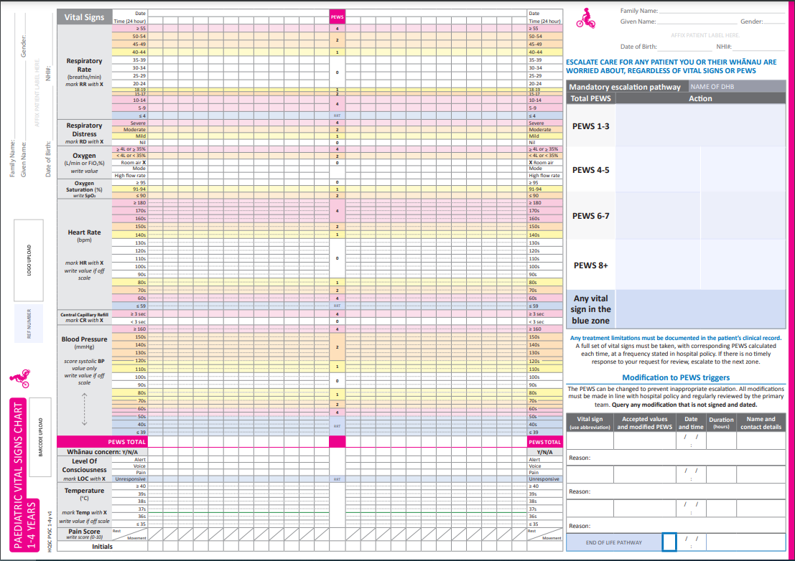
Total PEWS score
Recording vital signs:
scoring area
Recording vital signs:
non-scoring area
Mandatory
escalation
pathway
Modifications
box

Figure 2: Overview of the back of the draft paediatric vital signs chart
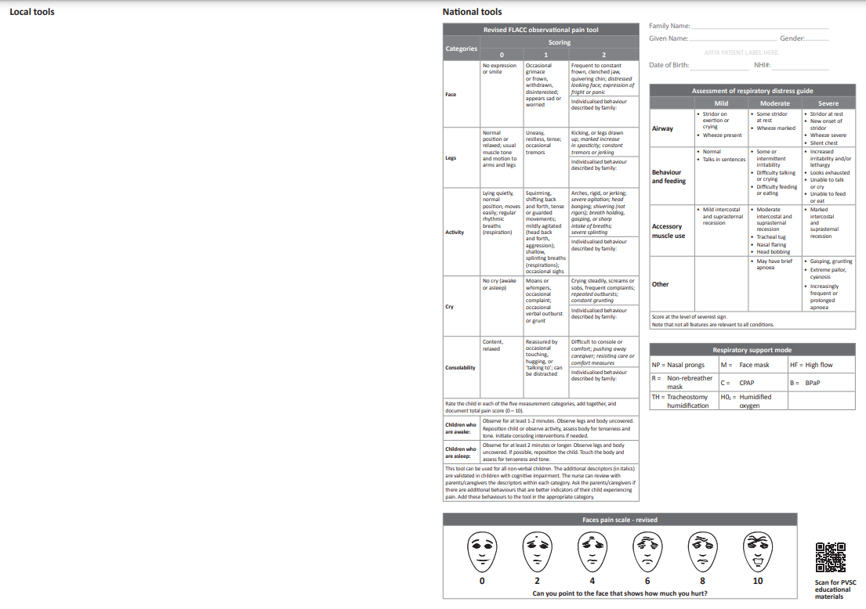
Local tools
editable section
National tools

Recording vital signs: scoring area
The purpose of the scoring area is to document the vital sign measurements of the core parameters that contribute to the total PEW score. The vital signs included for scoring are based on Bedside PEWS. These seven parameters are:
- respiratory rate
- respiratory distress
- oxygen
- oxygen saturation
- heart rate
- central capillary refill
- blood pressure.
Where the observation plots on the chart determines its score: 0,1, 2 or 4. The score increases as the observation becomes more abnormal.
When documentation in the scoring area is done in a clear and consistent manner it is easy to detect trends indicating improvement or deterioration in a tamariki’s condition. It is easier to visualise trends if you record using a symbol such as an ‘X’ rather than writing a numerical value (the exception being the oxygen saturation parameters where the numerical value is marked on the chart). However, if a measured value falls outside the range able to be plotted on the chart, it can still be recorded by writing the numerical value at the upper or lower margin of the chart area for that parameter.
Scores for the individual parameters are then added to calculate the total PEW score, which is documented in the bottom row of the scoring area. Abnormal vital signs associated with a given score are also identified by the differently coloured zones on the chart. Individual vital sign parameters in blue zones trigger escalation actions that the escalation pathway sets out, regardless of the total score.
The total PEW score reflects the sum of the scores from seven vital signs. As it is not always possible or necessary to obtain a complete set of observations, for example, a blood pressure in a distressed tamariki, there needs to be a way of indicating that an incomplete set of observations has been used to generate a score. The convention on this chart is to add a plus to the value recorded in the PEWS Total box, eg, 3+. See section 3.3 for more detail.
Figure 3: Paediatric early warning score colour key
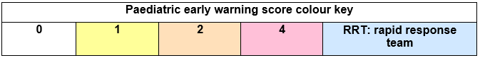

Recording vital signs: non-scoring area
The purpose of the non-scoring area is to document the vital sign parameters that do not contribute to the total PEWS. These parameters are:
- whānau concern
- level of consciousness
- temperature
- pain score.
There is also space for the staff member recording the observations to enter their initials. More detailed documentation in the clinical notes will include name and designation.

Mandatory escalation pathway
The escalation pathway states the actions to be taken when a particular total PEW score is reached, or a blue zone observation occurs. An increasing total PEW score indicates a higher risk of deterioration. Each organisation defines for their own location what the response to each level of the escalation pathway will be, reflecting available resources and processes of care. This includes determining the correct emergency response terminology for the blue zone, for example, RRT.

Modifications box
The modifications box is used to individualise escalation triggers for tamariki with chronic disease or vital sign abnormalities that do not necessarily represent clinical deterioration. Modifications are usually only required for one vital sign parameter but can be made to several. They can be made for the duration of admission or can be time limited. They should be made after considering the potential risks associated with altering the score an abnormal parameter will generate. The process for making modifications, including who can make them, is defined locally.
For example, a tamariki with a known cardiac condition resulting in lower oxygen saturation levels may trigger escalation of care inappropriately unless a single parameter modification for oxygen saturation is made.
Caution: This area is not to be used to modify an overall score; it is only for individual vital sign parameters. See section 3.5 for more information.

National and local tools
The back of the PVSC is divided into two sections ‒ national and local tools.
For sites using an electronic patient observation system, the method of accessing these tools needs to be locally determined if they are not able to be incorporated into the electronic system. For example, this may include posters in the clinical environment or laminated cards at computer stations.
The national tools are an un-editable set of resources to support the consistent use, completion, and interpretation of vital signs on the front of the chart. The national tools are:
- assessment of respiratory distress guide
- respiratory support mode abbreviations
- pain scores.
The pain scoring tools vary between age-banded charts to reflect the appropriate tools to use for different age groups.
The local tools section is editable, and the content is defined locally. It can be used to document non-scoring observations such as weight, blood sugar level, phlebitis score or pressure injury assessment. Associated guidance that explains how these observations are defined may be included. The multidisciplinary team will need to consider carefully what to include, if anything, in this space; it must be clinically relevant and enhance the care provided to the tamariki. If you are adding elements to this section, you will need support from your local communications team or design team.

Clinical use of the PVSC
This section describes clinical use of the PVSC and includes:
- documenting vital signs
- modifying PEWS triggers
- calculating PEW scores
- mandatory escalation of care.

Documenting scoring vital signs
Instructions for documenting each vital sign parameter, the accepted abbreviation and the unit of measurement appear in the grey column to the left of the scoring area of the PVSC. Where measurements exceed the range on the chart write the numerical value on the chart at the upper or lower margin of the chart area for that parameter.

Date and time
The top two rows of the PVSC provide space for recording the date and time each set of observations were taken. Use the 24-hour clock format for the time. Be aware the columns are evenly spaced across the chart, but the time interval between observations may vary.

Respiratory rate
Each row of the scoring area for respiratory rate (Figure 4) represents a range associated with varying severity of abnormality. Note that the vital sign parameters vary between charts so pay careful attention to ensure the correct score is generated.
Figure 4: Respiratory rate (example taken from 12+ years PVSC)
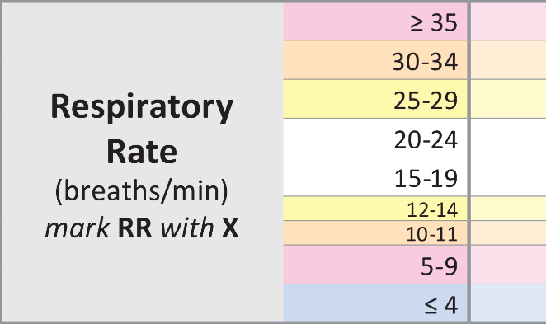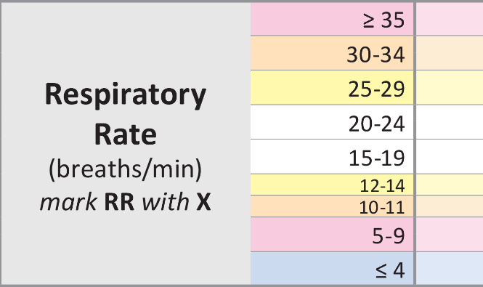
X
X
Respiratory rate = 18 breaths/minute, white zone, score 0 Respiratory rate = 27 breaths/minute, yellow zone, score 1

Respiratory distress
Assess the level of respiratory distress using the ‘Assessment of respiratory distress guide’ on the back of the chart (Figure 5), which is based on a tool developed by the Royal Children’s Hospital Melbourne. It is the same across all four age-based PVSC and is scored at the level of the most severe sign.

Figure 5: Assessment of respiratory distress guide from the back of the PVSC
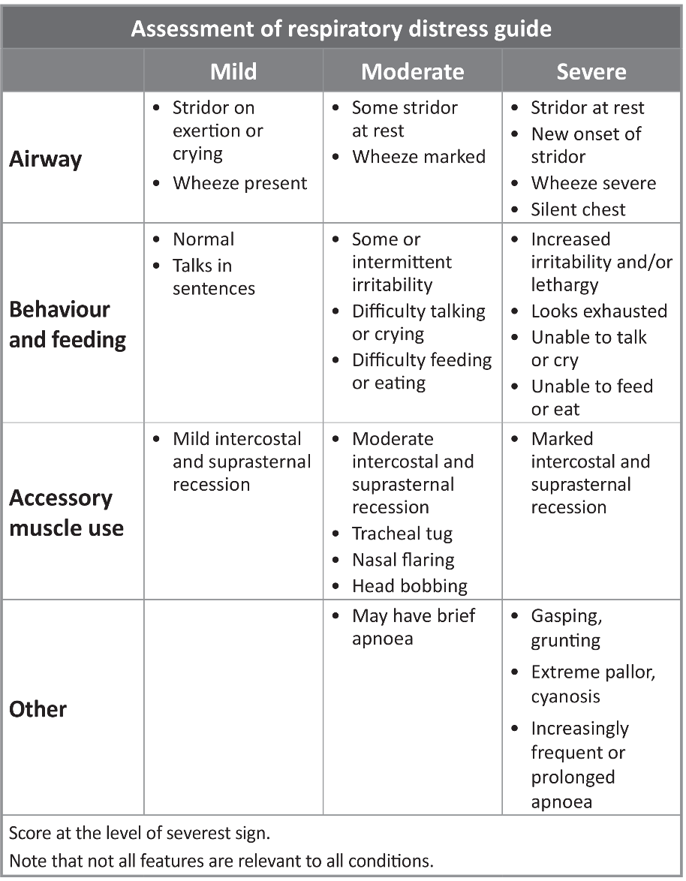
The level of respiratory distress can then be marked with an ‘X’ in the appropriate box (Figure 6). There are four levels of respiratory distress: nil, mild, moderate and severe.
Figure 6: Example of documenting respiratory distress
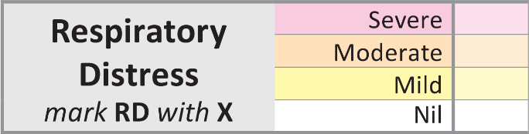
X

Oxygen
Tamariki receive a variety of oxygen therapies and modes of respiratory support. The challenge is to provide a format that captures information correctly and accurately reflects the oxygen therapy in use. The oxygen score is based mainly on the FiO₂, where an increasing oxygen requirement indicates a deterioration.
In some tamariki, for example, receiving nasal prong oxygen, the flow rate is varied but the FiO₂ remains unchanged at 100%. In another example, a tamariki may have high flow oxygen therapy in place, in this the flow rate is stable and the FiO₂ is varied. This information can be recorded on the PVSC to generate a score for the oxygen parameter, and by recording the numerical value on the chart, the trend in the amount of respiratory support needed is visible. A tamariki on room air only is marked with an ‘X’ (Figure 7). Room air refers to no respiratory support at all.
Figure 7: Oxygen
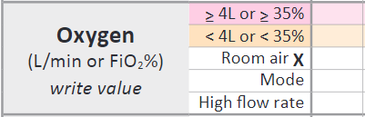
X
Record the mode of oxygen delivery using the abbreviations from the ‘Respiratory support mode’ panel on the back of the chart (Figure 8).
Figure 8: Respiratory support mode key as it appears on the back of all four PVSC
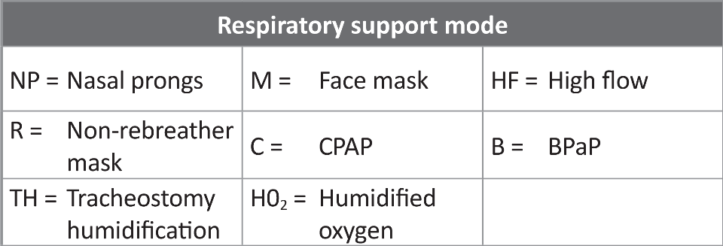
When a tamariki is receiving high flow oxygen therapy the weight-based flow rate is recorded in the high flow rate row. This allows the correct flow rate to be confirmed. The numerical value of the FiO₂ being delivered while on high flow therapy can be recorded in either one of the two top boxes in the oxygen section, as appropriate.

We have not allocated space to record the pressure (in cmH₂O) being delivered to tamariki on CPAP (continuous positive airway pressure), although know that this may be varied during treatment. This is because it is uncommon for tamariki to receive CPAP outside a higher acuity area, where there is likely to be a different chart in use, and also due to space constraints on the chart.
Examples of different oxygen therapies and how to record them are shown in Figure 9.
Figure 9: Examples of oxygen documentation

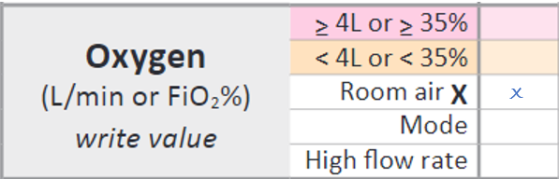
A tamariki on no respiratory support.
This parameter scores 0.

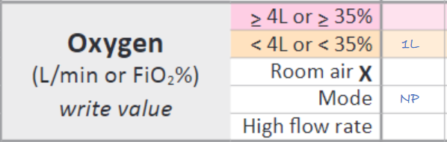
A tamariki on one litre of oxygen via nasal prongs.
This parameter scores 2.

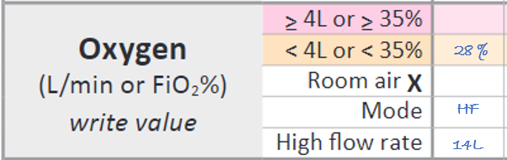
A 7 kg tamariki on high flow therapy with an Fi0₂ requirement of 28%.
This parameter scores 2.

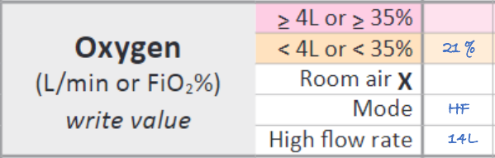
A 7 kg tamariki on high flow therapy with an Fi0₂ requirement of 21%.
This parameter scores 2.
Please note that 21% in this context is not referring to room air. The tamariki is on high flow therapy and requires respiratory support.

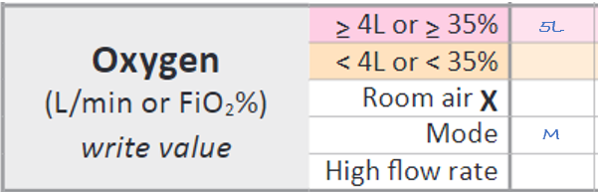
A tamariki receiving 5 L/min of oxygen via a mask.
This parameter scores 4.

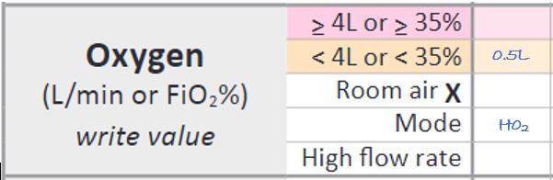
A tamariki receiving 0.5 L/min of humidified oxygen.
This parameter scores 2

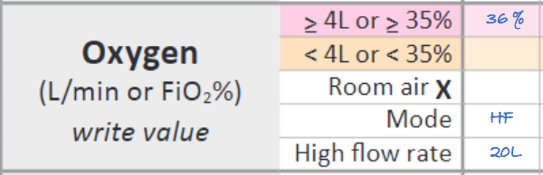
A 10 kg tamariki on high flow therapy with an Fi0₂ requirement of 36%.
This parameter scores 4.

Oxygen saturation
Document the numerical value for oxygen saturation in the relevant box of the scoring area (Figure 10).
Figure 10: Oxygen saturation examples
96
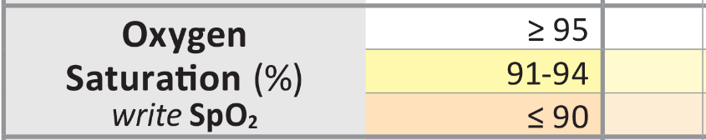
Oxygen saturation = 96%
Scores 0
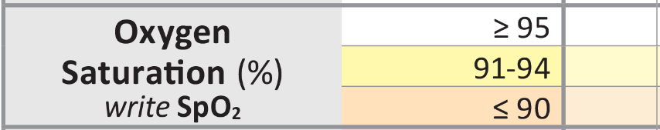
93
Oxygen saturation = 93%
Scores 1

Heart rate
Document heart rate by placing an ‘X’ in the relevant box of the scoring area (Figure 11). Each row of the scoring area for heart rate corresponds to a numerical range of 10 (eg, a heart rate in the 70s, 80s, 90s). In this way, you can clearly identify the relevant coloured zone if the heart rate value falls exactly on the line between zones (eg, a heart rate of 80 beats per minute is within the 80s range so scores within the yellow zone).

Figure 11: Heart rate examples
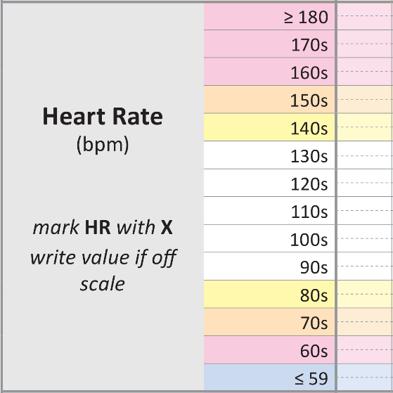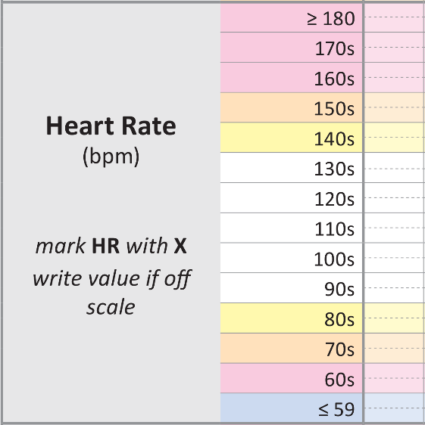
X
X
Heart rate = 96, white zone, score 0 Heart rate = 80bpm, yellow zone, score 1

Central capillary refill
When looking at skin perfusion as a marker of cardiovascular status, the most accurate assessment is made by determining central capillary refill. This is obtained by pressing a finger on the central chest, holding for 5 seconds and releasing. The white blanched area should fully regain colour in under 3 seconds. The observation is marked with an ‘X’ according to the time taken (Figure 12).
Figure 12: Example of documentation of a central capillary refill of 3 or more seconds

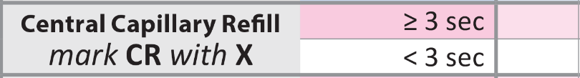
X

Blood pressure
The systolic blood pressure is the measurement used to generate a score for this vital sign. Document both systolic and diastolic on the chart as this is important clinical information.
Measure blood pressure using an appropriate size of cuff for the tamariki and document the cuff size on their care plan.
Each row of the scoring area for blood pressure corresponds to a numerical range of 10
(eg, a systolic blood pressure in the 90s, 100s, 110s). At times coloured zones change in the middle of a row as in one of the examples below, where the zone change is 125. That is, 124 is in the yellow and 125 is in the orange. If the observation plots on the line, score according to the colour above.

Figure 13: Blood pressure examples
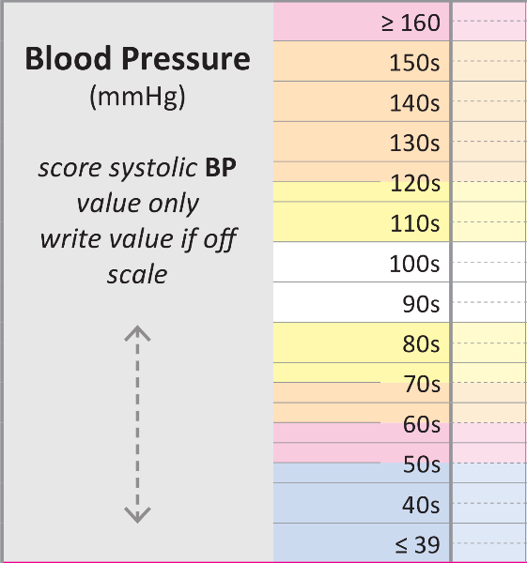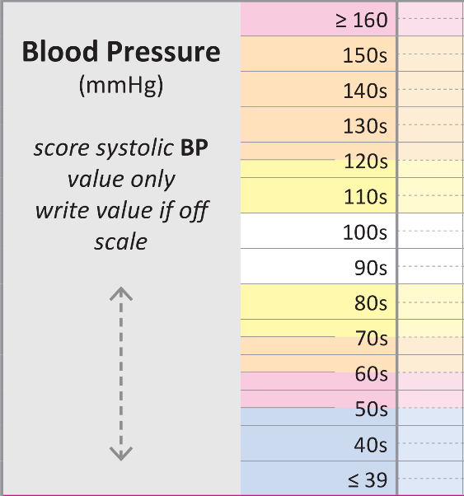
BP = 105/70, white zone, score 0 BP = 125/75, orange zone, score 2

Documenting vital signs that do not contribute to the PEWS

Whānau concern
Y = Yes N = No A = absent
This section requires staff to check in with whānau as to whether they have any concerns about their tamariki’s condition. Asking regularly gives whānau the opportunity to speak up and voice concern. Sharing the PVSC with whānau as part of the admission and orientation process, and when completing observations, supports communication, helps understanding and encourages partnership.
If there is concern, mark with a Y on the chart. Escalation of this concern can occur, even if the other observations and the total PEW score are normal. Staff may find that with listening to the concern, explanation or further discussion alleviates it. Document detail in the progress notes, including any action taken because of the concern being raised.
If there is no concern mark with an N.
If whānau members are absent mark with an A. This can then act as a reminder for other staff to check in with whānau when they return.
The whānau concern section of the PVSC needs to link in with local organisation policy regarding Kōrero mai processes to support patient, family and whānau escalation of concerns.

Level of consciousness
Assess level of consciousness using the alert, voice, pain or unresponsive (AVPU) scale. Document your assessment by placing an ‘X’ in the relevant box of the scoring area
(Figure 14). If the tamariki is asleep this can also be noted. Once you have assessed the tamariki and determined them to be sleeping normally, annotate ‘Asleep’ on the chart within the alert section of ‘Level of Consciousness’. An example of this is when you enter the room you see a baby stir to the noise but not wake fully. It is important to assess a tamariki closely and not assume they are sleeping.
Figure 14: Level of consciousness examples
Asleep
X
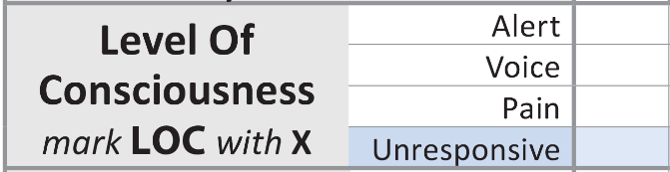

Temperature
Measure temperature using a consistent method each time (eg, oral, axillary, tympanic) and record the method in the care plan. Document temperature by placing an ‘X’ in the relevant position on the chart. Figure 15 shows the documentation of 38.5°C. You may also choose to write the actual value, to one decimal place, on the chart, but if doing so always write it above the X. For temperatures that are outside the plottable area write the actual value, to one decimal place, on the chart.
Figure 15: Temperature example
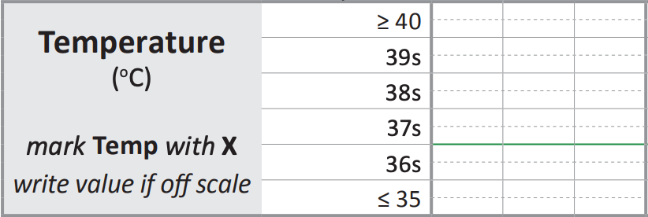
X

Pain score
Record pain on the PVSC to help interpret abnormal vital signs and manage the tamariki’s pain effectively.
The PVSC includes three pain scoring tools: the Numerical rating scale, Faces pain scale-revised and the revised FLACC observation pain tool. The score is documented at rest and with movement.
Many clinicians will be familiar with the FLACC observational pain tool, but note the revised version is included here. This is an objective tool that has been validated for use in non-verbal and cognitively impaired tamariki. Therefore, it can be used both for a four-month-old baby and a seven-year-old tamariki with global developmental delay, for example.
The tool used depends in part on the tamariki’s age (Figure 16). The age reflects the required cognitive ability of tamariki to be able to use the numeric and faces tool. The tool being used for an individual tamariki can be documented in their care plan.

Figure 16: Assessment of pain tools on each chart
Age-based PVSC | Numerical | Faces pain scale | Revised FLACC
0‒11 months | No | No | Yes
1‒4 years | No | Yes | Yes
5‒11 years | Yes | Yes | Yes
12+ years | Yes | Yes | Yes
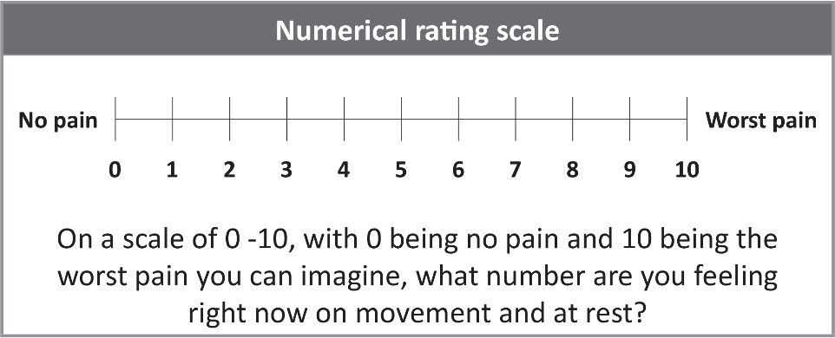
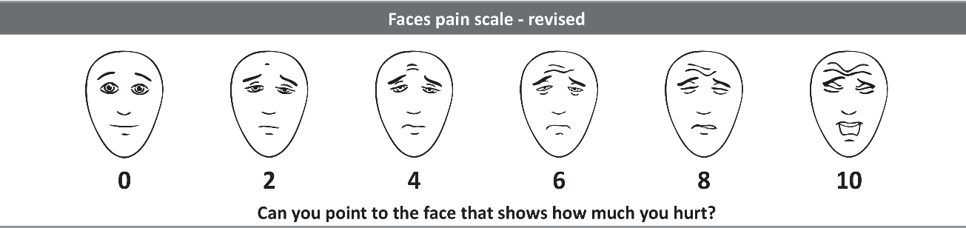
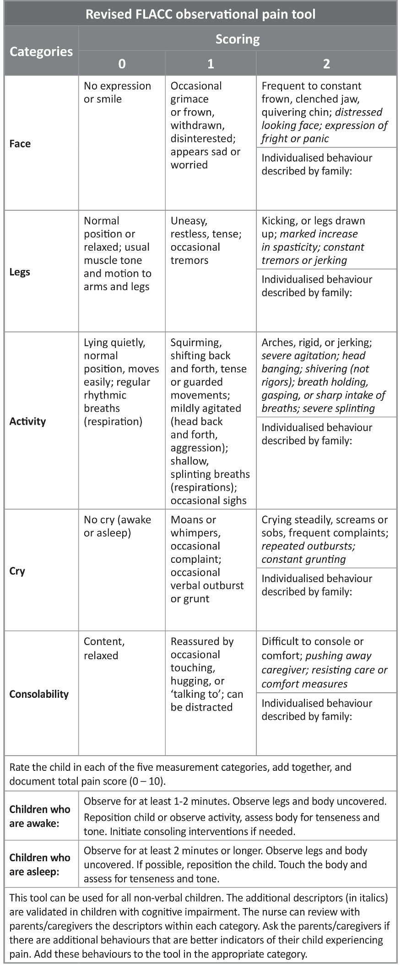

3.3 Partial PEWS
Some sets of observations will not include measurement of all the parameters required to calculate a total PEWS. The risk of not indicating that a score is based on an incomplete set of observations is that the user may underestimate how unwell the tamariki is and use an escalation pathway lower than what is required.
In this situation the PEWS from an incomplete set of observations is indicated by a plus (+) (Figure 17), and the user should act on the escalation pathway mandated by this score. They should also consider whether any other actions need to be taken, including completing the full set of observations, and follow local monitoring policy on what observations are required for specific circumstances.
Multiple sets of partial observations may occur in certain circumstances, for example, taking a series of blood pressure measurements after adjustment of medication. However, this practice should be the exception rather than the rule, to maintain the value of the PEWS.
Figure 17: PEWS recorded from an incomplete set of observations
3+
4
4

3.4. Accountability
To fulfil documentation requirements, the clinician who undertook the observations must place their initials at the bottom of the chart (Figure 19).
Figure 18: Initialling the chart
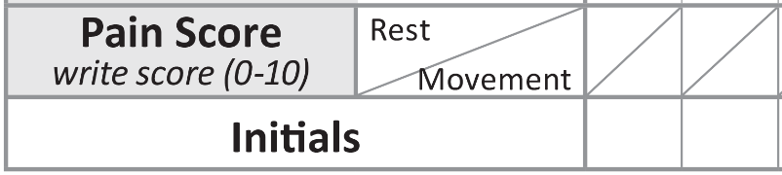
AL
1
3

3.5. Modifying PEWS triggers
It is possible to modify the PEWS triggers for individual tamariki when chronic disease, or abnormal vital sign parameters are present that do not necessarily represent clinical deterioration. This section of the chart is to capture what is ‘normally abnormal’ for a tamariki. Individual vital sign parameters are altered, not total PEW scores.
When making modifications, consider the clinical risk to the tamariki of normalising an abnormal vital sign. This risk is mitigated by discussing modifications with a senior clinician and reviewing them at regular intervals, so they remain appropriate as the tamariki’s condition changes. Document the duration for which modifications apply to ensure there is a timely clinical review.
Local policy on modifying PEWS triggers should be in place to ensure practice is appropriate for your local population and hospital context. This includes identifying which clinicians can make a modification and how often modifications need to be reviewed. Please ensure that clinicians tasked with making modifications have received appropriate education.
When a new PVSC is used, the modifications will need to be reviewed, redocumented and signed if they are still applicable. Staff should not just assume modifications remain in place. Figures 19 and 20 give examples of appropriate documentation.
Note: If a tamariki is unwell and generating high PEW scores, they are likely to remain high until treatment takes effect. In this situation, do not use the modification section to stop escalation. Rather, the review generated by the high PEW score should result in an understanding of why the PEW score is elevated and clear documentation in the patients notes of a treatment plan. This should include specific signs of further deterioration that should be notified, who should be called, and a recommended time for the next review.
Having a modification in place should not stop staff calling a clinical emergency if a parameter enters the blue zone, or if staff feel a significant deterioration is imminent.
Figure 19: Example of modification due to chronic condition
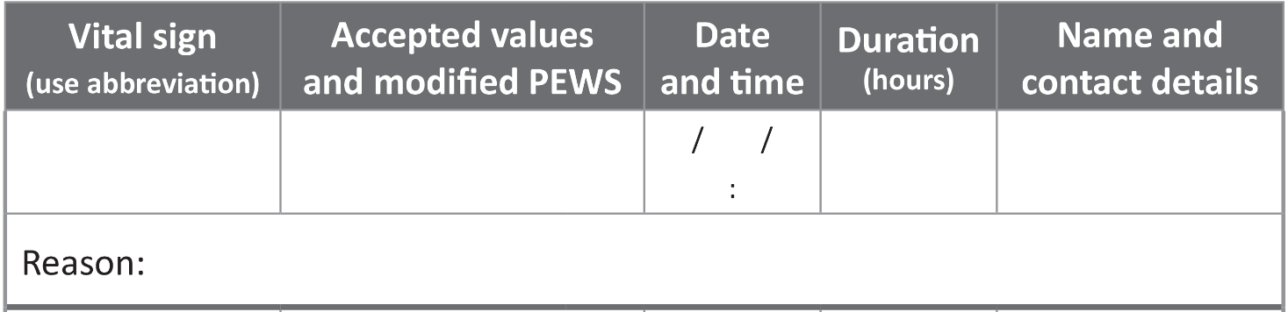
Oxygen saturation
≥ 91% score = 0
85−90% score = 1
≤ 85% score = 2
Throughout admission
N. Rivera #6132
Normal saturations for child is 91% due to cyanotic congenital heart disease
11 30 am
20 3 21
Figure 20: Example of modification for a teenager with athletic bradycardia
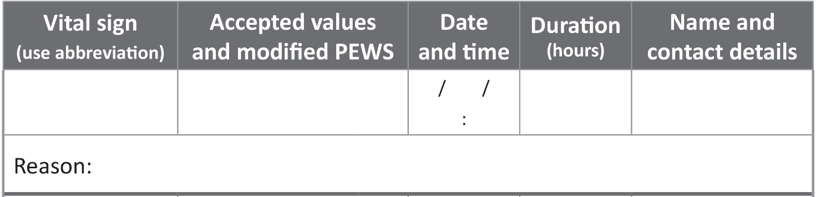
D. Ramoray #2611
50−109 score = 0
40−49, score = 1
30−39, score = 2
< 30 score = 4
11 30 am
20 3 21
Competitive rower, resting HR of 50 when well
HR
Until
discharge
There is also a space to accommodate the tamariki receiving palliative care. Underneath the modification section is the ability to identify if a tamariki is on an end-of-life pathway (Figure 21). This section is editable to reflect the terminology and pathway that reflects the organisational policy.
Figure 21: Space to indicate if a tamariki has an end-of-life pathway plan

3.6. Calculating the total score and using single-parameter
triggers
Each scoring vital sign parameter has coloured zones (white, yellow, orange and red) that are associated with a score of 0, 1, 2 or 4, respectively. Add together the score for each of the seven vital sign parameters to get a total PEW score. The total score can trigger action according to the escalation pathway.
The PVSC has single parameter triggers, which are any observations falling in the blue zone. The blue zone is not associated with a score because any parameter in the blue zone indicates severe deterioration and requires an emergency response.
Table 1 illustrates the PEWS matrix across the four charts.
Table 1: PEWS score matrix

PEWS matrix: 0‒11 months
Score | RRT | 4 | 2 | 1 | 0 | 1 | 2 | 4 | RRT
Zone | Blue | Red | Orange | Yellow | White | Yellow | Orange | Red | Blue
Respiratory rate | ≤ 9 | 10‒19 | 20‒24 | 25‒29 | 30‒49 | 50‒54 | 55‒69 | ≥ 70
Respiratory distress |  |  |  |  | Nil | Mild | Moderate | Severe
Oxygen |  |  |  |  | Room air |  | < 4 L/min or  < HF 35% | ≥ 4 L/min or  ≥ HF 35%
Oxygen saturation |  |  | ≤ 90 | 91‒94 | ≥ 95
Heart rate | 50‒59 | 60‒79 | 80‒89 | 90‒109 | 110‒159 | 160‒169 | 170‒179 | ≥ 180
Capillary refill time |  |  |  |  | < 3 sec |  |  | ≥ 3 sec
Blood pressure | ≤ 49 | 50‒54 | 55‒64 | 65‒74 | 75‒99 | 100‒119 | 120‒149 | ≥ 150
HF = high flow; RRT = rapid response team.

PEWS matrix: 1‒4 years
Score | RRT | 4 | 2 | 1 | 0 | 1 | 2 | 4 | RRT
Zone | Blue | Red | Orange | Yellow | White | Yellow | Orange | Red | Blue
Respiratory rate | ≤ 4 | 5‒14 | 15‒17 | 18‒19 | 20‒39 | 40‒44 | 45‒54 | ≥ 55
Respiratory distress |  |  |  |  | Nil | Mild | Moderate | Severe
Oxygen |  |  |  |  | Room air |  | < 4 L/min or  < HF 35% | ≥ 4 L/min or  ≥ HF 35%
Oxygen saturation |  |  | ≤ 90 | 91‒94 | ≥ 95
Heart rate | 50‒59 | 60‒69 | 70‒79 | 80‒89 | 90‒139 | 140‒149 | 150‒159 | ≥ 160
Capillary refill time |  |  |  |  | < 3 sec |  |  | ≥ 3 sec
Blood pressure | ≤ 54 | 55‒64 | 65‒74 | 75‒89 | 90‒109 | 110‒124 | 125‒159 | ≥ 160
HF = high flow; RRT = rapid response team.

PEWS matrix: 5‒11 years
Score | RRT | 4 | 2 | 1 | 0 | 1 | 2 | 4 | RRT
Zone | Blue | Red | Orange | Yellow | White | Yellow | Orange | Red | Blue
Respiratory rate | ≤ 4 | 5‒11 | 12‒14 | 15‒19 | 20‒29 | 30‒34 | 35‒44 | ≥ 45
Respiratory distress |  |  |  |  | Nil | Mild | Moderate | Severe
Oxygen |  |  |  |  | Room air |  | < 4 L/min or  < HF 35% | ≥ 4 L/min or  ≥ HF 35%
Oxygen saturation |  |  | ≤ 90 | 91‒94 | ≥ 95
Heart rate | 40‒49 | 50‒59 | 60‒69 | 70‒79 | 80‒129 | 130‒139 | 140‒154 | ≥ 155
Capillary refill time |  |  |  |  | < 3 sec |  |  | ≥ 3 sec
Blood pressure | ≤ 54 | 55‒69 | 70‒79 | 80‒89 | 90‒119 | 120‒139 | 140‒169 | ≥ 170
HF = high flow; RRT = rapid response team.

PEWS matrix: 12+ years
Score | RRT | 4 | 2 | 1 | 0 | 1 | 2 | 4 | RRT
Zone | Blue | Red | Orange | Yellow | White | Yellow | Orange | Red | Blue
Respiratory rate | ≤ 4 | 5‒9 | 10‒11 | 12‒14 | 15‒24 | 25‒29 | 30‒34 | ≥ 35
Respiratory distress |  |  |  |  | Nil | Mild | Moderate | Severe
Oxygen |  |  |  |  | Room air |  | < 4 L/min or  < HF 35% | ≥ 4 L/min or  ≥ HF 35%
Oxygen saturation |  |  | ≤ 90 | 91‒94 | ≥ 95
Heart rate | 30‒39 | 40‒49 | 50‒59 | 60‒64 | 65‒109 | 110‒119 | 120‒134 | ≥ 135
Capillary refill time |  |  |  |  | < 3 sec |  |  | ≥ 3 sec
Blood pressure | ≤ 64 | 65‒69 | 70‒84 | 85‒99 | 100‒134 | 135‒149 | 150‒189 | ≥ 190
HF = high flow; RRT = rapid response team.

3.7. Escalating care
An increase in the total PEW score indicates the potential or actual deterioration in the tamariki’s condition, and warrants an escalation in their care. The PVSC displays locally determined mandatory escalation pathways depending on the total PEW score (Figure 22). However, care can be escalated regardless of the total PEW score, including activating an emergency response, if there is significant whānau or staff concern.
Figure 22: Escalation pathway
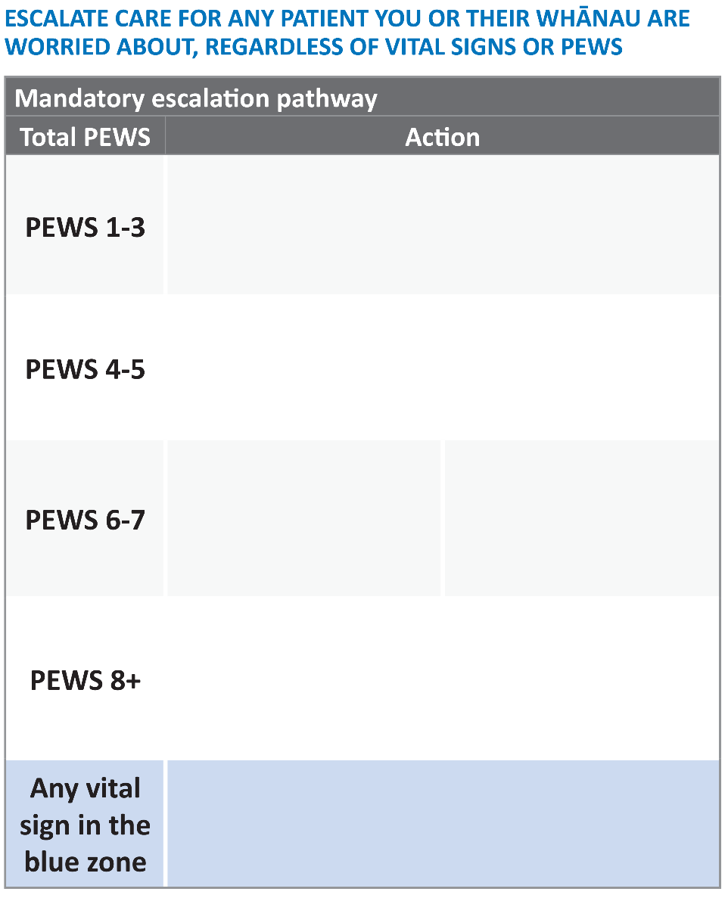

Design and printing information
This section provides information about design and print requirements for the PVSC.
Your organisation needs to develop an escalation pathway appropriate to your local area before you can use it clinically. You can make a few other amendments according to locally agreed policy and practice. The details that follow cover:
- required amendments
- allowable amendments
- print specifications.

Required amendments
The escalation pathways should be developed with the clinicians using the PVSC and reflect local systems and practice. The pathway should use unambiguous language, and briefly and clearly state expected actions and responses for each range of PEW score.
Enter the pathway in the ‘Action’ area of the chart (provided as an editable PDF). Use the guidance document, Paediatric early warning system escalation mapping tool, to develop the response for each level of physiological abnormality.

Allowable amendments
Table 2 sets out the amendments you may make to the PVSC.
Table 2: Allowable amendments to the PVSC
Chart area | Allowable amendment
Left-hand margin | For scanning purposes, you may add a barcode or QR code.
Left-hand margin | You may add a black-and-white version of the organisational logo below patient label. Do not use coloured logos because they add visual clutter and distract from the main purpose of the chart.
Central column of the scoring area | You may replace ‘RRT’ with a locally relevant number or acronym, eg, ‘777’. Note there is only space for three characters.
Beside ‘Mandatory escalation pathway’ heading | If you have different escalation pathways for different hospitals, you can add the name of the hospital next to this heading.
Right-hand bottom corner | You can replace ‘End-of-life pathway’ with your relevant local terminology.
Back of chart:  ‘Local tools’ | This space can be edited to include locally defined parameters or tools. Do this in conjunction with your communications team or design team.

Print specifications
The chart must be professionally printed to the following specifications:
- paper size A3 landscape
- double-sided (front and back)
- minimum paper quality 150gsm (uncoated stock)
- fold: chart is creased twice at 205 mm and 310 mm (from the left-hand edge) and then
Z-folded in front along these creases (Figure 24)
- hole-punched left-hand side with two holes
- no print offset required.
Figure 23: Z-fold demonstrated with the PVSC

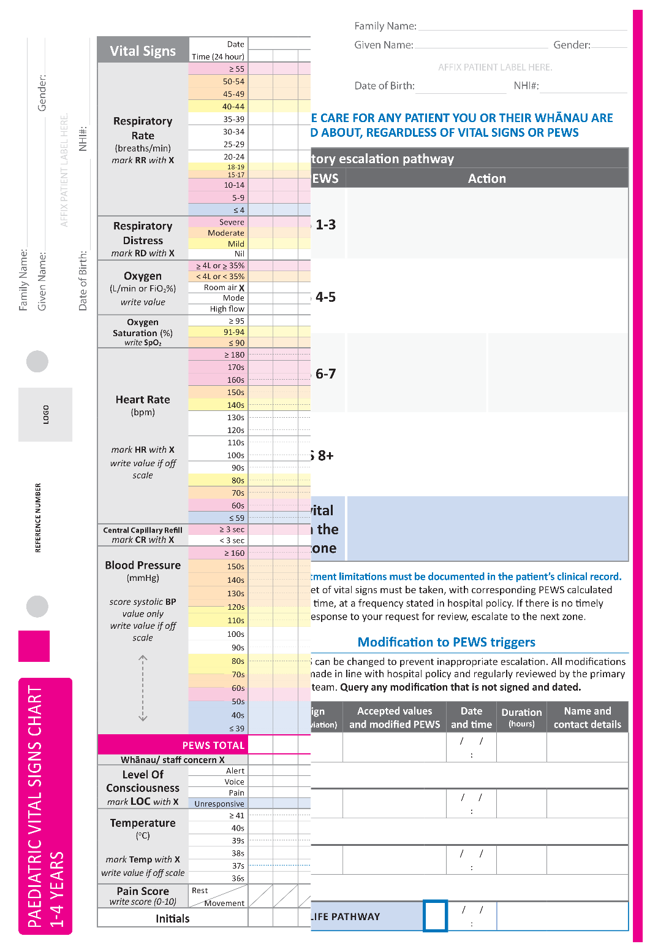

Colour specifications
CMYK (cyan, magenta, yellow and black) and RGB (red, green, blue) are two different ways of achieving a particular colour. Most printers print in CMYK and most screens display RGB.
The PVSC was designed using CMYK colour because it is intended for print use. The CMYK colour values listed in Table 3 are used at 60 percent tint on the scoring area of the chart to enable clear documentation with a black or blue ball point pen. The colour values are used at 100 percent tint in the other sections of the chart, such as the columns to the right and left of the scoring area, and the left-hand column of the escalation pathway.
If you want to use the colours in a screen display format, the CMYK values will need to be converted to RGB values (see Table 3). The CMYK and RGB colours have been used to shade the boxes Table 3 and you will see there are minor differences. This is to be expected.
You can select RGB values in Word documents using the ‘More Colors’ option in the shading or font colours tabs. Open ‘More Colors’ then select ‘Custom’ and insert the RGB values.
Table 3: Colour specifications for the PVSC
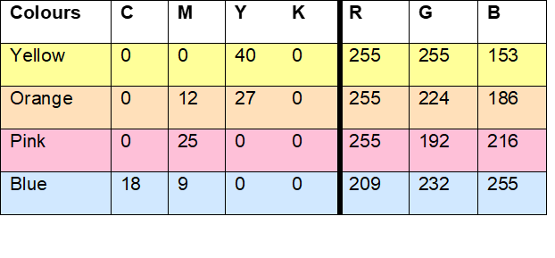

Parshuram CS, Hutchison J, Middaugh K. 2009. Development and initial validation of the Bedside Paediatric Early Warning System score. Crit Care 13: R135. URL: https://doi.org/10.1186/cc7998.
The Royal Children’s Hospital Melbourne. 2019. Observation and continuous monitoring (Clinical Guidelines (Nursing)). Melbourne: The Royal Children’s Hospital. URL: www.rch.org.au/rchcpg/hospital_clinical_guideline_index/Observation_and_continuous_monitoring/ (accessed 27 July 2021).
Royal College of Nursing. 2017. Standards for assessing, measuring and monitoring vital signs in infants, children and young people. London: Royal College of Nursing.
Health Quality & Safety Commission. Kōrero mai – patient, family and whānau escalation. Wellington: Health Quality & Safety Commission. URL: www.hqsc.govt.nz/our-programmes/patient-deterioration/workstreams/patient-family-and-whanau-escalation/.
Hicks CL, von Baeyer CL, Spafford P, et al. 2001. The Faces Pain Scale - Revised: Towards a common metric in pediatric pain measurement. PAIN 93: 173‒83.
Malviya S, Vopel-Lewis T, Burke C, et al. 2006. The revised FLACC observational pain tool: improved reliability and validity for pain assessment in children with cognitive impairment. Pediatric Anaesthesia 16: 258‒65.
Available at: www.hqsc.govt.nz/our-programmes/patient-deterioration/publications-and-resources/publication/4350/.

