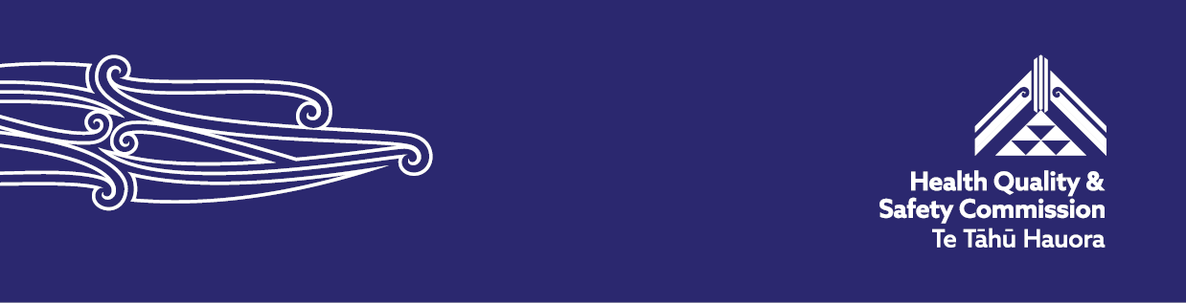

Reminders for the Paediatric Early Warning System (PEWS)

Here are some reminders for clinicians and health districts when using the Paediatric Early Warning System (PEWS).

Paediatric vital signs charts

Updating the paediatric vital signs charts

We have updated two paediatric vital signs charts: for 5–11 year olds and for children 12+ years.

**5–11 years**

Updated parameters:

Lower systolic blood pressure – change score 4 (red zone) to 60–69  
and blue zone ≤59 mmHg.

**12+ years**

Updated parameters:

Upper heart rate – change score 4 (red zone) to 135–139 and an added blue zone ≥140.

Lower systolic blood pressure scoring: score 1 (yellow zone) = 90–99 mmHg, score 2 (orange zone) = 80–89 mmHg, score 4 (red zone) = 75–79 mmHg, and blue zone = ≤74 mmHg.

[Access the paediatric vital sign charts – hqsc.govt.nz](https://www.hqsc.govt.nz/resources/resource-library/paediatric-early-warning-system-pews-preparation-and-implementation-guide/)

Take blood pressure for all age groups

It is important to know a child's blood pressure because when a child is sick, changes in the body can occur that result in either a high or low blood pressure, even if the child looks relatively well.

Causes of a high blood pressure can be pain, heart and cardiovascular defects, kidney, hormonal and metabolic conditions and changes in body habitus such as obesity. Low blood pressure can indicate a medical emergency resulting from conditions such as dehydration, blood loss, sepsis and allergic reactions.

When research was done to look at the vital signs that predict the need for a child to go to intensive care, the sensitivity and specificity of the paediatric early warning scores improved when systolic blood pressure was added. That is why it became part of the PEWS scoring system. Even if a child looks well, it is important to look at blood pressure trends and take note if the blood pressure is rising or falling.

This video supports staff to routinely measure blood pressure in paediatric patients.

[How to take blood pressure accurately in unwell children – hqsc.govt.nz](https://www.hqsc.govt.nz/resources/resource-library/video-how-to-take-blood-pressure-accurately-in-unwell-children/)

This guide is for health professionals and covers the common questions raised by paediatric teams.

[Guide to recording blood pressure in acutely unwell tamariki – hqsc.govt.nz](https://www.hqsc.govt.nz/resources/resource-library/guide-to-recording-blood-pressure-in-acutely-unwell-tamariki-he-aratohu-hei-tuhi-i-te-taukapa-o-te-toto-i-te-tamariki-e-mauiui-ana/)

Managing patients with chronic conditions (eg, cardiac illness) due to their altered baseline

The paediatric vital signs charts include a modifications box where clinicians can adjust score ranges for individual vital signs to suit children with chronic conditions like cyanotic congenital heart disease. This section is explicitly designed so clinicians can tailor the PEWS triggers without compromising the standardised national chart.

Modifications box: This space lets you individualise single-parameter triggers (eg, respiratory rate, heart rate, oxygen saturation) for a child. For example, if a child with congenital heart disease normally has lower oxygen saturation, you may shift that saturation range to reduce false alerts.

Do not use this approach for acutely unwell children, such as those with bronchiolitis or other short-term illnesses, where transient deviations from normal vital signs are expected. In these cases, use the notes to clearly document and outline the patient’s diagnosis, their treatment plan, and the criteria for requesting a review. This ensures clinical appropriateness while avoiding unnecessary escalations during periods of expected physiological stress.

For more detail, read:

[Aotearoa New Zealand national paediatric early warning system and paediatric vital signs chart user guide – hqsc.govt.nz](https://www.hqsc.govt.nz/resources/resource-library/pews-tools-and-guidance/)

Adding sepsis to the paediatric vital sign chart

PEWS is designed to support the early detection of clinical deterioration, not to identify sepsis or other diagnoses or conditions. Sepsis requires its own dedicated clinical pathway – such as the national Raise the Flag sepsis pathway – which includes targeted triggers and time sensitive treatment bundles. Keeping PEWS focused on general deterioration ensures it remains a sensitive and effective tool across a wide range of clinical presentations, without diluting its function.

[Access the national Raise the Flag sepsis pathway – hqsc.govt.nz](https://www.hqsc.govt.nz/our-work/improved-service-delivery/sepsis/)

Health districts’ responsibility

Improving uptake and engagement with online learning modules

Health districts are responsible for embedding online modules into local education plans, onboarding processes and ongoing staff development. Local clinical leaders and educators are expected to promote and monitor uptake to ensure consistent use across inpatient paediatric services.

[Access the PEWS e-learning – koawatealearn.co.nz](https://koawatealearn.co.nz/course/view.php?id=11599)

You will need to log in.

Ensure online learning meets the needs of new staff, casuals and those in remote settings

Health districts are encouraged to tailor the national online learning platform to local contexts, ensuring accessibility for all staff groups, including new starters and those in remote locations.

Adding a certification or record of completion for online-learning

Now that the implementation phase is complete, adding a documentation of completion for hospital staff would be a great initiative for districts to pursue. You can leverage the national e-learning platform while making local decisions moving forward.

There is flexibility to adapt escalation pathways, but keep paediatric vital signs charts unchanged

The national paediatric vital sign charts (PVSCs) incorporate both national standardisation and local adaptability.

The national PVSCs are designed to be consistent across all districts, ensuring uniformity in recognising and responding to early signs of clinical deterioration in tamariki. This consistency is crucial for maintaining a reliable and effective system nationwide, particularly given the integration of these charts into digital platforms accessed across various regions.

However, while the core charts remain standardised, health districts have the flexibility to develop and implement their own escalation pathways. These pathways allow each district to tailor their response protocols to align with local resources, staffing and clinical practices. This dual approach ensures that while the recognition of deterioration is consistent, the response can be adapted to meet local needs.

A standardised national paediatric vital signs chart is essential for consistency and reliability, especially in digital environments. At the same time, the flexibility to adapt local escalation pathways ensures that the system is responsive to the unique needs of each district.

Improving the recognition and integration of whānau concerns

Health districts and local communities can strengthen the recognition and integration of whānau concerns. Online learning modules can support this work, while local approaches can be tailored to better respond to the unique needs and voices of whānau.

A poster – [Team Tamariki](https://www.hqsc.govt.nz/resources/resource-library/team-tamariki-paediatric-early-warning-system-pews-poster-for-whanau-tamariki-and-staff/) – can be used to promote, communicate and initiate discussion about PEWS.

[‘Team Tamariki’: Paediatric early warning system (PEWS) poster for whānau, tamariki and staff – hqsc.govt.nz](https://www.hqsc.govt.nz/resources/resource-library/team-tamariki-paediatric-early-warning-system-pews-poster-for-whanau-tamariki-and-staff/)

Published September 2025 by Health Quality & Safety Commission Te Tāhū Hauora, PO Box 25496, Wellington, 6146. Available online at [www.hqsc.govt.nz](http://www.hqsc.govt.nz). Enquiries to: [info@hqsc.govt.nz](mailto:info@hqsc.govt.nz)

