

**Improving surgical   
teamwork and communication:   
A guide to preparing and implementing**

August 2021

Contents

Introduction 3

Goal 4

National measures 5

The surgical teamwork and communication interventions 5

Briefing 6

Paperless surgical safety checklist 8

Debriefing 10

Supporting communication tools 12

What does the ‘ideal’ day in theatre look like? 14

Preparation and implementation activities 16

Implementation period 23

Appendix A: Quality improvement approach 25

Appendix B: References 27

Published in August 2021 by the Health Quality & Safety Commission New Zealand,   
PO Box 25496, Wellington, New Zealand.

Published under Creative Commons licence CC BY-NC 4.0, which means you are free to:   
• share — copy and redistribute the material in any medium or format  
• adapt — remix, transform, and build upon the material  
under the terms outlined at: <https://creativecommons.org/licenses/by-nc/4.0/>

This document is available on the Health Quality & Safety Commission’s website:  
[www.hqsc.govt.nz](http://www.hqsc.govt.nz)

Purpose of this guide

This guide aims to help hospital teams continue to improve the teamwork and communication interventions across their operating theatres and surgical teams. We encourage teams to modify the contents and the approach offered in this guide to suit their local context and experience.

Partner resource

A partner resource, *Safer surgery journal articles*, is available in long and short versions (updated August 2021) on the Commission’s website:

<https://www.hqsc.govt.nz/our-programmes/safe-surgery-nz/publications-and-resources/publication/4343/>

Introduction

Surgical safety checklists, briefings and debriefings aim to improve the quality and safety of health care services provided to patients undergoing surgical procedures, including preventing adverse events. Such interventions have been found to deliver benefits, including better teamwork and communication, better satisfaction with care, better processes and reduced error rates (Catchpole 2013). The surgical safety checklist is now routinely used during operations in every district health board (DHB) in Aotearoa New Zealand.

Between 2014 and 2021, the Health Quality and Safety Commission New Zealand (the Commission) managed a national programme to improve teamwork and communication in operating theatres. The programme included the interventions of:

* briefings and debriefings
* a paperless surgical safety checklist
* supporting communication tools, such as: ISBAR (identify, situation, background, assessment, recommendation), the two-challenge rule, call-outs and closed-loop communication.

While the Commission no longer supports a national improvement programme, we encourage hospital theatres across the country to take up and continue using the interventions.

For more information, see the final report *Improving Teamwork and Communication within Surgical Teams: A Proof of Concept project: Programme Review and Recommendations*, available on the Commission’s website:   
[www.hqsc.govt.nz/our-programmes/reducing-perioperative-harm/publications-and-resources/publication/2045](http://www.hqsc.govt.nz/our-programmes/reducing-perioperative-harm/publications-and-resources/publication/2045)

Goal

Our goal is to improve teamwork and communication within surgical teams in New Zealand hospitals. This goal will contribute to reducing perioperative harm. The surgical teamwork and communication interventions we promote in this document have been tested through the proof of concept project.

The Commission will support organisations to implement these interventions.

Figure 1: Interventions and drivers to achieve the goal

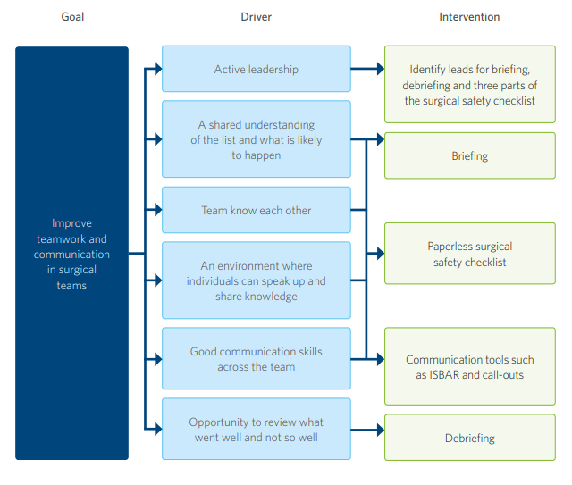

National measures

The existing quality outcome measures (which measure rates of venous thromboembolism, pulmonary embolism and sepsis) will remain. This will help the Commission and DHBs understand whether there has been an improvement in teamwork and communication in surgical theatres at a national level.

The surgical teamwork and communication interventions

The surgical teamwork and communication interventions are:

* briefing before the list check begins
* completing a paperless surgical safety checklist during each operation
* debriefing at the end of the list check
* supporting communication tools:
  + call-outs
  + closed-loop communication
  + ISBAR (identify, situation, background, assessment, recommendation)
  + two-challenge rule.

Many studies on the effectiveness of surgical safety checklists have been undertaken, with most showing reductions in surgical mortality and complications. A 2014 systematic review of 16 studies of surgical safety checklist implementation in hospitals worldwide noted that checklists ‘have been shown to significantly improve patient outcomes subsequent to surgery, and therefore their use is being widely encouraged and accepted’ (Patel et al 2014).

The evidence is also strong for briefings and debriefings. In a 2015 article in the *Australian and New Zealand Journal of Surgery*, Civil and Shuker noted that ‘briefings and debriefings in the theatre environment have reduced communication failures by two-thirds, reduced non-routine events by 25%, effectively surfaced potential surgical safety hazards, reduced staff perception of risk and increased their sense of team collaboration, and in a Johns Hopkins study, reduced unexpected delays by 31% and surgeon-reported unexpected delays by 82%’ (Civil and Shuker 2015). There is also a powerful link between routinely undertaking briefings and the safety culture within the operating theatre (Allard et al 2011).

The following pages provide an overview of the interventions and evidence. For more details on the evidence base behind the interventions, see *Checklists, briefings and debriefings: An evidence summary* (updated August 2016) on the Commission website: [www.hqsc.govt.nz/our-programmes/reducing-perioperative-harm/publications-and-resources/publication/2209](http://www.hqsc.govt.nz/our-programmes/reducing-perioperative-harm/publications-and-resources/publication/2209)

Briefings

Surgical teams take time before starting each day’s operating theatre list to complete the team briefing. The briefing is a standardised communication tool that aims to create an environment in which individuals can speak up, express concerns and alert team members to unsafe situations in a timely manner.

‘The team meets first and fully discusses the entire list. This enables changes to be made   
if necessary before any concerns normally found during the operation.’

– Surgeon, proof of concept project

Findings from the proof of concept project indicate that investing a small amount of time in briefing at the start of the list can save time over the list’s duration and increase efficiency. A 2015 study in orthopaedics bears this out, showing a reduction in interruptions and delays during the surgical list and increased surgeon satisfaction after briefings had been implemented. The study also noted that the briefing averaged less than a minute per case (Jain et al 2015).

The team briefing should occur as a four-step process, with all steps completed before the team starts the list.

1. Introductions
2. List outline
3. Case events for each case
4. Staffing and questions.

‘Overall, the concept of the team briefing is excellent. Everyone has an overall view of the day, and problems are discussed before the list starts, for example, allergies, positioning, equipment, etc.’

– Theatre team member, proof of concept project

We recommend that the person who knows the most about the list and the patients lead the briefing.

Briefings enable teams to share the operative plan, and they promote teamwork, mitigate hazards to patients, reduce preventable harm and ensure all equipment is available. They supply a broader knowledge base for the planned procedure so that each team member has a better understanding of the tasks at hand, can anticipate future events and can pre-plan accordingly.

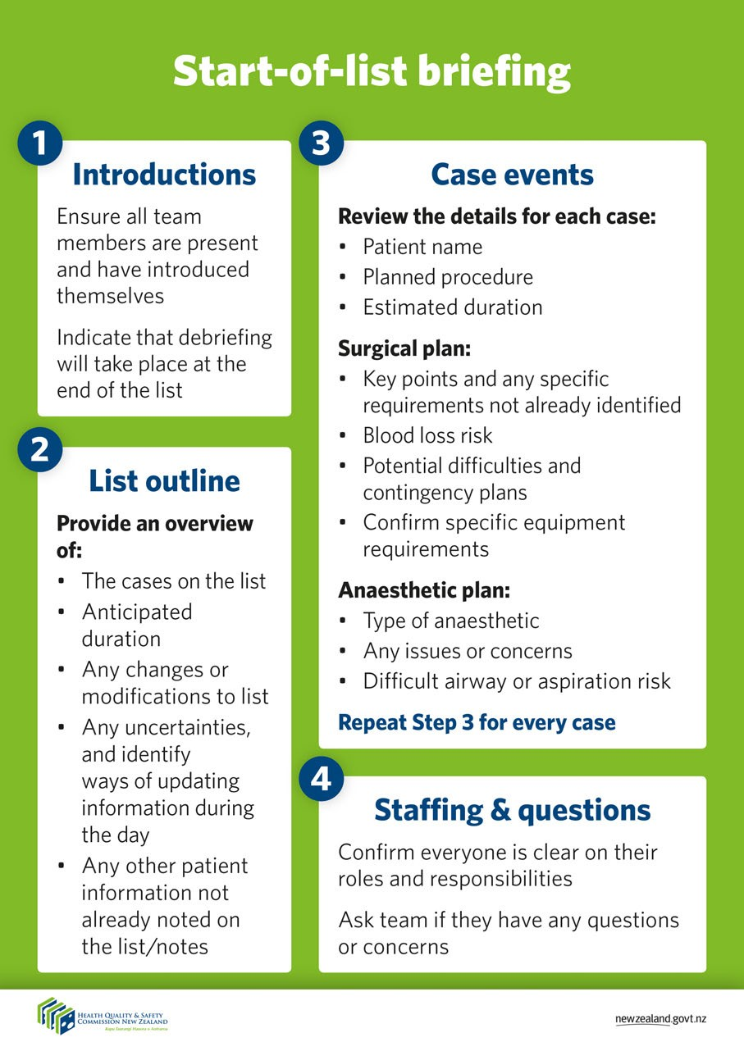

Paperless surgical safety checklist

The surgical safety checklist is not meant to be used as a ‘tick-box’ exercise; it is meant to:

* ensure that the theatre team performs key safety checks as a team (without having to rely on memory)
* increase verbal communication in the operating theatre
* instil a sense of shared accountability for the outcome of the procedure.

However, it is important that all three parts (sign in, time out and sign out) of the checklist are completed, as this increases the list’s effectiveness (Mayer et al 2015).

Theatre teams refer to a large poster-sized version of the checklist on the wall of the operating theatre. It acts as an aide-memoire for the person leading each section of the checklist, and having it visible on the wall allows all members of the team to see what will be asked and to use it as a discussion guide.

Studies and local experience have shown the system is improved when different team members lead the three parts of the checklist: there is more team engagement, and appropriate team members are present. We recommend that:

* the anaesthetist lead sign in, with nursing and anaesthetic team members present
* the surgeon lead time out, with all team members present
* the nurse leads sign out, with all team members present.

‘Information is not relayed by telepathy. The [interventions] help clarify in my mind whether   
I have considered all aspects of the patient’s anaesthesia and interventions required.’

– Anaesthetist, proof of concept project

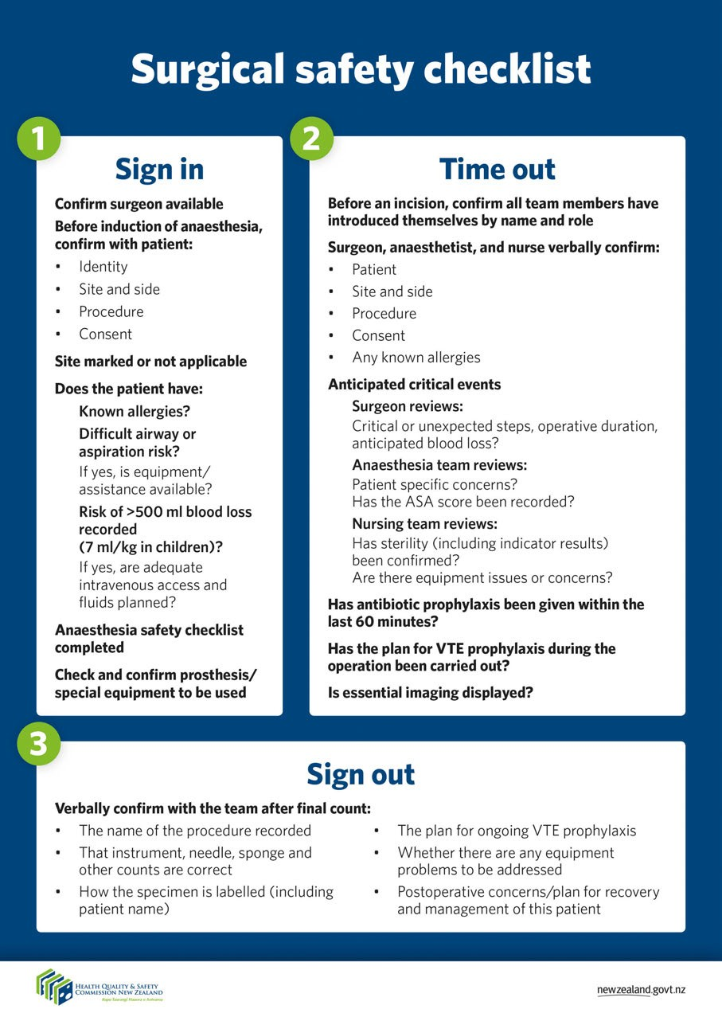

Debriefing

A five-minute debriefing is completed in theatre at the end of the patient list (for both full-day and half-day patient lists). This means before the last patient leaves theatre, while all team members are present or before teams change. The *End-of-list Debriefing* poster on the wall prompts discussion. The debriefing is completed verbally, and no written documentation is necessary. It will be important to capture informally any actions arising from the debriefing to ensure identified issues are resolved and suggestions for improvement are acted on.

Debriefings allow teams to take time to learn from real-time situations that went well or didn’t go to plan by discussing what happened after an operating session. They provide opportunities for improvement (including in staff wellbeing) and learning not blaming, and they offer a forum for saying thank you. In a 2014 study in Florida, USA, the participating hospital found that debriefing supported continuous process improvement by encouraging each team member to creatively identify solutions to issues they had encountered during the perioperative period (Marks et al 2014).

During the debriefing, team members are encouraged to raise any concerns or suggestions they may have had during any of the operations on the list and discuss what went well and not well and why, as well as what could be done better next time.

As part of debriefing, DHBs must implement some kind of action feedback loop, for instances where changes or improvements need to be made. It is essential that learnings from debriefings are acted on or the use of the tool will rapidly diminish.

‘Team debriefs highlight areas that can be improved, for example, always needing   
this piece of equipment for this particular surgery. I think they make everyone feel   
part of the team.’

– Nurse coordinator, proof of concept project

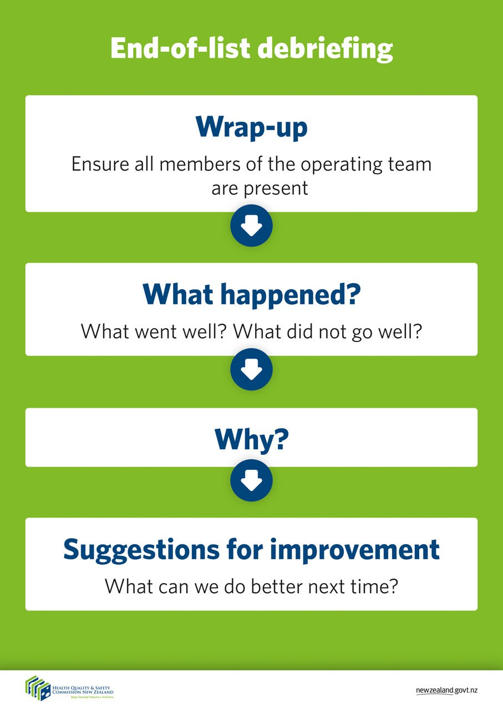

Supporting communication tools

The table below links the supporting communication tools with briefing, the surgical safety checklist and debriefing.

|  |  |  |  |
| --- | --- | --- | --- |
| **Tool** | **Briefing** | **Surgical safety checklist** | **Debriefing** |
| Call-outs |  |  |  |
| Closed-loop communication |  |  |  |
| Two-challenge rule |  |  |  |
| ISBAR |  |  |  |

While using these tools may seem awkward or forced at first, over time, they become natural and are important in enhancing the interventions.

Call-outs

A call-out is when someone vocalises or shouts out an important piece of information. Call-outs are most often used during emergency situations but can be useful in non-emergency situations too.

Information that all team members need to know or that will be critical for subsequent actions makes for good topics for call-outs during team briefings and the surgical safety checklist (BC Patient Safety & Quality Council 2013).

1. Define a set of circumstances under which call-outs are expected to be used (start small).
2. Use improvement cycles (see Appendix A) to:
   1. fine-tune the technique by first testing it with a small group of willing participants. Practise through role plays or simulations
   2. broaden use of the technique to other staff, specialties and procedures.

Closed-loop communication

When we communicate with others, we cannot be sure they have heard us as intended unless they tell us what they heard (BC Patient Safety & Quality Council 2013). This is the concept behind closed-loop communication. Closed-loop communication ensures the provider of the information knows that the receiver of the information has heard and understood their instructions.

Misinterpreted communication has the potential to lead to adverse events. It is always important to ensure that a message or instruction has been transferred as intended. Repeating back instructions right away to clarify what has been said allows the receiver to know they got the correct message and the provider to be assured their message has been received correctly.

Closed-loop communication is an important tool that can be applied to theatre team briefings, the surgical safety checklist and debriefing.

1. The sender states their message/instruction.
2. The receiver accepts the information, acknowledges its receipt and repeats the information.
3. The sender verifies the information has been interpreted correctly.

ISBAR

ISBAR (Identify, Situation, Background, Assessment, Recommendation) is a framework for communicating information in a clear, contextualised and collaborative way. When all members of the surgical team adopt ISBAR, patient information is more easily and clearly conveyed, with minimised risk of misinterpretation. ISBAR can be used in person or over the phone, in handovers between units and at shift changes (BC Patient Safety & Quality Council 2013).

In particular, ISBAR is useful during theatre team briefings, the surgical safety checklist and debriefings. Each ISBAR intervention requires patient information to be shared between team members in a collaborative way.

Using ISBAR will help ensure team members are operating with the same level of understanding and within the same context. Importantly, this tool allows staff to communicate assertively and effectively, reducing the need for repetition (NHS Institute for Innovation and Improvement 2010).

1. Identify: Who is the patient?
2. Situation: What is the situation at hand?
3. Background: What is the relevant background information about the patient?
4. Assessment: What is your assessment of the situation?
5. Recommendation: What do you think should be done or what do you need? What is the specific solution to the problem?

Two-challenge rule

It is human nature to say something once, and often to not listen to something the first time it is explained to you (BC Patient Safety & Quality Council 2013). The two-challenge rule supports the speaker to raise their concerns twice if those concerns are not addressed the first time.

This rule highlights the responsibility of the listener to respond to the speaker, at least the second time the speaker asserts their concern. If the listener continues to be unresponsive, the two-challenge rule empowers the concerned speaker to act and raise their concern with someone who can address the situation effectively.

1. Raise your concern for the first time and wait to be addressed by the team member to whom you are speaking.
2. If your initial request is not heard, speak up again. Assert your concern at least twice.
3. It is the responsibility of the listener to respond.
4. If the listener does not respond, raise your concern with someone who can address the situation.

A practical example that highlights the usefulness of the two-challenge rule is the Just a Routine Operation video. In this video, Martin Bromiley describes the mistakes that led to the loss of his wife during a seemingly routine procedure, including a breakdown in the decision-making and communication processes. As a result of this experience, Martin founded the United Kingdom’s Clinical Human Factors Group, a charity working to make health care safer. The video is available online: <https://www.youtube.com/watch?v=JzlvgtPIof4>

What might an ‘ideal’ day in theatre look like?

Here is an ideal approach to aim for when implementing the interventions.

Before the list begins – briefing

The first patient is due into theatre shortly. The team gathers for its standard pre-list team briefing. The team knows that a regular briefing is an indicator of a strong team culture as it increases collaboration and reduces risk. It is the opportunity for all team members to speak up and, as a result, reduce communication failures.

The briefing is led by the person who knows the most about the list, typically the surgeon or anaesthetist. With all team members present, the briefing begins. Using the team’s *Start-of-list Briefing* poster, which is on the theatre wall, the first part of this four-step process is introductions. This is where all those present quickly take turns to state their name and role. This breaks the ice – with everyone wearing theatre scrubs, assumptions about roles and experience can occur if a round of introductions does not take place. For example, today we have a student nurse and a trainee house surgeon present. Following introductions, everyone knows who is who and feels more relaxed, involved and part of the team.

Next, the team moves onto the list outline. Confirming the cases on the list is first. For example, today the list consists of short cases, so the logistics of a quick turnaround of cases is factored into the day. The anticipated duration is then discussed – this helps the team anticipate when the next case needs to be called for, or if any break cover is required. Any modifications, such as a late cancellation, or order change that team members need to know about are discussed. Any uncertainties, such as a specific piece of equipment required, can be confirmed at this time as well. The last step of the list outline is discussing any other patient information not already on the list. For example, today a translator will be required for the third case to help the surgeon and anaesthetist manage consents.

The team then moves onto the third step of briefing – case events. This is a more in-depth review of the details for each case. It involves confirming the details of the case: the patient’s name, the planned procedure and the estimated duration. Then the surgical plan is discussed, in particular, key points and specific requirements that have not already been identified. For example, today the second case requires specific positioning. Any potential difficulties are identified and contingencies planned for.

The anaesthetic plan is discussed next. The anaesthetist goes over each patient’s plan, including type of anaesthesia to be used, any issues or concerns and any airway or aspiration risk.

Typically, the whole briefing process takes about five minutes; the team agrees it is time well spent. Having a broader knowledge of the planned procedure, each team member now has a better understanding of the tasks at hand. Future events can now be anticipated and pre-planned accordingly.

The team has the chance to ask any questions and confirm everyone is clear about their roles and responsibilities. Everyone has an equal voice and an equal opportunity, which is empowering for all staff. At this point, the team is informed that a debriefing will occur at the end of the list.

Paperless surgical safety checklist for each operation

Since the removal of the paper-based checklist, the team is much more engaged. Having the checklist on the wall makes it a discussion point for all staff. The anaesthetist leads the sign-in with nursing and anaesthetic team members present before administering the anaesthesia. The sign-in covers areas such as patient and site identification, anaesthesia safety check and special equipment check.

Before the skin incision, the team have a time out – the surgeon leads with all team members present. It is confirmed that all members of the team have introduced themselves by name and role (the team may have changed since the briefing in the morning, so it is important to quickly go over this step again). Any anticipated events from a surgeon, anaesthetic team (including ASA score) and nursing team perspective are discussed as well as venous thromboembolism and antibiotic prophylaxis. Everyone is satisfied, and the team is able to proceed.

At the end of the operation, with all team members present and before the patient leaves the room, the team has their sign-out, led by theatre nursing staff. A good time to do this is during closing when the surgeon is still present. All counts are checked and signed off when correct. Any concerns are identified for postoperative care, such as potential blood loss and plans for analgesia while in the post-anaesthesia care unit (PACU) and for the ward.

Strong team engagement and communication are central features now the team has moved away from a paper-based tick-box approach.

End of the list – debriefing

Immediately after completing the list, there is the team debriefing. A good time to do this is immediately after the sign-out for the final case on the list as all team members should still be present. In some theatres, it is led by the theatre charge nurse manager.

The team start with a wrap-up, with the aim of ensuring all team members are still present. They discuss what went well, what didn’t go well and what should be done differently next time. The debriefing is an opportunity for learning, rather than blaming, and improving the team culture, for example, improving staff wellbeing by taking the time to say thank you. The question asked is ‘What can we improve and do better next time?’, focusing on systems and looking for areas that could be improved. Suggestions for improvement, such as ensuring the theatre cart is always fully stocked, can then be remedied immediately.

Preparation and implementation activities

This section outlines the activities and outputs project teams should do as part of the preparation and implementation periods.

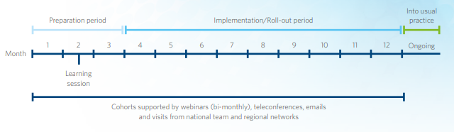

Preparation period

The period has been split into monthly activities to help teams manage the work that needs to be done to prepare for implementation. By chunking the work, teams can ensure that everything is in place and ready for implementation.

Teams can prioritise the actions they focus on, with particular emphasis on those that work for team and their organisation. If teams find actions take longer than anticipated, keep working on them within the preparation period.

Month one – commitment

| **Action** | **Output** |
| --- | --- |
| 🞐 Establish the project team  Make sure they are representative of the surgical team and can contribute actively to the project. | Confirmed project team |
| 🞐 Know your starting point  Your organisation may already be implementing one or more of these interventions in one or more areas of the hospital. Find out what has already been done in your organisation and what the challenges were to implementation. Are the interventions still being used and if not, why not? Explore what went well and not so well to help you decide how you will implement. | Completed assessment – starting point understood |
| 🞐 Agree what you are trying to accomplish  It’s important to know what you want to accomplish. Use Figure 1 on page 4 as a starting point. With your team, create a clear statement of your goal. For example: ‘Improve the use of the paperless checklist, briefing and debriefing in all our surgical theatres by July 2022’.  This also helps with confirming the scope of your implementation. You may need to clarify the terms you use so there is a common language. | Agreed goal statement |
| 🞐 Confirm what intervention(s) you will be implementing  Now you know what your starting point is and what you are trying to accomplish, get agreement on what interventions you will be implementing where and when.  As a team, you may choose to focus initially on implementing the paperless checklist and use the communication tools to support this. Alternatively, you may choose to implement briefings, the paperless checklist and debriefings at the same time by having an initial trial site for each of the interventions before spreading the implementation to further sites. | Agreed intervention(s) |
| 🞐 Agree how you will be implementing  Consider how you will implement the intervention(s) and the number of operating theatres and surgical staff you want to reach. You may want to start with a particular group of theatres or particular specialty. Set a date that works towards your goal.  Once the interventions are implemented in those areas, use your learning to implement them in other areas.  We recommend using a quality improvement approach, where you start by testing the intervention with one surgical team, using improvement cycles to refine processes. Once the intervention works with the first team, move to testing with two teams, then three and so forth.  This process will be useful in that you will be starting small with a willing team. It will help you iron out any issues and provide you with champions for your implementation. It also means that if you need to tweak an intervention for another team you can do so with minimal impact on others.  The Model for Improvement approach has four testing stages: plan‒do‒study‒act (PDSA). Refer to Appendix A for a summary of the steps and tips involved with this approach.  At the learning session, the Commission’s quality improvement advisor will provide training on the Model for Improvement and give you an opportunity to share your experiences of this approach if you are already familiar with it. | Agreed approach with milestones to track progress |
| 🞐 Agree how you will know that you have been successful  With your team, develop and agree how you will measure the success of your implementation and progress towards your goal. Measuring your efforts in this way will help you know whether any changes you make have improved your implementation. Then identify how you will collect data for these measures and who will do this. Incorporate quality outcome measures. | Agreed measures and data collection process |
| 🞐 Align the project to your organisation’s aim  Aligning the project to your organisation’s aim, values or strategy will help you engage better with senior staff members. You can communicate how your implementation relates to and benefits the organisation. | Project aligned to organisation |
| 🞐 Agree how and where the project will report progress  Work with your executive sponsor to agree how and where progress reporting will be completed. There may already be a surgical safety related committee or group into which the project fits.  Reporting progress helps in many ways, including:   * keeping you focused on what needs to be done and when * allowing you to raise risks, challenges and issues for assistance * raising the profile of the work you are doing.   The reporting shouldn’t be onerous – it should have limited impact on your time. Outline the current status of the project, any risks, issues or opportunities, and milestones coming up. | Agreed governance arrangements and reporting requirements |
| 🞐 Know who you need to engage with to accomplish your goal  Engaging with staff and other stakeholders is crucial to the success of implementation. This is true for all change activities.  Below is a three-step process you can follow with your project team.   * Identify who your stakeholders are.   + What are the staff groups in your surgical teams? For example, surgeons, anaesthetists, perioperative nurses (different levels), anaesthetic technicians, resident medical officers and junior nurses. Do you know how many are in each group? Do you know which theatres they are in?   + What other staff groups will be affected by implementing the interventions? Nursing staff in related wards/outpatients and quality staff might be affected. Infection prevention and control nurses, porters and cleaning staff might also be affected indirectly. Think about the management and senior clinical groups you need to engage with.   + Don’t forget to consider how you can engage consumers and their whānau. * Assess how much influence these groups have on the success of the project and how much interest they have. This can be done by sorting the groups into a grid with a low–high continuum.      * Once you’ve assessed the groups, identify your champions (high impact and high interest) and those with whom you need to engage who have a high impact on the success of the project but a low interest. | Stakeholder assessment |
| 🞐 Agree how you will engage with staff and other groups  Now that you know who you need to engage with, work out how you will do this. Every member of the project team will have a role to play in this. Look at where there are existing meetings where staff will be. Use a mixture of formal meeting presentations and informal discussions.  Identify the right people to do the engagement. There may be groups where an enthusiastic peer or champion will need to speak with your audience. Consider how your communications team could help you reach the wider staff group through your organisation’s intranet or newsletters.  Engagement activities will be needed throughout the preparation and implementation periods. The messages you give may need to change to reflect the progress you have made. | Engagement approach |
| 🞐 Document the outputs of earlier actions  Put all the outputs from the earlier actions into a project plan. This will help you and the project team know what you are doing, why you are doing it and when you will do it. | Project plan (sometimes known as a charter) |

Month two – engagement

| **Action** | **Output** |
| --- | --- |
| 🞐 Report progress to your executive sponsor  Your organisation has agreed to implement the interventions. Your executive sponsor has signed off on it. They will want to see how you are progressing with preparation. Giving them regular progress updates will identify where they need to visibly support the project. | Progress update |
| 🞐 Agree your starting version of the paperless surgical checklist  The paperless surgical checklist shows the minimum items that need to be discussed during sign in, time out and sign out. We recommend using this as your starting version. | Starting version |
| 🞐 Agree your starting version of the *Start-of-list briefing* poster  The *Start-of-list briefing* poster includes prompts for the surgical team to follow during their briefing at the start of the list.  We recommend using this as your starting version. | Starting version |
| 🞐 Agree your starting version of the *End-of-list debriefing* poster  The *End-of-list debriefing* poster includes prompts for the surgical team to follow during their debriefing once the list has been completed.  We recommend using this as your starting version. | Starting version |
| 🞐 Assess the challenges and opportunities related to using the paperless surgical checklist, briefing and debriefing posters and processes  Introducing a new way of doing the checklist will have both challenges and opportunities. Brainstorm what these could be with the team. Think about how your team currently use the checklist, where the completed checklist is filed and who uses the information collected from it.  We recommend that different members of the team lead each step in the brainstorm process – what will you need to consider when introducing this process?  Use the following list to explore challenges and opportunities.   * Patient * Staff * Environment * Processes * Tasks * Time * Team * Communication * Education/training * Equipment/resources   Introducing briefings at the start of the list will also have challenges and opportunities. Brainstorm what these could be with the team. We recommend the briefing is led by the person in the theatre who knows the most about the list and patients. Consider how your team will do the briefing in situ. The briefing should take no more than five minutes.  Introducing debriefings at the end of the list will also present both challenges and opportunities. Brainstorm what these could be with the team. We recommend the debriefing occurs after the sign-out step of the surgical safety checklist for the last patient on the list. Explore how the suggestions for improvement can be acted on so your team can see the benefits of debriefing. | Assessment and actions |
| 🞐 Identify the theatres and staff who are willing to be the initial sites  As you engage with staff, check who would be willing to be initial sites for implementing the intervention(s). Those who are willing are more likely to be patient with the initial improvement cycles. | List of willing staff and theatres |
| 🞐 Engage with staff at every opportunity  You’ve identified how you want to engage with staff. Use these opportunities to share key messages about the intervention(s) and how you envisage implementing them. As well as planned activities, other opportunities may present themselves. | Key formal and informal meetings |
| 🞐 Communicate your project to the organisation  It will be important to share what you are doing with the wider organisation. This will raise awareness of what you are doing, make it visible at all levels of the organisation and generate interest in the project. For example, include items in internal communications and reports to the board and senior-level groups. | Internal communications |
| 🞐 Arrange intervention education and training for staff who are willing to be the initial site(s)  Arrange a suitable venue, promote the training and make sure the staff you want to attend can do so. | Date for intervention training |

Month three – final checks

| **Action** | **Output** |
| --- | --- |
| 🞐 Report progress to your executive sponsor  Continue to give regular progress updates to your executive sponsor. | Progress update |
| 🞐 Engage with staff at every opportunity  Continue to engage with staff about the project and what you are doing. | Attend key formal meetings, informal meetings |
| 🞐 Communicate your project to the organisation  Continue to share what you are doing with the wider organisation. | Internal communications |
| 🞐 Attend intervention training  Encourage your project team, initial site teams and other willing staff to attend the intervention training.  Work out how you will train remaining surgical staff on the interventions. | Intervention training |
| 🞐 Prepare your initial site(s)  Meet with your initial site team(s) to agree when they will start the interventions and explain how the improvement cycles will work. Work out what support the team(s) will need and who from the project team will provide this support. | Prepared sites |
| 🞐 Complete final countdown  Have the intervention posters up on the wall and check that the initial site team(s) are ready for the first improvement cycle. | Final checks |

Implementation period

How you manage your implementation will depend on the approach you have agreed to use and have documented in your project plan. Splitting the implementation period into quarters (90-day cycles) or months (30-day cycles) will help you manage the work involved. This is particularly effective for managing improvement cycles and implementing the interventions across operating theatres.

We’ve identified some key actions you can incorporate into your plan.

Key actions

| **Action** | **Output** |
| --- | --- |
| 🞐 Work with the initial site(s) to make small steps of change  Using the improvement cycles, work with your initial site(s) to make small steps of change until the initial site(s) and your own team feel you are ready to implement at a further site. | Action cycles |
| 🞐 Measure for improvement  Use the measures and data collection processes you identified during the preparation period to monitor your progress towards achieving your goal for the project.  You can also use the results to promote the project to surgical staff who are not currently involved and to wider staff and patients. | Reports |
| 🞐 Identify the next site(s) where you will implement the intervention(s)  As you engage with staff and communicate your project to the organisation, check who would be willing to be the next site(s) to implement the intervention(s). Those who are willing are more likely to be more tolerant of the initial improvement cycles.  Encourage staff from your initial site(s) to share their experiences, particularly if their work has benefited from implementing the interventions, and how they overcame challenges. | Next site |
| 🞐 Work with the next site(s) to make small steps of change  Prepare your next site(s) – meet with them to agree when they will start the interventions, give them training and explain how the improvement cycles will work. Identify what support they will need and who from the project team will provide this support.  Using the improvement cycles, work with your next site(s) to make small steps of change until that next site and your team feel you are ready to implement at a further site.  Keep identifying and working with further sites until you have a final site to work with. | Action cycles |
| 🞐 Identify the final site where you will implement the intervention(s)  Identify the final site and encourage the staff from your earlier sites to share their experiences of working with the interventions, how they addressed challenges and what they perceived as benefits from the intervention(s). | Final site |
| 🞐 Work with the final site to make small steps of change  Prepare the final site – meet with them to agree when they will start the interventions, give them training and explain how the improvement cycles will work. Identify what support they will need and who from the project team will provide this support.  Using improvement cycles, work with your final site(s) to make small steps of change. | Action cycles |
| 🞐 Monitor how your earlier sites are going  Don’t forget to keep an eye on how your earlier sites are going. They will be used to working with you. Make sure you keep them engaged. | Regular touchpoints |
| 🞐 Report on progress to your executive sponsor  Continue to give regular progress updates to your executive sponsor. | Progress update |
| 🞐 Identify if you need more time to implement the intervention(s)  You may not have been able to implement all the interventions in all operating theatres, particularly if you are a large organisation. Work with your team and executive sponsor to agree the next steps and how you will continue implementation. | Agreement on next steps |
| 🞐 Consider how new staff will be trained on using the intervention(s)  As you near completion of implementation, work out how new staff will be trained on using the intervention(s). | Sustainable training approach  New staff induction |
| 🞐 Celebrate achievements  Take the time to celebrate what you have achieved. Recognise the efforts of team members and surgical teams to implement the interventions. Positive feedback and reinforcement combined with public recognition will help keep everyone motivated and focused. | Celebrations |

Appendix A: Model for Improvement approach

The Model for Improvement was developed by the training organisation Associates in Process Improvement ([www.apiweb.org](http://www.apiweb.org)) and has been used in a number of quality improvements for health care organisations.

The Model for Improvement is a framework for structured improvement activity to help you achieve your goals and support the spread for wider adoption. It is based on three key questions used with small-scale testing, improvement cycles that are often referred to as PDSA cycles (plan, do, study, act cycles). As part of your preparation period, you will address the three key questions. During your implementation, you can use the PDSA cycles to test out related change ideas.

Figure 1: The Model for Improvement



Tips for doing the PDSA cycles (Clark 2008)

* Expect the test not to work the first time.
* Starting with one patient and one team means that there will be the minimum delay to starting, the improvement activities can be observed easily and the impact is minimal if the improvement doesn’t work.
* Spread slowly. Once it works for one, test the improvement with three and then five. This will help you to resolve issues as you go so that you can have more confidence in the improvement.
* Work with the willing. Find a team that wants the change to work – they will have the tolerance to work through any issues that might arise.
* Use simulation if you are concerned about the impact – this could be as a desk review and/or a walk-through with colleagues.
* Assess whether testing will have an impact on people or processes beyond the area. Include these extra people or processes in the planning and studying stages of the improvement cycle. We’ve recommended assessing the challenges and opportunities during the preparation period.

There are other improvement methods like Lean Six Sigma, which is a methodology and toolset that aims to help users analyse their processes and make improvements to those processes. For more information, see the Six Sigma Quality website at: www.sixsigma.com Use these if your organisation has a stated preference for one over another.

Nearly every DHB has quality improvement advisors who you can contact for support and guidance.

References and bibliography

Allard J, Bleakley A, Hobbs A, et al. 2011. Pre-surgery briefings and safety climate in the operating theatre. *BMJ Qual Saf* 20(8): 711–7.

BC Patient Safety & Quality Council. 2013. *Culture Change Toolbox*. Vancouver: British Colombia (BC) Patient Safety & Quality Council. URL: <http://bcpsqc.ca/documents/2014/01/SQAN-Culture-Book_6x8_2013_web-FINAL.pdf>(accessed June 2015).

Catchpole K. 2013. Spreading human factors expertise in healthcare: untangling the knots in people and systems. *BMJ Quality and Safety* 22(10): 802–8.

Civil I, Shuker C. 2015. Briefings and debriefings in one surgeon’s practice. *ANZ J Surg* 85: 321–3.

Clark J. 2008. *The Quick Guide to Implementing Improvement.* London: Patient Safety First. URL: www.patientsafetyfirst.nhs.uk/ashx/Asset.ashx?path=/How-to-guides-2008-09-19/Quick%20Guide%201.1_17sept08.pdf (accessed June 2015).

de Vries EN, Ramrattan MA, Smorenburg SM, et al. 2008. The incidence and nature of in-hospital adverse events: a systematic review. *Quality & Safety in Health Care* 17(3): 216–23.

Gauld R, Horsburgh S. 2012. *Clinical Governance Assessment Project: Analysis of three quality and safety questions in a national survey of New Zealand health professionals.* Dunedin: Centre for Health Systems, University of Otago.

Jain AL, Jones KC, Simon J, et al. 2015. The impact of a daily pre-operative surgical huddle on interruptions, delays, and surgeon satisfaction in an orthopedic operating room: A prospective study. *Patient Safety in Surgery* 9: 8. DOI:10.1186/s13037-015-0057-6.

The Joint Commission. 2015. Sentinel Event Data – *Root Causes by Event Type*. 2004–2014. Oatbrook Terrace: The Joint Commission. URL: [www.jointcommission.org/assets/1/18/Root_Causes_by_Event_Type_2004-2014.pdf](http://www.jointcommission.org/assets/1/18/Root_Causes_by_Event_Type_2004-2014.pdf%20) (accessed June 2015).

Marks S, Loskove J, Greenfield A, et al. 2014. Surgical team debriefing and follow-up: creating an efficient, positive operating room environment to improve patient safety. *APSF Newsletter.* Indianapolis: Anaesthesia Patient Safety Foundation. URL: [www.apsf.org/newsletters/html/2014/June/04_surgicaldebrief.htm](http://www.apsf.org/newsletters/html/2014/June/04_surgicaldebrief.htm%20) (accessed June 2015).

Mayer E, Sevdalis N, Rout S, et al. 2015. Surgical Checklist Implementation Project: The impact of variable WHO checklist compliance on risk-adjusted clinical outcomes after national implementation: a longitudinal study. *Ann Surg* 00: 1–6.

NHS Institute for Innovation and Improvement. 2010. *The Handbook of Quality and Service Improvement Tools.* Coventry: National Health Service (NHS) Institute for Innovation and Improvement. URL: [www.miltonkeynesccg.nhs.uk/resources/uploads/files/NHS%20III%20Handbook%20serviceimprove.pdf](http://www.miltonkeynesccg.nhs.uk/resources/uploads/files/NHS%20III%20Handbook%20serviceimprove.pdf%20) (accessed June 2015).

Patel J, Ahmed K, Guru KA, et al. 2014. An overview of the use and implementation of checklists in surgical specialities: A systematic review. *International Journal of Surgery* 12: 1317–23.

Singer S, Jiang W, Huang LC, et al. 2015. Surgical team member assessment of the safety of surgery practice in 38 South Carolina hospitals. *Med Care Res Rev* 72(3): 298–323.