

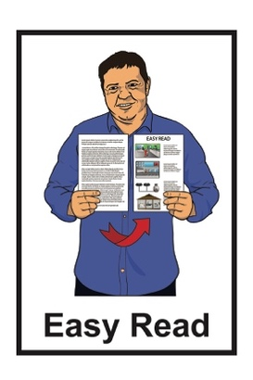

Recovering from sepsis
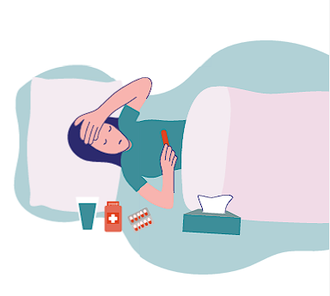

Published: August 2026


Before you start




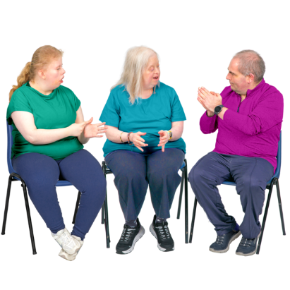
Some of the information in this document may make people:
upset
worried.

This information is not meant to scare anyone.

This information does not mean the things in this document will happen to:
you
people you know.

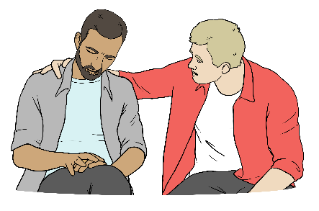
If you are worried you can talk to your:
whānau / family
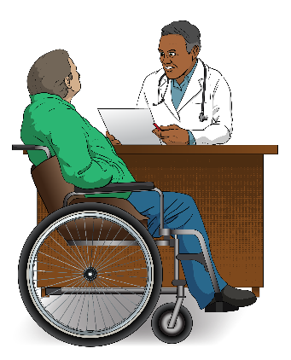
friends
doctor.

What you will find in here

Page number:


About this Easy Read 4


Post Sepsis Syndrome / PSS 5
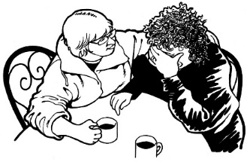

Sepsis and mental health 16


Recovering at home 17


Caring for a sepsis survivor 22
Other supports 25

Where to find more Easy Read information about sepsis 32

About this Easy Read
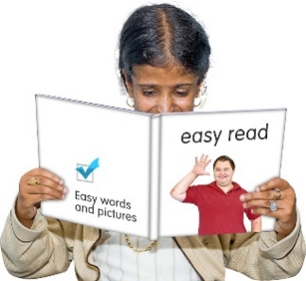

This Easy Read is about what happens after you have had sepsis.

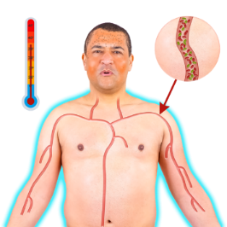
Sepsis can happen when your body reacts to an infection.

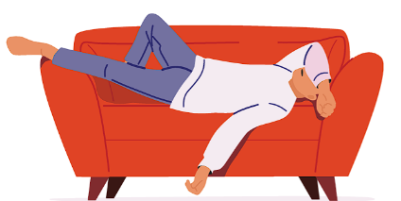
An infection is when you get sick from germs getting into your body.

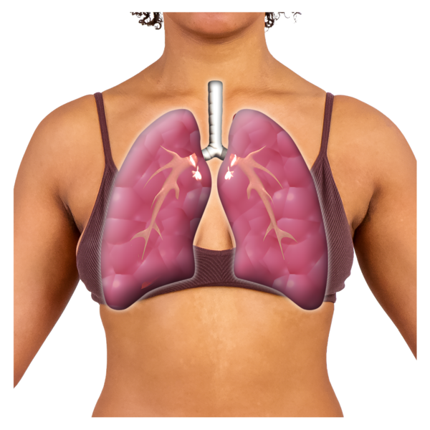
Some infections that can lead to sepsis are:
- chest infections like pneumonia
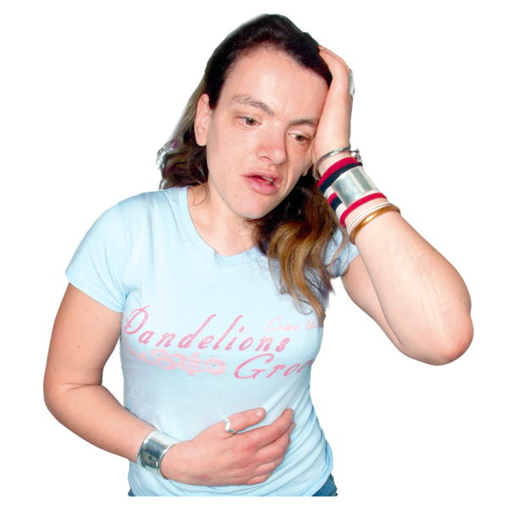
- urine infections / UTIs
- skin infections or infected cuts / wounds.

Post Sepsis Syndrome / PSS

Around half of all sepsis survivors will be all better in a few:
weeks
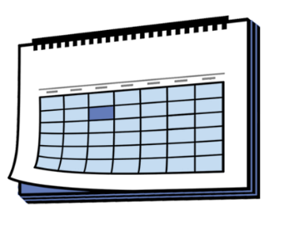
or
months.
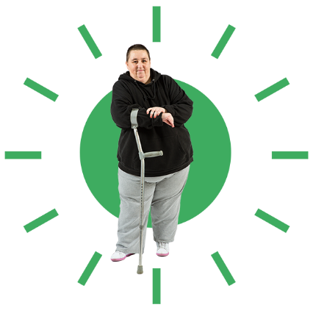
Sepsis survivors in this Easy Read means people who have lived after having sepsis.

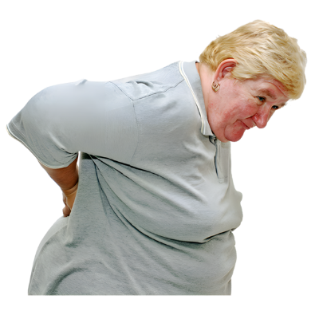
Some of the sepsis survivors will experience something called
Post Sepsis Syndrome / PSS.

Post Sepsis Syndrome / PSS is the name for any problems that last a long time caused by things like:
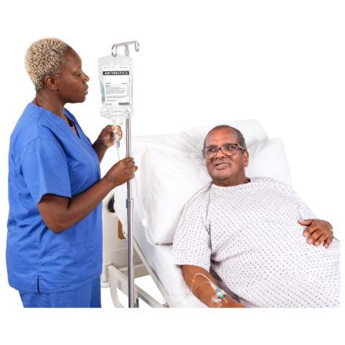
having had sepsis
the infection that caused the sepsis
the treatment for the sepsis.

Post Sepsis Syndrome / PSS will be called PSS in this Easy Read.


PSS causes changes to:
your ability to think
how your body works.

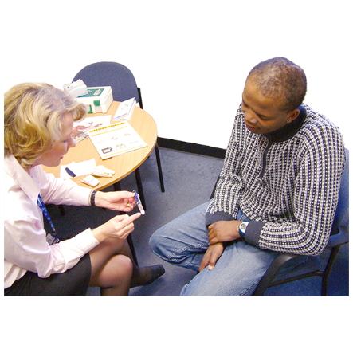
PSS can also cause:
health problems
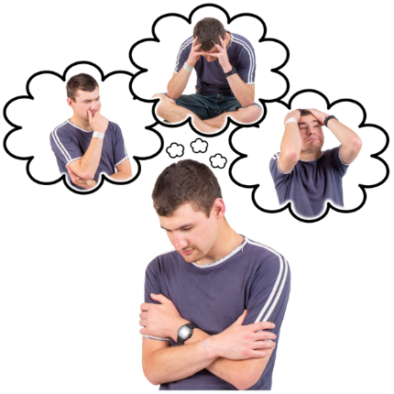
mental health challenges.

Mental health challenges are when you are having a hard time with your mental health.



PSS symptoms can be different for each person.


Symptoms are things that happen to show you are sick like:
feeling hot / cold
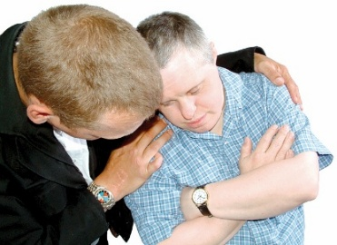
coughing
feeling sad all the time.

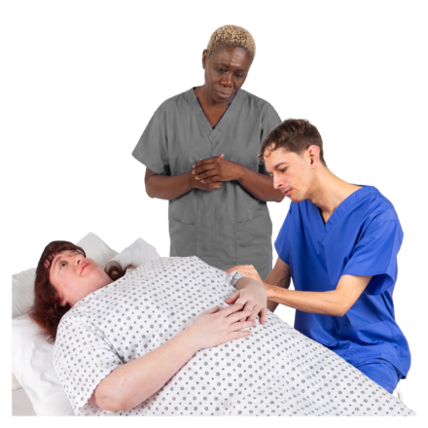
PSS might cause you to:
have new medical conditions that last a long time
find health conditions you had before the sepsis get worse.


It may take up to 2 years to recover from PSS.

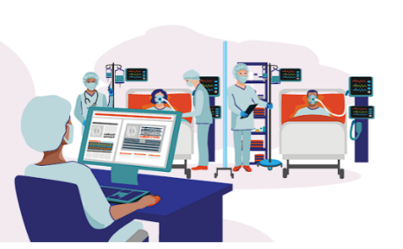
You can get PSS even if you did not spend time in the Intensive Care Unit / ICU.

Intensive Care Units / ICUs are places where hospitals send people who:
are at risk of dying
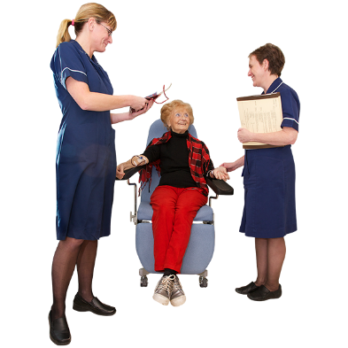
need treatment that cannot be done anywhere else in the hospital

need access to a nurse all the time
need specially trained medical staff like doctors who know a lot about sepsis.


You might notice the PSS symptoms after you get home from the hospital.

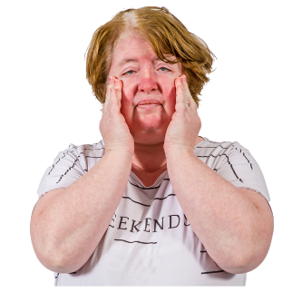
You might also notice some changes while you are recovering from sepsis like:
feeling very weak
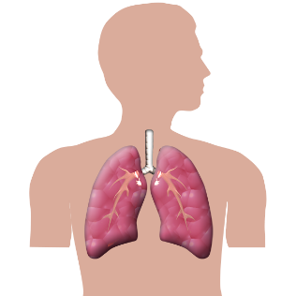
tiredness
feeling like you do not have enough breath
losing weight
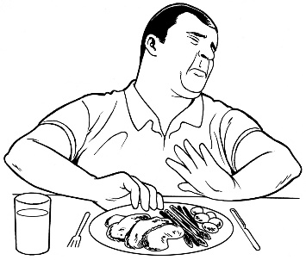
not feeling like eating
food tasting different
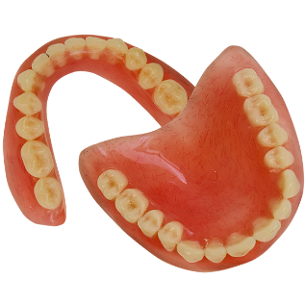
losing your hair
nails breaking easily
teeth breaking easily.

Other changes you might notice while you are recovering from sepsis are:
skin that is:
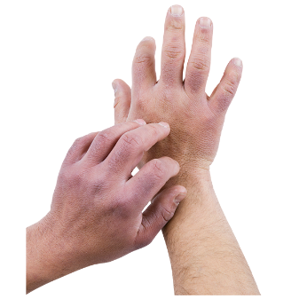
- dry
- itchy
- flaking
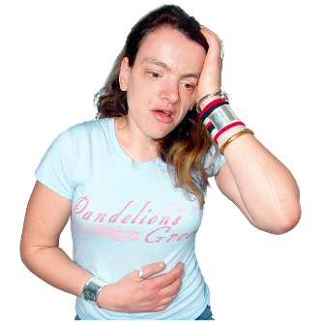
feeling dizzy
headaches
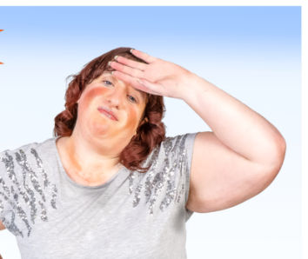
changes in your vision / what you see
you notice the temperature a lot more like:

- feeling hot easily
- feeling cold easily.

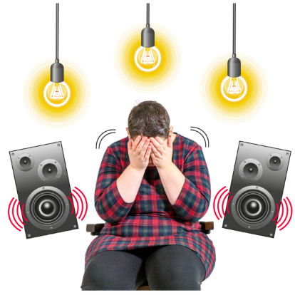
Other changes you might notice while you are recovering from sepsis are:
things around you bothering you more like:

- noise
- bright lights
- busy places
you get infections more often.

You should talk to your doctor / nurse about PSS if any of these symptoms:
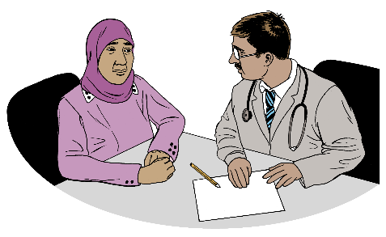
keep happening
get worse.

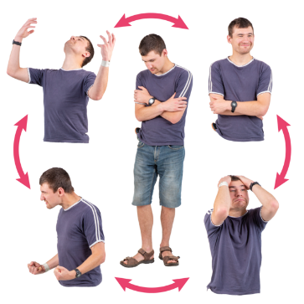
You might also experience different feelings when you get home like:
mood swings / your mood changing quickly
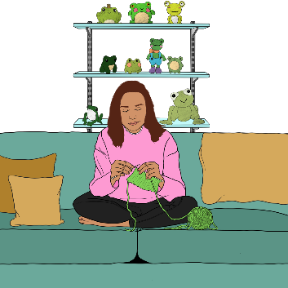
not caring about how you look
wanting to be alone
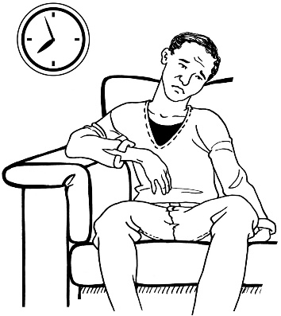
staying away from loved ones
feeling like you do not want to do anything
not believing in yourself

frustration that you are not back to how you usually are yet
guilt

stress
feeling like nobody understands how you feel.
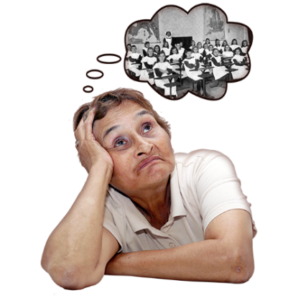
You might also experience things like:
remembering bad memories
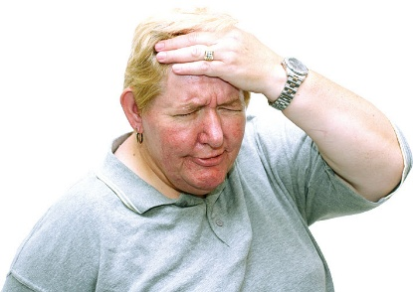
feeling bad feelings that are to do with bad memories
having a hard time working out what is real

not being able to focus on things like reading
having trouble remembering things
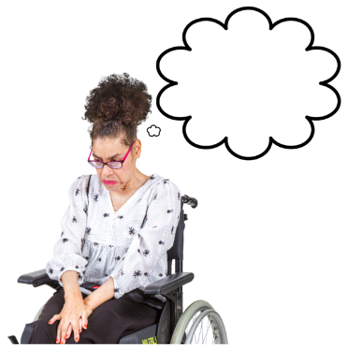
having trouble thinking
anxiety
depression.

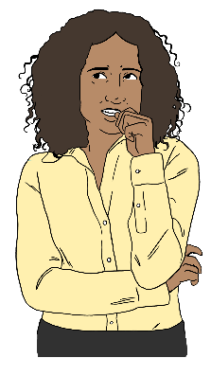
Here anxiety means feeling very worried for a long time.

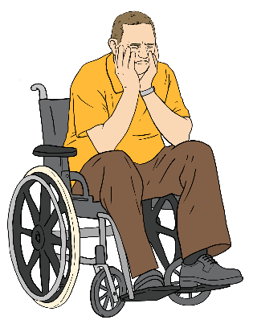
Here depression means feeling very sad for a long time.

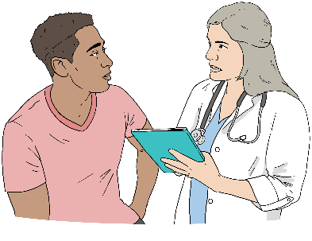
You should talk to your doctor / nurse about PSS if any of these symptoms:
keep happening
get worse.

Sepsis and mental health

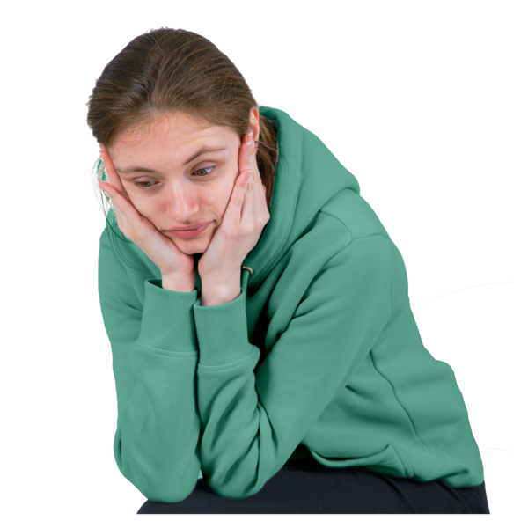
People who survive sepsis have been known to develop mental health conditions like:
anxiety
depression.
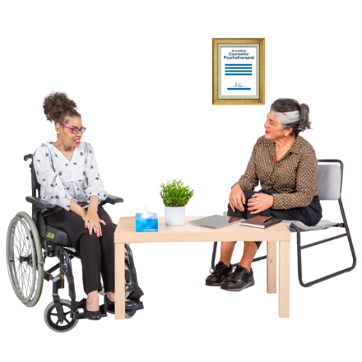
If someone is struggling with their mental health it is important that they see a nurse or doctor.

Recovering at home

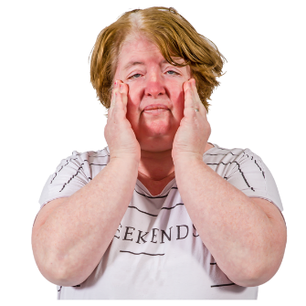
It is important to understand sepsis.


This is so you can understand that recovery from sepsis can be hard.

Here recovery means getting better once you do not have sepsis anymore.

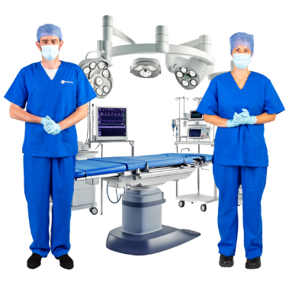
Recovery from sepsis can be harder than recovering from something like surgery.

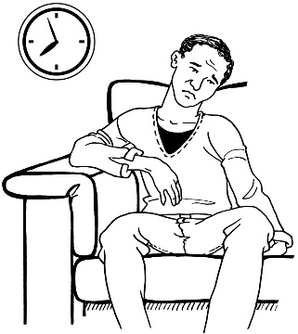
Recovery can:
be different for everyone
take longer than you think.
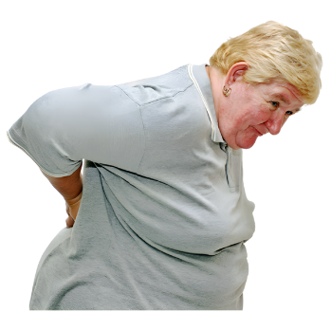
Some people might keep having problems after they have recovered.

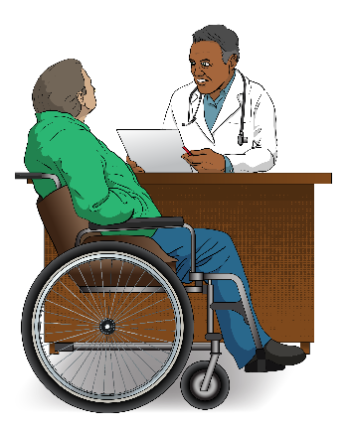
If you are worried about your recovery talk to your:
doctor
nurse.

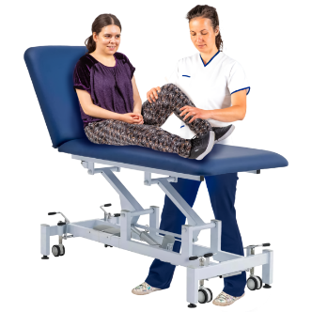
They might be able to find you the support you need from other health care providers like:
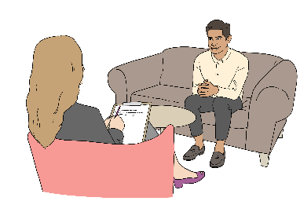
physiotherapists
counsellors.

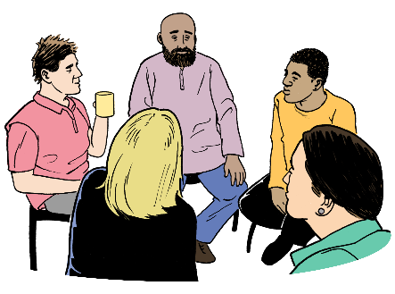
Some sepsis survivors might want different kinds of:
therapy
support.
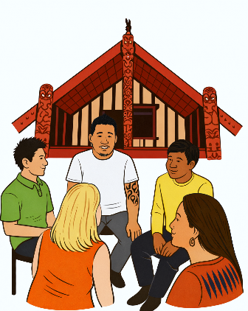

This could be through people like:
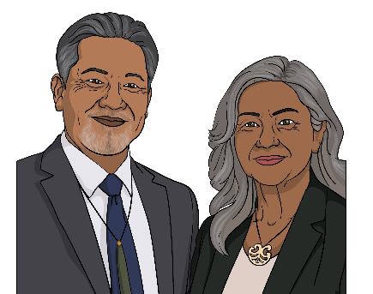
rongoa Māori / Māori medicine practitioners
religious leaders like priests
cultural leaders like kaumātua.


Sharing this information with them might give them ideas for the best ways to support you.


Sometimes recovery happens slowly.

This can make it hard to see that you are getting better.
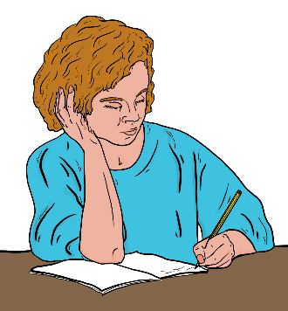

One thing you can do is keep a journal about something you do each week that supports you to get better.

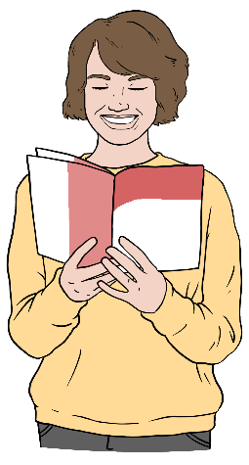
For example if you are having a hard time concentrating you could do a word puzzle each week.

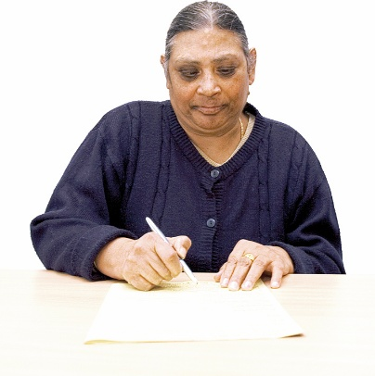
After you have done the word puzzle write how doing the puzzle was like:
was it easier than last week?
can you concentrate / work on it for longer?
As you write more in the journal you will see if you:
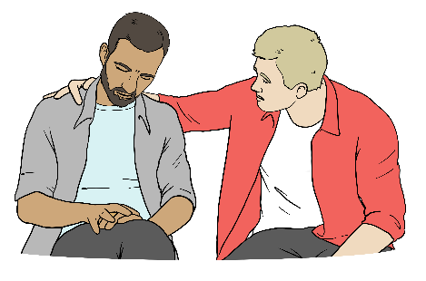
are doing better
need more support because you are not doing better.

Caring for a sepsis survivor

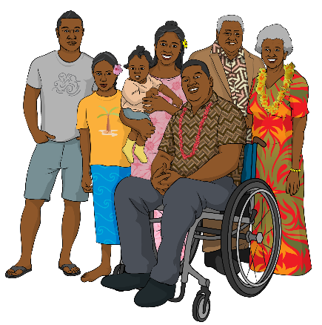
A loved one having sepsis can affect:
everyone at home
the whole whānau / family.

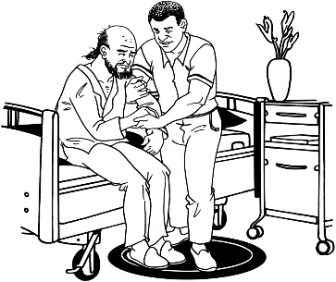
When you need to care for a sepsis survivor at home you might feel:
happy they are out of hospital

worried about caring for them.

Often people closest to a sepsis survivor feel a lot of different things.
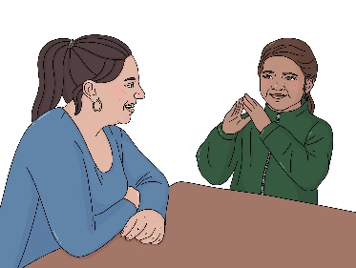

Children who know the sepsis survivor well may also get upset.
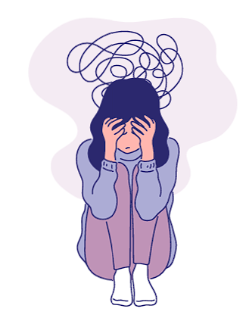
People close to a sepsis survivor might feel things like:
being upset
feeling like crying a lot
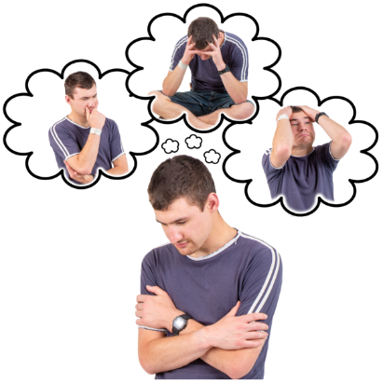
being anxious
being depressed
being tired.


It is important to take care of yourself too.


To take care of yourself you can do things like:
take time to do things you like
talk about how you are feeling with someone else.
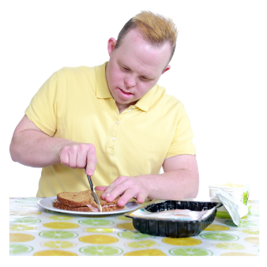
To take care of yourself you can also do things like:
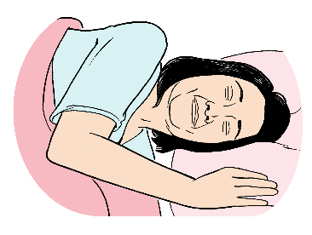
eat well
get enough sleep
ask for support if you need it.
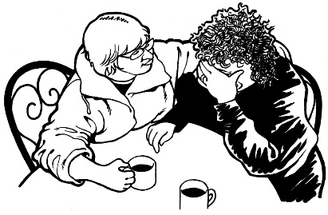

It is important to ask for support if:
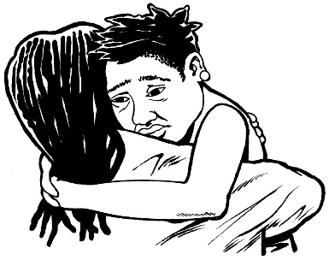
you are having a hard time
your family is having a hard time.

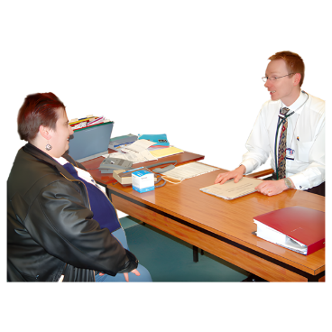
You can ask for support from your family doctor.

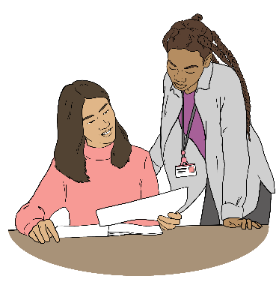
The next part of this Easy Read has other groups you can ask for support from.

Other supports


There are different groups that can support you when dealing with sepsis.

If you are worried about health

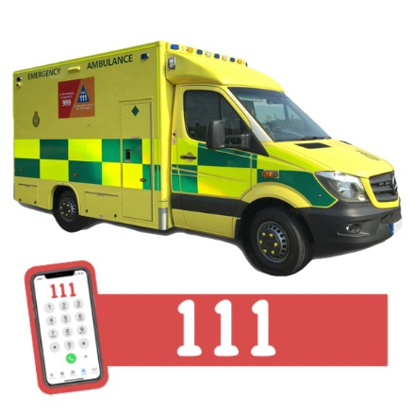
Call 111 if you:
are worried about someone with sepsis / who has had sepsis
think that someone might have sepsis.

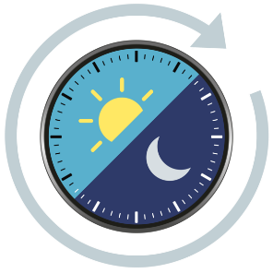
111:

can be called at any time
does not cost any money to phone.

Taking an ambulance to the hospital might cost you money.

If you need to talk to someone now

These next 2 places:
can be contacted at any time
do not cost any money.

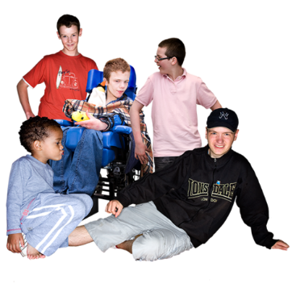
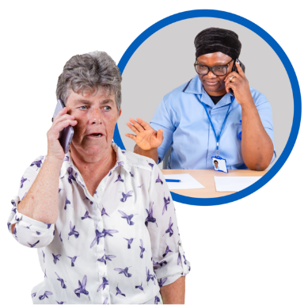
Anyone in Aotearoa New Zealand can contact Need to Talk by
text / phone call on:
1737

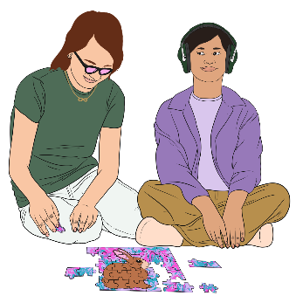
You can contact Youthline to talk if you are:
a young person
supporting a young person.

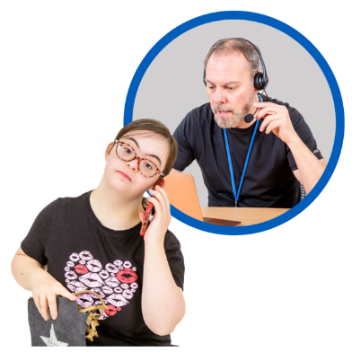
You can contact Youthline by:
phone:
0800 376 633
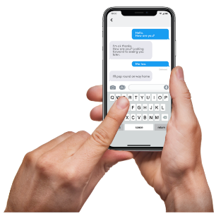
text:
234

You can also contact Youthline by:

WhatsApp message:
09 886 56 96
webchat on their website:

https://youthline.co.nz/web-chat-counselling

Support for mental health
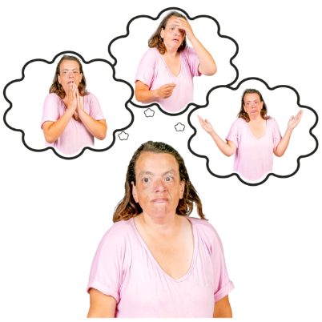
If you have a family member who is having mental health challenges you can contact Yellow Brick Road.

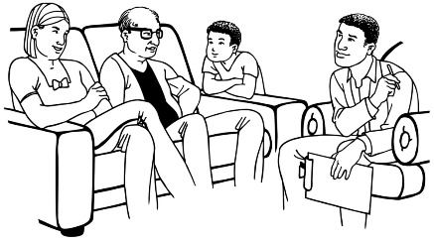
Yellow Brick Road gives mental health support to whānau / families
of people experiencing mental distress.


You can find out more about how to contact your local Yellow Brick Road office on their website at:
https://bit.ly/49DqSzx
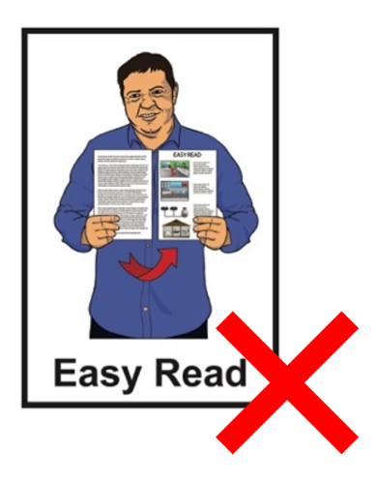

This website is not in Easy Read.

Support for life after being in the ICU

MyLifeAfterICU is a website that has information / tools for:

people who have been in ICU
whānau / families
caregivers.

You can find out more on their website at:

www.mylifeaftericu.com

This website is not in Easy Read.

Support for sepsis
Sepsis Trust NZ has
information / tools about sepsis on their website at:

www.sepsis.org.nz


Sepsis Australia also has information / tools about sepsis on their website at:

www.australiansepsisnetwork.net.au

The Health Quality & Safety Commission also has
information / tools about sepsis on their website at:

www.hqsc.govt.nz/sepsis-patient-resources

Where to find more Easy Read

information about sepsis
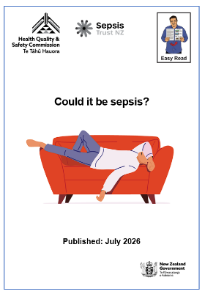
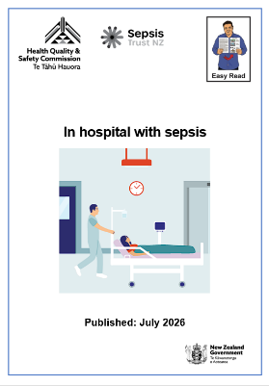

There are 2 other Easy Read documents about sepsis called:
Could it be sepsis?
In hospital with sepsis.


You can find these Easy Read at:
https://hqsc-sepsis-whanau


This information has been written by Health Quality & Safety Commission Te Tāhū Hauora.
The Health Quality & Safety Commission is part of the New Zealand Government.


It has been translated into Easy Read by the Make it Easy Kia Māmā Mai service of People First New Zealand Ngā Tāngata Tuatahi.

The ideas in this document are not the ideas of People First New Zealand Ngā Tāngata Tuatahi.

All images used in this Easy Read document are subject to copyright rules and cannot be used without permission.


Make it Easy uses images from:


- Photosymbols

- Change Images



- Huriana Kopeke-Te Aho

- SGC Image Works


- T Wood

- Studio Rebeko

- Inga Kramer.

