Sepsis in-person training resources

**VEMS Sepsis Screening Tool: Scenario: General Medical**

This sepsis scenario pack includes tools to assist staff to become more familiar with the sepsis pathway and to consolidate staff’s learning and awareness around sepsis.

The pack uses low-fidelity Visually Enhanced Mental Simulation (VEMS) which is a form of basic simulation. VEMS is a combination of mental simulation and think out loud with external representation of a patient and the treatments applied by the participants.

Unlike high-fidelity simulations with advanced equipment, low-fidelity VEMS focuses on communication and teamwork, allowing teams to practice scenarios and address learning outcomes in a low-pressure, engaging environment with minimal technical requirements.

VEMS allows participants to practice skills and decision-making in a safe and fun environment. Participants are expected to actively be involved in the scenario.

The VEMS can be run by the nurse educator or other designated nurse, it can be run anytime that suits the ward, at handover or as an in-service, so read on and give it a go!

**Learning Outcomes**:

* Familiarisation and utilisation with the Raise the Flag sepsis pathways.
* Demonstrate the basic initial treatment for a patient identified as having sepsis.
* Demonstrate effective communication skills to report sepsis and escalate care.

In your VEMS pack you will find the patient, feel free to add to your patient as you wish, adjuncts for the sepsis scenario, an OBs form, adult sepsis pathway and a case scenario.

**Setting up the VEMS:**

|  |  |
| --- | --- |
| **Step One:** |  |
| Outline drawing of a woman**Set up:**   * X1 patient to be laid out on floor or table as below. * Adjuncts to be placed around the patient. * Nurse educator or other designated nurse to have **pre-read the scenario.** * Adult sepsis pathway tool | Two medication bottles**A thermometer for checking patient temperature**Pulse oximeterPhlebotomy tubes**Bagged fluids for IV**Blood pressure cuffAn intravenous dripTrolley with equipment for measuring vitals including blood pressure and pulse**Adjuncts:** |

**Step Two:**

**Introduction for the group:**

The objective of this interactive short session is to familiarise yourself with the sepsis pathway. It is a VEMS based simulation. VEMS is a combination of mental simulation and think out loud with external representation of a patient and the treatments applied by you and the group. VEMS allows you to practice skills and decision-making in a safe and fun environment.

**Step Three:**

* Allocate roles as below

|  |  |  |
| --- | --- | --- |
| **Facilitator** | **Nurse (Group)** | **Patient** |
| Facilitator to read out the yellow | *Work as a group or ask for a volunteer to be the nurse.*  The nurse’s role is to place adjuncts onto the patient and ask questions to the patient. However, the group can be recording obs and reading the sepsis screening tool to feedback to the nurse. | To be the voice of the Patient. Respond how you feel the patient might be feeling. |
| **Ready to start:**  First: Ask the group first “Has anyone used the sepsis pathway? And how did you find it? *This is to facilitate discussion around past experience when using the pathway.* |  |  |
| Read out loud the sepsis scenario below Sepsis Scenario: Gen medical  Case Presentation:   * 62-year-old female * Māori   Situation:   * Pt come via ED; 4-day Hx of tiredness, weak and feeling off. Pt not wanting to come to hospital, but daughter insisted. Pt reduce appetite last two days. * Seen by district nurse in home for a non-healing leg wound, but this was over a long weekend.   Background:   * Type 2 DM * HTN * OSA * Hx of cellulitis in lower leg   Assessment in ED:   * Pt had a tender right lower abdo * At 1000hrs Vitals: Temp 36.2 pt cool to touch, RR 20, SaO2 96% on room air, BP 115/60, HR 85 bpm * Bandage on right lower leg. Reports of a lower leg non-healing wound.   Recommendation:   * Admit gen med * A/w further investigation from team   The coordinator has allocated you this admission and the patient has just arrived onto the ward from ED: What would you do now?  @1200hrs Obs RR 21, sat 96% on RA, HR 87, BP 110/60, temp 36, pt shivering and feels cold.   * *What actions can we take at this point?* * *What is the patient’s EWS? 2* * *When do you do the next set of obs? (within two hours)* * *Invite discussions around patient care and what it might look like.* |  |  |
| @1400hrs RR 22 sat 94% RA, HR 92, BP 99/60, temp 36, EWS 5   * *What is the Adult sepsis pathway indicating you to do?* * *Contact DR?* * *Contact PAR team?* * *What adjuncts would you use* * *Invite discussions around patient care and what it might look like.* |  |  |
| @ 1500hrs RR 23 sat 94% on 1L O2, HR 100, BP 95/58, temp 35.5, EWS 9   * What care adjuncts can you utilise from the sepsis pathway? |  |  |

**Take home message:** Think sepsis pathway.

**Note:**

* Low temp with sepsis has a higher mortality rate
* It is an all-clinician tool, so please use it.
* Calculate your EWS correctly
* Take note of the Māori and/or Pacific ethnicity box on the sepsis pathway form.

**Observations**

|  |  |  |  |
| --- | --- | --- | --- |
| **Time** | **1200** | **1400** | **1500** |
| **RR** | 21 | 22 | 23 |
| **Oxygen (L/min)** | Room air | Room air | 1L |
| **O2 Sats** | 96% | 94% | 94% |
| **HR** | 87 | 92 | 100 |
| **BP** | 110/60 | 99/60 | 95/58 |
| **Temp** | 36 | 36 | 35.5 |
| **LOC** | alert | alert | alert |

# Bagged saline solutionGen med adjuncts

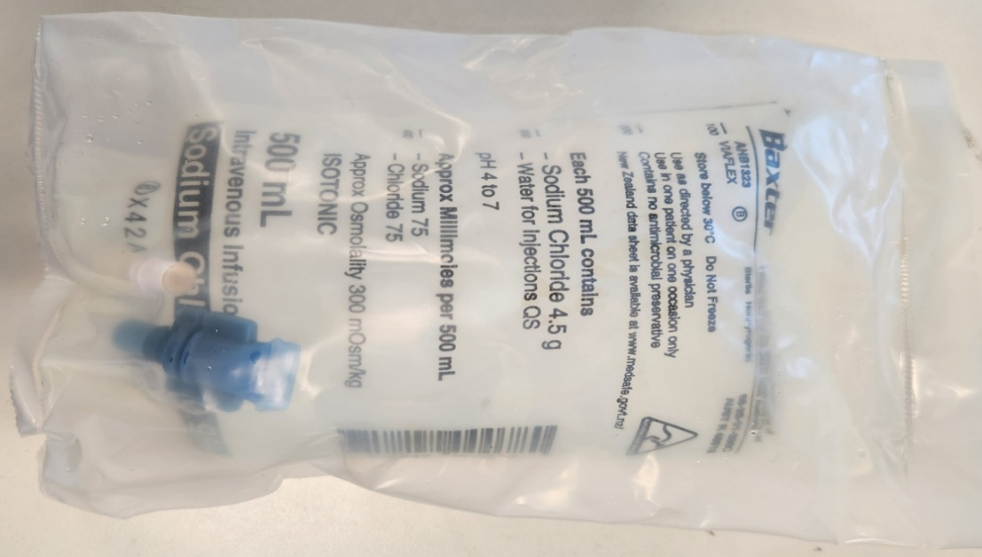

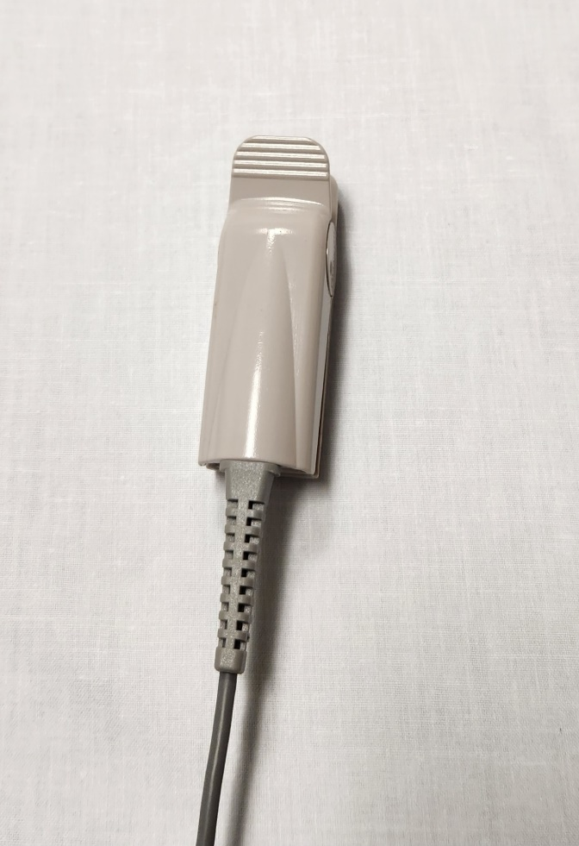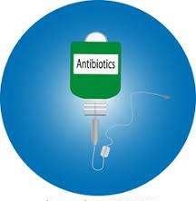 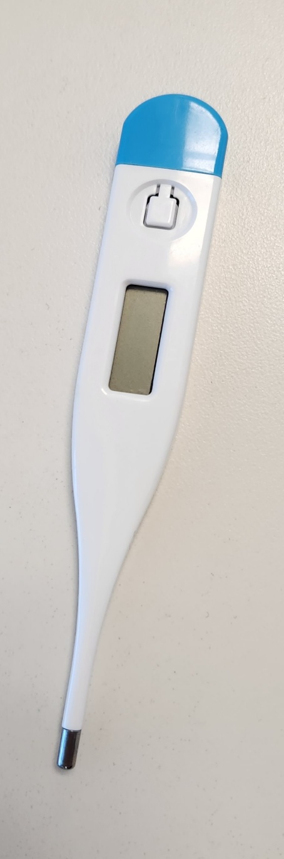

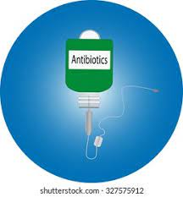

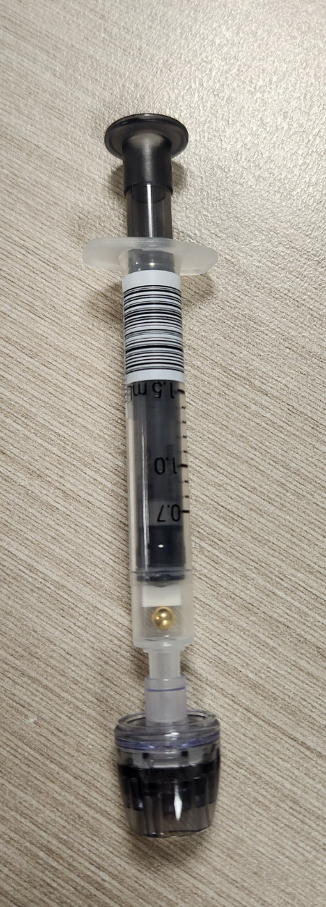 

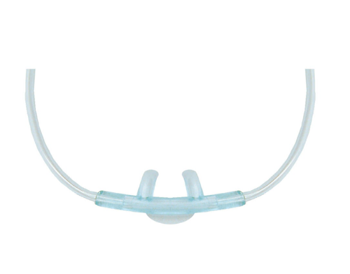

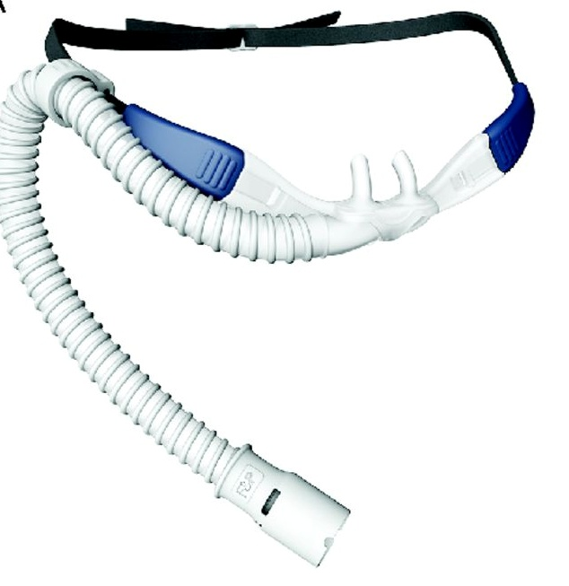

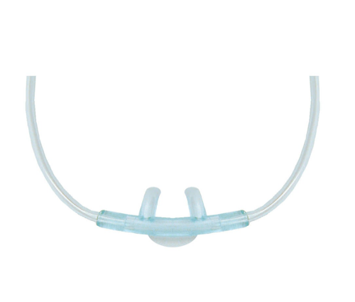

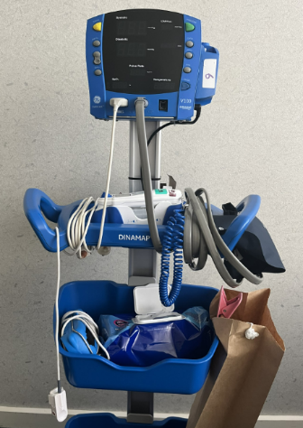

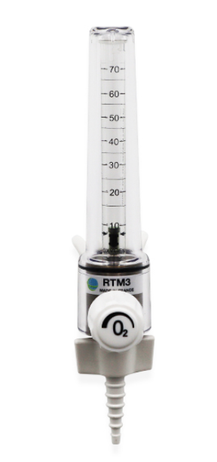

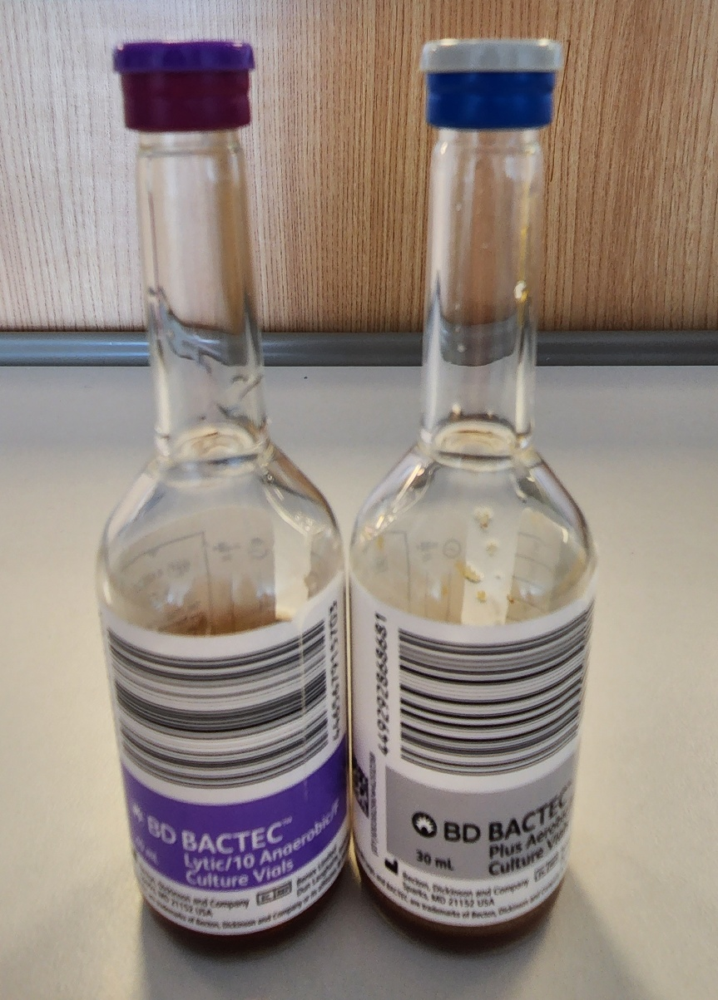

**Pathology**

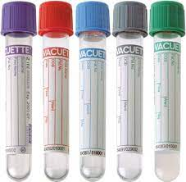

# An afraid faceFaces VEMS















