

Raise the Flag: Sepsis quality improvement: Clinical governance for sepsis

Hikitia te Haki: Kia kounga te whakapai mate whakataoke: Whakahaere rongoā

September 2025

Published in September 2025 by Health Quality & Safety Commission Te Tāhū Hauora,   
PO Box 25496, Wellington, 6146.

ISBN 978-1-991122-35-3 (online)

Available online at [www.hqsc.govt.nz](http://www.hqsc.govt.nz)

Enquiries to: [info@hqsc.govt.nz](mailto:info@hqsc.govt.nz)

This work is licensed under the Creative Commons AttributionNonCommercial-ShareAlike 4.0 International   
(CC BY-NC-SA 4.0). To view a copy of this licence, visit <https://creativecommons.org/licenses/by-nc-sa/4.0>



**Contents | Ngā ihirangi**

Purpose | Te whāinga 4

Introduction | He kupu whakataki 4

Governance structure for sepsis | Hanganga whakahaere 4

Governance functions for sepsis | Āheinga whakahaere 5

A framework for clinical governance | He anga whakahaere rongoā 7

Conclusion He kupu whakakapi 8

Purpose | Te whāinga

This document provides guidance on clinical governance for sepsis, with the goal of supporting early recognition, timely treatment and consistent care across all clinical settings. It offers information to support the effective implementation and long-term sustainability of the national sepsis package. It includes a summary of the clinical governance framework to assist health care professionals in delivering and embedding the national sepsis pathway.

Introduction | He kupu whakataki

The Sepsis Quality Improvement Programme Scoping Summary,[1] published by Health Quality & Safety Commission Te Tāhū Hauora (the Commission), identified significant variation in the effectiveness of governance for sepsis across public hospitals. It highlighted gaps in leadership and oversight, noting that the weakening of governance structures over time has contributed to reduced focus on sepsis and compromised the sustainability of improvements.

Clinical governance plays a pivotal role in the successful implementation and long-term sustainability of sepsis quality improvement initiatives. It provides the necessary oversight, accountability and strategic alignment to ensure that improvement efforts are integrated into routine clinical practice. Governance structures help to define clear leadership, roles and responsibilities, enabling effective decision-making and resource allocation. A strong governance framework fosters a culture of safety, learning and collaboration, which is critical for maintaining momentum and embedding sustained improvements in sepsis care over time.

Governance structure for sepsis | Hanganga whakahaere

A robust clinical governance structure is essential to ensuring safe, timely and effective care for patients with sepsis. This structure should include clearly defined leadership, with a designated clinical lead responsible for overseeing sepsis management and improvement initiatives.

Where existing clinical governance structures are in place, such as committees for patient deterioration, infection prevention and control, infectious diseases or quality and patient safety, these should be leveraged to support the implementation and oversight of the sepsis package.

Alternatively, a dedicated clinical governance group for sepsis can be established to provide leadership, coordination and accountability for the implementation and long-term sustainability of sepsis-related improvements.

Governance functions for sepsis | Āheinga whakahaere

Governance functions for sepsis ensure that clinical practices are aligned with national guidelines, improvement efforts are coordinated, and patient outcomes are prioritised, as follows.

1. **Strategic oversight and leadership:** Leadership provides strategic direction for sepsis‑related initiatives across the organisation.

Key focus areas:

Name a sepsis clinical lead at service and/or organisational level.

Establish clear executive and clinical leadership for sepsis improvement initiatives.

Align sepsis work with organisational clinical governance quality improvement priorities.

Ensure leadership accountability for implementation, monitoring and outcomes of the sepsis programme.

Champion sepsis improvement across departments and disciplines to drive engagement and ownership.

Allocate appropriate resources (time, staffing and funding) to support programme delivery and sustainability.

Foster a culture of continuous learning, safety and quality improvement across the organisation.

2. **Standardisation of clinical standards, protocols and tools:** A governance group ensures that care is consistent, evidence-based and aligned with national best practice across all settings. The group ensures the use of standardised tools that support timely sepsis recognition and management.

Key focus areas:

Review and approve modifications to clinical pathways, protocols and escalation plans.

Facilitate the use of the sepsis pathway and best practice across all clinical areas.

Promote standardised documentation and communication practices.

Promote consistency across clinical areas by standardising tools (eg, the sepsis pathway) to reduce variation in care delivery.

Promote and support implementation of the sepsis package.

Endorse evidence-based protocols and pathways for sepsis recognition, escalation and treatment to ensure they are clinically sound and widely accepted.

Ensure alignment with national guidance such as the Commission’s sepsis package and clinical frameworks.

Oversee clinical review and approval processes to adapt tools to local contexts while maintaining core clinical standards.

3. **Training and capability building:** Education and training are critical components of effective sepsis management. Ensuring that all health care professionals (clinical and non-clinical) are equipped with the knowledge and skills to recognise and respond to sepsis promptly is essential for improving outcomes.

Key focus areas:

Prioritise sepsis education as a critical safety and quality initiative within each organisation.

Set expectations and standards in terms of training content, frequency and target audiences (eg, nursing, medical, allied health and administrative) staff.

Monitor the uptake and outcomes of education through audit, feedback and clinical performance indicators.

Ensure consistency of training across departments and clinical areas, so all staff are equipped to recognise and manage sepsis effectively.

Support continuous learning by embedding sepsis-related education into onboarding, clinical credentialing and professional development.

Promote shared learning through multidisciplinary forums, clinical huddles and debrief sessions after sepsis-related incidents.

4. **Accountability:** The wider clinical governance structure must entail clear accountability, escalation and reporting processes.

Key focus areas:

Report regularly to the clinical governance board or equivalent leadership group.

Escalate risks or system failures identified through data or case review.

Maintain a record of decisions, actions and progress updates.

Ensure representation from relevant specialties and services.

5. **Data collection, monitoring and reporting:** The role of a sepsis governance group in data collection and reporting is central to driving quality improvement, ensuring accountability and tracking the effectiveness of sepsis care interventions across an organisation.

Key focus areas:

Establish clear data requirements: Define which data should be collected (eg, time to recognition, time to antibiotics, escalation rates, mortality, readmissions) to monitor sepsis care performance.

Oversee data quality and consistency: Ensure that data collection methods are reliable, standardised across services and aligned with national definitions and indicators.

Monitor performance and outcomes: Regularly review sepsis-related metrics to assess compliance with the sepsis pathway and identify trends, gaps or areas needing improvement.

Report to relevant stakeholders: Share performance data with clinical teams, senior leadership and external partners to drive transparency and inform decision-making.

Support national reporting requirements: Align with the expectations of agencies like the Commission by contributing to national data sets or quality improvement programmes.

Build a culture of learning: Encourage teams to use data not as a compliance tool but as a means to reflect, learn and innovate.

A framework for clinical governance | He anga whakahaere rongoā

‘Collaborating for quality: a framework for clinical governance' (Figure 1) sets out a high-level framework for clinical governance in health and disability services in Aotearoa New Zealand.

When used alongside the sepsis-specific guidance above, this framework can support hospitals in establishing effective clinical governance arrangements for sepsis care. Teams should use the framework to develop their own clinical governance arrangements, adapted to their context, to improve the quality and safety of care.

This framework includes four quality domains and four system drivers. The domains and drivers are interconnected. Together, they support a whole-of-system approach to clinical governance.

Figure 1: Clinical governance framework

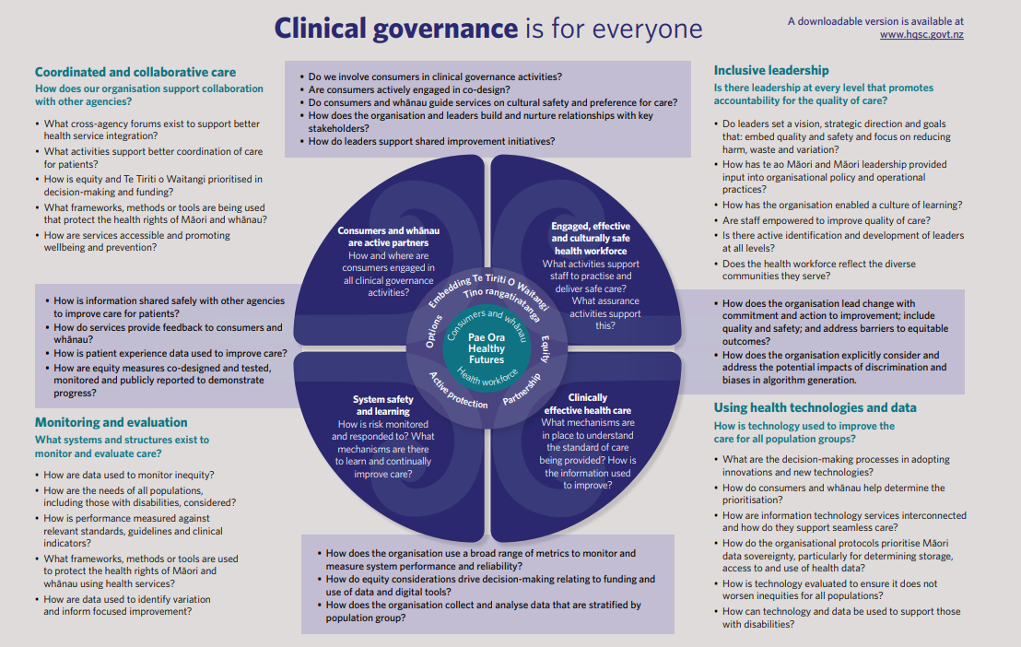

Further information and templates

[Collaborating for quality: a framework for clinical governance – hqsc.govt.nz](https://www.hqsc.govt.nz/resources/resource-library/collaborating-for-quality-a-framework-for-clinical-governance/)

Conclusion He kupu whakakapi

Establishing robust clinical governance for sepsis is essential to improving patient outcomes, reducing preventable harm and ensuring the sustainability of sepsis improvement initiatives. By providing clear leadership, accountability and a structured approach to quality and safety, clinical governance enables health services to deliver timely, coordinated and evidence-based care for people with sepsis. Ongoing collaboration, monitoring and commitment to continuous improvement will be key to embedding best practice into routine clinical care for sepsis across New Zealand.

1. *Sepsis quality improvement programme scoping summary*. August 2024. Health Quality & Safety Commission Te Tāhū Hauora.