

Raise the Flag: National Sepsis Pathway User Guide

Hikitia te Haki: He Ara ā-Motu hei Whakamahi Aratohu

September 2025

Published September by Health Quality & Safety Commission Te Tāhū Hauora,   
PO Box 25496, Wellington, 6146.

ISBN 978-1-991122-36-0

Available online at [www.hqsc.govt.nz](http://www.hqsc.govt.nz)

Enquiries to: [info@hqsc.govt.nz](mailto:info@hqsc.govt.nz)

This work is licensed under the Creative Commons AttributionNonCommercial-ShareAlike 4.0 International   
(CC BY-NC-SA 4.0). To view a copy of this licence, visit <https://creativecommons.org/licenses/by-nc-sa/4.0>



Contents | Ngā ihirangi

Acknowledgements | He whakamihi 4

Commitment to Te Tiriti o Waitangi and health equity │ Ū ki Te Tiriti me te hauora tautika 5

Purpose | Te whāinga 6

Introduction | He kupu whakataki 6

Overview of the sepsis pathway | He tiro whānui 6

Sections of the pathway (all patient cohorts) | Ngā wāhanga o te ara 7

Who should use this pathway 7

When to use this pathway 7

Pathway for various patient cohorts 8

Patient details and filing of pathway 8

Risk factors for sepsis 8

Initial screening for sepsis 9

Screening for RED FLAG sepsis 10

Screening for AMBER FLAG sepsis 10

Treatment/interventions for AMBER FLAG sepsis 10

Sepsis Six (sepsis resuscitation) 10

Reassess 12

Paediatric-specific pathway information | He mōhiohio ā-arotamariki 12

Additional information to assess severity of risk 12

Additional notes/instruction 13

Maternity-specific pathway information | He mōhiohio ā-ōmahu 13

Sepsis Six plus 2 13

Logos and printing the pathway | Ngā tohu hei tā i te ara 14

Acknowledgements | He whakamihi

Health Quality & Safety Commission Te Tāhū Hauora (the Commission) acknowledges the significant work of everyone who has been involved in the development of the sepsis package. In particular, the sepsis project team would like to thank the following:

Sepsis Trust NZ

National Sepsis Technical Advisory Group (STAG)

Members of the Commission’s STAG have been major contributors to the development of the national sepsis pathway and this Guide. This group was established in September 2024 and includes representatives from the following professional groups:

* Ambulance Services (Hato Hone St John and Wellington Free Ambulance)
* Australasian Society for Infectious Diseases
* Australian and New Zealand College of Anaesthetists
* Australian and New Zealand Intensive Care Society
* Australian College for Emergency Medicine
* Health New Zealand Te Whatu Ora
* New Zealand Antimicrobial Stewardship & Infection Pharmacist Expert Group
* New Zealand College of Critical Care Nurses
* New Zealand College of Medicine
* New Zealand College of Midwives
* New Zealand Microbiology Network
* New Zealand Nurses Organisation
* Paediatric Society of New Zealand
* Royal Australasian College of Surgeons
* Royal Australian and New Zealand College of Obstetricians and Gynaecologists
* Royal New Zealand College of General Practitioners
* Royal New Zealand College of Urgent Care
* Sepsis Trust New Zealand.

Commitment to Te Tiriti o Waitangi and health equity │ Ū ki Te Tiriti me te hauora tautika

The sepsis project team is committed to developing and implementing the sepsis project in a manner that enables equitable outcomes for Māori. The team incorporated Te Tiriti o Waitangi principles throughout the project.

The team applied an equity lens to various areas of the project by:

* having a Māori advisor in the project team, who consulted with other Māori elders when necessary
* using an ethnicity or demographic lens for data collection and review
* incorporating the lived experience of sepsis consumers and their whānau
* advising hospital project teams to collaborate with Māori and Pacific representatives, ensuring Te Tiriti principles are embedded and encouraging their involvement in relevant aspects of implementation.

Purpose | Te whāinga

This user guide will help health care professionals implementing the national sepsis pathway to improve their early recognition and timely treatment of sepsis within Aotearoa New Zealand hospitals. It explains how to complete and use the national sepsis pathway across a range of clinical settings.

Introduction | He kupu whakataki

In 2018, Sepsis Trust New Zealand developed a set of screening and action tools for sepsis. In 2025, through the ‘Raise the Flag’ sepsis quality improvement initiative, Health Quality & Safety Commission Te Tāhū Hauora (the Commission) refined those tools, incorporating sector feedback and current best-practice evidence to create a national sepsis pathway for New Zealand.

The pathway will support early screening, clinical decision-making and timely intervention to reduce mortality and morbidity in patients suspected of having sepsis. This pathway will facilitate a standardised approach to sepsis recognition and treatment.

The pathway is designed for use in acute clinical settings, and there are versions that apply to adult, maternity and paediatric populations, with modifications to reflect physiological differences and clinical risk profiles. The pathway supports early recognition of signs and symptoms, escalation to a senior clinician and the rapid initiation of treatment.

The Commission intends that the pathway will support clinical decision-making and not replace clinical judgement. For clinical information related to this pathway, refer to the [sepsis clinical guide*.*](https://www.hqsc.govt.nz/assets/Our-work/Improved-service-delivery/Sepsis/Clinical-guide-sepsis-management_Sept-2025.docx?vid=3)

You can find information about the national sepsis initiative on the Commission’s [website](https://www.hqsc.govt.nz/our-work/improved-service-delivery/sepsis/).

Overview of the sepsis pathway | He tiro whānui

This section provides a brief overview of the pathway. The following section gives more detailed guidance on each section of the pathway, and the next two sections, ‘Paediatric-specific pathway information’ and ‘Maternity-specific pathway information’ give patient cohort-specific information.

The national sepsis pathway is a two-sided document, printed front and back. Figure 1 illustrates the main areas of both sides. These two sides respectively provide information on:

screening/recognition: screening patients for sepsis and identifying the level of risk

‘Sepsis Six’ treatment: treating patients identified as having a high-risk of sepsis.

The two-page layout below is consistent across patient groups.

Figure 1: Sepsis pathway layout

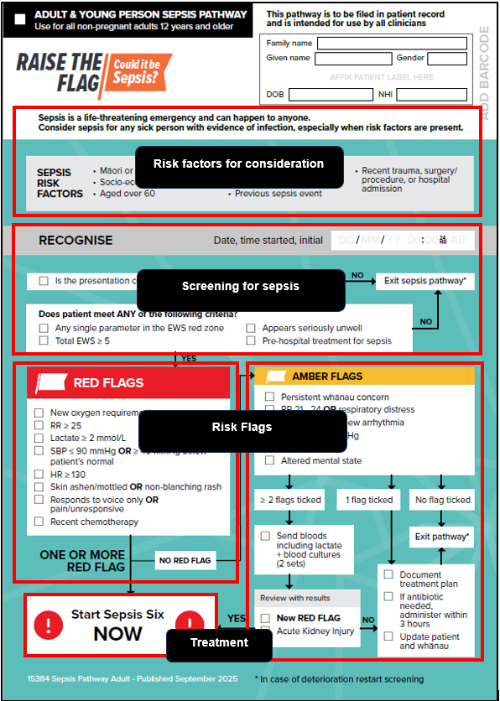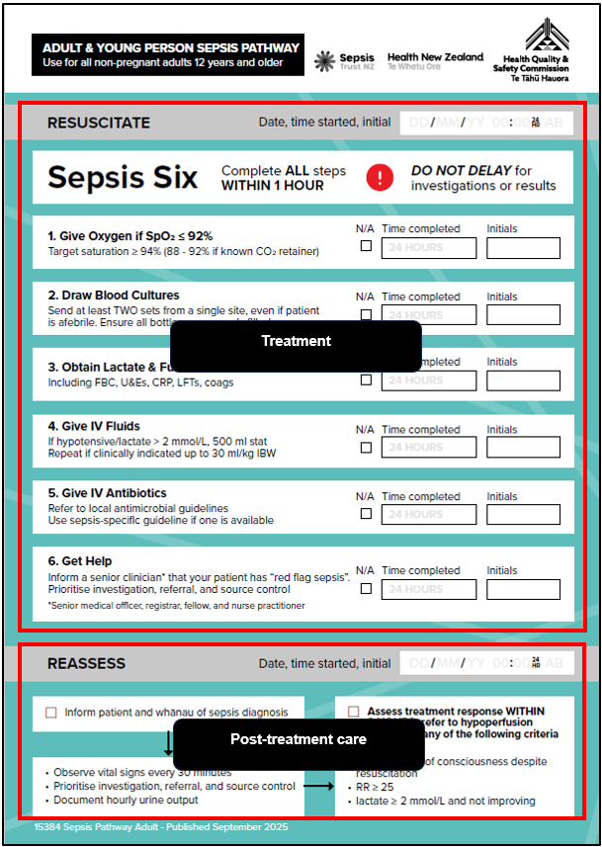

|  |  |
| --- | --- |
| Page one | Page two |

Sections of the pathway (all patient cohorts) | Ngā wāhanga o te ara

This section outlines the components of the pathway and provides general information on it, applicable to all patient cohorts. For cohort-specific guidance, see the following sections.

Who should use this pathway

Health professionals caring for patients who present to hospitals should use this pathway. It is applicable across a range of health care settings, including emergency departments, inpatient wards and other acute care environments.

When to use this pathway

Screen a patient for sepsis using this pathway when:

a patient looks unwell and infection is confirmed or suspected

a patient has previously exited the pathway and subsequently deteriorates. In this case, restart the screening process and reassess for RED and AMBER FLAGS.

Pathway for various patient cohorts

The national sepsis pathway applies to three specific patient groups, coded by colour within the pathway as follows.

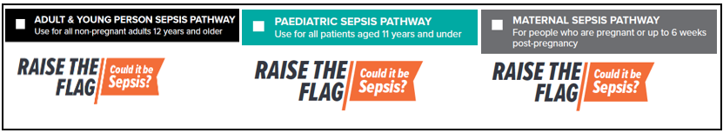

The pathways are applicable as follows.

**Adult pathway:** Use this pathway for any patient who is not pregnant and 12 years or older.

**Paediatric pathway:** Use this pathway for children aged from 29 days to under 12 years. Vital sign parameters are aligned with age-appropriate ranges.

**Maternity pathway**: Use this pathway for pregnant or postpartum patients up to six weeks post-delivery. The pathway gives special consideration to physiological changes in pregnancy.

Before using the pathway, review the patient’s age, select the appropriate pathway and tick the box next to the corresponding patient cohort.

Note: age groupings for the sepsis pathway are intentionally different from age groupings for national vital sign charts.

Patient details and filing of pathway

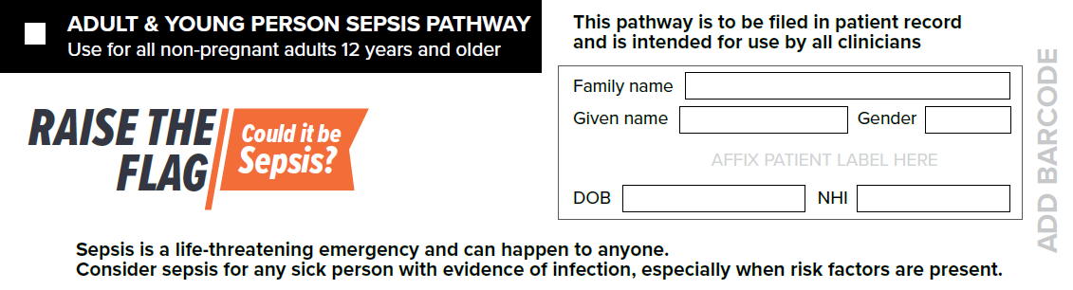

Affix the patient label in the patient detail space and file the pathway in the clinical notes.

Risk factors for sepsis

Health care professionals should be aware of key factors that increase a patient’s risk of developing sepsis. This section outlines common risk factors; though not exhaustive, it highlights high-risk groups such as older adults, immunocompromised people, people who have recently had surgery or have invasive devices, and patients with chronic health conditions.

When one or more sepsis risk factors are present, maintain a high level of clinical suspicion, even if signs and symptoms are minimal or unclear.

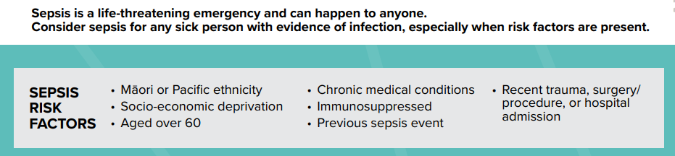

Initial screening for sepsis

Screening for sepsis is a crucial first step in identifying patients at risk of deterioration due to infection. The ‘Recognise’ section of the sepsis pathway will help you to complete the initial screening process. The screening criteria are tailored to each patient cohort, but the overall process remains consistent.

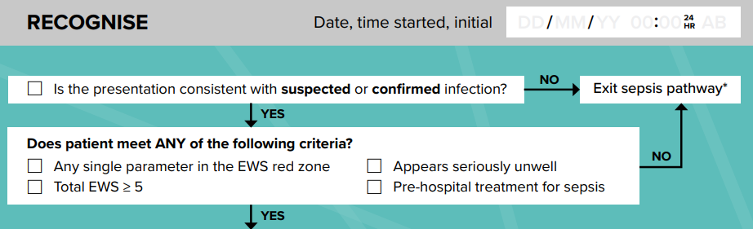

Use this section as follows.

Record the date, initials and time (in 24-hour format) screening started.

A checkbox (□) is provided in front of each step. Tick all options that are applicable for the patient.

If there are signs of suspected or confirmed infection, proceed to the next screening question; otherwise, exit the pathway and file it in the patient record.

At this point, the patient should continue to receive standard clinical care and monitoring in accordance with local protocols.

‘Suspected or confirmed infection’ refers to a clinical judgement that infection is likely, based on history, symptoms or early test results, even if this has not yet been confirmed by microbiology.

Tick ‘Appears seriously unwell’ if the patient has an altered mental status, hypotension, rapid breathing, mottled skin or signs of hypoperfusion.

‘Pre-hospital treatment for sepsis’ includes any antibiotic, IV fluids or oxygen provided in urgent care, an ambulance or interhospital transfer.

If the patient meets any of the criteria, assess the patient for RED FLAG sepsis.

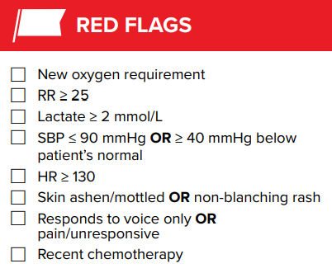Screening for RED FLAG sepsis

The red flags listed in the ‘RED FLAGS’ section on the sepsis pathway signal a high likelihood of life-threatening organ dysfunction requiring immediate action. Use this section as follows.

If the patient meets any of the RED FLAG criteria, tick the appropriate checkboxes.

If you have identified one or more RED FLAGS, initiate Sepsis Six (sepsis resuscitation) immediately.

If you have identified no RED FLAGS, assess the patient for AMBER FLAGS.

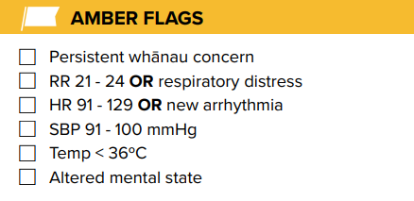Screening for AMBER FLAG sepsis

The presence of one or more AMBER FLAGS may indicate a moderate to high risk of deterioration requiring prompt clinical review.

If you have identified no RED FLAGS, assess the patient for AMBER FLAGS. Tick all checkboxes that are appliable.

Treatment/interventions for AMBER FLAG sepsis

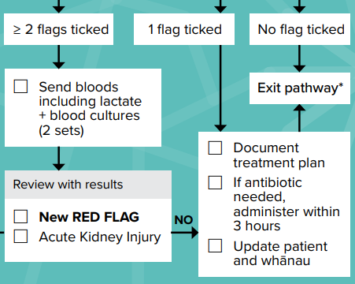Use this section as follows.

Where you have identified AMBER FLAGS, proceed with recommended treatment plan.

If you identified no flags, stop the pathway; record the date, time and your initials and file the pathway in the patient record.

If you have identified two or more AMBER FLAGS, initiate appropriate investigations (eg, blood tests, cultures), maintain fluid balance, and escalate to a senior clinician if concerns persist.

Where, during this process, you identify new RED FLAGS or acute kidney injury, initiate Sepsis Six (sepsis resuscitation) immediately.

Sepsis Six (sepsis resuscitation)

The Sepsis Six is a bundle of time-critical interventions designed to reduce mortality and serious health complications due to sepsis by ensuring early, structured intervention. Use the Sepsis Six as follows.

Record the date, time and your initials at the top of the pathway when you initiate resuscitation treatment. This provides a clear clinical timeline, supports timely escalation and communication and enables retrospective review and quality improvement.

Deliver all applicable interventions within one hour from the time you identified one or more RED FLAGs.

Not all interventions provided under Sepsis Six will be applicable for some patients. In such cases, tick ‘N/A’.

For each intervention, record the time (in 24-hour format) and your initials in the provided space.

Although the interventions are numbered, they are not intended to be carried out in a specific order.

The list of senior clinicians in the ‘Get Help’ section is a guide only. Follow your local escalation protocols. We strongly recommend you use the phrase ‘Patient has RED FLAG sepsis’ to prompt urgent response.

Use a sepsis-specific antibiotic guideline if available or follow national or local antimicrobial guidelines.

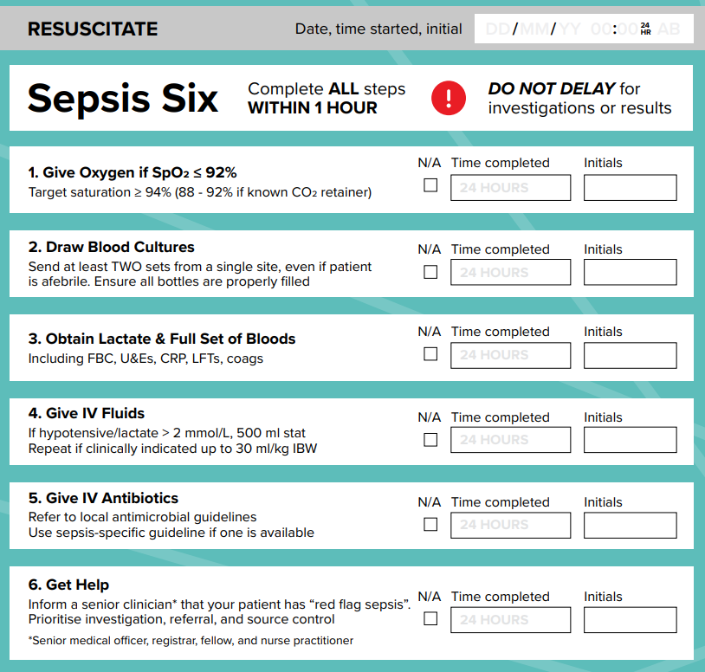

Reassess

Reassessment is a critical component of the sepsis pathway. It ensures that any deterioration is promptly addressed. This section provides guidance on the steps you should consider after delivering Sepsis Six. Use the reassessment section as follows.

Once you have provided the appropriate sepsis resuscitation/interventions, reassess the patient.

Record the date, time and your initials. Tick the checkboxes for the listed tasks.

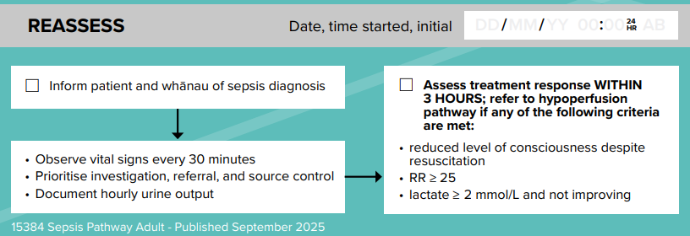

Paediatric-specific pathway information | He mōhiohio ā-arotamariki

All sections of the paediatric pathway align with those of the other pathways; the pathway also lists additional considerations applicable to paediatric patients.

Additional information to assess severity of risk

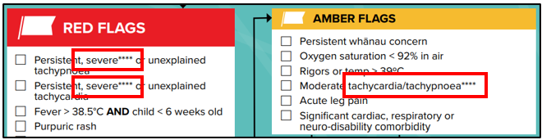

To assess the severity of a vital sign, refer to Paediatric Vital Signs Chart. PEWS parameters in the red or blue zones for RED FLAGS, and in the orange zone for AMBER FLAGS, in the age-appropriate PEWS Vital Signs Chart. Find the instructions for this at the end of page one of the pathway (also shown below).

Additional notes/instruction

The pathway provides additional instructions at the bottom of page one.

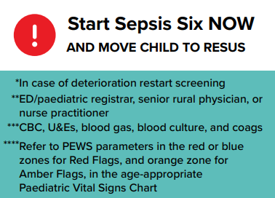

Maternity-specific pathway information | He mōhiohio ā-ōmahu

All sections of the maternal pathway align with those of the other pathways; the pathway also lists additional considerations applicable to maternity patients.

Early recognition and obstetric consultation are required to facilitate preparation for preterm birth and optimizing neonatal survival. <https://bestpracticeguide.carosikacollaborative.co.nz/docs/CHAPTER_Preparing_for_preterm_birth_when_it_is_anticipated_or_planned/preparing-for-preterm-birth-when-it-is-anticipated-or-planned/>

Sepsis Six plus 2

The resuscitation/Sepsis Six section of the maternal sepsis pathway includes two additional interventions. These appear in the ‘Reassess’ section of the pathway, but they must be delivered as part of the initial bundle within one hour of identifying RED FLAG sepsis.

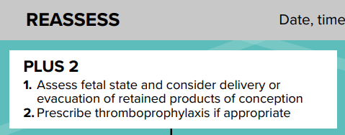

Logos and printing the pathway | Ngā tohu hei tā i te ara

When you print the pathway, we recommend the following specifications:

Use size A4 paper.

Print in portrait orientation, colour and double-sided.

Hole punches: punch two holes on the left-hand side.

No print offset is required

Use a minimum paper quality of 100gsm.

You may consider adding a black and white version of your organisational logo to the top left of the pathway, next to the ‘Raise the Flag’ logo. We do not recommend coloured logos, as they add visual clutter and detract from the main purpose of the tool.

