Healthcare-associated Staphylococcus aureus bacteraemia: Te Whatu Ora – Health New Zealand districts | Te tauwhiro hauora e hāngai ana ki te huakita ā-toto Staphylococcus aureus: Te Whatu Ora – rohe Hauora o Aotearoa

1 July 2022 to 30 June 2023

Contents | Ngā ihirangi
Executive summary | He kupu whakarāpopoto 3
Consumer stories | He kōrero nā te hunga kiritaki 4
Introduction | He kupu whakataki 5
Discussion | He kōrerorero 5
Conclusion | He kupu whakatepe 11

List of figures | Rārangi tātai
Figure 1: Median rate of HA-SAB per 1,000 bed-days, Aotearoa New Zealand,
January 2012–June 2023 5
Figure 2: Rate of HA-SAB per 1,000 bed-days by age, Aotearoa New Zealand,
1 July 2022–30 June 2023 7
Figure 3: Rate of HA-SAB per 100,000 people, age-standardised ethnicity,
Aotearoa New Zealand, 1 July 2022–30 June 2023 8
Figure 4: Rate of HA-SAB per 100,000 people, age-standardised ethnicity,
by CVC and PIVC source, Aotearoa New Zealand, 1 July 2022–30 June 2023 9
Figure 5: Rate of HA-SAB per 1,000 bed-days by vascular device,
Aotearoa New Zealand, 1 July 2022–30 June 2023 10

List of tables | Rārangi tūtohu
Table 1: Rate of HA-SAB per 1,000 bed-days by district, Aotearoa New Zealand,
1 July 2022–30 June 2023 6
Table 2: Percent of HA-SAB by ethnicity, Aotearoa New Zealand,
1 July 2022–30 June 2023 7
Table 3: Percent of HA-SAB by source, Aotearoa New Zealand,
1 July 2022–30 June 2023 9
Published in November 2023 by Te Tāhū Hauora Health Quality & Safety Commission,
PO Box 25496, Te Whanganui-a-Tara Wellington, 6146.
ISBN (online) 978-1-991122-07-0
Document available online at www.hqsc.govt.nz
Enquiries to info@hqsc.govt.nz
This work is licensed under the Creative Commons AttributionNonCommercial-ShareAlike 4.0 International
(CC BY-NC-SA 4.0). To view a copy of this licence, visit https://creativecommons.org/licenses/by-nc-sa/4.0

Executive summary | He kupu whakarāpopoto
Continuous ongoing surveillance of healthcare-associated Staphylococcus aureus bacteraemia (HA-SAB) is an important quality activity that make care safer and guides strategies to improve clinical practice.
Many HA-SAB events are preventable, especially those relating to intravascular devices, which are a major contributor of HA-SAB events.
Since 2012, the median rate of HA-SAB for all districts across Aotearoa New Zealand has increased from 0.11 to 0.15 events per 1,000 bed-days.
Since 1 July 2022, public hospitals have taken part in HA-SAB source surveillance and submitted data each quarter to Te Tāhū Hauora Health Quality & Safety Commission
using a standardised collection form.
This report summarises results from the first 12 months of this surveillance across all districts of Te Whatu Ora – Health New Zealand, from 1 July 2022 to 30 June 2023. Data was extracted on 14 August 2023.
The key findings are as follows.
- There were 471 HA-SAB events in total, which amounts to 1–2 events occurring each day within district hospitals. The absolute number per district ranged from 0 to 98.
- Of those patients with HA-SAB, 63.5 percent were European or other, 19.5 percent were Māori, 11.3 percent were Pacific peoples and 5.7 percent were Asian.
- Methicillin-susceptible S. aureus accounted for 87.3 percent of cases and methicillin-resistant S. aureus (MRSA) accounted for 12.7 percent of cases. MRSA is more common in the North Island.
- Medical devices were the source for just under three-quarters (71.1 percent) of all
HA-SAB events, followed by organ source (not surgical site infection (SSI) at
13.2 percent and SSI at 8.5 percent).
- All ethnic group data was age standardised using Census data to have identical age structures. This showed the highest expected HA-SAB rate was for Pacific peoples followed by Māori. Likewise, applying the same approach for HA-SAB related to central vascular catheter or peripheral intravascular catheter use, the highest expected HA-SAB rate was also for Pacific peoples followed by Māori.

Consumer stories | He kōrero nā te hunga kiritaki
To highlight the significant impact healthcare-associated infections can have on patients and their whānau, the infection prevention and control team at Te Tāhū Hauora Health Quality & Safety Commission interviewed three consumers about their experiences. The stories are available here.

Introduction | He kupu whakataki
Healthcare-associated Staphylococcus aureus bacteraemia (HA-SAB) causes significant mortality and morbidity in patients but many cases are preventable.
Continuous ongoing surveillance is an important quality activity that helps to make care safer and guides strategies to improve clinical practice.
The HA-SAB rate per 1,000 bed-days is an outcome measure for the Hand Hygiene
New Zealand programme as part of the national quality and safety marker reports.
In 2021, Te Tāhū Hauora Health Quality & Safety Commission (Te Tāhū Hauora) used data from 2017–21 provided by the then-district health boards to investigate the sources of
HA-SAB in Aotearoa New Zealand public hospitals. Invasive medical devices were the source for two-thirds (65 percent) of reported HA-SAB events, followed by surgical site infection (SSI) (10 percent) and organ site infection (8 percent), medical procedure
(7 percent), neutropaenic sepsis (4 percent) and pneumonia (2 percent).
Since 1 July 2022, public hospitals have taken part in HA-SAB source surveillance and submitted data to Te Tāhū Hauora each quarter using a standardised data collection form.
This report presents a summary of results for the first 12 months of HA-SAB source surveillance for the period 1 July 2022 to 30 June 2023 for all districts of Te Whatu Ora – Health New Zealand. Data was extracted on 14 August 2023.

Discussion | He kōrerorero

HA-SAB rate
Since 2012, the median rate for HA-SAB has increased from 0.11 to 0.15 events per 1,000 bed-days (Figure 1). This is despite notable improvements in hand hygiene compliance from 62 percent to 85 percent over the same period.
Figure 1: Median rate of HA-SAB per 1,000 bed-days, Aotearoa New Zealand,
January 2012–June 2023
HA-SAB = healthcare-associated Staphylococcus aureus.
Overall, there were 471 HA-SAB events, which amounts to 1–2 events occurring each day within district hospitals. The absolute number per district ranged from 0 to 98 (Table 1).
Table 1: Rate of HA-SAB per 1,000 bed-days by district, Aotearoa New Zealand,
1 July 2022–30 June 2023
District | Number of HA-SAB | Rate per 1,000 bed-days
Te Toka Tumai Auckland | 98 | 0.22
Hauora a Toi Bay of Plenty | 20 | 0.12
Waitaha Canterbury | 50 | 0.16
Capital, Coast and Hutt Valley | 43 | 0.14
Counties Manukau | 74 | 0.24
Tairāwhiti | 3 | 0.09
Te Matau a Māui Hawke's Bay | 4 | 0.03
Lakes | 10 | 0.13
Te Pae Hauora o Ruahine o Tararua MidCentral | 39 | 0.34
Nelson Marlborough | 10 | 0.12
Te Tai Tokerau | 16 | 0.12
South Canterbury | 7 | 0.19
Southern | 26 | 0.15
Taranaki | 3 | 0.04
Waikato | 46 | 0.14
Wairarapa | 5 | 0.21
Waitematā | 13 | 0.04
Te Tai o Poutini West Coast | 0 | 0.00
Whanganui | 4 | 0.09
HA-SAB = healthcare-associated Staphylococcus aureus.

HA-SAB antimicrobial susceptibility
Four hundred and eleven (87.3 percent) HA-SAB cases were methicillin-susceptible S. aureus and 60 (12.7 percent) were methicillin-resistant S. aureus (MRSA). MRSA is more common in the North Island.

HA-SAB by age, gender and ethnicity
Ages ranged from less than 1 years of age to greater than 80 years. The distribution of HA-SAB by age group was highest in the paediatric population for 1–4-year-olds and highest in the adult population for 20–24-year-olds, 40–44-year-olds and 65–69-year-olds. (Figure 2).
More than 60 percent of HA-SAB infections occurred in males.
Figure 2: Rate of HA-SAB per 1,000 bed-days by age, Aotearoa New Zealand,
1 July 2022–30 June 2023
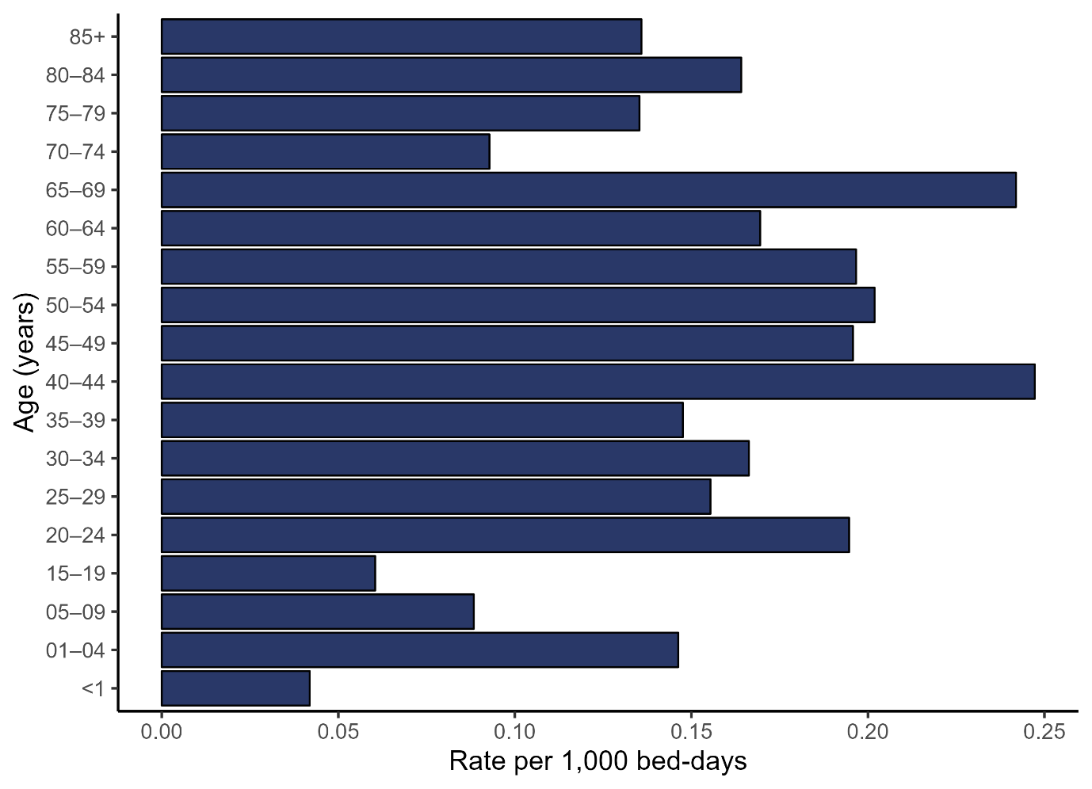
HA-SAB = healthcare-associated Staphylococcus aureus.
HA-SAB distribution by ethnic group was as follows: 299 (63.5 percent) were European or other, 92 (19.5 percent) were Māori, 53 (11.3 percent) were Pacific peoples and 27
(5.7 percent) were Asian (Table 2).
Table 2: Percent of HA-SAB by ethnicity, Aotearoa New Zealand,
1 July 2022–30 June 2023
Ethnicity | Percent of HA-SAB (number)
European/other | 63.5% (299)
Māori | 19.5% (92)
Pacific peoples | 11.3% (53)
Asian | 5.7% (27)
HA-SAB = healthcare-associated Staphylococcus aureus.
Age structures vary between ethnic groups in Aotearoa New Zealand, therefore, direct age standardisation is used to compare HA-SAB rates between Māori, Pacific, Asian and European and other ethnic groups. This adjusts the observed rates of HA-SAB within each group to the expected rate if all ethnic groups had identical age structures.
The highest expected HA-SAB rate was for Pacific peoples followed by Māori (Figure 3).
Using this same process for HA-SAB with a central vascular catheter (CVC) or peripheral intravascular catheter (PIVC) source, the highest expected rate was also for Pacific peoples followed by Māori (Figure 4).
Figure 3: Rate of HA-SAB per 100,000 people, age-standardised ethnicity,
Aotearoa New Zealand, 1 July 2022–30 June 2023
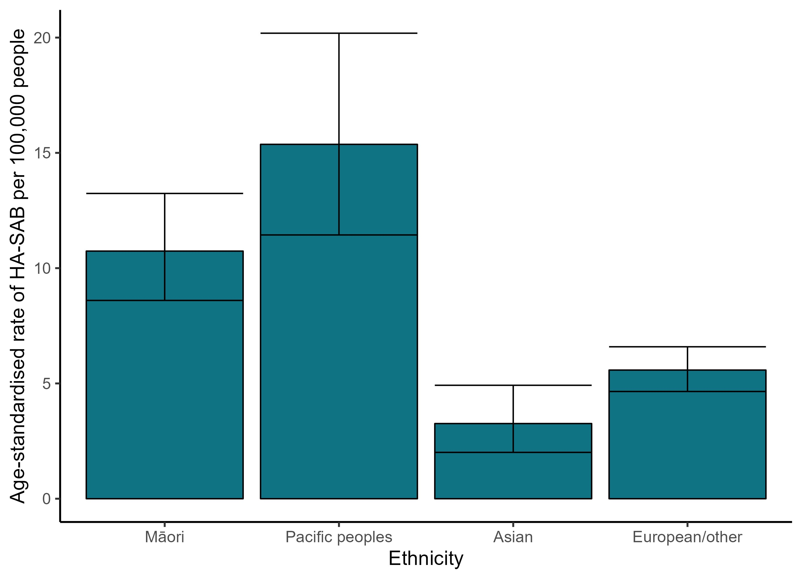
HA-SAB = healthcare-associated Staphylococcus aureus.

Figure 4: Rate of HA-SAB per 100,000 people, age-standardised ethnicity, by CVC and PIVC source, Aotearoa New Zealand, 1 July 2022–30 June 2023
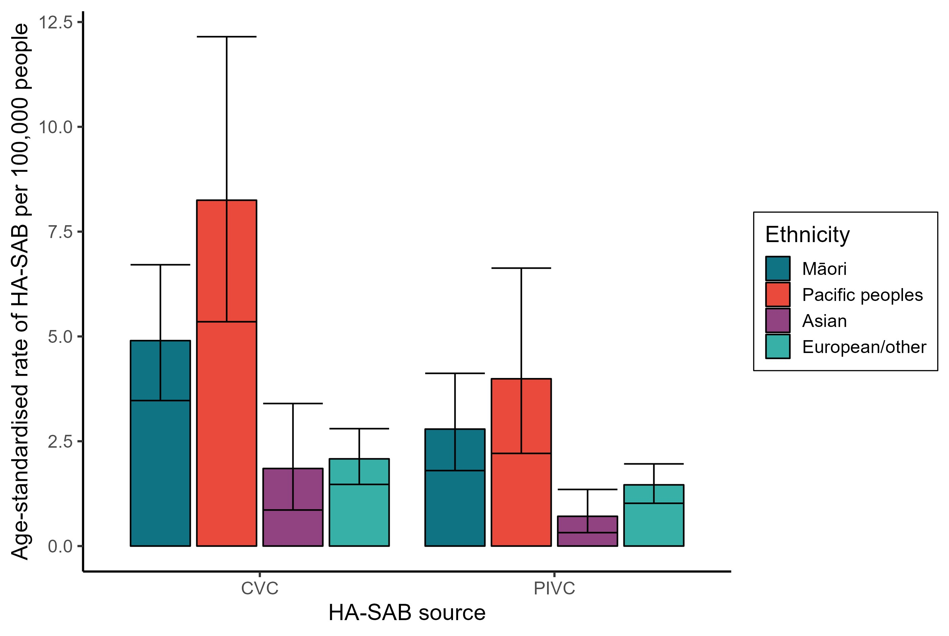
CVC = central vascular catheter; HA-SAB = healthcare-associated Staphylococcus aureus;
PIVC = peripheral intravascular catheter.

HA-SAB sources
The sources of HA-SAB are listed in Table 3.
Table 3: Percent of HA-SAB by source, Aotearoa New Zealand, 1 July 2022–
30 June 2023
Source | Percent of HA-SAB (number)
Device | 71.1% (335)
Organ source (not surgical site infection) | 13.2% (62)
Surgical site infection | 8.5% (40)
Unknown | 4.2% (20)
Neutropaenic sepsis | 1.3% (6)
Other procedure or intervention | 1.1% (5)
Other source | 0.6% (3)
HA-SAB = healthcare-associated Staphylococcus aureus.

Invasive medical devices
Of the 335 cases of HA-SAB caused by invasive medical devices, 162 (48.4 percent) were associated with a PIVC, 147 (43.9 percent) with a CVC, 13 (3.9 percent) with a urethral catheter, 7 (2.1 percent) with other devices, 3 (0.9 percent) with an endotracheal tube,
1 (0.3 percent) with a suprapubic catheter, 1 (0.3 percent) with a peritoneal dialysis catheter and 1 (0.3 percent) with a percutaneous endoscopic gastrostomy tube.
CVC-related HA-SAB accounted for 147 HA-SAB events and over one-third,
49 (38.1 percent) occurred in patients cared for by renal services.
PIVC-related HA-SAB accounted for 162 HA-SAB events and over half, 94 (58 percent), occurred in patients under the care of general medical or medical specialty services, with a further quarter (25.9 percent) occurring in patients under the care of surgical services.
The rate of HA-SAB attributed to invasive medical devices increased over the year due to increased rates for both PIVC- and CVC-related HA-SAB (Figure 5).
Figure 5: Rate of HA-SAB per 1,000 bed-days by vascular device,
Aotearoa New Zealand, 1 July 2022–30 June 2023
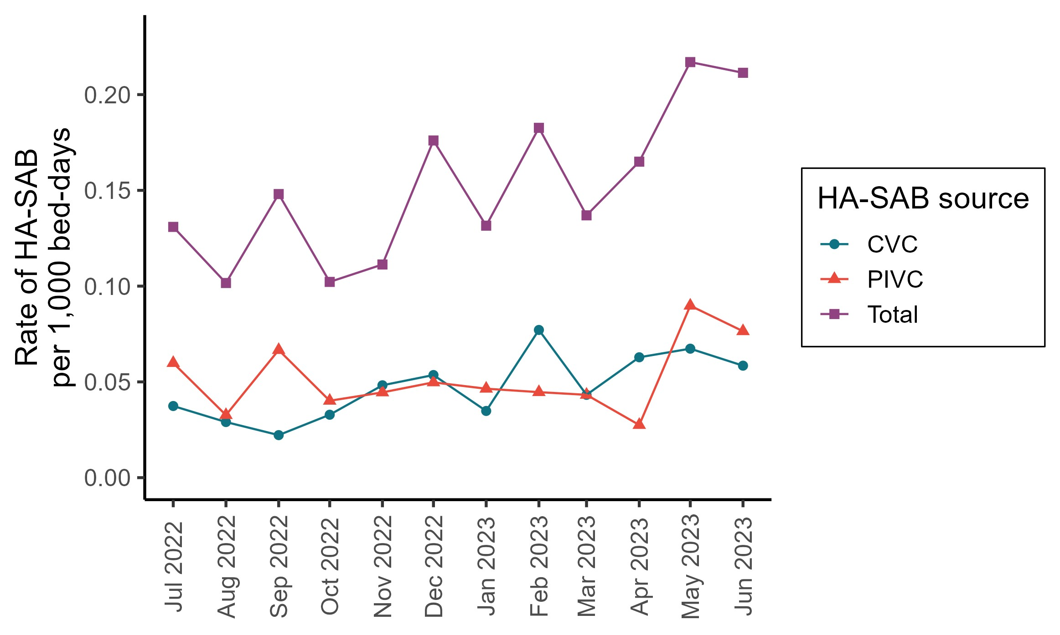
CVC = central vascular catheter; HA-SAB = healthcare-associated Staphylococcus aureus;
PIVC = peripheral intravascular catheter.

Organ source (not SSI)
Organ sites accounted for 62 (13.2 percent) of all HA-SAB infections with the majority being skin and soft tissue infections (56.5 percent), followed by pulmonary (25.8 percent), other organ source (9.7 percent), urinary tract (4.8 percent), hepatobiliary (1.6 percent) and cardiac (1.6 percent).

SSIs
There were 40 (8.5 percent) SSIs, of which 20 (50 percent) were deep SSI, 10 (25 percent) were superficial SSI and 8 were organ space (20 percent), The wound classification was unknown for 2 (5 percent).

Conclusion | He kupu whakatepe
The increased rates of HA-SAB in Māori and Pacific peoples require additional analysis if we are to understand the possible causes, adopt appropriate improvement strategies, enact
Te Tiriti o Waitangi and reduce inequity.
The causes of the increase in rates of HA-SAB attributed to invasive medical devices over the year are also unclear and likely due to multiple factors. Quality improvement initiatives are needed to improve the processes associated with PIVC and CVC use. Te Tāhū Hauora started a quality improvement initiative in 2023 working with districts to address the high rate of HA-SAB with a PIVC source.

