CERTIFICATE
OF RECOGNITION

Proudly presented to

In recognition of your

Commitment to the 5 moments for hand hygiene

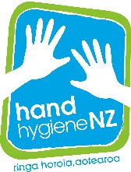

2020
INTERNATIONAL YEAR OF THE NURSE AND THE MIDWIFE

