Executive summary | He kupu whakarāpopoto

The purpose of this focus on seclusion reporting and reviewing is to sustain the quality improvement progress made by Te Whatu Ora | Health New Zealand (Health New Zealand) district project teams towards achieving zero seclusion in adult inpatient mental health and addiction (MHA) settings. This is part of the national project *Aukatia te noho punanga: Noho haumanu, tū rangatira mō te tokomaha | Zero seclusion: Safety and dignity for all* hosted by Te Tāhū Hauora Health Quality & Safety Commission (Te Tāhū Hauora). The work is being carried out in anticipation of the transition of the national MHA quality improvement programme to Health New Zealand by 30 June 2025.

To improve the visibility of seclusion events across the health system, and foster effective learning throughout the MHA sector, the proposed change is to include all seclusion events in the established Always Report and Review (ARR) list ([Healing, learning and improving from harm: National adverse events policy 2023](https://www.hqsc.govt.nz/assets/Our-work/System-safety/Adverse-events/Publications-resources/AdverseEventsPolicy2023_Eng_Feb24update_WEB.pdf)[1] (*the policy*)). This work is an essential step in ensuring that the gains made towards reducing seclusion are sustained and integrated into ongoing quality assurance processes within the MHA sector.

Context | Te horopaki

Standards New Zealand defines ‘seclusion’ as a situation where a service user is ‘placed alone in a room or area, at any time and for any duration, from which they cannot freely exit’.[2]

The current process for reporting seclusion events in Health New Zealand adult inpatient MHA settings is as follows.

|  |  |
| --- | --- |
| **Steps** | **Seclusion reporting** |
| 1 | Seclusion event occurs. |
| 2 | Health provider uses usual seclusion forms as part of Guidelines to the Mental Health (Compulsory Assessment and Treatment) Act 1992 resources:   * [Initiation of seclusion (Word, 92 KB)](https://www.health.govt.nz/system/files/2023-04/1-mh-initiation-of-seclusion-v2.docx) * [Authorisation to seclude for more than 2 hours (Word, 92 KB)](https://www.health.govt.nz/system/files/2023-04/2-mh-authorisation-to-seclude-for-more-than-2-hours.docx) * [Authorisation to seclude for a further 8 hours (Word, 90 KB)](https://www.health.govt.nz/system/files/2023-04/3-mh-authorisation-to-seclude-for-a-further-8-hours.docx) * [Ending seclusion (Word, 90 KB)](https://www.health.govt.nz/system/files/2023-04/4-mh-ending_seclusion.docx) * [Continuous observation and engagement record for use of seclusion (Word, 694 KB)](https://www.health.govt.nz/system/files/2023-04/6-mh-continuous-observation-and-engagement-record-for-use-of-seclusion.docx). |
| 3 | [Seclusion event evaluation](https://view.officeapps.live.com/op/view.aspx?src=https%3A%2F%2Fwww.health.govt.nz%2Fsystem%2Ffiles%2F2023-04%2F5-mh-seclusion-event-evaluation.docx&wdOrigin=BROWSELINK) template[3] is completed by the health provider (district level).  Includes learning and recommendations: what reviews or modifications are required to the person’s care or support plan, in collaboration with the person? |
| 4 | Event is reviewed locally (by health provider at district level). Review of seclusion events is part of Ngā Paerewa Health and Disability Services Standard NZS 8134:2021.[4]  Criterion 6.4.6: ‘Each seclusion event shall be evaluated as soon as reasonably possible after the event. The evaluation is undertaken by registered health professionals from at least two different disciplines and a Māori or Pacific cultural advisor and lived experience advisor, where available.’[5] (p 82) |
| 5 | The health provider (district level) conducts six-monthly reviews of all its seclusion events and provides feedback to local (district) leadership or governance (Criterion 6.4.7).[6] |
| 6 | The Director of Mental Health at Manatū Hauora | Ministry of Health (Ministry of Health) obtains seclusion numbers from the Programme for the Integration of Mental Health Data (PRIMHD) national database. |
| 7 | The district inspector has an independent role in all seclusion practices. |

To improve the visibility of all seclusion events across the health system and transition the project from quality improvement to quality assurance, the proposed change is to include all seclusion events, regardless of the legal status of the consumer under the MHA, in the established Always Report and Review (ARR) list and process as part of *the policy* to support effective learning across the MHA sector.

Always Report and Review

The ARR list is a subset of events within the National adverse events policy 2023that hospital specialist services health and disability providers should always report and review, irrespective of whether the consumer experienced harm. Events are placed on the ARR list to identify areas of local concern where review at regional and national levels may provide insights into how fundamental system safety processes can be improved. As part of *the policy*, each submitted event is allocated a severity assessment code (SAC).[7]

Documents containing SAC examples specific to particular areas of practice have been created for health care providers – such as those providing hospital and specialist services, maternity services or aged residential care. In 2022, a document of SAC examples for MHA[8] was created as part of the project outputs of *Te ako mai i ngā pamamaetanga me to wheako tangata whaiora me to whānau | Learning from adverse events and consumer, family and whānau experience*. Seclusion is not included in the current MHA examples, but this will be worked through prior to 1 July 2025.

The national process for reporting ARR events requires the health provider to submit a Part A: Harm event detail form to Te Tāhū Hauora Health Quality & Safety Commission (Te Tāhū Hauora) within 30 working days of being notified of the harm (adverse) event.

Once the appropriate review has been completed by the health provider, it must submit a Part B: Review details form to Te Tāhū Hauora within 120 working days of the event being reported to the provider. The expectation is that governance structures will be in place to ensure that system learning opportunities are implemented and evaluated.

The ARR list 2023/24[9] includes a section titled ‘Unconsented treatment’ which is relevant to MHA services (see below). However, this currently includes only the rare seclusion events when someone is not subject to the Mental Health (Compulsory Assessment and Treatment) Act 1992.

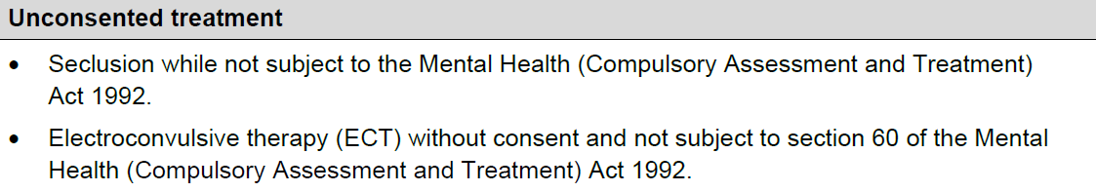

The change to the ARR list is to include **all seclusion events** by changing the wording in the list from ‘Seclusion while not subject to the Mental Health (Compulsory Assessment and Treatment) Act 1992’ to ‘All seclusion events of consumers’.

Effective from 1 July 2025, seclusion events in acute adult, child and adolescent, and older people’s mental health inpatient services will be included in ARR reporting. From the same date, forensic mental health services will also begin reporting seclusion events through ARR, starting with a focused scope – specifically, individuals who experience more than 24 hours in seclusion within a 28-day period. This approach aligns with current expectations for more detailed reviews of these cases and provides a practical entry point for implementation. The inclusion of additional forensic seclusion data will follow a phased process, supported by tailored messaging and engagement as guided by Health New Zealand.

The rationale for including all seclusion events in the ARR reporting and review process is to:

* make use of the ARR as an established process that will support effective learning across the MHA sector
* embed the ARR learning review process for all seclusion events and continue to reduce seclusion events
* reduce harm from seclusion to both consumer and staff through the review process
* improve the visibility of seclusion rates, and the outcome and process measures for seclusion, across the MHA sector
* enable robust monitoring to hold and sustain the gains made
* make use of the suite of resources available to the MHA sector (ie, change package, cultural kete) to support ongoing quality improvement.

Reporting seclusion events – future state

The enhanced process for the reporting and review of seclusion events is to include seclusion in the established ARR list and process to support effective learning across the MHA sector.

Four Health New Zealand district Zero seclusion project teams[10] will be testing this enhanced process from mid-March to end of April 2025. The project teams will also be providing feedback on what fields from the Seclusion event evaluation template should be included in an automated report.

Communication to the wider MHA and health sector on the enhanced process will follow the testing period, in anticipation of the transition of the national MHA quality improvement programme to Health New Zealand by 30 June 2025.

|  |  |
| --- | --- |
| **Steps** | **District seclusion reporting and review using ARR** |
| 1 | Seclusion event occurs. |
| 2 | 1. Health provider enters event in its incident reporting system and a risk assessment code (RAC) rating if required. 2. Health provider gives the event a provisional SAC rating to confirm the level of harm.   Note: Health providers using Datix incident reporting system currently rate seclusion as a SAC 3 event, but the MHA SAC guide will be updated to clarify the SAC levels in terms of the impact of harm from seclusion as agreed with the consumer and whānau.   1. Health provider uses usual seclusion forms as part of Guidelines to the Mental Health (Compulsory Assessment and Treatment) Act 1992 resources:  * [Initiation of seclusion (Word, 92 KB)](https://www.health.govt.nz/system/files/2023-04/1-mh-initiation-of-seclusion-v2.docx) * [Authorisation to seclude for more than 2 hours (Word, 92 KB)](https://www.health.govt.nz/system/files/2023-04/2-mh-authorisation-to-seclude-for-more-than-2-hours.docx) * [Authorisation to seclude for a further 8 hours (Word, 90 KB)](https://www.health.govt.nz/system/files/2023-04/3-mh-authorisation-to-seclude-for-a-further-8-hours.docx) * [Ending seclusion (Word, 90 KB)](https://www.health.govt.nz/system/files/2023-04/4-mh-ending_seclusion.docx) * [Continuous observation and engagement record for use of seclusion (Word, 694 KB)](https://www.health.govt.nz/system/files/2023-04/6-mh-continuous-observation-and-engagement-record-for-use-of-seclusion.docx). |
| 3 | Health provider submits a Part A: Harm (adverse) events form with a provisional SAC rating (informed by the consumer’s experience of seclusion) to Te Tāhū Hauora via the harm (adverse) events submission portal within 30 working days of the event being notified.[11] |
| 4 | Health provider completes the Seclusion event evaluation template.[12]  Criterion 6.4.6: ‘Each seclusion event shall be evaluated as soon as reasonably possible after the event. The evaluation is undertaken by registered health professionals from at least two different disciplines and a Māori or Pacific cultural advisor and lived experience advisor, where available.[13] (p 82) |
| 5 | Health provider reviews seclusion event(s) as part of existing harm (adverse) events review group/committee process. |
| 6 | Health provider submits an anonymised version of the Seclusion event evaluation template, and Part B: Harm (adverse) events form, to Te Tāhū Hauora via the harm (adverse) events submission page within 120 working days of the event.[14] |
| 7 | The health provider (district level) conducts six-monthly reviews of all its seclusion events (automated summary reports to be provided by Te Tāhū Hauora) and provides feedback to local (district) leadership or governance (Criterion 6.4.7).[15] |

Measures

Transition from quality improvement to quality assurance by having effective outcome measures, using the seclusion dashboard, and new process measures, using the ARR process, for effective learning and monitoring by 1 July 2025.

|  |  |
| --- | --- |
| Outcome measure | * Further reduction in seclusion to under 3 percent nationally. |
| Process measure(s) | * Handover of Zero seclusion project dashboard to Health New Zealand. * All 20 Health New Zealand districts will be using the ARR process to report and review seclusion events. |

Driver diagram

|  |  |  |  |
| --- | --- | --- | --- |
| **Aim** | **Primary drivers** | **Activities** | **Details** |
| To improve care for consumers/tāngata whaiora by tackling variation in seclusion rates across all districts and eliminating the equity gap.  The project will aim to reduce seclusion rates in both Māori and non-Māori, non-Pacific population groups in MHA adult unit inpatient settings to less than 3 percent by 1 June 2025, working towards the goal of health equity and ultimately zero seclusion.  To transition to Health New Zealand and/or business as usual. | Effective leadership for cultural and organisational change | Leadership hui, online, October 2024  Regular sector catch-ups | ARR process:   * Internal/external agreement re next steps September 2024 * Communications September 2024   + Consumer Advisory Group & Te Hiringa Kounga Māori   + Director of Mental Health, Ministry of Health   + Te Tāhū Hauora: System safety team; set up ARR process; work out timings to be in place; talk to health quality intelligence team about seclusion dashboard   + Director of Area Mental Health Services, Directors of Nursing Mental Health   + Clinical directors, general managers   + Sarah Jackson – National Chief, Quality and Patient Safety, Health New Zealand * Wider sector update: comms email – quarterly update Confirm district testing teams, December 2024 * Hui for testing teams, February 2025 * Testing period, March to May 2025 * Final ARR process confirmed end of May 2025 |
| Using data to support improvement and equity |  |
| Workforce development | ARR process  August 2024 – May 2025 |
| Equitable person-, family- and whānau-centred care provision |  |
| Proactive care and reductions interventions | District visits  November 2024 – April 2025 |
| Quality designed system | ARR process  August 2024 – May 2025 |

Appendix: Seclusion event evaluation template[16]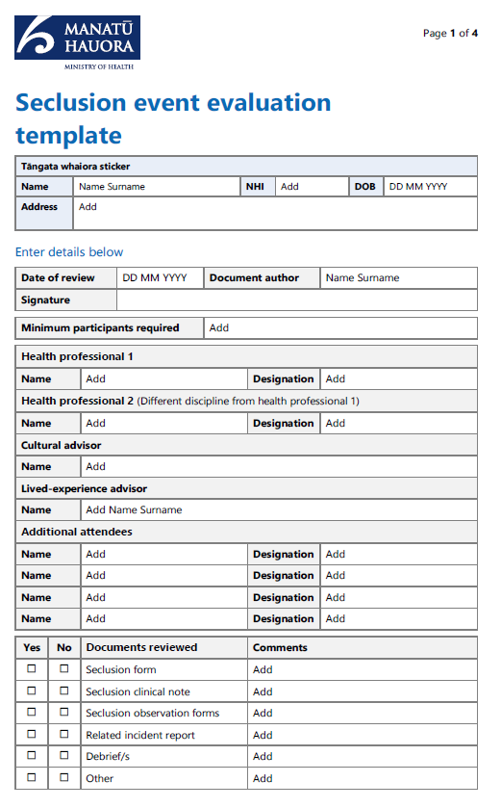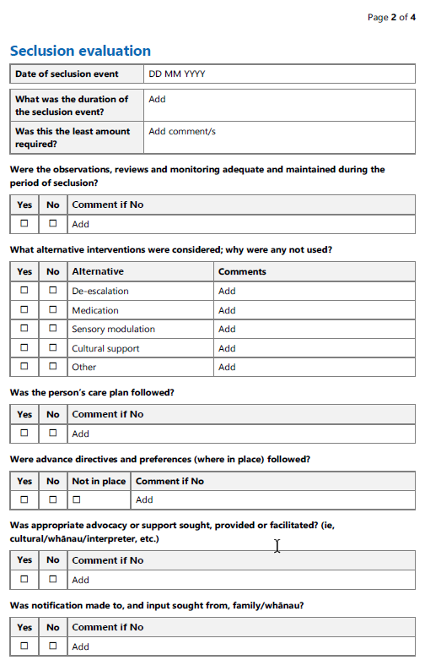

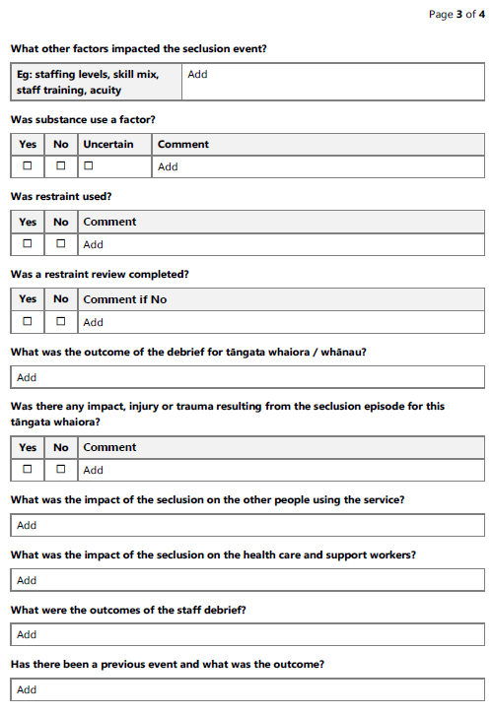

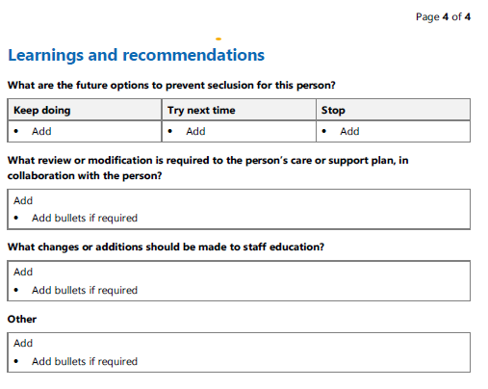

1. Te Tāhū Hauora Health Quality & Safety Commission. 2023. Healing, learning and improving from harm: National adverse events policy. Wellington: Te Tāhū Hauora. URL: [www.hqsc.govt.nz/assets/Our-work/System-safety/Adverse-events/Publications-resources/AdverseEventsPolicy2023_Eng_Feb24update_WEB.pdf](https://www.hqsc.govt.nz/assets/Our-work/System-safety/Adverse-events/Publications-resources/AdverseEventsPolicy2023_Eng_Feb24update_WEB.pdf) (accessed 15 May 2025).
2. See Standards New Zealand. 2021. *Ngā Paerewa Health and Disability Services Standard*. URL: [www.standards.govt.nz/shop/nzs-81342021](https://www.standards.govt.nz/shop/nzs-81342021) (accessed 15 May 2025).
3. To download the Seclusion event evaluation template, see the appendix or go to: Ministry of Health. 2023. *Guidelines for Reducing and Eliminating Seclusion and Restraint under the Mental Health (Compulsory Assessment and Treatment) Act 1992*. Wellington: Ministry of Health. URL: www.health.govt.nz/publications/guidelines-for-reducing-and-eliminating-seclusion-and-restraint-under-the-mental-health-compulsory (accessed 16 May 2023).
4. Standards New Zealand 2021, *op. cit.*
5. *Ibid.*
6. *Ibid.*
7. To download the Severity Assessment Code rating and process tool for Healing, learning and improving from harm, go to: Te Tāhū Hauora Health Quality & Safety Commission. System accountability. URL: [www.hqsc.govt.nz/our-work/system-safety/healing-learning-and-improving-from-harm-policy/system-accountability](http://www.hqsc.govt.nz/our-work/system-safety/healing-learning-and-improving-from-harm-policy/system-accountability) (accessed 16 May 2025).
8. See Te Tāhū Hauora Health Quality & Safety Commission. Mental health and addiction severity assessment code (SAC) examples 2024. URL: [www.hqsc.govt.nz/resources/resource-library/mental-health-and-addiction-severity-assessment-code-sac-examples/](http://www.hqsc.govt.nz/resources/resource-library/mental-health-and-addiction-severity-assessment-code-sac-examples/.) (accessed 16 May 2025).
9. See Te Tāhū Hauora Health Quality & Safety Commission. Always Report and Review List 2023–24. URL: [www.hqsc.govt.nz/resources/resource-library/always-report-and-review-list-2023-24/](https://www.hqsc.govt.nz/resources/resource-library/always-report-and-review-list-2023-24/) (accessed 16 May 2025).
10. Four Health New Zealand district Zero seclusion project testing teams: Te Toka Tumai Auckland, Te Tai Tokerau Northland, Lakes and MidCentral.
11. Te Tāhū Hauora Health Quality & Safety Commission 2023, *op. cit.*
12. To download the Seclusion event evaluation template, see the appendix or go to: Ministry of Health 2023, *op. cit.*
13. Standards New Zealand 2021, *op. cit.*
14. Te Tāhū Hauora Health Quality & Safety Commission 2023, *op. cit*.
15. Standards New Zealand 2021, *op. cit.*
16. To download the Seclusion event evaluation template, go to: Ministry of Health 2023, *op. cit.*